Install Microsoft Visual Studio -> Visual Studio Setup.exe -> It will download installer, then start installing it -> a screen then appears for the things you want to download -> .NET framework for console -> around 7 GB, download then install -> Launch Visual Studio 2022 -> Create new Project -> Choose C# project for console -> Name the project -> Solution space name could be different , it is a container for many different projects that you will build later on -> Chose the directory of your workspace -> Create Project.

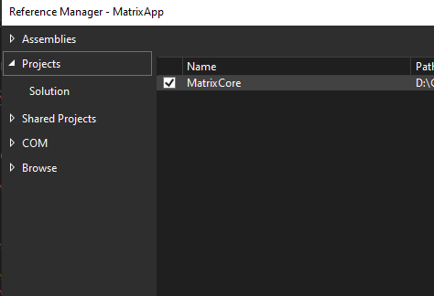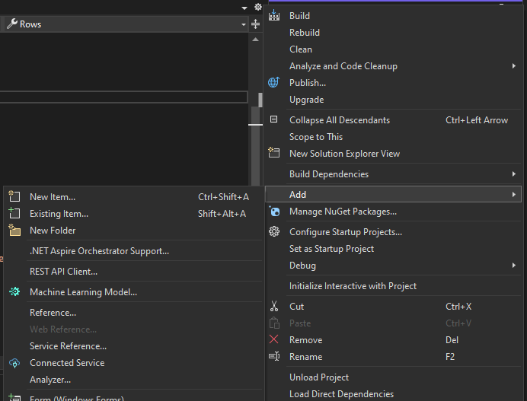You can have two or more different projects within same solution. Within each project your namespaces may be different. A good method is to have one project for defining classes and methods, like a library project( without any Main() method) , while a separate project would be the executable project. The latter would contain the Main() method: entry point of your app. The library project needs to be referenced in the executable project so that we can use its classes and methods. For this write **Using namespaceLibrary**; at top of the executable project. **Also** : *right click the executable project tab in Visual Studio-> Add -> Reference..* In the new window, select the(checkbox) library project from project list.

To measure the execution time of a code block in C#: Use the **Stopwatch** class from the **System.Diagnostics** namespace. Wrap the code you want to measure with Stopwatch.StartNew() and Stopwatch.Stop().  
  
using System;  
using System.Diagnostics;  
  
class Program   
{  
 static void Main(string[] args)  
 {  
 Stopwatch stopwatch = Stopwatch.StartNew(); // Create a new Stopwatch instance  
 PerformTask(); // Code block whose execution time you want to measure  
 stopwatch.Stop(); // Stop the stopwatch  
 TimeSpan ts = stopwatch.Elapsed; // Get the elapsed time as a TimeSpan value  
 Console.WriteLine($"Execution Time: {ts.TotalMilliseconds} ms");// Display the elapsed time  
 }  
}

Literals: fixed values, literally the character that is typed.  
Data types: integer, long, float, double, decimal  
Variable name: may use Camel case; start with alphabet or underscore; container for holding values

Console.WriteLine("Hello World!!"); // Outputs this line on terminal and appends a new line  
Console.ReadKey(); // Obtains the next character or function key pressed by user and displays it onto console. If it is the last statement the window will close following our key press.  
Console.ReadLine();// Reads the next line of characters from the standard input stream and returns this; return type: string  
int marks; // Variable Declaration- int can hold only integers of 32-bit signed integer – default  
marks = 21; // Variable initialization using assignment operator, done from right to left  
int age=33, x, y, salary = 2400000; // Multiple Variable Declaration and initialization.  
// x = 5, y= 6; Cannot assign like this using comma separator  
long ageOfUniverse = 160000000000L; // long integer - 64 bit signed   
double score = 36.4342D; // double precision floating point number – default  
float weight = 65.4f; // single precision floating point number - suffix f or F.  
decimal money = 793.34M; // decimal number

int num = Convert.ToInt32(Console.ReadLine()); // For Type Conversion; here string output is converted to integer

• **PascalCase**: For public-facing elements like classes, properties, methods, and events.

• **camelCase**: For local variables, method parameters, and sometimes private fields.

• **_camelCase**: For private fields, especially when there’s a public property with the same concept but a different casing.

• **lowercase**: For very short-lived variables in small scopes, like loop counters.

in the Solution Explorer: Right click on Project-->select properties-->select application tab-->select output type as Class library and save it and build it.

Right click the solution and properties…set the startup project….

Also right click on startup project and reference the library project..

If Visual Studio shows namespace error/ directive missing, simply restart ; uncheck the reference , save it, then again check the reference