University of North Carolina at Charlotte  
Department of Electrical and Computer Engineering

Junior Design Lab 2-0

**DC-to-DC BUCK CONVERTER**

Lab 2-0

Team 5: Andrew Nicola, Daniel Jolin, John Saavedra, Nathan Waters, and Christian Salitre

Date: 09/12/2023

**Objective:**

The objective of this lab was to design, model, and simulate a DC-to-DC Buck Converter using two MOSFETs, amongst other design parameters, to provide constant voltage over the load with less than 1% ripple and provide a current through the inductor with less than 10% ripple. The Buck Converter should be rated for 200 – 400 watts with a duty cycle of 70%.

**Relevant Theory:**

A DC-to-DC Buck Converter has two cyclic stages, "High" and "Low". In the "High" stage, a primary switching element (MOSFET) acts like a gate, allowing current to flow from the input voltage source through an inductor and into the load. The inductor uses this change in current to store energy. In the "Low" stage, the primary switching element turns off, and a reverse biased MOSFET turns on. The switch between these stages is nearly instantaneous, with the duty cycle determining the proportion per cycle in which the input voltage is actively high. This precision control allows for efficient conversion from a higher input voltage to a lower output voltage.

**Design Parameters:**

* Power rating: 200W- 400W
* DC voltage supply (input): 30V-40V
* Switching frequency: 10kHz – 50kHz
* Duty Cycle: 70% - 85%.
* Current ripple in the inductor: less than 10% of the max current
* Output voltage ripple measured at the load: less than 1% at the max load

**Design Elements:**

* (2) MOSFETS
* 218 µH Inductor
* 23.6 µF Capacitor
* 1.96 Ω Resistor
* DC Voltage Supply (Capable of 40V)
* PWM Generator
* Other elements needed to run the simulation (not essential in the converter operation)

**Schematic:**

**Questions:**

1. **Define your nominal operating conditions and specifications, i.e. switching frequency, input voltage, duty cycle, load resistance value, inductor and capacitor values, etc. Provide a justification on how to pick your inductor and capacitor values. Use standard values for capacitor values. I suggest using ceramic capacitors for filtering, voltage rating of about 100VAC.If you need bigger capacitance for filtering you can use Film capacitors.**

|  |  |
| --- | --- |
| **Design Specifications** | **Values** |
| Switching Frequency (*f)* | 27,000 Hz |
| Input Voltage (DC) (V­in) | 40 Volts |
| Duty Cycle (D) | 70% |
| Power Rating (P) | 400W |
| Load Resistance value (Ω) | 1.96 Ω |
| Inductor (H) | 218 µH |
| Capacitor (F) | 23.6 µF |

**Inductor:**

**L** = $\frac{{(V}_{in}-V_{Load})}{ΔI_{Load}(f)}$ $(\frac{V_{Load}}{V_{in}})$* = $\frac{40V-28V}{1.428A(26kHz)}$ $(\frac{28V}{40V})$* = **218** µH

**Capacitor:**

**C** = $\frac{ΔI_{Load}}{8f(ΔV_{c})}$ = $\frac{1.428A}{8(27kHz)(0.28V)}$ = **23.6** µF

**Load Resistance:** We chose to achieve a power rating of 400 Watts so our system can handle the highest power rating in the design parameters.

**P** = ${\frac{V_{Load}}{R_{Load}}}^{2}$ RLoad = = = **1.96** Ω

1. **Provide the theoretical input-output voltage relationship. This is sometimes called conversion** **ratio. With your simulation, include a plot showing the input and output voltage. Does it follow the theoretical (calculated) value?**

**Load Voltage:** We chose a Duty Cycle of 70%, to account for low quality MOSFETS.

**VLoad** = Vin (D) 40V(0.70) = **28** V

1. **Measure the current ripple in the inductor and voltage ripple across the output (capacitor) at your nominal operating point? With your simulation include a plot with your measurements.**

**Voltage Ripple:**

**Vripple** = ΔVCapacitor = VLoad(Ripple%) = 28V(0.01) = **0.28** V

**Maximum Output Current:**

**ILoad** = = = **14.286** A

**Ripple Current:**

**IRipple** = ΔILoad = Iout (Ripple%) = 14.286A (0.10) = **1.428** A

**Current Ripple: (Needs to stay between 12.857 A to 15.714 A) (10%)**

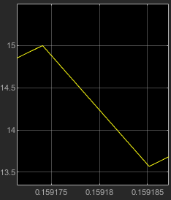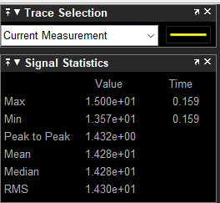

**Voltage Ripple: (Needs to stay between 27.72 V to 28.28 V) (1%)**

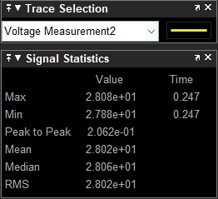

1. **Change the input voltage ±10V and run your simulation.**
2. **In one plot, measure the output voltage, output current, and output power**

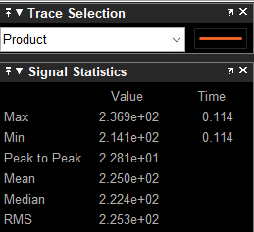

1. **In another plot, show the inductor current and output voltage. Measure the inductor current ripple and output voltage ripple. Compare them with your nominal operating point.**

**Conclusion:**

In conclusion, the Buck Converter we built met all design and performance criteria. Thorough testing ensured that the converter reliably stepped down the input voltage to the desired output level with minimal voltage ripple (<1%) as well as maintaining a low current variation through the inductor (<10%). As we move forward, the insights and experience gained from this Buck Converter project will be invaluable in refining and enhancing the designs of future electronic solutions.

**Appendix:**

GitHub:[**https://github.com/RocketDan11/JuniorDesign**](https://github.com/RocketDan11/JuniorDesign)