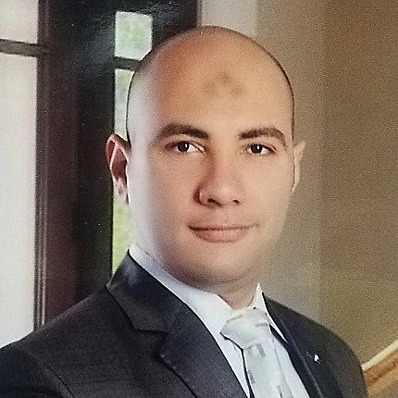

* Photoshop, illustrator
* Html, Css, Js
* Bootstrap, jQuery,
* MySQL, PHP

**Web Skills**

* Time Management
* Business Writing
* Communication
* Presentation
* Negotiation
* MS Office

**Business Skills**

**Contacts**

|  |  |
| --- | --- |
|  | +2 0122 5577 451 |
|  | eslam.dif@gmail.com |
|  | Alexandria, Egypt |
|  | /in/Eslam_Ahmed |
|  | www.e-slam.com |

© Design & Creative By Eslam Ahmed

Eslam Ahmed

AUDIT & REPORT COORDINATOR

|  |  |
| --- | --- |
| *Qualifications* | |
|  | * Measure the work output & efficiency of each activity. * Evaluate & measure the service center performance to ensure a high quality of service. * Prepare operation measuring reports * Repair order quality evaluation report. * Service branch car repair report. * Customer satisfaction report. * Transit Clients Area report. * Workshop repair report. * Come back report. |
| *Experience* | |
| -Jul-2009  -Present- | **Filing-Data entry**   * BMW (Bavarian Auto Group) :   Data entry and Analysis, Reporting and Disseminating Results. |
| -Oct-2008  -Feb-2009 | **CSS Coder**   * World Group Inc. :   Design and development of scripts in Web 2.0, and building styles forums. |
| -Jan-2008  -Apr-2008 | **Web Designer**   * Tourism website :   Design a tourism website about Alexandria, Planning and building its own internal pages.  -My Personal Project- |
| -Dec-2005  -Dec-2007 | **Project manager**   * RamaHost Inc. :   Planning, designing and building web sites and preparation the (Meta tags) for publication through the Internet. |
| *Education* | |
|  | * New Horizon Alexandria   + 2019     - Full Stack Web Development * Technological College in Alexandria   + 2003     - Devices and control |

To obtain a responsible and challenging position in the Administrative field of a growth-oriented organization and to further my professional development by gaining innovative technical career skills which will allow me to both further utilize my skills and acquire new ones.