|  |
| --- |
| **shoubra faculty of engineering benha university** |
| **Computer Architecture** |
| [ Html project ] |
|  |

|  |
| --- |
|  |

**Eslam Hamdy Abd ElHalim**

**ID:181**

**Name: Eslam Hamdy Abd ElHalim Mohamed**

**Sec: 8**

**ID: 181**

**Topic: Computer Architecture**

**Application Brief :**

In [computer engineering](https://en.wikipedia.org/wiki/Computer_engineering), **computer architecture** is a set of rules and methods that describe the functionality, organization, and implementation of [computer](https://en.wikipedia.org/wiki/Computer) systems.

Some definitions of architecture define it as describing the capabilities and programming model of a computer but not a particular implementation. In other definitions computer architecture involves [instruction set architecture](https://en.wikipedia.org/wiki/Instruction_set_architecture) design, [microarchitecture](https://en.wikipedia.org/wiki/Microarchitecture) design, [logic design](https://en.wikipedia.org/wiki/Logic_design), and [implementation](https://en.wikipedia.org/wiki/Implementation).

**Screen Shots :**

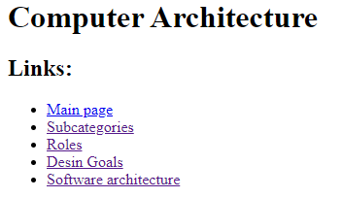

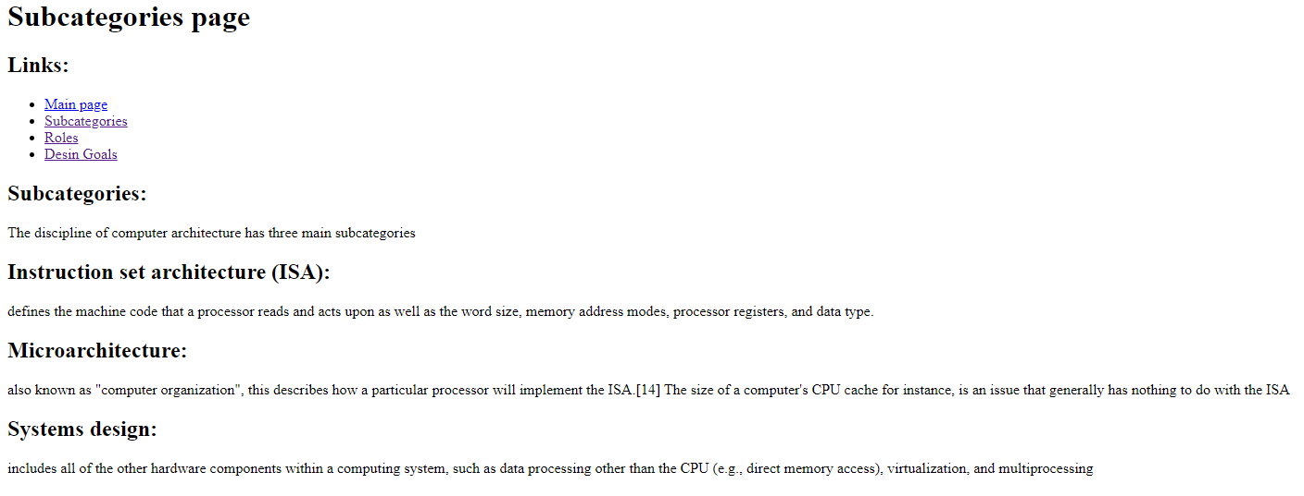

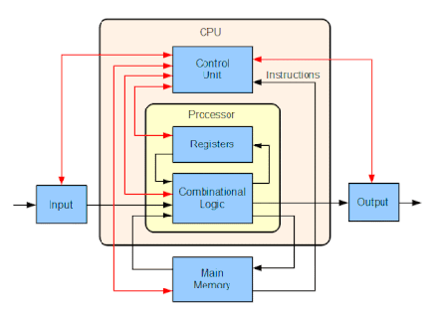

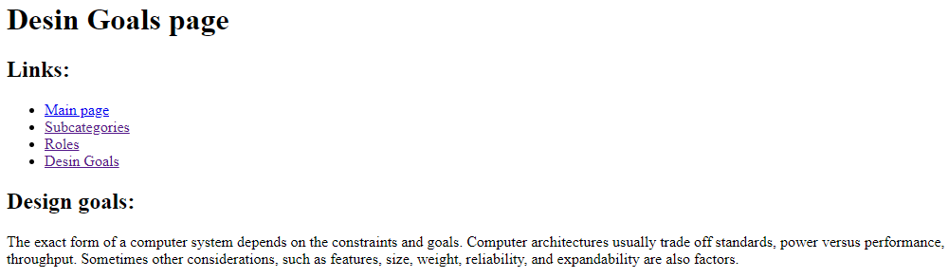

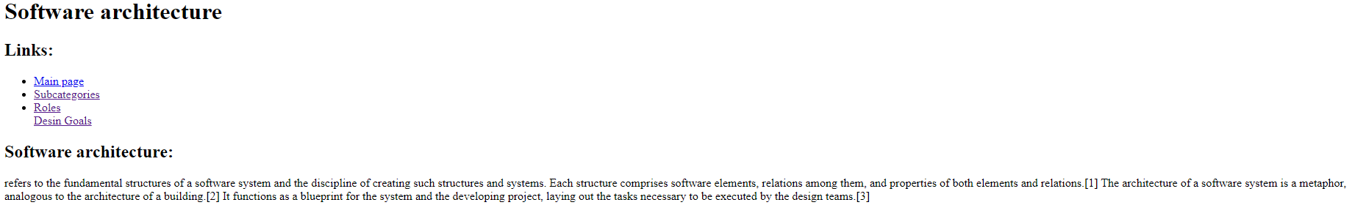

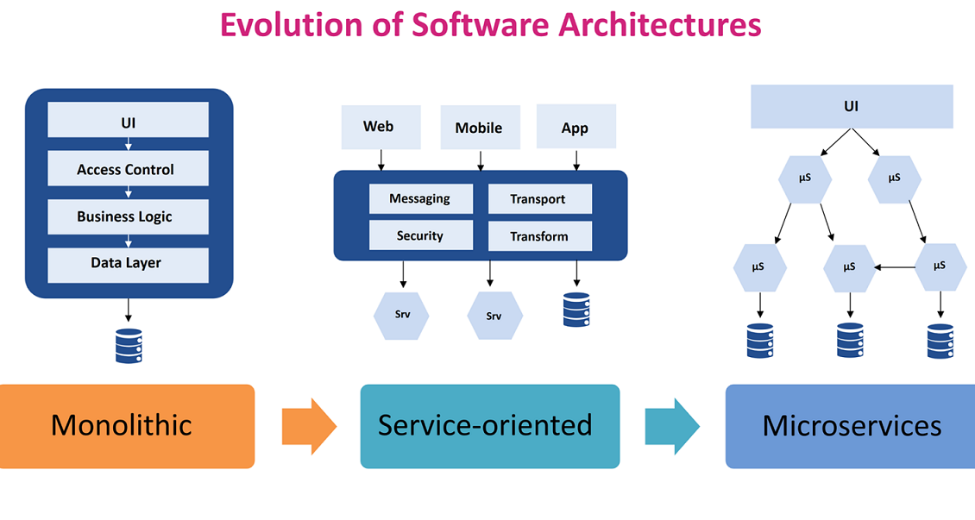

**Source Code** :

