

Faculty of Computers and Information

**CS-251: Software Engineering (I)**

**Course Project: Event Organizer**

**DR. Mohamed El-Ramly**

**T.A. Sara Tarek**

Software Design Specifications Document

For Event Organizer

**Team Leader: Mostafa Aly El-Sayad**

**mostafa.elsayad@hotmail.com**

**15/11/2014**

Contents

Team 2

Document Purpose and Audience 3

System Models 4

System Decomposition 4

Class diagrams 5

Sequence diagrams 6

Class - Sequence Usage 12

Physical Entity-Relationship Diagram 13

User Interface Design 14

Screen 1 – Home Screen 14

Screen 2 – User’s main Screen 15

Ownership Report 16

Team Members:

|  |  |  |  |  |
| --- | --- | --- | --- | --- |
| **ID** | **Name** | **Email** | **Signature** | **Mobile** |
| 20120382 | Mostafa Aly El-Sayad | mostafa.elsayad@hotmail.com | Mostafa El-Sayad | 01009252995 |
| 20110017 | Eslam Osama Mohamed Ibrahim | eom_realmadrid@live.com | Eslam Ibrahim | 01092741971 |
| 20110058 | Ahmed Saber | ahmed.saber99985@yahoo.com | Ahmed Saber | 01110126543 |
| 20110006 | Ibrahim Abd El-Reheem | ebrahimfci@yahoo.com | Ibrahim Abd El-Reheem |  |

Document Purpose and Audience:

This document provides all system models needed for the implementation processofthe event organizer application. This made specially to helpdeveloper, maintainer, and tester of the event organizer and will not be available for users.

System Models:

* **System Decomposition:**

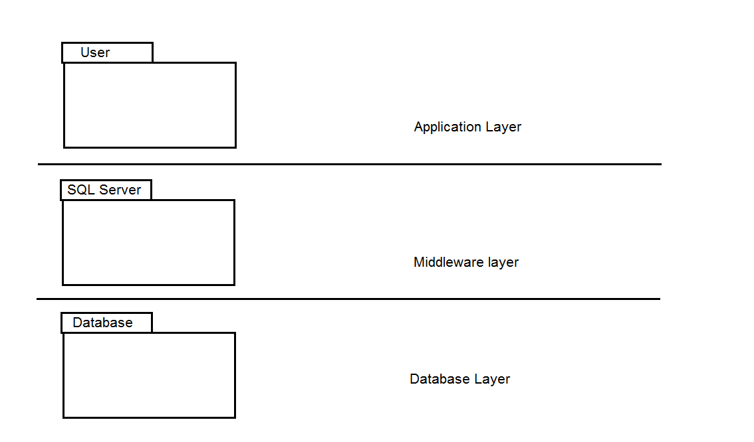

* 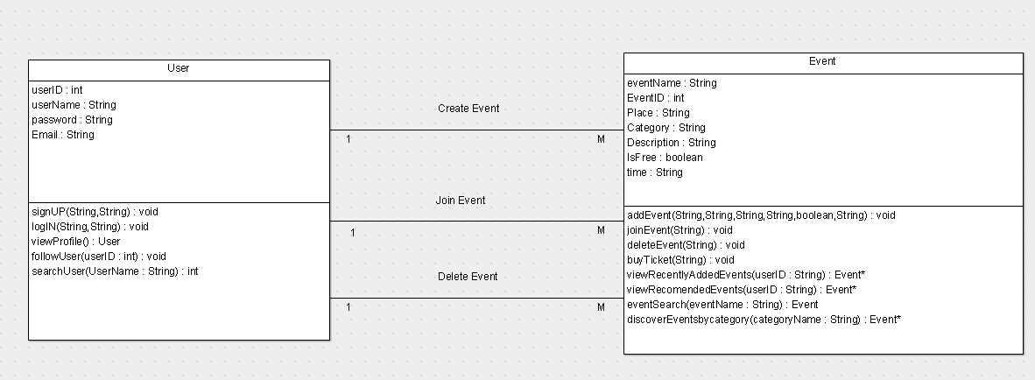**Class Diagram:**

| **Class ID** | **Class Name** | **Subsystem ID** | **Description** |
| --- | --- | --- | --- |
| 1 | User | Sub-1 | Representing the user entity in the system |
| 2 | Event | Sub-1 | Representing the event entity in the system |
| 3 | EventOrganizer | Sub-0 | Is the boundary class which will let the system user interact with all features in the application |

* **Sequence Diagrams:**

**Sequence Diagram #1: “use case table #1”**

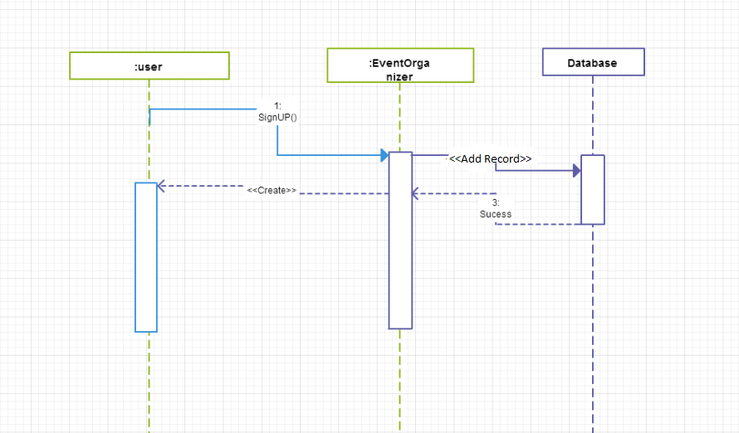

**Sequence Diagram #2: “use case table #3”**

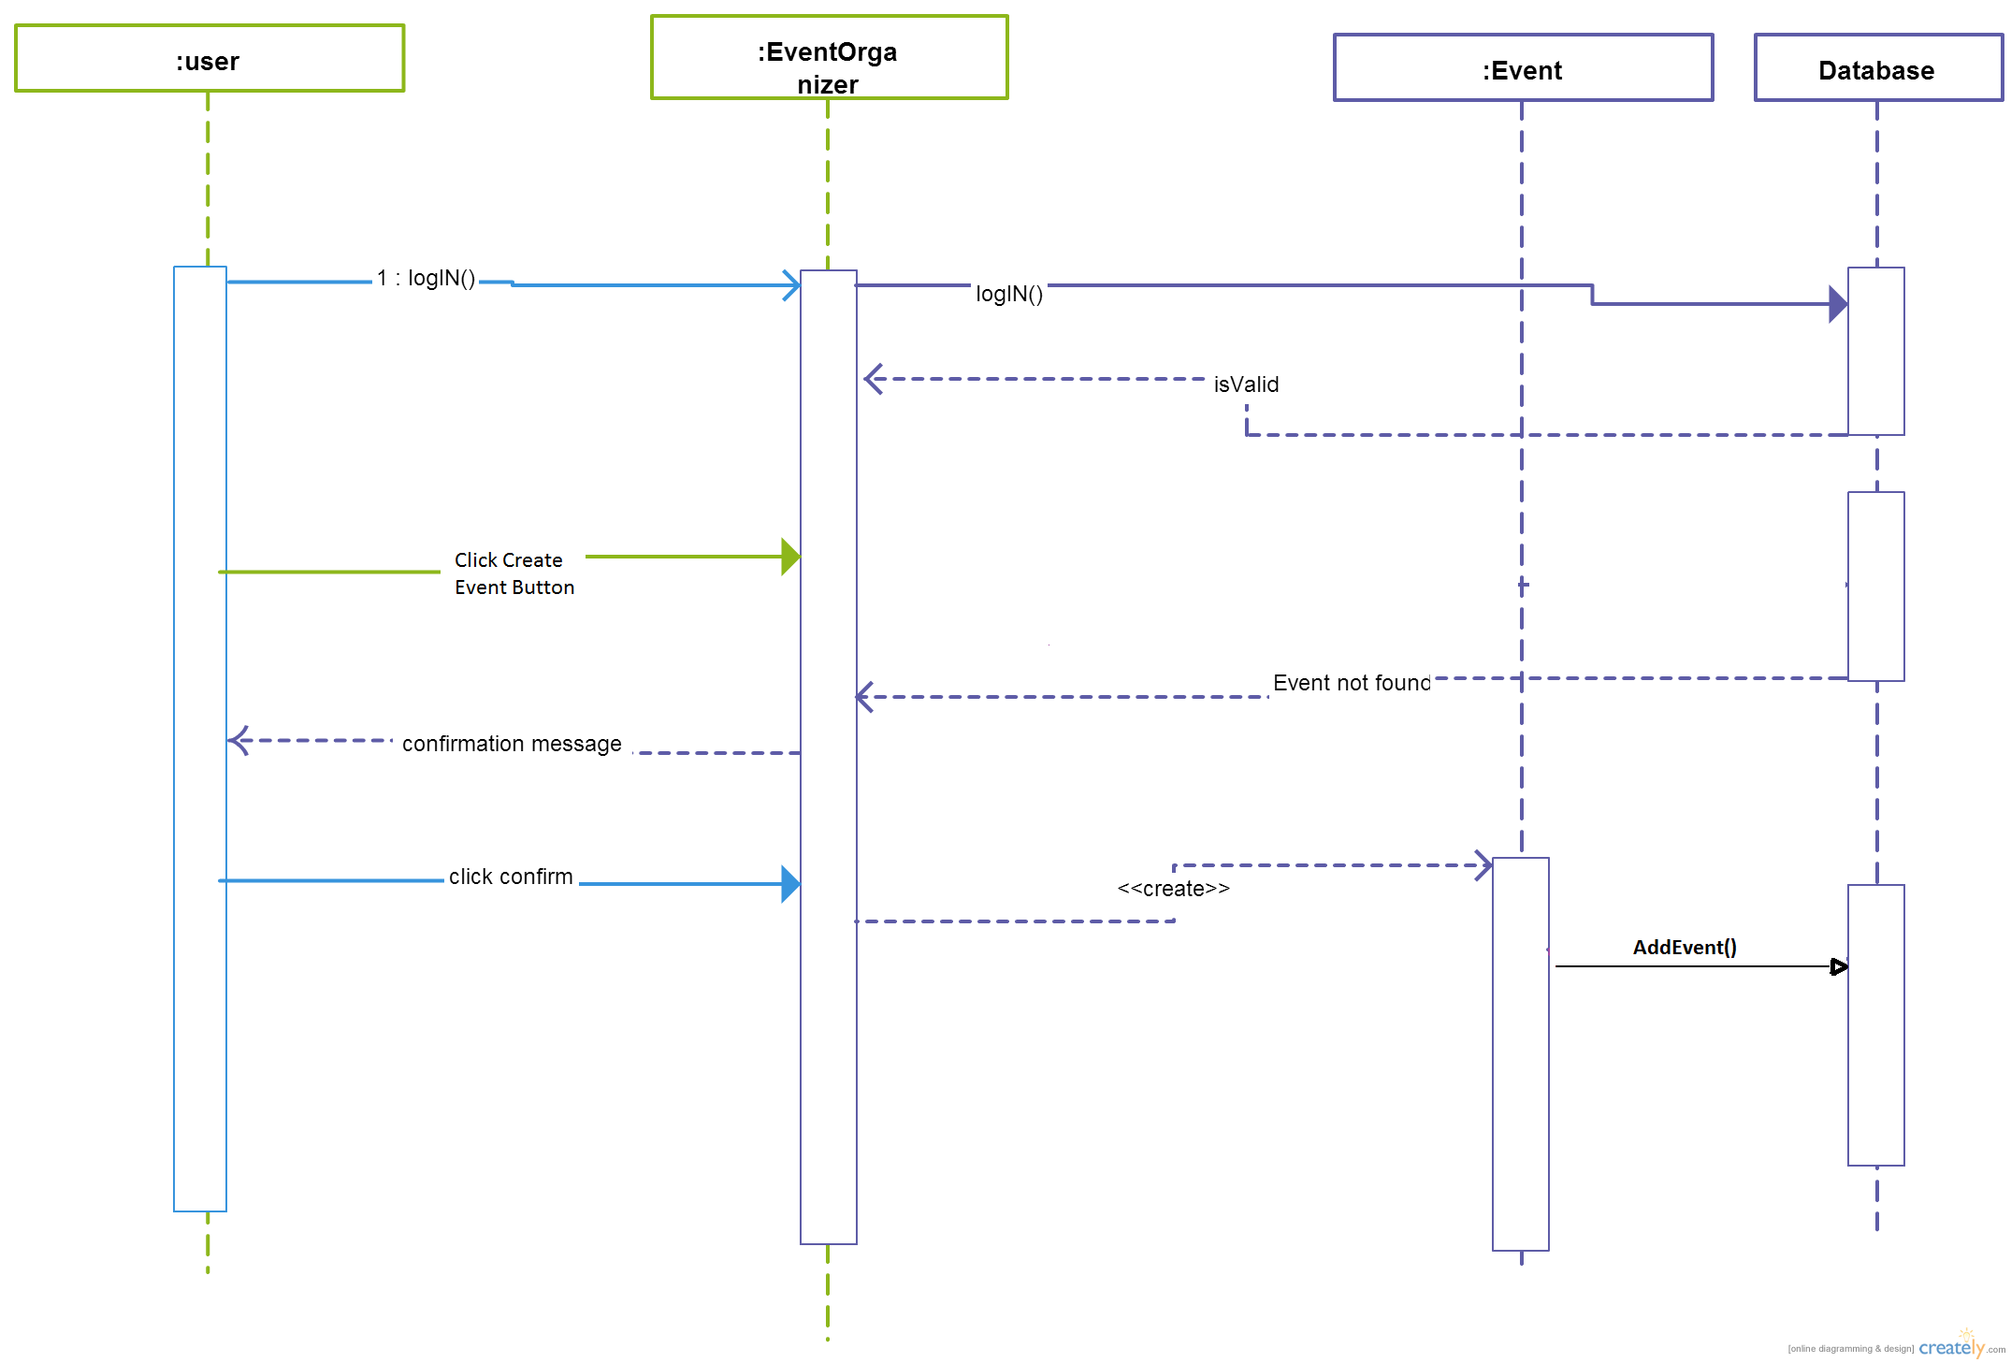

**Sequence Diagram #3: “use case table #4”**

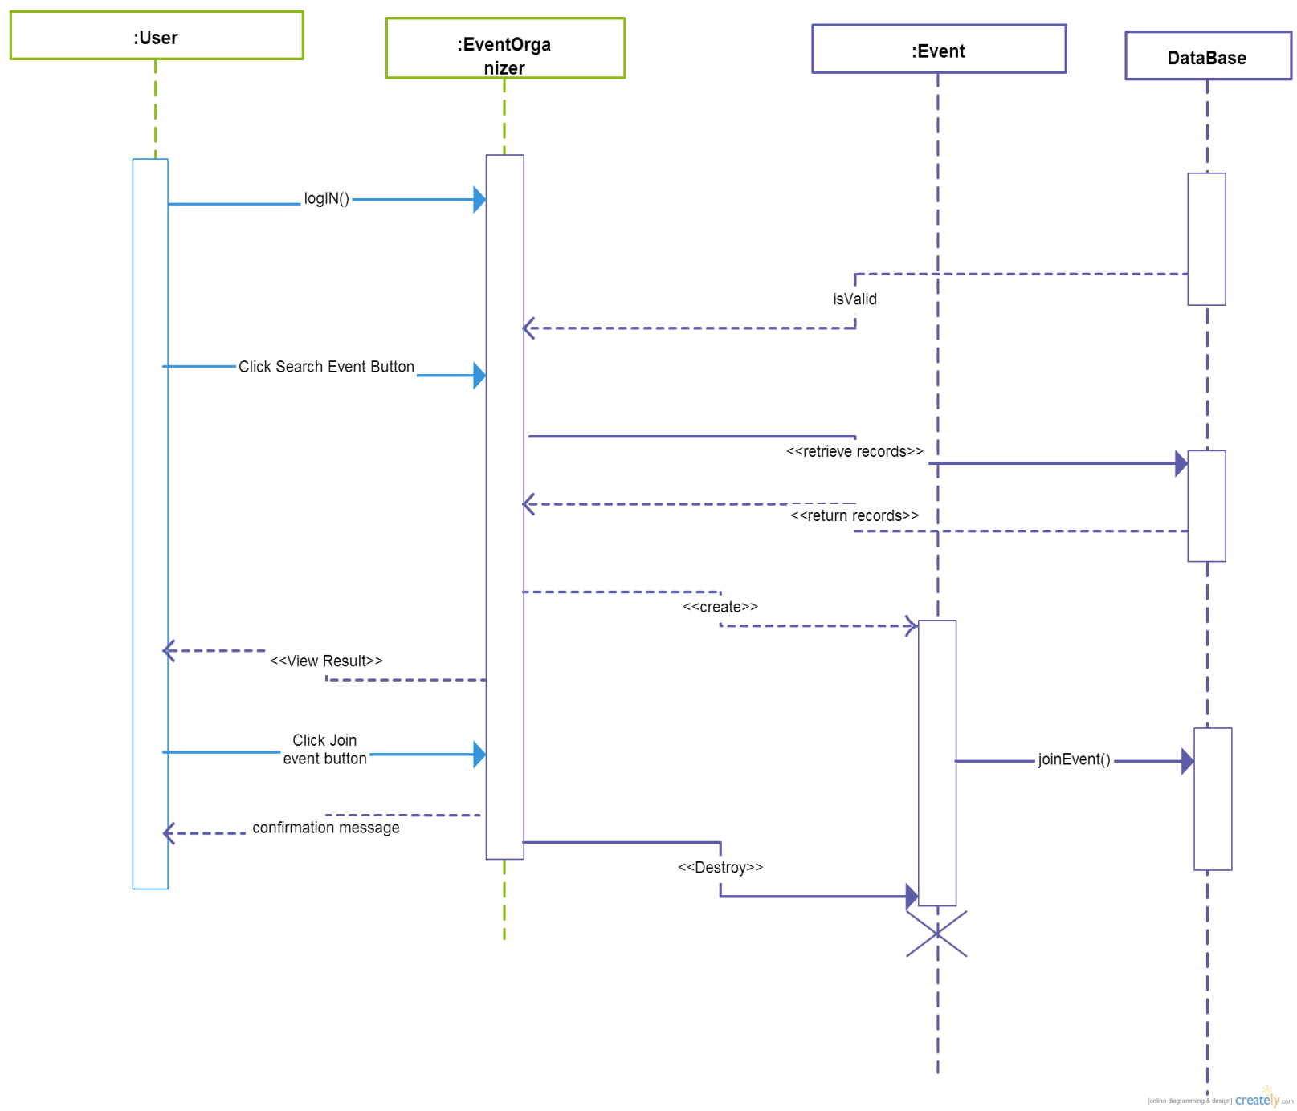

**Sequence Diagram #4: “use case table #6”**

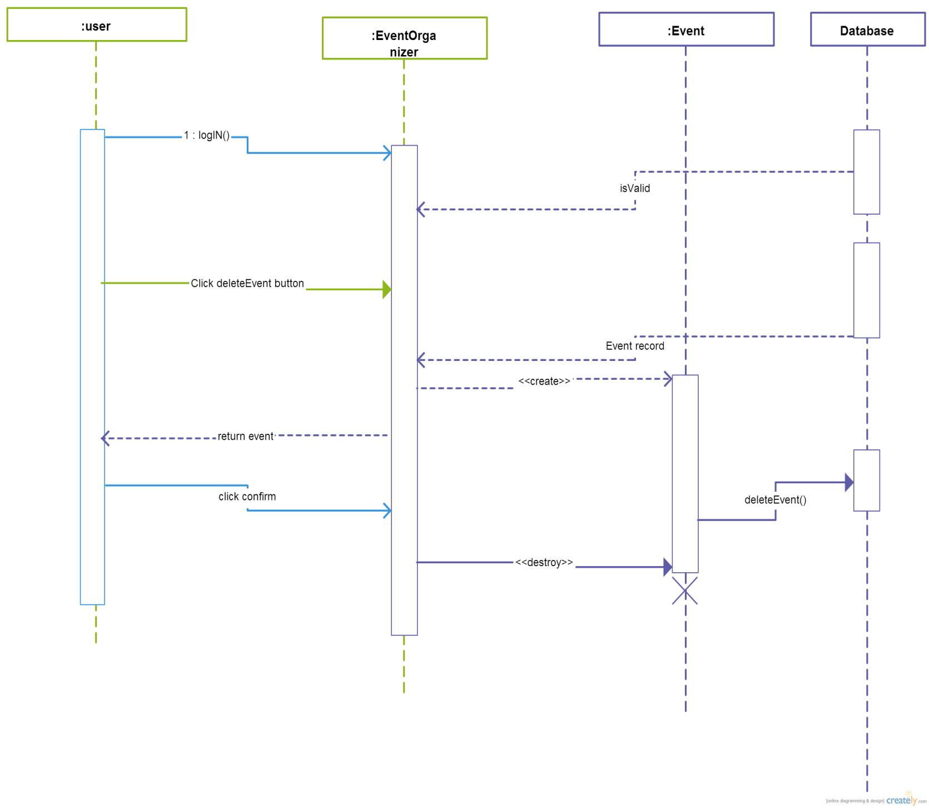

**Sequence Diagram #5: “use case table #8”**

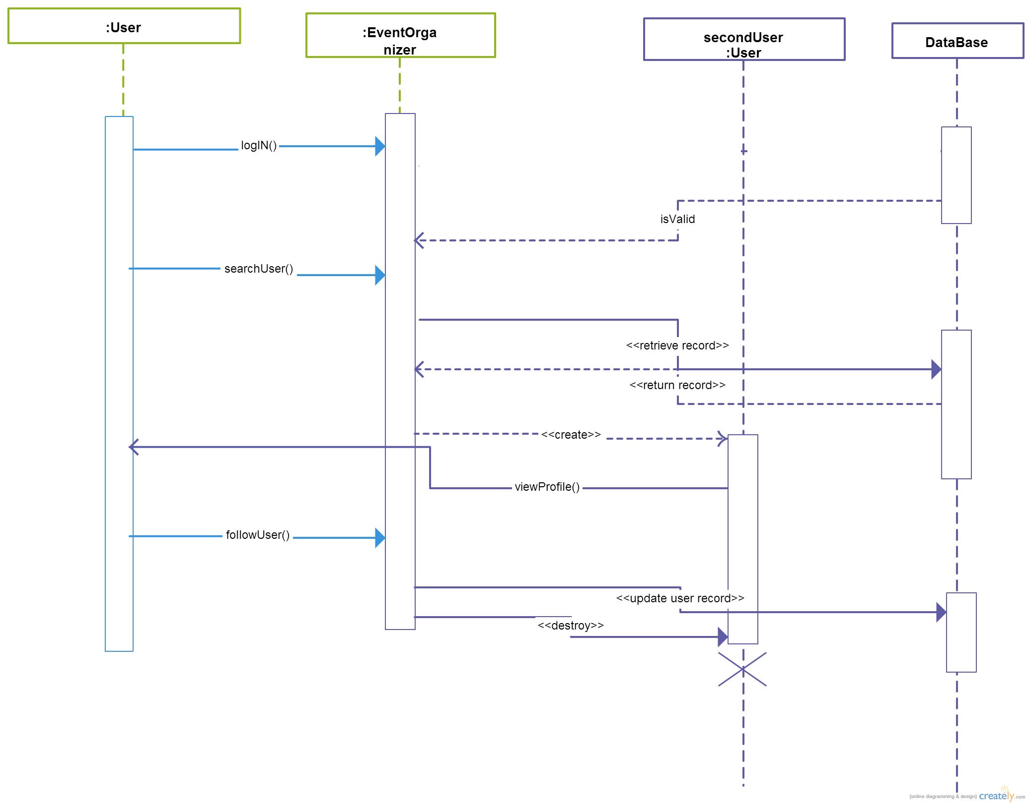

**Sequence Diagram #6: “use case table #9”**

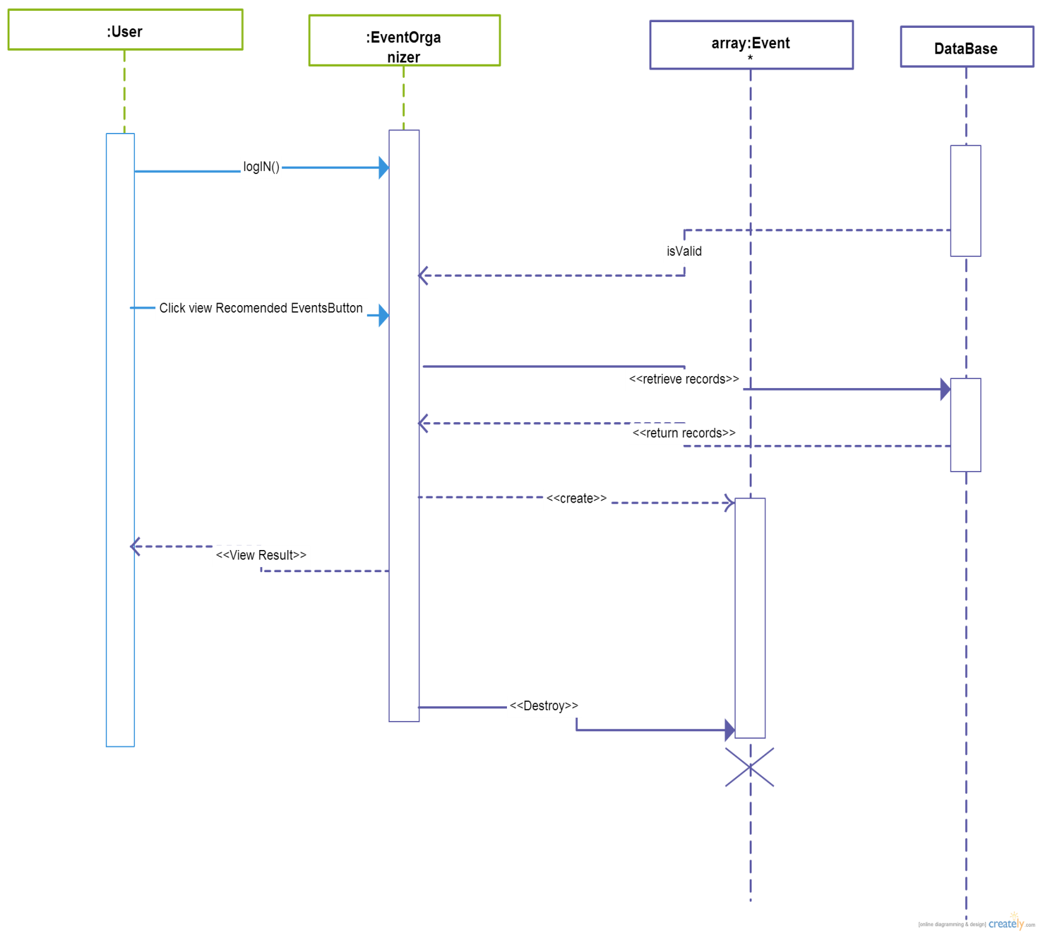

* **Class – Sequence Usage:**

| **Class Name** | **Sequence Diagrams** | **Overall used methods** |
| --- | --- | --- |
| User | All of sequence diagrams | logIN() , signUP(),viewProfile(),followUser(),searchUser() |
| Event | All of sequence diagrams | addEvent(),joinEvent(),deleteEvent(),searchEvent() |
| EventOrganizer (as a boundary class) | All of sequence diagrams | Main() |
| DataBase (as a storage entity) | All of sequence diagrams | N/A |

* **Physical Entity Relationship Diagram:**

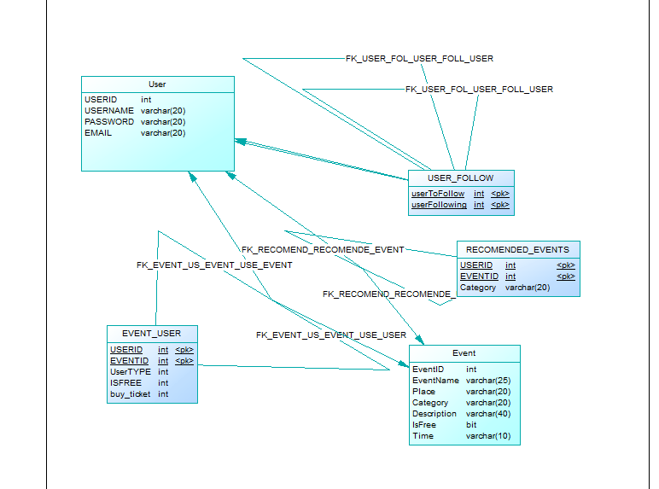

* **User Interface Design:**

**Screen One: “Home Screen”**

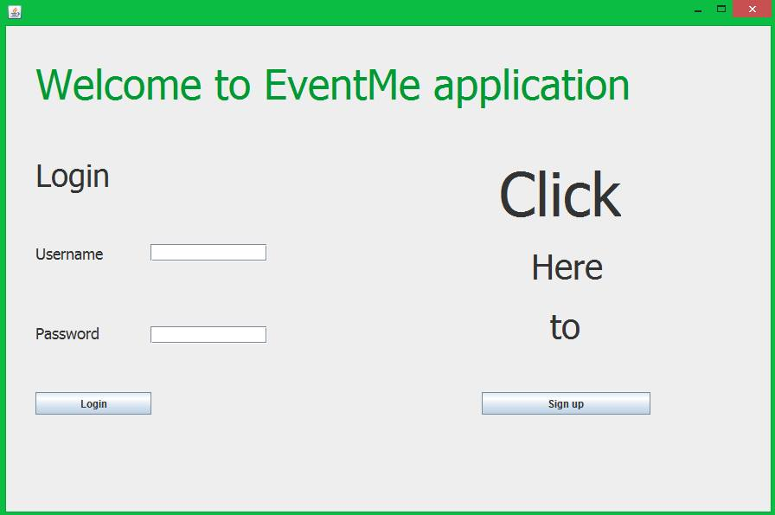

**Screen Two: “user’s main screen”**

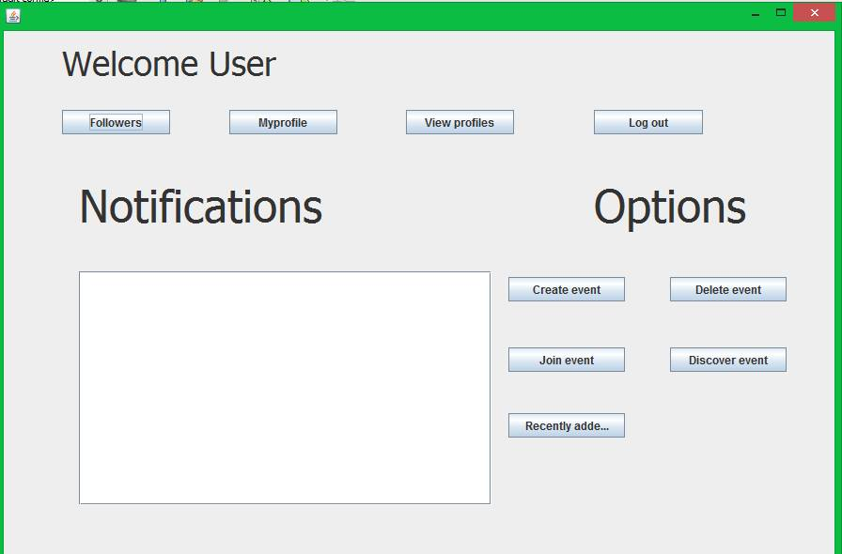

Ownership Report:

**Items Table:**

|  |  |
| --- | --- |
| Item | Owner |
| Document purpose and audience | All team members |
|  |  |
| System Decomposition | Mostafa El-Sayad |
|  |  |
| Class Diagram | Eslam Ibrahim & Ibrahim Abd El-Rheem |
|  |  |
| Sequence Diagrams | Eslam Ibrahim & Ahmed Saber |
|  |  |
| Physical Entity Relationship Diagram | Eslam Ibrahim &Mostafa El-Sayad |
|  |  |
| User Interface Design | Mostafa El-Sayad |

**Jobs Table:**

|  |  |
| --- | --- |
| Job | Team Member |
| Brainstorming | All team members |
| Typing SDS Document | Eslam Ibrahim&Mostafa El-Sayad |
| Reviewing SDS Document | Mostafa El-Sayad |