**Eslam Mahmoud Sentia Deliverable**

|  |  |
| --- | --- |
| Author | Eslam Sayed Mahmoud |
| Email address | eslamsayedattiama@gmail.com |
| Last Updated | 3 September 2018 |
| Version number | 1.0 |
|  |  |

Table of contents

• Pre-Requistes ii

• Assumptions ii

• Script Usage ii

• Script Validation iii

1. Resource Group iii

2. Storage Account iii

3. Virtual Network/Subnets iii

4. Policy Definition iv

5. Policy Assignmet v

6. Resources in Resource Group vi

• GitHub Structrure vii

• Time Log vii

## Pre-Requistes

* Powershell 5+ version.
* AzureRM Powershell package.
* Github repository.

## Assumptions

1. One of Azure PowerShell silent authentication methods (Azure SP with AD application, Azure SP with a certificate, …) is already configured on the machine that will run PowerShell scripts, I used "AD, service principal ID method, scripts are in " Silent AuthenticationScripts in GitHub", below dir.
   * <https://github.com/Eslam10/SentiaDeliverables/tree/master/Script/Silent%20AuthenticationScripts>
2. Naming Convention of Resource Group/Virtual Network/Subnets/Policy Definition/Policy Assignment were not provided, I put names starting with Sentia.
3. Location of created resources was not provided, I assumed all resources will take the same Resource Group location by default.
4. StorageAccountType parameter wasn’t provided, I put it as “Standard_GRS”.
5. Number of IPs per subnet wasn't mentioned, I assumed /24 subnet network.
6. Storage Account is encrypted by default, I didn't add any step for that in the Storage Account template

## Script Usage

* Script will create required resources based on template/parameter files which will be taken from GitHub repository.
* To keep it dynamic and to not update in the script itself in case of other template/parameter files required, I added another file called “FileLocations.txt” which includes all template/parameter files URLs in GitHub.
* Only this “FileLocations.txt” file URL is written in the script, everything else in the script is variables based.
* So, to re-use the script with other parameters, I can either,
  + Add a new “FileLocations.txt” file, Update all URLs in “FileLocations.txt” file to point to new template/parameter files, update “FileLocations.txt” URL in the script to point to new dir.
  + Or, update the required in the same template/parameter files.

## Script Validation

### Resource Group

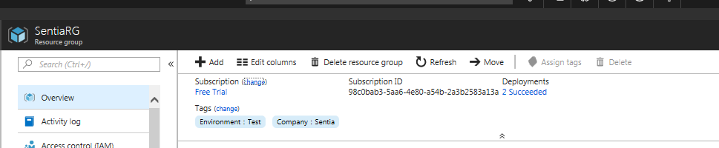

### Storage Account

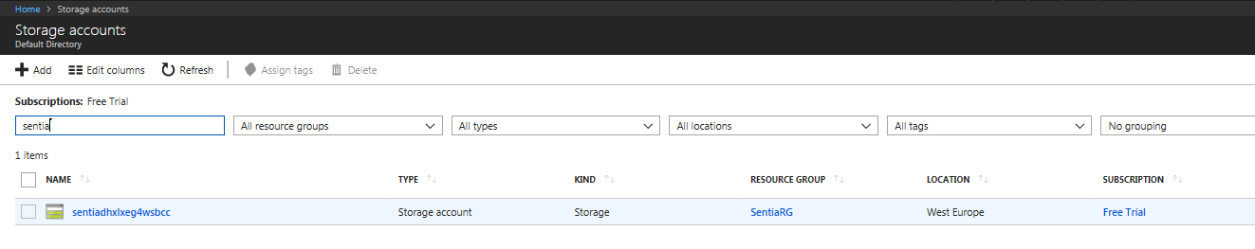

### Virtual Network/Subnets

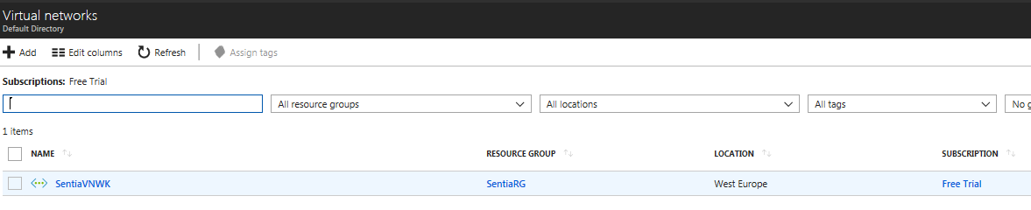

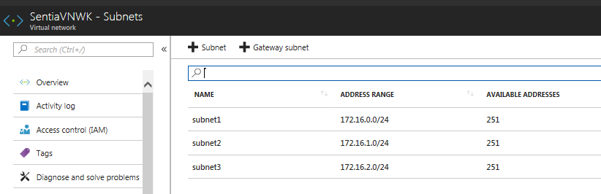

### Policy Definition

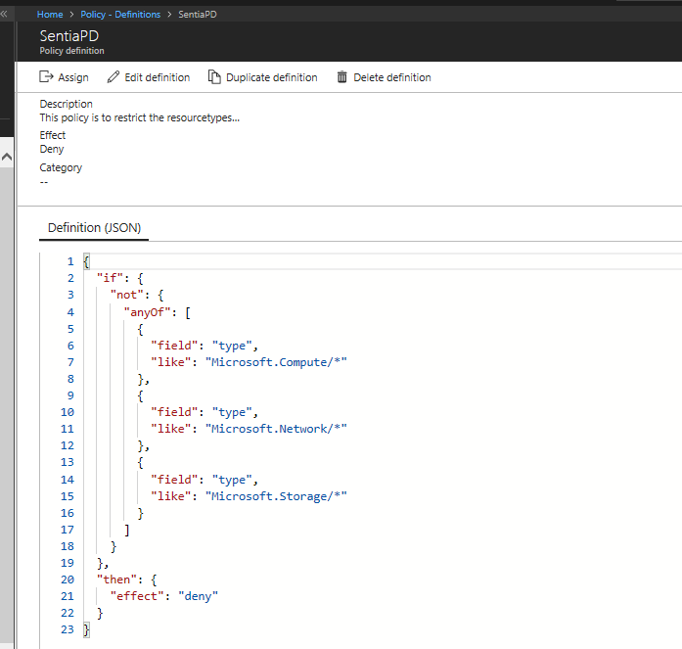

### Policy Assignmet

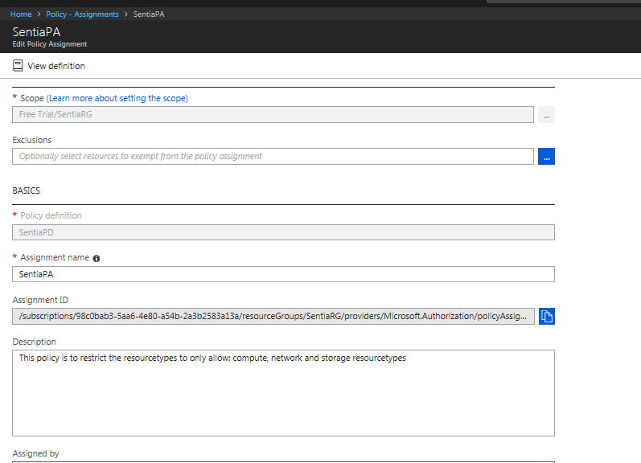

#### Policy Assignment Validation

* + Create resource not in the allowed resource types (ex: App Service)

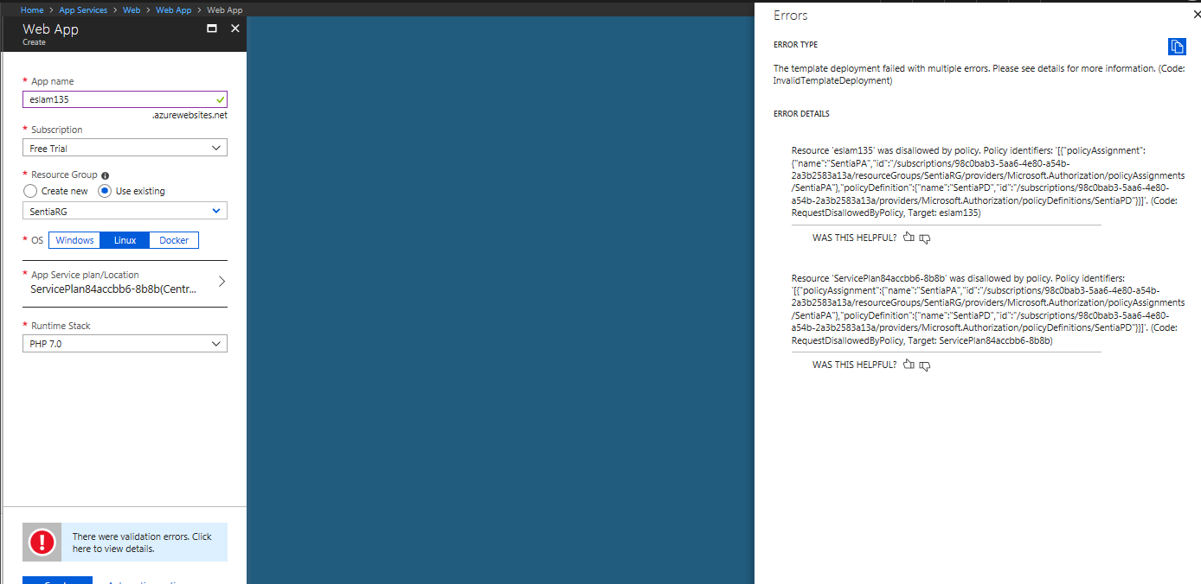

#### Create resource in the allowed resource types (ex: new Storage Account)

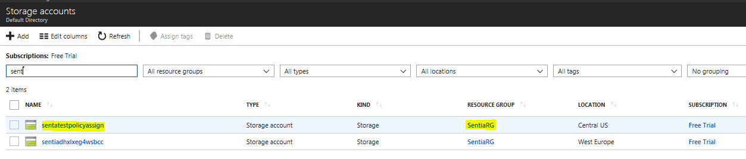

### Resources in Resource Group

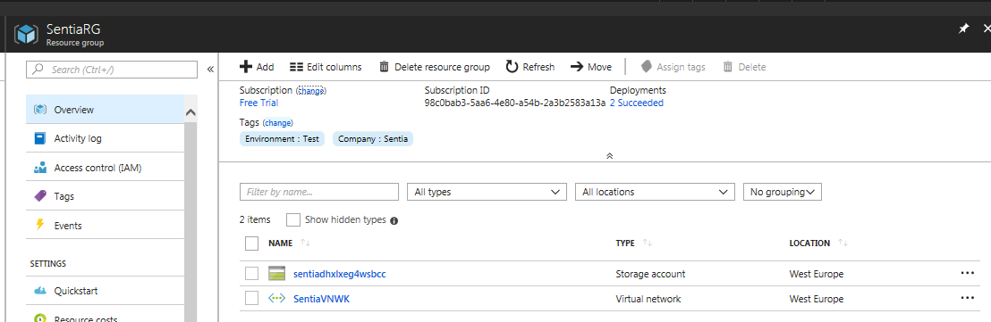

## GitHub Structrure

|  |  |
| --- | --- |
| **Item** | **Dir** |
| Main Script | <https://raw.githubusercontent.com/Eslam10/SentiaDeliverables/master/Script/Script.ps1> |
| Script Log | <https://raw.githubusercontent.com/Eslam10/SentiaDeliverables/master/Script/ScriptLog.txt> |
| ResourceGroup and FileLocations file | <https://github.com/Eslam10/SentiaDeliverables/tree/master/FileLocations_RGParameters> |
| Storage Account temp/param | <https://github.com/Eslam10/SentiaDeliverables/tree/master/StorageAccount> |
| Virtual Nwk temp/param | <https://github.com/Eslam10/SentiaDeliverables/tree/master/VirtualNwk> |
| Policy Def/Assign Body files | <https://github.com/Eslam10/SentiaDeliverables/tree/master/PolicyDefAss> |
| Silent Auth scripts | https://github.com/Eslam10/SentiaDeliverables/tree/master/Script/Silent%20AuthenticationScripts |

## Time Log

|  |  |
| --- | --- |
| **Action** | **Time Taken** |
| Reading/Research/Simple commands | 8 hrs |
| Scripting/Testing | 12 hrs |
| Documentation | 0.5 hr |