**The design purpose**

**At Posedge**

Both the Master and the slave take shifting operation which the Master writes data to the MOSI and the Slave Writes data to the MISO.

**AT negedge**

Both the Master and the Slave make sampling operation which the Master reads data From the MISO and The Slave reads data from the MOSI

After each CLK the Master chose The Slave Again with CS with Enable One Slave and Disable the Other

At Test Bench of the Master is to Send and Receive data from many Slaves at Same Time This Is Mainly Testing the ability Of the Exchange Between the Master and Many Slaves.

At Test Bench of The Slave Is to Receive Data from Master and makes shift Operation and Resend Shifted Data.

It wait the signal of start to begin the transmission (also the master will read "masterDataToSend" in order to send it to the slave).

And it takes 8 periods to send all data from the master to slave and slave to master.

We make it with 2 test cases different.

**The Simulation Results**

**The development testbench**

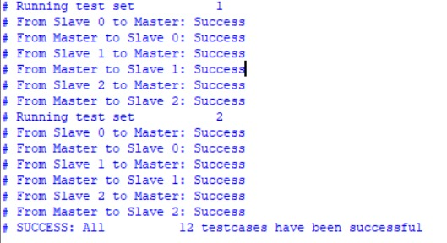

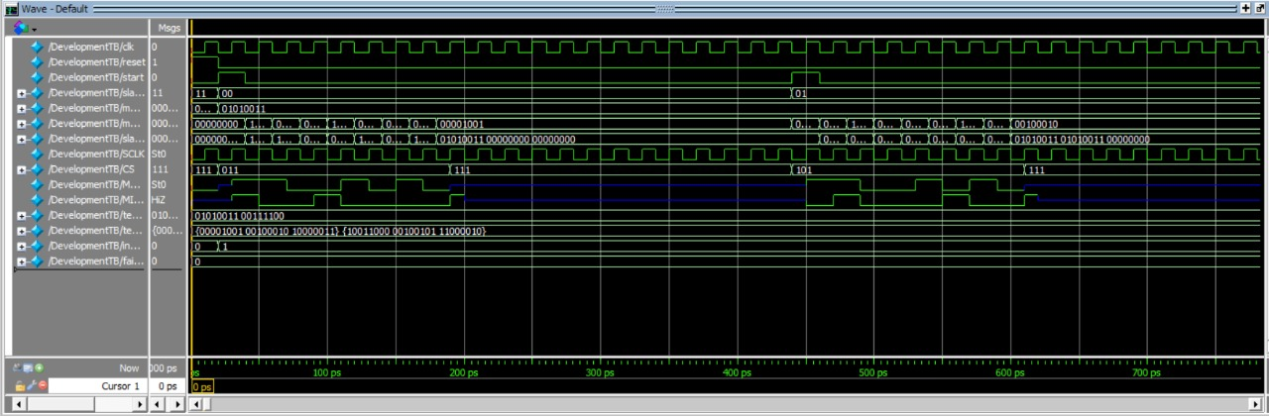

**Testbench Master**



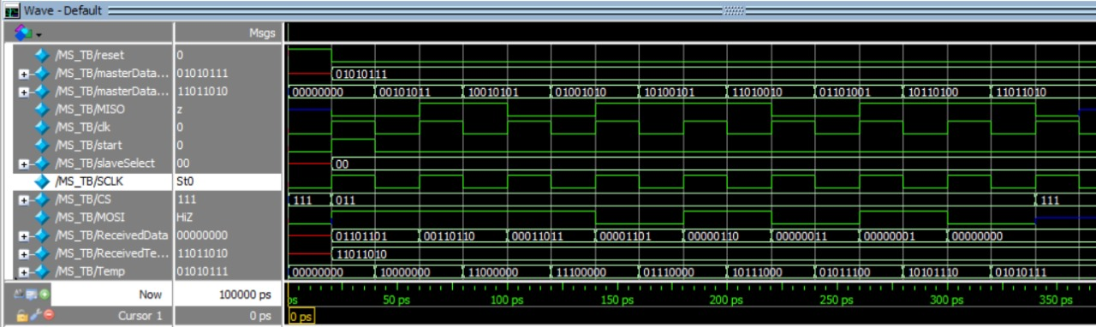

**Testbench slave**

