**Project Name :** Bank System

**Description :-**

This is a project for bank System that simulate the process of registration a new account transfer money to another account deposit money withdraw exchange rates view and many other functions in Gui Forms.

**Parts : 4 Classes , 9 Forms**

**Program Contain:-**

* **Registration**
* **Login**
* **Account Status**
* **Deposit**
* **Withdraw**
* **Transfer Money**
* **Account Log**
* **Exchange Rates**
* **Contact Us**
* **About Us**

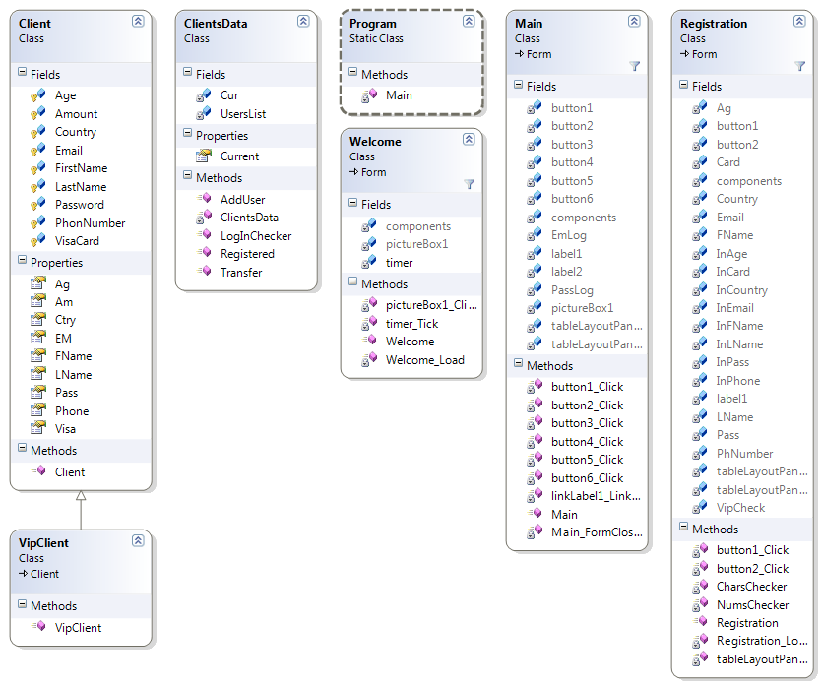**Class Diagrams :-**

