Temporal Evaluation, Calibrated Risk, and Conformal Delay-Severity Prediction in Pharmaceutical Logistics
Anonymized manuscript for double-anonymized review

Abstract
Delivery delays in global health supply chains disrupt treatment continuity, deplete buffer stocks, and complicate procurement and transportation planning. Machine-learning models for shipment-delay prediction are often evaluated with random cross-validation, which can obscure deterioration when the data-generating process changes over time. We evaluate an integrated logistics decision-support framework that combines prediction-time leakage control, expanding-origin temporal evaluation with 90-day post-delivery embargoes, calibrated delay-risk estimation, conditional delay-severity modeling, conformalized quantile uncertainty, and capacity-constrained shipment prioritization. Using the USAID Supply Chain Management System delivery-history data (N = 10,324 shipments across 42 recipient countries), random cross-validation overestimated PR-AUC relative to temporally ordered evaluation across all five tested classifiers, with relative inflation from 26.2% for logistic regression to 99.7% for LightGBM. Platt scaling reduced Brier score and expected calibration error while preserving continuous rankings. Conditional-median severity estimates achieved lower mean absolute error than LightGBM quantile point predictions, while the quantile models enabled Split Conformalized Quantile Regression. Under exchangeability, split CQR has finite-sample marginal coverage guarantees; here, temporally later cohorts are treated as empirical out-of-time coverage audits rather than formal guarantees under shift. On the secondary locked registry benchmark (N = 1,013; 61 delays), 90% CQR achieved 91.80% empirical coverage (56/61; exact 95% CI 81.90%-97.28%) with 46.27-day mean width. Simulated Top-K triage showed different trade-offs among risk, severity, and uncertainty. The results support temporally disciplined and uncertainty-aware logistics evaluation rather than a single universally dominant model or ranking policy.
Keywords: Pharmaceutical logistics; shipment delay; temporal validation; probability calibration; conformal prediction; decision support

1. Introduction
Global health supply chains operate under long international lead times, heterogeneous transport modes, procurement constraints, and uneven infrastructure. Delayed health-product deliveries can contribute to stockouts and emergency responses, making delivery reliability a practical logistics concern. Predictive analytics can help identify shipments that warrant attention, but a deployable logistics model must answer more than whether an order is likely to be late. It must be evaluated at a realistic prediction time, provide probabilities that are meaningful for decision thresholds, characterize how severe a delay may become, communicate uncertainty, and support prioritization when review capacity is limited.
A central methodological difficulty is temporal dependence. Randomly mixing historical and future shipments can allow model selection to exploit distributional information unavailable at deployment time. In shipment data, the problem is amplified by label maturity: an order can be known before its eventual delivery outcome is resolved. We therefore treat prediction-time integrity and temporal separation as part of the scientific problem rather than as implementation details.
The study evaluates a connected framework combining leakage-aware temporal validation, probability calibration, conditional severity, conformalized quantile uncertainty, and capacity-constrained shipment prioritization. The contribution is methodological integration and evidence governance rather than a new learning algorithm.

2. Related work
Prior work establishes several components separately: pharmaceutical lead-time forecasting, general delivery-delay classification, pharmaceutical disruption prediction, probability calibration, quantile regression, and conformal uncertainty. Recent literature also connects predictive risk or uncertainty to supplier optimization, terminal scheduling, and risk-based inspection.
Most closely in domain, SCaLDR (Pathak et al., 2025) models HIV-medicine shipment-delay occurrence and duration. In broader logistics, Yang (2026) jointly models risk classification and delay forecasting, while Faulkner et al. (2026, preprint) combines classification, quantile duration modeling, and conformalized uncertainty. Makhado et al. (2026) propagates conformal uncertainty into capacity-constrained terminal scheduling, Zaghdoudi et al. (2024) connects delay prediction to supplier optimization, and Liang et al. (2026) addresses risk-based inspection under resource constraints.
To the best of our knowledge, this is the first study to jointly evaluate, in pharmaceutical shipment logistics, a leakage-aware temporally ordered delay-risk pipeline with post-delivery embargoes, post-hoc probability calibration, conditional delay-severity modeling, conformalized quantile uncertainty, and capacity-constrained shipment prioritization. This is a qualified joint-combination priority claim based on literature reviewed through 31 August 2026.

3. Data and prediction-time formulation
The canonical public USAID SCMS Delivery History file contains 10,324 completed shipment records across 42 recipient countries, including 1,186 delayed records (11.488%). Delay is defined relative to the scheduled delivery date; positive severity is the number of calendar days late and is modeled only among delayed shipments.
The frozen prediction-time contract contains 39 pre-outcome features. Target-derived and post-outcome fields, including Delay_Days, Delay_Flag, Delivered to Client Date, and Delivery Recorded Date, are excluded. Feature preprocessing is fitted within training data only.

4. Temporal evaluation and leakage control
Primary evidence is produced by five expanding-origin temporal development folds over 7,306 shipments (1,125 delays). A 90-day post-delivery embargo separates eligible training outcomes from each validation window to reduce label-maturity leakage. A later 717-row calibration buffer contains 103 delayed shipments.
The secondary Locked Registry Evaluation Set contains 1,013 shipments and 61 delays (6.02%) from 24 August 2014 through 24 August 2015. Because this period had been evaluated historically by the serving registry, it is reported as a secondary locked benchmark rather than a newly untouched confirmatory holdout.
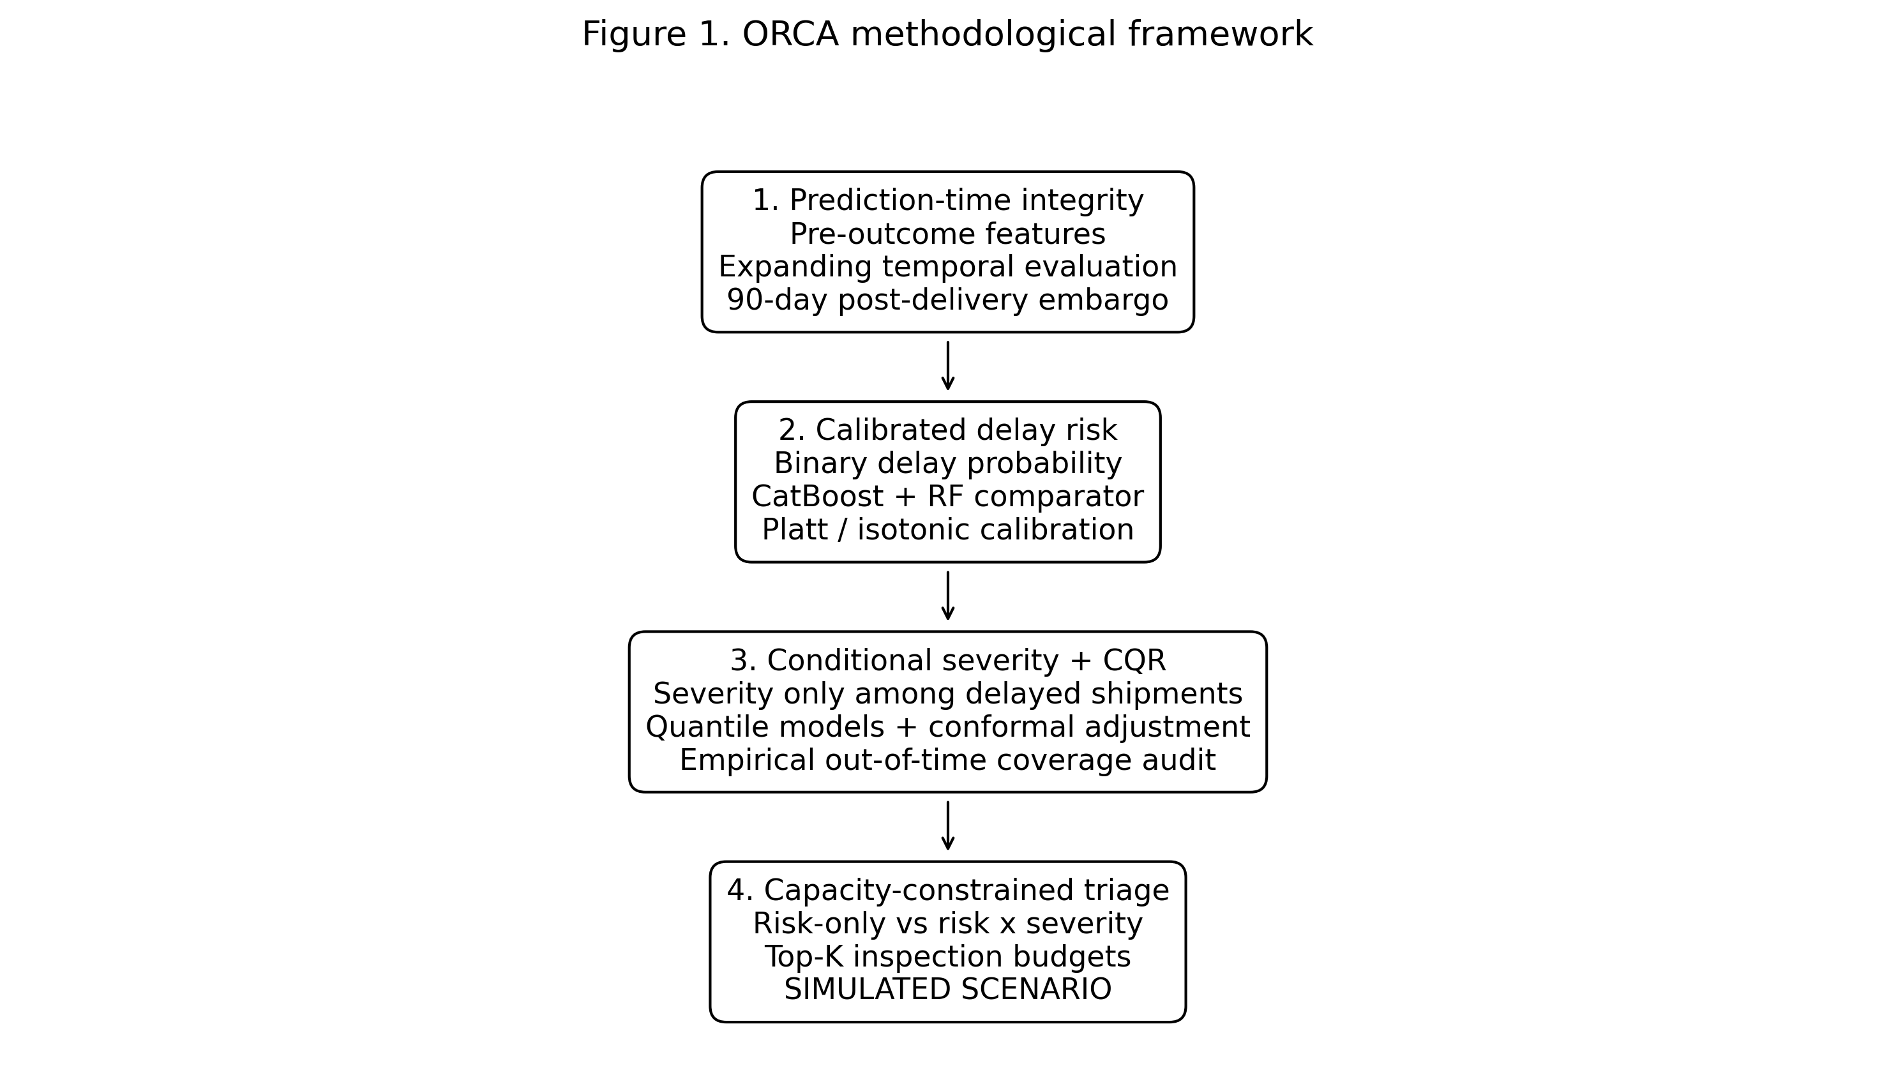
Figure 1. ORCA methodological framework.
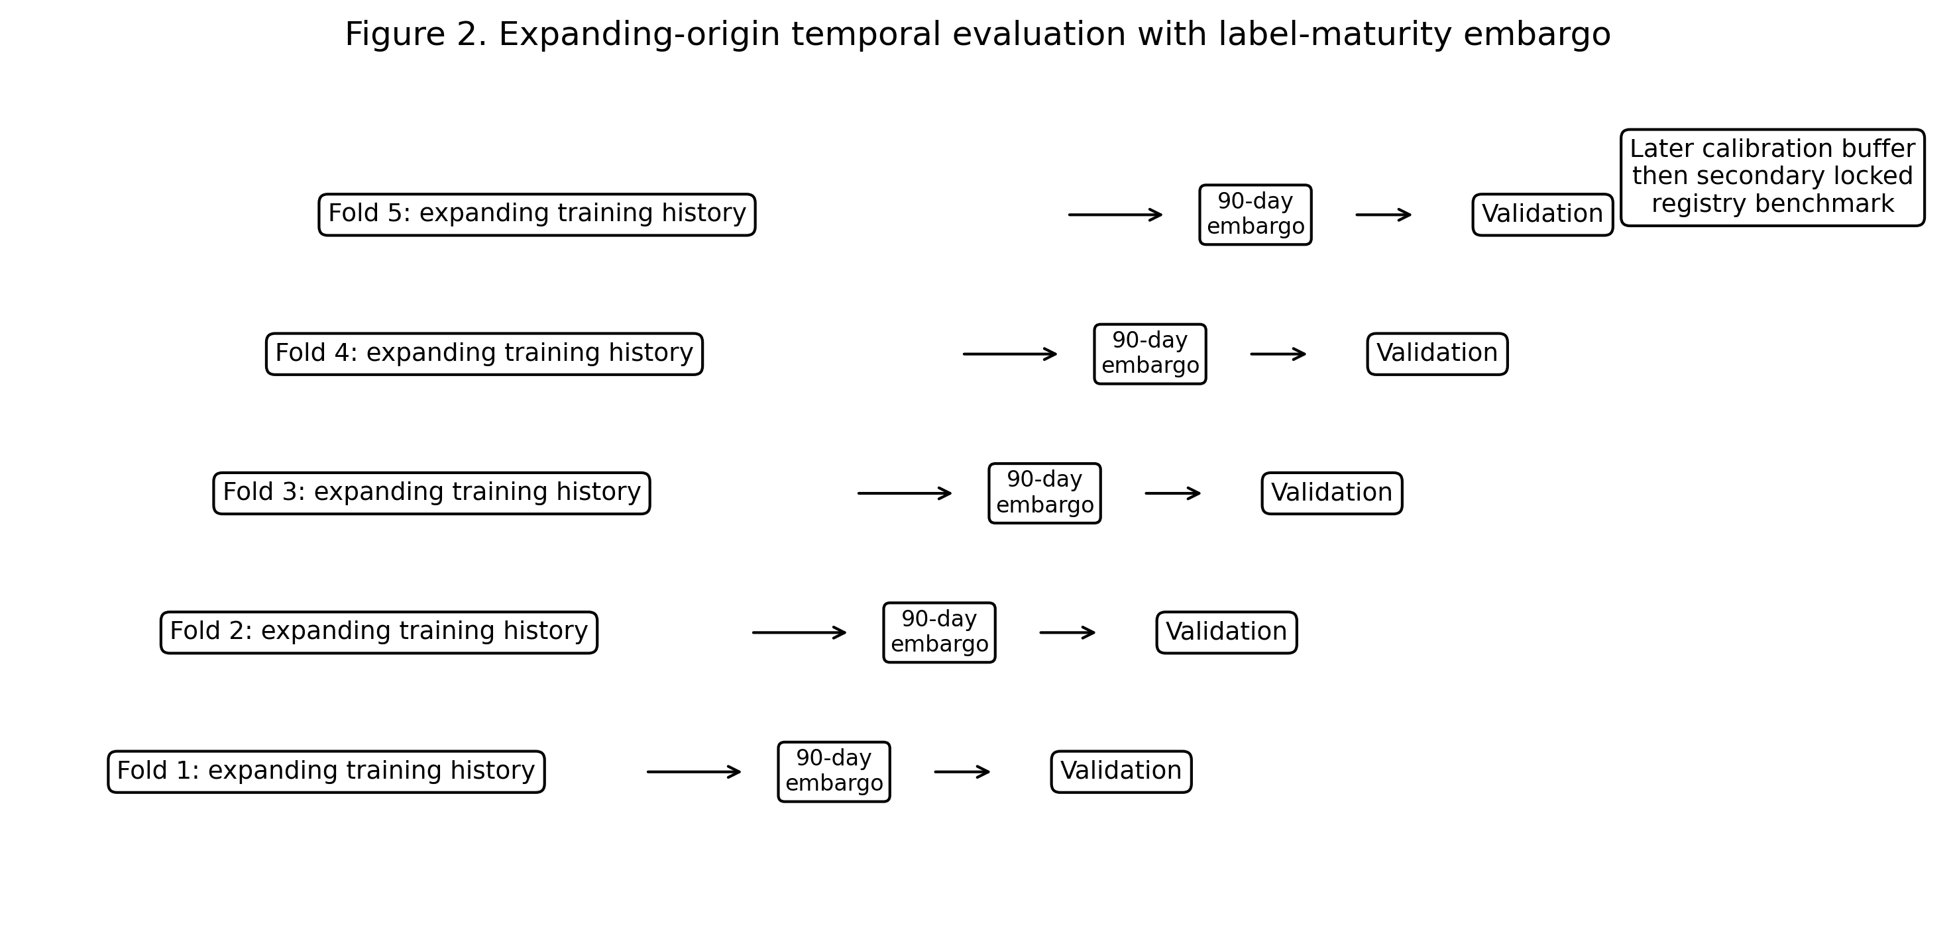
Figure 2. Expanding-origin temporal protocol with 90-day label-maturity embargo.
Cohort | N | Delayed | Role
Canonical SCMS population | 10,324 | 1,186 | Historical source population
Temporal development | 7,306 | 1,125 | Primary 5-fold evidence
Calibration buffer | 717 | 103 | Frozen probability/CQR calibration
Locked registry benchmark | 1,013 | 61 | Secondary historical benchmark

5. Delay-risk classification and random-split diagnostic
Five tabular classifiers were compared. PR-AUC is primary due to class imbalance. Random five-fold cross-validation is diagnostic only; scientific claims rely on expanding temporal evaluation. Random splitting produced higher PR-AUC for every architecture, with relative inflation from 26.2% to 99.7%. This gap is described as consistent with temporal dependence and distribution structure, not as proof of a specific causal leakage mechanism.
Model | Random PR-AUC | Temporal PR-AUC | Inflation | Temporal ROC-AUC | Temporal Brier
Logistic Regression | 0.3799 | 0.3011 | +26.2% | 0.7132 | 0.2001
Random Forest | 0.4780 | 0.3238 | +47.6% | 0.7316 | 0.1605
CatBoost | 0.5608 | 0.3164 | +77.3% | 0.7401 | 0.1417
XGBoost | 0.5591 | 0.2917 | +91.6% | 0.7128 | 0.1395
LightGBM | 0.5975 | 0.2992 | +99.7% | 0.7277 | 0.1430

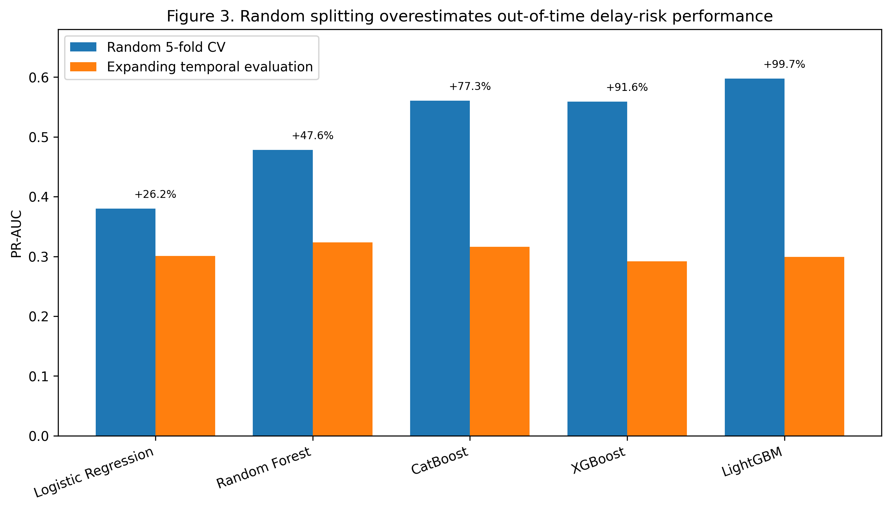
Figure 3. Random versus temporally ordered PR-AUC.

6. Probability calibration
Platt scaling reduced Brier score and ECE while preserving continuous rankings. Isotonic regression sometimes achieved lower calibration error but introduced ties and lower PR-AUC. No statistical-significance claim is made.
Model | Calibration | Brier | ECE | PR-AUC | ROC-AUC
CatBoost | Raw | 0.1398 | 0.0850 | 0.2999 | 0.6916
CatBoost | Platt | 0.1357 | 0.0807 | 0.2999 | 0.6916
CatBoost | Isotonic | 0.1336 | 0.0760 | 0.2730 | 0.6854
Random Forest | Raw | 0.1797 | 0.2051 | 0.3296 | 0.7269
Random Forest | Platt | 0.1317 | 0.0866 | 0.3296 | 0.7269
Random Forest | Isotonic | 0.1316 | 0.0774 | 0.2904 | 0.6985

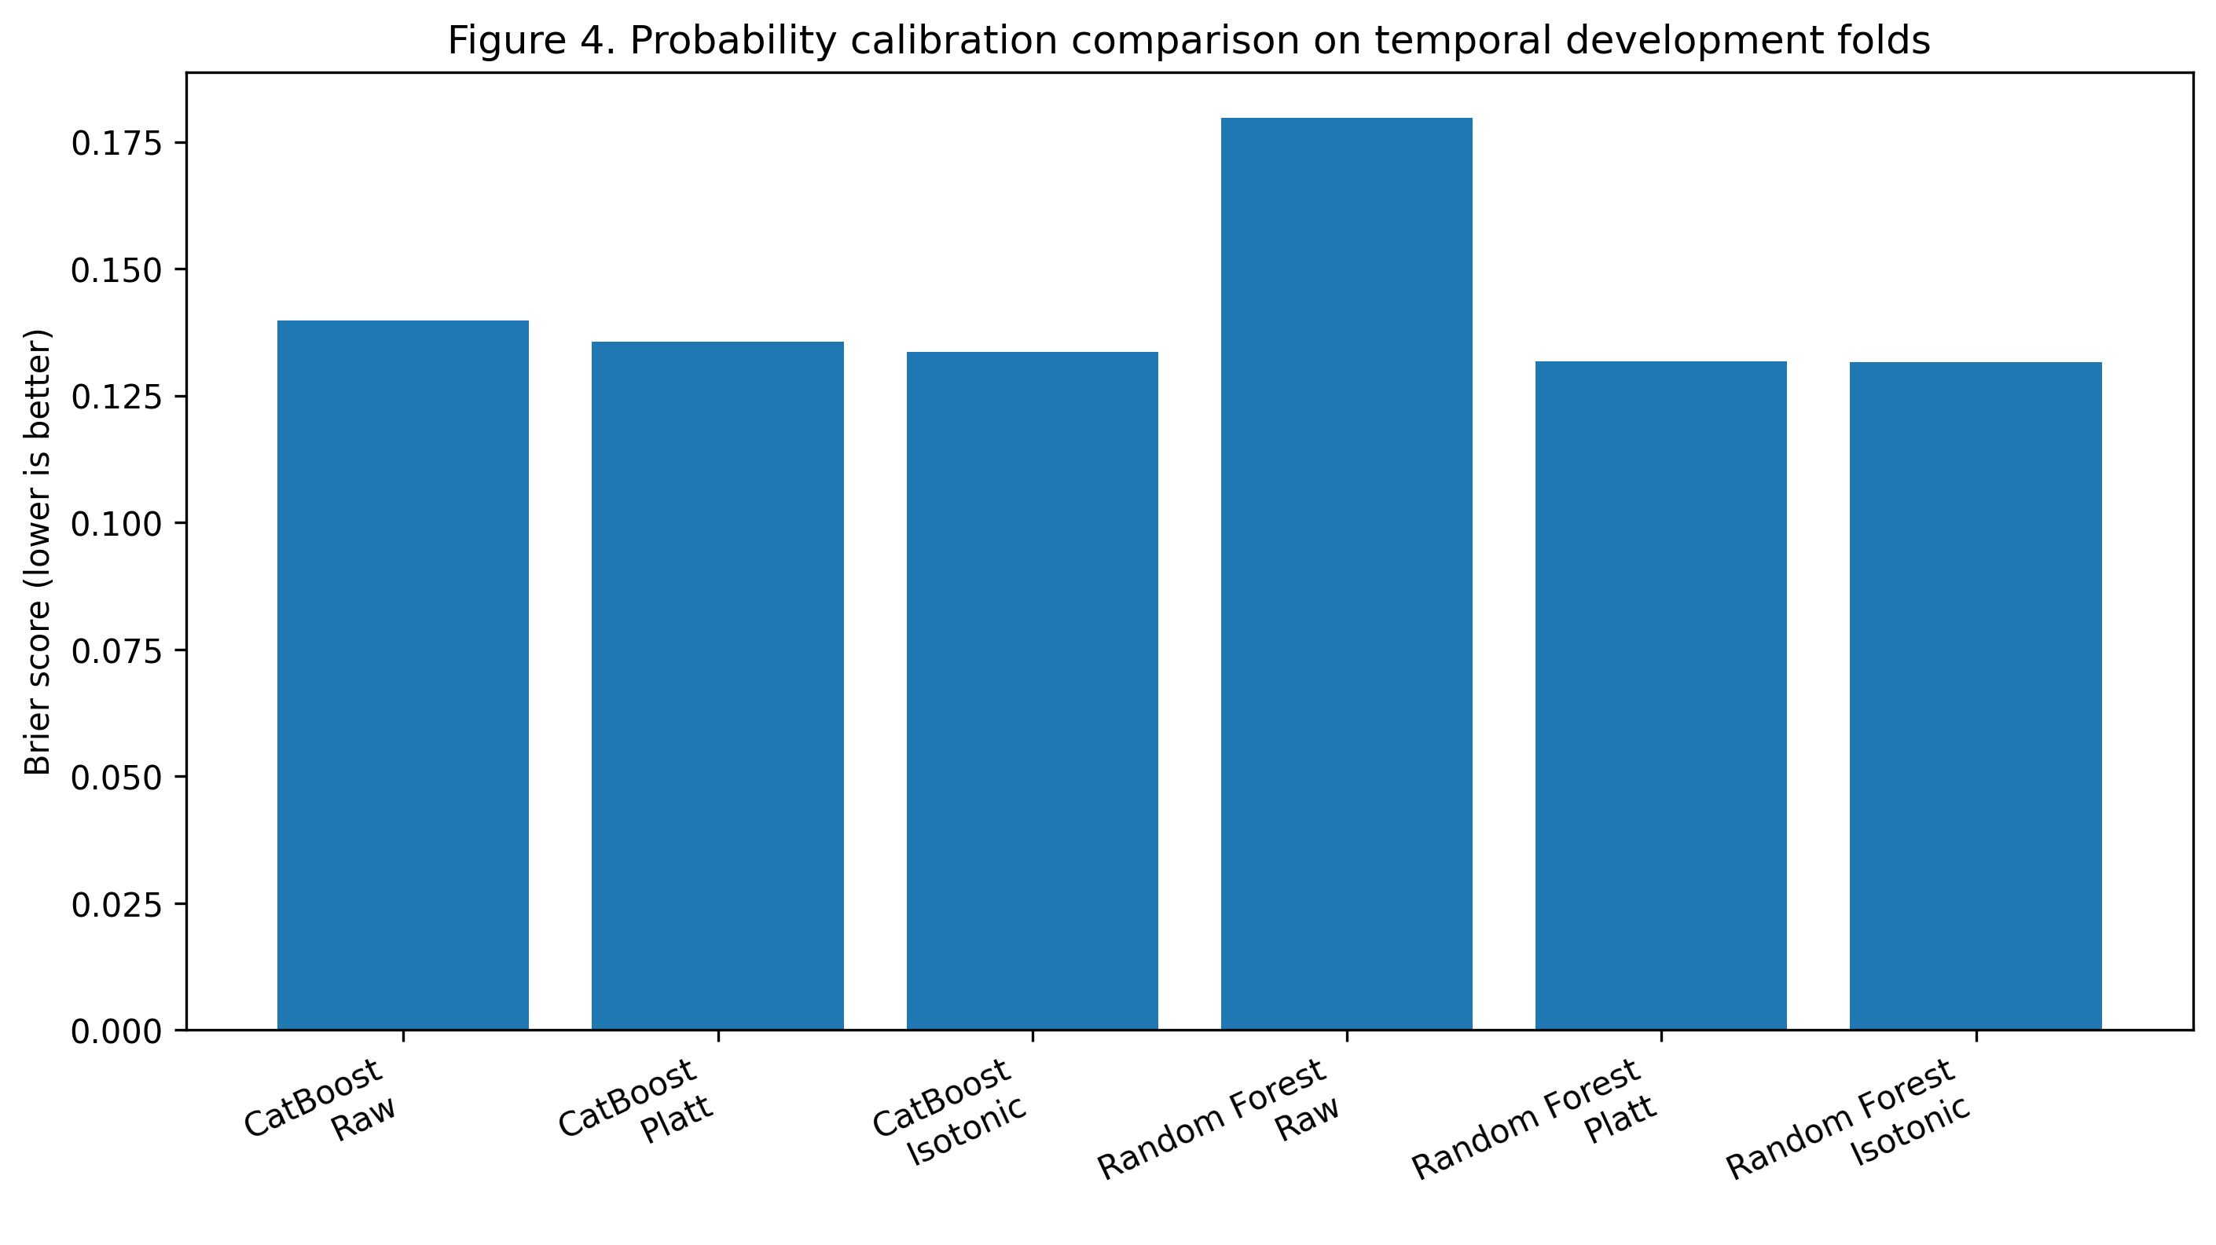
Figure 4. Brier-score comparison for calibration strategies.

7. Conditional delay-severity modeling
Severity is modeled only among delayed shipments. The conditional median achieved lower mean point error than LightGBM quantile regression, while the quantile models provide asymmetric bounds for conformalization. The quantile model is therefore not claimed to be a universally superior point predictor.
Model | MAE (days) | Median AE (days) | q0.50 pinball
Conditional median | 15.62 +/- 6.43 | 7.60 +/- 0.89 | 7.81
LightGBM quantile q0.50 | 16.96 +/- 4.66 | 8.74 +/- 1.64 | 8.48
Ridge regression | 23.76 +/- 3.92 | 15.01 +/- 0.54 | 11.88

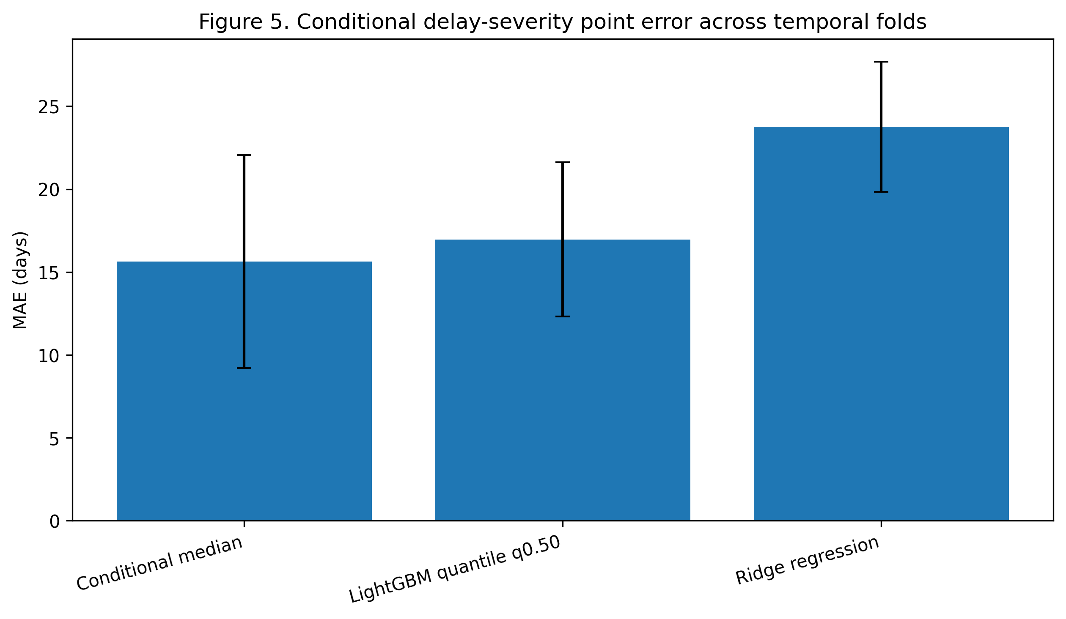
Figure 5. Conditional severity MAE across temporal folds.

8. Conformalized quantile regression
Standard split CQR provides finite-sample marginal coverage guarantees under exchangeability. Because this study evaluates temporally later cohorts under potential distribution shift, future-period coverage is treated as an empirical out-of-time audit rather than a formal distribution-free guarantee under shift. All 80%, 90%, and 95% levels are reported.
Nominal | Dev coverage | Dev mean width | Dev median width | Locked coverage | Exact 95% CI | Locked mean width
80% | 78.33% +/- 8.37% | 46.37 | 40.55 | 70.49% (43/61) | 57.43-81.48% | 41.04
90% | 85.76% +/- 15.24% | 110.33 | 106.73 | 91.80% (56/61) | 81.90-97.28% | 46.27
95% | 95.84% +/- 6.02% | 153.55 | 151.98 | 100.00% (61/61) | 94.13-100.00% | 61.74

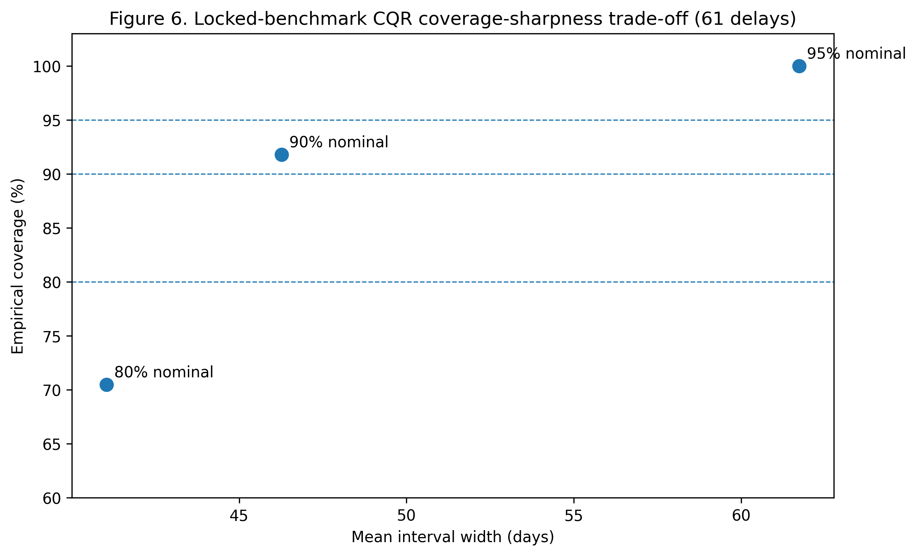
Figure 6. Locked-benchmark CQR coverage-sharpness trade-off.

9. Secondary locked registry benchmark
CatBoost is the deployment-aligned primary model; Random Forest is the development PR-AUC sensitivity comparator. Random Forest outperformed CatBoost on several locked-benchmark metrics, while CatBoost had slightly higher F1 and precision. Model roles are not redefined post hoc.
Model | Role | Tau | PR | ROC | Brier | ECE | Prec. | Recall | F1 | Bal. Acc.
CatBoost | Primary | 0.1000 | 0.2709 | 0.7477 | 0.0527 | 0.0568 | 0.2174 | 0.7377 (45/61) | 0.3358 | 0.7899
Random Forest | Sensitivity | 0.1050 | 0.3195 | 0.7898 | 0.0493 | 0.0314 | 0.2117 | 0.7705 (47/61) | 0.3322 | 0.8037

On the 61 delayed benchmark shipments, the conditional median achieved MAE 9.05 days versus 14.21 days for the LightGBM quantile median; LightGBM had lower median absolute error (4.91 versus 7.00 days). These mixed results are reported without a universal severity winner.

10. Capacity-constrained operational prioritization [SIMULATED SCENARIO]
At K=1%, risk-only ranking captured 1/15 high-severity delays, compared with 8/15 for both severity-aware rankings. At K=5%, the counts were 2/15 versus 10/15. At K=20%, risk-only captured all 15 high-severity delays and more total delayed shipments. Thus, risk, severity, and uncertainty provide different prioritization trade-offs under constrained inspection capacity. No real intervention or realized savings are claimed.
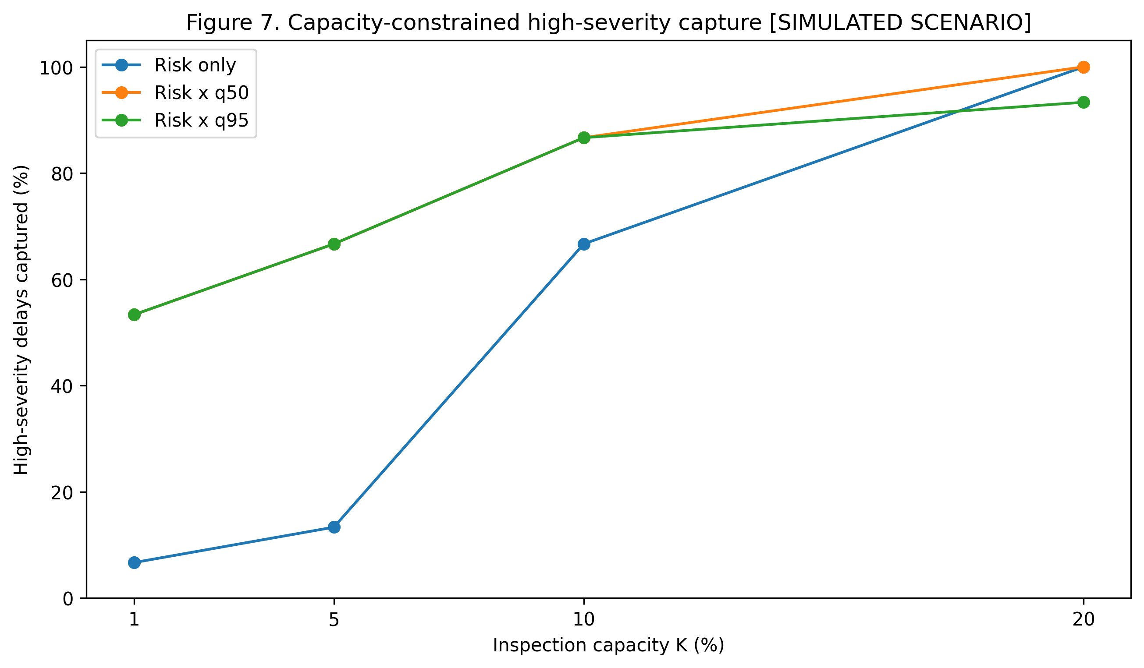
Figure 7. High-severity capture across review capacities [SIMULATED SCENARIO].

11. Discussion
The strongest result is the evaluation-design effect: random splitting substantially overstates PR-AUC relative to temporally ordered validation, and the magnitude is model-dependent. The 90-day embargo should be understood as a label-maturity policy specific to this historical logistics context rather than a universal constant.
Calibration matters because operational policies consume probability values, not only ranks. Platt scaling provided a useful compromise in this study, but isotonic results show that calibration and ranking can trade off. Likewise, the conditional-median result demonstrates that simple baselines can remain competitive even when richer models are needed for uncertainty bounds.
CQR coverage must be audited rather than assumed under temporal shift. The locked 90% result is encouraging but does not erase development variability or the 80% undercoverage point estimate. Finally, the Top-K experiment shows that operational policy depends on capacity and objective; uncertainty-aware ranking is not globally dominant.

12. Limitations
The study uses one historical USAID SCMS dataset and therefore has limited external validity. The records are observational; no randomized interventions or realized financial savings are observed. The secondary benchmark contains only 61 delayed shipments, so empirical coverage has substantial finite-sample uncertainty. Temporal prevalence changes complicate direct Brier-score comparisons. Standard CQR exchangeability assumptions need not hold under shift. The locked registry benchmark is secondary historical evidence, not a newly untouched confirmatory test. The literature-priority statement is qualified by the review cutoff and accessible indexing.

13. Reproducibility and evidence governance
The canonical dataset SHA-256 is 918b992dd3e8d4b64d2a727b2c4ea607603d0c58f19484e73f7b78528c6a8673. The final evaluation freeze SHA-256 is 631F1FA4241FBE697B46D9658B8720D2CE13CFB5A9F65E32C7532F8A1F6CD21A. The benchmark manifest SHA-256 is 62BE80CE9BC977767BC983EDABF61DAA23609A1801251F4E93CFA9693EBDD9AB. The frozen integrity suite reported 26/26 tests passing. Repository identity is blinded in this review copy.

14. Conclusion
The study supports treating shipment-delay prediction as a connected evaluation-and-decision problem: define what is knowable at prediction time, validate chronologically, calibrate probabilities, separate delay occurrence from severity, audit uncertainty under future shift, and make operational capacity explicit. Across five model families, random splitting substantially inflated PR-AUC. The results also show that richer models and uncertainty-aware policies are not automatically superior on every metric or capacity level. For pharmaceutical shipment logistics, the contribution is an evidence-governed integration of these components rather than a new learning algorithm.

Data availability
The USAID SCMS Delivery History Dataset is publicly available. The final submission should include the stable current dataset URL and the canonical file checksum reported above.

Code availability
Code and frozen research artifacts are maintained in a version-controlled repository. Repository identity is [BLINDED FOR DOUBLE-ANONYMIZED REVIEW] in this submission copy.

Ethics and responsible use
This retrospective shipment analysis is intended for decision support. Predictions should not be used for automatic punitive assessment of suppliers or personnel. Simulated prioritization results are not causal intervention estimates.

Declaration of generative AI and AI-assisted technologies in the manuscript preparation process
During the preparation of this work, the author used OpenAI ChatGPT and Google Gemini to support literature-search organization, manuscript structuring, language refinement, bibliographic integrity checks, and submission-readiness review. After using these tools/services, the author reviewed and edited the content as needed, independently verified quantitative results and references against frozen artifacts and primary sources, and takes full responsibility for the content of the publication.

References
Müller, N., Burggräf, P., Steinberg, F., Sauer, C.R., Schütz, M. (2025). An analytical review of predictive methods for delivery delays in supply chains. Supply Chain Analytics 11, 100130. https://doi.org/10.1016/j.sca.2025.100130
Biazon de Oliveira, M., Zucchi, G., Lippi, M., Cordeiro, D.F., Rosa da Silva, N., Iori, M. (2021). Lead Time Forecasting with Machine Learning Techniques for a Pharmaceutical Supply Chain. ICEIS, 634-641. https://doi.org/10.5220/0010434406340641
Pathak, N., Keshari, S., Rai, S., Saksham, K., Raj, P. (2025). Predicting Global Supply Chain Delays for HIV Medicines Using SCaLDR: A Two-stage ML Framework. IEEE CICT. https://doi.org/10.1109/CICT67193.2025.11399211
Yang, X. (2026). O²RDL-net for joint risk classification and delay forecasting in logistics systems using interaction amplified deep. Scientific Reports 16, 24683. https://doi.org/10.1038/s41598-026-55703-6
Faulkner, S., Zandehshahvar, R., Eghbal Akhlaghi, V., Ouellet, S., Jordan, C., Van Hentenryck, P. (2026). Uncertainty-Aware Delivery Delay Duration Prediction via Multi-Task Deep Learning. arXiv:2602.20271. Preprint.
Makhado, N., Sejeso, M., Paepae, T. (2026). Conformal prediction-based sequential scheduling for container terminal operations under uncertainty. Operations Research Perspectives 17, 100409. https://doi.org/10.1016/j.orp.2026.100409
Liang, X., Fan, S., Li, H., Goerlandt, F., Yang, Z. (2026). Freeports under the lens: securing container supply chains with a risk-based inspection framework. Transportation Research Part E 208, 104658. https://doi.org/10.1016/j.tre.2025.104658
Zaghdoudi, M.A., Hajri-Gabouj, S., Ghezail, F., Darmoul, S., Varnier, C., Zerhouni, N. (2024). Collaborative and integrated data-driven delay prediction and supplier selection optimization: A case study in a furniture industry. Computers & Industrial Engineering 197, 110590. https://doi.org/10.1016/j.cie.2024.110590
Hupman, A.C., Zhang, J., Li, H. (2024). Predicting pharmaceutical supply chain disruptions before and during the COVID-19 pandemic. Risk Analysis 44(12), 2797-2811. https://doi.org/10.1111/risa.17453
Gali, J.S., Molavi, N., Alavi, S. (2025). Predicting Global Healthcare Supply Chain Delays: A Machine Learning Approach Leveraging Country-level Logistics Metrics. Journal of International Technology and Information Management 34(1), Article 3. https://doi.org/10.58729/1941-6679.1634
Sadeek, S.N., Hanaoka, S., Sugishita, K. (2026). Uncertainty quantification of departure delay considering network properties and conformal prediction framework. Journal of Air Transport Management 136, 103037. https://doi.org/10.1016/j.jairtraman.2026.103037
Bassiouni, M.M., Chakrabortty, R.K., Sallam, K.M., Hussain, O.K. (2024). Deep learning approaches to identify order status in a complex supply chain. Expert Systems with Applications 250, 123947. https://doi.org/10.1016/j.eswa.2024.123947
Thomas, A., Panicker, V.V. (2023). Application of Machine Learning Algorithms for Order Delivery Delay Prediction in Supply Chain Disruption Management. In Intelligent Manufacturing Systems in Industry 4.0, 491-500. https://doi.org/10.1007/978-981-99-1665-8_42
Kapoor, S., Narayanan, A. (2023). Leakage and the reproducibility crisis in machine-learning-based science. Patterns 4(9), 100804. https://doi.org/10.1016/j.patter.2023.100804
Roberts, D.R. et al. (2017). Cross-validation strategies for data with temporal, spatial or phylogenetic structure. Ecography 40(8), 913-929. https://doi.org/10.1111/ecog.02881
Niculescu-Mizil, A., Caruana, R. (2005). Predicting good probabilities with supervised learning. ICML, 625-632. https://doi.org/10.1145/1102351.1102430
Romano, Y., Patterson, E., Candès, E. (2019). Conformalized Quantile Regression. NeurIPS 32, 3543-3553.
Barber, R.F., Candès, E.J., Ramdas, A., Tibshirani, R.J. (2023). Conformal prediction beyond exchangeability. Annals of Statistics 51(2), 816-845. https://doi.org/10.1214/23-AOS2276
Yadav, P. (2015). Health Product Supply Chains in Developing Countries. Health Systems & Reform 1(2), 142-154. https://doi.org/10.4161/23288604.2014.968005
Vledder, M., Friedman, J., Sjöblom, M., Brown, T., Yadav, P. (2019). Improving Supply Chain for Essential Drugs in Low-Income Countries. Health Systems & Reform 5(2), 158-177. https://doi.org/10.1080/23288604.2019.1596050
Baryannis, G., Validi, S., Dani, S., Antoniou, G. (2019). Supply chain risk management and artificial intelligence: state of the art and future research directions. International Journal of Production Research 57(7), 2179-2202. https://doi.org/10.1080/00207543.2018.1530476
Guo, C., Pleiss, G., Sun, Y., Weinberger, K.Q. (2017). On Calibration of Modern Neural Networks. ICML 70, 1321-1330.
Koenker, R., Bassett, G. (1978). Regression Quantiles. Econometrica 46(1), 33-50. https://doi.org/10.2307/1913643
Bertsimas, D., Kallus, N. (2020). From Predictive to Prescriptive Analytics. Management Science 66(3), 1025-1044. https://doi.org/10.1287/mnsc.2018.3253
USAID SCMS Project (2015). Supply Chain Management System: Final Program Report (2005-2015). U.S. Agency for International Development and Partnership for Supply Chain Management.

