**Instructions**

1. Step into swapi-graphql folder and run:

*Npm install*

To install all dependencies

1. Run server

*Yarn start*

Copy uri to be used for react app

Ex: http://localhost:54112

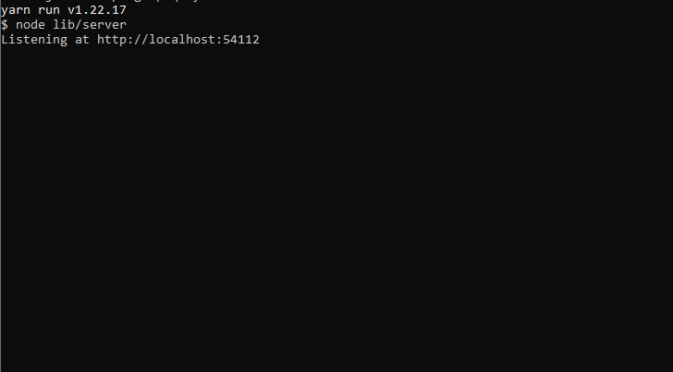

1. Step into star-war-ui folder

Run:

*yarn install*

Then:

*yarn start*

Paste uri ex: ‘http://localhost:54112’ at apolloClient.ts

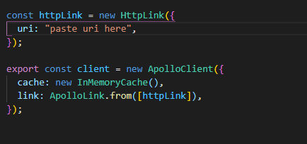

You are done :)

If I have more time I would do

1. Pagination for list of characters with max 5/10 per page
2. Search for a specific character in list
3. Show details of character like (age, gender, etc…)
4. Undo favourite of character
5. Delete character from favourite