
ICAM Technical Project Plan | July 24, 2026
ICAM Technical Project Plan

Submitted To:  . | Submitted By:  General Dynamics Information Technology, Inc.  3150 Fairview Park Drive  Suite 100  Falls Church, VA 22042-4504  (703) 995-8700  http://www.gdit.com  DUNS Number: 067641597  CAGE Code: 07MU1  Business Size Status for the North American Industry Classification System (NAICS) code: Large  POC:  Randy Mears  (256) 947-5032  randy.mears@gdit.com

Table of Contents
1.0 Background & Our Understanding of the Requirements 1
2.0 TECHNICAL VOLUME & APPROACH – Phase 1 1
2.1 Rapid onboarding of 250 – 300 applications to DOD E-ICAM Identify Provider (IDP) and Automated Account Provisioning (AAP) 1
2.1.1 Quick Win – Post Submission Quality Control 2
2.1.2 AI Concierge Bot – Question and Answer functionality 3
2.2 SYSTEM ARCHITECTURE 4
3.0 PROGRAM MANAGEMENT 5
4.0 STAFFING PLAN 5
5.0 QUALITY ASSURANCE 6
6.0 SECURITY & COMPLIANCE 6
7.0 SCHEDULE & MILESTONES 6
8.0 RISKS, ASSUMPTIONS, ISSUES, DEPENDENCIES 7
9.0 ALIGNMENT WITH FUTURE STATE (PHASE 2) 9
9.1 FUTURE STATE SYSTEM ARCHITECTURE 12
10.0 CONCLUSION 13

Background & Our Understanding of the Requirements

In response to the Government’s urgent onboarding requirement, authorized under the Undefinitized Agreement Action (UAA) of July 9, 2026, this Technical Project Plan (TPP) details GDIT’s strategy for providing technical labor support to rapidly onboard approximately 250-300 applications into the E-ICAM Identity Provider (IDP) and Automated Account Provisioning (AAP) services. These applications cover both Financial Management and non-Financial Management Systems, spanning across IL5 and IL6.
The TPP is structured to address bottlenecks identified across the end-to-end onboarding lifecycle. We introduce a quick win feature designed to be completed by the Government’s 30 day technical work deadline of 8-AUG-2026.
In anticipation of additional requirements from the PMO, this TPP introduces a question and answer functionality feature designed to be deployed prior to the 9-SEPT-2026 date. Furthermore, this TPP introduces a path to view the initial 60 day period of performance activities as a foundational step to a future state, where onboarding becomes automated and seamless.

For the remainder of the TPP, the 60-day period of performance to rapidly onboard 250-300 applications is designated as Phase 1. The future state is designated as Phase 2.

TECHNICAL VOLUME & APPROACH – Phase 1

Rapid onboarding of 250 – 300 applications to DOD E-ICAM Identify Provider (IDP) and Automated Account Provisioning (AAP)
Successful onboarding is heavily dependent on Mission Partners possessing a comprehensive understanding of their roles and responsibilities. Currently, process knowledge gaps create significant inefficiencies for Customer Success Managers (CSMs). These challenges fall into two main categories:
1) Data Quality: Mission Partners frequently receive incomplete role information submissions. For complex applications, this necessitates excessive CSM time dedicated solely to quality assurance and data gap resolution.
2) Support Strain: CSM effort is significantly diverted from guiding high-complexity applications to the finish line due to a persistent volume of basic (Level 100) and intermediate (Level 200) inquiries. Despite available onboarding guides and forums, this resource drain compromises CSM capacity for application completion

To directly address these bottlenecks, GDIT's Phase 1 objective is to dramatically improve Mission Partner information accessibility and expedite the completion of onboarding prerequisites. GDIT recommends implementing two techniques:
1) Post Submission Quality Control: These analytical techniques automatically evaluate the Mission Partner onboarding submission, which can have over 1200 fields of information, for errors and typos. An internal report is presented to the CSM to quickly understand areas where re-work is needed.
2) AI Concierge Bot: A new digital channel powered by Artificial Intelligence (AI), which empowers Mission Partners with instant, self-service question resolution capabilities. This drastically reduces reliance on human intervention, allowing CSMs to redirect their specialized time toward the Government’s requirement of executing the “standardized and rapid enterprise onboarding process.”
The two techniques and how they support the rapid onboarding of applications is seen below.
Feature | Benefit | Outcomes | How this supports the Rapid Onboarding Mission
Quick Win – Post Submission Quality Control. | Identify inaccuracies in complex onboarding submissions | Support data quality efforts on Mission Partner submissions.  Align development team with Azure operational model. | Quickly flag missing roles that make it through existing quality control checks so that Mission Partners can fix/resubmit.
AI Concierge Bot – Question and Answer functionality | Reduce cognitive burden of having to manually search Onboarding Guides | Faster answers to level 100 questions for Mission Partners; reduction of CSM interactions for Level 100 questions | Mission Partners will be brought up to speed faster on onboarding expectations due to a digital channel that is available 24/7  CSMs will have more capacity to reduce application backlog instead of answering level 100 questions

Working backwards from the target of completing application onboarding by 9-SEPT, each of the above technical feature needs to be deployed and operationalized prior to that date.
Sections 2.1.1 and 2.1.2 describe the strategies for achieving a “Time to Market” solution for each feature. Either feature is independent of each other. GDIT recommends the Government proceed with both, however the Government can elect to proceed with just one.

Quick Win – Post Submission Quality Control
Onboarding one role requires up to 34 fields of information to be identified and filled in by the Mission Partner. This includes basic information on the role, such as the name & description, attributes for dynamic approval, and intra SOD conflict policies.
Mission Partners with large applications sometimes struggle with identifying the required information on the first submission – critical roles are sometimes omitted, and typos make their way into the role data.
For a quick win, GDIT recommends deploying quality control analytics scripts in the Azure environment, to evaluate the submission quality from a Mission Partner. These scripts, which will be internal facing at first, help analyze individual role submission data for anomalies.
An example of a post-submission quality control report that identified unusual role submission data can be seen in Figure 1 below:
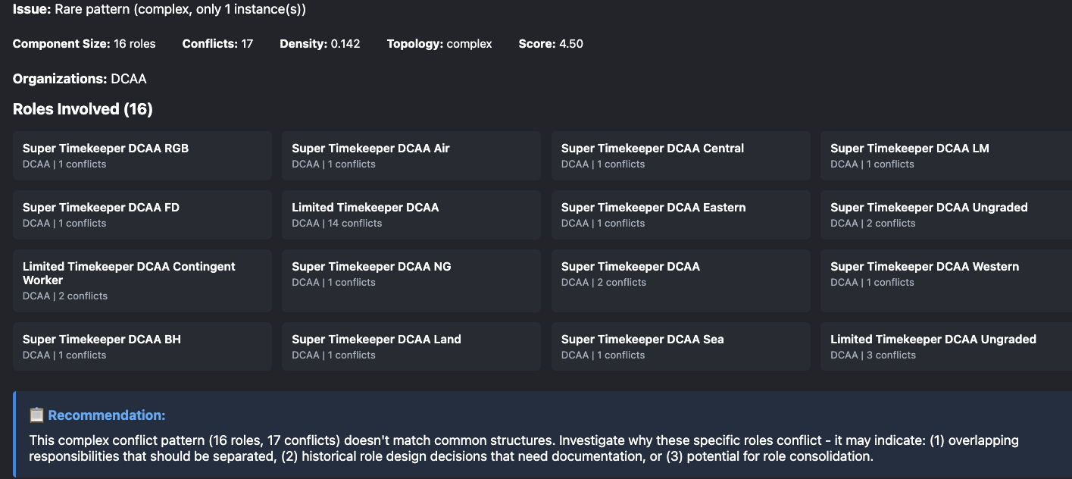
Figure 1: Report of Segration of Duties errors during a recent application submission
The quick win has a dual purpose. The first is to share information back to CSMs and determine which specific roles are having quality issues with a new Mission Partner submission.
The second purpose is to align the new technical experts with the specific Azure operational controls for the environment, such as aligning with existing financial/billing, security, DevSecOps methodologies and CAB procedures. This will reduce risk and improve developer velocity for additional feature development.

AI Concierge Bot – Question and Answer functionality
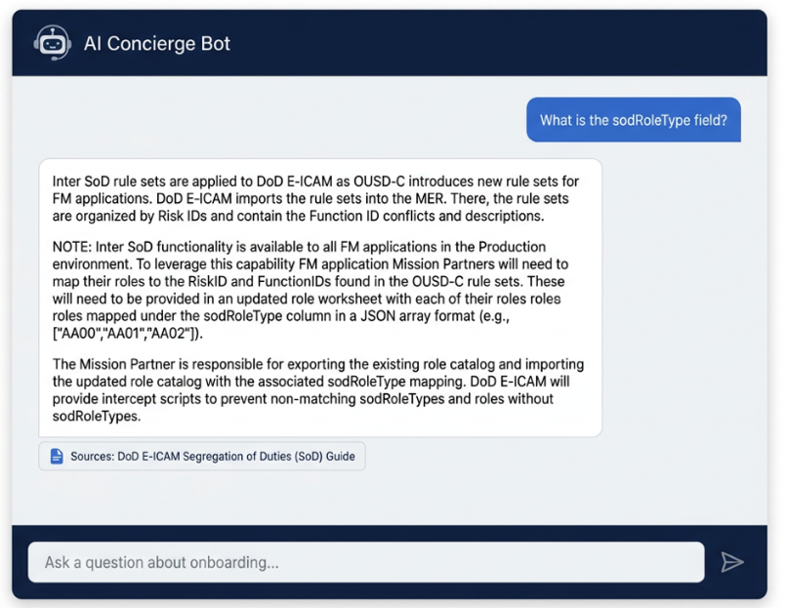
The AI Concierge Bot provides a 24/7 digital channel where Mission Partners can ask Level 100 and Level 200 about their specific onboarding process.
Figure 2: Example Question and Answer User Experience with a Onboarding Guide citation in the response
Questions can include status requests to identifying next steps to asking pointed questions about role fields, as seen in Figure 2.
The objective is to integrate this User Interface (UI) component into the broader front end web application to reduce friction for Mission Partners. Instead of having to switch screens or navigate to the Onboarding guide, Mission Partners can leverage the AI Concierge as their questions arise.
GDIT has evaluated several AI Concierge bot technologies and recommends proceeding with the “IRIS” bot from Microsoft Consulting Services. The benefit with IRIS is that it is the fastest “time to market” solution, due to Microsoft’s intimate knowledge with operating the existing web application that is used by Mission Partners.
GDIT further recommends that GDIT technical engineers act as the testing mechanism prior to IRIS going into production, to ensure AI risks are managed and that Mission Partner questions are answered both accurately and quickly. Quality enforcement mechanisms are introduced in Section 5, while comprehensive risks with this strategy are discussed in Section 8.

SYSTEM ARCHITECTURE
Figure 3 is a consolidated system architecture for both the Quick Win – Post Submission Quality Control and for the AI Concierge Bot. GDIT would like to highlight how this approach further aligns with NISTs AI Risk Management Framework controls which include input guardrails (purple) and post validation guardrails (blue) that ensure a predictable and safe user experience for our Mission Partners.
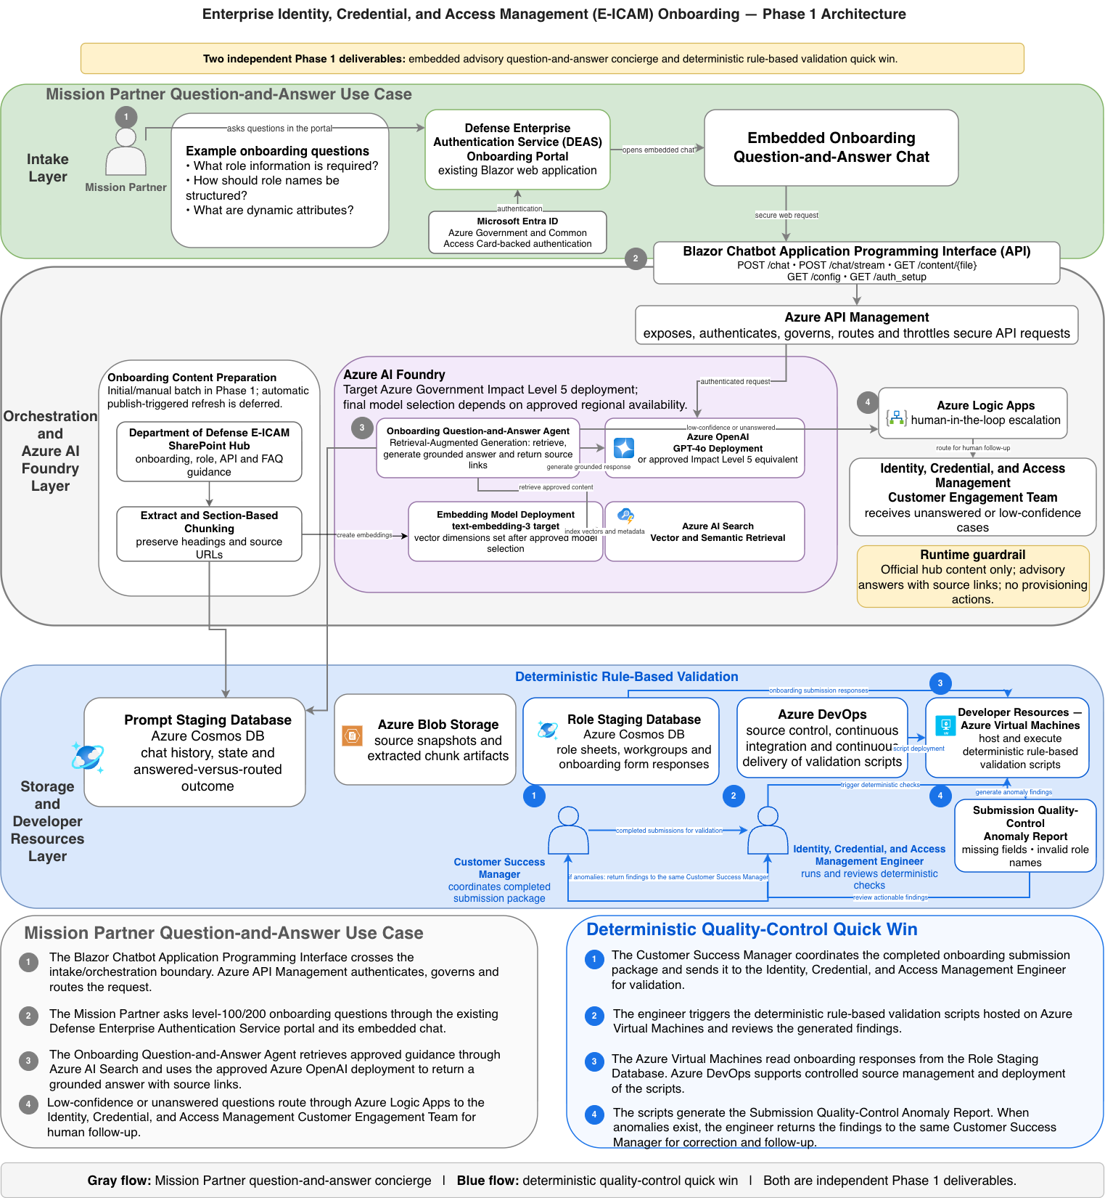
Figure 3: Consolidated System Architecture that Supports Role Onboarding
All platform services leverage Azure serverless services, eliminating persistent attack surfaces, reducing the OS and runtime patch burden, and enabling native integration with Azure Key Vault, Managed Identity, and Azure Monitor for end-to-end IL5-compliant security controls.
Each of the AI agents runs under a discrete Azure Managed Identity with least-privilege permissions scoped to the resources it requires. Input guardrails further block attempts to override agent instructions. All agent activity, including LLM calls and orchestration decisions, are written to Azure Monitor logs providing a full audit trail.

PROGRAM MANAGEMENT
GDIT recommends a single prioritized backlog managed by a Product Owner. Work is organized into two week sprints, each producing working software improvements that DISA stakeholders can review and provide feedback on directly.
Daily standups keep cross-discipline dependencies between cloud infrastructure, AI, data and UI engineers visible and resolved before they become blockers.
GDIT recommends monthly milestone reviews tied to reviewing metrics including onboarding process time. This provides DISA a recurring touchpoint to assess improvement and align on next months tasks to improve onboarding velocity.
Progress is tracked in an Azure DevOps board, complete with sprint burndown, cumulative onboarding process time reduction, and defect trends. This cadence delivers the transparency and adaptability to keep the team focused on delivery a platform that onboards a variety of applications faster with every successive sprint.
The quick win – quality control feature is a low risk, quick deployment option that can be developed and operationalized by GDIT engineers.
The AI Concierge Bot – Question and Answer feature carries significantly higher execution and delivery risk. Delivery and integration with the existing Blazor web application will be exclusively carried out by Microsoft. GDIT will support the operationalization through testing against NIST AI Risk Management Framework controls and performing stress testing in the Azure development environment. In production, GDIT will further promote the feature by systemically analyzing the quality of responses and fine tuning the prompts and instructions.

STAFFING PLAN
To rapidly implement the AI Concierge Bot while simultaneously increasing onboarding capacity, GDIT has leveraged its Defense Chief Technology Office (CTO) team to provide immediate surge support staffing.
This team consists of AI/ML engineers, cloud infrastructure, and product management technical experts to build, deploy, and continuously refine the CSM and Mission Partner pain points over the next 60 days. In addition, Customer Success Manager (CSM) capacity is bolstered to sustain application onboarding cadences throughout the surge period while ensuring a positive onboarding experience for our Mission Partners.
The staffing composition below reflects this balance between technical delivery and customer-facing support, allowing GDIT to scale onboarding capacity without disrupting ongoing onboarding operations.

Labor Category | Quantity | Description
Solution Architect/ Product Manager | 1 | Feature prioritization, backlog management and delivery execution
AI/ML Engineer – Tech Lead | 1 | Responsible for Agentic Workflow buildout and overall accuracy of responses
AI/ML Engineer | 2 | Owns data collection and data pipelines as well as integration of the Concierge Bot with a User Interface
Cloud Infrastructure Architect | 1 | Configuration of data model, data interfaces, databases and storage using Infrastructure as Code
AI/ML Engineer SME | 1 | Supporting Technical Project Plan and voice of the customer feedback mechanisms
CSMs | 6 | Supports Application Onboarding Tasks

QUALITY ASSURANCE
Improving Agentic Workflow Quality for the Dept of State
For the Department of State GSE&SC Contract, GDIT implemented a GenAI evaluation framework to measure the quality of AI derived responses.
Engineers leveraged the framework to identify and prioritize enhancements and within three weeks, were able to increase the accuracy of the AI workflows from 65% to 98%.
To ensure that Mission Partners are receiving accurate information through the newly proposed AI Concierge Bot digital channel, GDIT will deploy a GenAI evaluation framework to quantitively measure the accuracy of a sample of question & answer workflows.
This is to ensure trust that the AI Concierge bot is returning truthful and cited responses to user questions.
This quality mechanism leverages a ground truth data set verified by humans. This data consists of common question-and-answer pairs that are derived from the onboarding guide.
Prior to each feature release being pushed to production, test cases are generated and evaluated against the ground truth data set. The target is to obtain a 95% accuracy during a sampling of question-and-answer pairs during testing. If the accuracy thresholds are not met, the new feature is blocked from becoming customer facing.

SCHEDULE & MILESTONES
GDIT proposes the following schedule across the next 60 days.
Description | Target | Outcome
Bottlenecks prioritized and evaluated | 22-JUL | Identify pain points that constrain application onboarding
Technical Project Proposal Submitted | 24-JUL | Achieve initial alignment with Government stakeholders
Price Proposal Submitted | 24-JUL | Achieve initial alignment with Government stakeholders
First batch of GDIT developers obtain access to Azure environment. | 27-JUL | Perform discovery and assess environment so that the schedule can be further refined
Technical work completion deadline; Quick win plans are deployed | 8-AUG | Faster identification of missing and incomplete submission data
Government and GDIT commence negotiations | 10-AUG | Achieve alignment with Government stakeholders
AI Concierge Bot plans are presented to the CAB for approval by Microsoft.* | 12-AUG | Obtain approval to deploy both features from the Government
AI Concierge Bot (IRIS) Version 1 is released by vendor Microsoft* | 28-AUG | Initial application onboarding mission partners are pointed to the Concierge bot. A significant uptick in usage with that digital channel is expected.
AI Concierge Bot is refined for accuracy and optimized for initial feedback by GDIT * | 4-SEPT | Sustain mission partner usage across the Concierge bot
Government to issue the final, definitized modification deadline | 9-SEPT | Full-cycle onboarding time optimized for 50k+ app onboarding workflows with 99.9% system uptime. Zero touch onboarding achieved for 80% of simple applications.
*Preparation for anticipated requirements by the PMO

RISKS, ASSUMPTIONS, ISSUES, DEPENDENCIES
# | Category | Description | Next Action | Owners | Phase
1 | Assumption | Development and deployment of the knowledgebase AI concierge chatbot on the Azure platform will be developed by Microsoft. | The Microsoft team is mostly aligned. They will require re-prioritization of tasking from the PMO to pivot to AI chatbot development. | GDIT, Microsoft, Government | 1
2 | Assumption | Microsoft Foundry services such as AI Azure AI Search, Azure Open AI may not be available for use in the environment | Verify services are enabled and if not, request them as part of the CAB | Microsoft, Government | 1
3 | Assumption | Periodic updates to the knowledge base sources will not propagate automatically to the chatbot. | The administrator for AI Concierge Bot is responsible for manually initiating all updates. | Government and/or GDIT | 1
4 | Dependency/Risk | Government Provided Resources such as CACs and access request approvals will delay developer velocity | Submit users for CACs | GDIT, Government | 1
5 | Dependency | Alignment with PMO on developer access need | Tanis G./ GDIT to follow up with PMO | GDIT, PMO | 1
6 | Dependency | Provisioning of test accounts with diverse RBAC (Role-Based Access Control) configurations and permission sets. | GDIT will work with Azure infrastructure team to provide appropriate test accounts. | GDIT | 1
7 | Dependency | Budgetary approval is required prior to the provisioning of Azure-hosted infrastructure, including Foundry AI and the Azure vector store. | GDIT Management to follow up | Government, PMO | 1
8 | Dependency | The development of quality control scripts is contingent upon a comprehensive understanding of the Segregation of Duties (SOD) and role-based access configurations. | GDIT CSM to provide reference document to build the relational validation scripts | GDIT | 1
9 | Dependency | The execution of quality control scripts is contingent upon the initiation of the onboarding submission process, whether triggered manually or programmatically. | GDIT to work with Blazer app team to implement best possible solution | GDIT | 1
10 | Risk | The knowledge base contents lack individual classification; therefore, questionnaire access controls are managed via user authentication and associated roles. | Integration and testing strategies should account for these constraints. | GDIT, Government | 1
11 | Risk | AI Concierge Bot's audit is provided "as-is" and may not be entirely consistent with the established FAQs. | Ongoing coordination and subsequent actions may impact the delivery timeline. | GDIT, Microsoft | 1
12 | Risk | Potential for diminished accuracy: The current implementation lacks a reranking process, relying entirely on internal semantic search, which may result in suboptimal retrieval performance. | Mitigate data integrity and performance risks by hardening the validation harness and implementing Chain-of-Thought (CoT) prompting. | GDIT, Microsoft | 1
13 | Risk | Deployment risks are heightened by a lack of parity between prototyping and production environments. Discrepancies in the AI stack, including embedding models and LLM versions, may lead to unpredictable performance drift and latency issues upon scaling. | This risk can be mitigated by implementing a rigorous validation pipeline and benchmarking phase using production-grade resources prior to final deployment. This allows us to identify and resolve any performance drift or latency issues before they impact the live environment. | GDIT, Microsoft | 1

ALIGNMENT WITH FUTURE STATE (PHASE 2)
Phase 1 established the foundational architecture pattern for this program: a shared LLM backend serving specialized agents, an orchestration layer coordinating their work, and a human-in-the-loop review. Phase 1 also introduced a deterministic quality-control layer containing automated scripts that analyze Mission Partner role submissions for anomalies. These quality control scripts are well-suited to run as serverless Azure Functions, triggered on on-boarding submission in Phase 2.
The AI Concierge Bot and quality control scripts validate the Phase 1 architecture at small scale, reducing manual burden on the support team while catching submission errors early. The architecture is not a one-off; it’s the reusable foundation that this program can build on.
Phase 2 extends that foundation to address a problem of a different order of magnitude: onboarding the full population of applications that need to integrate with ICAM. That population is not uniform. A small application with a dozen roles and a large application with hundreds of dynamic, interdependent roles have fundamentally different onboarding burdens. A single intake channel can’t serve both well. Onboarding one role alone requires 34 fields of information to be identified, including basic role attributes, dynamic approval criteria, and intra SOD conflict policies. This burden compounds quickly as role count grows and definitions continue to shift over time.
Phase 2 focuses on supporting application owners by providing two complementary channels for efficiently collecting role and entitlement data.
Channel 1 enhances the existing Self-Service Onboarding Portal with intelligent tooling and agentic workflows that reduce the manual burden of collecting and validating information. Channel 1 builds off the Digital Channel proposed in Phase 1.
Channel 2, which is targeted for complex applications, provides a downloadable data collection toolkit that application owners can integrate with their existing code repository and CI/CD pipelines to capture entitlement information directly from the source.
The features, benefits and outcomes of both channels are listed below.
Channel 1: Improvements to the Self-Serve Onboarding Portal (DEAS Admin Portal)
Feature | Benefit | Outcome | How this supports the Rapid Onboarding Mission
AI Concierge Bot | Reduce cognitive burden of having to manually populate the self-Serve Onboarding Portal (DEAS Admin Portal) | Improve quality and accuracy of responses by 15% | Mission Partners can proceed with blockers without having to wait for a CSM to respond
Agentic Role Parser – Role Mining | Allows application owners to copy and paste role information in the formats they prefer | Reduces data collection time by 50% automatically structuring the unstructured data | Quality Control is moved from post processing to a real time state. Mission Partners obtain real time feedback on potential quality errors prior to submitting.
Agentic Role Parser – SCIM API Translator | Applications with predefined SCIM 2.0 standards can be queried efficiently | Leverage existing standards to maintain accuracy of existing defined roles | Identity Providers capture structured role data that can be re-used and re-captured, which speeds up data collection
Agentic Role Parser – Spreadsheet & ATO Document Ingestion | Process existing access matrices and ATO packages that application developers have already maintained | Reduce duplicative data collection efforts by leveraging existing ATO documents | Mission Partner ATO documents and Readme’s often contain role data that can be parsed automatically, to speed up data collection

Channel 2: ICAM Onboarding Software for App Owners
Large application owners already have static code analysis, readme documentation, configuration file parsing, API scanning and OAuth metadata searches – all of which can be used to identify roles and descriptions. This channel is a toolkit that gets deployed in the customer environment, by the customer, to collect informational automatically from the source.
Feature | Benefit | Outcome | How this supports the Rapid Onboarding Mission
Self-deployable Role Discovery Toolkit: designed to search application repositories and documentation | Automated extraction pulls up to hundreds of roles directly from the code repository and sources of truth | 50% improvement in accuracy, 50% improvement in data collection | Information is collected automatically from the source, which improves quality and accuracy of role data and prevents manual input and potential re-work from the introduction of typos.
Toolkit with CI/CD Pipeline Hooks | Reduces onboarding administrative burden for applications that expect to have many changing roles | Ensures maximum consistency on role adds and role deletions, with auditability | For applications where roles change, ICAM role attributes can be continuously updated through automation. Every code commit with a new role or a change to the role’s scope is identified automatically.

FUTURE STATE SYSTEM ARCHITECTURE
The future state system architecture is displayed in Figure 4.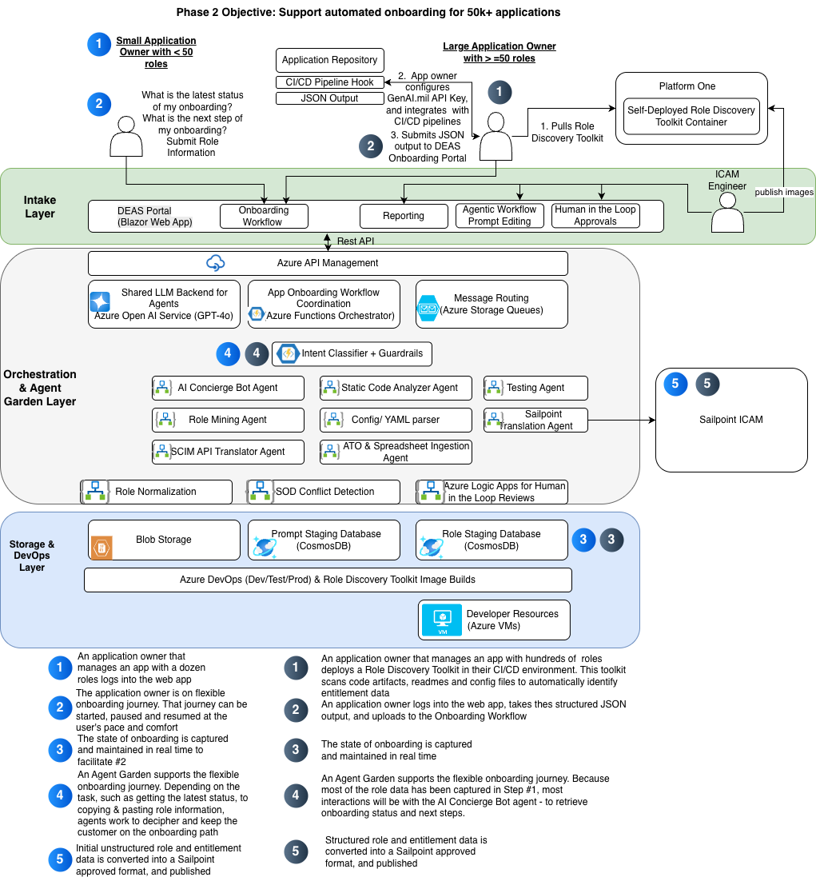
Figure 4: Future State Agentic Workflow Architecture

CONCLUSION

GDIT is well positioned to execute on DISA’s mission of increasing the number of applications that are onboarded. Our focus for the next 60 days will be to onboard 250-300 applications while systemically reducing bottlenecks during the process. By leveraging a talented team of CSMs and technical engineers, combined with strong program management, GDIT proposes two technical enhancements for the Government to review.
The first enhancement is to perform quality checks on Mission Partner onboarding application submissions, and reduce the time to identify typos and anomalies. The second enhancement is Mission Partner facing – adding a AI Concierge chat bot directly into the web application so that Mission Partners are able to ask questions, and receive accurate responses instantaneously. The benefit is that Mission Partners do not need to pause application onboarding and request a call from the CSMs.
Both enhancements offer different risk and execution profiles. The first can be performed solely by GDIT. The second will require a collaboration with Microsoft. Yet both contribute to a future state architecture where application onboarding can significantly expand in scope from the requirements offered today.

