Audio Annotation Tool
This manual explains how to use the Audio Annotation Tool to load, visualize, segment, label, and export audio recordings. The tool is now designed as a general-purpose audio annotation application. It can be used for many types of .wav recordings, such as environmental sounds, machines, water sounds, vehicle sounds, speech fragments, clinical recordings, or custom research datasets.
The application displays a waveform and spectrogram, supports playback, stores annotations per file as JSON sidecars, and exports all segment labels to CSV for later analysis or machine learning workflows.

1. Starting the Application and Selecting Data
When you start the application, the folder selection window appears. This dialog is only used to choose a dataset folder. Metadata is no longer entered in the startup window.
- Click Choose folder…
- Select the folder that contains your .wav files.
- Confirm with OK to load the dataset.
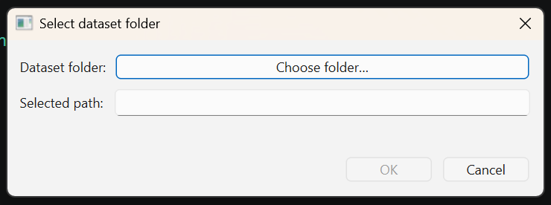
The application scans the selected folder and its subfolders for .wav files. If no .wav files are found, the app will show a message and wait for another folder selection.

2. Main Interface
After opening a dataset, the main interface is split into a large audio viewer on the left and controls on the right.
- The upper plot shows the waveform: the audio amplitude over time.
- The lower plot shows the STFT spectrogram: the distribution of sound energy across frequency and time.
- The right panel contains file navigation, selected interval controls, metadata, label buttons, segment editing tools, filter controls, and export options.

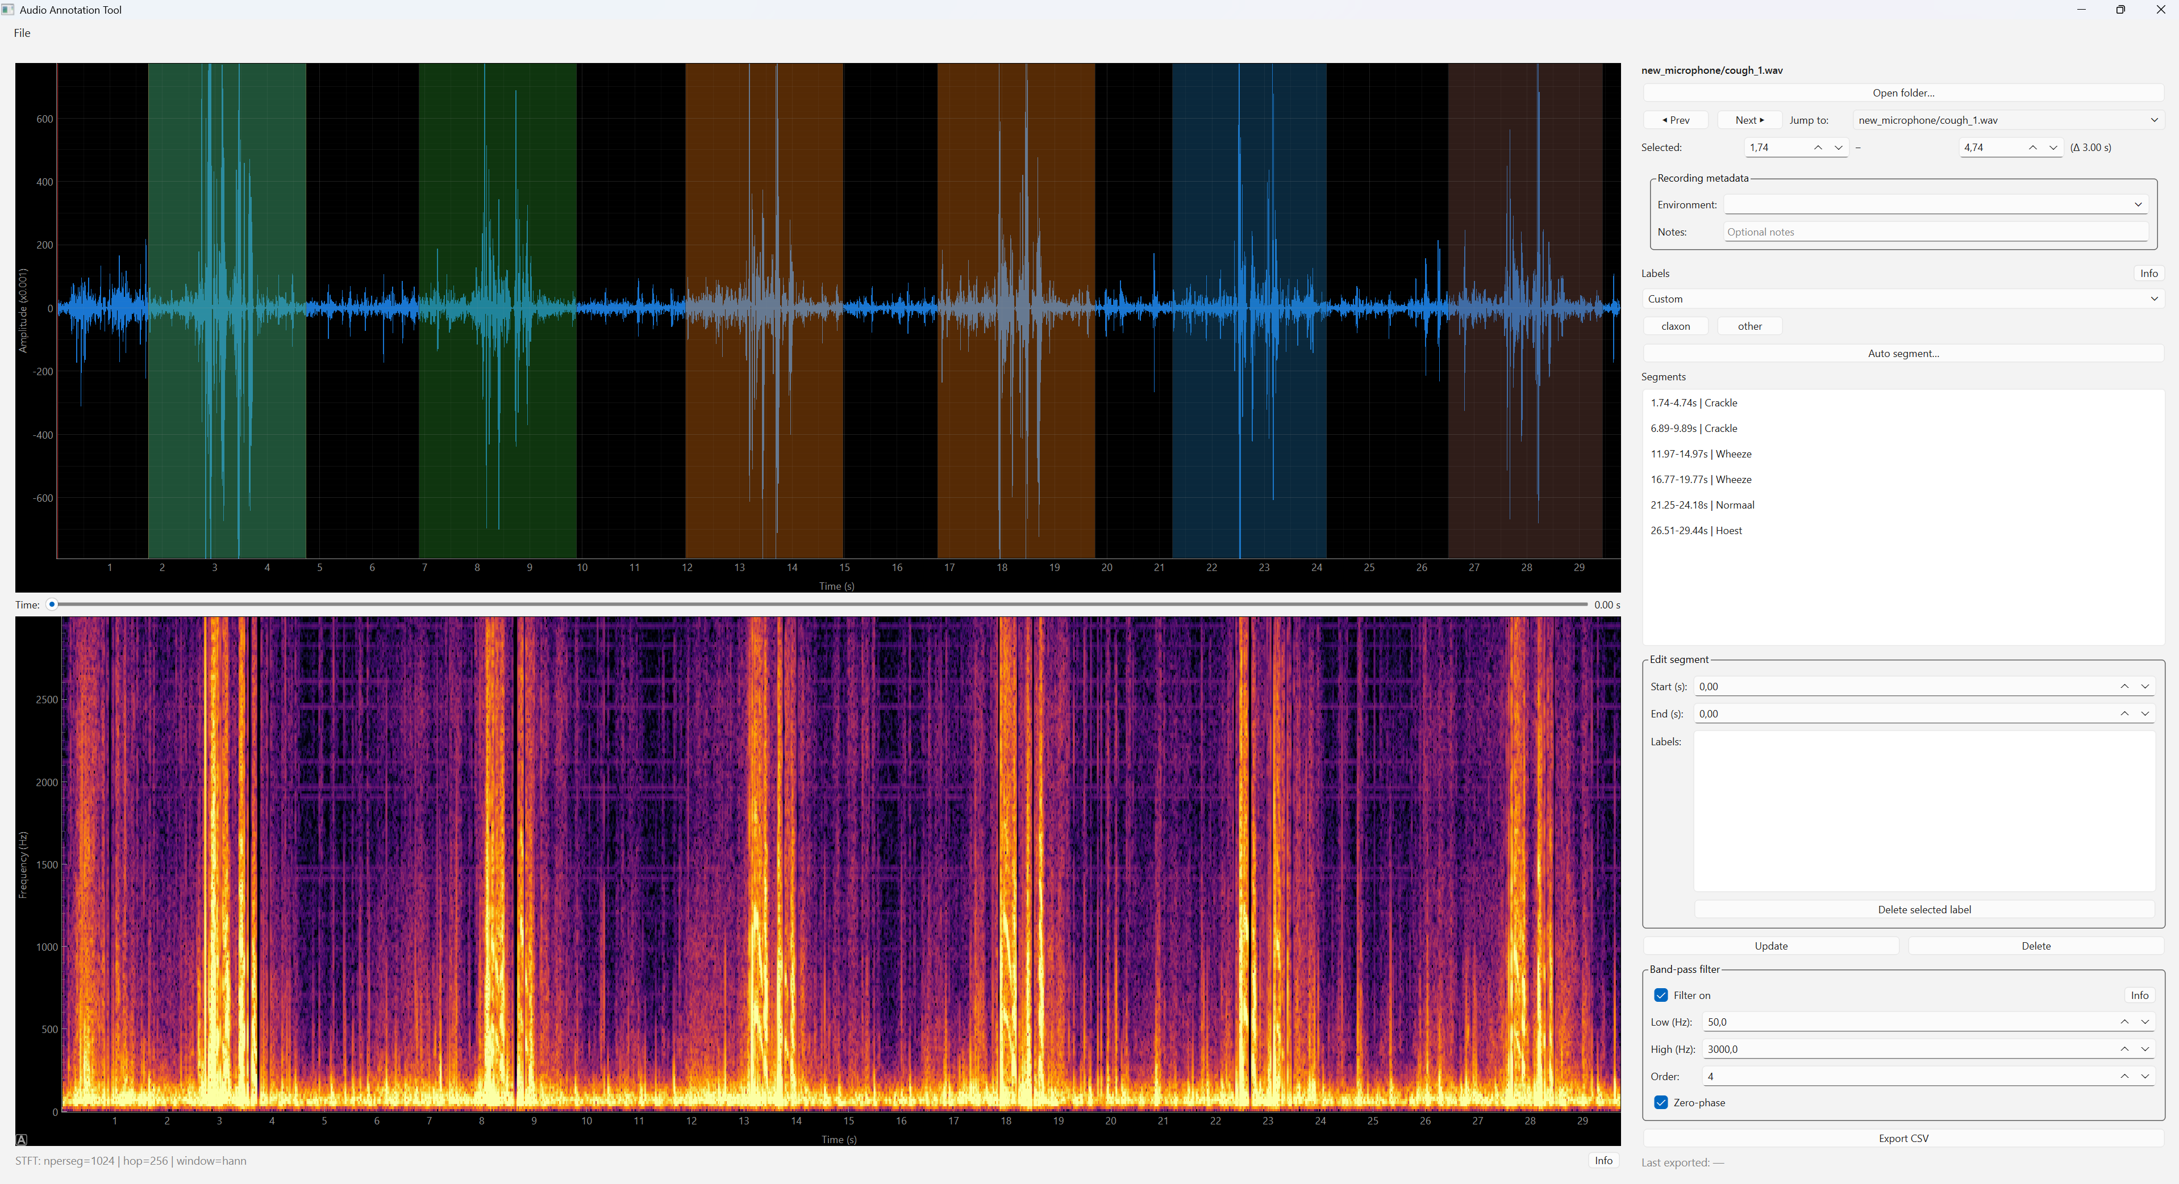

- The time slider between the plots controls the playback position. The red playhead shows the current playback time.
You can play or pause the sound using the spacebar. During playback, the red line (playhead) moves across the waveform.

3. Navigating Files
The current file name is shown at the top of the right panel. Use Prev and Next to move through the loaded files. Use the Jump to menu to open a specific file directly. The Open folder… button lets you choose a different dataset at any time.
Use Prev (P) and Next (N) to move through the files in the folder. The Jump to menu lets you go directly to a specific file.
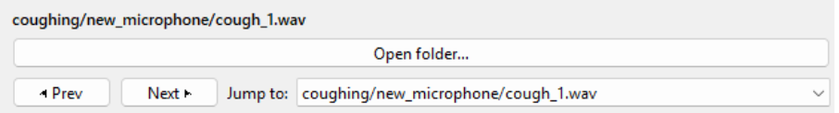

4. Selecting an Interval
The blue selection region in the waveform defines the active time interval. You can drag this region directly in the waveform or adjust the Selected start and end fields in the right panel.
- Start and end times are shown in seconds.
- Δ indicates the duration of the selected interval.
- The selection snaps to the app time step, currently 0.01 seconds.

5. Recording Metadata
Metadata is edited per recording in the Recording metadata section. The current metadata fields are intentionally generic:
- Environment: the recording context, such as indoor, outdoor, traffic, lab, home, noisy, or another custom value.
- Notes: optional free text for additional information about the recording.
If Environment is filled in, it is remembered during the current session and offered again for later files. Empty metadata fields are not included in the exported CSV.
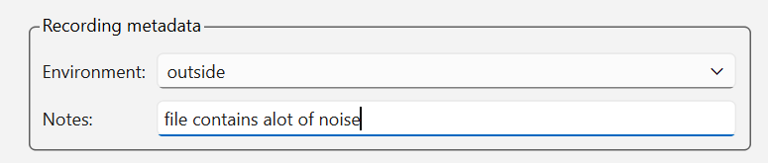

6. Labels and Label Configuration
Labels are loaded from labels_dataset.json. The tool no longer contains built-in lung or heart label sets. This makes the app suitable for any audio annotation project.
Each label appears as a button in the label bar. Click a label button to add or remove that label from the selected
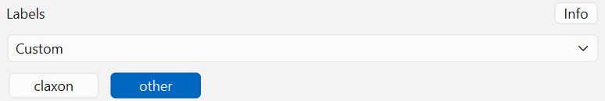
Above the metadata section is the Label set control. Here you choose which label categories and recording locations you want to use:
File | Purpose
labels_dataset.json | Defines the available labels and default display/processing settings.
<audio_filename>.json | Stores annotations and metadata for one .wav file as a sidecar.
CSV export | Combines all segments from the dataset into one table for analysis.

7. Creating, Selecting, and Labeling Segments
To create a labeled segment, select an interval in the waveform and click a label button. The segment appears in the segment list and as a colored region in the waveform.
- Click a segment in the segment list to select it.
- Click a colored segment region in the waveform to select it directly from the audio viewer.
- Hold Shift and click another segment to select the full range between the first and second segment.
- Hold Ctrl and click a segment to toggle it in or out of the current selection.
- When multiple segments are selected, label actions are applied to all selected segments.

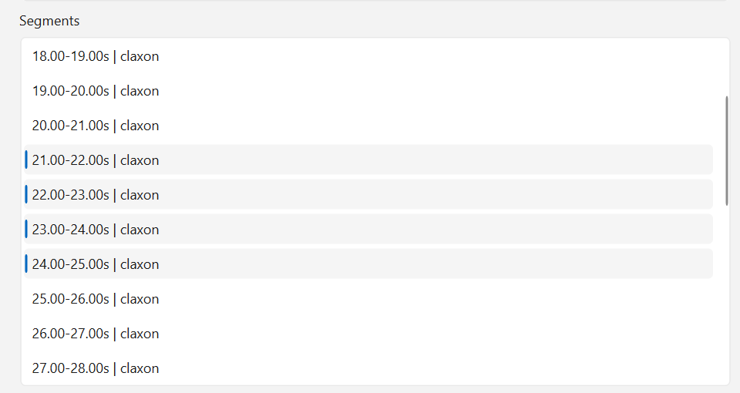
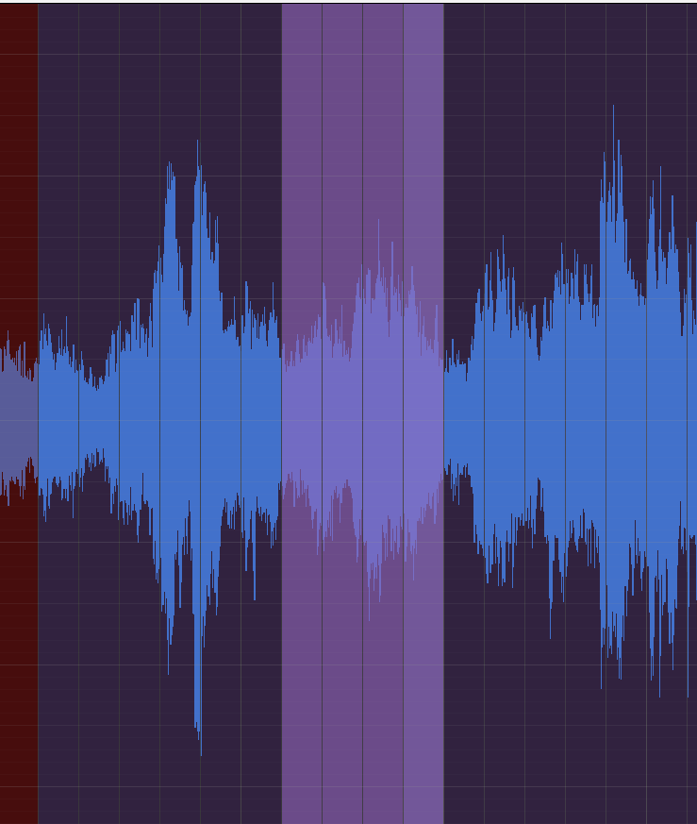
Selected segments are shown more strongly in the waveform view, so it is easier to see which annotations are currently active. Segment colors are based on label names; different labels receive different overlay colors.

8. Editing Segments
All labeled segments are listed in the Segments panel. The list is ordered chronologically from the start of the audio to the end.
- Use Start and End to adjust the selected segment boundaries.
- Use Delete selected label or the × button next to a label to remove that label from the selected segment or selected segments.
- Click Update to save edited start/end times and labels.
- Click Delete to remove the selected segment or all selected segments.
- Use Ctrl+Z to undo and Ctrl+Y to redo recent segment edits.

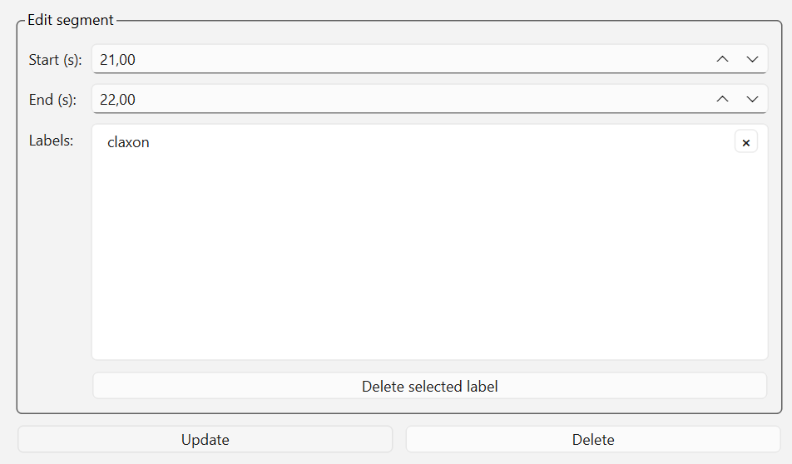
All edits are saved automatically to the JSON sidecar for the current .wav file.

9. Automatic Segmentation
Auto segment… can create fixed-length segments across the current recording. This is useful when many files need to be annotated in consistent time windows.
- Segment length defines the duration of each generated segment.
- Overlap defines how much adjacent segments overlap.
- Replace existing segments clears the current segments before generating new ones.
- A label can optionally be assigned to every generated segment.
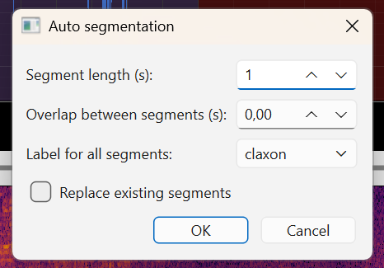
Once you press OK, all segments will be generated across the entire file in one step.

10. Band-Pass Filter, and Spectrogram
The band-pass filter can be enabled to focus on a selected frequency range. This is useful for reducing low-frequency rumble or high-frequency noise while annotating. The filter only changes what is displayed and played during annotation; it does not change the original .wav file.
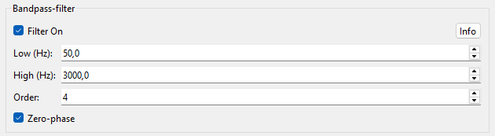

- Low / High define the cutoff frequencies in Hz.
- Order controls how steep the filter edges are. Higher values can introduce artifacts.
- Zero-phase avoids phase delay and is useful for offline annotation and visualization.
The spectrogram shows how the sound evolves over time and frequency. When the band-pass filter is active, the displayed frequency range follows the selected filter settings.

11. Saving and Exporting
The app automatically saves annotations for each .wav file as a JSON sidecar with the same base filename. When you reopen the dataset, these annotations are loaded again.
Click Export CSV to create one CSV file containing all labeled segments from the current dataset. The export includes filename, start time, end time, labels, date, and only metadata fields that are actually filled in.

12. Keyboard Shortcuts
Shortcut | Action
Space | Play or pause audio
N | Go to next file
P | Go to previous file
Enter / Return | Update selected segment
Delete | Delete selected segment(s)
Ctrl+Z | Undo
Ctrl+Y | Redo
Ctrl+R | Reset waveform and spectrogram view
Left / Right | Move the selected interval left or right
Shift+Left / Shift+Right | Move the start of the selected interval
Ctrl+Left / Ctrl+Right | Move the end of the selected interval
1–9 | Toggle the first nine label buttons

13. Resetting the View and Practical Tips
- Use Ctrl+R if you have zoomed or panned too far and want to reset the waveform and spectrogram views.
- Keep labels in labels_dataset.json project-specific and concise.
- Use Environment for recurring recording context and Notes only for details that are specific to one file.
- Use Shift-click for fast range selection when applying the same label to multiple adjacent segments.
