1.1

Policy = random

Y = 1

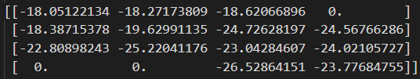

Policy = random

Y = 0.9

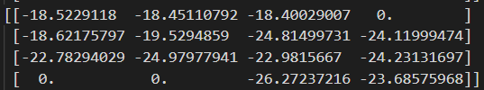

Policy = optimal

Y = 1

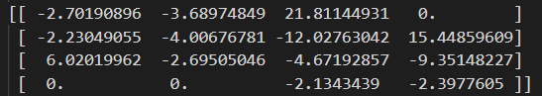

Policy = optimal

Y = 0.9

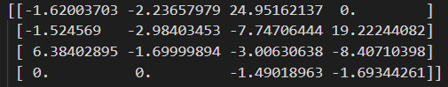

1.2

Policy = optimal

Y = 1

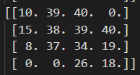

Policy = optimal

Y = 0.9

