**Question (1): [30 Marks]**

**The following class diagram shows a purchase order system where customers can use their credit cards, checks or cash to make orders of different items.**

|  |
| --- |
| UML Class Diagram |
|  |

1. What is the suitable assoiciation type between two classes: credit and payment , order and order detail **[4 Marks]**
2. Draw an object diagram for two customers who have bought similar items via different orders and paid by cash **[6 marks]**
3. If the class model is to be extended by adding warehouse/store places to keep the items there, customer categories (new, potnetial ) update the class diagram show where to add the new classes and how to relate them to the rest of the model **[6 marks]**
4. For the above system create a needed and reasonable use case diagram showing all possible actors and required and important use cases **[6 marks]**
5. Show a time sequence diagram including control and boundary classes that computes the cost of a given order **[4 marks]**
6. List two INVEST user stories one for the customer and one for the seller **[4 marks]**

**Question (2): [20 Marks]**

**The following state transition diagram shows the behaviour of soda vending machine**

1. List all events and actions  **[5 marks]**
2. Show the list of events and resultant state sequence required to insert three 20 cents coins and then order soda  **[5 marks]**
3. Show how can this state transition diagram be tested using state coverage method (list needed test cases) **[5 marks]**
4. Modify the diagram to return the change if the customer does not press soda button for a long period of time **[5 marks]**

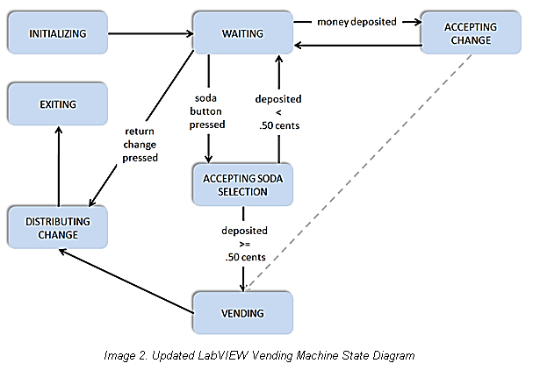

**Question (3): [20 Marks]**

**Explain brifely with diagrams when possible the following**

1. The transition coverage vs event coverage testing **[4 marks]**
2. The waterfalls model vs agile development lifecycle models **[4 marks]**
3. User Interface (UI) vs User Experience (UX) **[4 Marks]**
4. The V model with prototype vs the spiral model  **[4 Marks]**
5. The ideate vs empathize steps in design thinking **[4 Marks]**

**END of Exam, Good Luck**

|  |  |
| --- | --- |
| ***Examination Committee*** | ***Exam. Date: 22nh of January, 2022*** |
| *Dr. Islam El-Maddah* |  |

CSE608 Fall 2021

Final Exam Questions/ILO Matrix

|  |  |  |  |  |  |  |  |  |  |  |  |
| --- | --- | --- | --- | --- | --- | --- | --- | --- | --- | --- | --- |
|  | a1 | a2 | a3 | a4 | b1 | b2 | b3 | c1 | c2 | c3 | d1 |
| Q1 | ● | ● | ● |  | ● | ● | ● |  |  |  |  |
| Q2 | ● |  | ● |  | ● | ● | ● |  |  |  |  |
| Q3 |  | ● |  | ● |  | ● | ● |  |  |  |  |