**Question (1): [35 Marks]**

The following class diagram shows how the customers can order different items and pay for them using cash, credit cards or checks

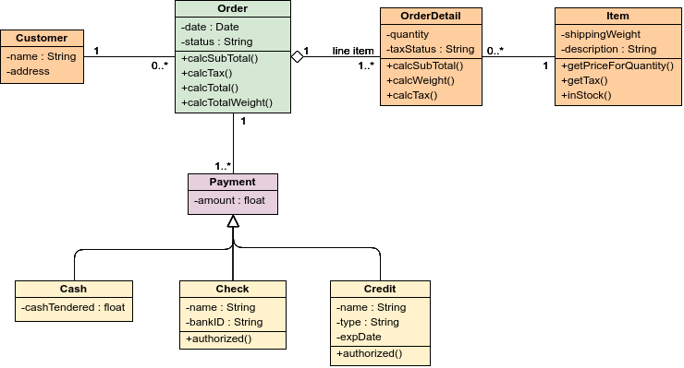

1. Explain whether a customer can pay for one order using two credit cards or not **[5 Marks]**

**Yes he/she can pay using multiple methods/amounts each has its own type as the associiation between order and payment are 1 to 1..* and order could be any of the three types**

1. Draw an object diagram for two customers who ordered two similar orders containing the same items but one of them is paying in cash other paying in credit card **[5 marks]**

**[:C1]----[:O1]---[:OD1]------[:item1]**

**| ----[:OD2]------[:item2]**

**|-----[:OD3]-----[:Item3]**

**|------[:Payment1]-----[:cash1]**

**[:C2]----[:O2]---[:OD4]------[:item1]**

**| ----[:OD5]------[:item2]**

**|-----[:OD6]-----[:Item3]**

**|------[:Payment2]-----[:credit1]**

1. If the class model is to be extended by adding search for items, customers and orders, show the needed control and boundary classes **[5 marks]**

**A control class is needed per use case so three control classes are needed for the three use cases and one boundary class is needed per use case per actor since we have just human actors so we need three boundary classes like “search forms”**

**Each search form and control will be linked to one of the three classes customer, order and item using dashed lines**

1. Add one class for ***delivery*** which is used to show when an order is fulfilled. the delivery may contain more than one kind of items and could be delivered for at most one order Show the class details and how it is connected to the other existing classes **[5 marks]**

**[order] –1---------1:*--[delivery]---1--------1:*---[Deliverydetail]---1---*--[item]**

1. For the above system create a possible use case diagram showing all possible actors and needed and important use cases **[5 marks]**
2. Show a time sequence diagram that computes the total price for a given order **[5 marks]**

|  |  |  |  |  |  |
| --- | --- | --- | --- | --- | --- |
| clerk | Compute_order_price_form | COP_Controller | Order | OrederDetail | item |
|  |  |  |  |  |  |
|  |  |  |  |  |  |
|  |  |  |  |  |  |
|  |  |  |  |  |  |
|  |  |  |  |  |  |
|  |  |  |  |  |  |

1. Create one row of a CRUD matrix between the use case of ***create_an_order*** and the above data classes **[5 marks]**

|  |  |  |  |  |  |  |
| --- | --- | --- | --- | --- | --- | --- |
| **Class** | **item** | **order** | **customer** | **orderdetail** | **Create_order_form** | **Create_order_controller** |
| **Create_an_order** | **R\*** | **C** | **R/C** | **C\*** | **RCUD** | **RCUD** |

**Question (2): [35 Marks]**

The following table rows show the current state of a given microwave oven system, whereas the columns are the possible events that can happen the intersection between the row and the column is the next state starting from the current state and receiving an event. For example if the current state is ***cooking*** and ***dooropened*** event happened the next state will be ***Cooking interrupted***

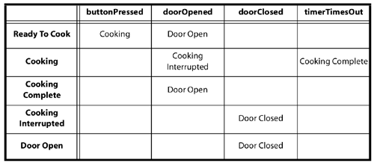

1. List two functional and two non-functional requirements about the controller of the oven system. **[6 marks]**

**Functional 1: oven is switched on when needed**

**This is considered as liveness**

**Functional 2: oven is switched off when needed or after some pre determined time**

**This is considered as controlable property as the food may be alredy cooked**

**Non functional 1: safety oven should not work if the door is open**

**For the safety when the door is open the oven should stop heating if it ws working or if button pressed while the door is open it should not heat at all**

**Non functional 2: economy oven should work if it is empty**

1. Create a state transition diagram from the above table, make any needed assumptions and state them **[6 marks]**

open_door



close_door



Button_pressed



close_door



open_door

Time_out

Button_pressed



Open_door

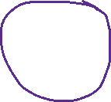

1. If the initial state is ***Door open***, what is the shortest needed event list that move the system from the initial state to ***cooking interrupted*** state **[5 marks]**



|  |  |  |
| --- | --- | --- |
| Current state | Event | Next state |
| Door open | Close door | Ready to cook |
| Ready to cook | buttonpressed | Cooking |
| Cooking | Door opened | Cooking interrupted |

1. If a beep sound is needed to be produced as an action when start cooking show where to put this action on the state transition diagram **[5 marks]**

**On the transition between ready to cook and cooking, also after door is closed from state cooking interrupted**

1. Show how can the state transition diagram be tested using state coverage method **[4 marks]**

**Need to cover all states**

**Possibly three scienarios**

1. **normal operation till cooking complete**
2. **interupt cooking**
3. **open door then close it and button pressed**

**in each case the system should produce next state as expected in the table**

1. Repeat part (e) but using event coverage method **[4 marks]**

**We need to cover all events at least once for each event. So door open is needed just once to be tested and button pressed should also be tested once as well**

1. Reduce the state transition diagram if there is no timer; add some indetermisim to compnestate for not knowing when the cooking job is done **[5 marks]**

**There will be no cooking complete state but the system will possibly return to ready to cook state**

open_door

close_door



Button_pressed



close_door



open_door



**END of Exam, Good Luck**

|  |  |
| --- | --- |
| ***Examination Committee*** | ***Exam. Date: 19th of August, 2020*** |
| *Dr. Islam El-Maddah* |  |