Software engineering CSE334

UI, UX, Design Thinking

Model answers

Dr Islam El-Maddah

Fall 2021

Q1: Why UI is easier than code Design?

No algorithms and could be done by drag and drop the prototypes are easy to create even on papers, easy to modify and have template for (reuse)

Choose either A or B and validate your answer

A is better image above text you still feel it is a command button the UI must be easy to find and minimize the mistakes or waiting time for deep thinking by user

B is correct UX means general use of the software UI only the interface, ux could include the sequence of what to do in the different pages/dialog boxes while UI means what and how to create user input/output in each part

A is correct even the feedback could be only for ideate but B dose not have feedback at all and the discovering stage do not how to discover but in A it is hearing the user problems we can start understanding what his problem so what he needs to get rid of them

B is better there are separation between the subtopics not like in A

B is better the email is expected to be filled, while in A you may misunderstand you will click to send an email usually centered text is command buttons while left aligned and grey means text to be filled here

A is better for mobile screens as you still know what is the data after you filled them but in B you may forget what does this field mean

A The expected action should be first and have bright color than background, we expect most of the users will click cancel here

A is better because the sub topics or details aligned or idented one level compared to the main topics

Design Thinking

It is design thinking not thinking design 😊

It means How to think in a design related way like analytical thinking or critical thinking

Q1. is design thinking a problem solving framework?

* True
* False

Q2. What is not part of the design thinker's profile?

* Empathy
* Integrative Thinking
* Creativity
* Optimism

Creative when feeling a problem and start find a solution with your team, integrative when you combine ideas together

Q3. can design thinking be applied in other professions?

* False
* True

Any activity that you can create a proto type for it, may be composing a text, film or movie scripting

Q4 Ms. Eva is creating a new product for university students. She takes a design-thinking approach. Her first step is addressing who she is creating the product for and conducts research on understanding this target market. What is this step in the design thinking process?

* Define
* Ideate
* Empathise
* Prototype

Q5. Is 'prototyping' a step in the design-thinking process?

* True
* False

Q6. A university is re-designing their website. The main user of the website is university students. The web-developer is choosing what elements to put on the home page. For the best user-experience, what element should be on the home page?

* Student Log-in
* University's philosophy
* Letter from the Dean
* Library hours

See below customer CX or customer journey

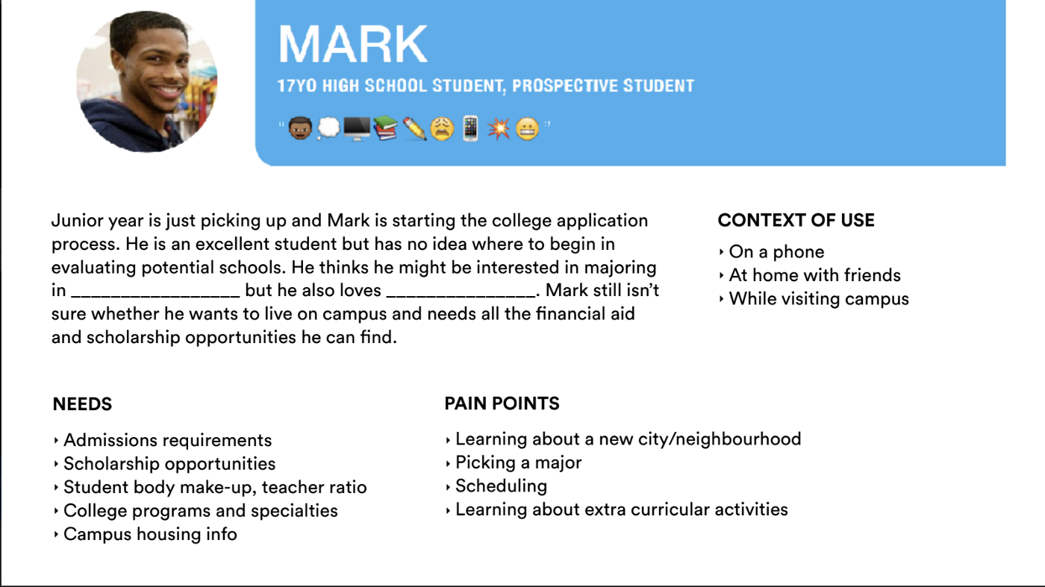

Q7. Design Thinking is a ……

* way of thinking about design
* Method and mindset to define, frame and solve problem
* Way to separate thinking form making
* Curriculum for teaching non- designer design

Q8. Design Thinking starts with………

* Sketching and prototyping with craft material
* Sticky notes or note cards
* Empathy and a understanding of human needs
* Identifying solution for your problem

Q9. Which of the following is not a part of Idea selection process in Design Thinking

* Grouping related concepts together
* Identifying selection criteria
* Deliberating
* Prototyping

Q10. Design thinking is a methodology

* for finding simplicity in complexity
* improving quality of experience with the designed products
* serving the needs of customers
* All of the above