app.py
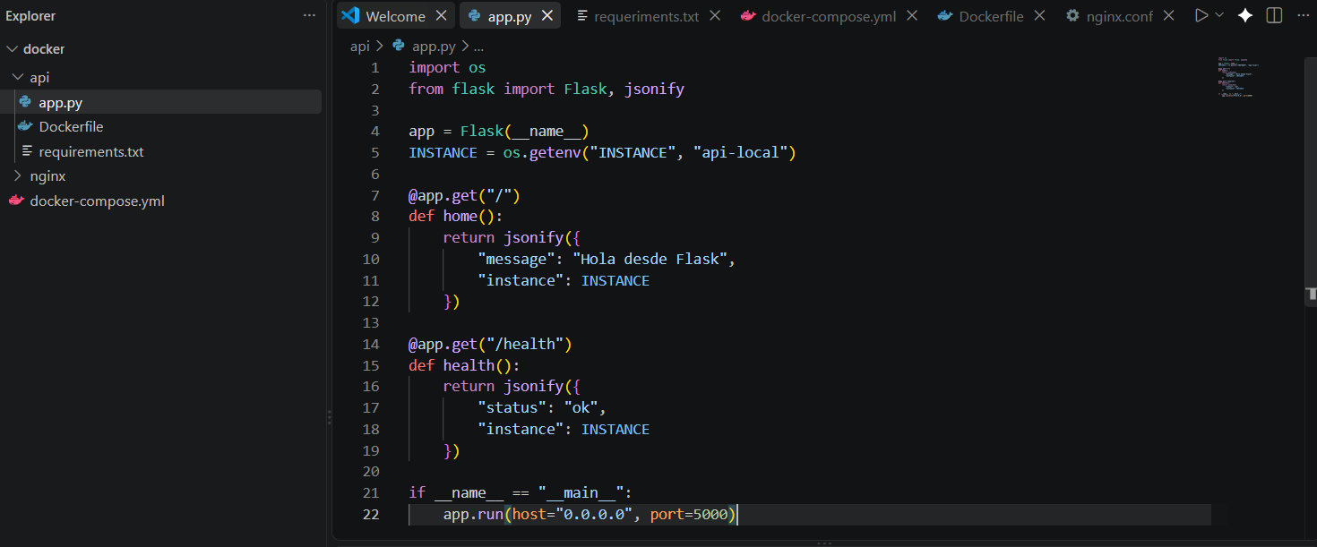

Dockerfile
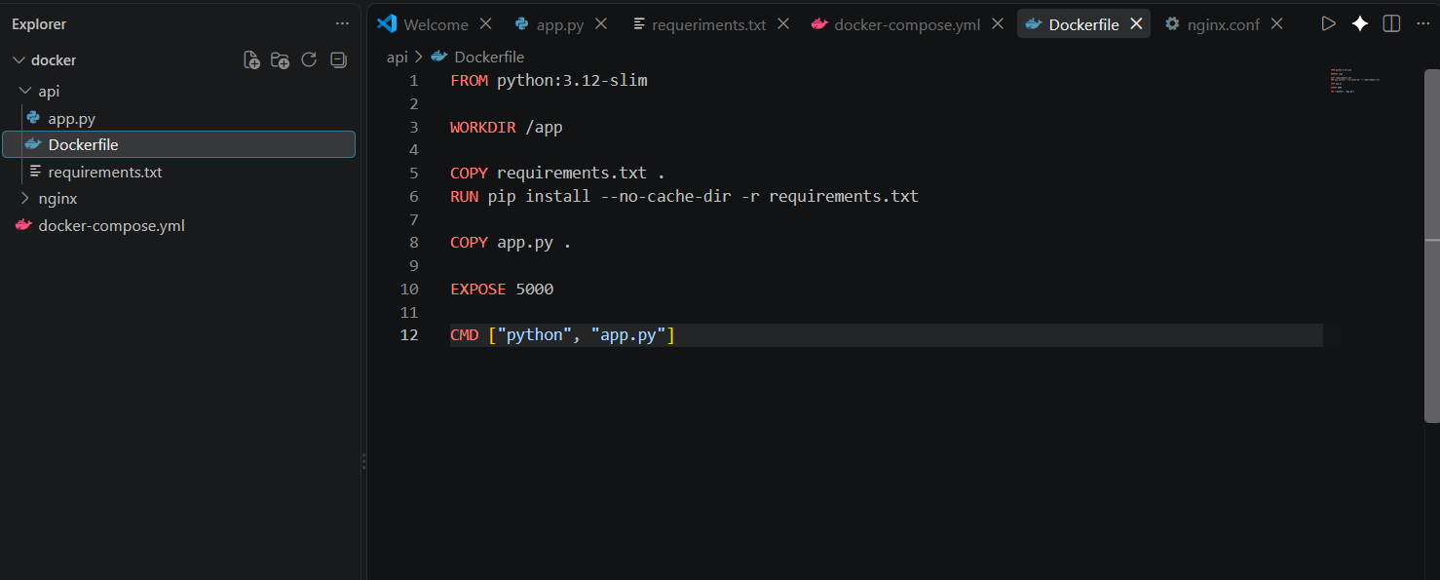

requirements.txt
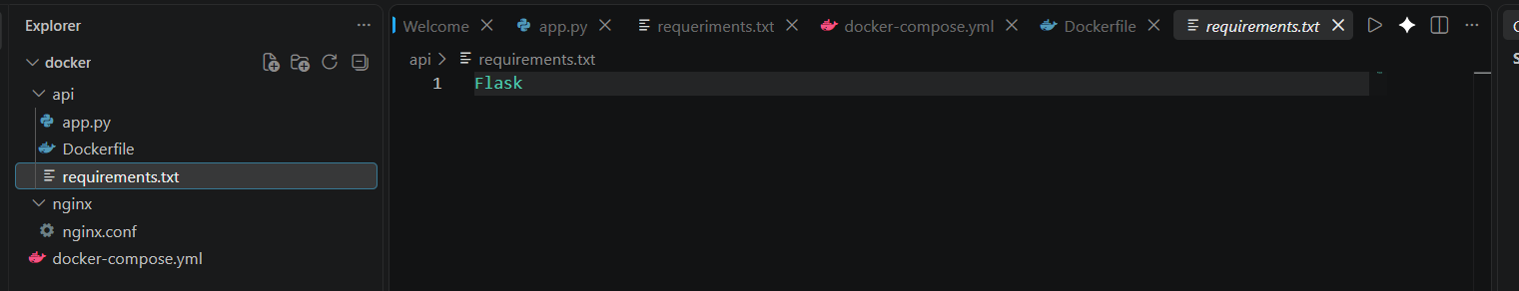

nginx.conf
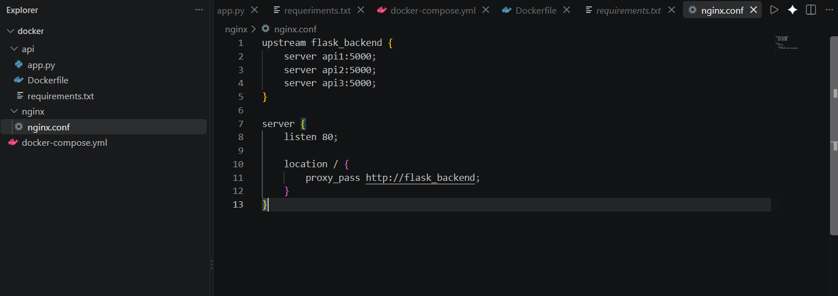

docker-compose.yml
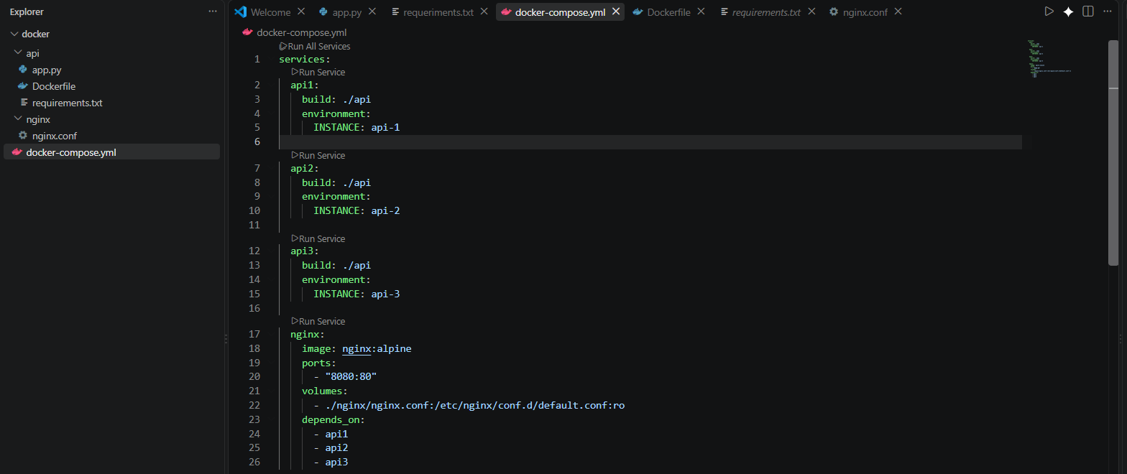

Evidencia de compilación
docker compose up –build
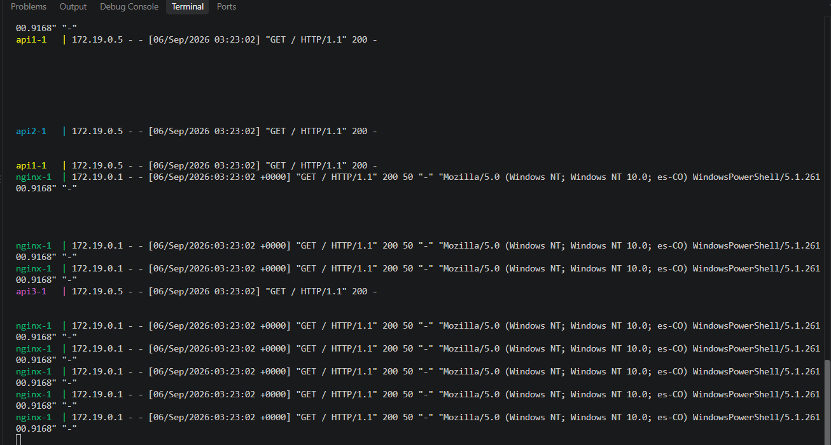

for ($i=1; $i -le 12; $i++) { Invoke-RestMethod -Uri "http://localhost:8080/" }
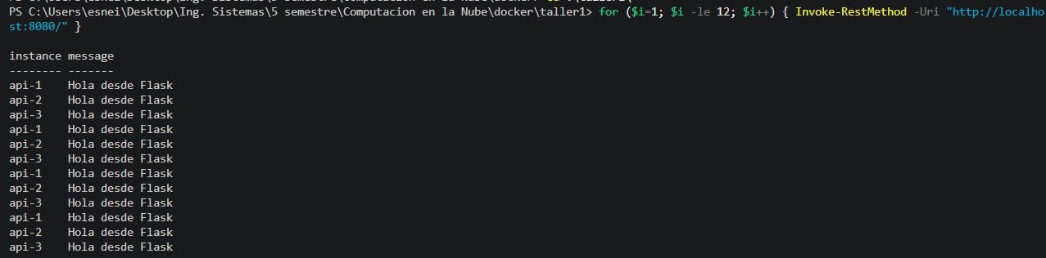

docker compose stop api2

for ($i=1; $i -le 12; $i++) { Invoke-RestMethod -Uri "http://localhost:8080/" }
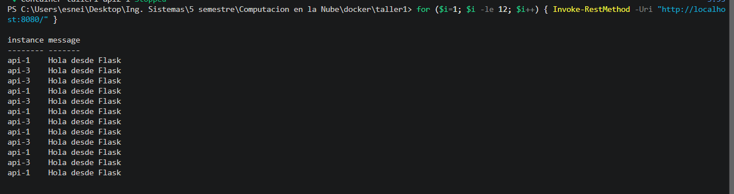
Invoke-RestMethod -Uri "http://localhost:8080/health"
