Taller2- Docker
Users/app.py
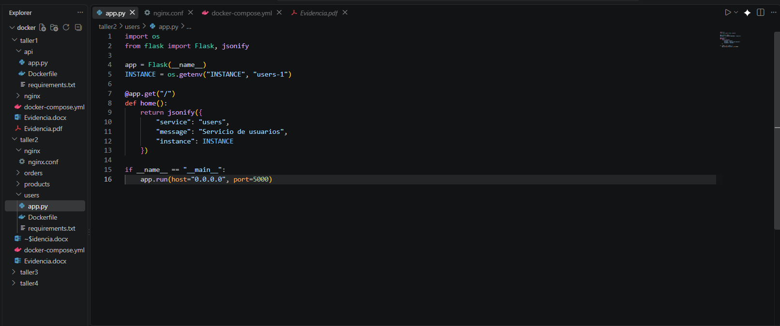

products/app.py
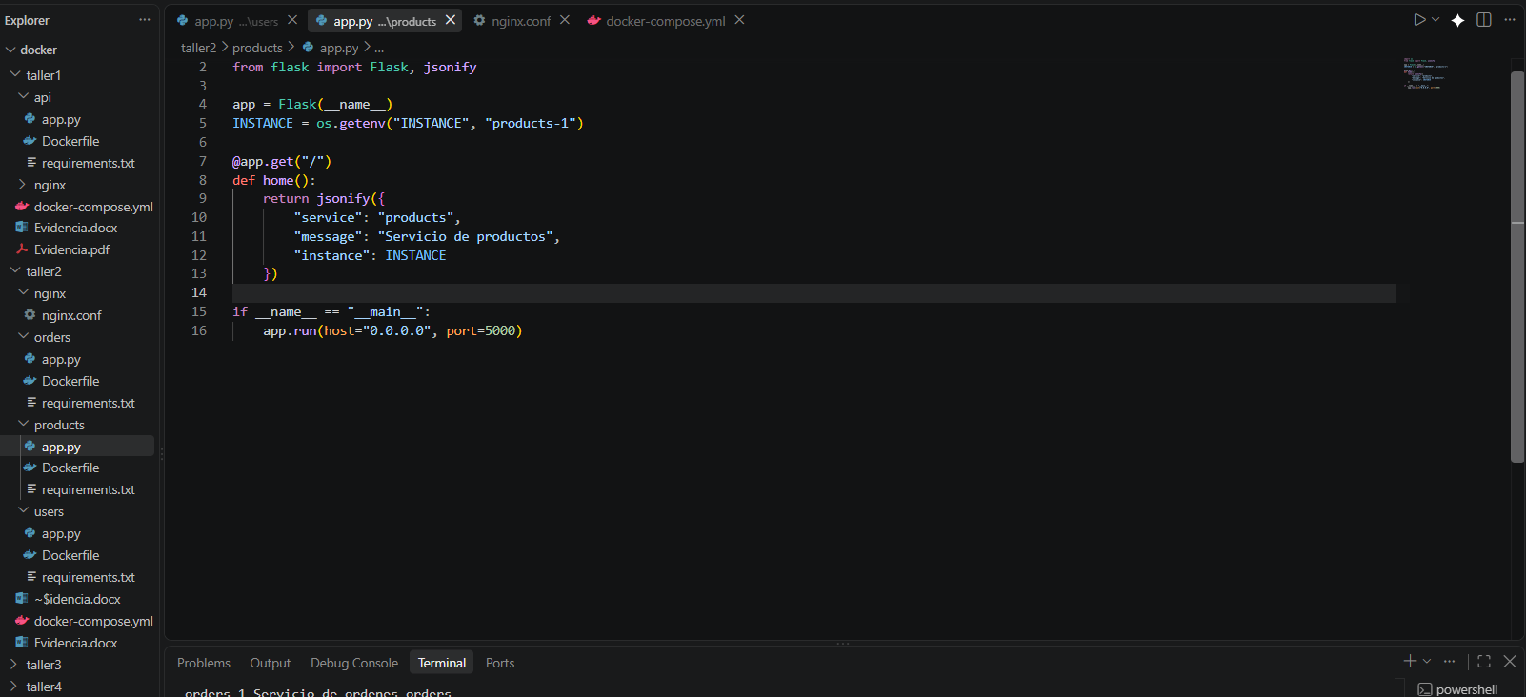

orders/app.py
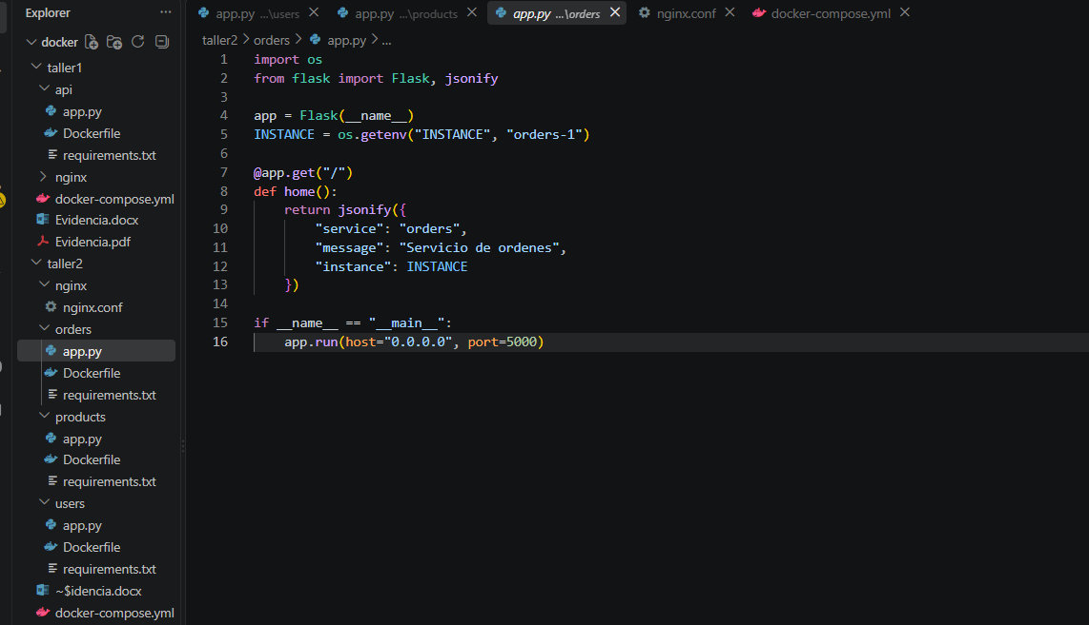

Dockerfile de users, orders y products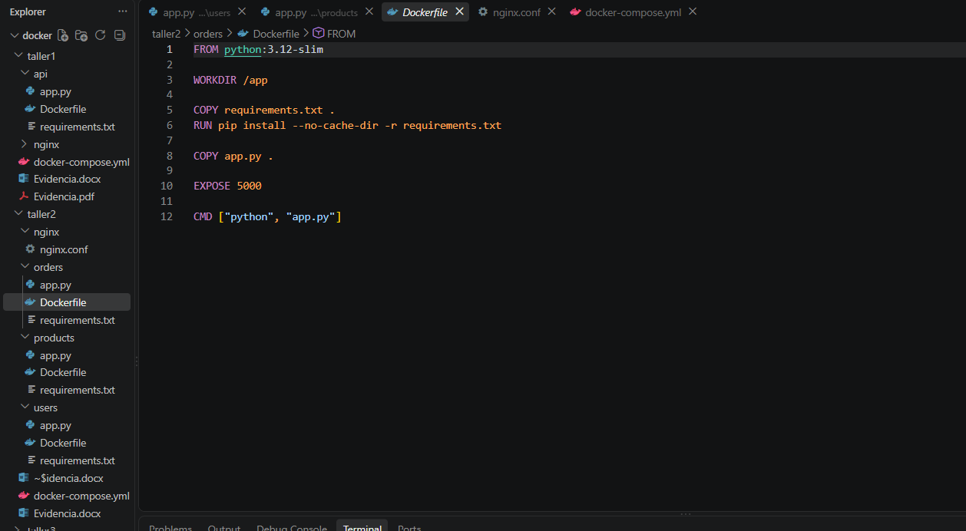

Requeriments de users, orders y products 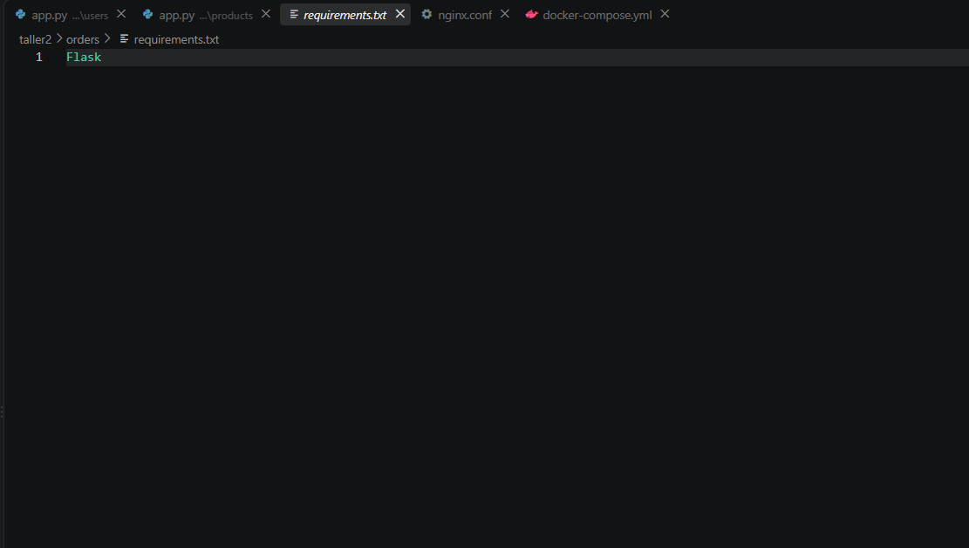

Evidencia de compilación
docker compose up --build
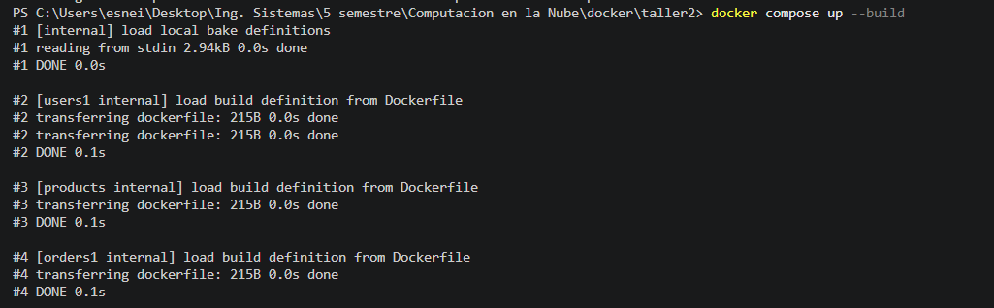
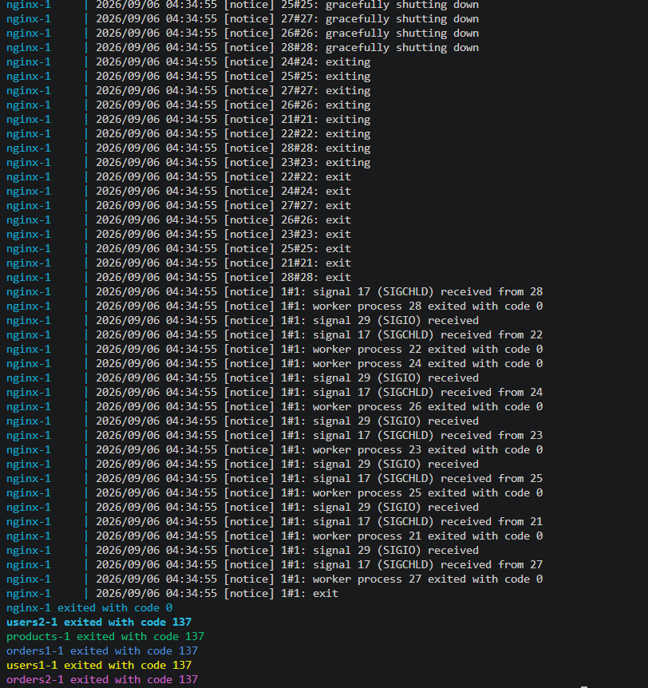

Invoke-RestMethod -Uri "http://localhost:8080/api/users/"
Invoke-RestMethod -Uri "http://localhost:8080/api/products/"
Invoke-RestMethod -Uri "http://localhost:8080/api/orders/"
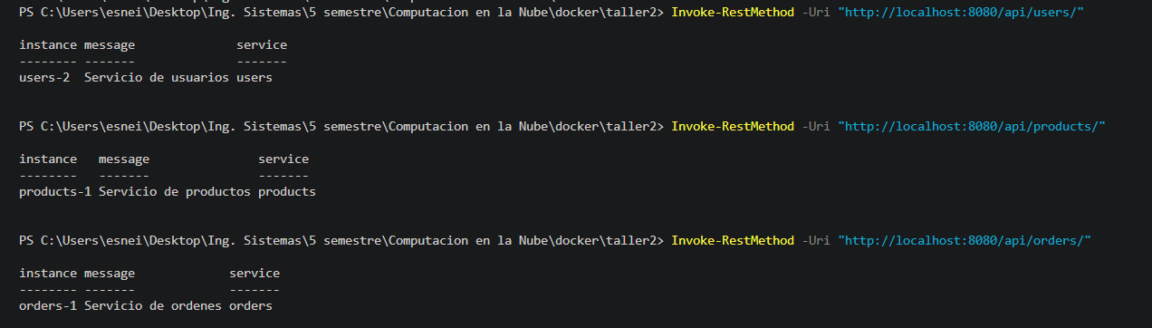

# Probar balanceo en Users (rotará entre users-1 y users-2)
for ($i=1; $i -le 4; $i++) { Invoke-RestMethod -Uri "http://localhost:8080/api/users/" }
# Probar balanceo en Orders (rotará entre orders-1 y orders-2)
for ($i=1; $i -le 4; $i++) { Invoke-RestMethod -Uri "http://localhost:8080/api/orders/" }
