Postgres/init/01-schema.sql
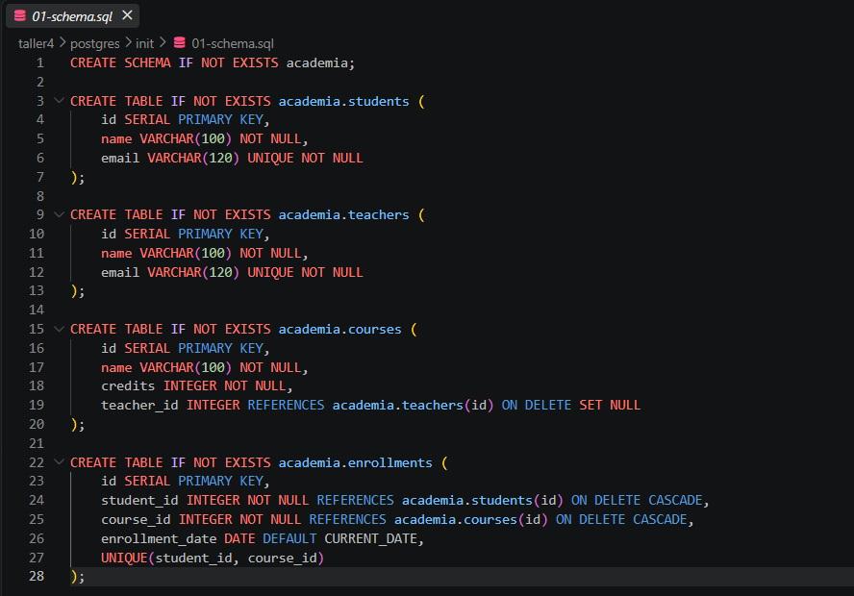

Postgres/init/02-data.sql
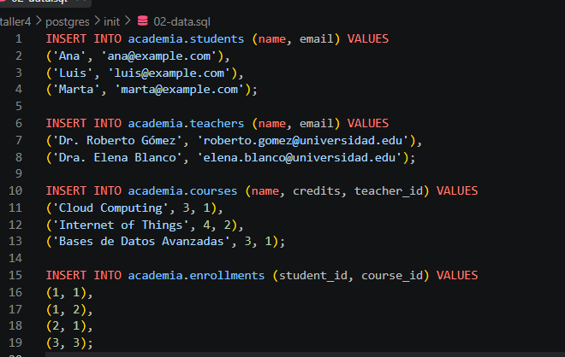

Dock-compose.yml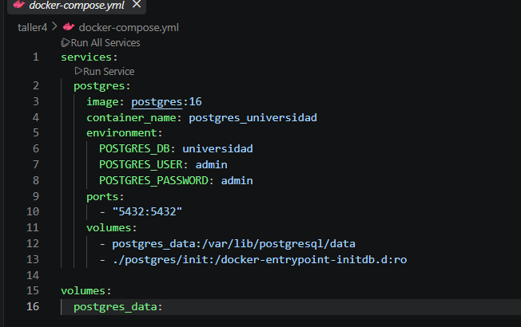

Evidencia de compilación
docker compose exec postgres psql -U admin -d universidad -c "\dn"
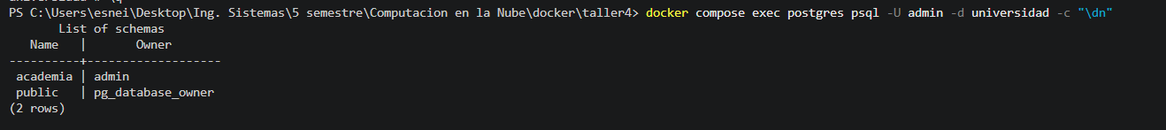
docker compose exec postgres psql -U admin -d universidad -c "\dt academia.*"v
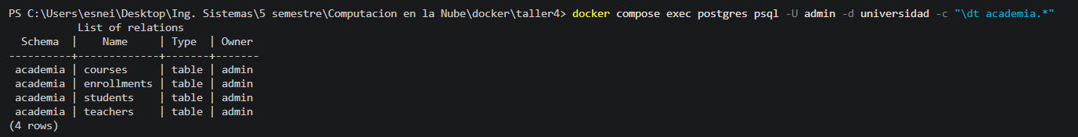docker compose exec postgres psql -U admin -d universidad -c "SELECT s.name AS estudiante, c.name AS curso, t.name AS profesor FROM academia.enrollments e JOIN academia.students s ON e.student_id = s.id JOIN academia.courses c ON e.course_id = c.id LEFT JOIN academia.teachers t ON c.teacher_id = t.id;"
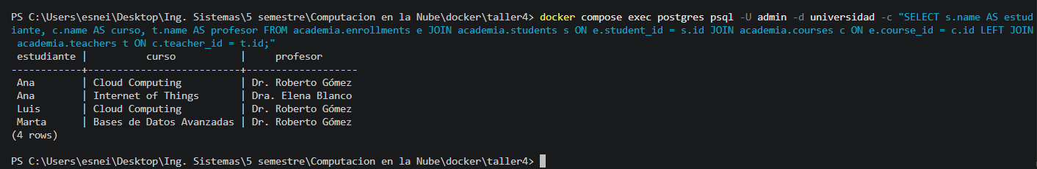
docker compose down 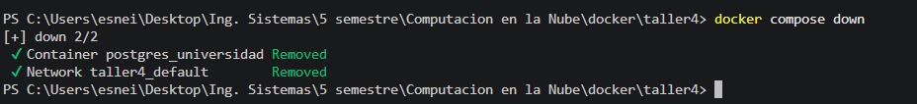

docker compose up -d

docker exec -it postgres_universidad psql -U admin -d universidad -c "SELECT * FROM academia.students;"
