mongo/init/01-init.js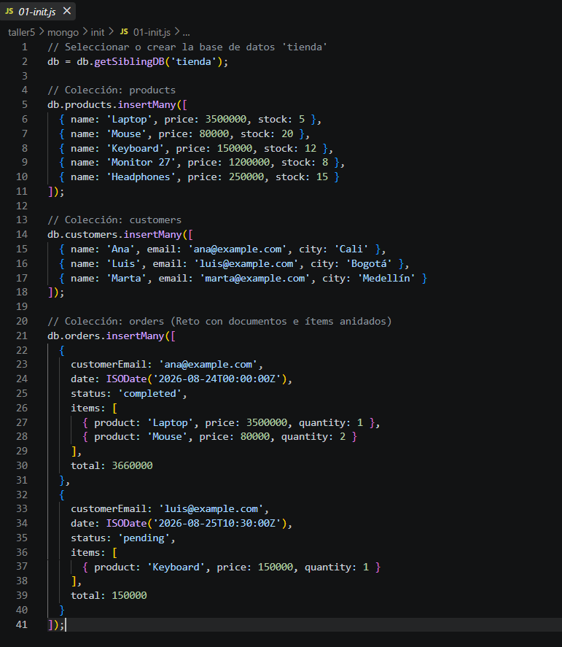

Docker-compose.yml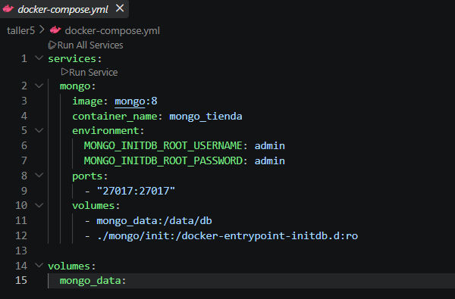

Evidencia de compilación
Docker compose up -d

docker exec -it mongo_tienda mongosh -u admin -p admin --authenticationDatabase admin tienda --eval "db.products.find()"
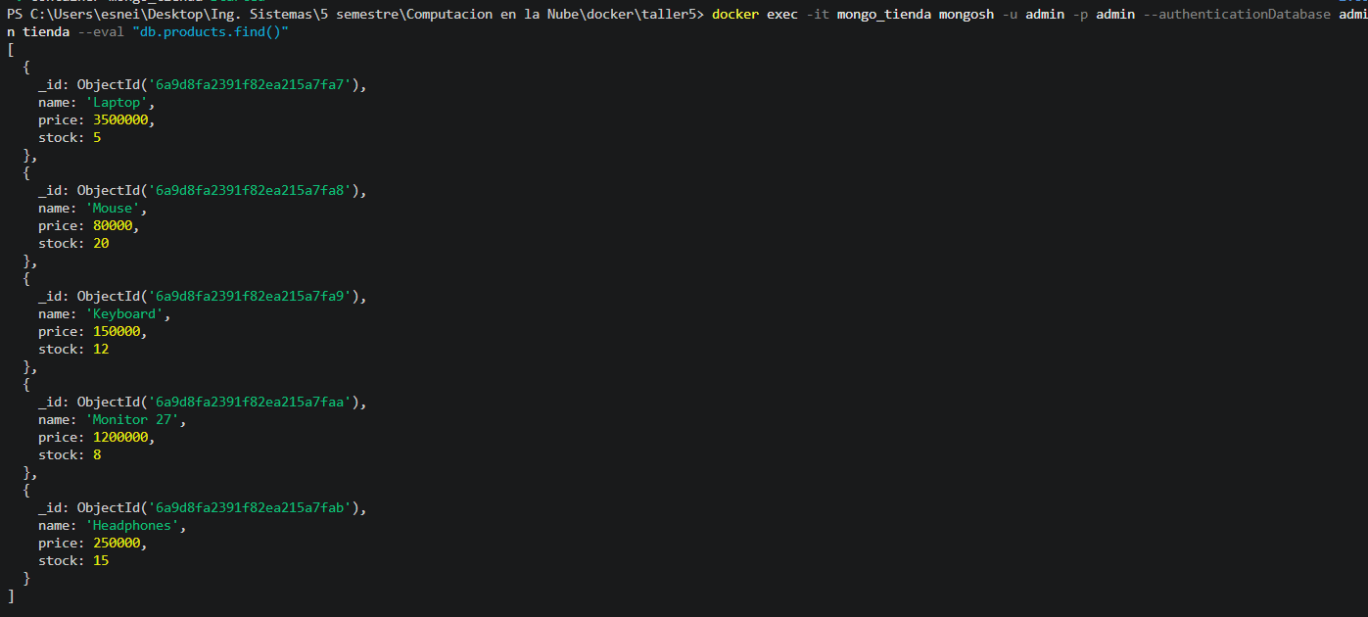

docker exec -it mongo_tienda mongosh -u admin -p admin --authenticationDatabase admin tienda --eval "db.orders.find()"
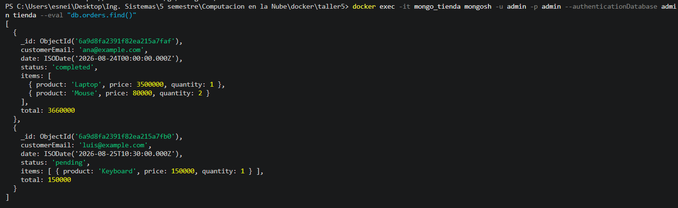

docker exec -it mongo_tienda mongosh -u admin -p admin --authenticationDatabase admin tienda --eval "db.customers.insertOne({name: 'Esneider', email: 'esneider@example.com', city: 'Cali'})"

docker compose down
docker compose up -d
docker exec -it mongo_tienda mongosh -u admin -p admin --authenticationDatabase admin tienda --eval "db.customers.find({name: 'Esneider'})"
