

Università degli Studi di Salerno

Corso di Laurea Triennale in Informatica

Image Recognition and Augmented Reality for Painting Narration

Relator: Prof. Andrea F. Abate

Candidate: Michelangelo Esposito – 0512104784

Academic year 2019/2020

**Index**

Introduction 3

1. Image Recognition 5

1.1 Image Recognition using Convolutional Neural Networks 6

1.2 Data science process overview 11

2. Augmented Reality 13

2.1 AR Overview 13

2.2 AR hardware and tracking methods 15

3. Application Overview 21

3.1 Requirements 22

3.2 Use case model 25

3.3 User interface mock-ups 28

4. Application design 30

4.1 Architecture overview 30

4.2 Android client 32

4.2.1 ARCore 32

4.2.2 Sceneform 33

4.2.3 Painting information 33

4.2.4 Text-To-Speech 34

4.2.5 Packages and classes 35

4.3 Node.js Server 36

4.3.1 NoSQL and MongoDB 36

4.4 Django Server 37

4.4.1 Django 37

4.4.2 TensorFlow 37

4.5 Case study 38

4.5.1 Painting analysis 38

4.5.2 Data Science Process 39

Conclusions 40

Bibliography 41

# Introduction

When visiting a museum or an art gallery, inspecting a painting is an activity limited to a quick visual analysis and, in some cases, to a small description found on a plate; for the most part, the history behind a piece and some of its details get lost and forgotten. A guide can help enhancing the discovering experience, however guided tours are not always available, as in the case of small private galleries, or they often provide long routes to which the visitor may not be interested in.

The purpose of this thesis work is to identify alternative support tools for the analysis and the fruition of art pieces, focusing on paintings. The main question that arises is the following: What technologies fit this purpose and are capable of delivering a smart and flexible system that can be used by a wide range of users?

In order to answer this question, we realized a mobile application which magnifies the educational experience provided by a painting, using Artificial Intelligence and Augmented Reality techniques. Through the usage of a convolutional neural network, the implemented system can recognize a piece in a scene and then generate a virtual augmented guide, which will start narrating the painting to the user, while projecting its details in the virtual environment. The application is corrected by a visual interface that facilitates navigation within the different descriptive segments of the work ; besides, the employment of Text-To-Speech technology in the narration strengthens the usability of the software for visually impaired or disabled users.

“The Birth of Venus”, by Italian renaissance artist Sandro Botticelli was chosen as a case study for the experimentation of the application; such a piece lends itself perfectly to the purpose, given the rich history that characterizes it and the clear spatial separations of characters and elements in the scene depicted. It was therefore possible to verify the applicability of the used technologies, in particular relatively to the training mechanisms of the neural network, for which a limited number of samples produced a satisfactory result.

This thesis is made up of four main chapters: in the first two, an overview of the main Image Recognition and Augmented Reality principles is provided. In the second chapter we specify the general design ideas of the developed application, CiceroAR: its functional and non-functional requirements are described, along with user scenarios detailing the interaction with the application at a high level, a use case model and the user interface prototypes. In the third and final chapter, we discuss the details of the application from an architectural and software point of view, describing the used technologies and tools, and highlighting the choices we encountered during the development process.

# Image Recognition

As humans, the perception of what surrounds us happens daily and with relative ease: recognizing the physical properties of our world, such as the color of an object, the texture of a surface or the translucency of a container, quickly becomes an unchallenging activity; an indisputably harder ability, like deriving context information from an environment, is still a capacity we develop early on in our life.

Computer Vision is a scientific field that deals with how computers can gain high-level understanding from digital images or videos; in the last decades, impressive milestones have been reached in various fields: in medicine, segmentation of brain tumor has high clinical relevance for the estimation of the volume and spread of a tumor and skeleton segmentation techniques have been able to provide a fast and reliable 3D observation of fractured bones; in the security industry, CV techniques such as real-time face recognition or object detection, combined with biometry are able to provide an easier control over entire buildings.

<<However, despite all of these advances, the dream of having a computer interpret an image at the same level as a two-year old remains elusive.>>[1]

So, why must an “intelligent” machine resort to physics-based and probabilistic models to disambiguate between different possible solutions, when describing the world and reconstructing its properties is such an effortless task for humans?

The problem is based both on the still limited understanding of biological vision and on the complexity of vision perception in a dynamic and nearly infinite varying physical world: focusing on the latter from a machine perspective, the recognition problem can be broken down into several components: if we know what we are looking for, the problem falls into object detection, which involves quickly scanning an image to determine where a match may occur. If we have a specific rigid object we are trying to recognize, we can search for characteristics feature points and verify that they align in a geometrically plausible way. A more challenging version of recognition is general category recognition, which may involve recognizing instances of extremely varied classes such as animals or furniture. Some techniques rely purely on the presence of features and their relative positions, while others involve segmenting the image into semantically meaningful regions; in many instances, recognition depends heavily on the context of surrounding objects and scene elements.

## Image Recognition using Convolutional Neural Networks

Image Recognition is a computer vision technique that allows machines to interpret and categorize what they “see” in images or videos. While recognizing image patterns and extracting features is often the initial step of more complex computer vision techniques, like object detection or image segmentation, there are various standalone applications that make the technique an essential machine learning task and the employment of neural networks has become the state-of-the-art approach for it. With this technology, a machine learning model is trained to receive an image as the input and output a target class, which is a label or a set of labels describing the image; usually the model also outputs a confidence score along with the predicted class: this is nothing more than the probability that the image belongs to that class, according to the model. The technique can be broken into two separate branches: single and multiclass recognition; in single class image recognition, a model, or binary classifier, predicts only one label per image. On the other hand, multiclass models can assign several labels to a single image, outputting a confidence score for each one.

Nearly all image recognition models begin with an encoder, which is made up of blocks of layers that learn statistical patterns in the pixels of images that correspond to the labels they are attempting to predict. The encoder is then typically connected to a fully connected or dense later, that outputs confidence scores for each possible label.

Generally speaking, an Artificial Neural Network (ANN) is an algorithm designed to recognize patterns in data and group them together; it is based on a collection of connected units or nodes, called artificial neurons, which can receive signals, process them and then signal the other neurons connected to them through connections called edges. Each neuron and edge can have an adjustable weight, which increases or decreases the strength of the signal received. The original goal of the ANN approach was to solve problems in the same way that a human brain would, however over time the focus shifted to performing specific tasks in various fields, such as computer vision, speech recognition, machine translation or medical diagnosis.

Formally, A neural network is a sorted triple *(N, V, w)* with two sets *N*, *V* and a function *w*, where *N* is the set of neurons and *V* a set *{(i, j)* | *i, j ∈ N}* whose elements are called connections between neuron i and neuron j. The function *w: V → R* defines the weights, where *w((i, j))*, the weight of the connection between neuron i and neuron j, is shortened to *wi,j*. Depending on the point of view it is either undefined or 0 for connections that do not exist in the network.[2]

Looking at a neuron *j* and at its connected neighbours, the propagation function of *j* is defined as the function used to transport values through neuron *j*; it usually receives the outputs *oi1*, …, *oin* of other neurons *i1*, ..., *in* and transforms them in consideration of the connecting weights *wi,j*into the network input net*j* that can be further processed by the activation function. The network input is thus the result of the propagation function.

Let I = {*i1*, *i2*, …, *in*} be the set of neurons, such that ∀*z* ∈ {*1*, …, *n*} : ∃*wiz*, *j*. Then the network input of j, called net*j* is calculated by the propagation function *fprop* as follows:

net*j* = *fprop* (*oi1*, …, *oin, wi1, j*,…, *win, j*) = ∑ i ∈I (*oi . wi,j*)

The activation state of a neuron indicates the extent of a neuron’s activation and is often referred as just activation. Its formal definition is as follows:

Let *j* be a neuron. The activation state *aj* is explicitly assigned to *j*, indicates the extent of the neuron’s activity and results from the activation function. Each neuron may also have a threshold such that a signal is sent only if the aggregate signal crosses the threshold: This value, Θj is uniquely assigned to *j* and marks the position of the maximum gradient value of the activation function.

Let *j* be a neuron. The activation function is defined as:

*aj*(*t*) = *fact* (net*j*(*t*), *aj*(*t – 1*), Θj)

It transforms the network input net*j*, as well as the previous activation state a*j*(t – 1) into a new activation state a*j*(t), with the threshold value Θ playing an important role, as already mentioned. The activation function is usually defined globally, for all neurons, and only the threshold values are different for each neuron and can be adjusted by a learning procedure.

When it comes to networks architecture, different topologies exist for ANNs: in a feedforward network, the neurons are clearly separated into one input layer, one or more hidden processing layers and one output layer. Neurons in one layer have only directed connections to the neurons of the next layer, towards the output layer; if each neuron is connected to all neurons of the next layer, the topology is completely linked. Some feedforward networks allow “shortcut connections”: connections that skip one or more levels and are usually directed towards the output layer.

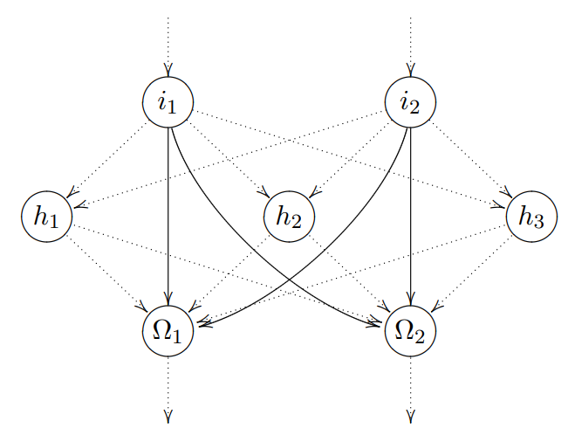

Figure 1 A feedforward network with shortcuts

Some networks allow the neurons to be connected to themselves (direct recurrence) or to the input layer (indirect recurrence): in the first case neurons inhibit and strengthen themselves un order to reach their activation limits; with indirect recurrence, on the other hand, a neuron can indirect forwards connection in order to influence itself.

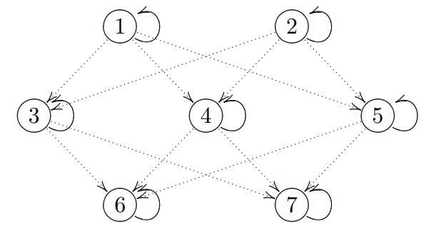

Figure 2 A network containing recurrent nodes

Finally, a completely linked network permits connections between all neuron, except for direct recurrences; furthermore, the connections must be symmetric.

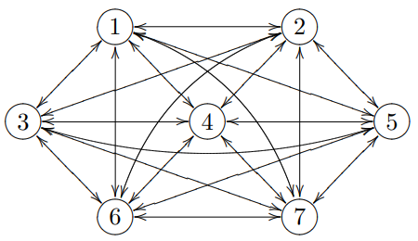

Figure 3 A completely linked neural network

Suitable architectures for Image Recognition are based on variations of Convolutional Neural Networks (CNNs). A CNN is a Deep Learning algorithm which can take an input image, assign importance to various aspects/objects in it (learnable weights and biases) and be able to differentiate one from the other. While in primitive methods filters are hand-engineered, with enough training, CNNs have the ability to learn these filters/characteristics.

The architecture of such a network is analogous to the connectivity patterns of human neurons and was inspired by the organization of the visual cortex, where individual neurons respond to stimuli only in a restricted region of the visual field, known as receptive field; a collection of such fields overlap to cover the entire visual area.

The first part of the CNN consists of convolutional and max-pooling features extractor layers, while the second part consists of the fully connected layer which performs non-linear transformations of the extracted features and acts as the classifier. If the neurons in the convolutional layer find the features they are looking for they produce a high activation.

In image processing, to calculate convolution at a particular location (x, y), a k x k sized chunk, the kernel, is extracted from the image, centred at location (x ,y); the values in this chunk are then multiplied element-by-element with the convolution filter, also sized k x k, and then they are added together to obtain a single output.

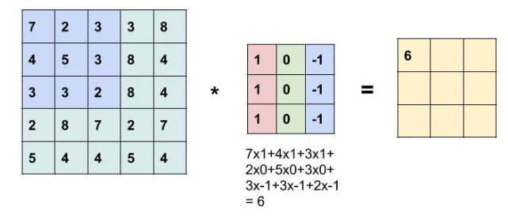

Figure 4 Convolution operation example

Storing an image means keeping track of the color information associated to each individual pixel in a color matrix; the size of each pixel depends on the color depth (8-16-24 bit). Once images reach a notable dimension, calculations can get very intensive, so the role of the CNN is to reduce the images into a form easier to process, without losing features which are critical for prediction sake.

This is achieved by a max pooling layer, which is responsible of reducing the spatial size of the image (not the depth); this reduces the number of parameters, avoiding overfitting, the condition when a trained model learns too much out of the training data and loses the ability to generalize. A common form of pooling is max pooling where a filter of size p is taken and the maximum operation over the sized part of the image is applied.

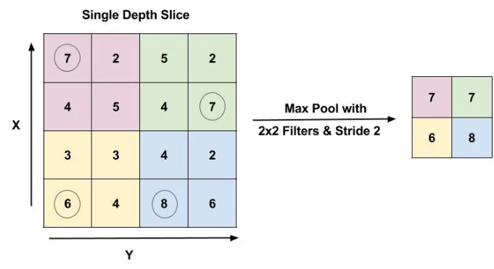

Figure 5 Max pooling example

The fully connected layer is made up of an ANN, which purpose is to combine the detected features into more attributes, in order to predict the classes with greater accuracy.

Many neural network architectures[9] exist for image recognition, including:

* AlexNet: deep neural network winner of the ImageNet classification in 2012; it’s widely credited with sparking a resurgence of interest in using deep convolutional neural networks to solve computer vision problems. The network is relatively large, with over 60 million parameters and many internal connections, thanks to dense layers that make the network quite slow to run in practice.
* VGGNet: network developed by researchers from the Visual Geometry Group (VGG) at Oxford University. VGGNet has more convolution blocks than AlexNet, making it “deeper”, and it comes in 16- and 19-layer varieties, referred to as VGG16 and VGG19, respectively.

## Data science process overview

Image Recognition and Machine Learning in general are both task that heavily rely on data to use for their training process, in order to disambiguate between different possible positive candidates. The following diagram[8] highlights the essentials step of a data science process, starting from the set up of the research goal, all the way to the presentation and automation of the model.

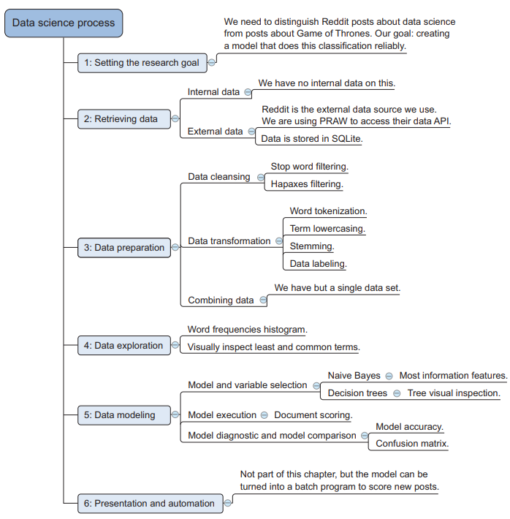

Figure Data science process for an example application

The first step of any data science project is to determine its goal and evaluate it the technology is suitable for the purpose. Once the goal is set, the data source must be identified: this can be internal, such as user generated data, or external, where the data is fetched from an external source (free online databases, websites, …).

Before performing any analysis, some operations on the retrieved data may be performed, since oftentimes data can be quite messy, especially if it wasn’t generated with any particular data science purpose in mind or it wasn’t well maintained during its lifecycle; if the data is textual common operations to perform are word filtering, term lowercasing or labelling; if on the other hand, we are working with images, these are usually rescaled, color-transformed or labelled. Data preparation is the most crucial step required to get correct results. The fourth step is data exploration: once the data is filtered, rescaled or labelled, its sheer size can hinder us from getting a good grip on whether it’s clean enough for actual use; in this step further transformations may be applied. During data modelling, statistical, mathematical and technological knowledge is applied to the data in order to find any possible insight: comparison algorithms or machine learning models are executed on the data and the result is then tested, often with unseen data, and its performance is measured. Finally, the results of the process can either be turned into a useful application or presented to others

# Augmented Reality

## AR Overview

Augmented Reality is a relatively new technology which is focused on the blending of digital elements, such as visual overlays or 3D models and animations, into real-world environments: with the help of advanced AR technologies (e.g. adding computer vision, incorporating AR cameras into smartphone applications and object recognition) the information about the surrounding real world of the user becomes interactive and digitally manipulated. Furthermore, an AR experience can enhance the overall user experience by providing additional stimuli for other sense in addition to visual augmentation: a system can improve the immersivity of an application with augmented sounds, scents and aptic feedbacks.

<<Achieving this connection is an incredible goal, one that draws upon knowledge from many areas of computer science, yet can lead to misconceptions about what AR really is. For example, many people associate the visual combination of virtual and real elements with the special effects in movies. While the computer graphics techniques used in movies may be applicable to AR as well, movies lack one crucial aspect of AR, interactivity.”>>[3]

The most widely accepted formal definition of AR was proposed by R. Azuma in his 1997 paper, “A Survey of Augmented Reality”. According to him, AR must have the following three characteristics:

* Combines real and virtual;
* Interactive in real time;
* Registered in 3D.

A simple AR system requires at least three components: a tracking component, a registration component and a visualization component; the first is the core of the system: it calculates the relative pose of the camera in the scene in real time and enables the system to add virtual components as part of the real scene. A fundamental difference between AR systems and other image processing tools, is that in Augmented Reality virtual objects are in 3D coordinates instead of 2D image coordinates. The registration component… . The visualization component draws the virtual image on top of the camera image; in CG, the virtual scene is projected on an image place using a virtual camera, while in AR a virtual camera, identical to the system’s real camera, is used in order to make the result more convincing.

Compared to Virtual Reality, where the user’s perception of reality is completely based on virtual information, Augmented Reality is considered an example of “Mixed Reality”, since it incorporates both real world and fictional elements. For example, in architecture, VR can be used to create a walk-through simulation of the inside of a new building, while AR can be employed to show a building’s structures and systems super-imposed on a real-life view.

The term “Mixed Reality” was introduced by Paul Milgram in a 1994 publication called “Augmented Reality: A class of displays on the reality-virtuality continuum”; this paper presented the idea that between virtual and real there is a spectrum of different mixtures of both.

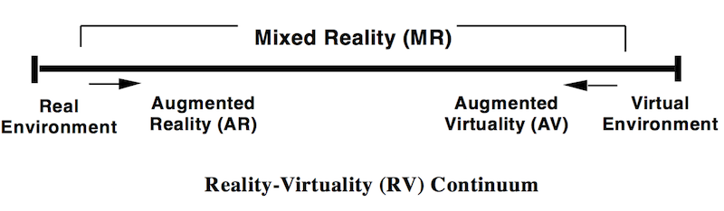

Figure 7 Milgram et al., The Reality-Virtuality Continuum

The term Mixed Reality was introduced as follows:

<<Within this framework it is straightforward to define a generic Mixed Reality (MR) environment as one in which real world and virtual world objects are presented together within a single display, that is, anywhere between the extrema of the RV continuum>> [5].

The first “AR experience” was achieved, to some extent, by a cinematographer called Morton Heilig in 1957: he invented the Sensorama, a machine capable to deliver visuals, sounds, vibrations and smell to the viewer; obviously it wasn’t computer controlled, however it was the first example of an attempt at adding additional depth to a visual experience. The first actual AR system ever built was developed by Louis Rosenberg in 1992 at the USAF Armstrong Labs; it was called Virtual Fixtures and was a complex robotic system, designed to compensate for the lack of high-speed 3D graphics processing power in the early 90s. In order to create the augmented experience, a unique optics configuration was employed that involved a pair of binocular magnifiers aligned so that the user’s view of the robot arms were brought forward so as to appear registered in the same location of the user’s real arms.

Today there are applications available for or being researched for AR in nearly every field, including archaeology, art, medicine, military industry and entertainment; it is expected that even more potential areas of application are soon to be rising. The technology is well suited for on-site visualization both indoor and outdoors, for visual guidance in assembly, maintenance and training; it enables interactive games, social applications and new forms of advertising: in interior design, AR allows users to virtually preview a piece of furniture and test its look in their own living rooms; in assembly, an AR system can guide the assembler through each step, visualizing the relative instructions or its interaction points; finally, in the game industry, where accuracy is less critical than in the medical or military industry, AR can make games more attractive by providing new mechanisms of interaction between the player and the game. Although some impressive milestones and goals have been reached in recent years, due to the technology still being relatively young, a lot of areas still require further research before the employment of highly reliable AR systems, especially in fields where the precision of the tracking systems is crucial.

## AR hardware and tracking methods

<<In Augmented Reality, virtual objects supplement rather than supplant the real world. Preserving the illusion that the two coexist requires proper alignment and registration of the virtual objects to the real world. Even tiny errors in registration are easily detectable by the human visual system>>[6].

This contributes to the identification of a key measurement for AR systems: how realistically they integrate augmentations with the real world: such a system must be able to derive real world coordinates, independently of the camera used to move through the scene, and interpret the semantic context of the environment; all of this must happen in real time in order to allow interaction.

Traditional motion tracking devices can be classified based on the technologies used for the measurements: mechanicals, electromagnetic, optic, acoustic and inertial; these can be classified based on a series of reference parameters:

* Work volume: the physical region of space in which the tracking device works reliably;
* Sampling rate: the rate at which the device detects and updates variables in the environment;
* Resolution: the smallest position variation detected.
* Latency: the time slot between an event and its recognition;
* Precision of the device.

Mechanical tracking systems are arm-based systems that use potentiometers or optic encoders to measure the rotation of the connecting pins of the connecting rods. Once the angles of each joint and the length of the chain rods kinematics are known it’s possible to easily calculate the position of the object to track. These systems are relatively cheap and completely latency-free, due to the lack of a transmission-reception component; however, their work volume is usually small, and the movable parts are subject to usury.

Electromagnetic systems are based on the usage of a transmitter and a receiver: the transmitter generates a floating magnetic field by means of three orthogonal spires; this field is detected by three similar spires in the receiver component and the variations in the strength of the signal is interpreted as a variation of the position of the object which is being tracked. These devices are relatively small and can be easily installed on the user’s body or on other small objects and, although the work volume isn’t quite big, its possible to increase it by chaining different devices together. Interferences from other electronic devices are the main disadvantage of using such a system

Optical tracking systems are highly accurate, however they present high complexity and costs as well; they work by using a series of light sources (usually infrared), placed on the object of interest and employing cameras to detect their movements.

In acoustic-based tracking an emitter generates an audio signal which is picked up by a microphone, measuring the time necessary to the sound to traverse the path. Data from three devices is processed and used to calculate the position and the orientation of the object. The technology is cheap, however the speed of sound variates with weather conditions such as pression and temperature, making the system unreliable.

Inertial systems use gyroscopes to measure changes in the rotation of the object along one or multiple axes.

Later, the concept of user movement tracking drastically changes, as researchers in various fields, such as computer vision and robotics, have developed a series of different tracking techniques, which can be classified, based on the equipment used, into visual tracking methods and hybrid methods. In visual tracking, the system deduces the camera pose based on observations of the scene; this is considerably hard in an unknown environment since it requires effort to collect enough data to detect the pose, which will still fluctuate over time. A simple solution to overcome this obstacle is to add an easily recognizable element in the environment. This element is called marker and is a sign or an image built in such a way to be recognized by a computer system, via image processing, pattern recognition and computer vision techniques, and then used as a reference point in a scene.

Other approaches for visual tracking are feature-based and model-based methods; in model-based tracking, the system has a model of the scene or part of the scene and what happens is essentially a comparison between the visual observations and the model, from which a best match is found to define the pose of the camera, while in feature-based tracking the system detects optical features in the images and learns the environment based on observations of movements between frames.

In order to be easily and reliably detectable under all circumstances, a marker must follow specific constraints:

* It must be perfectly squared, with well-defined proportions.
* The external borders must be well defined and continuous;
* The inner image must be completely asymmetric, so that different orientations cannot cause any ambiguity.
* Different markers must be as loosely coupled as possible; this way, when the camera is far away from the image, which is represented by fewer pixels the greater the distance, it is still possible to distinguish it.

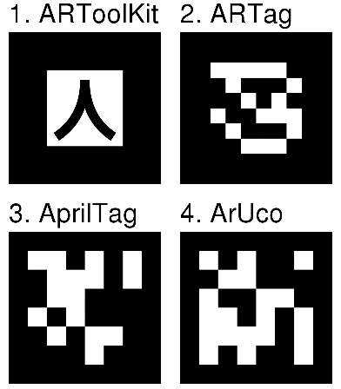

Figure 8 Comparison of some augmented reality fiducial markers for computer vision, ARTag, Wikipedia

In “Theory and applications of marker-based augmented reality”[7], S. Siltanen describes the basic marker detection procedure as a series of steps:

1. Image acquisition

* acquisition of an intensity image.

1. Preprocessing

* low level image processing
* undistortion
* line detection/line fitting

1. Detection of potential markers and discard of obvious non-markers

* fast rejection of obvious non-markers
* fast acceptance test for potential markers

1. Detection and decoding of markers

* template matching (template markers)
* decoding (data markers)

1. Calculation of the marker pose

* estimation of marker pose
* iterative pose calculation for accurate pose

The image acquisition step is actually a separate process and just provides the image for the marker detection procedure.

Before the actual detection of the marker, the system must obtain an intensity image (a grayscale image). If the capture image format is something else, the system converts it. The first task of the marker detection process is to find the boundaries of the potential marker. Two approaches are used by detection systems to achieve this: either they first threshold an image and search for markers from the binary image, or they detect edges from a grayscale image. In traditional offline computer vision applications, the captured image is undistorted using the inverse distortion function calculated during the camera calibration process; in AR, systems typically undistort only the locations of feature points in order to speed up the system. Applications use several methods for line detection, line fitting and line sorting: methods based on edge sorting are generally robust against partial occlusion, but their computational cost is more expensive, which makes them unsuitable for mobile devices.

Since time is of the essence in AR applications, many implementations use fast calculable acceptance/rejection criteria to distinguish real markers from objects that are clearly something else. First, The histogram of a black and white marker is bipolar, and the marker detection system may check the bipolarity as a fast acceptance/rejection criterion, however eventual reflection may creates grey scale values, which are to be considered. Calculating the number of pixels belonging to the perimeter is a very fast process, and a system can carry it out as part of the labelling process, whereas calculating the exact size of the object is more complicated and time consuming. Therefore, it is rational to estimate the size of an object using the number of edge pixels, for example. Another useful technique used when the system has information about the overall appearance of the marker, which contain a small known number of holes (white areas) is to calculate the number of said holes and use it as an acceptance/rejection criterion during pre-processing.

The pose of an object refers to its location and orientation: the location can be expressed with three translation coordinates, (*x*, *y*, *z*), while the orientation can be represented as three rotation angles, (*α*, *β*, *γ*). Since the pose of a calibrated camera can be uniquely determined from a minimum of four coplanar but non-collinear points, a system can calculate a marker’s pose, relative to the camera using the four corner points of the marker in image coordinates. A few complications take place during the pose calculation process: the detection of x and y translations is more reliable than the detection of z translation. The camera geometry explains this. If an object moves a certain distance in the z direction, the corresponding movement on the image plane is much smaller that if it moves the same distance in the x or y direction. Vice versa: small detection errors on the image plane have a greater effect on the z component of the translation vector than on x and y components. In addition, the pose of a marker seen from the front is more uncertain than a pose of a marker seen from an oblique angle.

By using the marker-based approach, tracking becomes possible as long as the marker is in the camera’s field of view; additionally, any eventual noise in the camera stream can impact on the detection of the only marker in the scene. Some workarounds exist for these limitations such as the multi-marker approach, where a cluster of markers is used to allow for a freer camera movement in the scene. With this method, the detection is more fault tolerant, since a detection error on one of the markers, caused by camera noise or lighting conditions, can be corrected by using the other markers.

Since the usage of markers is not always possible due to physical limitations, and with the recent emergence of advanced camera systems and more precise sensors in mainstream devices, markerless AR solutions have become an industry preference.

The technique requires little to no environment preparation, however the tracking itself becomes much more complicated; it uses a combination of camera systems, dedicated sensors and complex math to effectively detect and map the real-world environment; after obtaining a map of the area, the AR application makes it possible to place and track the virtual objects without the need of any marker in the scene. With this approach, tracking works great in most of the cases, but becomes a problem when the target surface is not easily identifiable or has no distinctive texture, since not many features can be extracted from it.

Markerless AR has recently seen its biggest impact in the gaming industry, with the AR-enabled Pokemon Go becoming a git in 2016, but fields such as advertising and education have seen a rise in AR-focused applications in the recent years as well.

Both technologies show advantages and limitations; for this reason, hybrid tracking techniques also exist: the combined usage of a multi-marker system and hardware such as gyroscopes and accelerometers which calculate and predict the user’s movements, allows to compensate for tracking errors when detection fails.

# Application Overview

CiceroAR aims to deliver an enhanced educational experience through the usage of Augmented Reality and Artificial Intelligence technology, in order to provide the user with additional information about a painting or help visually impaired people receive auditive aid. Anyone with a supported device can come across new ways to appreciate art and even discover new details in an evocative piece.

The following UML activity diagram aims to provide an initial high-level understanding of the system’s typical flow of events.

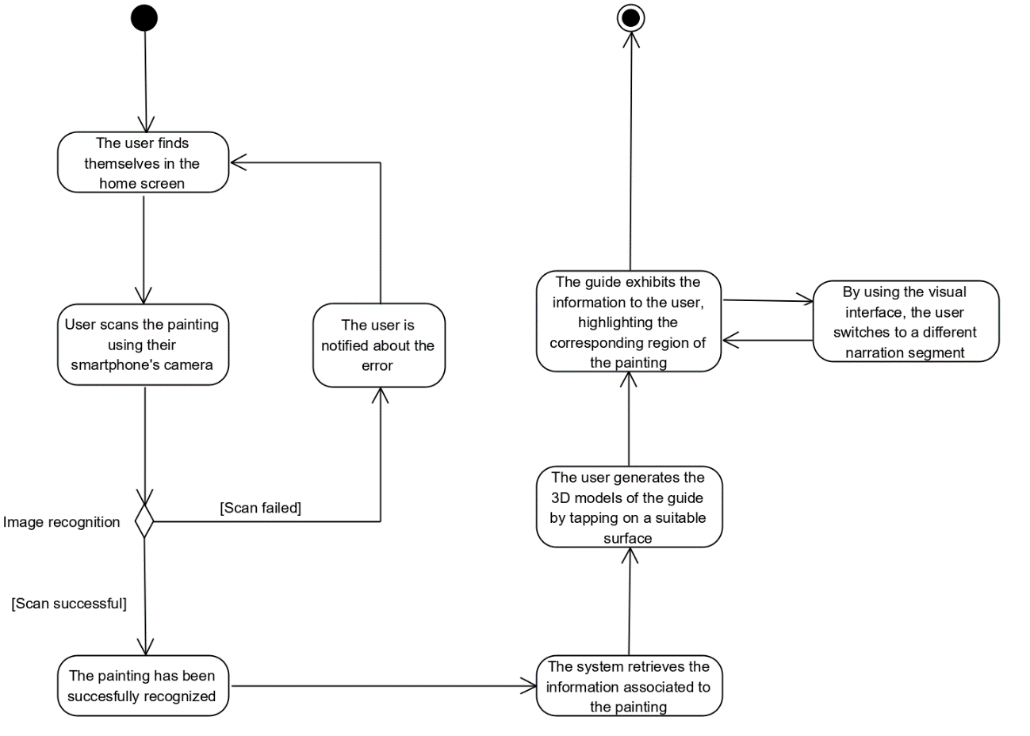

Figure 1 UML activity diagram depicting the interaction between a user and the system.

After launching the application, a user will have the ability to scan a painting by using their smartphone’s integrated camera; if the image is recognized, the system will then lookup its associated information and generate a virtual guide using AR. The guide will begin interacting with the user via Text-To-Speech technology, by narrating the details of the painting, while projecting them forward in the augmented environment. At any time during the narration, the user can pause, resume and navigate to the previous and next segments.

## Requirements

The system aims to achieve the following goals:

* Enhance the educational experience for students and art enthusiasts.
* Create a more interactive alternative to traditional museum guides.
* Aid visually impaired people experience art.

Functional requirements:

* **FR_1**: The system must allow the user to scan a painting with the smartphone’s integrated camera and identify it.
* **FR_2**: The system must be able to retrieve the information associated to a scanned painting.
* **FR_3**: The system must be able to project an augmented reality guide in the environment.
* **FR_4**: The system must be able to highlight the details on the painting by using Augmented Reality.
* **FR_5**: The system must utilize Text-To-Speech technology when providing the user with the requested information.
* **FR_7**: The system must allow an administrator to add a new painting and its related information to the archive.

Non-functional requirements:

* **NFR_U1**: The system’s interface must be easy to use and not ambiguous.
* **NFR_U2**: The system must ensure operations are performed in the most direct way available.
* **NFR_R1**: The information provided by the system must always be reliable and consistent.
* **NFR_R2**: The system must ensure any error message is delivered to the user in less than 3 seconds.
* **NFR_P1**: System response time must not exceed 3s when performing recognition operations.
* **NFR_P2**: The recognition component must not exceed the threshold of x occurrences per month.
* **NFR_S1**: The system must include an exhaustive documentation, in order to more easily support maintenance.

In order to illustrate the usage of the application at a very high abstraction level, a series of scenarios have been crafted; these highlight the sequence of action performed by different kinds of users in different environments, when the system is operational.

Each scenario is characterized by a name, a unique identifier, its participants and the flow of actions that make up the usage example.

This first scenario depicts the most expected use of the application: scanning a painting when visiting a museum.

|  |  |
| --- | --- |
| **Scenario name** | MuseumUsage |
| **Scenario ID** | SC_1 |
| **Participants** | Ann: art student visiting the Salvador Dalí Museum in Figueres with her class. |
| **Flow of events** | 1. Ann is wandering into the halls of the museum when a particular piece catches her eye, Palladio’s Corridor of Thalia, so she gets closer and starts examinating it. 2. The girl isn’t satisfied with the little information provided by the plate next to the painting and wants to know more. 3. Ellie, one of Ann’s classmates suggests her CiceroAR, to quench her thirst for more details. 4. Ann decides to give it a try, so she downloads the app and, after reading the manual, tries to scan the painting using her smartphone. 5. The system recognizes the painting and proceeds to generate an interactive talking head of the artist, in the space in front of Ann, using AR. 6. The artist then begins to narrate the story of the painting to Ann, in particular he tells Ann how the piece is heavily influenced by Italian Renaissance art. 7. Moving to the painting itself, the guide starts to speak about the strongly lit figure of a girl playing with a skipping rope in the top left, while the corresponding region is projected towards her in the virtual environment. |

|  |  |
| --- | --- |
| **Scenario name** | HomeUsage |
| **Scenario ID** | SC_2 |
| **Participants** | Frank: art enthusiast working from home during quarantine. |
| **Flow of events** | 1. After being stuck at home for more than three weeks, Frank decides to go through his old photo books. 2. While browsing the pages, the man notices a picture of him next to “The Bedroom” by Vincent Van Gogh, snapped during a trip some years ago. 3. Frank decides to use CiceroAR to try and get more info on the painting in the picture, so using his phone he scans it. 4. The system correctly recognizes it and proceeds to generate the guide, which then begins the narration process. |

This scenario highlights an use case that, while not frequent as the others, is just as important for the accessibility of the application: the usage of the system by a visually impaired man.

|  |  |
| --- | --- |
| **Scenario name** | AidedUsage |
| **Scenario ID** | SC_3 |
| **Participants** | : visually impaired art lover. |
| **Flow of events** | By using the Text-To-Speech functionalities, … can experience the details of the piece. |

## Use case model

From the identified scenarios a more formal use case model has been constructed: this provides a series of use cases performed by the different users of the system, along with the flow of events which … during its execution. Two actors have been identified during this phase: a generic user of the system and an administrator; the

. The only additional task performed by the administrator is the management of the system’s data, with possibility to add, remove or update a new painting and its information. Further boundary use cases will be later discussed, after introducing the system’s architecture.

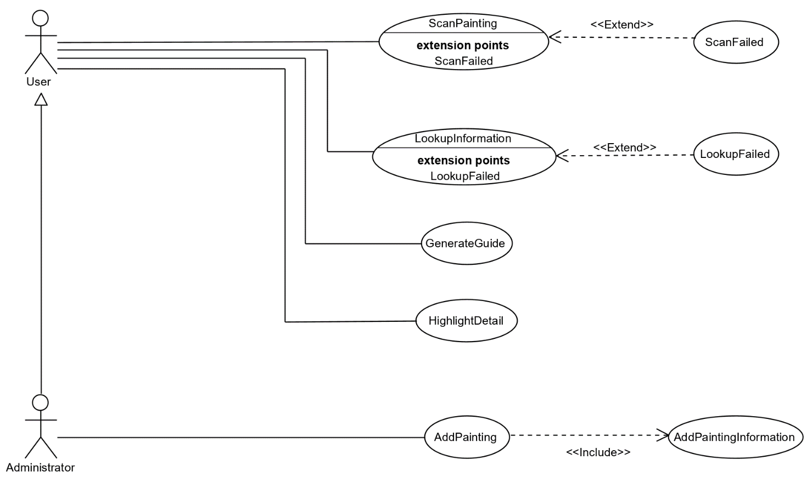

Figure 2 UML Use Case Diagram of the system

|  |  |
| --- | --- |
| **Use case name** | ScanPainting |
| **Use case ID** | UC_1 |
| **Participating actors** | User |
| **Preconditions** | 1. The user finds themselves in the home screen |
| **Flow of events** | 1. The user points the camera towards the painting. 2. The system begins looking for a match of the painting. |
| **Postconditions** | The scanning process was successful and the user is waiting for the system to lookup the associated information. |
| **Exceptions** | * 1. The system cannot find any match for the painting   (Use case “ScanFailed” – UC_1.1). |

|  |  |
| --- | --- |
| **Use case name** | ScanFailed |
| **Use case ID** | UC_1.1 |
| **Participating actors** | User |
| **Preconditions** | The system cannot find any match for a painting. |
| **Flow of events** | 1. The system notifies the user about the error. |
| **Postconditions** | The user is redirect in the home screen of the application. |

|  |  |
| --- | --- |
| **Use case name** | LookupInformation |
| **Use case ID** | UC_2 |
| **Participating actors** | User |
| **Preconditions** | A painting has been successfully scanned and the user is waiting for the system to lookup the associated information. |
| **Flow of events** | 1. The system retrieves the painting information in its internal archive. |
| **Postconditions** | The system is able to retrieve the requested information. |
| **Exceptions** | * 1. The system cannot find any information for the matched painting   (Use case “LookupFailed” – UC_2.1). |

|  |  |
| --- | --- |
| **Use case name** | LookupFailed |
| **Use case ID** | UC_2.1 |
| **Participating actors** | User |
| **Preconditions** | The system cannot find the information associated to a scanned painting. |
| **Flow of events** | 1. The system notifies the user about the error. |
| **Postconditions** | The user is redirect in the home screen of the application. |

|  |  |
| --- | --- |
| **Use case name** | GenerateGuide |
| **Use case ID** | UC_3 |
| **Participating actors** | User |
| **Preconditions** | User has scanned a painting and the system has correctly recognized it and has retrieved its associated information. |
| **Flow of events** | 1. Based on the scanned painting’s author, the system retrieves the 3D model of the guide to display and projects it in the space pointed by the user. |
| **Postconditions** | The 3D guide has been successfully generated in the application. |

|  |  |
| --- | --- |
| **Use case name** | HighlightDetail |
| **Use case ID** | UC_4 |
| **Participating actors** | User |
| **Preconditions** | The system has generated the virtual guide for a painting. |
| **Flow of events** | 1. The guide mentions a region of the painting. 2. The system highlights that region. |
| **Postconditions** | The virtual copy of the painting has been successfully generated in the application. |

|  |  |
| --- | --- |
| **Use case name** | AddPainting |
| **Use case ID** | UC_5 |
| **Participating actors** | Administrator |
| **Preconditions** | The administrator requests the form to add a new painting. |
| **Flow of events** | 1. The admininistrator compiles the form with the painting image and the information associated to the it (Use Case “AddPaintingInformation” – UC_6) |
| **Postconditions** | The new painting has benn successfully added to the archive and will now be recognized when scanned. |

|  |  |
| --- | --- |
| **Use case name** | AddPaintingInformation |
| **Use case ID** | UC_6 |
| **Participating actors** | Administrator |
| **Preconditions** | An administrator is adding a new painting to the archive |
| **Flow of events** |  |
| **Postconditions** | The |

## User interface mock-ups

According to both the identified requirements and the use case model, a first user interface prototype has been constructed: three main windows provide the system with the most essential functionalities.

The first window acts as the homescreen of the application: it contains a banner image and a button to start the device’s camera. The second window is used by the system to capture and process the image (in the background).

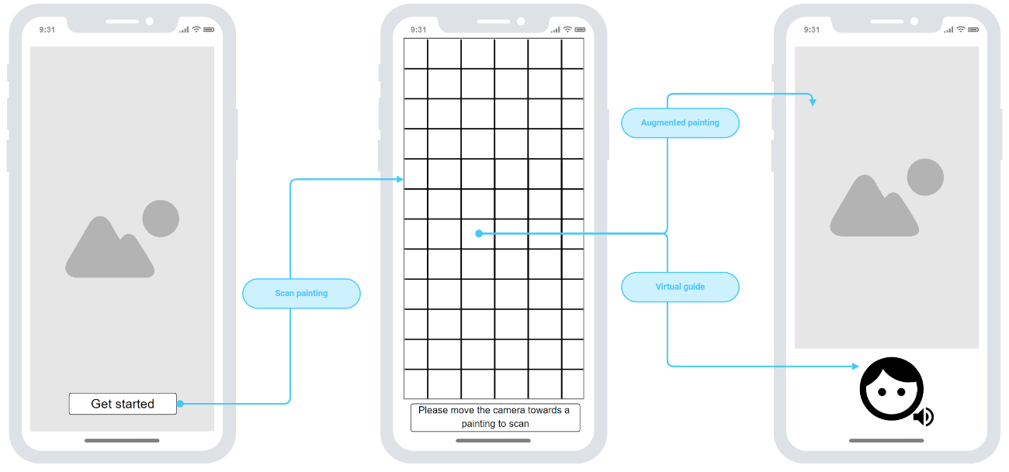

A second, refined, version of the UI includes a preview of the captured image, along with the options for the user to process it or cancel the operation. The first two windows are the same, but we felt like the user should have more control over the image processing steps, so the addition of a fourth window, where the captured image is previewed, fulfils this purpose, allowing the user to cancel the operation or manually initiate the image processing.

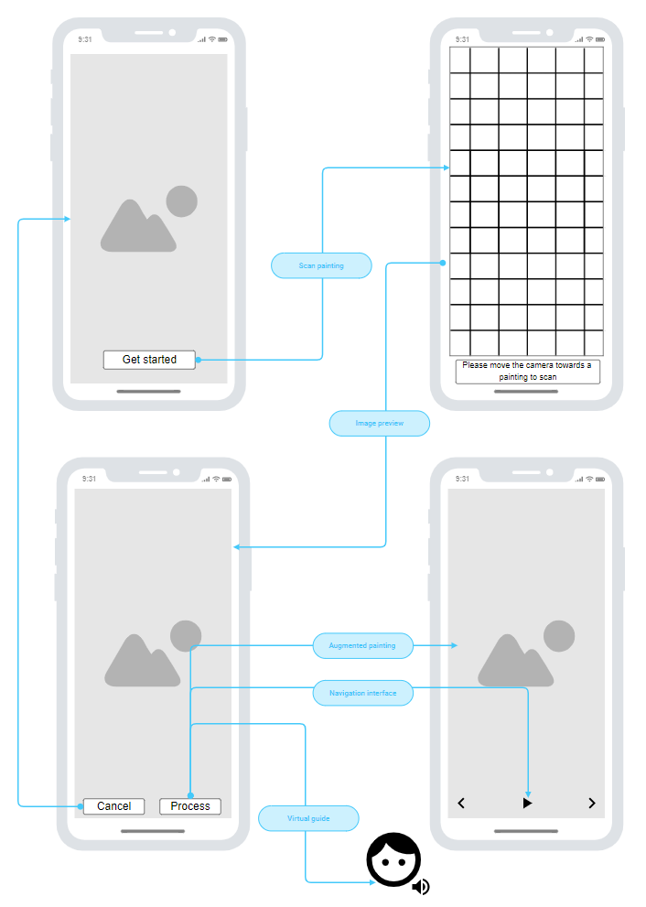

# Application design

## Architecture overview

Following the initial requirements analysis, a set of design goals for the application has been identified; these will act as guidelines during the development, in order to ensure the implementation will not shift away from its original design views.

* **DG_01: Accessibility**: Ensuring the application is targeted towards a wide spectrum of users is a high priority;
* **DG_02: Reliability**: The information provided by the system must always be reliable;
* **DG_03: Usability**: The application’s user interface must be simple and friendly to newcomers.

At the hardware level, a distinction between three devices is made: the user’s smartphones acts as the client side of the application: the Image component encapsulates the camera control and the network functionalities, while the AR Narration component is where the actual narration of the painting takes place.

On one of the web hosts, the Node.js server acts as a middle-ground between the client and the image recognition component. The Node API component manages the network requests, while the Database component handles the persistent information associated to each painting.

On the second web host, a REST API, realized via the djangoRestFramework module, is used to interface the Django AI server with the Node server. Here the neural network is encapsulated in the ImageDetector component, in its own class which provides the methods necessary to run a pre-trained inference graph on the received image and output a title and a confidence score. If this confidence score, expressed as the probability of a specific painting being present in the scene, is greater than a pre-set threshold, a positive feedback is sent back to the Node server.

The two web servers could potentially be deployed onto the same machine; the reason they have been implemented as two distinct entities is just to keep a logic separation between the components.

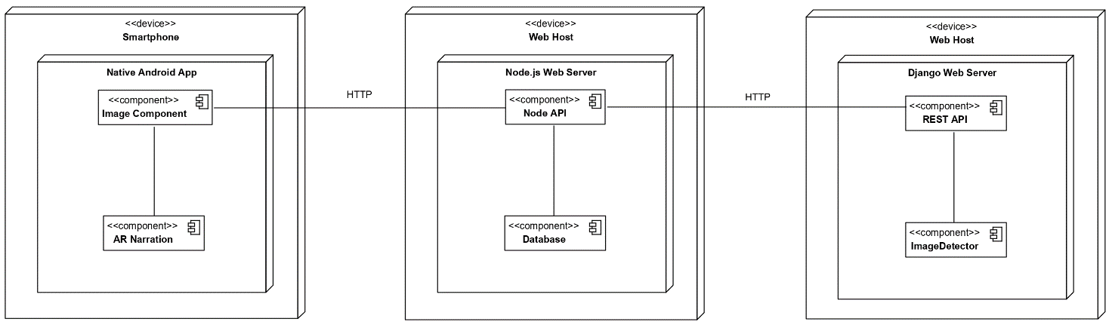

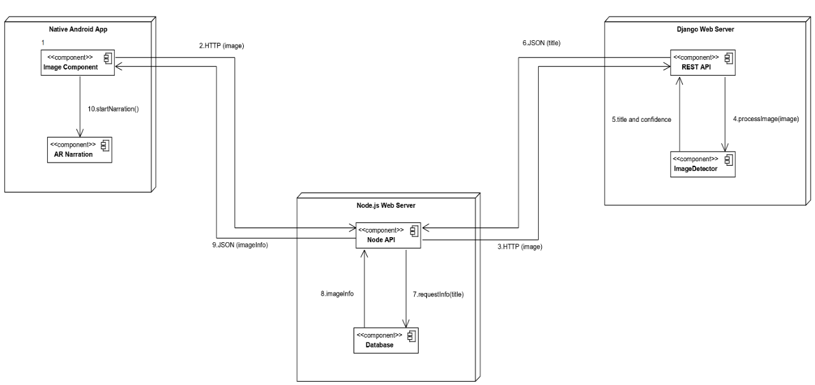

Here a list of steps illustrating the processing of the image is presented:

1. User starts up the application and captures and image with the smartphone’s integrated camera.
2. The captured image is sent to the Node.js server, using an HTTP multipart form-data request.
3. Once received, the image is forwarded from the Node API to Django server, via the exposed REST API.
4. The Django server receives the image and processes it via the underlying neural network, in the ImageDetector component.
5. A title and a confidence score are output for the received image by the neural network. It then passes it to the REST API component.
6. Response is then sent back to the Node.js server as a JSON object containing the two fields.
7. The Node.js server retrieves the information associated to the identified painting from a MongoDB relational database.
8. Any retrieved information is sent to the Node API component.
9. The information is sent back to the Android client.
10. The control is finally sent to the AR Component, which proceeds with the narration of the painting.

## Android client

This section is dedicated to the client side of the system, a native Android application written in Java;

### ARCore

The AR functionalities are provided by the ARCore SDK, Google’s AR solution. By using various APIs, it allows smartphones to detect the surrounding environment, understand the world and interact with its information; ARCore is based on three key technologies to integrate the virtual content into the real world, as seen through the smartphone’s camera:

* Six degrees of freedom allows the device to understand and track its position relative to the world;
* With environmental understanding, the device can detect the size and location of surfaces;
* Light estimation allows the device to estimate the environment’s current lighting conditions.

ARCore calculates position and orientation of a device by detecting feature points in the captured images; the AR application looks for clusters of feature points to lie on common horizontal or vertical surfaces, and identifies them as planes, making them available to the application; it also defines each plane’s information, which can be used to place virtual objects on flat surfaces. Another useful feature offered by this SDK is lighting estimation: based on the lighting of the camera image’s environment, ARCore can light up objects accordingly and strengthen the overall augmented experience. Once a virtual object has been placed, the user can move the camera around it or away from it without affecting its tracking.

One of the main limitations of the library, and of markerless AR in general, is the difficulty of tracking a texture-less surface, such as a blank white wall; for this reason, the augmented images projected in the scene are anchored on top of the painting, which is tracked by the native ARCore AugmentedImage component, after being recognized.

### Sceneform

When it comes to the handling of the 3D environment, the choice was between a fully-fledged game engine, like Unity or Unreal Engine, and an external Android library, such as Google’s Sceneform. We decided for the latter, since this allowed us to keep a higher control over the whole application development; furthermore, this would make future maintenance or additions easier. Sceneform makes it straightforward to render 3D scenes into AR and non-AR applications, without having to learn OpenGL; it includes:

* A high-level scene graph API;
* A realistic physically based rendered provided by Filament;
* An Android Studio plugin for importing, viewing and building 3D assets.

### Painting information

After receiving from the Node.js server a JSON file containing the painting information, along with the resource urls, the system must download the images corresponding to each description fragment. In order to not block the main UI thread, this operation is performed asynchronously in the background, by a singleton class, SingletonAsyncDownloadTask. Singleton is a creational design pattern, which ensures only one object of a class can exist at any time and provides a unique access point to it for any other object; in the context of our application, the ImagePreviewActivity class creates the unique instance after receiving the respone from the server and starts up the download process. Once the narration begins, the ArActivity class accesses the previously created instance and retrieves the downloaded data, before using it to display the images in the scene.

### Text-To-Speech

In order to handle the Text-To-Speech narration, the integrated android.speech.tts module has been used; since each TTS utterance is executed asynchronously, the narration works by setting up a custom UtteranceProgressListener for the TTS object and using two handlers to receive messages from the its thread during the utterance life cycle. The reason why the messaging is necessary in the first place, is because all operations influencing the augmented elements of the scene must be performed on the main thread on which the application is running.

The first handler, onTtsStartHandler, receives a message as soon as the speak() method on the TextToSpeech object has been called: it proceeds to generate the image corresponding to the segment which is being narrated and animates it forward in the environment. The second handler, onTtsDoneHandler, receives a message when an utterance has been successfully completed, without any errors, and it destroys the previously generated image node in the scene.

In order to provide a better user experience, we decided to implement user interface functionalities to navigate through the narration; these include a pause/resume button and two buttons to move to the previous and next narration segments. Since the native TTS module doesn’t provide any pause functionalities we found ourselves with two main alternatives:

1. Make the TTS object record the narration to an audio file, using the native synthesizeToFile() method, and then use a MediaPlayer object to control the narration;
2. On resume, make the narration start from the beginning of the current segment.

By using the first approach any future implementation of any kind of interaction mechanism would require a reengineering of the speech context. We decided to proceed with the second approach, by carefully dividing the segments into smaller, independent parts.

### Packages and classes

CiceroAR

│

├───activities

│ ├───MainActivity

│ ├───ImagePreviewActivity

│ └───ArActivity

│

├───painting

│ ├───Painting

│ └───PaintingDetail

│

├───texttospeech

│ ├───TextToSpeechManager

│ └───CustomUtteranceProgressListener

│

├───network

│ ├───SingletonAsyncDownloadTask

│ ├───UploadAPI

│ └───UploadHandler

│

└───CustomArFragment

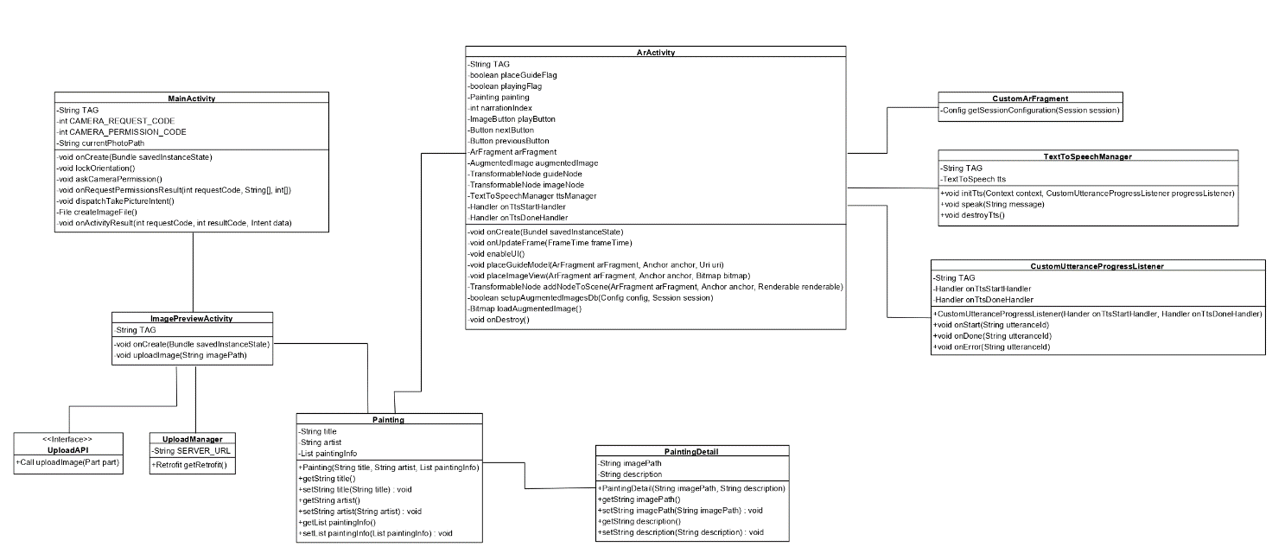

The activities package includes the three Android activities composing the application; each of this is paired with an XML layout file, in which the UI and its styling attributes are specified.

The MainActivity class provides the homescreen functionalities and the access to the camera component.

The ImagePreviewActivity class is used to display to the user the preview of the captured image and handle its upload.

## Node.js Server

External modules used:

* **cors:** Cross-Origin Resource Sharing authorization;
* **express:**
* **multer:** storage;
* **mongodb:** database access;
* **fs:** file system access;
* **request :** request forwarding.

### NoSQL and MongoDB

In NoSQL databases, data is not stored in the traditional tabular relations used in relational databases; such systems may still support SQL-like query languages or sit alongside SQL databases and for this reason the technology is often referred to as “Not only SQL”. The main motivation behind this approach, which is seeing an increased usage in big data and real-time web applications, includes simplicity of the design, simpler “horizontal” scaling to clusters of machines, finer control over avaliability and limiting the object-relational impendance mismatch ; the data stuctures used in NoSQL databases are different from those used by default in relational databases, making some operations faster in NoSQL. In distribuited contexts, a NoSQL database offers a concept of “eventual consistency”, in which database changes are propagated to all nodes “eventually”, so queries for data might not return updated data immediately; this compromise in consistency is made in favor of avaliability, partition olerance and speed.

MongoDB is one of the most widely used NoSQL databases; its data storage is based on JSON-like documents with optional schemas

Example of a JSON data-entry/response in CiceroAR:

{

“artist” : “Sandro Botticelli”,

“title” : “Venere”,

“paintingDetails” : [

{

“imagePath” : null,

“description”: “The main focus of the composition…”

},

{

“imagePath” : “http://localhost:8080/paintings/Venere/Venus.jpg”,

“description”: “The goddess is standing on a giant scallop shell…”

},

{

“imagePath” : “http://localhost:8080/paintings/Venere/Shell.jpg”,

“description”: ”You may wonder why Venus is standing on a shell…”

},

{

“imagePath” : “http://localhost:8080/paintings/Venere/Zephyrus.jpg”,

“description”: “In the top left of the piece we can notice Zephyrus…”

},

{

“imagePath” : “http://localhost:8080/paintings/Venere/Zephyrus.jpg”,

“description”: ” The Hora herself might be a complementary version of…”

}

]

}

## Django Server

In this last section dedicated to the main components of the application, we provide an in-depth overview of the Django AI server.

### Django

To provide the network functionalities necessary to interface the Node.js server to the Image Recognition component, we used Django and the djangoRestFramework module.

Django

### TensorFlow

TensorFlow is an open source platform for machine learning developed by Google’s Brain team. It provides a comprehensive, flexible ecosystem of tools, libraries and community resources that lets researchers push the state-of-the-art in ML.

## Case study

“The Birth of Venus”, by Italian renaissance artist Sandro Botticelli was chosen as a case study for the experimentation of the application; such a piece lends itself perfectly to the purpose, given the rich history that characterizes it and the clear spatial separations of characters and elements in the scene depicted.

### Painting analysis

Here we provided the analysis of the painting used for the augmented narration.

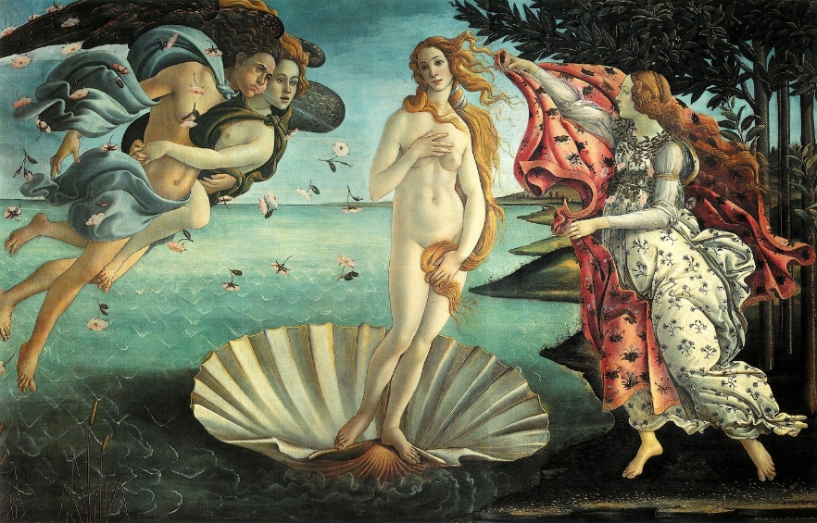

Figure 3 The birth of Venus - Sandro Botticelli

The main focus of the composition is the goddess of love and beauty, Venus, born by the sea spray and blown on the island of Cyprus by the winds, Zephyr and, perhaps, Aura. She is met by a young woman, sometimes identified as the Hora of Spring, who holds a cloak covered in flowers, ready to cover her. A detail often overlooked is the lack of shadows in the scene; according to some interpretations, the … is set in an alternative reality, still very similar to our own.

The goddess is standing on a giant scallop shell, as pure and perfect as a pearl. She covers her nakedness with long, blond hair, which has reflections of light from the fact it has been gilded. The fine modelling and white flesh colour give her the appearance of a statue, an impression fortified by her stance, which is very similar to the Venus Pudica, an ancient statue of the greek-roman period.

You may wonder why Venus is standing on a shell; the story goes that the God Uranus had a son named Chronus, who overthrew his father and threw his genitals into the sea; this caused the water to be fertilised, and thus the goddess was born.

In the top left of the piece we can notice Zephyrus, god of the winds; he is holding Aura, personification of a light breeze. The two are highlighting the pale face of the goddess, while blowing the shell towards the coast.

Regarding Aura, some scholars are in doubt about her identity; she may in fact be Chloris a nymph which married Zephyrus in an alternative story.

The Hora herself may be a complementary version of the nymph Chloris. Are they two versions of the same person then? It might be; the story of this woman is narrated in “I Fasti” by latin author Ovidio and the painted in “The Spring”, by Botticelli himself, where the woman gets kidnapped by Zephyrus to become a mystical figure. The theory is quite farfetched, however there’s a detail in its favour: the roses falling around her and Zephyrus.

### Data Science Process

Following the schema of the Data Science Process from Chapter 1.1.1, we will be presenting the steps we followed during the construction of CiceroAR’s training image dataset: firstly, the goal we set was obviously to recognize a particular painting in an image, with an acceptable accuracy; the data used to train the network came from a mixture of internal and external sources: we used part of a larger painting dataset from Kaggle.com, a website used for machine learning projects and competitions, and we snapped a series of picture containing the painting from a book and a poster in different lighting conditions and from different angles.

The images were prepared using a labelling tool, LabelImg, used to identify the regions of the images that contained the painting by drawing a rectangle around them; the tool then output an xml file for each one, containing the coordinates. The only transformation applied to the images was a rescaling to a resolution of 800x600 pixels, in order to speed up the training process.

# Conclusions

Although this work has been focused on the recognition of two-dimensional pictorial pieces and the narration of their history and details, with few modifications the system could be able to operate on three-dimensional artefacts. The most noticeable difference would be the method used to position the augmented elements in the scene: since the AugmentedImage module of ARCore, used to find the image in the scene after it has been recognized by the AI server, can only track 2D images, a different anchor point is necessary to place the eventual images and models during the narration of a 3D piece.

When it comes to the neural network, a 3D object would make the training process considerably easier, assuming that it would be possible to create a dataset made up of images taken from different angles, an operation not quite possible with 2D images.

…

In order to further expand the accessibility and the taget of the application, other narration opions could be implemented, such as subtitles or some interaction mechanism beween the user ad the virtual guide. The realized software, following an appropriate reengineering, could also be integrated as a service into other systems: a museum application, for example, could provide the use of the system following the purchase of a ticket or as a reference for specific targeted tours.

# Bibliography

[1] R. Szeliski, Computer Vision: Algorithms and Applications, Springer, 2010

[2] D. Kriesel, A Brief Introduction to Neural Networks, 2005 , p38

[3] D. Schmalstieg, T. Höllerer, Augmented Reality: Principles and Practices, 2016

[4] R.Azuma, A Survey of Augmented Reality, 1997

[5] P. Milgram, Augmented Reality: A class of displays on the reality-virtuality, 1994

[6] R. Azuma. Tracking requirements for augmented reality. Communications of the ACM, 36(7):50-51, 1993

[7] S. Siltanen, Theory and applications of marker-based augmented reality, 2012

[8] D. Cielen, A. D. B. Meysman, M. Ali, Introducing Data Science: Gib data, machine learning, and more, using Python tool, Manning, 2016, p. 233

[9] Fritz AI, Image Recognition Guide, <https://www.fritz.ai/image-recognition/>