The following are my solutions to the assignments in Lab03:
2. Method overloading:
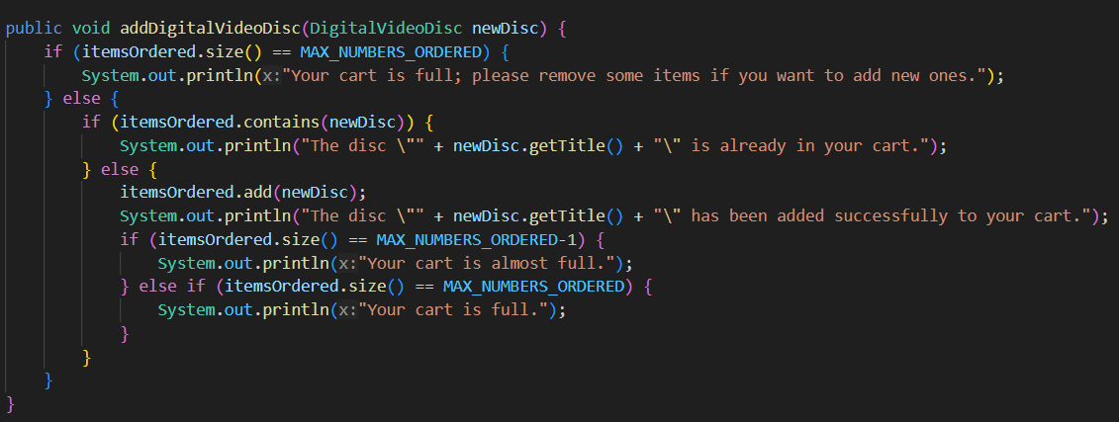
Fig. 2.1: method already coded in Lab02
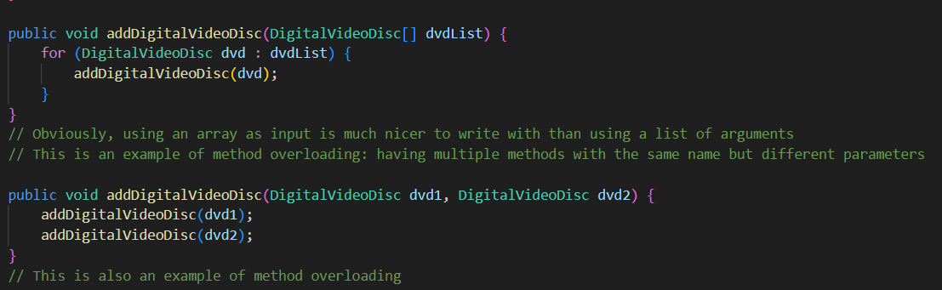
Fig. 2.2: Methods newly created in Lab03

3. Passing Parameter:
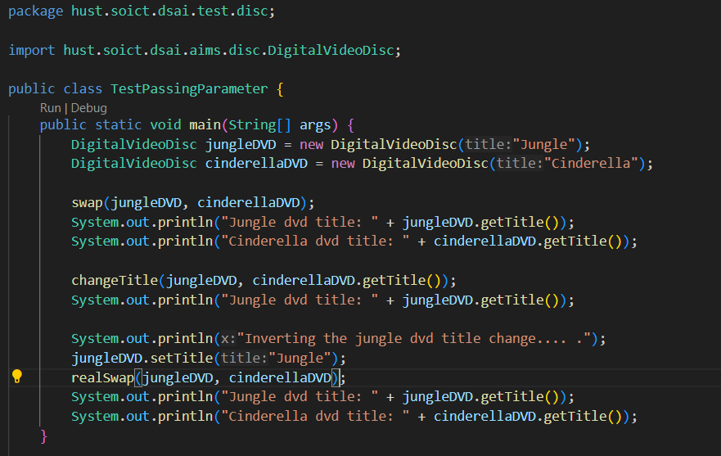
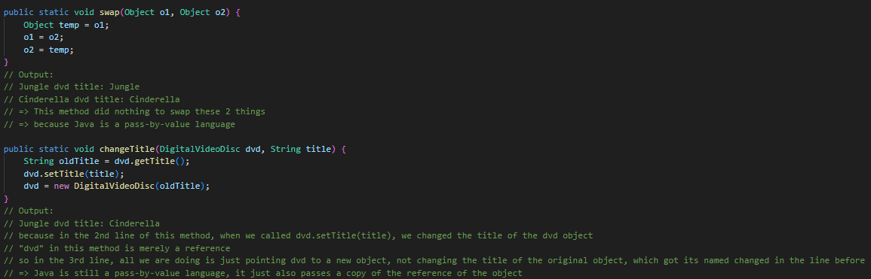
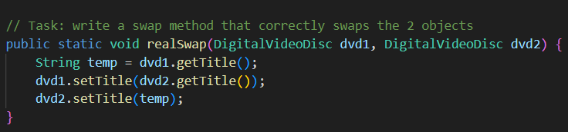

Fig. 3.1, 3.2, 3.3: TestPassingParameter.java + answers to the questions
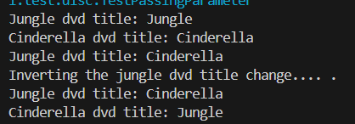
Fig 3.4: Results in terminal
4. Debugger for Java:
Video response link here.
(If you don’t really like me yapping and is comfortable with hearing English, just set the video to like 1.25x or 1.5x)
5. Class member/ Instance member:
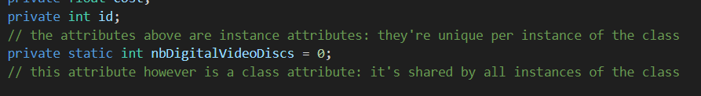
Fig 5.1: Newly created attributes in DigitalVideoDisc.java
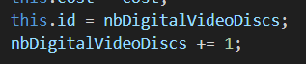
Fig 5.2: How they are used in the class (this is written in every constructor method in the class)

6. New Cart.java methods:
Fig 6.1: Newly written method in DigitalVideoDisc.java to help with this exercise
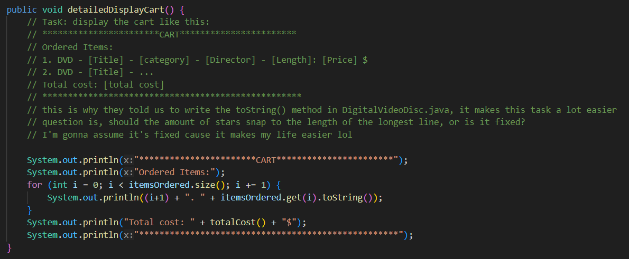
Fig 6.2: Method for detailed class display, using the method above
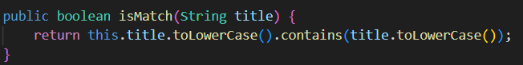
Fig 6.3: Another newly written method in DigitalVideoDisc.java to help with this exercise
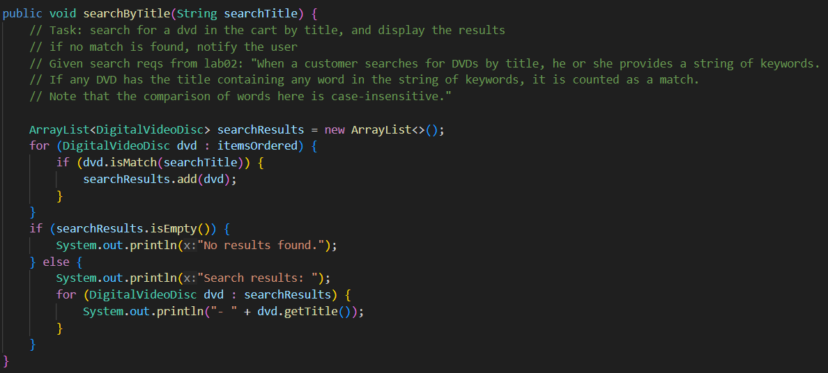Fig 6.4: Search for DVDs in the Cart by title
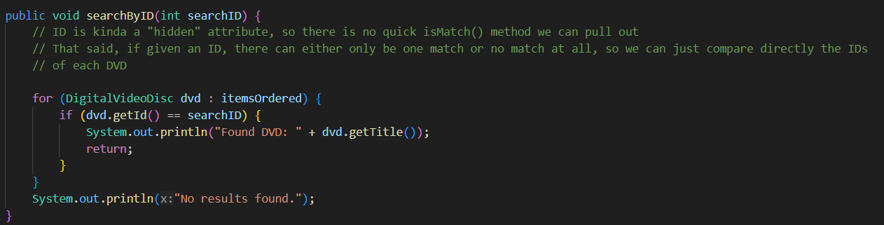Fig 6.5: Search for a DVD in the Cart by ID

7. Store class:
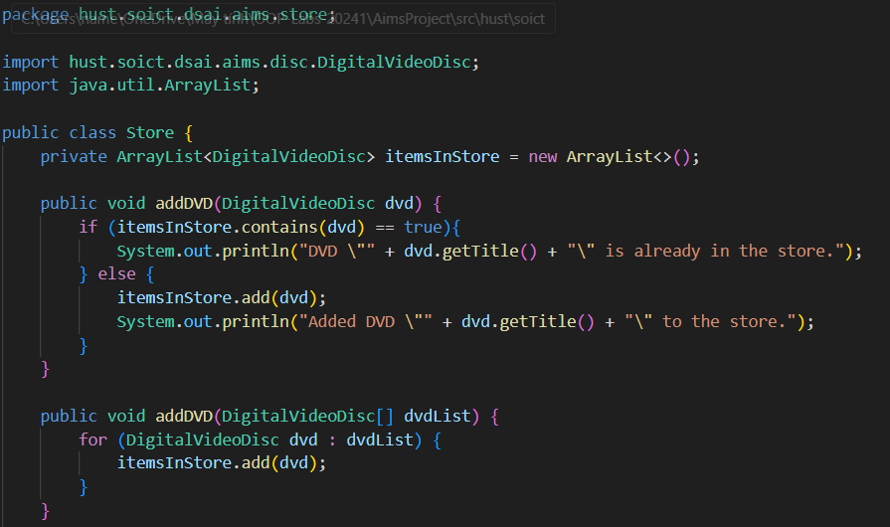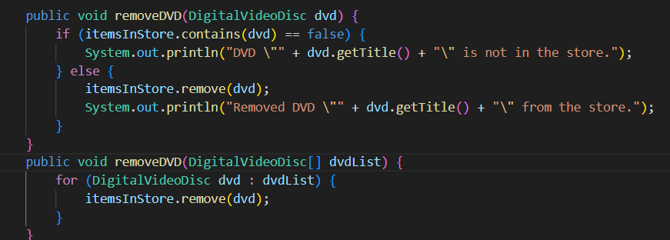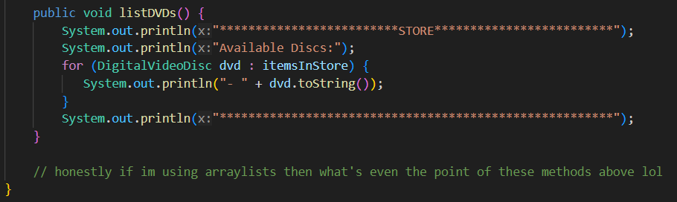
Fig 7.1, 7.2, 7.3: Store.java
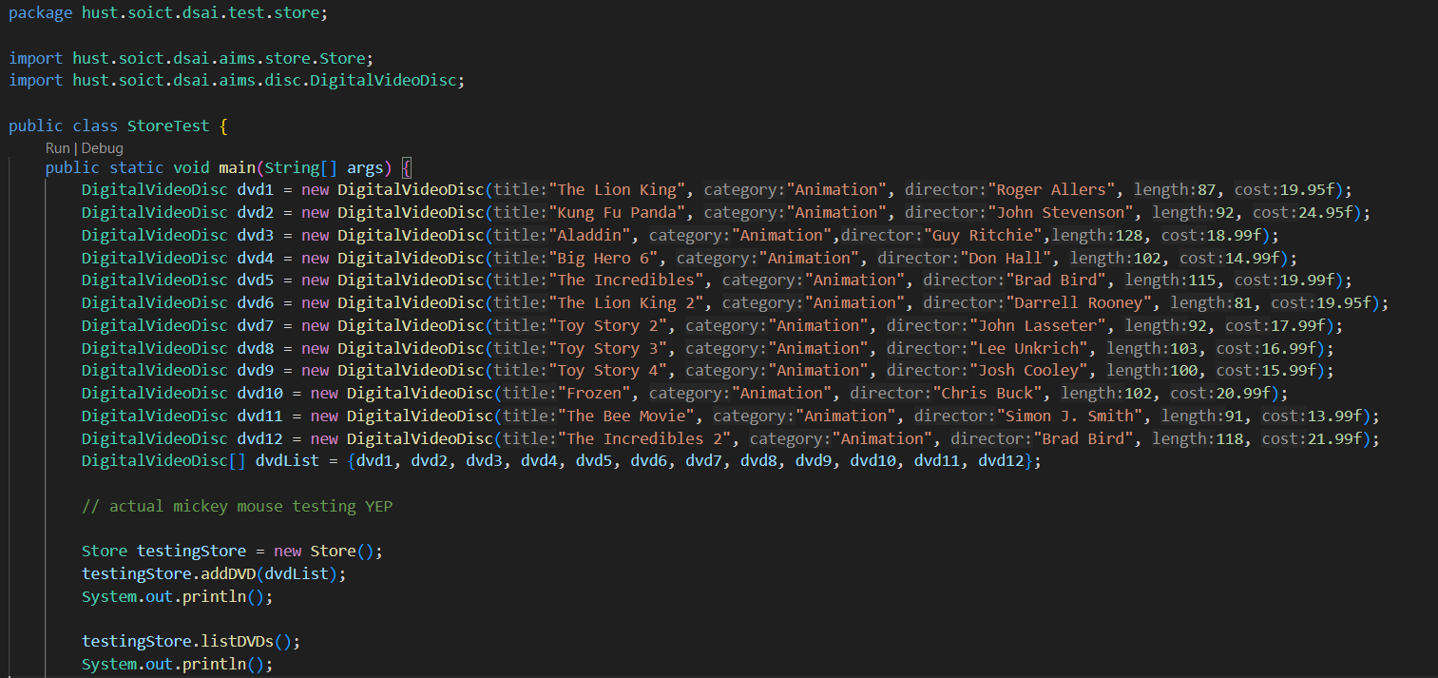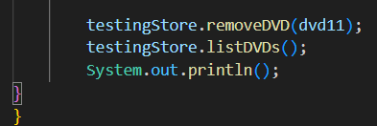
Fig 7.4, 7.5: StoreTest.java
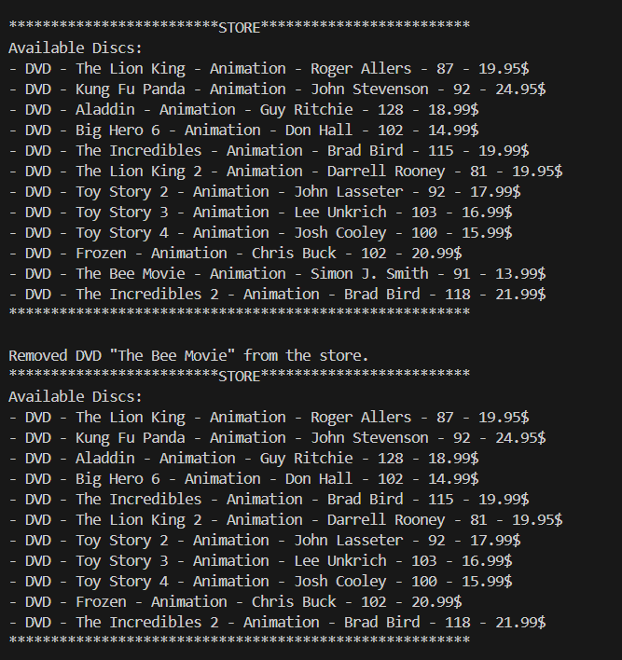
Fig 7.6: StoreTest.java’s terminal results
9. + operator/StringBuilder/StringBuffer:
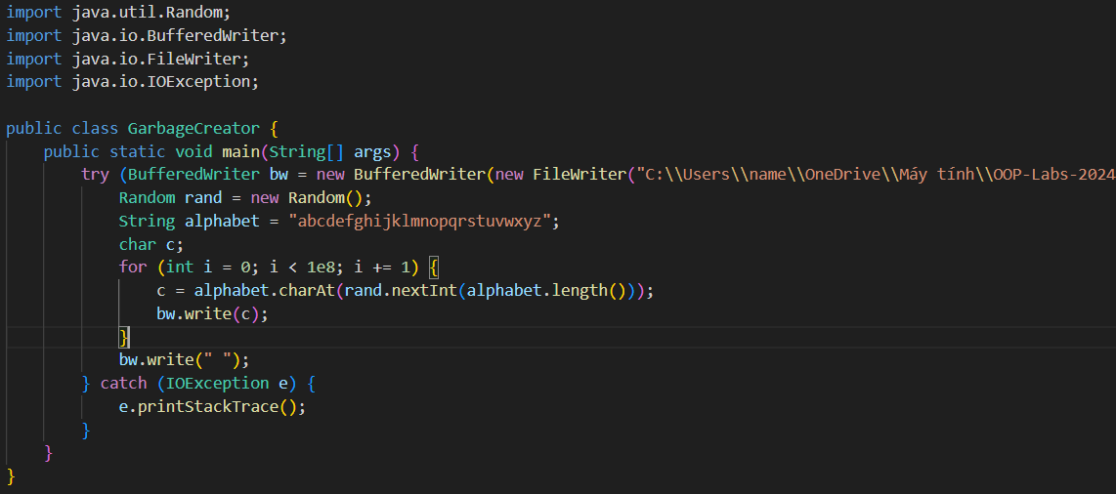
Fig 9.1: GarbageCreator.java (im not giving u my private computer directory bro)
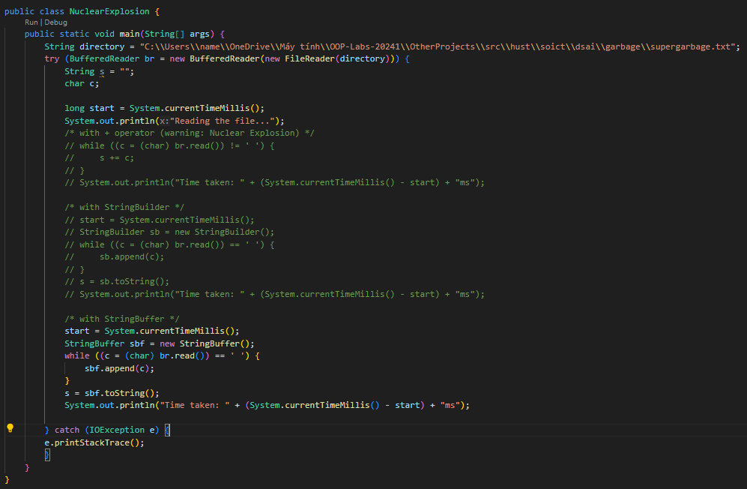
Fig 9.2: “NoGarbage.java” (I didn’t actually name the program that)
Video response link here.
(again, just put the video on 1.25x if you want)

