Object-Oriented Programming
Lecturer:
Teaching Assistant:

Lab 04: Inheritance and Polymorphism

In this lab, you will practice with:
- Java Inheritance mechanism
- Abstract class and interface
- Use the Collections framework (specifically, ArrayList)
- Polymorphism
- Re-organize the application with menu-based UI for users.

Assignment Submission
For this lab class, you will have to turn in your work twice, specifically:
- Right after the class: for this deadline, you should include any work you have done within the lab class.
- Three days after the class: for this deadline, you should include the source code of all sections of this lab, into a branch namely “release/lab04” of the valid repository. You should make a branch from previous lab branch “release/lab03”.
- After completing all the exercises in the lab, you have to update the use case diagram and the class diagram of AIMS project.
- You have to write the answers for all available questions into a text file named “answers.txt” and submit it in your branch.
- You have to upload the source code of the AIMS project into the repository, with structure similar to last lab.
Each student is expected to turn in his or her own work and not give or receive unpermitted aid. Otherwise, we would apply extreme methods for measurement to prevent cheating. Please note that you need to write down answers for all questions into a text file named “answers.txt” and submit within it within your repository.

Import the existing project into the workspace of Eclipse
- Open Eclipse
- Open File -> Import. Type zip to find Archive File if you have exported as a zip file before. You may choose Existing Projects into Workspace if you want to open an existing project in your computer. Ignore this step if the AimsProject is already opened in the workspace.
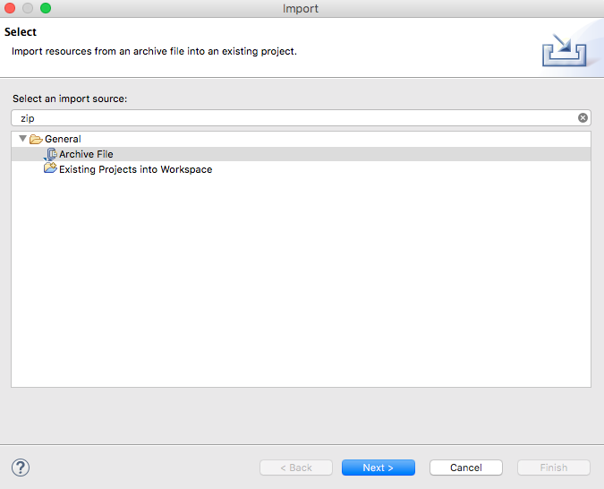
Figure 1. Import existing project
- Click Next and Browse to a zip file or a project to open
Once the project is imported, you should see the classes you created in the previous lab, namely, Aims, Cart, DigitalVideoDisc.
- We can apply Release Flow here by creating a branch, e.g., topic/aims-project/add-media-class, writing our codes, testing them, pushing them, and then merging it with master.

Additional requirements of AIMS
Starting from this lab, you extend the AIMS system that you created in the previous exercises to allow customer to order 2 new types of media: books and CD.
A book’s information includes: id, title, category, cost and list of authors.
A CD’s information includes: id, title, category, artist, director, track list and price. Additionally, each track is unique in a CD with its own title and length. The length of a CD is sum of the lengths of its tracks.
When a user sees the details of a media in the store, the information displayed depends on the type of media.
- For books, the system shows their title, category, author list, the content length (i.e., the number of tokens).
- For CDs, the system displays the CD’s information (i.e. CD title, category, artist, director, CD length, and the cost for the CD) and then displays the information of all the tracks in that CD.
- For DVDs, the system displays the DVD’s information (i.e. DVD title, category, director, DVD length, and the cost for the DVD).
Additionally, the user can choose to play some media when browsing the list of media in the store or seeing the current cart. For simplicity, we establish the way the system plays a media is as follows: When a CD is played, the system displays the CD information (i.e., CD title and CD length) and plays all the tracks of the CD. To play a track, the system displays the track’s name and its length. Similarly, a DVD can also be played, i.e., the system displays the title and length of the DVD. If a DVD or track has the length 0 or less, the system must notify the user that the track, the DVD or the CD of that track cannot be played.

Creating the Book class
- In the Package Explorer view, right-click the project and select New -> Class. Adhere to the following specifications:
- Package: hust.soict.dsai.aims.media
- Name: Book
- Access modifier: public
- Superclass: java.lang.Object
- public static void main(String[] args): do not check
- Constructors from Superclass: Check
- All other boxes: Do not check

Add fields to the Book class
- To store the information about a Book, the class requires five fields: an int field id, String fields title and category, a float field cost and an ArrayList of authors. You will want to make these fields private, with public accessor methods for all but the authors field.
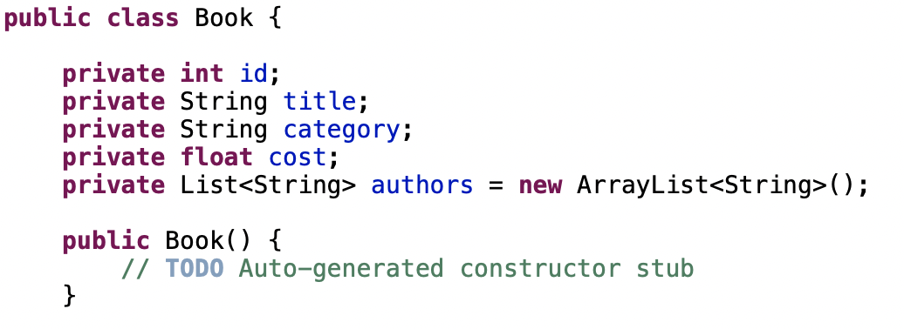
Figure 2. Adding fields to Book class
- Instead of typing the accessor methods for these fields, you may use the Generate Getter and Setter option in the Outline view pop-up menu (i.e., Right Click -> Source -> Generate Getters and Setters...). Note that in reality, not all attributes need to have getter and setter. We only create this when necessary. Getter and setter generator of Eclipse also let you decide with attribute will get getter or setter or both.
- Next, create addAuthor(String authorName) and removeAuthor(String authorName) for the Book class
  - The addAuthor(...) method should ensure that the author is not already in the ArrayList before adding
  - The removeAuthor(...) method should ensure that the author is present in the ArrayList before removing
  - Reference to some useful methods of the ArrayList class

Creating the abstract Media class
At this point, the DigitalVideoDisc and the Book classes have some fields in common namely id, title, category and cost. Here is a good opportunity to create a common superclass between the two, to eliminate the duplication of code. This process is known as refactoring. You will create an abstract class called Media which contains these fields and their associated get and set methods.
Create the Media class in the project
- In the Package Explorer view, right click to the project and select New -> Class. Adhere to the following specifications for the new class:
- Package: hust.soict.dsai.aims.media
- Name: Media
- Access Modifier: public, abstract
- Superclass: java.lang.Object
- Constructors from Superclass: Check
- public static void main (String[] args): do not check
- All other boxes: Do not check
- Add fields to the Media class
- To store the information common to the DigitalVideoDisc and the Book classes, the Media class requires four private fields: int id, String title, String category and float cost
- You will want to make public accessor methods for these fields (by using Generate Getter and Setter option in the Outline view pop-up menu)
- Remove fields and methods from Book and DigitalVideoDisc classes
- Open the Book.java in the editor
- Locate the Outline view on the right-hand side
- Select the fields id, title, category, cost and their accessors & mutators (if exist)
- Right click the selection and select Delete from the pop-up menu
- Save your changes
- Do similarly for the DigitalVideoDisc class and move it to the package hust.soict.dsai.aims.media. Remove the package hust.soict.dsai.aims.disc.
- After doing that you will see a lot of errors because of the missing fields
- Extend the Media class for both Book and DigitalVideoDisc
  - public class Book extends Media
  - public class DigitalVideoDisc extends Media
- Save your changes.

Creating the CompactDisc class
As with DigitalVideoDisc and Book, the CompactDisc class will extend Media, inheriting the id, title, category and cost fields and the associated methods.

5.1. Create the Disc class extending the Media class
- The Disc class has two fields: length and director
- Create getter methods for these fields
- Create constructor(s) for this class. Use super() if possible.
- Make the DigitalVideoDisc extending the Disc class. Make changes if need be.
- Create the CompactDisc extending the Disc class. Save your changes.

5.2. Create the Track class which models a track on a compact disc and will store information incuding the title and length of the track
- Add two fields: String title and int length
- Make these fields private and create their getter methods as public
- Create constructor(s) for this class.
- Save your changes

5.3. Open the CompactDisc class
- Add 2 fields to this class:
- a String as artist
- an ArrayList of Track as tracks
- Make all these fields as private. Create public getter method for only artist.
- Create constructor(s) for this class. Use super() if possible.
- Create methods addTrack() and removeTrack()
- The addTrack() method should check if the input track is already in the list of tracks and inform users
- The removeTrack() method should check if the input track existed in the list of tracks and inform users
- Create the getLength() method
- Because each track in the CD has a length, the length of the CD should be the sum of lengths of all its tracks.
- Save your changes

Create the Playable interface
The Playable interface is created to allow classes to indicate that they implement a play() method. You can apply Release Flow here by creating a topic branch for implementing Playable interface.
- Create Playable interface, and add to it the method prototype: public void play();
- Save your changes
- Implement the Playable with CompactDisc, DigitalVideoDisc and Track
- For each of these classes CompactDisc and DigitalVideoDisc, edit the class description to include the keywords implements Playable, after the keyword extends Disc
- For the Track class, insert the keywords implements Playable after the keywords public class Track
- Implement play() for DigitalVideoDisc and Track
- Add the method play() to these two classes
- In the DigitalVideoDisc, simply print to screen:
public void play() {
System.out.println("Playing DVD: " + this.getTitle());
System.out.println("DVD length: " + this.getLength());
}
- Similar additions with the Track class
- Implement play() for CompactDisc
- Since the CompactDisc class contains a ArrayList of Tracks, each of which can be played on its own. The play() method should output some information about the CompactDisc to console
- Loop through each track of the arraylist and call Track's play() method

Update the Cart class to work with Media
You must now update the Cart class to accept not only DigitalVideoDisc but also Book and CompactDisc. Currently, the Cart class has methods:
- addDigitalVideoDisc()
- removeDigitalVideoDisc().
You could add more methods to add and remove Book and CompactDisc, but since DigitalVideoDisc, Book and CompactDisc are all subclasses of type Media, you can simply change Cart to maintain a collection of Media objects. Thus, you can add a DigitalVideoDisc, or a Book, or a CompactDisc using the same methods.
- Remove the itemsOrdered array, as well as its add and remove methods.
  - From the Package Explorer view, expand the project
  - Double-click Cart.java to open it in the editor
  - In the Outline view, select the itemsOrdered array and the methods addDigitalVideoDisc() and removeDigitalVideoDisc() and hit the Delete key
  - Click Yes when prompted to confirm the deletion
  - Recreate the itemsOrdered field, this time as an object ArrayList instead of an array.
- The qtyOrdered field is no longer needed since it was used to track the number of DigitalVideoDiscs in the itemsOrdered array, so remove it and its accessor and mutator (if exist).
- Add the itemsOrdered to the Cart class
  - To create this field, type the following code in the Cart class, in place of the itemsOrdered array declaration that you deleted:
private ArrayList<Media> itemsOrdered = new ArrayList<Media>();
- Note that you should import the java.util.ArrayList in the Cart class
  - A quicker way to achieve the same affect is to use the Organize Imports feature within Eclipse
  - Right-click anywhere in the editor for the Cart class and select Source -> Organize Imports (Or Ctrl+Shift+O). This will insert the appropriate import statements in your code.
  - Save your class
- Create addMedia() and removeMedia() to replace addDigitalVideoDisc() and removeDigitalVideoDisc()
- Update the totalCost() method

Update the Store class to work with Media
- Similar to the Cart class, change the itemsInStore[] attribute of the Store class to ArrayList<Media> type.
- Replace the addDigitalVideoDisc() and removeDigitalVideoDisc() methods with addMedia() and removeMedia()

Constructors of whole classes and parent classes
- Update the UML class diagram for the AimsProject. Update the new .astah & .png file in the Design directory. We can apply Release Flow here by creating a branch, e.g., topic/update-class-diagram/aims-project/lab04, push the diagram and its image, and then merge with master.
- Which classes are aggregates of other classes? Checking all constructors of whole classes if they initialize for their parts?
- Write constructors for parent and child classes. Remove redundant setter methods if any

Unique item in a list
To make sure the list of media in cart or list of tracks in a CD should not contain identical objects, we can override the equals() method of the Object class
- Previously, when you add a media to a cart or a track to a CD, you may use the contains() methods of the list of medias in the cart or the list of tracks in the CD to ensure that a similar object is not added to that list.
When calling this by default, contains() will check a variety of condition in order to confirm that 2 tracks are identical. However, you can define your own requirements to perform the verification.
The contains() method returns true if the list contains the specific element. More formally, it returns true if and only if the list contains at least one element e such that e such that (o==null?e==null:o.equals(e)). So the contains() method actually use equals() method to check equality.
- Please override the boolean equals(Object o) of the Media and the Track class so that two objects of these classes can be considered as equal if:
+ For the Media class: the title is equal
+ For the Track class: the title and the length are equal
When overriding the equals() method of the Object class, you will have to cast the Object parameter obj to the type of Object that you are dealing with. For example, in the Media class, you must cast the Object obj to a Media, and then check the equality of the two objects’ attributes as the above requirements (i.e. title for Media; title and length for Track). If the passing object is not an instance of Media, what happens?
Note: We can apply Release Flow here by creating a topic branch for the override of equals() method.

Polymorphism with toString() method
This exercise gives an illustration for polymorphism at behavior level.
Recall that for each type of media, we have implemented a toString() method that prints out the information of the object. When calling this method, depending on the type of object, corresponding toString() will be performed.
- Create an ArrayList of Media, then add some media (CD, DVD or Book) into the list.
- Iterate through the list and print out the information of the media by using toString() method. Observe what happens and explain in detail.
Sample code:
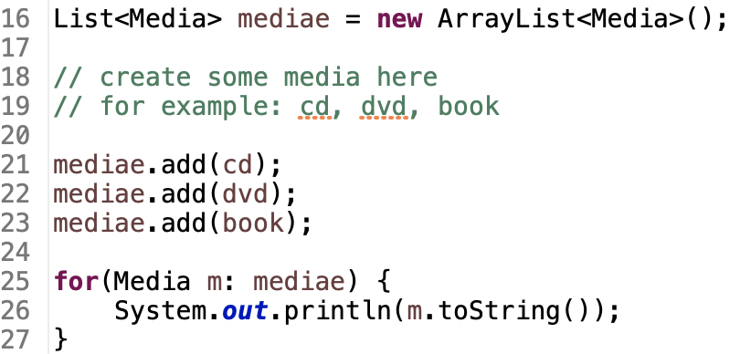
Figure 3. Polymorphism sample code

Sort media in the cart
As mentioned before, when seeing the current cart, the user can sort the items in the cart by title or by cost:
- Sort by title: the system displays all the medias in the alphabet sequence by title. In case they have the same title, the medias having the higher cost will be displayed first.
- Sort by cost: the system the system displays all the medias in decreasing cost order. In case they have the same cost, the medias will be ordered by title (alphabetical).
Here, we can use Comparator to allow multiple sorting ways of Media:

Note: The Comparator interface is a comparison function, which impose a total ordering on some collection of objects. Comparators can be passed to a sort method (such as Collections.sort()) to allow precise control over the sort order.
Please open the Java docs to see the information of this interface.
- Create two classes of comparators, one for each type of ordering

- Implement the compare() method of each comparator class to reflect the ordering that we want, either by title then cost, or by cost then title. You may utilize the method Comparator.thenComparing()to sort using multiple fields.
- Add the comparators as attributes of the Media class:
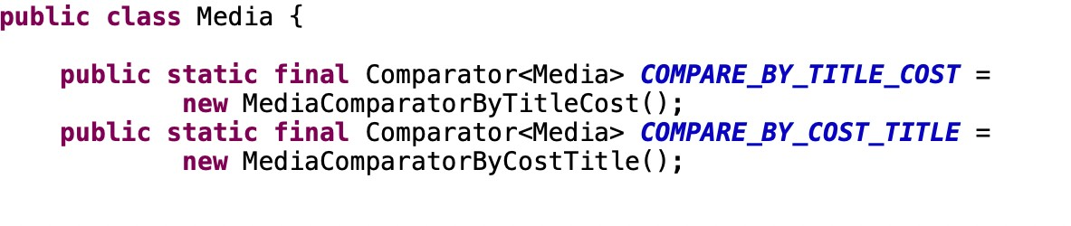
- Pass the comparator into Collections.sort: java.util.Collection.sort(collection,Media.COMPARE_BY_TITLE_COST)
or
java.util.Collection.sort(collection, Media.COMPARE_BY_COST_TITLE)

Question: Alternatively, to compare items in the cart, instead of using Comparator, we can use the Comparable interface and override the compareTo()method. You can refer to the Java docs to see the information of this interface.
Suppose we are taking this Comparable interface approach.
- What class should implement the Comparable interface?
- In those classes, how should you implement the compareTo()method be to reflect the ordering that we want?
- Can we have two ordering rules of the item (by title then cost and by cost then title) if we use this Comparable interface approach?
- Suppose the DVDs has a different ordering rule from the other media types, that is by title, then decreasing length, then cost. How would you modify your code to allow this?

Create a complete console application in the Aims class
In the main method of Aims, you will now implement a complete console application, by first create an instance of the Store class and then, provide a list of functionalities through a menu that the user can interact with. For the home interface, you will create the main menu as following:
public static void showMenu() {
System.out.println("AIMS: ");
System.out.println("--------------------------------");
System.out.println("1. View store");
System.out.println("2. Update store");
System.out.println("3. See current cart");
System.out.println("0. Exit");
System.out.println("--------------------------------");
System.out.println("Please choose a number: 0-1-2-3");
}
- From the main menu, if the user choses option “View store”, the application will display all the items in the store, and a menu as following:
public static void storeMenu() {
System.out.println("Options: ");
System.out.println("--------------------------------");
System.out.println("1. See a media’s details");
System.out.println("2. Add a media to cart");
System.out.println("3. Play a media");
System.out.println("4. See current cart");
System.out.println("0. Back");
System.out.println("--------------------------------");
System.out.println("Please choose a number: 0-1-2-3-4");
}
- The option “See a media’s details” will ask the user to enter the title of the media and display the information of that media. Please remember to check the validity of the title. Under the information display, the system also shows the following menu (note that the “Play” option is only available to CD and DVD type.
public static void mediaDetailsMenu() {
System.out.println("Options: ");
System.out.println("--------------------------------");
System.out.println("1. Add to cart");
System.out.println("2. Play");
System.out.println("0. Back");
System.out.println("--------------------------------");
System.out.println("Please choose a number: 0-1-2");
}
- The option “Add a media to cart” will ask the user to enter the title of the media that he/she sees on the screen (the list of medias in store), then add the media to cart. Please remember to check the validity of the title. After adding a DVD to cart, the system will display the number of DVDs in the current cart.
- The option “Play a media” will ask the same input from the user as option 2. You should again check the validity of the title.
- From the main menu, if the user choses option “Update store”, the application will allow the user to add a media to or remove a media from the store
- From the main menu, if the user choses option “See current cart”, the application will display the information of the current cart, and a menu as following:

public static void cartMenu() {
System.out.println("Options: ");
System.out.println("--------------------------------");
System.out.println("1. Filter medias in cart");
System.out.println("2. Sort medias in cart");
System.out.println("3. Remove media from cart");
System.out.println("4. Play a media");
System.out.println("5. Place order");
System.out.println("0. Back");
System.out.println("--------------------------------");
System.out.println("Please choose a number: 0-1-2-3-4-5");
}
The “Filter medias in cart” option should allow the user to choose one of two filtering options: by id and by title.
The “Sort medias in cart” option should allow the user to choose one of two sorting option: by title or by cost.
Note: When the user chooses option “Place order”, the system is supposed to move on to the Delivery Information gathering & Payment step. However, for simplicity, within the scope of this lab course, when the user chooses this option, we only need to notify the user that an order is created and empty the current cart.

