Electrospun PVDF Nanofiber Membrane
Product Description
E-Spin Nanotech manufactures high-performance electrospun PVDF nanofiber membranes designed for advanced filtration, sensing, and energy storage applications. Polyvinylidene difluoride (PVDF) is a chemically stable thermoplastic fluoropolymer known for its excellent mechanical strength, thermal stability, and strong piezoelectric properties. It is lightweight, flexible, chemically inert, and highly durable under demanding operating conditions, making it an ideal material for functional nanofiber membranes.
Electrospun PVDF membranes possess high porosity, ultrafine fibre diameter, and strong electrostatic properties, which enable efficient capture of fine particulate matter in air filtration systems. Their controlled pore structure and chemical resistance also make them suitable for gas separation and advanced filtration processes.
Due to their intrinsic piezoelectric behaviour, PVDF nanofibers are widely used in sensor technologies, where they convert mechanical stimuli such as pressure, vibration, or motion into electrical signals. Additionally, PVDF nanofiber membranes are widely used in energy storage systems, particularly as lithium-ion battery separators, where they provide excellent electrolyte compatibility, thermal stability, and mechanical integrity.
Key Applications
- Air filtration membranes
- Gas separation systems
- Sensors and piezoelectric devices
- Semiconductor processing
- Battery separators for energy storage systems
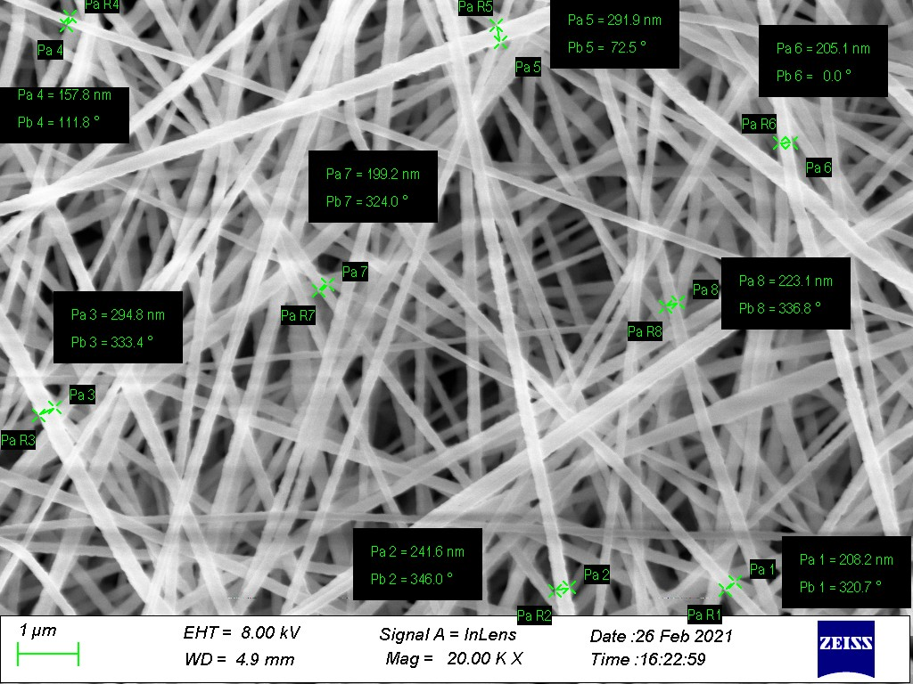
Membrane Specifications
Nanofiber Spinning Capability
- Pure PVDF
- PVDF blended with other polymers, drugs, nanoparticles etc.
Membrane Construction
- Free-standing nanofiber membrane
- Supported on substrates (e.g., aluminium foil, non-woven PP fabric, etc.)
Nanofiber Diameter Range
- 100 – 300 nm
Thickness and weight Density
- Thickness 60-100 µm
- Up to 8.0 gsm
Custom Sizes
- Rolls
- Sheets (10 × 10 cm, 14 × 28 cm, 25 × 200 cm)
- Custom-sized patches (as per specific requirements)

Polysulfone Nanofiber Membrane
Product Description
E-Spin Nanotech manufactures high-performance electrospun Polysulfone nanofiber membranes designed for advanced energy and filtration applications. These membranes feature a highly porous nanofibrous structure, excellent thermal stability, and superior chemical resistance, making them ideal for use in battery separators and other high-efficiency systems.
Our Polysulfone nanofiber membranes are engineered to deliver enhanced electrolyte uptake, improved ionic conductivity, and reliable mechanical strength, which are critical for next-generation battery technologies.
In addition to energy storage systems, these membranes are also suitable for a wide range of applications, including air filtration, water purification, and sensor technologies, where high surface area and controlled porosity are essential for performance.
Key Applications
- Battery separators for energy storage systems
- Air filtration membranes
- Water filtration and purification
- Sensor and advanced functional materials

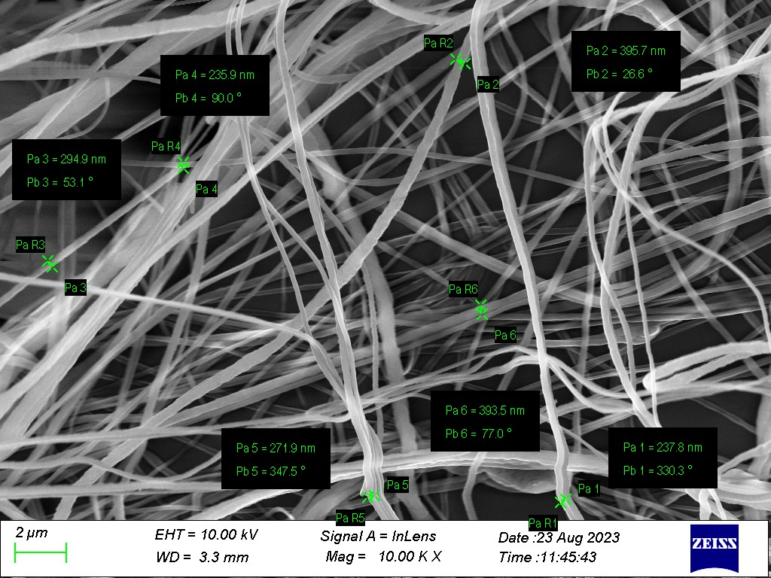
Nanofiber Spinning Capability
- Pure Polysulfone
- Blended with other polymers, nanoparticles, additives etc.
Membrane Construction
- Free-standing nanofiber membrane
- Supported on substrates (e.g., aluminium foil, non-woven PP fabric, etc.)
Nanofiber Diameter Range
- 200 – 500 nm
Thickness and weight Density
- Thickness 50-80 µm
- Up to 4.0 gsm
Custom Sizes
- Rolls
- Sheets (10 × 10 cm, 14 × 28 cm, 25 × 200 cm)
- Custom-sized patches (as per specific requirements)

