PVDF-HFP Nanofiber membrane
Poly(vinylidene fluoride-co-hexafluoropropylene) (PVDF-HFP) is widely used as a base polymer due to its outstanding chemical resistance, thermal stability, and mechanical strength. In many membrane designs, PVDF-HFP is electrospun into a non-ionic nanofiber framework that acts as a robust structural support. The porous nanofiber network is then impregnated or coated with ion-conducting polymers (ionomers) to form a composite ion-exchange membrane with enhanced conductivity and durability.
This composite structure combines the mechanical robustness of PVDF-HFP nanofibers with the functional ion-transport properties of ionomers, enabling efficient ion exchange while maintaining structural stability under demanding operating conditions. The nanofibrous architecture also improves electrolyte uptake, reduces transport resistance, and enhances overall membrane performance.
Due to their stability and tunable properties, PVDF-HFP based ion-exchange nanofiber membranes are suitable for various electrochemical and separation technologies where efficient ion transport and long-term durability are required.
Key Applications
- Fuel cells and electrochemical energy systems
- Redox flow batteries
- Electrodialysis and water purification systems
- Ion-conductive separators for advanced batteries
- Electrochemical reactors and sensors
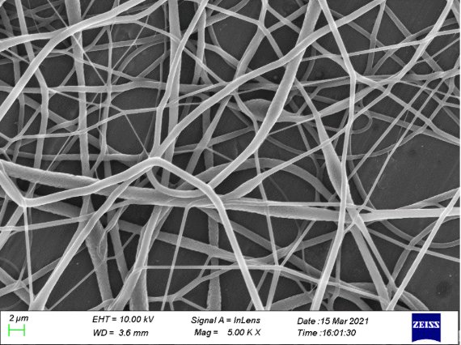
Sulfonated Poly (ether ether ketone) (SPEEK) membrane
E-Spin Nanotech develops advanced ion-exchange nanofiber membranes using Sulfonated Poly (ether ether ketone) (SPEEK), a high-performance hydrocarbon polymer widely recognized as a cost-effective alternative to perfluorinated ionomers such as Nafion. SPEEK offers excellent thermal stability, strong mechanical properties, and good proton conductivity, making it highly suitable for electrochemical and energy-related applications.
Through electrospinning technology, SPEEK can be fabricated into ultrafine nanofiber membranes with high surface area and interconnected porous structures. The nanofibrous morphology enhances ion transport pathways and improves electrolyte interaction, contributing to efficient ion exchange and improved membrane performance.
One of the challenges associated with highly sulfonated SPEEK is excessive swelling in aqueous environments. To address this, SPEEK nanofibers are often integrated into composite membrane architectures where the nanofiber network is combined with a denser, low-swelling polymer matrix. This composite design effectively reduces dimensional swelling while maintaining high ion conductivity and structural stability.
By combining the advantages of hydrocarbon-based ionomers with advanced nanofiber engineering, SPEEK-based membranes provide a durable, high-performance, and economically attractive solution for modern electrochemical systems.
Key Applications
- Proton exchange membranes for fuel cells
- Electrochemical energy systems
- Redox flow batteries
- Water treatment and electrodialysis
- Ion-conductive membranes for advanced electrochemical devices
