Accurate Prediction of HOMO-LUMO Gap using DFT Functional and Application to Next-generation Organic Telluro[n]helicenes Materials†
Rahul Kumar,^{1,2} Rahul Kar,³ and Dilip K. Maity^{1,2,*}
*Correspondence to: Dilip Kumar Maity (E-mail: dkmaity@barc.gov.in; maitydk@hbni.ac.in )
ORCID ID: 0000-0003-4284-3578

1 Homi Bhabha National Institute, Training School Complex, Anushaktinagar, Mumbai-400094, India
2Bhabha Atomic Research Centre, Trombay, Mumbai-400085, India
3Department of Chemistry, Dibrugarh University, Dibrugarh-786004, Assam, India
†In honor of Prof. Shridhar R. Gadre on the occasion of his 75th birthday.

Table of contents
1. | Cartesian coordinates for the most stable structures of neutral telluro[n]helicenes, n=1-10. | S3-S13
2. | Most stable structures of neutral telluro[n]helicenes , [n]TeH, n=1,2,4-6,8-10 with the complete labelling of molecular properties | S14-S15
3. | Gematrical parameters of neutral and radical cations of telluro[n]helicenes, n=1-10 | S16
4. | Most stable structures of telluro[n]helicenes radical cation, [n]TeH^{•+}, n=1-10 with the complete labelling of molecular properties | S17-S18
5. | Cartesian coordinates for the most stable structures of radical cations of end substituted telluro[n]helicenes, n=1-10 | S19-S29
6. | Spin density plot with contour cutoff = 0.003 a.u. for the most stable structures of end substituted telluro[n]helicenes radical cation, n=1-10 following ROHF formalism | S30-S31
7. | Ionization energies plots and table for thia[n]helicenes, seleno[n]helicenes, and telluro[n]helicenes in gas phase and in DCM solvent | S32-S33.
8. | Cartesian coordinates for the most stable structures π-dimer of unsubstituted telluro[7]helicene radical cation, π-dimer of substituted telluro[7]helicene radical cation, π-dimer of radical cation of substituted telluro[7]helicene with two PF₆⁻ counter anions | S34-S39
9 | Table related to statistical errors (MSE, MAE and MAX_UE)$ analysis for different density functionals against CCSD(T) level of theory | S40-S51
10. | Figures for density of states spectra for telluro[n]helicenes, [n]TeH, , n=1-10 in gas phase | S52-S54
11 | HOMO-LUMO gaps at B2PLYP and ωB97XD functional. Basis set used: 6-311++G(d,p) for H, C, Si, S, Se, Br atoms and def2-TZVPP basis set for Te atoms.  Calculated HOMO-LUMO gaps (E_{g}) at LC-ωPBE DFT functional for telluro[n]helicene, [1]TeH in gas phase with varying ω.  Optimized ω parameter satisfying Koopmans' theorem at LC-ωPBE and ωB97XD functionals | S55-56
12 | Computational cost comparison table for thia[n]helicenes, [n]TH, seleno[n]helicenes, [n]SH and telluro[n]helicenes [n]TeH | S57-S58
13. | Simulated electronic absorptions spectra [3]TH and [7]TH in DCM, and experimentally reported UV-Visible absorption spectra of 1 [7]TH and 4 [3]TH in DCM | S59
14. | TDDFT calculation data for neutral telluro[n]helicenes (n=1-10) and their radical cations | S60-S56
15 | Plots of UV-Vis spectra for telluro[n]helicenes (n=1-10) and their corresponding radical cations | S66-S68
16. | Molecular orbital plots with contour cutoff = 0.03 a.u. for the most stable structure of telluro[n]helicenes radical cation, n=1-6,8-10 | S69-70

Theoretical Methods:
- DFT Functionals: B3LYP, B3LYP-D (full optimization), ωB97XD (single point energy calculations)
- Basis Set: 6-311++G(d,p) for H, C, Si, Br, P, and F and lanl2dz for Te atoms
- Solvent Used: Dichloromethane (DCM)
- Solvent Model: Solvation model based on solute density (SMD)
1 Cartesian coordinates for the most stable structures of neutral telluro[n]helicenes, n=1-10 calculated at B3LYP-D with 6-311++G(d,p) basis set is used for H, C, Si, Br atoms and lanl2dz basis set is for Te atoms in DCM solvent.

1.1 Neutral telluro[1]helicene
C 0.000000 0.000000 0.000000
Si 0.000000 0.000000 1.881462
C 1.748442 0.000000 2.576333
C -0.938481 -1.518824 2.518371
C -0.696038 -2.848632 2.353860
Br 0.837652 -3.425682 1.313051
Te -2.662698 -1.308819 3.688526
C -2.657212 -3.403155 3.684755
Si -3.999188 -4.384470 4.595439
C -4.958288 -5.436000 3.364867
C -1.585593 -3.823896 2.957540
Br -1.259304 -5.724680 2.736110
C -0.919408 1.520877 2.505388
C -3.209912 -5.436013 5.941246
C -5.162398 -3.130882 5.384819
H -3.987765 -5.959332 6.511817
H -2.529648 -6.186354 5.527204
H -2.642354 -4.810005 6.639907
H -5.958942 -3.657171 5.925365
H -4.642796 -2.488994 6.106153
H -5.640790 -2.488986 4.635524
H -5.775819 -5.959333 3.876957
H -5.397896 -4.809984 2.579383
H -4.322254 -6.186329 2.885629
H 0.488615 0.908639 -0.374299
H 0.531874 -0.864511 -0.408571
H -1.025357 -0.016145 -0.387969
H 2.276731 0.908646 2.260514
H 1.730291 -0.016143 3.672484
H 2.324561 -0.864512 2.232959
H -0.408631 2.427846 2.158742
H -1.949040 1.558429 2.130181
H -0.951024 1.558449 3.600797

1.2 Neutral telluro[2]helicene
C 0.000000 0.000000 0.000000
Si 0.000000 0.000000 1.882464
C 1.790214 0.000000 2.479898
C -0.804912 -1.582700 2.547491
C -2.065590 -2.080979 2.420776
Br -3.296030 -0.995860 1.370184
Te 0.358283 -2.899308 3.712191
C -1.414564 -3.955882 3.744031
C -2.456727 -3.352549 3.040382
C -3.700289 -4.130582 3.084486
Br -5.337480 -3.555487 2.199006
Te -1.914658 -5.749400 4.634843
C -3.779783 -5.312714 3.755284
Si -5.210470 -6.533103 3.997904
C -4.551051 -7.951363 5.054076
C -0.860954 1.521857 2.579871
C -6.629596 -5.711473 4.922393
C -5.769277 -7.232963 2.342127
H -5.352129 -8.682718 5.218223
H -3.721234 -8.477666 4.567267
H -4.212080 -7.609593 6.039401
H -6.523092 -8.013828 2.505977
H -6.207326 -6.466932 1.696080
H -4.925133 -7.686502 1.809213
H -7.404086 -6.455758 5.148314
H -6.279938 -5.290491 5.872544
H -7.089723 -4.906414 4.342547
H 2.293297 0.903883 2.114582
H 1.860413 0.005213 3.574256
H 2.351619 -0.863052 2.102355
H -0.320570 2.426292 2.271955
H -1.894433 1.607801 2.232595
H -0.870869 1.492395 3.675912
H 0.561109 0.867825 -0.369958
H 0.484910 -0.904181 -0.386773
H -1.011380 0.046890 -0.413489

Neutral telluro[3]helicene
C 0.000000 0.000000 0.000000
Si 0.000000 0.000000 1.885863
C 1.756313 0.000000 2.569809
C -0.975208 -1.475470 2.568974
C -0.711401 -2.809642 2.600463
Br 0.710774 -3.473628 1.442449
C -0.868732 1.568295 2.479276
C -1.624432 -3.768408 3.216789
C -2.859986 -3.217594 3.521975
Te -4.359733 -4.631217 3.826313
C -2.720734 -5.891716 3.571329
C -1.513531 -5.221752 3.441174
C -0.357918 -6.079590 3.688936
Br 1.306769 -5.264979 4.296945
C -0.467591 -7.431973 3.787078
Si 0.817846 -8.797138 4.067544
C -0.050071 -10.450177 3.783702
Te -2.518779 -7.943155 3.706230
C 2.222579 -8.643054 2.820387
C 1.467651 -8.765270 5.837634
Te -2.911422 -1.158837 3.360202
H 2.281960 0.904709 2.243314
H 1.747604 -0.005055 3.664613
H 2.334809 -0.863578 2.233232
H 0.491403 0.907030 -0.370562
H 0.527753 -0.862181 -0.414572
H -1.022436 -0.009787 -0.391532
H -0.321572 2.444607 2.113825
H -1.893473 1.648608 2.101054
H -0.899382 1.634801 3.571524
H 0.669581 -11.264678 3.923525
H -0.869276 -10.620358 4.490482
H -0.448788 -10.537725 2.767962
H 2.139886 -9.615518 6.000961
H 2.022079 -7.850275 6.059315
H 0.646672 -8.845344 6.557600
H 2.911393 -9.488509 2.930584
H 1.836725 -8.657362 1.795884
H 2.797399 -7.723203 2.951393

Neutral seleno[4]helicene
C 0.000000 0.000000 0.000000
Si 0.000000 0.000000 1.885796
C 1.780963 0.000000 2.498266
C -0.937191 -1.509309 2.508123
C -0.897123 1.565611 2.443468
C -1.301181 1.970575 3.674970
Br -0.564838 1.053661 5.233664
Te -1.386271 3.084518 1.048882
C -2.079517 4.022092 2.761757
C -2.046008 3.205512 3.881372
C -2.600235 3.777113 5.113628
C -3.041249 3.115766 6.346705
C -3.548774 1.766109 6.554845
Br -4.105662 0.728365 4.997470
Te -2.539587 6.007184 3.214833
C -2.726677 5.154070 5.112706
Te -3.066198 5.961405 7.009456
C -3.157169 3.926329 7.465221
Te -3.668310 2.880503 9.179442
C -3.872551 1.296050 7.786960
Si -4.469672 -0.405989 8.346849
C -6.220798 -0.731058 7.734611
C -3.273285 -1.720269 7.726403
C -4.469891 -0.403452 10.232643
H -6.588963 -1.683821 8.136592
H -6.902348 0.061327 8.066155
H -6.264806 -0.781491 6.642530
H -4.791479 -1.383507 10.606094
H -3.470803 -0.204627 10.638076
H -5.160498 0.345641 10.639103
H -3.595910 -2.715895 8.056890
H -3.210750 -1.726007 6.633954
H -2.266340 -1.541722 8.121727
H -0.438643 -2.429994 2.178928
H -0.997785 -1.524883 3.600585
H -1.959754 -1.517611 2.112656
H 0.494707 -0.905619 -0.372169
H -1.018536 0.013046 -0.405584
H 0.542723 0.861769 -0.407548
H 2.316487 -0.870353 2.097528
H 2.306903 0.902776 2.165572
H 1.833276 -0.040123 3.590408

Neutral telluro[5]helicene
C 0.000000 0.000000 0.000000
Si 0.000000 0.000000 1.880501
C 1.767352 0.000000 2.545932
Te 2.327990 -1.400687 4.028453
C 4.079244 -0.299247 3.982459
C 4.110410 0.647959 2.971777
C 5.371719 1.390777 2.823830
C 5.857021 2.243662 1.727858
C 6.818612 3.171056 2.092251
Te 7.205601 4.611766 0.633254
C 5.925087 3.353267 -0.424618
Te 5.302017 3.329278 -2.397782
C 4.694617 1.374913 -1.863336
Si 4.011809 0.213481 -3.186655
C 2.391052 -0.554797 -2.621691
C -0.820496 -1.586428 2.489209
C -0.943211 1.481216 2.562144
C 2.819629 0.827186 2.315521
Br 2.482956 2.457281 1.302318
Te 5.703673 -0.180856 5.282401
C 6.212016 1.317491 3.922029
Te 7.681308 2.796989 3.953621
C 5.532634 2.234858 0.292845
C 4.977370 1.180626 -0.549258
Br 4.903702 -0.643950 0.130917
C 3.687270 1.257085 -4.724856
C 5.286491 -1.110644 -3.599164
H 3.277797 0.624697 -5.522342
H 2.959567 2.052970 -4.526550
H 4.603663 1.719591 -5.111107
H 4.922231 -1.744323 -4.418044
H 6.231171 -0.654536 -3.918315
H 5.494104 -1.752420 -2.737313
H 2.011018 -1.235503 -3.394502
H 2.510794 -1.122344 -1.695220
H 1.633469 0.216265 -2.448321
H -1.032185 0.011329 -0.373485
H 0.520283 0.870886 -0.407010
H 0.490633 -0.897605 -0.390011
H -1.990468 1.445788 2.235348
H -0.930261 1.479004 3.658565
H -0.510649 2.426508 2.219969
H -1.851457 -1.636834 2.117532
H -0.293976 -2.477658 2.127552
H -0.863935 -1.635177 3.584022

Neutral telluro[6]helicene
C 0.000000 0.000000 0.000000
Si 0.000000 0.000000 1.887330
C 1.783503 0.000000 2.493373
C -0.926658 1.517761 2.497862
C -0.894962 -1.566832 2.437115
C -1.282959 -2.002413 3.665877
Br -0.552361 -1.075071 5.218203
Te -1.309671 -3.081379 1.024453
C -1.976290 -4.061517 2.714839
C -1.971355 -3.273637 3.855226
C -2.562611 -3.882999 5.056796
C -3.008383 -3.270738 6.316484
C -3.354569 -1.875927 6.624825
C -3.727527 -0.765181 5.734994
C -4.254275 -0.762486 4.375448
Br -5.073133 -2.385229 3.668584
Te -2.532893 -6.035309 3.063878
C -2.723421 -5.255488 4.987050
Te -3.118516 -6.155545 6.824928
C -3.119929 -4.148177 7.383331
Te -3.256302 -3.205762 9.236626
C -3.326802 -1.552238 7.969780
Te -3.356308 0.496548 8.350081
C -3.661800 0.502190 6.292370
Te -4.010936 2.023647 4.941187
C -4.441024 0.388466 3.675190
Si -5.097273 0.705074 1.935295
C -4.863684 2.544973 1.585745
C -4.104052 -0.284867 0.682864
C -6.932711 0.295513 1.827429
H -5.464358 3.169691 2.258183
H -3.814361 2.846770 1.683973
H -5.179712 2.770013 0.559507
H -4.486402 -0.098902 -0.329293
H -3.050141 0.007682 0.706747
H -4.158529 -1.358625 0.878864
H 1.840031 0.040385 3.585277
H 2.306929 -0.903904 2.159692
H 2.318326 0.869286 2.089288
H -1.942690 1.539363 2.092849
H -0.999908 1.537249 3.588106
H -0.409726 2.429171 2.170254
H 0.462807 0.923192 -0.370391
H 0.572562 -0.841083 -0.409908
H -1.017159 -0.047858 -0.406048
H -7.118875 -0.771724 1.980587
H -7.499553 0.850827 2.584176
H -7.323276 0.574150 0.840119

Neutral telluro[7]helicene
C 0.000000 0.000000 0.000000
Si 0.000000 0.000000 1.880293
C 1.769462 0.000000 2.530101
C -0.881709 -1.557722 2.476795
C -0.916486 1.469452 2.628030
C -0.814871 2.806994 2.419423
Br 0.621021 3.437003 1.263136
Te -2.132849 1.150108 4.330559
C -2.155898 3.216549 4.334807
Te -2.657616 4.607678 5.796159
C -1.909147 5.877990 4.327366
C -1.603193 5.246085 3.134560
C -1.436189 6.141831 1.979173
C -1.492848 5.857568 0.535818
C -1.983770 4.671644 -0.183723
C -2.850726 3.571482 0.263396
C -3.899704 3.543145 1.278332
Br -4.602682 5.231786 1.949194
C -1.547503 3.779603 3.224798
Te -1.676621 7.944543 4.279843
C -1.235191 7.474074 2.300929
Te -0.624207 8.658323 0.700853
C -0.959641 6.848238 -0.272334
Te -0.564275 6.231885 -2.220698
C -1.520042 4.538856 -1.481047
Te -1.774367 2.636408 -2.285550
C -2.788288 2.407239 -0.485000
Te -3.948973 0.874517 0.272808
C -4.579298 2.409214 1.587152
Si -6.061308 2.089384 2.709541
C -6.263499 0.217471 2.831177
C -7.596862 2.829393 1.904755
C -5.843720 2.777817 4.445690
H -0.836026 -1.666718 3.567148
H -1.935761 -1.559823 2.175282
H -0.406804 -2.444687 2.039298
H 0.603255 -0.846856 -0.353434
H -1.014233 -0.118374 -0.392829
H 0.421647 0.917911 -0.414755
H -7.513850 3.917574 1.815712
H -7.745320 2.417589 0.899518
H -8.490034 2.602088 2.500861
H -5.026594 2.272485 4.969085
H -5.636349 3.849901 4.443817
H -6.768719 2.606626 5.012317
H -7.095016 -0.023924 3.504940
H -6.487595 -0.238162 1.859060
H -5.359811 -0.256184 3.232341
H 2.312671 0.893164 2.204316
H 1.780740 -0.022331 3.626230
H 2.312000 -0.882060 2.166254

Neutral telluro[8]helicene

C 0.000000 0.000000 0.000000
Si 0.000000 0.000000 1.887404
C 1.804753 0.000000 2.438311
C 2.379030 -0.136966 3.662304
Br 1.188108 -0.133262 5.204641
C -0.939157 -1.516373 2.484985
C -0.835603 1.575251 2.498535
Te 3.297836 0.551979 1.048756
C 4.480117 0.469582 2.741052
C 3.819950 -0.003117 3.863961
C 4.637932 -0.139801 5.078942
C 4.346631 -0.806949 6.355605
C 3.455394 -1.937171 6.644058
C 2.815117 -2.881624 5.720499
C 3.082645 -3.134941 4.297803
C 4.314745 -2.964950 3.512328
C 5.710178 -2.864923 3.933696
Br 6.206719 -3.382819 5.745404
Te 6.392571 1.180780 3.134550
C 5.854500 0.519994 5.030973
Te 6.736190 0.789152 6.896794
C 5.081419 -0.350847 7.435551
Te 4.447848 -1.109426 9.268843
C 3.178251 -2.142437 7.982169
Te 1.572682 -3.424413 8.318628
C 1.747103 -3.584641 6.249408
Te 0.502421 -4.420936 4.807352
C 2.021694 -3.679588 3.593540
Te 2.302504 -3.733785 1.534206
C 4.171672 -3.054613 2.136742
Te 5.920891 -2.717171 1.090411
C 6.721605 -2.678089 3.045412
Si 8.595194 -2.627317 3.263739
C 9.136758 -1.405527 4.587534
C 9.220050 -4.358592 3.670395
C 9.327980 -2.084914 1.611116
H 9.112186 -2.801301 0.808767
H 8.948058 -1.102678 1.306097
H 10.419059 -2.008277 1.696480
H 10.222818 -1.485578 4.728461
H 8.908617 -0.378143 4.286581
H 8.651687 -1.595527 5.547548
H -0.865425 1.614358 3.592020
H -0.298748 2.462408 2.142130
H -1.866462 1.629597 2.125342
H -0.551318 -2.425467 2.014598
H -0.877043 -1.639705 3.568465
H -1.997426 -1.415786 2.209768
H -1.031976 -0.032940 -0.370889
H 0.467305 0.902573 -0.412954
H 0.526269 -0.873949 -0.401773
H 8.825308 -4.712145 4.628156
H 8.917512 -5.072250 2.894862
H 10.316188 -4.364555 3.728195

Neutral telluro[9]helicene
C 0.000000 0.000000 0.000000
Si 0.000000 0.000000 1.888104
C 1.806705 0.000000 2.434613
C 2.394379 -0.169913 3.646865
Br 1.216617 -0.161360 5.199940
C -0.946495 -1.512858 2.481128
C -0.834393 1.576326 2.498866
Te 3.277129 0.642480 1.058092
C 4.475644 0.516809 2.738180
C 3.838554 -0.032835 3.838625
C 4.682081 -0.232055 5.027332
C 4.423654 -0.988692 6.259654
C 3.437166 -2.040195 6.531888
C 2.761468 -2.947693 5.600159
C 3.057461 -3.223018 4.190582
C 4.311660 -3.065733 3.444406
C 5.696750 -2.938192 3.925024
C 6.316274 -3.302817 5.200892
Br 5.415054 -4.566617 6.379818
Te 6.383082 1.240962 3.136034
C 5.889587 0.444911 4.993840
Te 6.851038 0.533841 6.836791
C 5.212769 -0.638738 7.342033
Te 4.474339 -1.320280 9.166448
C 3.127411 -2.224931 7.864933
Te 1.489750 -3.469821 8.179144
C 1.666159 -3.614963 6.111268
Te 0.440814 -4.445158 4.649025
C 1.998452 -3.737269 3.461555
Te 2.313655 -3.727076 1.408472
C 4.182178 -3.092360 2.064299
Te 5.900236 -2.547040 1.026767
C 6.624421 -2.542252 2.973508
Te 8.526589 -2.246587 3.733322
C 7.620627 -3.040287 5.470883
Si 8.721336 -3.469967 6.941717
C 7.958671 -2.982922 8.590277
C 9.098056 -5.316755 6.911385
C 10.332566 -2.509667 6.723612
H 10.882851 -2.821990 5.827394
H 10.149324 -1.431022 6.655850
H 10.987378 -2.683529 7.586571
H 8.592889 -3.361518 9.402813
H 7.893347 -1.894368 8.686973
H 6.955642 -3.395184 8.718079
H -0.867231 1.611737 3.592506
H -0.294285 2.463680 2.147498
H -1.863941 1.634083 2.122948
H -0.580349 -2.420284 1.990349
H -0.866412 -1.654626 3.560956
H -2.008254 -1.391954 2.228335
H -1.031355 -0.054565 -0.370222
H 0.447893 0.912510 -0.412429
H 0.544992 -0.862541 -0.401183
H 8.189617 -5.911852 7.049650
H 9.548975 -5.603983 5.954206
H 9.803505 -5.576950 7.711131

Neutral telluro[10]helicene
C 0.000000 0.000000 0.000000
Si 0.000000 0.000000 1.879089
C 1.766249 0.000000 2.537706
C -0.879517 -1.562216 2.471483
C -0.937264 1.467524 2.601773
Te -2.170433 1.142409 4.289198
C -2.230762 3.208915 4.264092
C -1.635353 3.773566 3.148217
C -1.724257 5.241009 3.045948
C -1.454594 6.143861 1.916836
C -1.372475 5.857910 0.480222
C -1.844488 4.688439 -0.259884
C -2.862723 3.709223 0.117678
C -3.956882 3.832958 1.087147
C -4.541205 5.033174 1.704231
C -4.483282 6.449188 1.300171
C -4.242126 7.063823 -0.004947
Br -4.443846 5.978233 -1.611655
C -0.860393 2.804604 2.373761
Br 0.646725 3.435123 1.309933
Te -2.755735 4.592609 5.720257
C -2.064450 5.873586 4.230559
Te -1.699017 7.920042 4.232239
C -1.220934 7.464730 2.261668
Te -0.402010 8.601190 0.719990
C -0.705988 6.803294 -0.277179
Te -0.118393 6.093835 -2.144501
C -1.245826 4.479672 -1.485270
Te -1.652334 2.614341 -2.301690
C -2.818399 2.515867 -0.579456
Te -4.012381 1.028045 0.245167
C -4.541888 2.634316 1.461100
Te -5.823215 2.792058 3.089732
C -5.325576 4.792432 2.820612
Te -5.875297 6.505872 3.869390
C -4.898512 7.366050 2.251784
Te -4.684804 9.336768 1.664052
C -4.194508 8.410971 -0.173433
Si -4.028535 9.493763 -1.707823
C -3.732325 11.259302 -1.107725
C -5.636776 9.438425 -2.689594
C -2.579374 8.988545 -2.792113
H -0.849657 -1.668996 3.562754
H -1.928800 -1.574862 2.153810
H -0.390142 -2.446154 2.043748
H 0.560232 -0.872524 -0.361492
H -1.021139 -0.064939 -0.388555
H 0.461739 0.899790 -0.411859
H -5.843889 8.428023 -3.056661
H -6.483368 9.753635 -2.068181
H -5.580328 10.112376 -3.554183
H -1.635235 9.080503 -2.246149
H -2.667545 7.958443 -3.143655
H -2.534772 9.649988 -3.667511
H -3.591228 11.923415 -1.969605
H -4.578459 11.650520 -0.529655
H -2.832050 11.324034 -0.485317
H 2.311183 0.892655 2.214035
H 1.773092 -0.022592 3.633914
H 2.309134 -0.882900 2.176219

2 Most stable structures of telluro[n]helicenes, [n]TeH, n=1-2,4-6,8-10

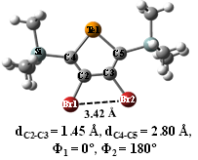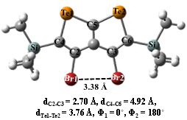
S1a S1b
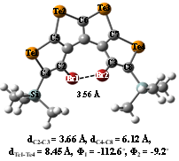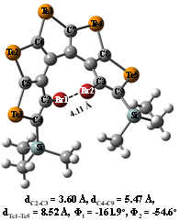
S1c S1d
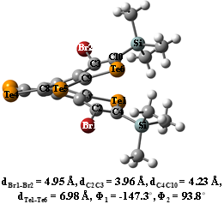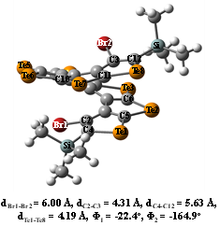
S1e S1f
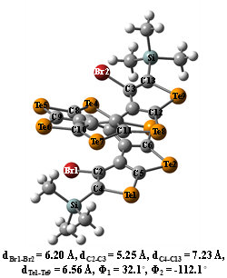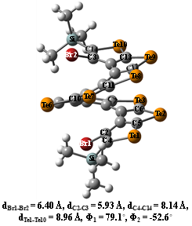
S1g S1h

Figure S1. Optimized structures of tellurophene-based (a-h) [n]helicenes a) [1]helicene, b) [2]helicene, c) [4]helicene, d) [5]helicene, e) [6]helicene, f) [8]helicene, g) [9]helicene, and h) [10]helicene. Φ₁ = δ(Br1C2C3Br2) and Φ₂ = δ(Br2C3C2C4) Computed using B3LYP-D functional in DCM solvent. Basis set used: 6-311++G(d,p) for H, C, Si, Br atoms and lanl2dz for Te atoms. Selected bond distances and dihedral angles are labelled in all figures mentioned above.
3 Selected geometrical parameters of neutral and radicla cations of telluro[n]helicenes, n=1-10
Table S1. Bond distances# and dihedral angles# for the most stable molecular structures of tellurophene-based [n]helicenes and their corresponding radical cations (n=1-10) calculated at B3LYP-D (without brackets) and B3LYP (in parenthesis) functionals in DCM solvent. Lanl2dz basis set is used for Te atoms and 6-311++G(d,p) basis set is considered for all other atoms.
Neutral tellurophene-based [n]helicenes ([n]TeH, n=1-10) in DCM solvent
N | 1 | 2 | 3 | 4 | 5 | 6 | 7 | 8 | 9 | 10
d_{C2-C3 (Å)} | 1.45 | 2.70 | 3.44 | 3.66 | 3.60 | 3.96 | 3.37 | 4.31 | 5.25 | 5.93
ªd_{C4-C5+n (Å)} | 2.80 | 4.92 | 6.07 | 6.12 | 5.47 | 4.23 | 3.92 | 5.63 | 7.23 | 8.15
^{b}d_{Te1-Te(n) (Å)} | - | 3.76,  (3.75) | 6.82,  (6.80) | 8.45,  (8.48) | 8.52,  (8.70) | 6.98,  (7.28) | 4.45,  (5.30) | 4.19,  (4.76) | 6.56,  (6.90) | 8.96,  (9.26)
d_{Br1-Br2 (Å)} | 3.42,  (3.40) | 3.38,  (3.36) | 3.44,  (3.42) | 3.56,  (3.55) | 4.11,  (4.12) | 4.95,  (5.11) | 5.56,  (5.77) | 6.00,  (6.17) | 6.20,  (6.41) | 6.40,  (6.70)
Φ₁ = δ(Br1C2C3Br2) (degree) | 0,  (0) | 0,  (0) | 72.0,  (69.2) | -112.6,  (-109.8) | -161.9,  (-159.2) | -147.3,  (-145.0) | -91.9,  (-91.0) | -22.4,  (-26.6) | 32.1,  (27.2) | 79.1,  (75.3)
Φ₂ ₌ δ(Br2C3C2C4) (degree) | 180,  (180) | 180,  (180) | -78.9,  (-82.7) | -9.2,  (-7.0) | -54.6,  (-53.5) | 93.8,  (95.6) | 140.7,  (139.9) | -164.9,  (-168.5) | -112.1,  (-117.0) | -52.6,  (-56.0)
Tellurophene-based [n]helicenes radical cations ([n]TeH^{•+}, n=1-10) in DCM solvent
d_{C2-C3 (Å)} | 1.50 | 2.70 | 3.44 | 3.63 | 3.60 | 3.28 | 3.34 | 4.30 | 5.29 | 6.00
ªd_{C4-C5+n (Å)} | 2.86 | 4.93 | 6.11 | 6.07 | 5.50 | 4.22 | 3.86 | 5.59 | 7.28 | 8.20
^{b}d_{Te1-Te(n) (Å)} | - | 3.74  (3.73) | 6.82,  (6.80) | 8.35,  (8.39) | 8.50,  (8.68) | 6.95, (7.32) | 4.25,  (5.28) | 4.15,  (4.75) | 6.62,  (6.92) | 9.05,  (9.35)
d_{Br1-Br2 (Å)} | 3.40,  (3.36) | 3.37,  (3.35) | 3.42,  (3.40) | 3.57,  (3.57) | 4.06,  (4.07) | 4.96, (5.10) | 5.59,  (6.01) | 6.01,  (6.17) | 6.21,  (6.42) | 6.39,  (6.66)
Φ₁ = δ(Br1C2C3Br2) (degree) | 0,  (0) | 0,  (0) | 68.6,  (65.5) | -112.2,  (-109.3) | -159.3,  (-156.6) | -148.1,  (-146.3) | -90.5,  (-92.9) | -21.2,  (-27.9) | 33.0,  (27.5) | 79.1,  (75.2)
Φ₂ ₌ δ(Br2C3C2C4) (degree) | 180,  (180) | 180,  (180) | -84.2,  (-88.2) | -6.1,  (-3.5) | -51.7,  (-50.5) | 92.4,  (93.8) | 141.5,  (137.9) | -164.2,  (-170.0) | -116.9,  (-111.7) | -51.7,  (-56.1)
#Figure 1 may be referred for identifying bond distances and dihedral angles.
ªr_{C4-C5+n}, n=0 for telluro[1]helicene, n=1 for telluro[2]helicene and so on.
^{b}r_{Te1-Te(n)}, n = 1 for telluro[1]helicene, n = 2 for telluro[2]helicene and so on.
4 Most stable structures of telluro[n]helicenes radical cation, [n]TeH^{•+}, n=1-10
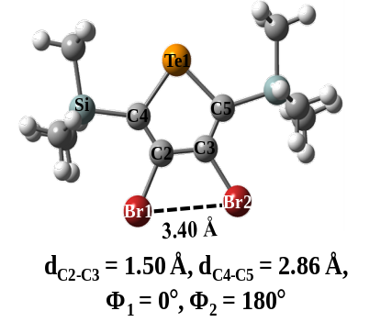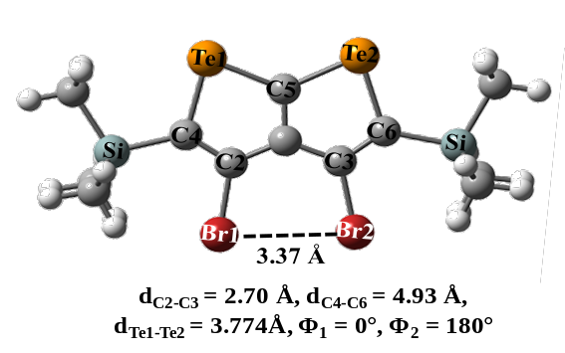
S2a S2b
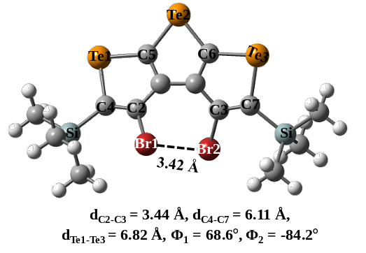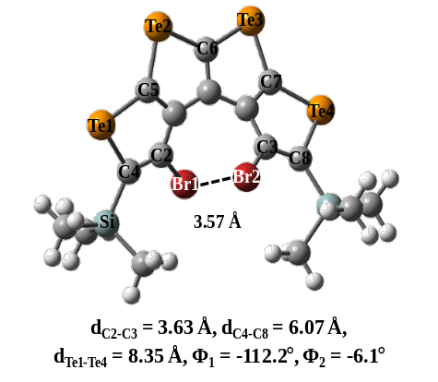
S2c S2d
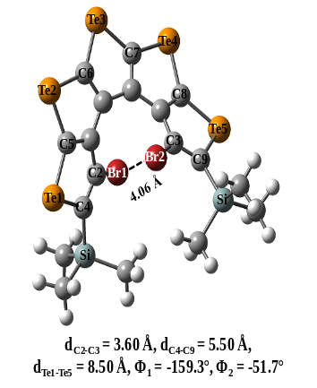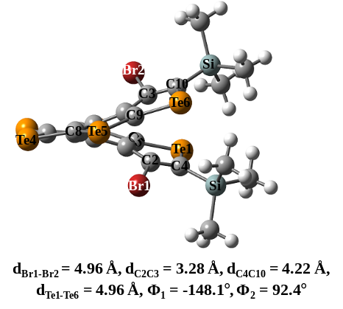
S2e S2f
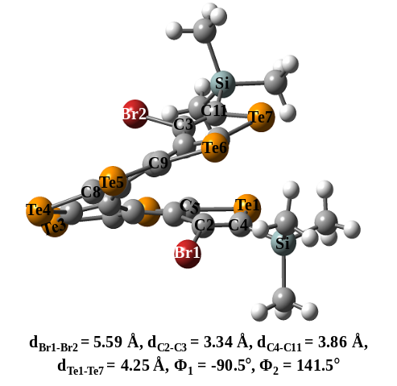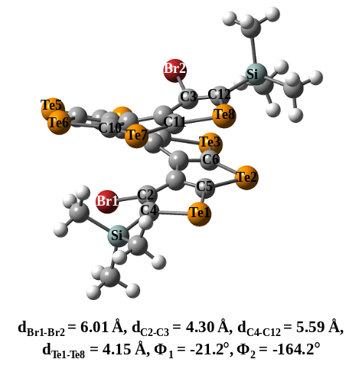
S2g S2h
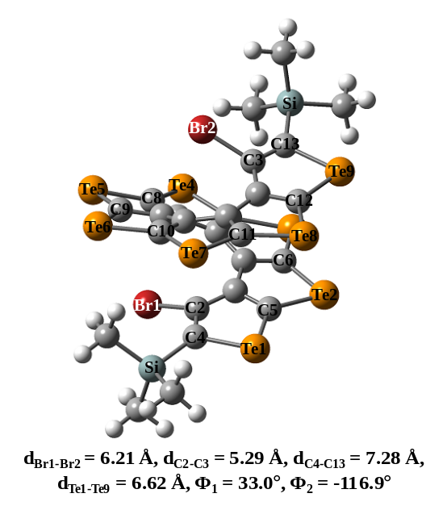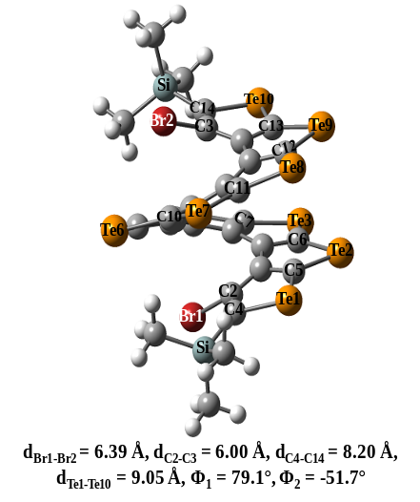
S2i S2j

Figure S2. Most stable structures (S1a-S1j) of telluro[n]helicene radical cations, a) [1]helicene, b) [2]helicene, c) [3]helicene, d) [4]helicene, e) [5]helicene, f) [6]helicene, g) [7]helicene, h) [8]helicene, i) [9]helicene, and j) [10]helicene. Φ₁ = δ(Br1C2C3Br2) and Φ₂ = δ(Br2C3C2C4). Computed using B3LYP-D functional in DCM solvent. Basis set used: 6-311++G(d,p) for H, C, Si, Br atoms and lanl2dz for Te atoms. Selected bond distances and dihedral angles are labelled in all figures mentioned above.

5 Cartesian coordinates for the most stable structures of radical cations of end substituted telluro[n]helicenes, n=1-10 calculated at B3LYP-D with 6-311++G(d,p) basis set for H, C, Si, and Br atoms and lanl2dz basis set for Te atom in DCM solvent.

5.1 Telluro[1]helicene radical cation
C 0.000000 0.000000 0.000000
Si 0.000000 0.000000 1.875072
C 1.721724 0.000000 2.617739
C -0.911376 -1.579134 2.474504
C -0.640600 -2.892204 2.296178
Br 0.890075 -3.422575 1.288937
Te -2.666278 -1.461130 3.629320
C -2.629560 -3.564753 3.604357
Si -3.980142 -4.599616 4.492373
C -4.871435 -5.628823 3.203102
C -1.542734 -3.934740 2.889381
Br -1.153838 -5.784532 2.632811
C -1.005531 1.440900 2.536447
C -3.149519 -5.629900 5.820708
C -5.147720 -3.346351 5.261003
H -3.916770 -6.142255 6.414482
H -2.483260 -6.391367 5.404734
H -2.566479 -4.996075 6.498798
H -5.952947 -3.869536 5.790550
H -4.637714 -2.705626 5.990869
H -5.615862 -2.705036 4.504105
H -5.720581 -6.141248 3.672274
H -5.263137 -4.994391 2.399648
H -4.225896 -6.390193 2.755478
H 0.415149 0.948757 -0.362300
H 0.602397 -0.811448 -0.418856
H -1.020088 -0.092102 -0.390401
H 2.218832 0.948748 2.380022
H 1.676166 -0.092082 3.709033
H 2.344912 -0.811461 2.230521
H -0.540486 2.385734 2.230578
H -2.030467 1.438456 2.145505
H -1.052527 1.438444 3.632404

5.2 Telluro[2]helicene radical cation
C 0.000000 0.000000 0.000000
Si 0.000000 0.000000 1.877867
C 1.776149 0.000000 2.503208
C -0.777778 -1.625908 2.519245
C -2.041558 -2.152596 2.370875
Br -3.273774 -1.098270 1.343859
Te 0.381441 -2.919908 3.655657
C -1.349354 -4.022652 3.667160
C -2.399982 -3.440025 2.969421
C -3.619738 -4.249817 2.995988
Br -5.245862 -3.719025 2.124954
Te -1.808674 -5.830505 4.523035
C -3.659380 -5.455317 3.660610
Si -5.066054 -6.732436 3.884471
C -4.335625 -8.122428 4.923775
C -0.917773 1.467262 2.606711
C -6.492420 -5.941319 4.815060
C -5.575166 -7.408532 2.208143
H -5.101692 -8.890211 5.086365
H -3.485939 -8.608516 4.428467
H -4.007554 -7.774117 5.911007
H -6.286389 -8.231834 2.352021
H -6.055658 -6.654440 1.578663
H -4.707365 -7.804726 1.668178
H -7.237463 -6.710517 5.055080
H -6.146469 -5.502761 5.758245
H -6.990503 -5.159102 4.235560
H 2.276454 0.915187 2.164222
H 1.830410 -0.015260 3.598835
H 2.352337 -0.849691 2.116414
H -0.388575 2.391522 2.342029
H -1.943336 1.548332 2.236008
H -0.951847 1.401046 3.700360
H 0.563051 0.870150 -0.360802
H 0.488062 -0.900992 -0.389387
H -1.007961 0.052946 -0.420690

5.3 Telluro[3]helicene radical cation
C 0.000000 0.000000 0.000000
Si 0.000000 0.000000 1.879657
C 1.737392 0.000000 2.593631
C -0.926814 -1.538726 2.520032
C -0.568740 -2.870926 2.501969
Br 0.850753 -3.400434 1.307364
C -0.955124 1.493454 2.512993
C -1.385447 -3.875284 3.133191
C -2.636991 -3.401834 3.516782
Te -4.024394 -4.905683 3.764342
C -2.366197 -6.072051 3.393256
C -1.193541 -5.329968 3.284357
C -0.005137 -6.112097 3.508307
Br 1.619271 -5.245206 4.084692
C -0.053509 -7.489334 3.572913
Si 1.349753 -8.769817 3.740137
C 0.561590 -10.456499 3.461426
Te -2.037617 -8.115104 3.516022
C 2.635107 -8.435187 2.411912
C 2.074769 -8.689071 5.472459
Te -2.818953 -1.342534 3.364329
H 2.256698 0.920854 2.299481
H 1.707612 -0.035447 3.688791
H 2.329605 -0.849209 2.239944
H 0.429884 0.941350 -0.365245
H 0.587898 -0.825044 -0.412418
H -1.021369 -0.077915 -0.390275
H -0.461591 2.412779 2.175078
H -1.983880 1.516963 2.132349
H -0.990534 1.519678 3.608333
H 1.328649 -11.236127 3.543399
H -0.210803 -10.679397 4.208091
H 0.112796 -10.536611 2.464491
H 2.799844 -9.502403 5.603218
H 2.588408 -7.741916 5.660835
H 1.291404 -8.810969 6.229466
H 3.408758 -9.212771 2.443525
H 2.178484 -8.453857 1.415586
H 3.124905 -7.466061 2.545533

5.4 Telluro[4]helicene radical cation
C 0.000000 0.000000 0.000000
Si 0.000000 0.000000 1.882565
C 1.770491 0.000000 2.515621
C -0.976416 -1.472410 2.524034
C -0.885644 1.589611 2.427100
C -1.285033 2.009578 3.651068
Br -0.580567 1.115729 5.224149
Te -1.378985 3.103031 1.014465
C -2.051412 4.061492 2.685388
C -2.019065 3.261379 3.825708
C -2.619356 3.835582 5.005081
C -3.108090 3.209084 6.209083
C -3.599654 1.851652 6.437255
Br -4.121288 0.780030 4.904497
Te -2.597452 6.053128 3.078662
C -2.751445 5.256929 4.975903
Te -3.056654 6.087709 6.839720
C -3.228045 4.047266 7.315803
Te -3.718879 3.050221 9.026875
C -3.919669 1.415586 7.678904
Si -4.499530 -0.286407 8.291066
C -6.237386 -0.638128 7.665348
C -3.266369 -1.578789 7.706326
C -4.506507 -0.209804 10.172061
H -6.607781 -1.573296 8.104357
H -6.926540 0.164934 7.951874
H -6.266086 -0.739807 6.576376
H -4.795568 -1.184766 10.582651
H -3.516163 0.038245 10.572262
H -5.224583 0.530100 10.546822
H -3.552356 -2.568594 8.084081
H -3.218188 -1.632455 6.614510
H -2.261108 -1.351161 8.079591
H -0.511060 -2.407244 2.186798
H -1.019017 -1.488885 3.617276
H -2.004652 -1.449698 2.144683
H 0.465029 -0.921041 -0.371646
H -1.017526 0.045174 -0.406290
H 0.571172 0.843490 -0.407217
H 2.308954 -0.867015 2.112138
H 2.300560 0.904771 2.195690
H 1.813285 -0.052157 3.607626

5.5 Telluro[5]helicene radical cation
C 0.000000 0.000000 0.000000
Si 0.000000 0.000000 1.878292
C 1.782007 0.000000 2.528968
Te 2.366526 -1.411120 3.978334
C 4.121732 -0.350195 3.890098
C 4.130713 0.627208 2.911080
C 5.390979 1.363155 2.763970
C 5.898912 2.166371 1.687490
C 6.905118 3.086172 2.068104
Te 7.234829 4.567514 0.690056
C 5.942454 3.346085 -0.415156
Te 5.344152 3.382250 -2.378523
C 4.695438 1.434243 -1.911620
Si 3.955466 0.336190 -3.270163
C 2.314914 -0.378063 -2.698812
C -0.804305 -1.586537 2.500552
C -0.918246 1.486961 2.575178
C 2.834050 0.827320 2.278734
Br 2.502756 2.448411 1.268035
Te 5.794547 -0.280649 5.147257
C 6.259403 1.259472 3.876809
Te 7.772950 2.691203 3.921063
C 5.554731 2.203795 0.262123
C 4.973102 1.185882 -0.601990
Br 4.832326 -0.640790 0.032528
C 3.664138 1.445725 -4.765251
C 5.185411 -1.015060 -3.718751
H 3.253007 0.851836 -5.590688
H 2.946244 2.243857 -4.542238
H 4.591188 1.908636 -5.125325
H 4.794847 -1.616203 -4.549694
H 6.141562 -0.581828 -4.035135
H 5.378091 -1.685541 -2.875514
H 1.883893 -0.997237 -3.496024
H 2.425418 -1.000354 -1.807274
H 1.600801 0.418610 -2.466839
H -1.033386 -0.018597 -0.369415
H 0.492143 0.884825 -0.411312
H 0.514248 -0.883673 -0.391321
H -1.968533 1.460976 2.257999
H -0.895870 1.479664 3.671288
H -0.483012 2.430724 2.232251
H -1.848351 -1.626219 2.166679
H -0.297705 -2.476665 2.109202
H -0.808529 -1.647662 3.595818

5.6 Telluro[6]helicene radical cation
C 0.000000 0.000000 0.000000
Si 0.000000 0.000000 1.884784
C 1.777955 0.000000 2.501638
C -0.947719 1.497765 2.508550
C -0.878577 -1.587168 2.429063
C -1.254133 -2.030693 3.663354
Br -0.547115 -1.101186 5.217237
Te -1.277781 -3.091221 1.015065
C -1.929013 -4.087372 2.696090
C -1.919204 -3.308931 3.841967
C -2.494952 -3.939388 5.038451
C -2.969543 -3.357886 6.274601
C -3.354885 -2.000429 6.591163
C -3.729306 -0.881488 5.714611
C -4.245447 -0.863804 4.357631
Br -5.031324 -2.480429 3.617844
Te -2.477004 -6.062369 3.043686
C -2.661645 -5.320901 4.950491
Te -3.102419 -6.253280 6.777567
C -3.074807 -4.272756 7.358759
Te -3.170522 -3.363497 9.209486
C -3.311715 -1.691443 7.950082
Te -3.349644 0.323549 8.347716
C -3.664522 0.375364 6.293450
Te -4.024372 1.913348 4.971605
C -4.435828 0.305391 3.680862
Si -5.091942 0.648478 1.937629
C -4.879357 2.496253 1.632771
C -4.082093 -0.312125 0.677483
C -6.919998 0.213156 1.835995
H -5.483790 3.097660 2.322967
H -3.833342 2.808826 1.730479
H -5.205291 2.741499 0.614451
H -4.465714 -0.112210 -0.331386
H -3.032024 -0.007600 0.706348
H -4.126544 -1.389859 0.853113
H 1.831254 0.042734 3.593522
H 2.304244 -0.902889 2.170250
H 2.312497 0.869721 2.098541
H -1.958430 1.520525 2.091148
H -1.031644 1.504512 3.598161
H -0.431759 2.415514 2.197961
H 0.458986 0.925668 -0.368520
H 0.578377 -0.837160 -0.409909
H -1.015853 -0.051866 -0.408366
H -7.092132 -0.859390 1.965982
H -7.489699 0.745237 2.606926
H -7.319460 0.507794 0.857089

5.7 Telluro[7]helicene radical cation
C 0.000000 0.000000 0.000000
Si 0.000000 0.000000 1.879007
C 1.764796 0.000000 2.534382
C -0.902863 -1.537517 2.488846
C -0.902441 1.487980 2.623191
C -0.788594 2.822013 2.412419
Br 0.624413 3.443839 1.233673
Te -2.116958 1.191081 4.331922
C -2.092838 3.240345 4.365192
Te -2.598876 4.639152 5.825944
C -1.870558 5.898929 4.350225
C -1.571219 5.248401 3.140983
C -1.438528 6.128158 1.990284
C -1.534524 5.827768 0.554394
C -2.034434 4.640894 -0.121656
C -2.882578 3.561842 0.359674
C -3.895478 3.544144 1.415976
Br -4.600949 5.233868 2.063849
C -1.496931 3.799272 3.240199
Te -1.596881 7.946997 4.291727
C -1.225158 7.466210 2.295752
Te -0.680375 8.611478 0.667551
C -1.035824 6.815562 -0.285190
Te -0.712777 6.175302 -2.244531
C -1.584783 4.480904 -1.443530
Te -1.829138 2.562850 -2.189443
C -2.820325 2.376742 -0.364811
Te -3.890356 0.851454 0.489432
C -4.538315 2.405585 1.772975
Si -5.996408 2.077735 2.934327
C -6.136680 0.206547 3.107610
C -7.553238 2.757168 2.122704
C -5.766391 2.830861 4.640355
H -0.858863 -1.636644 3.580107
H -1.956263 -1.531088 2.185702
H -0.438073 -2.434408 2.061403
H 0.552149 -0.883395 -0.347051
H -1.015618 -0.055584 -0.402138
H 0.482570 0.887513 -0.414879
H -7.498892 3.843996 2.001206
H -7.702195 2.311916 1.132061
H -8.434127 2.526087 2.734987
H -4.896876 2.409052 5.152489
H -5.646212 3.915660 4.602290
H -6.657341 2.606260 5.241590
H -6.951727 -0.041768 3.798397
H -6.360525 -0.281081 2.151198
H -5.214697 -0.229666 3.509173
H 2.314422 0.886964 2.202532
H 1.773383 -0.014217 3.630525
H 2.303236 -0.887663 2.178864

5.8 Telluro[8]helicene radical cation
C 0.000000 0.000000 0.000000
Si 0.000000 0.000000 1.885371
C 1.812779 0.000000 2.431680
C 2.394741 -0.221246 3.640748
Br 1.219841 -0.355002 5.187845
C -0.945953 -1.512318 2.482034
C -0.812392 1.575139 2.520577
Te 3.280808 0.707043 1.084425
C 4.481869 0.491685 2.751715
C 3.830675 -0.082133 3.841202
C 4.660239 -0.321367 5.021216
C 4.378759 -1.082815 6.243499
C 3.536068 -2.244956 6.433449
C 2.924215 -3.113389 5.449438
C 3.167165 -3.207915 4.005457
C 4.381434 -2.958333 3.230142
C 5.775640 -2.872368 3.642747
Br 6.303257 -3.561541 5.385853
Te 6.400383 1.135796 3.172550
C 5.890189 0.314864 5.010037
Te 6.792259 0.394890 6.875469
C 5.135613 -0.725412 7.354503
Te 4.550695 -1.675717 9.125912
C 3.271514 -2.581603 7.778722
Te 1.682089 -3.882442 8.009644
C 1.855673 -3.867329 5.923308
Te 0.586516 -4.494376 4.431653
C 2.084533 -3.656775 3.267862
Te 2.340108 -3.504314 1.213088
C 4.216625 -2.913903 1.847664
Te 5.948308 -2.455364 0.818165
C 6.768508 -2.571237 2.763397
Si 8.649041 -2.484683 2.965035
C 9.180332 -1.499152 4.476460
C 9.318464 -4.241854 3.058661
C 9.322213 -1.628632 1.425996
H 9.103607 -2.187283 0.507597
H 8.911479 -0.618048 1.319541
H 10.413100 -1.540525 1.500333
H 10.276680 -1.437972 4.484523
H 8.784676 -0.479933 4.448744
H 8.859022 -1.964292 5.411045
H -0.819810 1.604907 3.615200
H -0.278109 2.461998 2.160289
H -1.850472 1.638035 2.170132
H -0.477333 -2.438665 2.137951
H -1.022361 -1.552912 3.570872
H -1.962782 -1.472230 2.069433
H -1.033006 -0.014372 -0.368808
H 0.481384 0.892685 -0.417985
H 0.510002 -0.884237 -0.399174
H 8.937193 -4.765868 3.941378
H 9.029650 -4.816920 2.171153
H 10.414414 -4.230958 3.114767

5.9 Telluro[9]helicene radical cation
C 0.000000 0.000000 0.000000
Si 0.000000 0.000000 1.886061
C 1.778515 0.000000 2.505092
C -0.843497 -1.601677 2.434447
Te -0.967485 -3.201490 1.052907
C -1.619685 -4.207054 2.731171
Te -1.872533 -6.227612 3.117001
C -2.371254 -5.430298 4.972994
Te -2.765567 -6.326414 6.791546
C -2.991411 -4.345926 7.332851
Te -3.280122 -3.384780 9.160898
C -3.400981 -1.764208 7.900835
Te -3.724808 0.271505 8.215510
C -3.936454 0.172530 6.143442
Te -4.046929 1.599476 4.666905
C -4.194895 -0.120604 3.497162
Te -4.299468 -0.446156 1.460243
C -4.640468 -2.370006 2.129462
Te -5.004807 -4.145664 1.108088
C -5.331284 -4.767304 3.058042
Te -5.942583 -6.576139 3.837385
C -6.212106 -5.390518 5.570811
Si -7.099849 -6.153895 7.056325
C -7.004610 -8.025938 6.847495
C -0.913922 1.528742 2.487166
C -1.254936 -2.044520 3.650248
C -1.802511 -3.386943 3.842556
C -2.374133 -4.039571 5.019708
C -2.907958 -3.473215 6.262460
C -3.372777 -2.122868 6.548695
C -3.877426 -1.130706 5.637641
C -4.263223 -1.284854 4.241621
C -4.704815 -2.479612 3.515135
C -5.244518 -3.747878 4.003673
C -5.843454 -4.115048 5.286420
Br -6.534724 -2.716535 6.454577
Br -0.690560 -1.010264 5.202678
C -6.288904 -5.688847 8.687165
C -8.905494 -5.619606 7.033343
H -7.521550 -8.366028 5.941611
H -5.966717 -8.375998 6.803333
H -7.486774 -8.517029 7.701690
H -6.847866 -6.154895 9.509223
H -5.255716 -6.048175 8.732864
H -6.280860 -4.608741 8.850303
H 1.824183 0.011938 3.598641
H 2.311363 -0.891145 2.152935
H 2.311200 0.883403 2.130461
H -1.930561 1.567679 2.082614
H -0.979852 1.567711 3.576860
H -0.376997 2.423089 2.144711
H 0.458931 0.925695 -0.368480
H 0.577853 -0.836671 -0.411795
H -1.017430 -0.052310 -0.404740
H -9.006794 -4.537576 7.163820
H -9.378276 -5.892448 6.082492
H -9.458731 -6.115214 7.841304

5.10 Telluro[10]helicene radical cation
C 0.000000 0.000000 0.000000
Si 0.000000 0.000000 1.878908
C 1.763092 0.000000 2.539890
C -0.890583 -1.552078 2.477304
C -0.935523 1.478166 2.593662
Te -2.191857 1.159504 4.264358
C -2.250502 3.219529 4.241135
C -1.629482 3.784758 3.135030
C -1.722061 5.245491 3.031784
C -1.450608 6.150560 1.916161
C -1.338822 5.867411 0.483573
C -1.807917 4.718821 -0.251046
C -2.833565 3.773334 0.113856
C -3.931252 3.931635 1.070421
C -4.511805 5.147644 1.637583
C -4.436829 6.547207 1.203340
C -4.163845 7.133200 -0.108761
Br -4.339193 6.020262 -1.698471
C -0.849412 2.814408 2.367319
Br 0.665087 3.438561 1.312203
Te -2.819478 4.603853 5.686500
C -2.089999 5.881085 4.217829
Te -1.764749 7.923741 4.219014
C -1.253072 7.478692 2.256443
Te -0.455460 8.612390 0.712170
C -0.677105 6.821918 -0.276733
Te -0.089925 6.112237 -2.154447
C -1.182242 4.490319 -1.486940
Te -1.552079 2.604665 -2.246368
C -2.774277 2.555465 -0.549885
Te -3.943459 1.110864 0.332748
C -4.509932 2.742481 1.482977
Te -5.805998 2.957352 3.090960
C -5.312883 4.938718 2.760397
Te -5.840417 6.674829 3.774321
C -4.848412 7.489330 2.136732
Te -4.603064 9.438422 1.513415
C -4.095571 8.475838 -0.299594
Si -3.884174 9.535311 -1.850039
C -3.591561 11.305758 -1.266876
C -5.465568 9.469106 -2.869941
C -2.410007 8.996980 -2.883138
H -0.862429 -1.653063 3.569093
H -1.939372 -1.564929 2.157931
H -0.403601 -2.440209 2.056078
H 0.514940 -0.901002 -0.358407
H -1.020257 -0.010769 -0.396163
H 0.512810 0.872519 -0.410502
H -5.667936 8.455214 -3.229618
H -6.326783 9.796976 -2.276059
H -5.382538 10.131048 -3.741438
H -1.482644 9.041261 -2.303460
H -2.523767 7.978834 -3.261573
H -2.308299 9.673162 -3.742126
H -3.425923 11.955570 -2.135016
H -4.450373 11.710156 -0.717421
H -2.706789 11.378457 -0.623436
H 2.314255 0.886552 2.210429
H 1.768739 -0.015449 3.636074
H 2.300894 -0.888551 2.185194

6 Spin density plot with contour cutoff = 0.003 a.u. for the most stable structures of telluro[n]helicenes radical cation, [n]TeH^{+●}, n=1-2,4-6,8-10 calculated at B3LYP-D functional with 6-311++G(d,p) basis set for H, C, Si, and Br atoms and lanl2dz basis set for Te atom in DCM solvent.
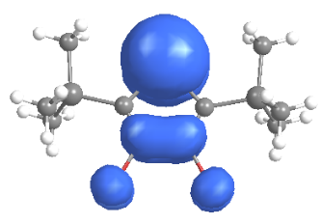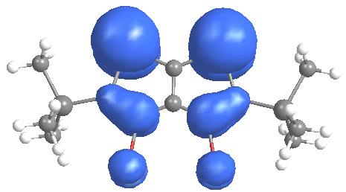
[1]TeH^{+●} [2]TeH^{+●}
S3a S3b
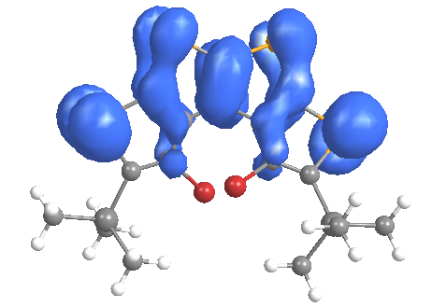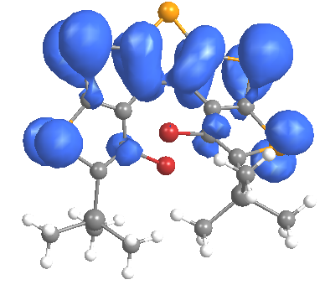
[4]TeH^{+●} [5]TeH^{+●}
S3c S3d
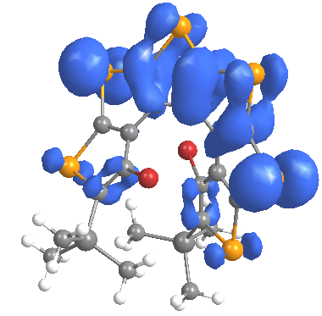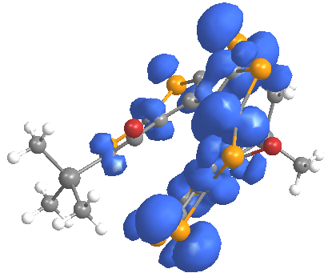
[6]TeH^{+●} [8]TeH^{+●}
S3e S3f

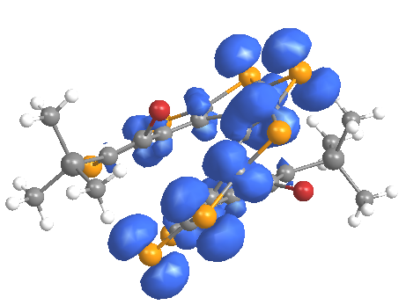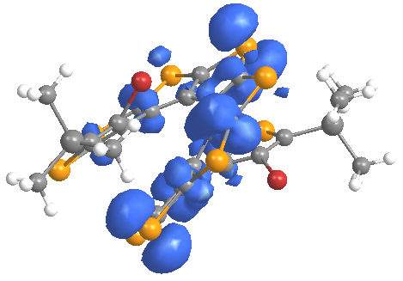
[9]TeH^{+●} [10]TeH^{+●}
S3i S3j
Figure S3. Spin density plot for the most stable structures of telluro[n]helicenes radical cation, [n]TeH^{•+} (n=1-2, 4-6, 8-10) (S2a-S2h) at B3LYP-D functional (ROHF formalism) with 6-311++G(d,p) basis set for H, C, Si, and Br atoms and LANL2DZ basis set for Te atoms in DCM solvent.

7. Ionization energies (in eV) plots and table for thia[n]helicenes, [n]TH, n=1-10 and seleno[n]helicenes, [n]SH n=1-10, and telluro[n]helicenes, [n]TeH, in DCM solvent

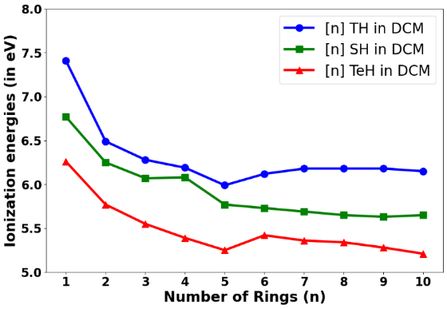
Figure S4. Plot of ionization energies (in eV) vs the number of rings in thia[n]helicenes, [n]TH, n=1-10 and seleno[n]helicenes, [n]SH n=1-10, and telluro[n]helicenes, [n]TeH, n=1-10 in DCM solvent: DFT Method: B3LYP functional (most stable geometries) and then single point energy calculations at ωB97XD functional. Basis set used: 6-311++G(d,p) for H, C, Si, S, Se, Br atoms and LANL2DZ basis set for Te atoms.

Table S2. Calculated ionization energies (in eV) vs the number of rings in thia[n]helicenes, [n]TH, n=1-10 and seleno[n]helicenes, [n]SH n=1-10 and telluro[n]helicenes, [n]the, n=1-10 in DCM solvent. Values in italics braces are for neutral systems in gas phase
Number of rings  (n) | E_{g} for [n] TH  (in eV) | E_{g} for [n] SH  (in eV) | E_{g} for [n] TeH  (in eV)
1 | 7.41, (8.81) | 6.77, (8.49) | 6.26, (8.18)
2 | 6.49, (7.82) | 6.25, (7.88) | 5.77, (7.48)
3 | 6.28, (7.55) | 6.07, (7.80) | 5.55, (7.22)
4 | 6.19, (7.46) | 6.08, (7.49) | 5.39, (6.96)
5 | 5.99, (7.21) | 5.77, (7.33) | 5.25, (6.80)
6 | 6.12, (7.34) | 5.73, (7.28) | 5.42, (6.93)
7 | 6.18, (7.34) | 5.69, (7.24) | 5.36, (6.86)
8 | 6.18, (7.32) | 5.65, (7.18) | 5.34, (6.79)
9 | 6.18, (7.30) | 5.63, (7.09) | 5.28, (6.73)
10 | 6.15, (7.26) | 5.65, (7.09) | 5.21, (6.59)
DFT Method: B3LYP functional (most stable geometries) and then single point energy calculations at ωB97XD functional. Basis set used: 6-311++G(d,p) for H, C, Si, S, Se, Br atoms and LANL2DZ basis set for Te atoms.

8. Cartesian coordinates for the most stable structures of π-dimer systems
Functional used : B3LYP-D, Basis set used:6-311++G(d,p) for H, C, P, F atoms and lanl2dZ for Te atom, Solvent used: DCM (in SMD model)
8.1 π-dimer of unsub-[7]TeH)₂²⁺ system

C 0.000000 0.000000 0.000000
Te 0.000000 0.000000 2.069554
C 2.055350 0.000000 1.738279
C 2.361658 -0.029207 0.418500
C 1.274373 -0.079847 -0.532651
C 1.365528 -0.141473 -1.991354
C 2.507715 -0.440982 -2.826858
C 3.804648 -1.037304 -2.483813
C 4.197018 -1.882997 -1.350364
C 3.373052 -2.615895 -0.411758
C 1.955370 -2.886578 -0.509758
C 1.365568 -3.603295 0.468203
Te 2.734222 -4.209713 1.930679
C 4.022847 -3.184205 0.684177
Te 6.089870 -2.991311 0.620819
C 5.575042 -2.036666 -1.164888
Te 6.694714 -1.347943 -2.740841
C 4.816941 -0.773703 -3.392197
Te 4.164393 0.097611 -5.164141
C 2.373987 -0.036854 -4.167175
Te 0.444961 0.517152 -4.700413
C 0.184667 0.165710 -2.672690
Te -1.476892 0.262860 -1.453792
C -0.068638 -3.446480 -3.387560
C -1.319829 -3.169626 -2.968599
Te -2.547277 -2.525538 -4.536517
C -0.799807 -2.831224 -5.595860
Te -0.213927 -2.385709 -7.538709
C 1.607956 -3.029738 -6.742362
Te 3.528532 -2.983961 -7.461081
C 3.875294 -3.922621 -5.649354
C 2.723593 -4.183144 -4.924833
C 1.511395 -3.538099 -5.442587
C 0.237944 -3.305994 -4.793794
Te 5.626928 -4.529794 -4.709386
C 4.254389 -5.161986 -3.318757
C 2.921300 -5.044282 -3.751756
C 1.973627 -5.843053 -3.005478
C 0.613581 -6.247598 -3.363181
C -0.013130 -6.189465 -4.664637
C -1.301689 -6.595550 -4.772257
Te -2.069983 -7.266125 -2.956933
C -0.145617 -6.808492 -2.351480
Te 0.949858 -7.164310 -0.609205
C 2.429907 -6.325046 -1.774750
Te 4.473739 -6.125350 -1.491366
H 2.769291 0.030009 2.550615
H 3.391028 -0.001684 0.087867
H 1.385625 -2.516211 -1.345776
H 0.318581 -3.866054 0.519490
H -1.888908 -6.595647 -5.680881
H 0.534041 -5.846303 -5.532120
H -1.680293 -3.243515 -1.952568
H 0.689199 -3.773654 -2.695275

8.2 π-dimer of sub-[7]TeH)₂²⁺ system

C 0.000000 0.000000 0.000000
Si 0.000000 0.000000 1.884512
C 1.770104 0.000000 2.528602
C -0.792051 1.618616 2.471059
Te 0.425875 3.207138 3.106781
C -1.354117 4.243831 3.010730
Te -1.825628 6.263151 2.967682
C -3.703380 5.467541 2.654183
Te -5.570316 6.379711 2.445663
C -6.146157 4.405493 2.713700
Te -8.010757 3.536375 2.818222
C -6.813126 1.912134 3.358752
Te -7.203332 -0.095905 3.633424
C -5.235974 -0.049668 4.254751
Te -3.926775 -1.545039 4.870156
C -2.760214 0.123440 5.222171
Te -0.896757 0.365698 6.066791
C -1.533346 2.388732 6.156623
Si -0.515921 3.606216 7.190210
C -1.326874 3.747159 8.883484
C -3.416084 1.332883 4.970203
C -4.681552 1.226291 4.261657
C -5.478800 2.249493 3.561783
C -5.076477 3.529091 3.000102
C -3.752038 4.080531 2.765531
C -2.440382 3.427887 2.754042
C -2.073854 2.072850 2.377851
Br -3.345906 1.032035 1.376089
C -2.766938 2.477428 5.600224
Br -3.831155 4.060503 5.991631
C -0.891433 -1.524556 2.525943
C 1.203530 2.855402 7.368364
C -0.355319 5.303154 6.397119
Br -4.565522 -2.185586 0.960489
C -6.088600 -3.340461 0.722807
C -5.914715 -4.670623 0.932598
Te -7.816423 -5.559412 1.141745
C -8.439483 -3.617366 0.933681
Te -10.271955 -2.690374 1.280721
C -9.130729 -1.050344 0.770037
Te -9.644293 0.940772 0.591142
C -7.708087 0.972597 -0.191832
Te -6.493508 2.510720 -0.810598
C -5.418168 0.901894 -1.545652
Te -3.569632 0.767731 -2.493868
C -4.107735 -1.223574 -2.478744
Te -3.054627 -2.957956 -2.923585
C -4.934766 -3.762550 -2.529161
Te -5.699022 -5.663380 -2.674532
C -7.538838 -4.628474 -2.523351
Si -9.139731 -5.563758 -2.904855
C -8.754752 -7.400476 -2.728301
C -7.415477 -2.738689 0.610096
C -7.823015 -1.364067 0.331700
C -7.162398 -0.294530 -0.396103
C -6.020553 -0.326770 -1.319175
C -5.406846 -1.455373 -2.010693
C -5.902842 -2.804227 -2.248126
C -7.269970 -3.308827 -2.368692
Br -8.710564 -2.040333 -2.685821
Si -4.367502 -5.685533 1.343194
C -3.831346 -5.231225 3.092094
C -9.618457 -5.190945 -4.687246
C -10.552635 -5.121657 -1.744585
C -4.876033 -7.499224 1.277288
C -2.940513 -5.399353 0.152978
H 1.187345 1.911104 7.925944
H 1.664017 2.671818 6.390699
H 1.854029 3.546151 7.918741
H 0.165445 5.966290 7.100506
H 0.233338 5.260342 5.475891
H -1.324713 5.748964 6.164611
H -1.019359 -0.018172 -0.399731
H 0.503028 0.891540 -0.392393
H 0.531352 -0.883401 -0.376375
H -0.763241 -1.635938 3.606721
H -1.960828 -1.499542 2.311360
H -0.468567 -2.412882 2.039041
H 2.267434 -0.937616 2.251703
H 2.363137 0.821591 2.109157
H 1.796048 0.079865 3.621784
H -2.328704 4.183032 8.811973
H -1.418023 2.761440 9.354417
H -0.723606 4.384298 9.542576
H -5.638293 -7.743316 2.027668
H -5.266940 -7.769356 0.289380
H -4.005730 -8.136202 1.476707
H -2.059680 -5.931520 0.536009
H -3.160788 -5.789424 -0.845119
H -2.683982 -4.341974 0.059294
H -9.846235 -4.129337 -4.828068
H -8.804187 -5.456968 -5.371346
H -10.505205 -5.770918 -4.972894
H -10.356866 -5.465272 -0.724325
H -10.745973 -4.047195 -1.713411
H -11.463142 -5.621934 -2.100056
H -9.663504 -7.987246 -2.910374
H -8.000827 -7.735130 -3.451432
H -8.397116 -7.643425 -1.721073
H -3.461944 -4.202195 3.136861
H -4.663092 -5.327915 3.799703
H -3.024540 -5.897184 3.423987

8.3 π-dimer of sub-[7]TeH)₂²⁺.(PF₆)₂²⁻ system
C 0.000000 0.000000 0.000000
Si 0.000000 0.000000 1.878868
C 1.773338 0.000000 2.524976
C -0.775551 1.636996 2.441659
C -2.042695 2.115885 2.367431
Br -3.353977 0.999221 1.455270
Te 0.507363 3.227456 2.978761
C -1.250338 4.294119 2.900847
C -2.372976 3.499969 2.707036
C -3.654939 4.204844 2.738286
C -3.557114 5.588103 2.584033
Te -1.640228 6.334538 2.836032
Te -5.340581 6.519793 2.128639
C -6.005208 4.590175 2.481912
C -5.015247 3.708351 2.892275
C -5.513134 2.447006 3.480139
C -6.845845 2.159418 3.209862
Te -7.897037 3.771401 2.470526
Te -7.381748 0.184126 3.569686
C -5.430510 0.177304 4.263764
Te -4.164093 -1.370466 4.817499
C -2.923073 0.262049 5.184306
C -3.532758 1.484817 4.954520
C -4.815489 1.432710 4.252572
Te -1.056795 0.432256 6.036647
C -1.610931 2.471544 6.138080
Si -0.537756 3.656450 7.146195
C -1.296040 3.823507 8.862652
C -2.840790 2.605774 5.580987
Br -3.849414 4.228340 5.958450
C -0.884610 -1.510735 2.561887
C 1.169552 2.867810 7.283684
C -0.354574 5.349985 6.350199
F -1.523820 -2.894440 -0.317317
P -1.832460 -3.324490 -1.871884
F -0.706699 -4.521119 -1.766028
F -2.993016 -4.371794 -1.351170
F -0.676724 -2.279687 -2.397162
F -2.958635 -2.130933 -1.980387
F -2.145559 -3.758380 -3.428993
C -4.979310 0.417447 -2.259042
Si -3.774879 0.946779 -3.604429
C -2.029209 0.957070 -2.904566
C -4.102507 2.702758 -4.251065
C -5.229287 3.346558 -4.654076
Br -6.865016 2.297184 -4.806651
Te -2.430567 3.884624 -4.800481
C -3.914978 5.113112 -5.546523
C -5.200512 4.684460 -5.233840
C -6.289401 5.569932 -5.655580
C -5.925462 6.514502 -6.604121
Te -3.871272 6.715226 -6.862208
Te -7.525566 7.540607 -7.429918
C -8.529502 6.393307 -6.038532
C -7.690843 5.652801 -5.219104
C -8.338234 5.133788 -4.019865
C -9.751198 5.066869 -4.079873
Te -10.567597 6.187205 -5.606063
Te -10.600779 3.852325 -2.644128
C -8.606118 3.832963 -2.036116
Te -7.576598 2.597702 -0.783284
C -6.000848 3.804333 -1.386138
C -6.399299 4.795818 -2.266287
C -7.766355 4.659364 -2.790438
Te -4.042601 3.971704 -0.817880
C -4.163506 5.739573 -1.911491
Si -2.694543 6.937902 -1.828463
C -3.073237 8.276402 -0.556387
C -5.422755 5.850252 -2.434689
Br -5.987707 7.568895 -3.121990
C -3.879260 -0.243113 -5.057774
C -1.211562 5.929349 -1.245940
C -2.290128 7.722682 -3.485378
F -13.196385 4.588342 -4.377786
P -14.276978 5.580315 -3.610091
F -15.515551 4.744964 -4.288661
F -14.247495 6.595252 -4.901307
F -13.023024 6.405363 -2.936029
F -15.343856 6.564067 -2.845604
F -14.286671 4.554988 -2.324181
H 1.142286 1.909945 7.817770
H 1.611648 2.697828 6.295166
H 1.840765 3.532805 7.841055
H 0.289609 5.968316 6.989394
H 0.113129 5.277268 5.364416
H -1.312779 5.861108 6.235169
H -1.016699 -0.042363 -0.394347
H 0.479593 0.907400 -0.386085
H 0.542283 -0.868038 -0.389549
H -0.747561 -1.587205 3.645190
H -1.954556 -1.504441 2.346157
H -0.452321 -2.406007 2.098956
H 2.257822 -0.949582 2.265929
H 2.375539 0.804080 2.084317
H 1.805629 0.103073 3.616168
H -2.299291 4.259989 8.813679
H -1.375402 2.844706 9.350046
H -0.674103 4.469238 9.495705
H -1.359019 5.500044 -0.247988
H -0.979599 5.119021 -1.946251
H -0.330897 6.580835 -1.184789
H -1.447452 8.412057 -3.343111
H -1.993427 6.970712 -4.221266
H -3.128507 8.290181 -3.895237
H -4.887380 -0.268049 -5.485560
H -3.179692 0.046280 -5.850695
H -3.620329 -1.256047 -4.726219
H -4.849472 1.001854 -1.344687
H -6.020473 0.494165 -2.581121
H -4.772402 -0.629901 -2.015817
H -1.798474 -0.029854 -2.495966
H -1.277083 1.175307 -3.672906
H -1.924910 1.692055 -2.099317
H -4.050902 8.739187 -0.724321
H -3.051573 7.861898 0.456635
H -2.309969 9.063096 -0.612154

9 Statistical Errors (MSE, MAE and MAX_UE)$ analysis for different density functionals against CCSD(T) level of theory
Table S3: HOMO energies from different density functionals for Thia[n]helicenes, n=1-5
n | Units | Set 1 |  |  |  |  |  |  |  | Set 2
n | Units | BLYP | B3LYP | B3LYP-D | B3LYP-D3 | PBE0 | LC-BLYP | MN15 | ωB97XD | M06 | CAM-B3LYP | ωB97XD | LC-ωPBE | LC-BLYP
1 | a.u | -0.20862 | -0.24580 | -0.24583 | -0.24577 | -0.28767 | -0.35691 | -0.27814 | -0.32088 | -0.25579 | -0.30025 | -0.32030 | -0.35037 | -0.35402
1 | eV | -5.67676 | -6.68846 | -6.68928 | -6.68765 | -7.82779 | -9.71188 | -7.56847 | -8.73147 | -6.96030 | -8.17010 | -8.71568 | -9.53392 | -9.63324
2 | a.u | -0.19746 | -0.23263 | -0.23269 | -0.23269 | -0.27179 | -0.33287 | -0.26204 | -0.30286 | -0.23997 | -0.28344 | -0.30346 | -0.33049 | -0.33390
2 | eV | -5.37308 | -6.33009 | -6.33173 | -6.33173 | -7.39568 | -9.05773 | -7.13037 | -8.24112 | -6.52982 | -7.71269 | -8.25745 | -8.99296 | -9.08575
3 | a.u | -0.19048 | -0.22457 | -0.22457 | -0.22448 | -0.26261 | -0.32397 | -0.25360 | -0.29403 | -0.23178 | -0.27445 | -0.29445 | -0.32098 | -0.32323
3 | eV | -5.18315 | -6.11077 | -6.11077 | -6.10833 | -7.14588 | -8.81555 | -6.90071 | -8.00085 | -6.30697 | -7.46806 | -8.01228 | -8.73419 | -8.79541
4 | a.u | -0.18571 | -0.21901 | -0.21904 | -0.21893 | -0.25618 | -0.31651 | -0.24790 | -0.28782 | -0.22625 | -0.26788 | -0.28782 | -0.31377 | -0.31613
4 | eV | -5.05335 | -5.95948 | -5.96030 | -5.95730 | -6.97091 | -8.61255 | -6.74561 | -7.83187 | -6.15649 | -7.28928 | -7.83187 | -8.53800 | -8.60221
5 | a.u | -0.18331 | -0.21629 | -0.21638 | -0.21628 | -0.25306 | -0.31293 | -0.24477 | -0.28442 | -0.22306 | -0.26486 | -0.28471 | -0.31074 | -0.31319
5 | eV | -4.98805 | -5.88547 | -5.88792 | -5.88520 | -6.88602 | -8.51514 | -6.66044 | -7.73935 | -6.06969 | -7.20711 | -7.74724 | -8.45555 | -8.52221

Table S4: LUMO energies from different density functionals for Thia[n]helicenes, n=1-5
n | Units | Set 1 |  |  |  |  |  |  |  |  | Set 2
n | Units | BLYP | B3LYP | B3LYP-D | B3LYP-D3 | PBE0 | LC-BLYP | MN15 | ωB97XD | M06 |  | CAM-B3LYP | ωB97XD | LC-ωPBE | LC-BLYP
1 | a.u | -0.04819 | -0.02568 | -0.02585 | -0.02578 | 0.01916 | 0.03413 | 0.00558 | 0.04375 | -0.03496 |  | 0.01803 | 0.04375 | 0.04003 | 0.03416
1 | eV | -1.31130 | -0.69878 | -0.70340 | -0.70150 | 0.52136 | 0.92871 | 0.15184 | 1.19048 | -0.95130 |  | 0.49061 | 1.19048 | 1.08926 | 0.92953
2 | a.u | -0.05178 | -0.03088 | -0.03106 | -0.03106 | 0.01185 | 0.03080 | -0.00050 | 0.04009 | -0.03587 |  | 0.01312 | 0.03805 | 0.03599 | 0.03074
2 | eV | -1.40899 | -0.84028 | -0.84517 | -0.84517 | 0.32245 | 0.83810 | -0.01361 | 1.09089 | -0.97606 |  | 0.35701 | 1.03538 | 0.97932 | 0.83647
3 | a.u | -0.05605 | -0.03613 | -0.03631 | -0.03636 | 0.00508 | 0.02877 | -0.00638 | 0.03413 | -0.03811 |  | 0.00696 | 0.03216 | 0.03414 | 0.02869
3 | eV | -1.52518 | -0.98313 | -0.98803 | -0.98939 | 0.13823 | 0.78286 | -0.17361 | 0.92871 | -1.03701 |  | 0.18939 | 0.87511 | 0.92898 | 0.78068
4 | a.u | -0.05925 | -0.03997 | -0.04020 | -0.04026 | 0.00027 | 0.02757 | -0.01078 | 0.02977 | -0.04007 |  | 0.00251 | 0.02783 | 0.03323 | 0.02751
4 | eV | -1.61225 | -1.08762 | -1.09388 | -1.09551 | 0.00735 | 0.75021 | -0.29333 | 0.81007 | -1.09034 |  | 0.06830 | 0.75728 | 0.90422 | 0.74857
5 | a.u | -0.06177 | -0.04301 | -0.04328 | -0.04332 | -0.00350 | 0.02684 | -0.01424 | 0.02634 | -0.04058 |  | -0.00094 | 0.02443 | 0.03244 | 0.02679
5 | eV | -1.68082 | -1.17035 | -1.17769 | -1.17878 | -0.09524 | 0.73034 | -0.38748 | 0.71674 | -1.10422 |  | -0.02558 | 0.66476 | 0.88272 | 0.72898
Table S5: CCSD(T) energies of anions, cations and neutral systems (in a.u) and CCSD(T) IP and CCSD(T) EA (in eV) for Thia[n]helicenes, n=1-5 systems
number of rings (n) | CCSD_Ani (a.u) | CCSD_Cat (a.u) | CCSD_Neu (a.u) | CCSD_IP (eV) | CCSD_EA (eV) | IP-EA (eV)
1 | -552.077445 | -551.784484 | -552.109713 | 8.8498036 | -0.87805271 | 9.72785631
2 | -1025.78947 | -1025.51532 | -1025.81736 | 8.21886214 | -0.75895561 | 8.97781775
3 | -1499.50171 | -1499.24082 | -1499.52681 | 7.78216369 | -0.68309134 | 8.46525502
4 | -1973.21342 | -1972.95906 | -1973.23657 | 7.55144978 | -0.63015778 | 8.18160756
5 | -2446.92447 | -2446.67445 | -2446.94638 | 7.39944641 | -0.59598076 | 7.99542718
Table S6: HOMO energies from different density functionals for Seleno[n]helicenes, n=1-4
n | Units | Set 1 |  |  |  |  |  |  |  | Set 2
n | Units | BLYP | B3LYP | B3LYP-D | B3LYP-D3 | PBE0 | LC-BLYP | MN15 | ωB97XD | M06 | CAM-B3LYP | ωB97XD | LC-ωPBE | LC-BLYP
1 | a.u | -0.20781 | -0.24518 | -0.24518 | -0.24511 | -0.28724 | -0.34846 | -0.27647 | -0.31847 | -0.25372 | -0.29827 | -0.31831 | -0.34478 | -0.34855
1 | eV | -5.65472 | -6.67159 | -6.67159 | -6.66969 | -7.81609 | -9.48195 | -7.52303 | -8.66589 | -6.90397 | -8.11622 | -8.66153 | -9.38181 | -9.48439
2 | a.u | -0.19098 | -0.22439 | -0.22449 | -0.22446 | -0.26222 | -0.32227 | -0.25189 | -0.29279 | -0.23148 | -0.27415 | -0.29357 | -0.31990 | -0.32392
2 | eV | -5.19676 | -6.10588 | -6.10860 | -6.10778 | -7.13527 | -8.76929 | -6.85418 | -7.96711 | -6.29880 | -7.45990 | -7.98833 | -8.70480 | -8.81419
3 | a.u | -0.18533 | -0.21852 | -0.21873 | -0.21861 | -0.25571 | -0.31620 | -0.24602 | -0.28629 | -0.22589 | -0.26788 | -0.28711 | -0.31362 | -0.31657
3 | eV | -5.04301 | -5.94615 | -5.95186 | -5.94860 | -6.95812 | -8.60412 | -6.69445 | -7.79024 | -6.14669 | -7.28928 | -7.81255 | -8.53391 | -8.61419
4 | a.u | -0.18054 | -0.21332 | -0.21344 | -0.21329 | -0.24975 | -0.30913 | -0.24092 | -0.28044 | -0.22072 | -0.26151 | -0.28083 | -0.30630 | -0.30954
4 | eV | -4.91267 | -5.80465 | -5.80792 | -5.80383 | -6.79595 | -8.41174 | -6.55567 | -7.63105 | -6.00601 | -7.11595 | -7.64167 | -8.33473 | -8.42289

Table S7: LUMO energies from different density functionals for Seleno[n]helicenes, n=1-4
n | Units | Set 1 |  |  |  |  |  |  |  | Set 2
n | Units | BLYP | B3LYP | B3LYP-D | B3LYP-D3 | PBE0 | LC-BLYP | MN15 | ωB97XD | M06 | CAM-B3LYP | ωB97XD | LC-ωPBE | LC-BLYP
1 | a.u | -0.05388 | -0.03237 | -0.03263 | -0.03248 | 0.01099 | 0.03359 | -0.00219 | 0.03880 | -0.03533 | 0.01248 | 0.03689 | 0.03963 | 0.03362
1 | eV | -1.46613 | -0.88082 | -0.88789 | -0.88381 | 0.29905 | 0.91402 | -0.05959 | 1.05579 | -0.96136 | 0.33959 | 1.00381 | 1.07837 | 0.91483
2 | a.u | -0.05869 | -0.03931 | -0.03959 | -0.03953 | 0.00068 | 0.03120 | -0.01080 | 0.02919 | -0.03592 | 0.00301 | 0.02719 | 0.03635 | 0.03115
2 | eV | -1.59701 | -1.06966 | -1.07728 | -1.07565 | 0.01850 | 0.84898 | -0.29388 | 0.79429 | -0.97742 | 0.08191 | 0.73987 | 0.98912 | 0.84762
3 | a.u | -0.06264 | -0.04440 | -0.04469 | -0.04466 | -0.00605 | 0.02953 | -0.01686 | 0.02307 | -0.04080 | -0.00316 | 0.02108 | 0.02934 | 0.02943
3 | eV | -1.70450 | -1.20817 | -1.21606 | -1.21524 | -0.16463 | 0.80354 | -0.45878 | 0.62776 | -1.11021 | -0.08599 | 0.57361 | 0.79837 | 0.80082
4 | a.u | -0.06554 | -0.04801 | -0.04841 | -0.04833 | -0.01078 | 0.02820 | -0.02125 | 0.01877 | -0.04439 | -0.00743 | 0.01683 | 0.02460 | 0.02481
4 | eV | -1.78341 | -1.30640 | -1.31728 | -1.31511 | -0.29333 | 0.76735 | -0.57823 | 0.51075 | -1.20790 | -0.20218 | 0.45796 | 0.66939 | 0.67510

Table S8: CCSD(T) energies of anions, cations and neutral systems (in a.u) and CCSD(T) IP and CCSD(T) EA (in eV) for Seleno[n]helicenes, n=1-4
number of rings (n) | CCSD_Ani (au) | CCSD_Cat (au) | CCSD_Neu (au) | CCSD_IP (eV) | CCSD_EA (eV) | IP-EA (eV)
1 | -2554.32179 | -2554.02864 | -2554.35275 | 8.81938 | -0.84257 | 9.66195
2 | -5030.28087 | -5030.01423 | -5030.30798 | 7.99314 | -0.73770 | 8.73084
3 | -7506.24041 | -7505.98387 | -7506.26482 | 7.64484 | -0.66411 | 8.30896
4 | -9982.20000 | -9981.94816 | -9982.22141 | 7.43555 | -0.58255 | 8.01811

Table S9: HOMO energies from different density functionals for Telluro[n]helicenes, n=1-4
n | Units | Set 1 |  |  |  |  |  |  |  | Set 2
n | Units | BLYP | B3LYP | B3LYP-D | B3LYP-D3 | PBE0 | LC-BLYP | MN15 | ωB97XD | M06 | CAM-B3LYP | ωB97XD | LC-ωPBE | LC-BLYP
1 | a.u | -0.19548 | -0.22822 | - 0.22812 | - 0.22819 | -0.2668 | -0.32350 | -0.25500 | -0.29749 | -0.23225 | -0.27703 | -0.2974 | -0.32244 | -0.32380
1 | eV | -5.31921 | -6.21009 | -6.20737 | -6.209278 | -7.26017 | -8.80276 | -6.93881 | -8.095 | -6.31975 | -7.53826 | -8.09119 | -8.77391 | -8.81092
2 | a.u | -0.17694 | -0.20889 | - 0.20903 | - 0.20897 | -0.246 | -0.30244 | -0.23394 | -0.27582 | -0.21301 | -0.25691 | -0.2766 | -0.30269 | -0.30414
2 | eV | -4.81471 | -5.68411 | -5.68792 | -5.68628 | -6.69309 | -8.22969 | -6.36574 | -7.505338 | -5.79622 | -6.99078 | -7.5252 | -8.2365 | -8.27595
3 | a.u | -0.17234 | -0.20448 | - 0.20471 | - 0.20459 | -0.2415 | -0.29854 | -0.22968 | -0.27123 | -0.20874 | -0.25248 | -0.272 | -0.29868 | -0.30006
3 | eV | -4.68954 | -5.56411 | -5.57036 | -5.567098 | -6.57146 | -8.12357 | -6.24982 | -7.38044 | -5.68002 | -6.87023 | -7.40248 | -8.12738 | -8.16493
4 | a.u | -0.16909 | -0.20113 | - 0.20117 | - 0.20116 | -0.2375 | -0.29436 | -0.22669 | -0.26770 | -0.20562 | -0.24843 | -0.2682 | -0.29415 | -0.29505
4 | eV | -4.60111 | -5.47295 | -5.47404 | -5.473764 | -6.46261 | -8.00983 | -6.16846 | -7.284385 | -5.59513 | -6.76003 | -7.2969 | -8.00412 | -8.02861

Table S10: LUMO energies from different density functionals for Telluro[n]helicenes, n=1-4
n | Units | Set 1 |  |  |  |  |  |  |  | Set 2
n | Units | BLYP | B3LYP | B3LYP-D | B3LYP-D3 | PBE0 | LC-BLYP | MN15 | ωB97XD | M06 | CAM-B3LYP | ωB97XD | LC-ωPBE | LC-BLYP
1 | a.u | -0.06229 | -0.04246 | - 0.04289 | - 0.04272 | -0.0013 | 0.03267 | -0.00948 | 0.02735 | -0.04061 | -0.00082 | 0.02518 | 0.03395 | 0.03014
1 | eV | -1.69497 | -1.15538 | -1.16708 | -1.162453 | -0.03619 | 0.88898 | -0.25796 | 0.744221 | -1.10504 | -0.02231 | 0.68517 | 0.92381 | 0.82014
2 | a.u | -0.07596 | -0.05691 | - 0.05718 | - 0.05719 | -0.0162 | 0.02603 | -0.02668 | 0.01380 | -0.04997 | -0.01443 | 0.01131 | 0.02426 | 0.02146
2 | eV | -2.06695 | -1.54858 | -1.55592 | -1.556197 | -0.44027 | 0.70830 | -0.72599 | 0.375512 | -1.35973 | -0.39265 | 0.30775 | 0.66013 | 0.58394
3 | a.u | -0.07990 | -0.06138 | - 0.06133 | - 0.0616 | -0.0214 | 0.02134 | -0.03258 | 0.00883 | -0.05298 | -0.01922 | 0.00633 | 0.01966 | 0.01650
3 | eV | -2.17416 | -1.67021 | -1.66885 | -1.676197 | -0.58123 | 0.58068 | -0.88653 | 0.240273 | -1.44164 | -0.523 | 0.17224 | 0.53496 | 0.44898
4 | a.u | -0.08536 | -0.06742 | - 0.06755 | - 0.06766 | -0.0281 | 0.01540 | -0.03991 | 0.00218 | -0.05874 | -0.02550 | -0.0003 | 0.01343 | 0.01040
4 | eV | -2.32273 | -1.83457 | -1.8381 | -1.841096 | -0.76408 | 0.41904 | -1.08599 | 0.05932 | -1.59837 | -0.69388 | -0.0068 | 0.36544 | 0.28299

Table S11: CCSD(T) energies of anions, cations and neutral systems (in a.u) and CCSD(T) IP and CCSD(T) EA (in eV) for Telluro[n]helicenes, n=1-4
number of rings (n) | CCSD_Ani (au) | CCSD_Cat (au) | CCSD_Neu (au) | CCSD_IP (eV) | CCSD_EA (eV) | IP-EA (eV)
1 | -6737.15828 | -6736.89897 | -6737.19244 | 7.98565 | -0.92948 | 8.91513
2 | -13395.97128 | -13395.73596 | -13396.00174 | 7.23220 | -0.82892 | 8.06113
3 | -20054.79259 | -20054.55770 | -20054.81367 | 6.96531 | -0.57349 | 7.53879
4 | -26713.60010 | -26713.37059 | -26713.62128 | 6.82151 | -0.57631 | 7.39782

Table S12. Calculated HOMO-LUMO gaps (E_{g}), for thia[n]helicenes, [n]TH, n=1-4 and seleno[n]helicenes, [n]SH, , n=1-4 and telluro[n]helicenes, [n]TeH, , n=1-4in gas phase.
[n]TH | HOMO | LUMO | Energy gap (eV) | [n]SH | HOMO | LUMO | Energy gap (eV) | [n]TeH | HOMO | LUMO | Energy gap (eV)
1 | -0.23610 | -0.05402 | 4.95, (5.99) | 1 | -0.234980 | -0.061430 | 4.72, (5.78) | 1 | -0.22382 | -0.06889 | 4.22, (5.12)
2 | -0.21965 | -0.04816 | 4.67, (5.49) | 2 | -0.214610 | -0.057630 | 4.27, (5.03) | 2 | -0.20585 | -0.07788 | 3.48, (4.21)
3 | -0.21642 | -0.05024 | 4.52, (5.13) | 3 | -0.209610 | -0.059140 | 4.09, (4.73) | 3 | -0.19996 | -0.08327 | 3.18, (3.97)
4 | -0.21251 | -0.05161 | 4.38, (4.87) | 4 | -0.206360 | -0.060690 | 3.96, (4.49) | 4 | -0.19771 | -0.08077 | 3.18, (4.49)
Method: HSE06 functional, Basis set used: 6-311++G(d,p) for H, C, Si, S, Se, Br atoms and LANL2DZ basis set for Te atom. Values in the braces are corresponding values at B3LYP functional with same basis set.

10 Figures for density of states spectra of telluro[n]helicenes, [n]TeH, , n=1-10 in gas phase
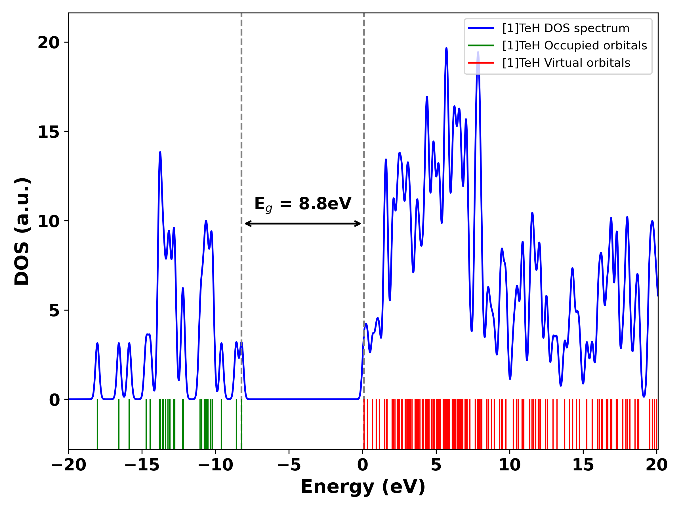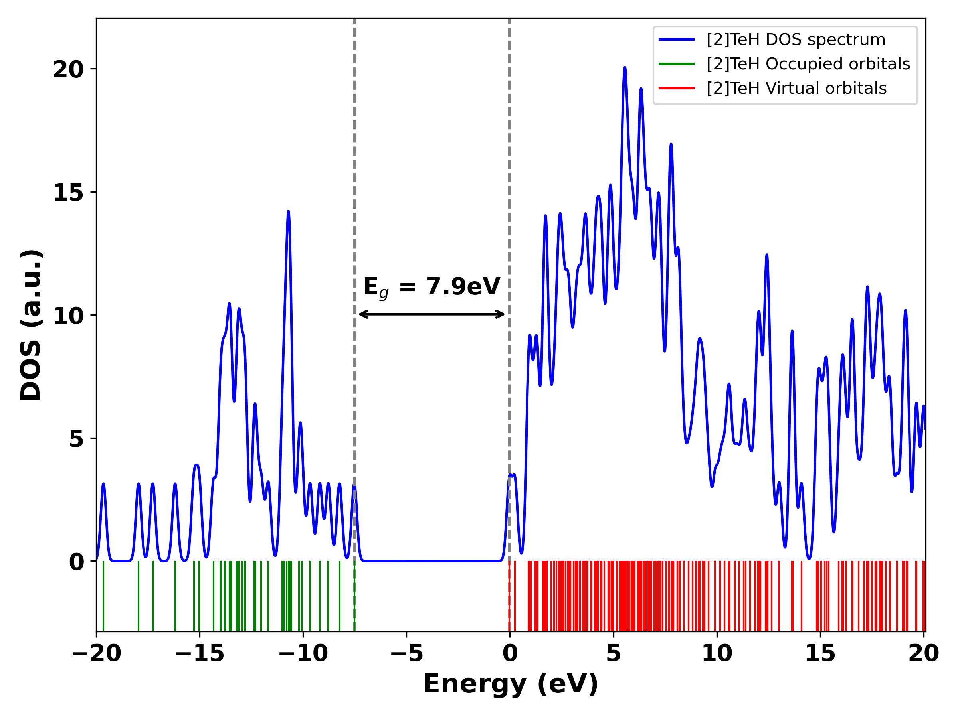
S5 ([1]TeH) S5b ([2]TeH)
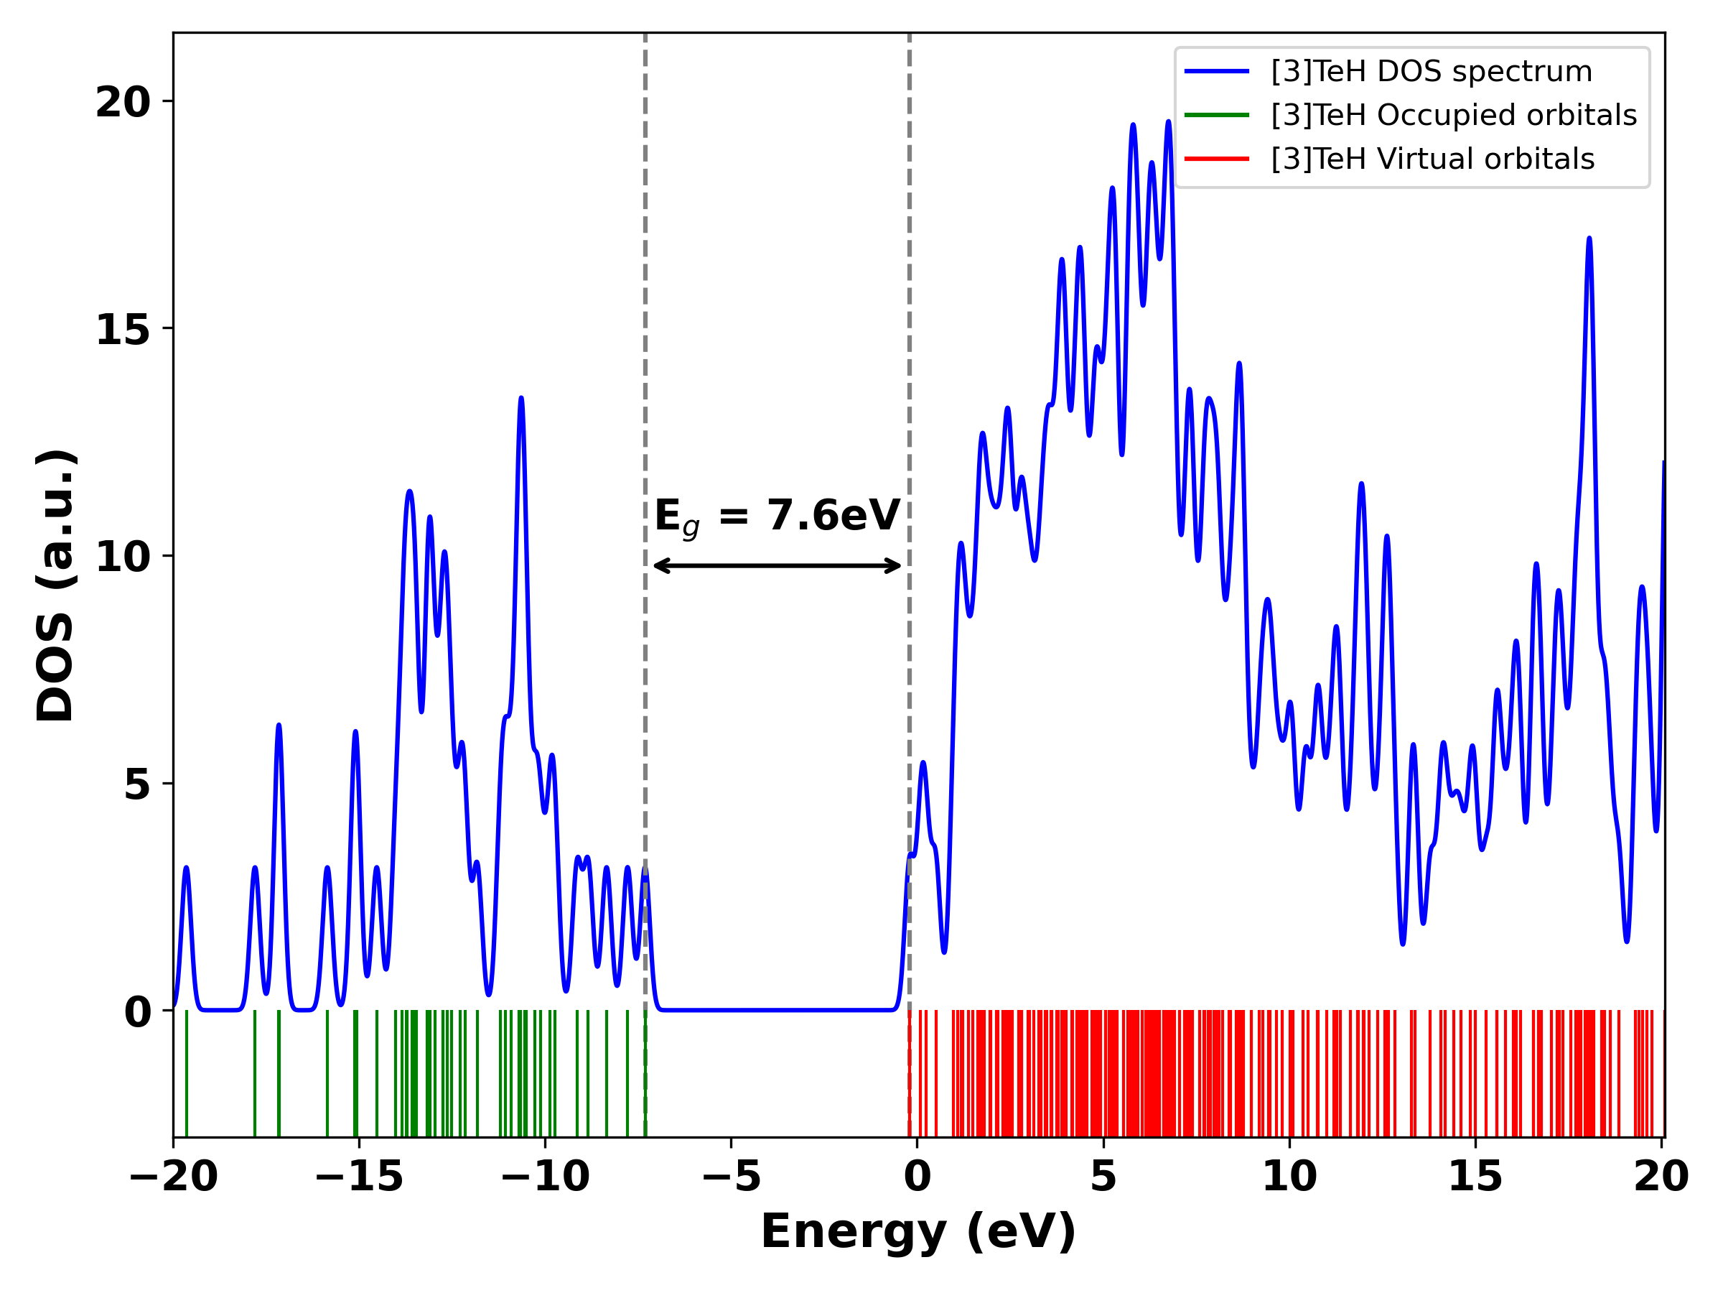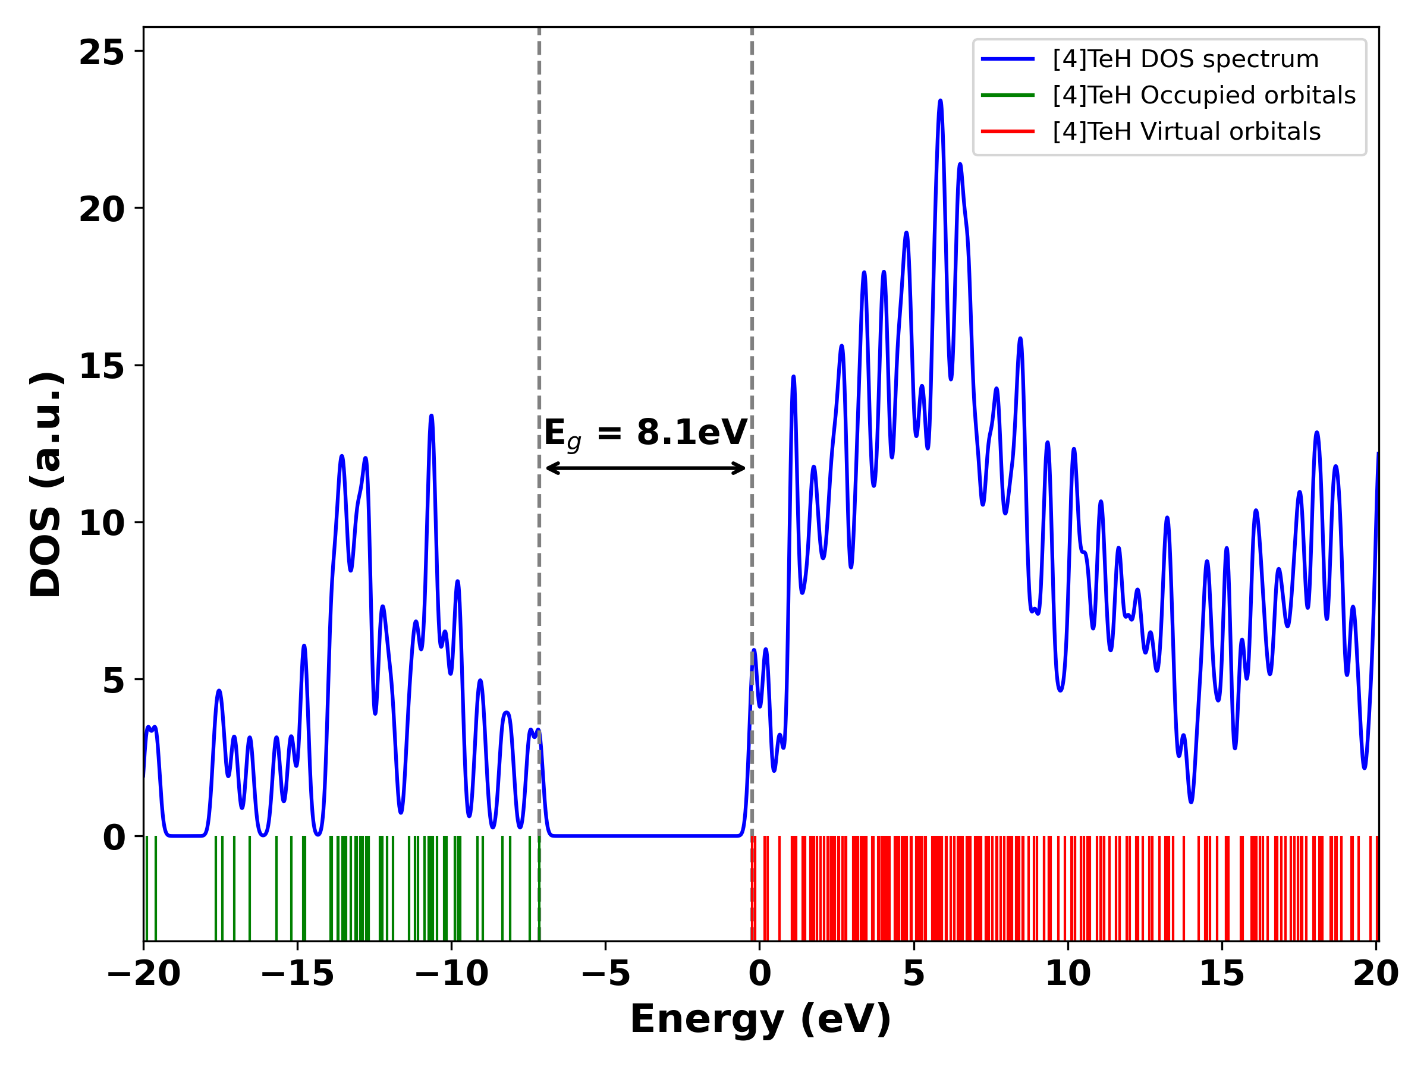
S5c ([3]TeH) S5d ([4]TeH)
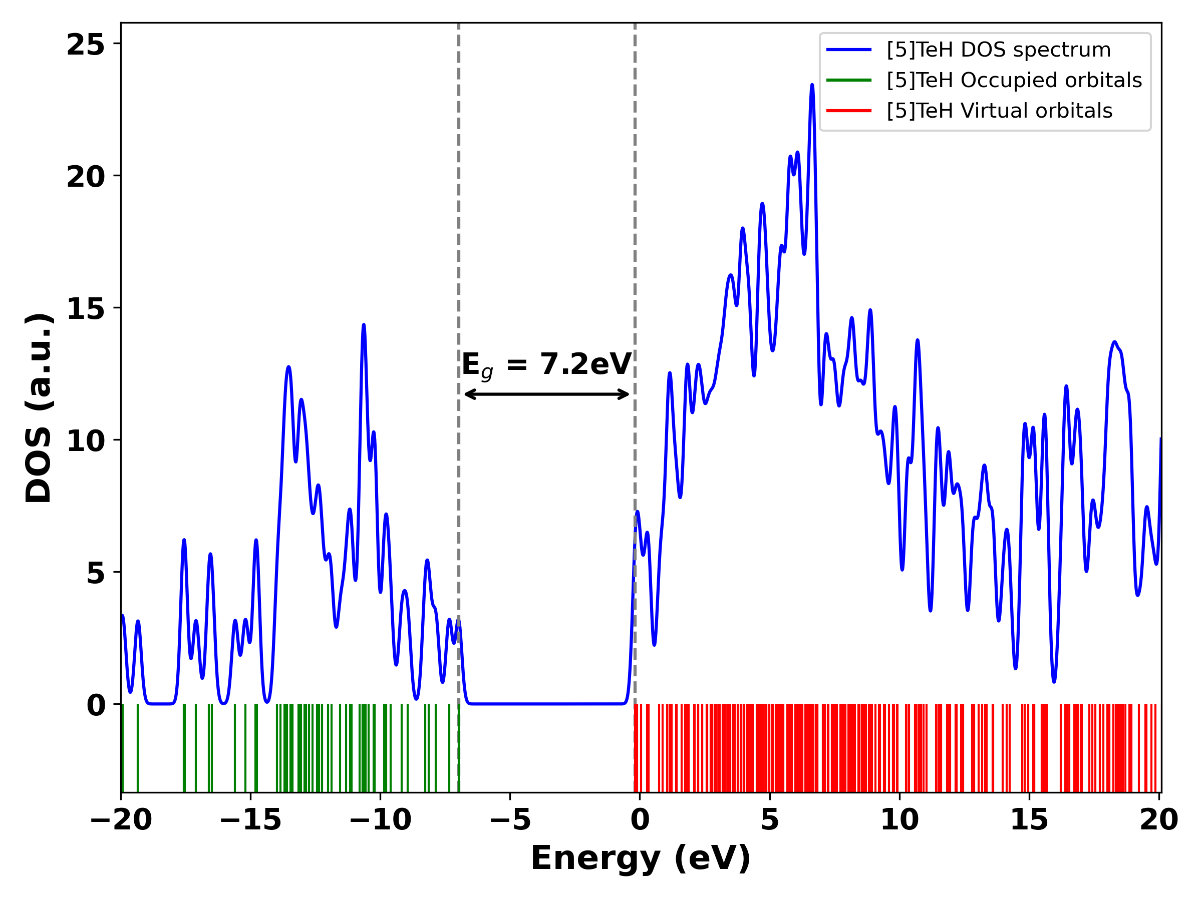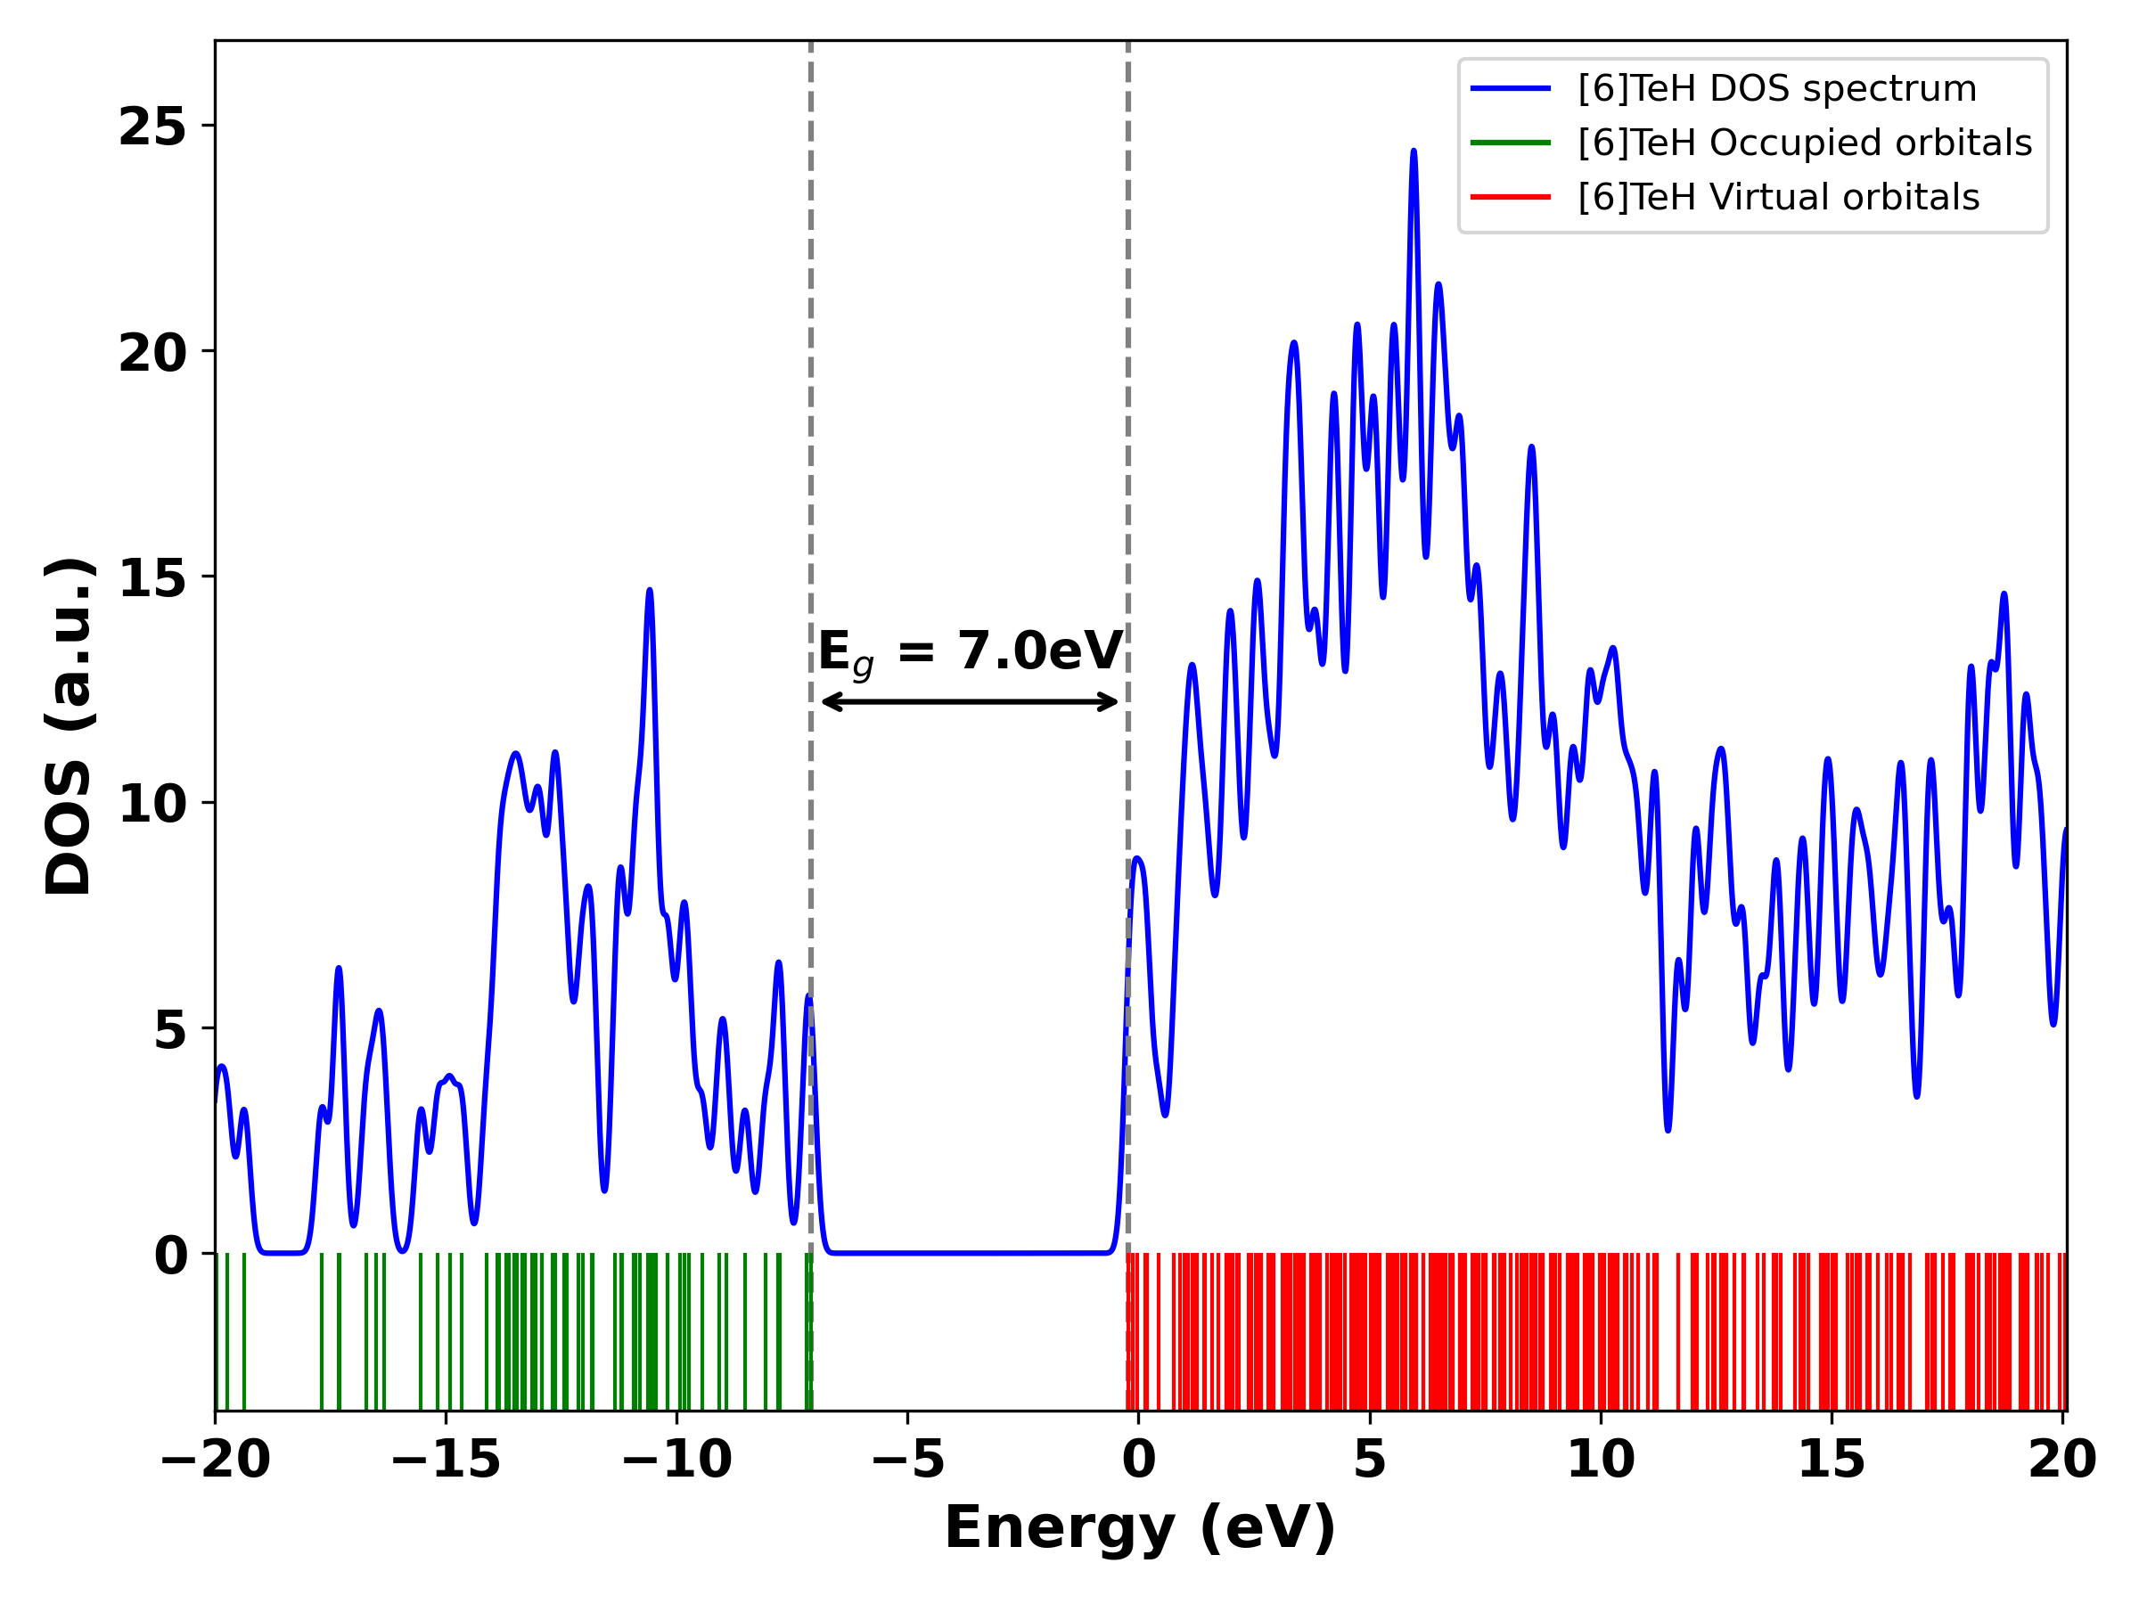
S5e ([5]TeH) S5f ([6]TeH)
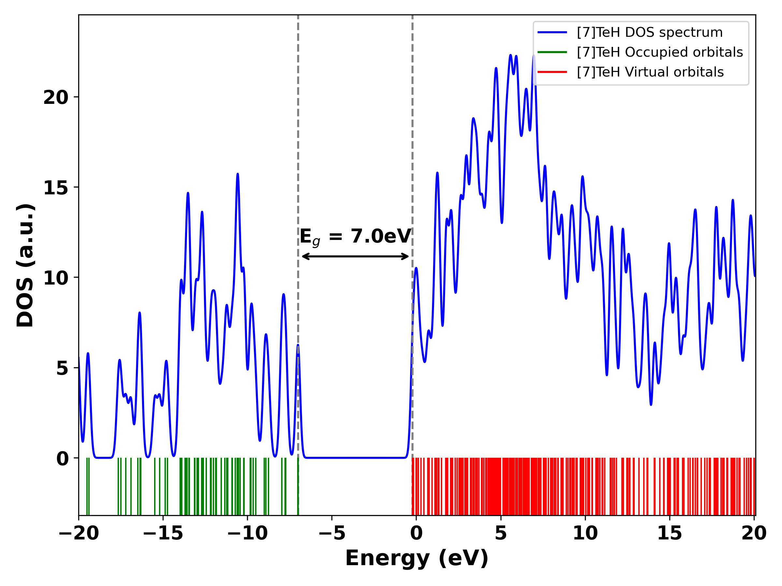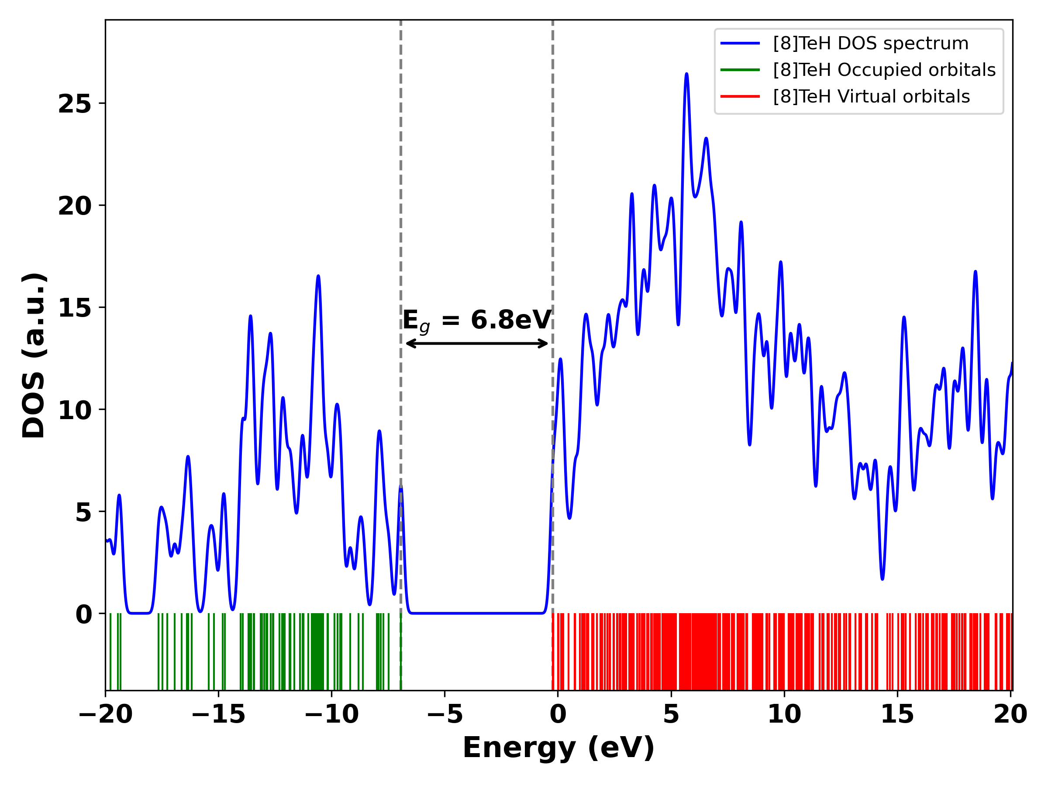
S5g ([7]TeH) S5h ([8]TeH)
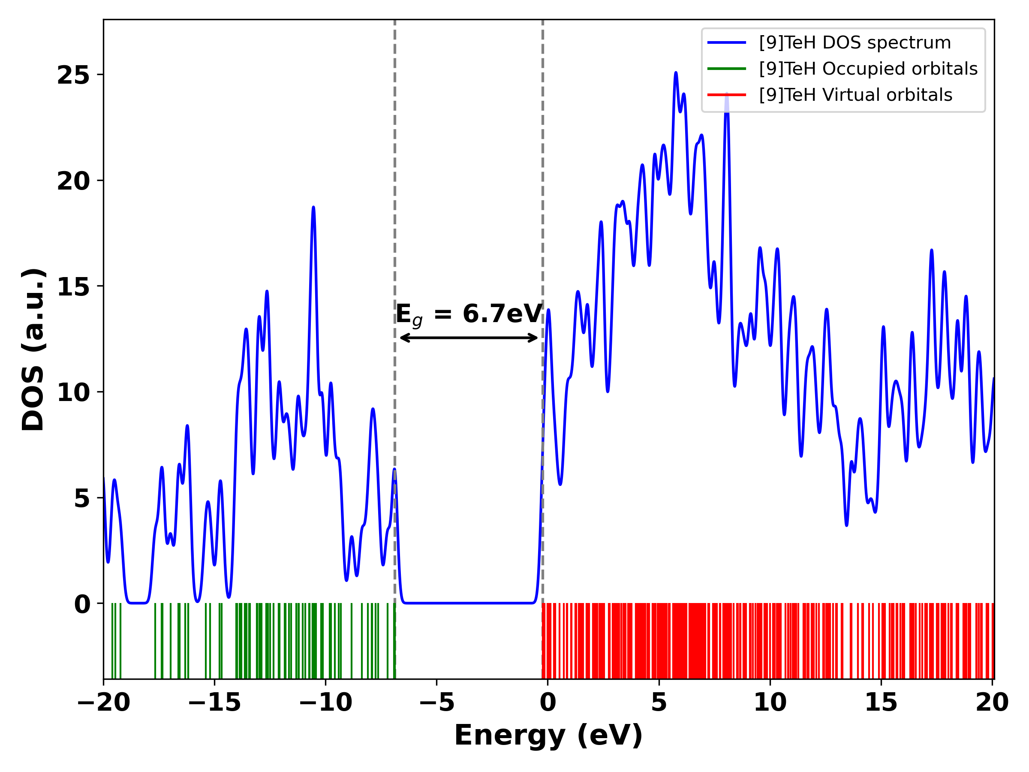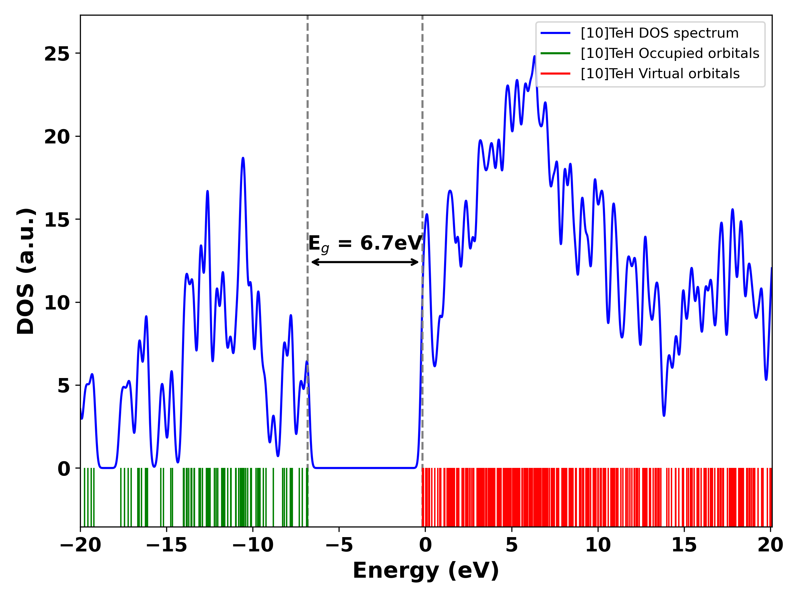
S5i ([9]TeH) S5j ([10]TeH)
Figure S5. Telluro[n]helicenes, [n]TeH (n=1-10, a-j) calculated using single point energy calculations using ωB97XD functional with geometries obtained at B3LYP functional. Basis set used: 6-311++G(d,p) for H, C, Si, S, Se, Br atoms and def2-TZVPP basis set for Te atoms.
11. HOMO-LUMO gaps (E_{g}), for thia[n]helicenes, [n]TH, and seleno[n]helicenes, [n]SH and telluro[n]helicenes, [n]TeH
Table S13. Calculated HOMO-LUMO gaps (E_{g}), for thia[n]helicenes, [n]TH, n=1-5 and seleno[n]helicenes, [n]SH, n=1-5 and telluro[n]helicenes, [n]TeH, n=1-5 in gas phase.
Number of rings (n) | E_{g} for [n]TH (in eV)ª | E_{g} for [n]SH (in eV) ª | E_{g} for [n]TeH (in eV) ª | E_{g} for [n]TeH (in eV)^{b}
1 | 7.62 | 7.4 | 6.82 | 8.27
2 | 7.33 | 7.09 | 6.05 | 7.55
3 | 7.1 | 6.61 | 5.66 | 7.52
4 | 6.94 | 6.48 | 5.48 | 7.30
5 | 6.75 | 6.34 | 5.42 | 7.10
Method: B2PLYPª functional including Grimme’s D3 dispersion correction with Becke-Johnson damping is used. E_{g} for telluro[n]helicenes calculated using ωB97XD^{b} functional. Basis set used: 6-311++G(d,p) for H, C, Si, S, Se, Br atoms and def2-TZVPP basis set for Te atoms.

Table S14. Calculated HOMO-LUMO gaps (E_{g}), for telluro[n]helicene, [1]TeH in gas phase.¹ with varying ω in bohr⁻¹
Tuning parameter (ω in bohr⁻¹) | E_{g} for [1]TH (in eV) with  LANL2DZ basis set for Te atoms | E_{g} for [1]TH (in eV)  def2-TZVP basis set for Te atoms
0.1 | 4.94 | 4.99
0.2 | 6.76 | 6.74
0.3 | 7.67 | 7.56
0.4 (default value) | 9.71 | 9.29
0.5 | 8.34 | 8.70
Method: LC-ωPBE DFT functional. Basis set used: LANL2DZ and def2-TZVP basis sets for Te atom and 6-311++G(d,p) for all other atoms.

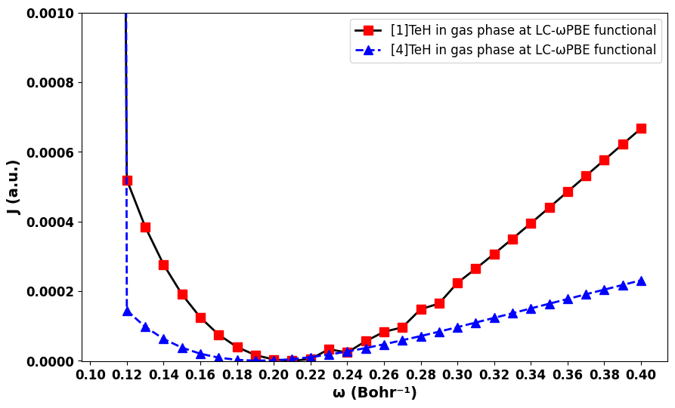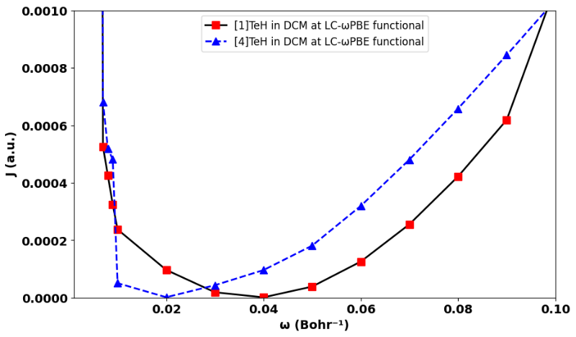
- b)
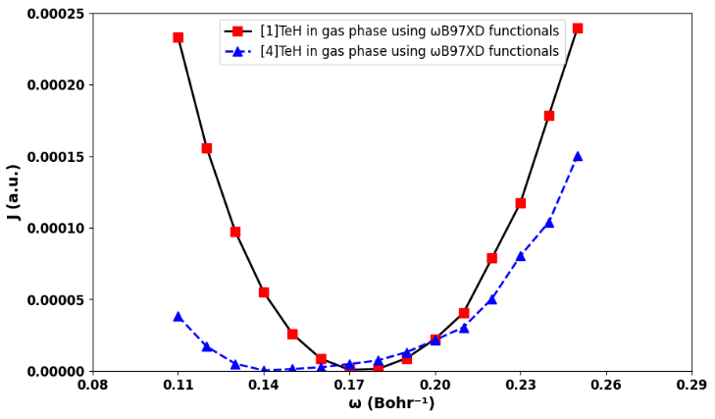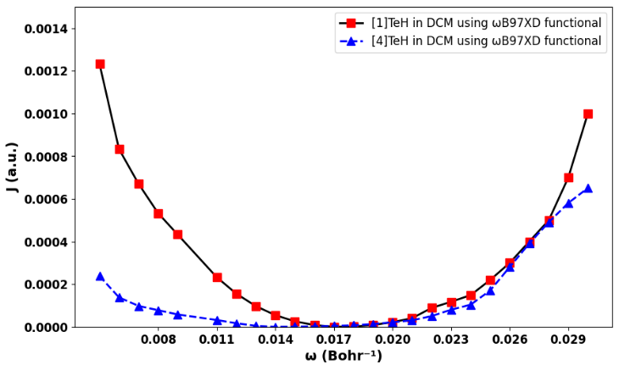
c) d)
Figure S6. Optimized range-separation parameter (ω) values satisfying Koopmans' theorem for (a) telluro[1]helicene (0.21 bohr⁻¹) and telluro[4]helicene (0.19 bohr⁻¹) in gas phase at LC-ωPBE functional, (b) telluro[1]helicene (0.04 bohr⁻¹) and telluro[4]helicene (0.02 bohr⁻¹) in DCM solvent at LC-ωPBE functional, (c) telluro[1]helicene (0.17 bohr⁻¹) and telluro[4]helicene (0.14 bohr⁻¹) in gas phase at ωB97XD functional, (d) telluro[1]helicene (0.018 bohr⁻¹) and telluro[4]helicene (0.012 bohr⁻¹) in DCM solvent. The deviation from Koopmans’ condition, 𝐽=(𝜀_{HOMO} + IP)², was minimized to determine the optimal ω values. Basis set used: LANL2DZ basis sets for Te atoms and 6-311++G(d,p) for all other atoms. Solvation model: SMD
12. Computational cost comparison
Table S15: Computational cost for thia[n]helicenes, [n]TH, seleno[n] helicenes, [n]SH, Telleuro[n]helicenes, [n]TeH, n=1-10 HOMO-LUMO gap values in gas phase.
 | Thia[n]helicenes, [n]TH, n=1-10
 | ωB97XD Functional Full optimization | B3LYP Functional Full optimization | ωB97XD Functional single point energy calculation
 | CPU time | CPU time | CPU time
1 | 12 minutes 47.1 seconds | 1 minutes 2.3 seconds | 1 minutes 49.9 seconds
2 | 18 minutes 35.7 seconds | 1 minutes 26.3 seconds | 2 minutes 9.7 seconds
3 | 22 minutes 21.2 seconds | 1 minutes 54.5 seconds | 3 minutes 19.3 seconds
4 | 41 minutes 8.6 seconds | 2 minutes 47.4 seconds | 4 minutes 15.5 seconds
5 | 1 hours 55 minutes 40.8 seconds | 3 minutes 38.7 seconds | 7 minutes 6.4 seconds
6 | 2 hours 6 minutes 24.9 seconds | 15 minutes 40.2 seconds | 8 minutes 24.3 seconds
7 | 2 hours 28 minutes 23.9 seconds | 22 minutes 59.6 seconds | 12 minutes 21.3 seconds
8 | 2 hours 9 minutes 20.5 seconds | 20 minutes 40.2 seconds | 17 minutes 9.2 seconds
9 | 5 hours 23 minutes 7.9 seconds | 29 minutes 49.1 seconds | 20 minutes 58.1 seconds
10 | 3 hours 59 minutes 5.3 seconds | 48 minutes 44.7 seconds | 27 minutes 44.7 seconds
Total | 19 hours, 36 minutes, and 55.9 seconds | 2 hours, 28 minutes and 43 seconds | 1 hours, 45 minutes and 43 seconds
 | Seleno[n]helicenes, [n]SH, n=1-10
1 | 0 hours 12 minutes 39.4 seconds | 7 minutes 7.9 seconds | 0 minutes 53.6 seconds
2 | 19 minutes 39.1 seconds | 10 minutes 42.8 seconds | 0 hours 1 minutes 29.6 seconds
3 | 36 minutes 23.5 seconds | 19 minutes 46.5 seconds | 2 minutes 6.0 seconds
4 | 51 minutes 47.8 seconds | 32 minutes 13.2 seconds | 1 minutes 50.8 seconds
5 | 1 hours 23 minutes 1.5 seconds | 58 minutes 15.3 seconds | 10 minutes 41.6 seconds
6 | 2 hours 43 minutes 26.3 seconds | 1 hours 17 minutes 56.4 seconds | 6 minutes 19.9 seconds
7 | 5 hours 14 minutes 24.3 seconds | 2 hours 32 minutes 35.1 seconds | 0 hours 9 minutes 1.5 seconds
8 | 5 hours 6 minutes 55.1 seconds | 2 hours 59 minutes 25.4 seconds | 0 hours 11 minutes 14.7 seconds
9 | 8 hours 57 minutes 49.4 seconds | 4 hours 4 minutes 15.7 seconds | 15 minutes 53.8 seconds
10 | 5 hours 12 minutes 45.2 seconds | 3 hours 46 minutes 58.8 seconds | 13 minutes 11.2 seconds
Total | 30 hours, 38 minutes, and 51.6 seconds. | 19 hours, 18 minutes, and 0.1 seconds | 2 hours, 58 minutes, and 25.7 seconds.
 | Telluro[n]helicenes, [n]TeH, n=1-10
1 | 0 hours 12 minutes 39.4 seconds | 9 minutes 20.8 seconds | 2 minutes , 12.8 seconds
2 | 23 minutes 39.1 seconds | 1 hours 44 minutes 48.9 seconds | 3 minutes 16.5 seconds
3 | 38 minutes 33.5 seconds | 20 minutes 29.7 seconds | 5 minutes, 18.0 seconds
4 | 59 minutes 57.8 seconds | 39 minutes 34.6 seconds | 7 minutes , 24.5 seconds
5 | 1 hours 53 minutes 20.5 seconds | 1 hours 14 minutes 0.4 seconds | 9 minutes , 30.0 seconds
6 | 1 hours 53 minutes 26.3 seconds | 6 hours 58 minutes 31.6 seconds | 13 minutes, 41.0 seconds
7 | 6 hours 14 minutes 24.3 seconds | 1 hours 49 minutes 3.3 seconds | 13 minutes , 46.9 seconds
8 | 7 hours 6 minutes 55.1 seconds | 1 hours 44 minutes 28.5 seconds | 16 minutes, 54.6 seconds
9 | 9 hours 57 minutes 29.4 seconds | 3 hours 58 minutes 51.7 seconds | 18 minutes 4.7 seconds
10 | 7 hours 12 minutes 55.2 seconds | 1 hours 53 minutes 3.8 seconds | 27 minutes 3.5 seconds
Total | 36 hours, 33 minutes, and 20.6 seconds. | 20 hours, 32 minutes, and 13 seconds | 1 hour, 36 minutes, and 32.5 seconds.
#SMP Processors: Each worker uses 36 SMP processors, enabling shared-memory parallelism within each node.
Linda Workers: Linda enables distributed-memory parallelism across nodes, combining shared-memory parallelism within nodes.
Comparison
ωB97XD Functional full optimization: 86 hours, 49 minutes, and 8.1 seconds.
B3LYP Functional full optimization and ωB97XD Functional single point energy calculation: 48 hours, 39 minutes, and 37.3 seconds
Basis set used: LANL2DZ basis set for Te atom and 6-311++G(d,p) for all other atoms.

13. Simulated electronic absorptions spectra [3]TH and [7]TH in DCM, and experimentally reported UV-Visible absorption spectra of 1 [7]TH and 4 [3]TH in DCM
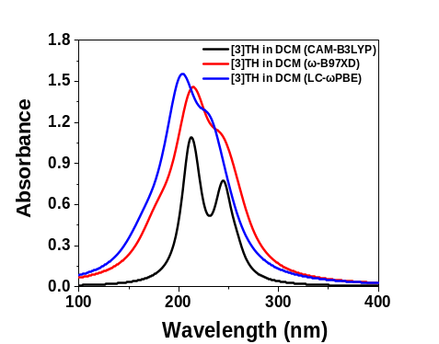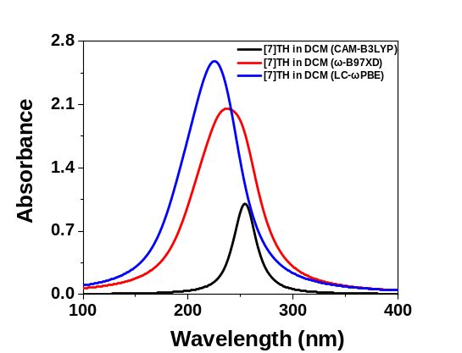
S7a S7b
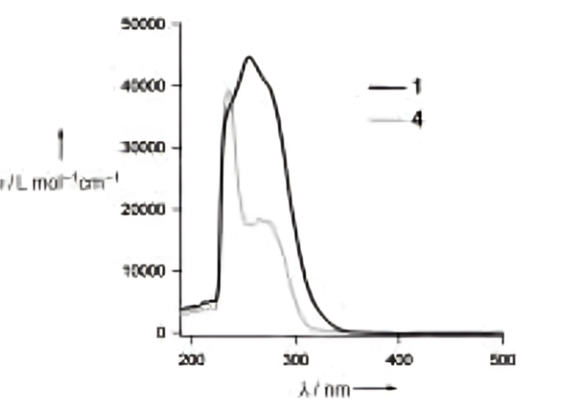
S7c
Figure S7. a) Simulated electronic absorptions spectra [3]TH in DCM, b) Simulated electronic absorptions spectra [3]TH in DCM, and c) experimentally reported UV-Visible absorption spectra of 1 [7]TH and 4 [3]TH in DCM²
 | Absorption maxima values (λ_{max} in nm)
Systems | LC-ωPBE | ω-B97XD | CAM-B3LYP | Experimental values
[3]TH | 204, 230 | 214, 242 | 223, 246 | 236, 266
[7]TH | 227, 237 | 239, 248 | 230, 255 | 235, 256
Methods: CAM-B3LYP, ω-B97XD, and LC-ωPBE functionals are used to calculate the UV-Vis spectra for [3]TH and [7]TH applying TDDFT procedure.

14. TDDFT calculations of neutral tellurophene-based [n]helicene (n=1-10) in DCM solvent
Table S16. Selected absorption bands (λ_{max}, in nm) with corresponding oscillator strength (f) extracted from UV-Vis spectral data (50 lowest electronic transitions) of tellurophene-based [n]helicenes, [n]TeH (n=1-5) and corresponding radical cations, [n]TeH^{•+} in DCM solvent.
n | λ_{max} (nm) and f | Electronic Transitionsª in UV region | n | λ_{max} (nm) and f | Electronic Transitionsª in UV region
1 | 288, (0.129) | H → L (0.68) | 6 | 322, (0.189) | H-1 → L (-0.23), H-1 → L+2 (0.39)
1 | 260, (0.170) | H → L+2 (0.68) | 6 | 296, (0.128) | H-2 → L+2 (-0.22), H → L+8 (0.24)
2 | 313, (0.190) | H → L+1 (0.67) | 7 | 332, (0.112) | H-1 → L+1 (0.38), H → L+2 (-0.35)
2 | 276, (0.041) | H-1 → L+1 (0.67) | 7 | 321, (0.097) | H-1 → L+7 (0.42), H-1 → L+8 (0.29)
2 | 240, (0.580) | H-1 → L+3 (0.63) | 7 | 288, (0.186) | H-4 → L+3 (0.29), H-1 → L+7 (-0.24)
3 | 316, (0.133) | H-1 → L (0.45), H → L+1 (0.41) | 8 | 325, (0.109) | H →L+3 (0.24), H → L+6 (0.42)
3 | 306, (0.078) | H → L+2 (0.51) | 8 | 284, (0.282) | H-3 →L+2 (0.21), H → L+11 (0.23)
3 | 292, (0.234) | H → L+3 (0.51) | 8 | 273, (0.251) | H-4 →L (-0.23), H-4 →L+2 (0.25)
3 | 272, (0.132) | H-1 → L+3 (0.44) | 8 | 266, (0.057) | H-3 →L+2 (-0.21), H →L+11 (0.21)
4 | 322, (0.121) | H-1 → L+1 (0.43), H → L (-0.39) | 9 | 341, (0.022) | H-1 → L+2 (0.38), H → L (0.38)
4 | 301, (0.132) | H → L+3 (0.29), H → L+2 (-0.38) | 9 | 332, (0.109) | H-2 → L+1 (-0.31), H → L+1 (0.38)
4 | 261, (0.155) | H-2 → L+2 (0.42), H → L+8 (0.28) | 9 | 282, (0.358) | H-6 → L+3 (0.24), H-4 → L+4 (0.20)
5 | 354, (0.068) | H → L+2 (0.63) | 10 | 340, (0.015) | H-1 → L+3 (0.24), H → L+2 (0.38)
5 | 320, (0.202) | H-1 → L (0.32), H-1 → L+12 (0.33) | 10 | 330, (0.088) | H-1 → L+3 (0.34), H-1 → L+7 (-0.27)
5 | 296, (0.207) | H-2 → L+1 (-0.25), H → L+6 (0.34) | 10 | 282, (0.233) | H-3 → L+4 (0.27), H-4 → L+2 (0.20)
TD-CAM-B3LYP functional with 6-311++G(d,p) basis set for H, C, Br, Si, atoms and lanl2dz basis set is considered for Te atoms.
ªH = Highest occupied molecular orbital (HOMO) & L = Lowest unoccupied molecular orbital (LUMO).
Values in the braces show the relative contribution of the transition for the optical band. Transitions with major contributions are only shown.
Table S17. Selected absorption bands (λ_{max}, in nm) with corresponding oscillator strength (f) extracted from UV-Vis spectral data (50 lowest electronic transitions) of tellurophene-based [n]helicenes radical cations, [n]TeH^{•+} in DCM solvent.
n | λ_{max} (nm) and f | Electronic Transitionsª in  UV region | n | λ_{max} (nm) and f) | Electronic Transitions^{b} in visible and IR regions
1 | 1174, (0.001) | H → L (0.95) | 6 | 1186, (0.188) | H-1 → L (0.89)
1 | 445, (0.051) | H-2 → L (0.88) | 6 | 887, (0.074) | H-2 → L (0.88)
2 | 1614, (0.029) | H → L (0.94) | 7 | 2104, (0.088) | H-1 → L (0.99)
2 | 1045, (0.102) | H-1 → L (0.92) | 7 | 1488, (0.132) | H-2 → L (0.92)
2 | 500, (0.070) | H-3 → L (0.93) | 7 | 1068, (0.089) | H-3→ L (0.92)
3 | 2085, (0.011) | H-1 → L (0.89) | 8 | 1384, (0.142) | H-2 → L (0.98)
3 | 1047, (0.130) | H-2 → L (0.88) | 8 | 1135, (0.207) | H-1 → L (0.65)
3 | 793, (0.029) | H-3 → L (0.96) | 8 | 806, (0.042) | H-5 → L (0.90)
3 | 593, (0.068) | H-1 → L (0.89) | 8 | 571, (0.039) | H-6 → L (0.97)
4 | 1127, (0.196) | H-1 → L (0.93) | 9 | 1557, (0.053) | H-2 → L (0.73)
4 | 677, (0.052) | H-3 → L (0.92) | 9 | 1413, (0.149) | H-3 → L (0.96)
4 | 575, (0.075) | H-4 → L (0.91) | 9 | 972, (0.010) | H-2 → L (0.58)
5 | 1185, (0.240) | H-1 → L (0.96) | 10 | 1683, (0.044) | H-3 → L (0.80)
5 | 756, (0.054) | H-2 → L (0.74) | 10 | 1574, (0.107) | H-2 → L (0.74)
5 | 539, (0.035) | H-4 → L (0.80) | 10 | 809, (0.086) | H-6 → L (0.80)
TD-CAM-B3LYP functional with 6-311++G(d,p) basis set for H, C, Br, Si, atoms and lanl2dz basis set is considered for Te atoms. The SMD model is used to incorporate effect of DCM solvent.
ªH = Highest doubly occupied molecular orbital (HDOMO) & L = Lowest singly occupied molecular orbital (LSOMO).
Values in the braces show the relative contribution of the transition for the optical band.
Transitions with major contributions are only shown.
15. UV-Vis spectra for telluro[n]helicenes (n=1-10) and their corresponding radical cations
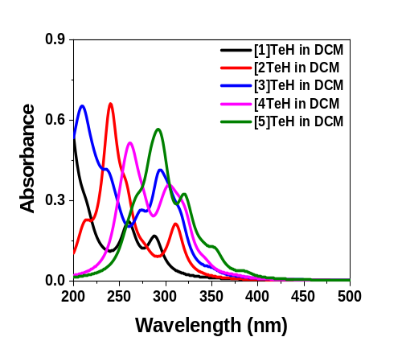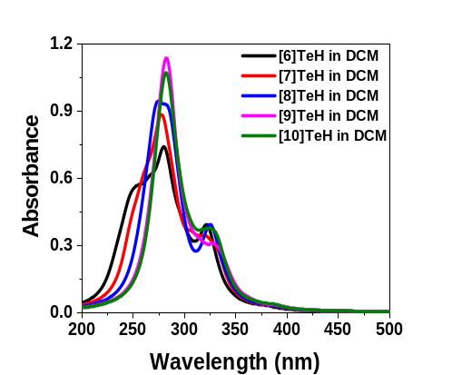
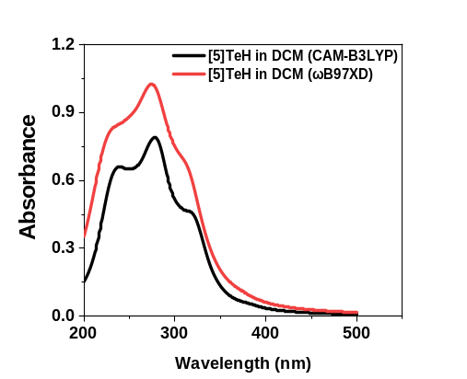
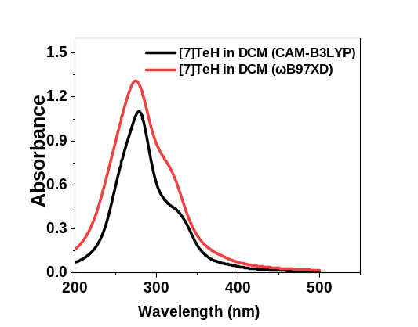
S8a S8b

S8c S8d
Figure S8. Simulated electronic absorptions spectra, a) [n]TeH, n=1-5,b) [n]TeH, n=6-10 c) comparison of electronic absorptions spectra [5]TeH and d) [7]TeH in DCM solvent using CAM-B3LYP and ω-B97XD functionals. Basis set used: LANL2DZ basis set for Te atoms and 6-311++G(d,p) basis set for all other atoms. Solvent effect in DCM is accounted by using SMD model.
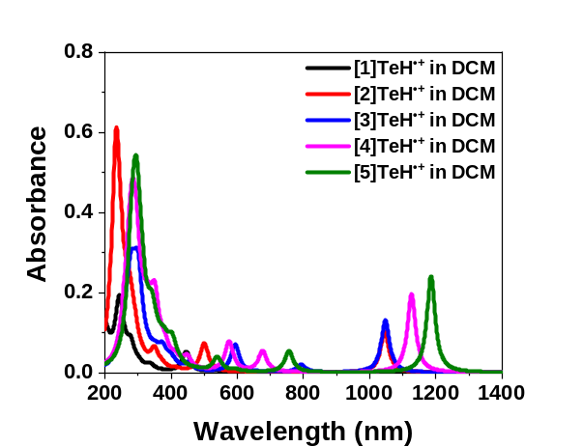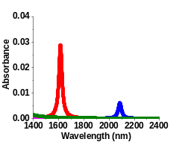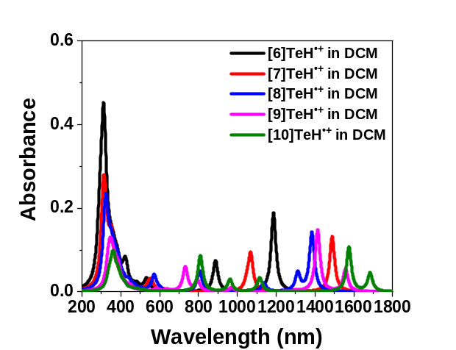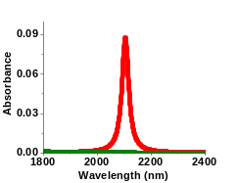
S9a S9b
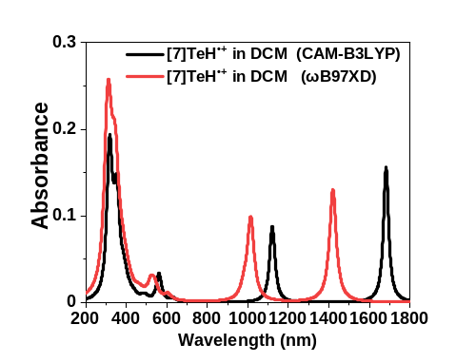
9c
Figure S9. Simulated electronic absorptions spectra, a) [n]TeH^{•+}, n=1-5 and b) [n]TeH^{•+}, n=6-10 and c) comparison of electronic absorptions spectra [7]TeH^{•+}calculated in DCM solvent using CAM-B3LYP and ω-B97XD Functionals. Basis set used: LANL2DZ basis set for Te atoms and 6-311++G(d,p) basis set for all other atoms. Solvent effect in DCM is accounted by using SMD model.

16 Molecular orbital plots with contour cutoff = 0.025 a.u. for the most stable structure of end substituted telluro[n]helicenes radical cation calculated at B3LYP-D functional with 6-311++G(d,p) basis set for H, C, Si, and Br atoms and lanl2dz basis set for Te atoms in DCM solvent.
- [1]TeH^{●+}
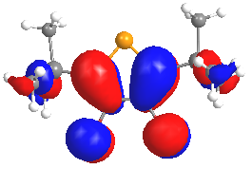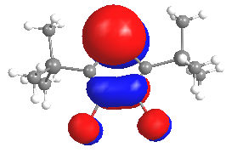
S10a1(H) S10a2(L)
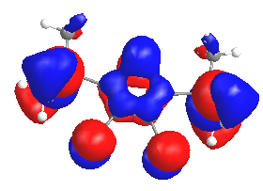
S10a3(H-2)

- [2]TeH^{●+}
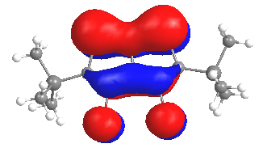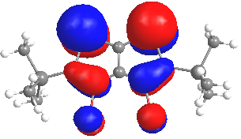
S10b1 (H-1) S10b2 (L)
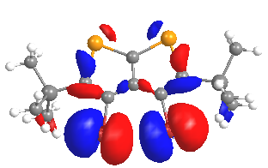
S9b3 (H-2)

- [3]TeH^{●+}
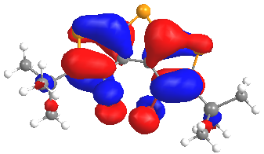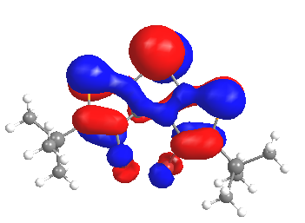
S10c1 (H-1) S10c2 (L)
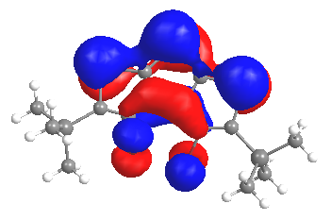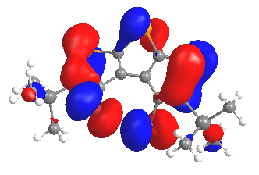
S10c3(H-2) S10c4(H-3)

- [4]TeH^{●+}

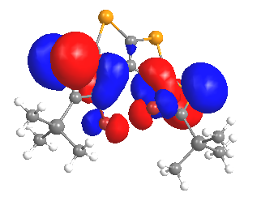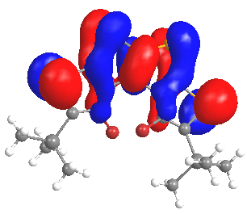
S10d1(H-1) S10d2(L)
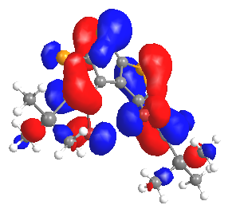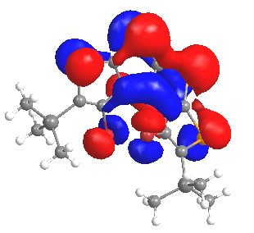
S10d3(H-3) S10d4(H-4)

- [5]TeH^{●+}

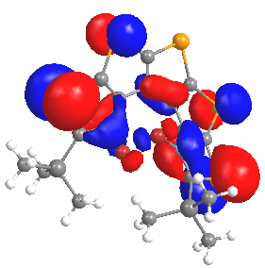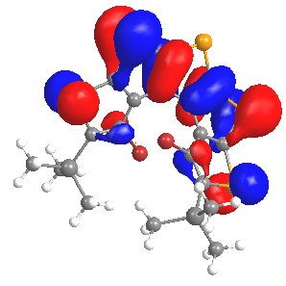
S10e1(H-1) S10e2(L)
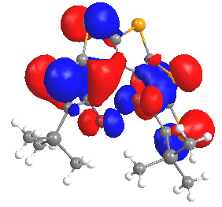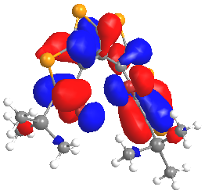
S10e3(H-2) S10e4(H-3)
- [6]TeH^{●+}

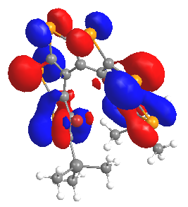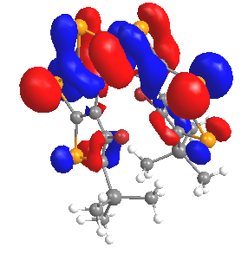
S10f1(H-1) S10f2(L)
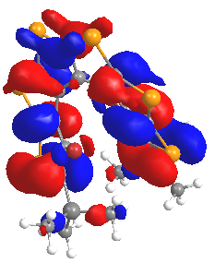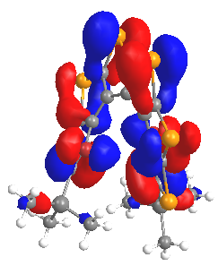
S10f3(H-2) S10f4(H-5)
- [7]TeH^{●+}

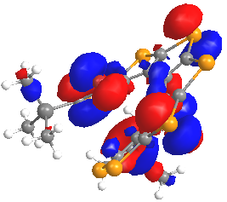
S10g1(H-5)
- [8]TeH^{●+}
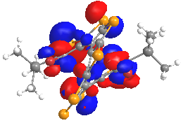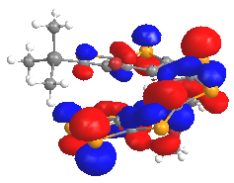
S10h1(H-1) S10h2(L)
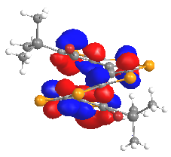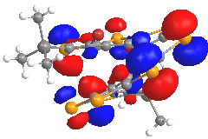
S10h3(H-2) S10h4(H-5)
- [9]TeH^{●+}
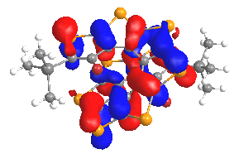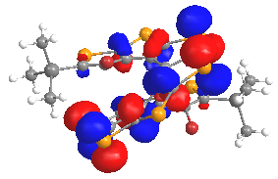
S10i1(H-2) S10i2(L)
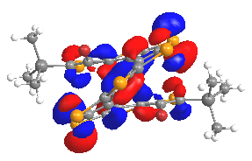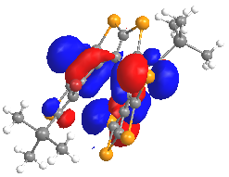
S10i2(H-3) S10i1(H-4)
- [10]TeH^{●+}

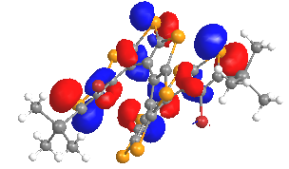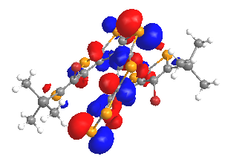
S10j1(H-2) S10j2(L)
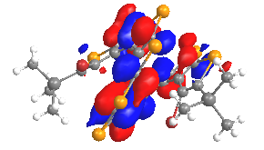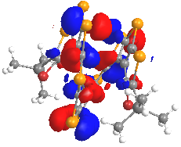
S10j1(H-3) S10j1(H-5)
Figure S10 Molecular orbital plot for telluro[n]helicenes radical cation, [n]TeH^{•+}, n=1-10, S7a-S7j calculated using B3LYP-D as functional with 6-311++G(d,p) basis set for H, C, Si, and Br atoms and lanl2dz basis set for Te atoms in DCM solvent with contour cutoff= 0.03 a.u.

References:
(1) Vikramaditya, T.; Chai, J. Da; Lin, S. T. Impact of Non-Empirically Tuning the Range-Separation Parameter of Long-Range Corrected Hybrid Functionals on Ionization Potentials, Electron Affinities, and Fundamental Gaps. J. Comput. Chem. 2018, 39 (28), 2378–2384. https://doi.org/10.1002/jcc.25575.
(2) Rajca, A.; Wang, H.; Pink, M.; Rajca, S. Annelated Heptathiophene: A Fragment of a Carbon–Sulfur Helix. Angew. Chem. Int. Ed. 2000, 39 (24), 4655–4657.

