CMO.AI Ad & Content Generation Agent

1. Introduction

The Ad & Content Generation Agent is a core module within the CMO.AI multi-agent system. It functions as an intelligent content creator that automatically generates high-quality marketing materials for startups and brand-led businesses.

This agent simulates the role of a professional content marketing team by analyzing brand inputs and producing platform-optimized content — personalized through a Retrieval-Augmented Generation (RAG) layer backed by Pinecone vector storage.

2. Objective

The primary objective of this agent is to:
- Automatically generate high-quality content for social media posts, email campaigns, and promotional messaging
- Leverage brand-specific knowledge retrieval (RAG) to ensure all content aligns with the brand identity
- Apply platform-specific rules and character limits for Instagram, Twitter, LinkedIn, Facebook, and Email
- Produce multiple content variations to enable A/B testing and audience engagement optimization
- Integrate SEO optimization including keywords, meta descriptions, and suggested titles
- Serve as a modular component within the larger CMO.AI multi-agent architecture

3. Input Parameters

The agent accepts the following structured inputs via the ContentRequest schema:

Parameter | Type | Required | Description
content_type | Literal | Yes | social_media_post / email_campaign / promotional_message
brand_name | str | Yes | Name of the brand or startup
industry | str | Yes | Industry or business sector
target_audience | str | Yes | Description of the intended audience
tone | Literal | No | professional / casual / humorous / inspirational
platform | Literal | No | instagram / twitter / linkedin / facebook / email
topic_or_offer | str | Yes | The main topic, product, or offer to promote
cta | str | No | Call to Action text (default: Learn more)
extra_notes | str | No | Any additional brand or content instructions

4. System Architecture

The Ad & Content Generation Agent follows a multi-layered architecture that combines Retrieval-Augmented Generation (RAG), platform intelligence, and large language model generation:

4.1 Components

- Input Layer: Accepts structured ContentRequest objects from the backend API or directly from run_agent.py
- RAG Layer (Pinecone + Cohere): Retrieves brand-specific knowledge including tone guidelines, product info, audience data, and successful post examples
- Platform Rules Engine: Applies platform-specific constraints such as character limits, best practices, and optimal posting times
- Prompt Engineering Layer: Three specialized ChatPromptTemplates guide the LLM to produce structured, brand-aligned content
- LLM Layer (Groq + LLaMA 3.3 70B): Generates the final content using retrieved knowledge and platform rules
- Post-Processing Layer: Extracts hashtags, parses content variations, extracts SEO data, and validates character limits
- Output Layer: Returns a structured ContentOutput object with all generated content and metadata

4.2 Architecture Diagram
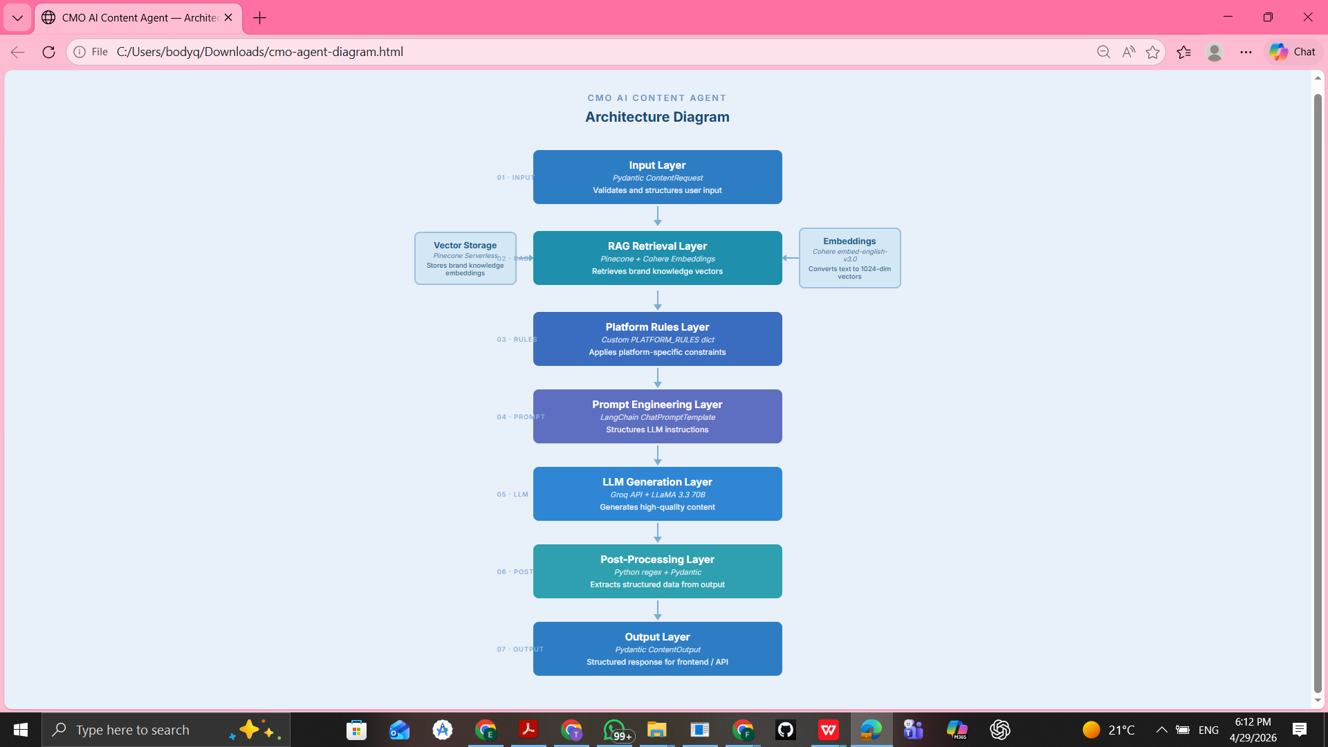

5. Agent Behavior

The Content Generation Agent demonstrates intelligent, tool-augmented behavior through the following capabilities:

- Context-aware generation: Retrieves relevant brand knowledge before generating any content, ensuring all outputs are consistent with the brand identity
- Platform intelligence: Automatically selects and applies the correct rules, character limits, and best practices for each social media platform
- Variation generation: Produces multiple content variations (A/B testing) for social media posts and promotional messages
- SEO integration: Automatically extracts and structures SEO keywords, meta descriptions, and suggested titles from email campaign outputs
- Validation: Checks all generated content against platform character limits and reports compliance

6. RAG Knowledge Base

The RAG layer is organized around the following knowledge types and retrieval workflow:

6.1 Knowledge Base Structure

Each brand stores documents across the following knowledge types:

Knowledge Type | Description | Example
tone_guideline | How the brand communicates | Warm, friendly, energetic. Speak like a coffee friend.
audience | Target audience profile | Young professionals aged 22-35 who value sustainability.
product | Key products or services | Oat Milk Latte, Cold Brew, Single Origin Pour Over.
brand_values | Core brand values | Sustainability, quality sourcing, community, innovation.
successful_post | High-performing content examples | Your Monday got an upgrade. Cold Brew hits different.

6.2 RAG Workflow

- Step 1 — Embedding: Brand knowledge documents are embedded using Cohere embed-english-v3.0 (1024 dimensions)
- Step 2 — Storage: Embeddings are stored in a Pinecone Serverless index with brand name as metadata filter
- Step 3 — Retrieval: At generation time, top-3 most relevant documents are retrieved using cosine similarity search
- Step 4 — Injection: Retrieved knowledge is injected into the prompt template under the BRAND KNOWLEDGE BASE section

7. Output Structure

The agent returns a structured ContentOutput object containing all generated content and metadata:

Field | Type | Description
content_type | str | Type of content generated
platform | str | None | Target platform
generated_content | str | The full generated content text
variations | list[ContentVariation] | Parsed A/B variations with IDs
hashtags | list[str] | Extracted hashtags (social media only)
subject_line | str | None | Email subject line (email only)
seo | SEOData | None | Keywords, meta description, title (email only)
platform_rules | dict | None | Platform rules that were applied
char_count | int | Character count of generated content
within_limit | bool | Whether content is within platform limit

8. Technologies Used

Component | Technology | Version | Purpose
LLM | LLaMA 3.3 70B (via Groq) | groq API | Content generation
LLM Framework | LangChain + LangChain-Groq | 0.3.25 | LLM orchestration
Vector Database | Pinecone Serverless | 6.0.2 | Brand knowledge storage
Embeddings | Cohere embed-english-v3.0 | langchain-cohere | Text vectorization
Data Validation | Pydantic | 2.11.4 | Input/output schemas
Environment | python-dotenv | 1.1.0 | API key management
Backend Ready | FastAPI + Uvicorn | 0.115.12 | API endpoint exposure

9. Platform-Specific Rules

The agent applies different rules and constraints depending on the target platform:

Platform | Char Limit | Best Practices | Best Post Time
Instagram | 2,200 | Storytelling, emojis, 5-10 hashtags, strong hook in first line | Tue–Fri 9–11AM or 7–9PM
Twitter | 280 | Concise, max 2 hashtags, create curiosity | Mon–Thu 8–10AM or 6–9PM
LinkedIn | 3,000 | Hook opener, line breaks, 3-5 hashtags, professional tone | Tue–Thu 7–9AM or 12–1PM
Facebook | 63,206 | Questions to boost comments, short and engaging | Wed–Fri 1–4PM
Email | 5,000 | Strong subject line, single CTA, mobile-friendly | Tue or Thu 10–11AM

10. Role in CMO.AI System

This agent represents the Content Generation Module within the overall CMO.AI multi-agent architecture. It is designed to be fully modular and integrable with the other agents in the system.

It will be integrated with:
- Brand Coaching Agent — provides brand identity and audience data that seeds the knowledge base
- Marketing Planner and Scheduler Agent — triggers content generation as part of automated campaign schedules
- Image Generation Agent — receives content output to generate matching visual assets
- Video Generation Agent — uses generated copy as scripts for short-form video content
- Performance Analytics Agent — feeds engagement data back to improve future content generation

Together, these agents form a complete end-to-end marketing automation system orchestrated through LangGraph and CrewAI.

11. Model Selection and Justification

11.1 Selected Model
The Ad & Content Generation Agent uses LLaMA 3.3 70B Versatile, accessed through the Groq API via the langchain-groq integration.

11.2 Why This Model is Suitable

Criterion | Justification
High-Quality Text Generation | Produces professional, brand-aligned marketing content with natural language fluency
Instruction Following | Handles complex multi-part prompts including brand knowledge, platform rules, and variation requirements
Speed (Groq Infrastructure) | Groq provides ultra-low latency inference, suitable for real-time user interaction
Cost-Effective | Free tier available through Groq API, ideal for academic MVP development
No Fine-Tuning Required | RAG approach provides brand personalization without retraining the model
Open Source | LLaMA 3.3 is open-source, aligning with the project's academic and research goals

11.3 Embedding Model
Cohere embed-english-v3.0 was selected for generating knowledge base embeddings due to its high semantic accuracy, 1024-dimensional output compatible with Pinecone, and free tier availability.

12. Testing and Evaluation

The agent was tested across all three content types using the following evaluation criteria:

Test Case | Content Type | Platform | Result
Test 1 | Social Media Post | Instagram | Generated 2 variations with 10 hashtags, within 2200 char limit
Test 2 | Email Campaign | Email | Generated subject line, full body, and SEO section
Test 3 | Promotional Message | General | Generated 3 variations all under 150 characters

All tests confirmed:
- RAG retrieval successfully injected brand knowledge (audience, products, tone) into generated content
- Platform rules were correctly applied to each content type
- Character count validation worked correctly for all platforms
- SEO data was accurately parsed from email campaign output
- Content variations were correctly identified and structured

- Social Media Post:
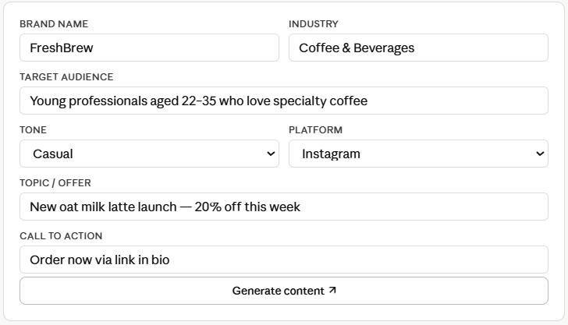
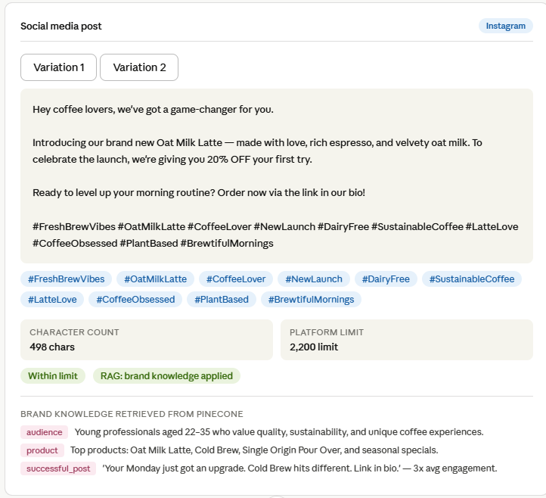
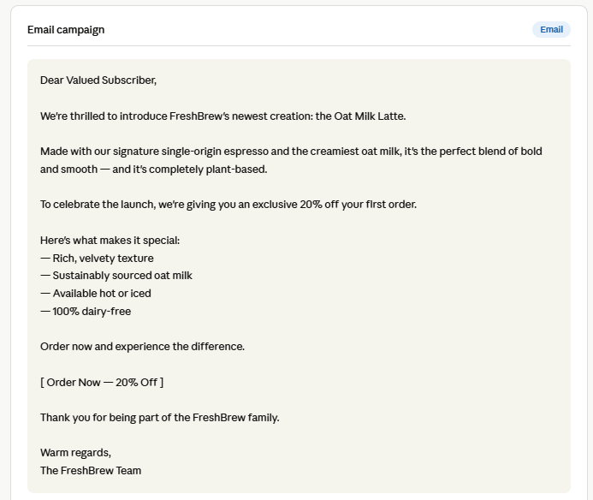
- Email Campaign:
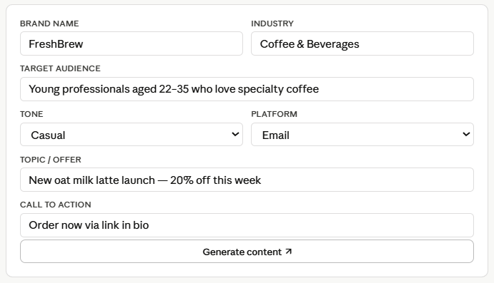
- Promotional Message:
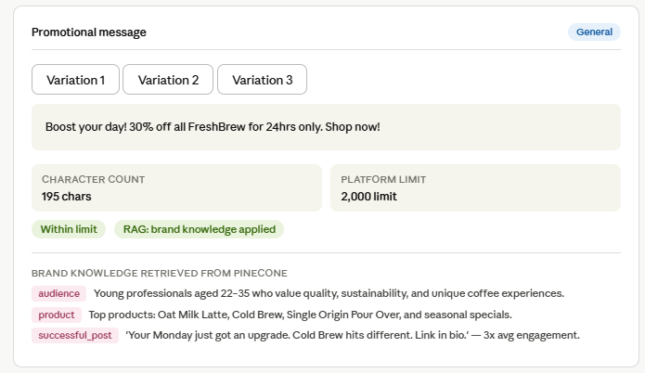
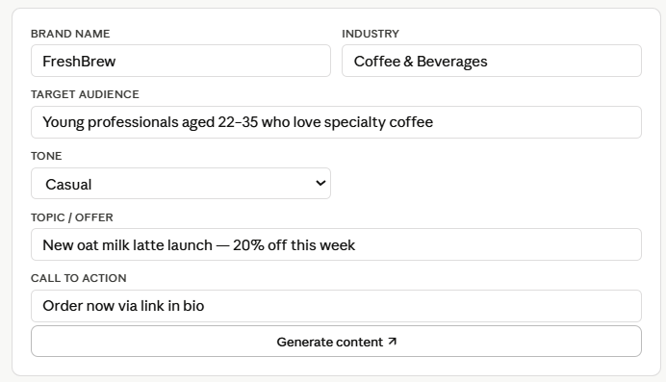

13. Conclusion

The Ad & Content Generation Agent successfully demonstrates how generative AI combined with Retrieval-Augmented Generation (RAG), platform intelligence, and structured prompt engineering can produce realistic, high-quality, and brand-consistent marketing content automatically.

The agent is fully proposal-grade, satisfying all requirements outlined in the CMO.AI graduation project proposal including automated content generation, SEO optimization, multi-platform support, content variation testing, and brand knowledge personalization.

It serves as a foundational component in the CMO.AI intelligent marketing automation platform, with all integration points detailed in Section 10.

