**TOols and TechnolOgies**

**Inside Chapter:**

3. Technologies and Algorithms

3.1 Google MAP API

3.2 IP Finder API

3.3 Levenshtein Search Algorithm

3.4 MVC Design Pattern

3.5 Rating Technique

3.6 Project Tools

**3.1 Google MAP API**

The Maps JavaScript API lets you customize maps with your own content and imagery for display on web pages and mobile devices. The Maps JavaScript API features four basic map types (roadmap, satellite, hybrid, and terrain) which you can modify using layers and styles, controls and events, and various services and libraries.

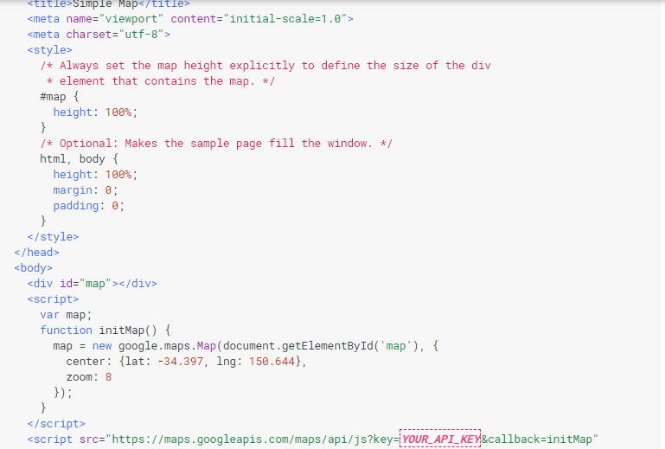

Figure 3.1 – Simple MAP using JavaScript

Loading the Maps JavaScript API

The URL contained in the script tag is the location of a JavaScript file that loads all of the symbols and definitions you need for using the Maps JavaScript API. This script tag is required.

The async attribute lets the browser render the rest of your website while the Maps JavaScript API loads. When the API is ready, it will call the function specified using the callback parameter.

The key parameter contains your application's API key.

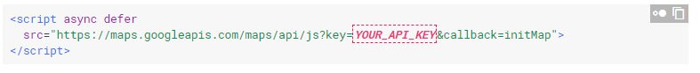

Figure 3.2 – URL of Google MAP API

### HTTPS or HTTP

We think security on the web is pretty important, and recommend using HTTPS whenever possible. As part of our efforts to make the web more secure, we've made all of the Maps JavaScript API available over HTTPS. Using HTTPS encryption makes your site more secure, and more resistant to snooping or tampering.

* We recommend loading the Maps JavaScript API over HTTPS using the <script> tag provided above.
* If required, you can load the Maps JavaScript API over HTTP by requesting http://maps.googleapis.com/.

### Map Options

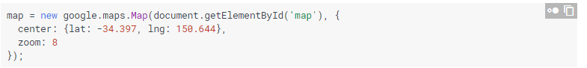

### Zoom Levels

The initial resolution at which to display the map is set by the zoom property, where zoom 0 corresponds to a map of the Earth fully zoomed out, and larger zoom levels zoom in at a higher resolution.

## The Map Object



The JavaScript class that represents a map is the Map class. Objects of this class define a single map on a page. (You may create more than one instance of this class — each object will define a separate map on the page.) We create a new instance of this class using the JavaScript new operator.

When you create a new map instance, you specify a <div> HTML element in the page as a container for the map. HTML nodes are children of the JavaScript document object, and we obtain a reference to this element via the document.getElementById() method.

**3.2 IP Finder API**

The API endpoint path is <http://ip-api.com/json/>

### Parameters

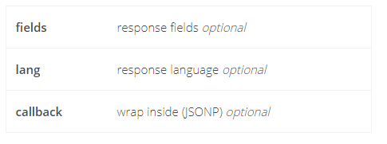

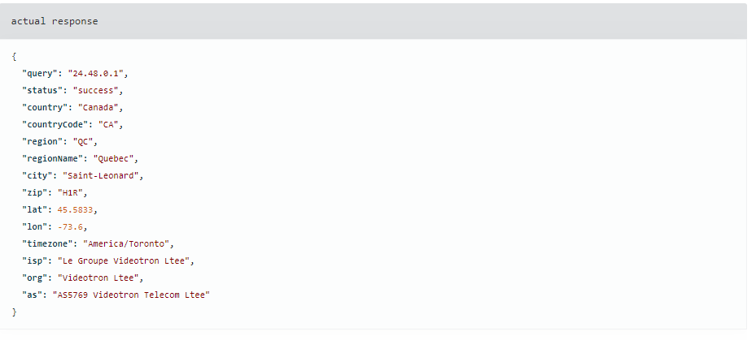

### Usage limits

This endpoint is limited to 150 requests per minute from an IP address. If you go over this limit your IP address will be blackholed.

**3.3 Levenshtein Search Algorithm**

fuzzy searching

Approximate string matching (often colloquially referred to as fuzzy string searching) is the technique of finding approximate matches to a [pattern](http://en.wikipedia.org/wiki/Pattern) in a [string](http://en.wikipedia.org/wiki/String_%28computing%29).

* Levenshtein : is searching for the most similar word in the array based on Levenshtein Algorithm. A matrix is initialized measuring in the (m,n)-cell. The Levenshtein distance between the m character prefix of one with the n-prefix of the other word. The matrix can be filled from the upper left to the lower right corner. The cost is normally set to 1 for each of the operations For the diagonal: 0 if match ,1 if not match.



* Soundex : is searching for the most similar word based on its pronunciation using the soundex algorithm and matching it by Levenshtein
* Metaphone : the same as soundex but accurate.

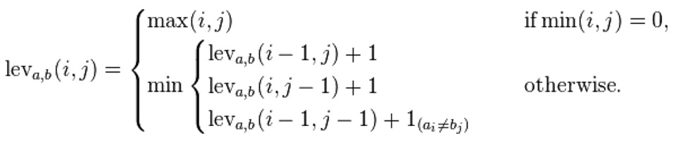

**Coding of leven score**

**PHP Code:**

function get_leven_score($string, $compare_string)

{

// *** DATA

# internal

$_leven = 0;

# return

$score = 100;

// *** MANIPULATE

# get levenshtein distance

$_leven = levenshtein($string, $compare_string);

# convert to percentage score relative to string

$score = ($_leven/strlen($compare_string))*100;

return $score;

}

**Example**

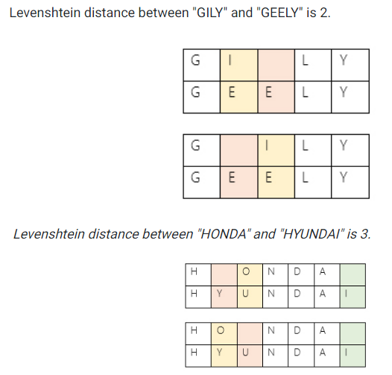

**3.4 MVC (Model View Controller)**

Front-End Engineering (FEE) concerned with VIEW phase on MCV schema, is the skill of creating presentations of content (usually hypertext or hypermedia) that is delivered to an end-user through the World Wide Web, by way of a Web browser or other Web-enabled software like Internet television clients, micro blogging clients and RSS readers.

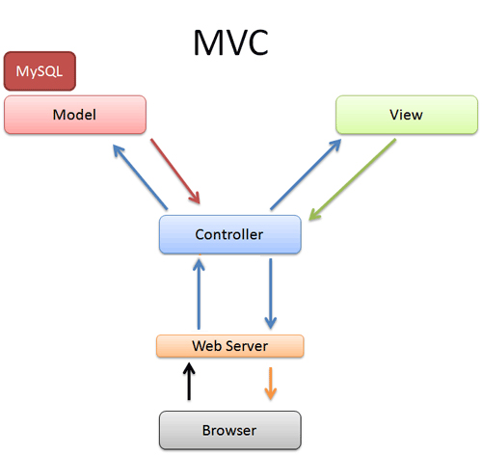

What's MVC??

Model–view–controller (MVC), an architectural design pattern used in software development.

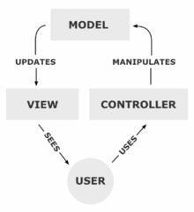

MVC is often seen in web applications where the view is the HTML or XHTML generated by the app. The controller receives GET or POST input and decides what to do with it, handing over to domain objects (i.e. the model) that contain the business rules and know how to carry out specific tasks such as processing a new subscription.

The project basically is divided into two sections: - Server and Client.

* The server has the full control of the information.
* Client who can chat with another client for any reason or can search any file he wants.
* The chat part basically deals with message sending and receiving between one client to another client. When a client requests for the chat, server starts the session of chat and both can send and receive the message one at a time.
* The server can store files, search, delete them. The information is stored in the database at server. When client requests for it, the server searches the required from the database and replies back to the client.
* The system is basically divided into two broad sections: -
* **Server**: - It is responsible for hosting the server so that client can start communication session.
* **Client**: - Client connects to the server by giving the server IP address and port number to which it should connect to.

**3.5 Rating Technique**

**Introd**uction

Rating in general is the [evaluation](http://en.wikipedia.org/wiki/Evaluation) or [assessment](http://en.wikipedia.org/wiki/Assessment) of something, in terms of quality (as with a critic rating a novel), quantity (as with an athlete being rated by his or her [statistics](http://en.wikipedia.org/wiki/Statistics#See_also)), or some combination of both.

Rating in sites typically show a series of images (or other content) in random fashion, or chosen by computer algorithm, rather than allowing users to choose. They then ask users for a rating or assessment, which is generally done quickly and without great deliberation. Users score items on a scale of 1 to 10 or (yes or no).

The slope one family of easily implemented item-based rating-based collaborative filtering algorithm was proposed. Essentially, instead of using linear regression from one item’s ratings to another item’s rating, it uses a simpler form of regression with a single free parameter (f(x) = x+b)

Example:

1. Joe gave a 1 to Dion and assign 2 to Lohan
2. Jill gave 2 to Dion
3. How do you think Jill rated Lohan?
4. The slope one answer is to easy (2-1+2 = 3)

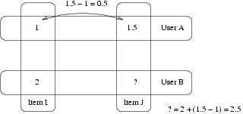

**3.6 Project Tools**

**3.6.1 PHP**

PHP is a server-side scripting language designed for web development but also used as a general purpose programming language. As of January 2013, PHP was installed on more than 240 million websites (39% of those sampled) and 2.1 million web servers.

Originally created by Rasmus Lerdorf in 1994,the reference implementation of PHP (powered by the Zend Engine) is now produced by The PHP Group. While PHP originally stood for Personal Home Page, it now stands for PHP: Hypertext Preprocessor, which is a recursive backronym.

**3.6.2 MYSQL**

MYSQL is (as of March 2014) the world's second most[a] widely used open source relational database management system (RDBMS).It is named after cofounder Michael Widenius's daughter, The MySQL acronym stands for Structured Query Language. The MySQL development project has made its source code available under the terms of the GNU General Public License, as well as under a variety of proprietary agreements. MySQL was owned and sponsored by a single for-profit firm, the Swedish company MySQL AB, now owned by Oracle Corporation.

**3.6.3 AJAX**

AJAX = Asynchronous JavaScript and XML. AJAX is not a new programming language, but a new way to use existing standards. AJAX is the art of exchanging data with a server, and updating parts of a web page without reloading the whole page. Ajax is not a single technology, but a group of technologies.

HTML and CSS can be used in combination to markup and style information. The DOM is accessed with JavaScript to dynamically display, and allow the user to interact with, the information

presented.

JavaScript and the XML Http Request object provide a method for exchanging data asynchronously between browser and server to avoid full page reloads. Ajax is a group of interrelated we development techniques used on the client-side to create asynchronous web applications.

With Ajax, web applications can send data to, and retrieve data from, a server asynchronously (in the background) without interfering with the display and behavior of the existing page. Data can be retrieved using the XMLHttpRequest object. Despite the name, the use of XML is not required (JSON is often used instead), and the requests do not need to be asynchronous.

**3.6.4 jQuery**

JQuery is a lightweight, "write less, do more", JavaScript library. The purpose of jQuery is to make it much easier to use JavaScript on your website. jQuery takes a lot of common tasks that require many lines of JavaScript code to accomplish, and wraps them into methods that you can call with a single line of code.

JQuery also simplifies a lot of the complicated things from JavaScript, like AJAX calls and DOM manipulation. There are a lots of other JavaScript frameworks out there, but jQuery seems to be the most popular, and also the most extendable. jQuery is not a language, but it is a well written JavaScript code. As quoted on official jQuery website, "it is a fast and concise JavaScript Library that simplifies HTML document traversing, event handling, animating, and Ajax interactions for rapid web development".

**Why JQuery**

JQuery is very compact and well written JavaScript code that increases the productivity of the developer by enabling them to achieve critical UI functionality by writing very small amount of code.

* It helps to improve the performance of the application
* It helps to develop most browser compatible web page
* It helps to implement UI related critical functionality without writing hundreds of lines of codes
* It is fast It is extensible – jQuery can be extended to implement customized behavior
* No need to learn fresh new syntaxes to use jQuery, knowing simple JavaScript syntax is enough
* Simple and cleaner code, no need to write several lines of codes to achieve complex functionality jQuery is a multibrowser JavaScript library designed to simplify the clientside scripting of HTML.

**3.6.5 CSS**

Maybe you already heard about CSS without really knowing what it is. In this lesson you will learn more about what CSS is and what it can do for you. CSS is an acronym for Cascading Style Sheets.

CSS was a revolution in the world of web design. The concrete benefits of CSS include:

* control layout of many documents from one single style sheet;
* more precise control of layout;
* apply different layout to different mediatypes (screen, print, etc.); numerous advanced and sophisticated techniques.
* CSS helps Web developers create a uniform look across several pages of a Web site.
* Instead of defining the style of each table and each block of text within a page's HTML, commonly used styles need to be defined only once in a CSS document.
* Once the style is defined in cascading style sheet, it can be used by any page that references the CSS file.
* Plus, CSS makes it easy to change styles across several pages at once.
* For example, a Web developer may want to increase the default text size from 10pt to 12pt for fifty pages of a Web site.
* If the pages all reference the same style sheet, the text size only needs to be changed on the style sheet and all the pages will show the larger text.
* While CSS is great for creating text styles, it is helpful for formatting other aspects of Web page layout as well.
* For example, CSS can be used to define the cell padding of table cells, the style, thickness, and color of a table's border, and the padding around images or other objects. CSS gives Web developers more exact control over how Web pages will look than HTML does.
* This is why most Web pages today incorporate cascading style sheets.

**3.6.6 Photoshop**

Adobe Photoshop is hands down, the most popular program for creating and modifying images for the web. This is true not only because Photoshop is available on a wide array of platforms ranging from Mac to Windows to UNIX, but because after four generations of development, Adobe Photoshop has the most intuitive user

interface, the most complete set of tools, and the largest number of

reference books around.

In fact, as Deke McClelland says in Photoshop 3 Bible, "Some estimates say that Photoshop sales exceed those of all of its competitors combined."

Photoshop is only one tool in a good designer's arsenal. Other popular tools include Paint Shop Pro, DeBabelizer, or LView Pro for Windows and GIF Converter or Graphics Converter for Macintosh. Fractal Design, Aldus and HSC also put out some excellent programs.

One thing to keep in mind about using Photoshop however is that since Photoshop is so powerful, it requires a fairly souped up working environment.

Specifically, it would be a good idea to have at least 32MB of RAM. After all, as a web designer, you will be tasking your system while developing. Often you will have two browsers; Photoshop, an HTML editor, a word processor, and two or three ftp/telnet sessions open all at one time. Without enough resources, your computer will not have enough gusto to keep up

with you.

Another downside to Photoshop is that it can be rather expensive to get the latest and greatest version. However, this tutorial is written with this in mind. We have limited our discussion mainly to 3.0 basics (which still apply for 4.0 users).

These basics represent the foundation of your skills with Photoshop regardless of the version. Thus, after reading through this tutorial, you will have what you need to make stunning web graphics by investing in a 1/4 price year old version of Photoshop. Eventually, of course, you will want to upgrade.