**System Implementation**

**Inside Chapter:**

4.1 System Coding Screen Shoots

4.1.1 Google MAP Request

4.1.2 Login

4.1.3 Register

4.1.4 IP Finder

4.2 System Design Screen Shoots

4.2.1 Home Page

4.2.2 Register

4.2.3 Profile

4.2.4 Dashboard

**4.1 System Coding Screen Shoots**

4.1.1 Google MAP Request

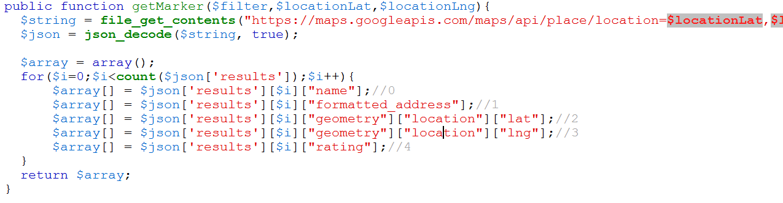

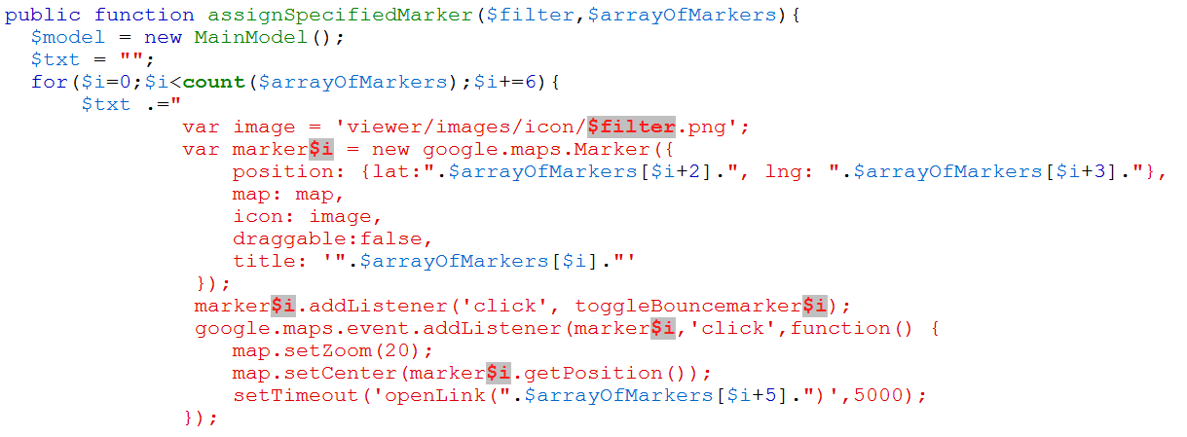

Figure 4.1 – Google MAP API Request and Response

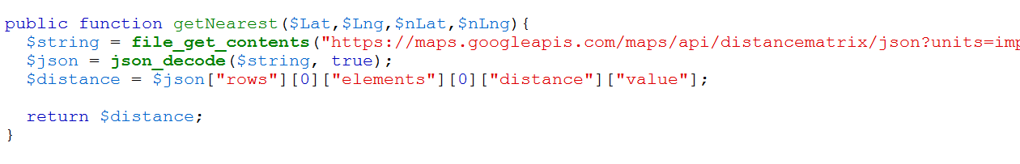

Figure 4.2 – Google MAP API for Compute Distance Between two Different Places

4.1.2 Login

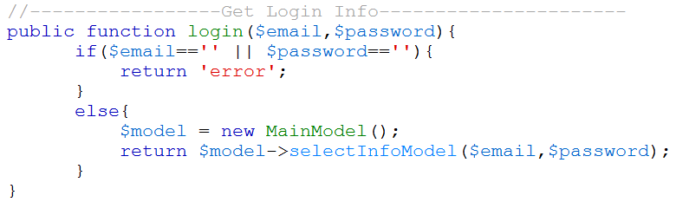

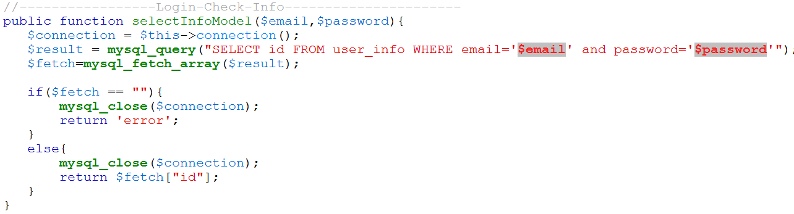

Figure 4.3 – Controller and Model Code of Login

4.1.3 Register

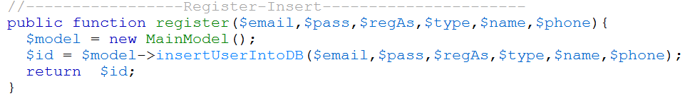

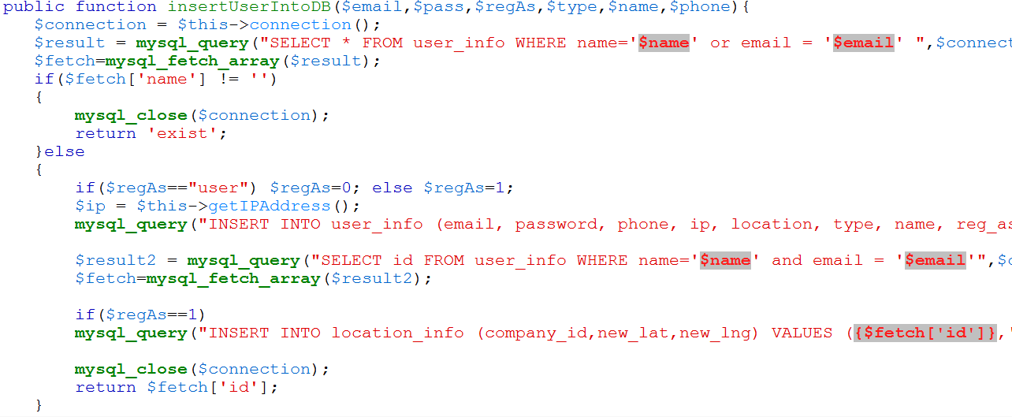

Figure 4.4 – Controller and Model Code of Registration

4.1.4 IP Finder

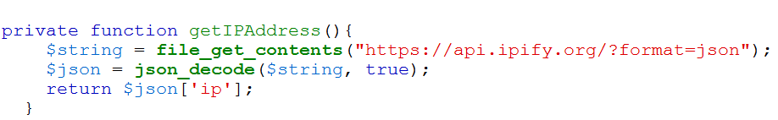

Figure 4.5 – IP Finder API

**4.2 System Design Screen Shoots**

4.2.1 Home Page

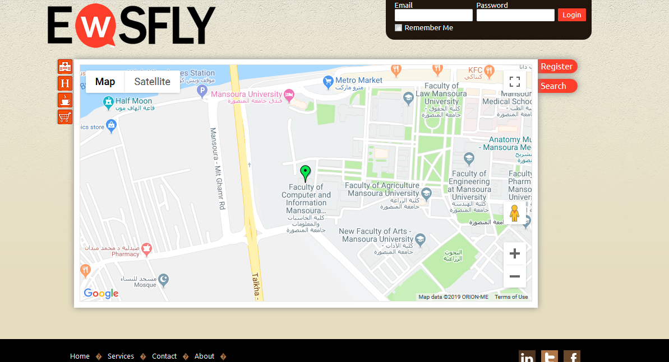

Figure 4.6 – Home Page Before Registration

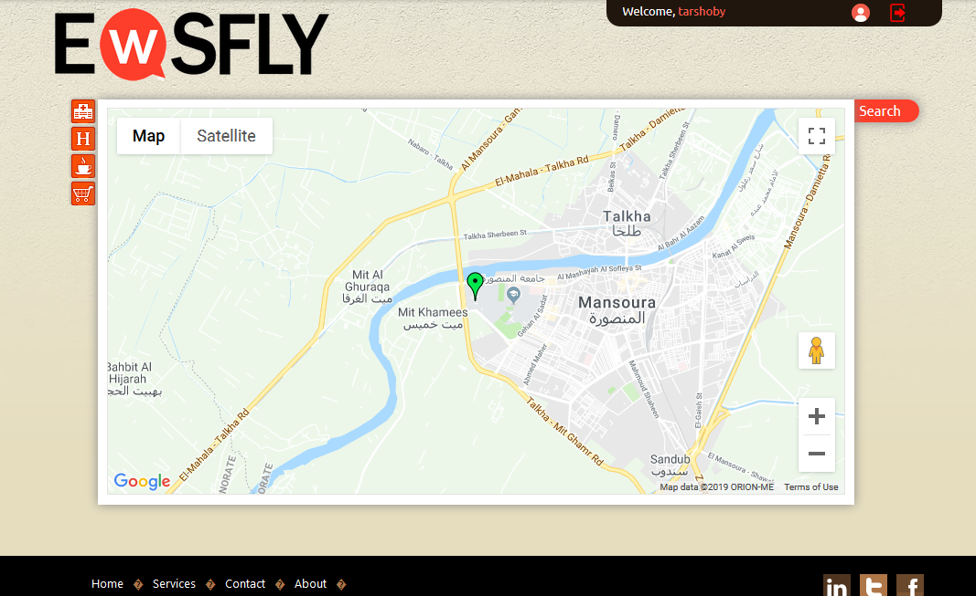

Figure 4.7 – Home Page After Registration

4.2.2 Registration

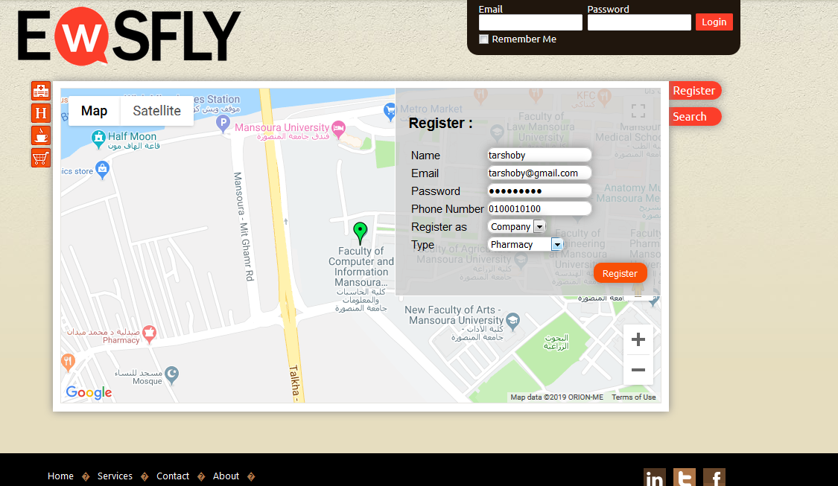

Figure 4.8 –Registration

4.2.3 Profile Page

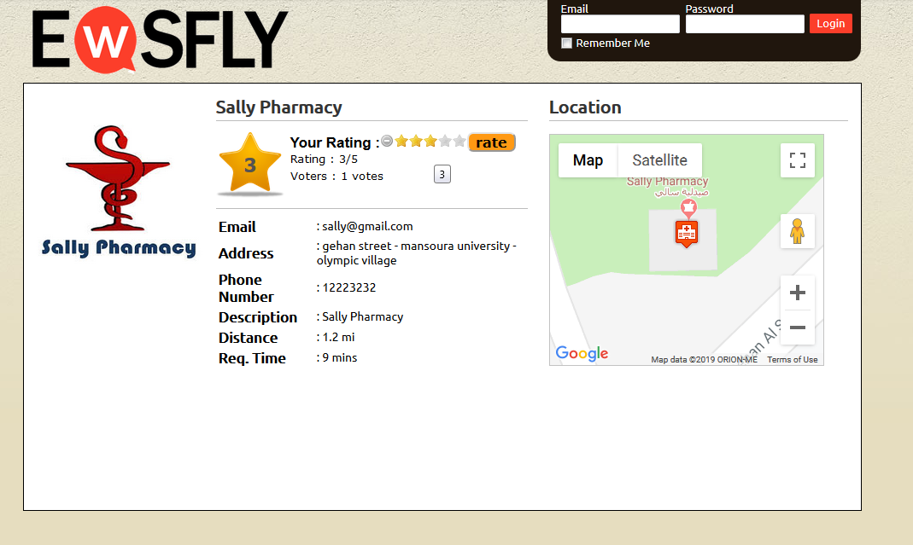

Figure 4.9 –Profile Page

4.2.4 Dashboard

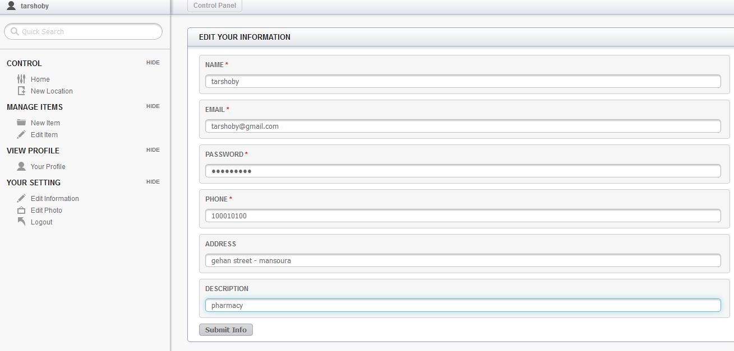

Figure 4.10 –Update Profile Information

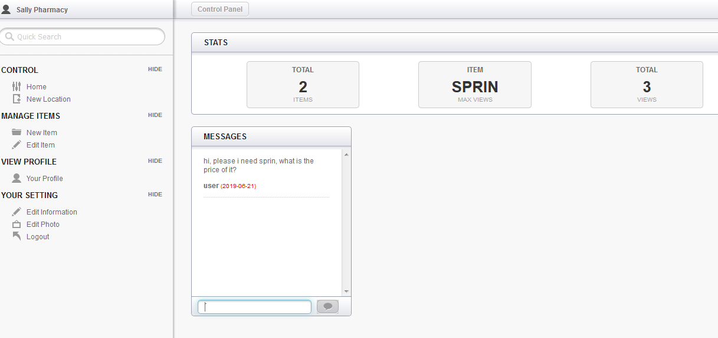

Figure 4.11 –Send Messages and Show Statistical Information

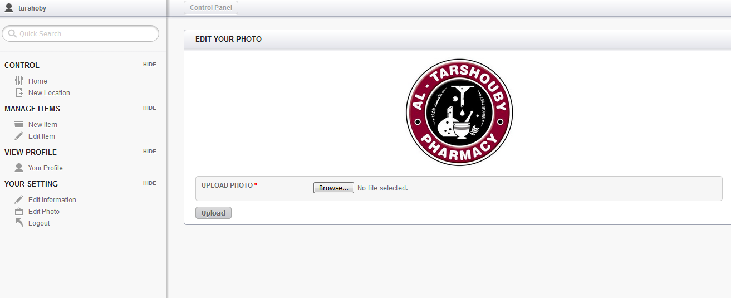

Figure 4.12 –Update Logo

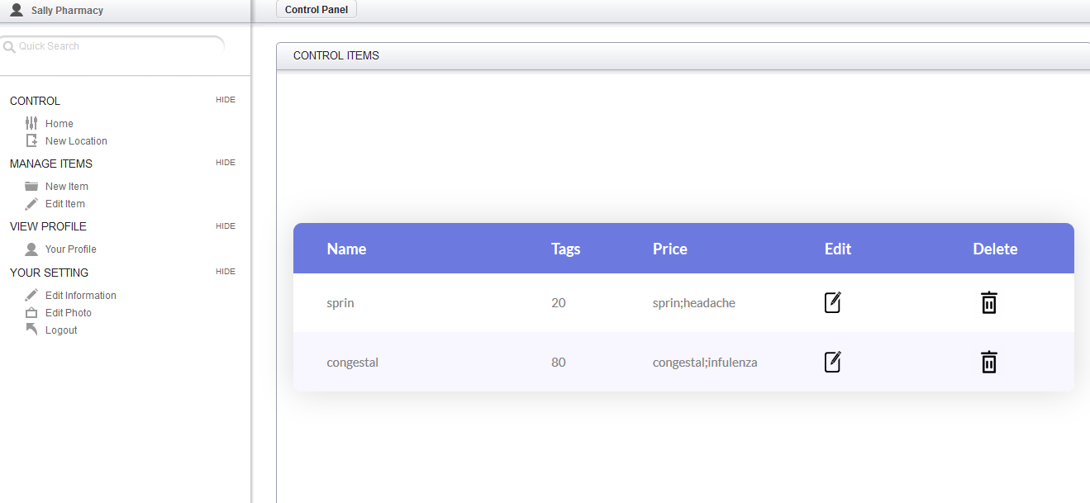

Figure 4.13 –Create and Update Items Information

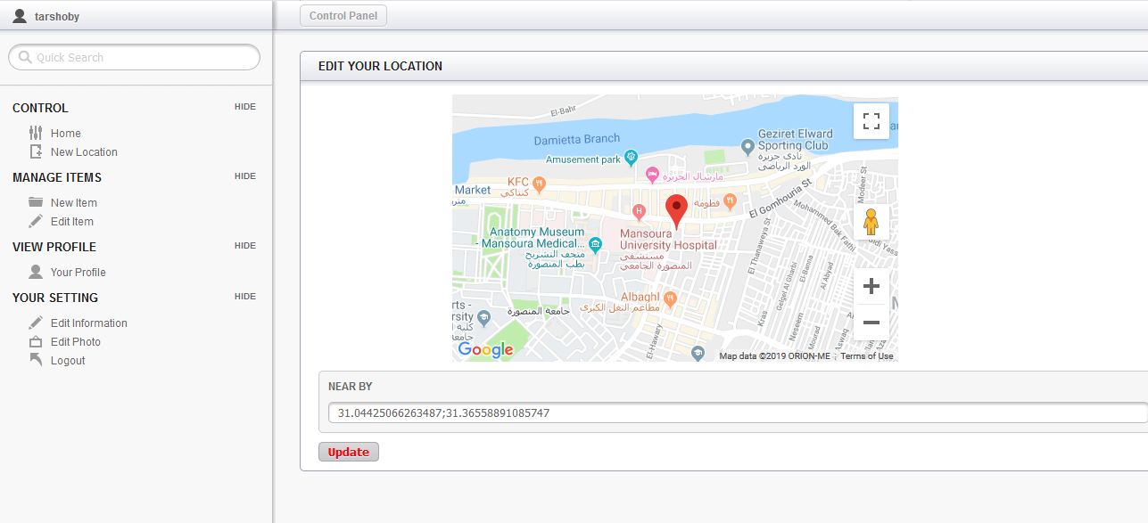

Figure 4.14 –Update Location