IEEE ManCSC Task

1. What is the difference between Abstract and Interface in php?

It’s similar but have some technical keys differences :

First: Interface Class (doesn’t contain properties – Have methods can be shared between different classes with different implementation – doesn’t contain constructors – by default access modifier is public- support multiple inheritance)

Second: Abstract Class (it contain properties and methods and other data – it’s contain constructors - doesn’t support multiple inheritance – can contain other access modifiers)

1. Explain MVC Design Pattern.

**an architectural pattern that separates an application into three main logical components.**

**Model – View - Controller**:

Model: Handles data logic.

View: It displays the information from the model to the user.

Controller: It controls the data flow into a model object and updates the view whenever data changes.

**-** First the user hit an path in the URL we called it route which will go to a specific controller to implement the code inside it then, there’s two ways if the code will be showed as view or it will go to model for getting some data and also showed it with model.

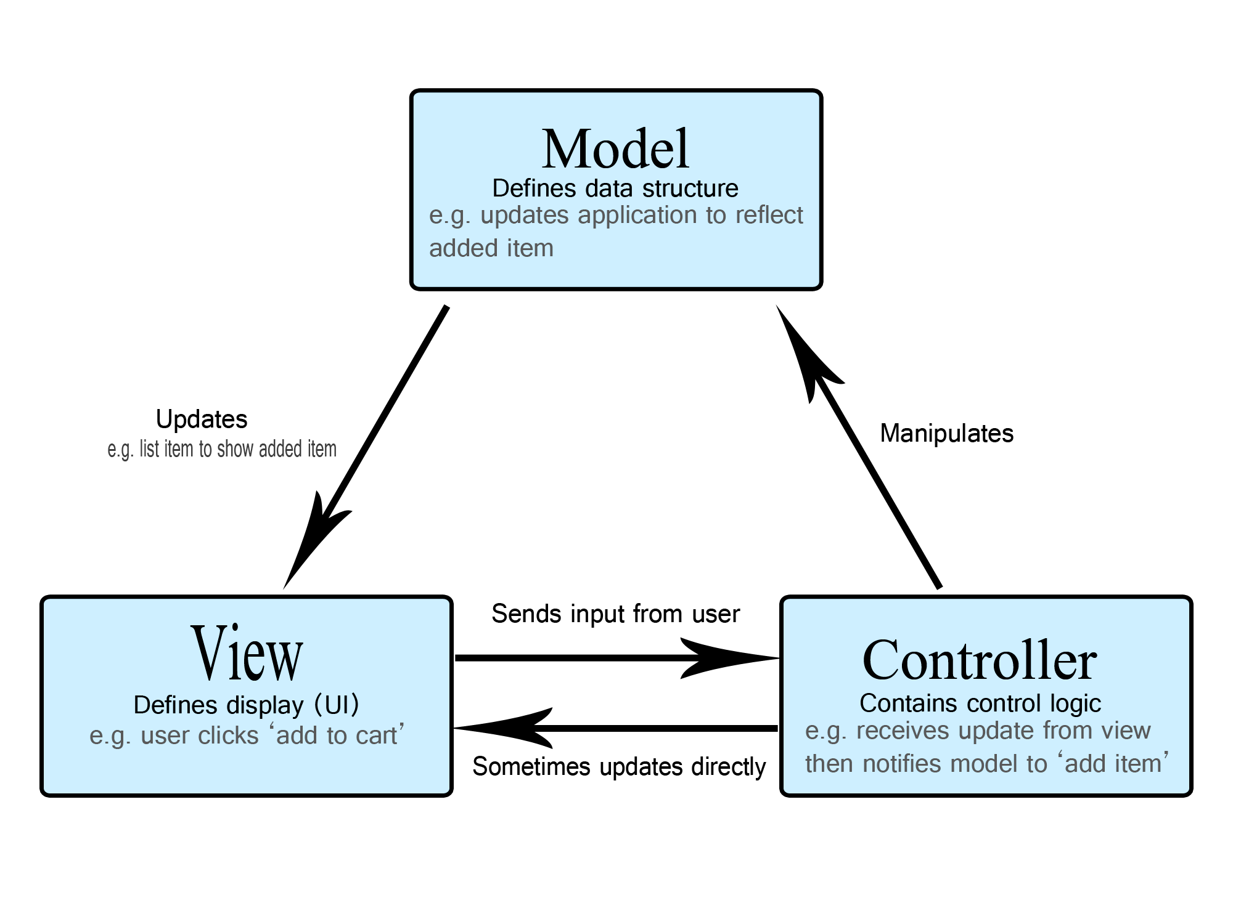

1. How to turn off CRSF protection for specific route in Laravel?

- since version 5.1 in Laravel it allows to you to write all routes that are excluded from csrf validation (protection) in file VerifyCsrfToken in middleware (outside web middleware) but you should declare an array called $except and its access modifier “Protected” as shown in the code

1. How to use custom table in Laravel Model?

- so simple that we can override the protected ‘$table’ property of Eloquent model like the code.