**Name:** Esraa Nasser Abobakr Ali

**Email:** [esraanasser95@hotmail.com](mailto:esraanasser95@hotmail.com)

**Project:** Implementing EDF Scheduler

**Analytical Methods**

|  |  |  |  |
| --- | --- | --- | --- |
| **Tasks** | **Period** | **Execution Time** | **Number of occurrences in hyperperiod** |
| Button_1_Monitor | 50 ms | 2.1 us | 2 |
| Button_2_Monitor | 50 ms | 2.1 us | 2 |
| Periodic_Transmitter | 100 ms | 55.7 us | 1 |
| UART_Receiver | 20 ms | 21 us | 5 |
| Load_1_Simulation | 10 ms | 5 ms | 10 |
| Load_2_ Simulation | 100 ms | 11.84 ms | 1 |

**1-Hyperperiod**

Hyperperiod is the least common multiplier of all Periods= 100 ms

**2-CPU Load**

CPU Load= sum (tasks execution time * Times of task running during period)/period time

= [(0.0021*2) + (0.0021*2) +(0.055*1) +( 0.021*5) +(5*10) +(11.84*1)]/100=62.01%

**3-System schedulability**

**A-using Rate Monotonic utilization bound**

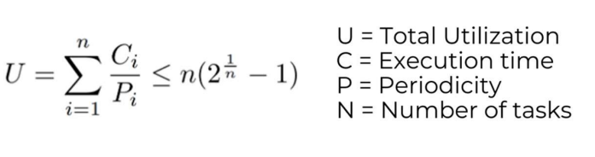

R.H.S (URM) = n [2 ^ (1/n) - 1] = 6 [2 ^ (1/6) - 1] = 0.7347=73.47%

L.H.S (U) = CPU load =62.01%

Since U < URM (50.2% < 73.47%) then, System is Schedulable.

**B- Using Time Demand Analysis**

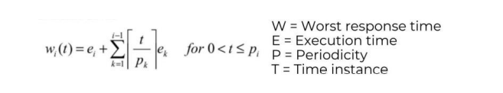

T1{P:50, E:2.1us, D:50}

T2{P:50, E:2.1us, D:50}

T3{P:100, E:55.7us, D:100}

T4{P:20, E:21us, D:20}

T5{P:10, E:5ms, D:10}

T6{P:100, E:11.84ms, D:100

Reordering our tasks based on priorities

|  |  |  |  |  |
| --- | --- | --- | --- | --- |
| Tasks |  | Period | Execution Time | Priority |
| Button_1_Monitor | T1 | 50 ms | 2.1 us | 1 |
| Button_2_Monitor | T2 | 50 ms | 2.1 us | 1 |
| Periodic_Transmitter | T3 | 100 ms | 55.7 us | 0 |
| UART_Receiver | T4 | 20 ms | 21 us | 2 |
| Load_1_Simulation | T5 | 10 ms | 5 ms | 3 |
| Load_2_ Simulation | T6 | 100 ms | 11.84 ms | 0 |

T5 =W (10) = 5+0 = 5 ms < 10 ms

Load 1 Simulation task is schedulable

T4 =W (20) = 0.021+(20/10) *5 = 10.021 < 20 MS

UART Receiver task is schedulable.

T1 =W (50) = 0.0021+(50/10) *5+(50/20) * 0.021 = 25.0546 <50

Button 1 Monitor task is schedulable.

T2 =W (50) =0.0021+(50/10) *5+(50/20) * 0.021+(50/50) * 0.0021=25.0567<50

Button 2 Monitor task is schedulable.

T3 =W (100) = 0.0557+(100/10) *5+(100/20) * 0.021+(100/50) * 0.0021+(100/50) * 0.0021=50.1691 <100

Periodic Transmitter task is schedulable.

T6 =W (100) = 11.84+(100/10) *5+(100/20) * 0.021+(100/50) * 0.0021+(100/50) * 0.0021+(100/100) *0.0557=62.0091 <100

Load 2 Simulation task is schedulable.

**Then, System is Schedulable.**

**SEMSO**

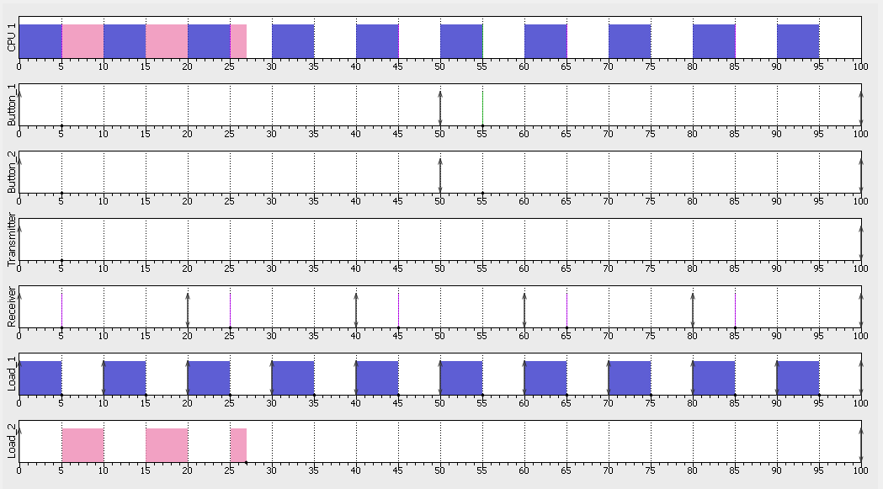

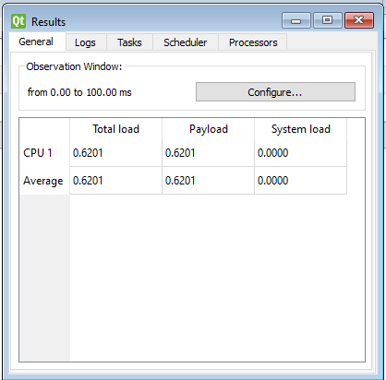

**Keil**

