Low_Design_reg_1

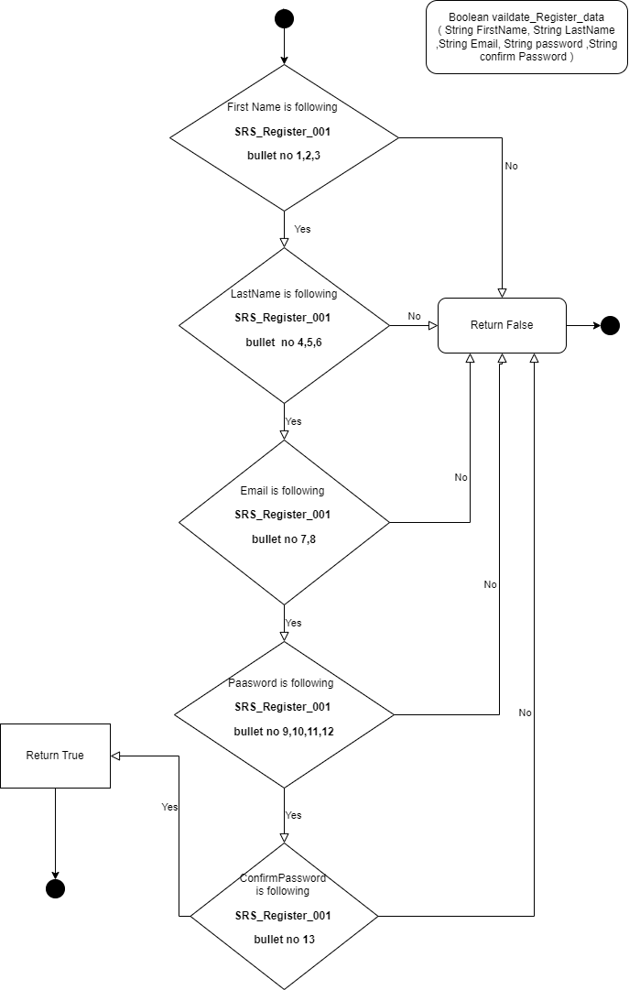

Low_Design_login_1

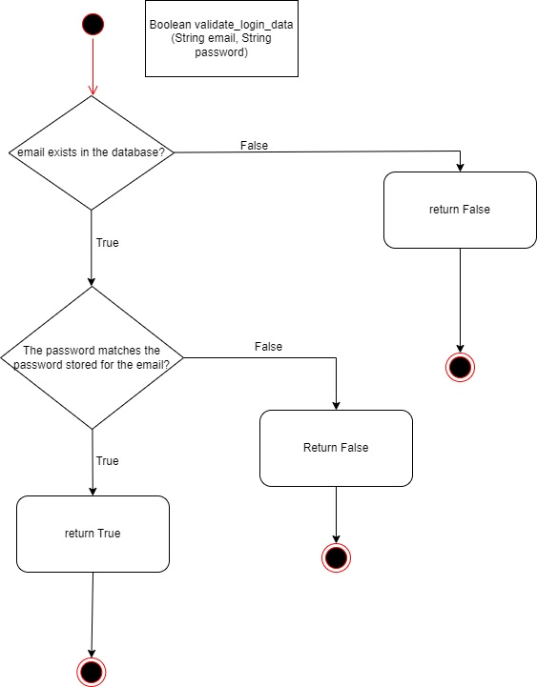

Low_Design_PerformTransaction _1

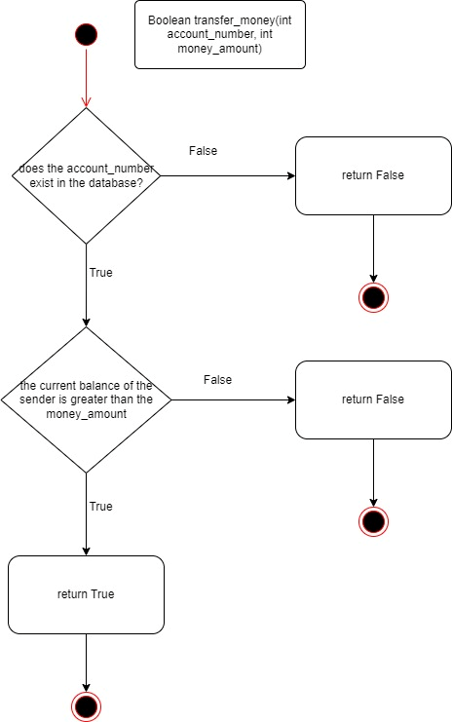

Low_Design_CloseAccount_1

