Internet Banking System

Design Document

Version 6

27/4/2023

## Revision History

|  |  |  |  |
| --- | --- | --- | --- |
| **Date** | **Description** | **Author** | **Comments** |
| 8/4/2023 | Version 1 | Esraa | Create Design document |
| 9/4/2023 | Version 2 | Hana & Amany | Updating Design  Document. |
| 9/4/2023 | Version 3 | Hana | Adding functions |
| 26/4/2023 | Version 4 | Hana | Update as per coach review |
| 27/4/2023 | Version 5 | Amany | Update high level design |
| 6/5/2023 | Version 6 | Hana | Update as per  Coach review. |

## 1. Introduction

Internet Banking System, where the client can register using his name, email, and password, then the client can login using his email and password and redirected to the view Account page, where he can add a new account, view drop down list containing all his account. He can choose one of his accounts, then the current balance and the previous transactions related to this account are displayed, also the client can transfer money by entering the destination account number and the amount of money to be transferred.

Admin can login by his email and password, then redirected to the view admin page where he can view all the accounts of each client, also he can close a client’s account if the balance of this account is zero.

Both users can logout.

## 2. Generic Diagrams

## Wire Frames

Register_wireFrame_1

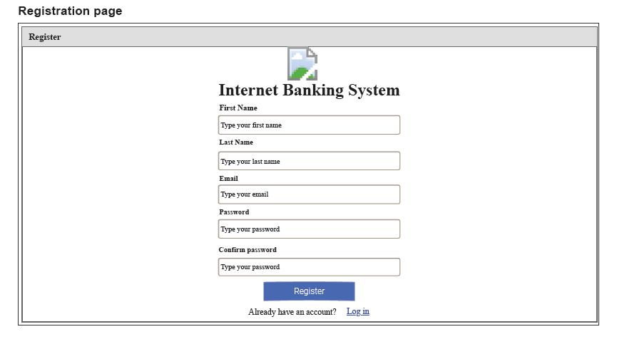

Login_wireFrame_1

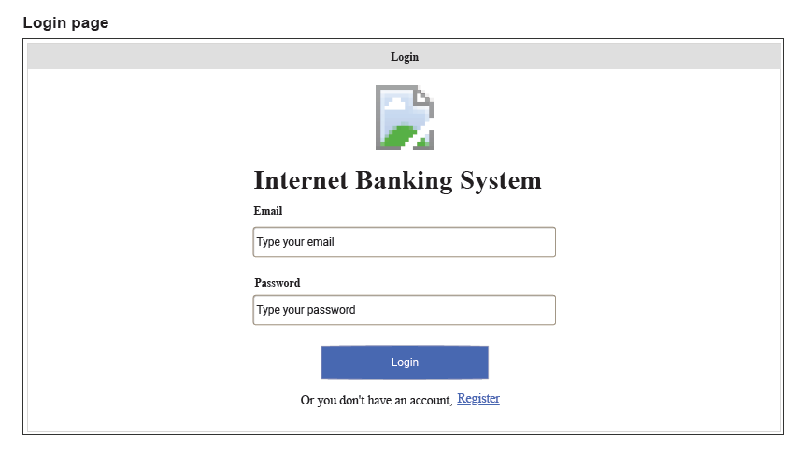

ViewClient_wireFrame_1

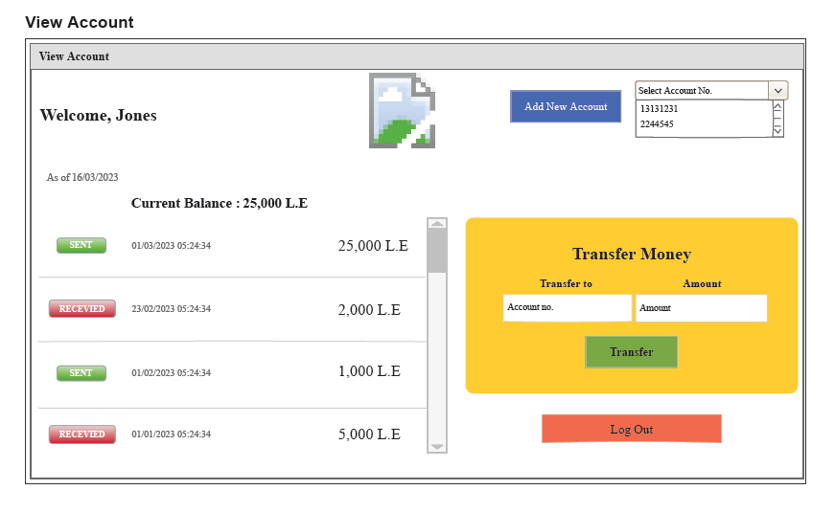

viewAdmin_wireFrame_1

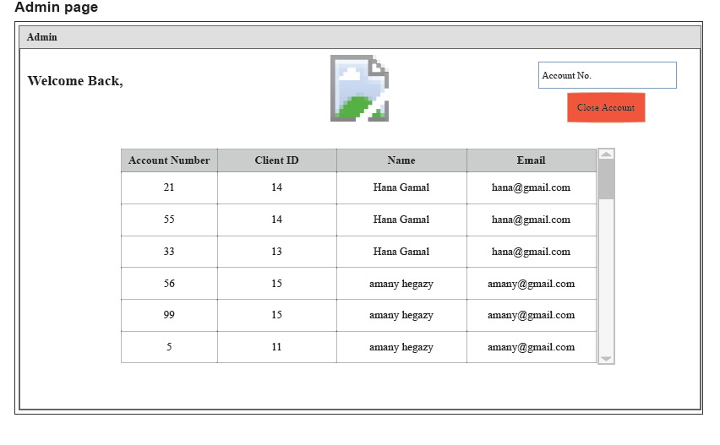

ERD_001

## 2.2 Use Case

UseCase_001

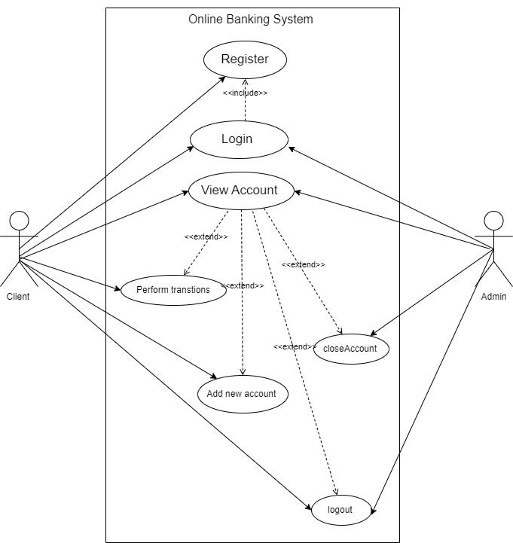

## 3. Model Based Section

## 3.1 Login

## 3.1.1Class Diagram

classDiagram_login_001

## 3.1.2 High Level

Client

Generic sequence diagram which is not related to one function, it is related to login and view Account features.

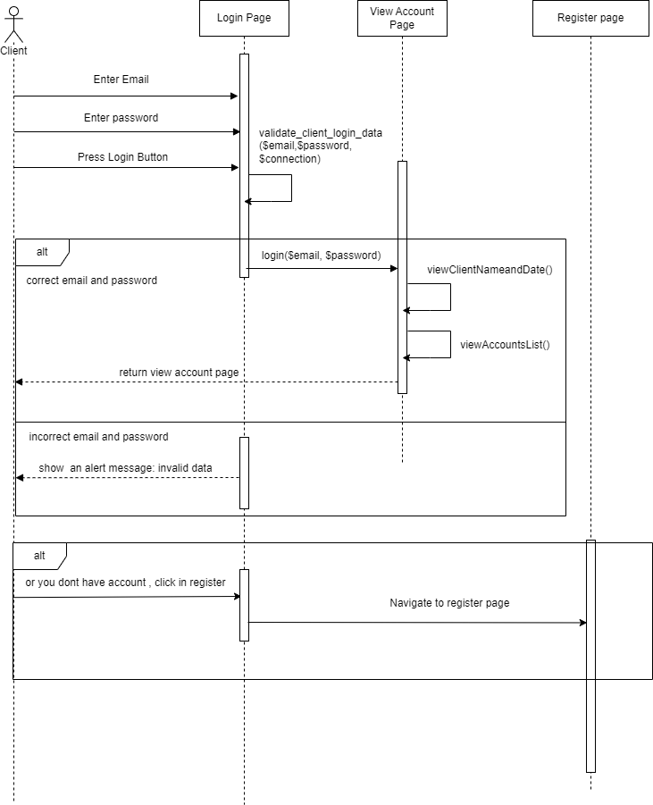

Admin

Generic sequence diagram which is not related to one function, it is related to login and view admin features.

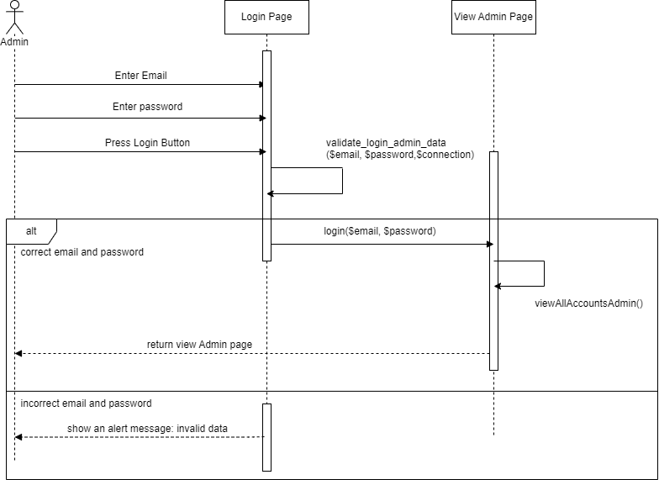

## 3.1.3 Low Level

Low_Design_login_1

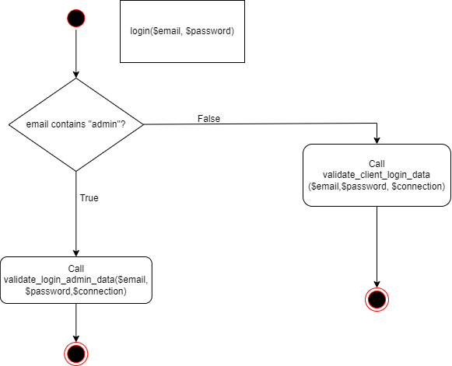

Low_Design_login_client_2

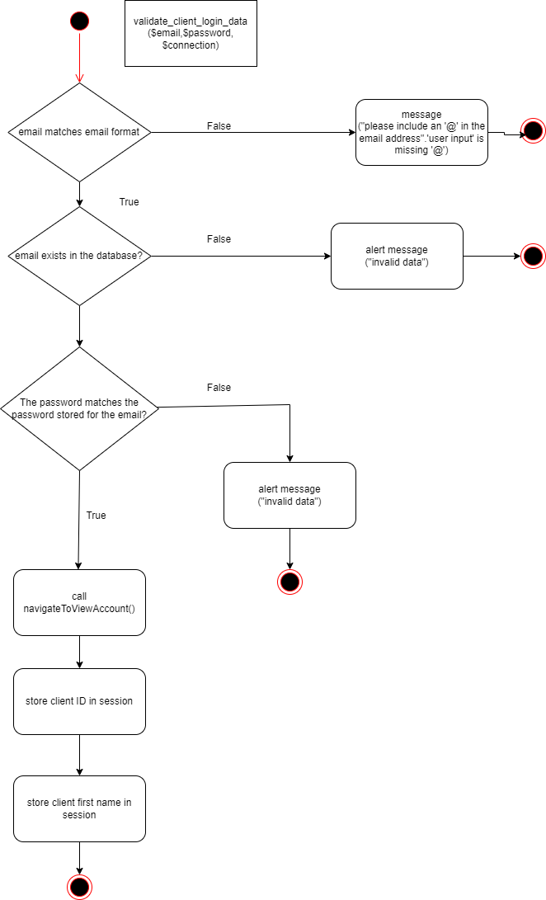

Low_Design_login_admin_1

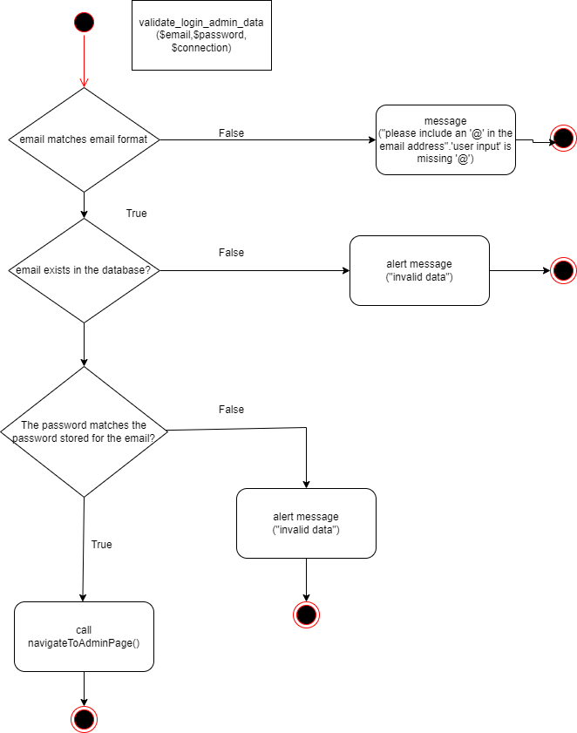

High_Design_navigate_to_admin_page_1

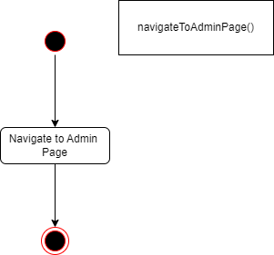

High_Design_navigate_to_view_account_page_1

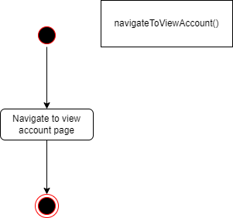

Low_Design_loginMain_1

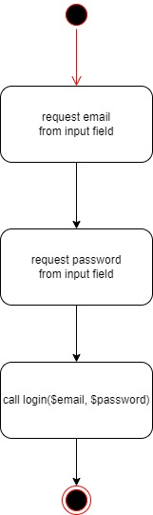

## 3.2 Register

## 3.2.1 Class Diagram

classDiagram_register_001

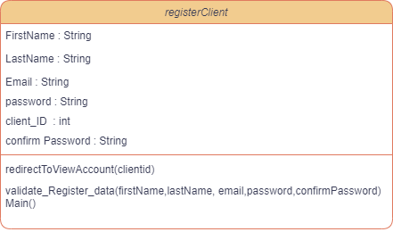

## 3.2.2 High Level

Generic sequence diagram, which is not related to specific function, but describes register feature.

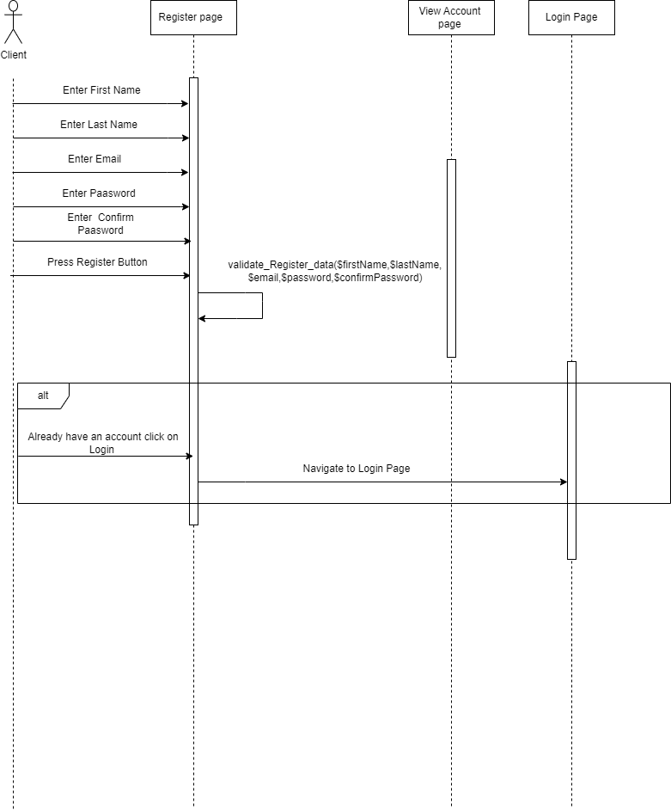

## 3.2.3 Low Level

Low_Design_reg_1

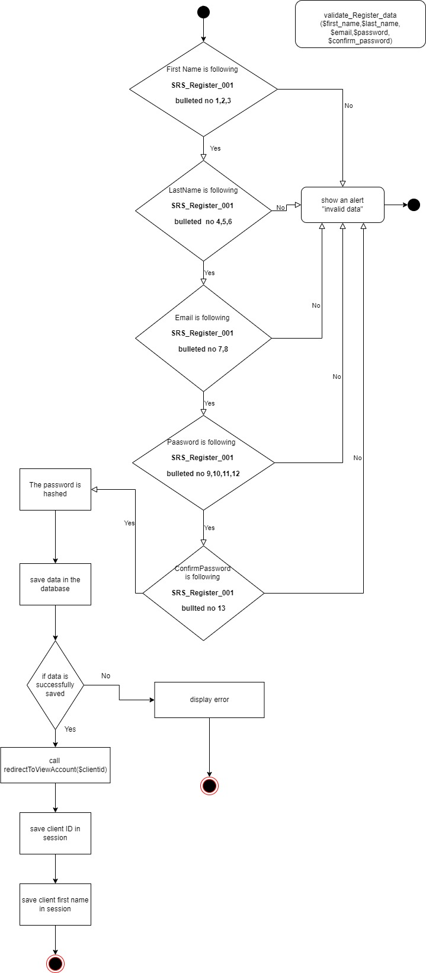

High_level_navigate_after_register_1

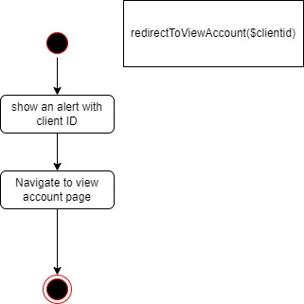

Low_Design_regMain_3

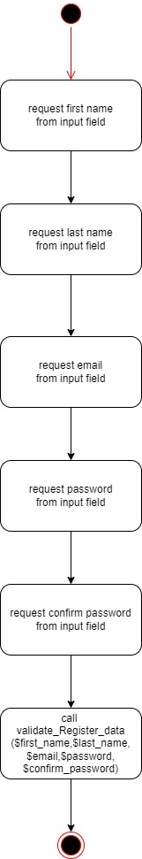

## 3.3 View Account

## 3.3.1 Class Diagram

classDiagram_viewAccount_Client_001

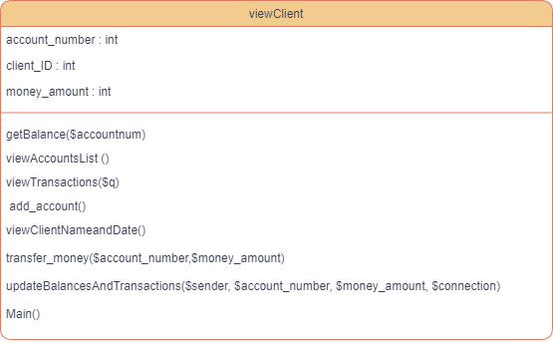

classDiagram_viewAccount_Admin_001

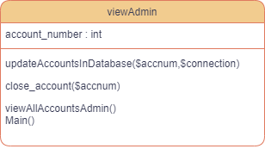

## 3.3.3 Low Level

Low_Design_ViewTransaction_1

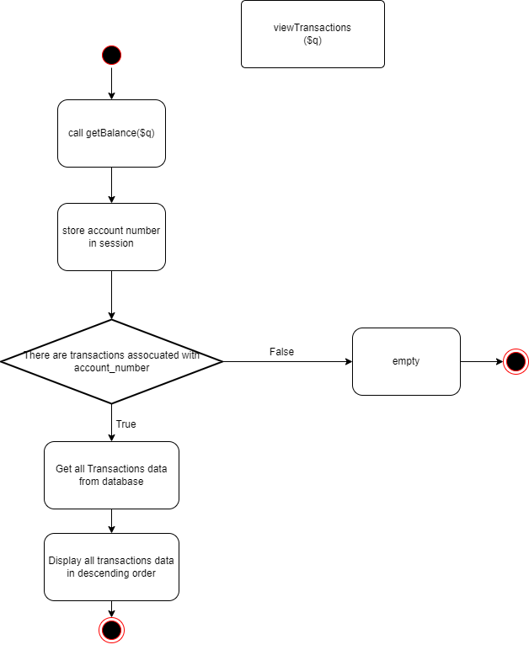

Low_Design_Display_ClientName_Date_1

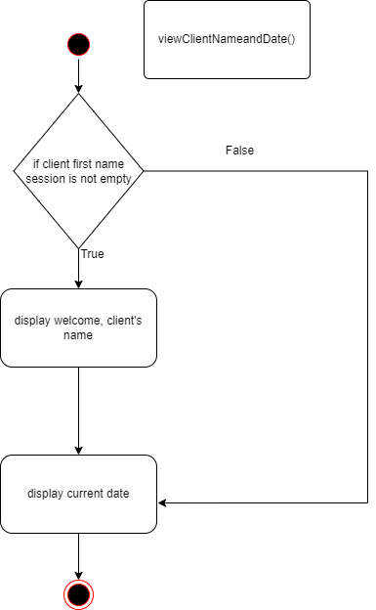

Low_Design_ViewAllAccounts_Admin_1

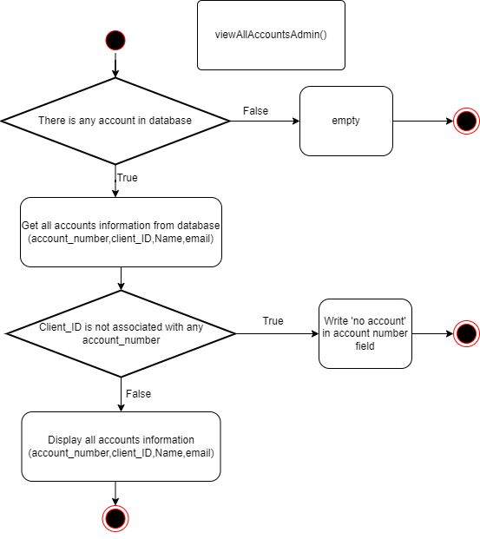

Low_Design_closeAccount_Admin_1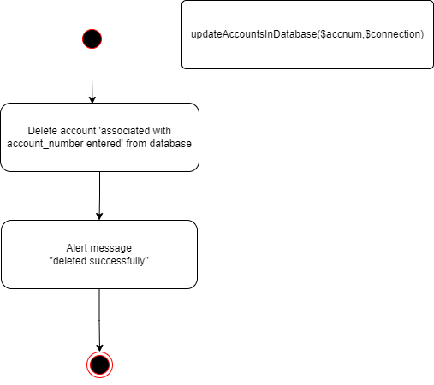

Low_Design_closeAccount_Admin_2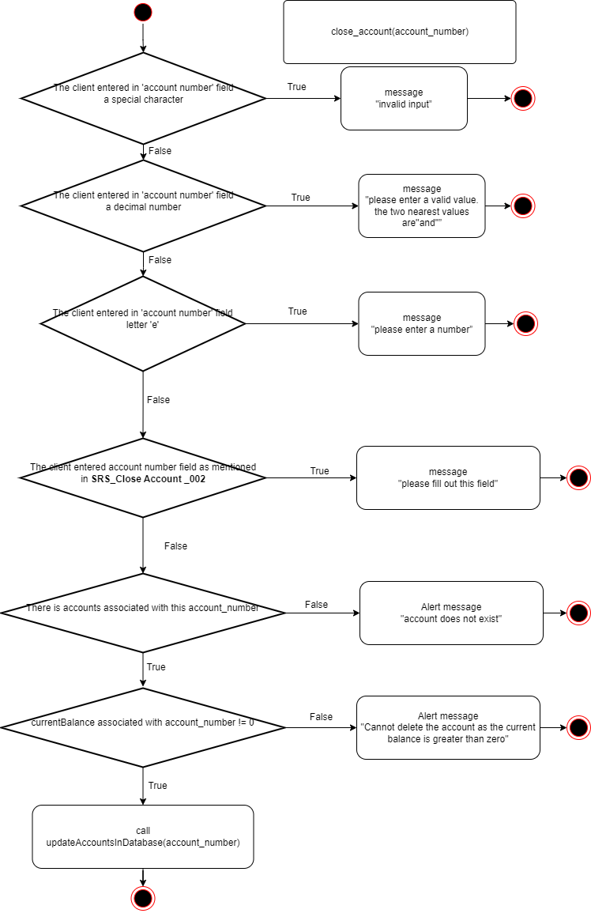

Low_Design_getBalance_Client_1

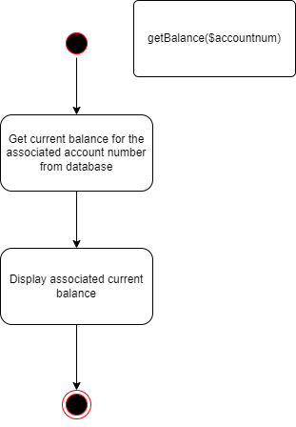

Low_Design_transferMoney_Client_1

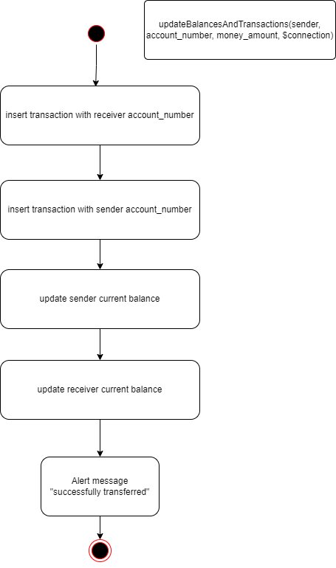

Low_Design_transferMoney_Client_2

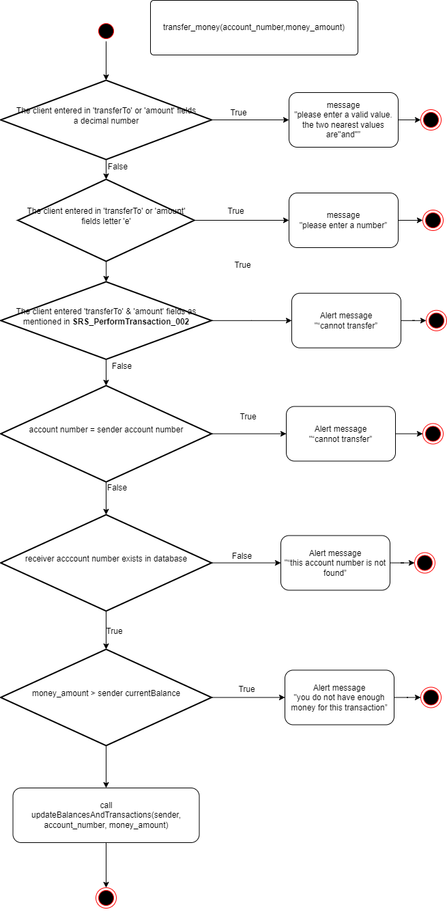

Low_Design_addAccount_client_1

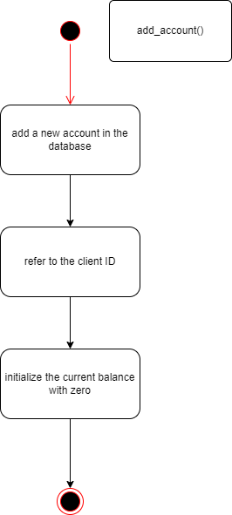

Low_Design_ViewClientMain_1

Low_Design_ViewAdminMain_1

## 3.4 Logout

## 3.4.1 Class Diagram

classDiagram_logout_1

## 3.4.2 High Level

High_level_Logout_client_1

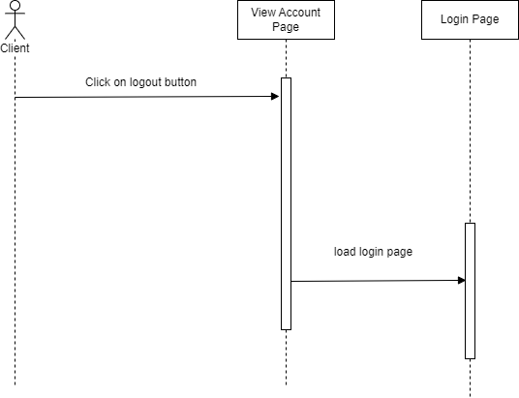

High_level_Logout_admin_1

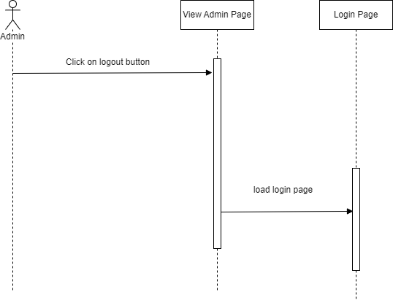

## 3.4.3 Low Level

Low_Design_Logout_1

