**1.4 Customers' Analysis**

Our customer-base is divided into three target segments across three years.

2nd and 3rd year customer analysis is relative to 1st year analysis; only major differences are listed

***1st Year Customer Base (Egypt)***

After conducting a survey on a sample of (115) based on our previous customer

analysis we reached the following responses and accordingly determined our

customer segment

##### **Age:**

* 18-24(63.07%)
* 25-34 (23.07%)

##### **Gender:**

Males (47.82%) and Females (52.17%)

##### **Educational Level:**

* Primary Certificate
* Junior Certificate
* General Education Certificate
* University and Above

##### **Work :**

* Employed (full-time / part-time) with free hours per day. (40.86%)
* Un-Employed sector (59.13%)

##### **Income:**

* Below Average ( 18 %)
* Average (36%)
* Above Average (45%)

##### **Social Status:**

* Class A
* Class B
* Class C

##### **Behavioral Characteristics**

###### **Spending:**

* Varies According to the social status
* Class A: Extravagant and Lavish
* Class B: Conservative and Thrifty

###### **Consumption:**

* High consumption in the three social classes.

##### **Personal Characteristics:**

* We have three main customer personas (Mentors, Talents, Audience)

|  |  |  |
| --- | --- | --- |
| **Talent** | **Mentor** | **Audience** |
| Sociable | Sociable | Sociable |
| Friendly | Friendly | Friendly |
| Practical | Practical | Practical |
| Creative | Creative |  |
|  | Judicious | Judicious |
| Skilled | Skilled |  |
| Receptive | Enlightened | Open-minded |
| Persistent | Expert |  |
| Energetic | Helpful |  |
| Ambitious |  |  |

## [figure no.1]

**Talents statistics:**

|  |  |  |
| --- | --- | --- |
| Talent or not | percentage | Real number |
| yes | 49.56 | 57 |
| No | 9.56 | 11 |
| Don’t Know | 37.39 | 43 |
| Don’t care | 3.47 | 4 |

## [figure no.2]

**Categories:**

|  |  |  |  |  |
| --- | --- | --- | --- | --- |
| Writing | Design | Drawing | Teaching | Acting |
| Learning Languages | Leader Ship | Poetry | Music |  |

## [figure no.3]

**Spending Money on Nurturing Talents:**

|  |  |  |
| --- | --- | --- |
| Answer | percentage | Real number |
| yes | 71.30 | 82 |
| no | 28.69 | 33 |

## [figure no.4]

**Number of people who liked idea:**

|  |  |  |
| --- | --- | --- |
| Answer | percentage | Real number |
| yes | 96.52 | 111 |
| no | 3.47 | 4 |

## [figure no.5]

**Their desired role in the site:**

|  |  |  |
| --- | --- | --- |
| Answer | percentages | Real number |
| Audience | **21.73** | **25** |
| Mawhoob | **60.86** | **70** |
| Mentor | **17.39** | **20** |

## [figure no.6]

**Our survey questions:**

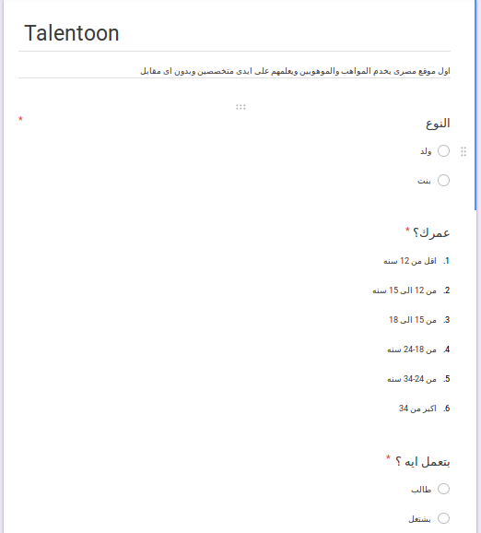

[figure no.7]

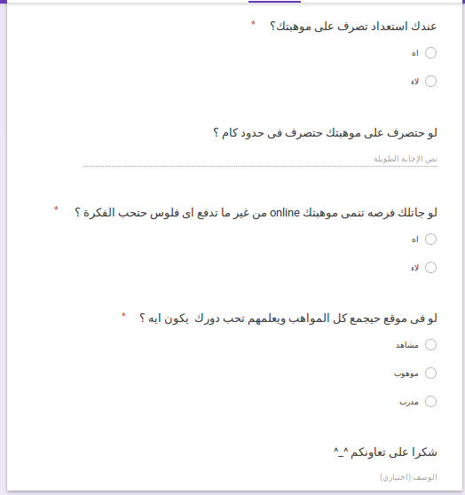

## [figure no.8]

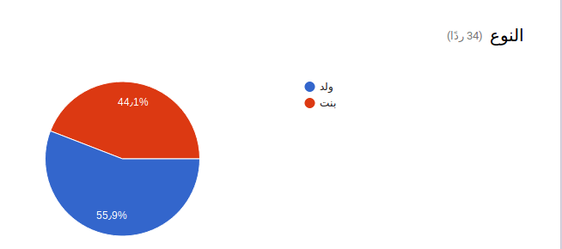

[figure no.9]

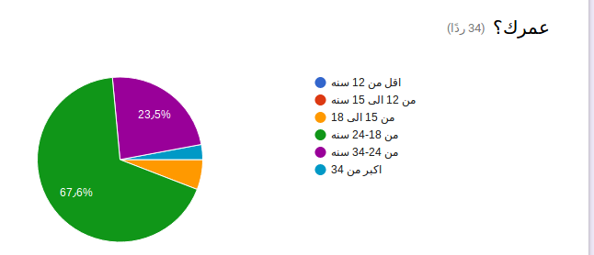

[figure no.10]

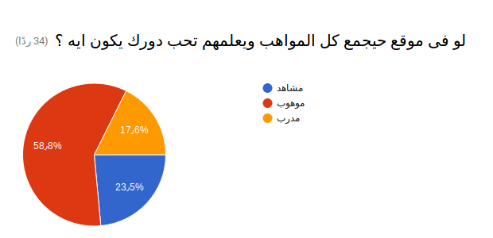

[figure no.11]

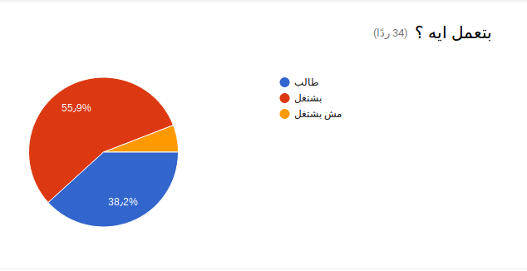

[figure no.12]

#### **2nd year Customer-Base (Middle East)**

##### **Age:**

* 11-34

##### **Educational Level:**

* Junior education is done in two stages
  + First stage (11-14 ) Start from the sixth grade to the eighth grade
  + High school (15-17) Start from the ninth grade to the eleventh grade
* University and Above

##### **Income Level:**

* Above Average
* Average

##### **Behavioral Characteristics :**

###### **Spending :**

* Class A,B: Extravagant and Lavish

**1.5 Scope**

**1.6 Stakeholders/Beneficiaries**

* **Stakeholders**
* Mentors
* Talents
* Audiences
* Sponsors
* Google
* YouTube
* Facebook
* Sound cloud
* Centers of Culture and Creativity
* Investors
* Universities
* Opera
* online store owner
* **Beneficiaries**
  + Talents
  + Audiences
  + Mentors
  + online store owner
  + Sponsors

**1.7 Business Model**

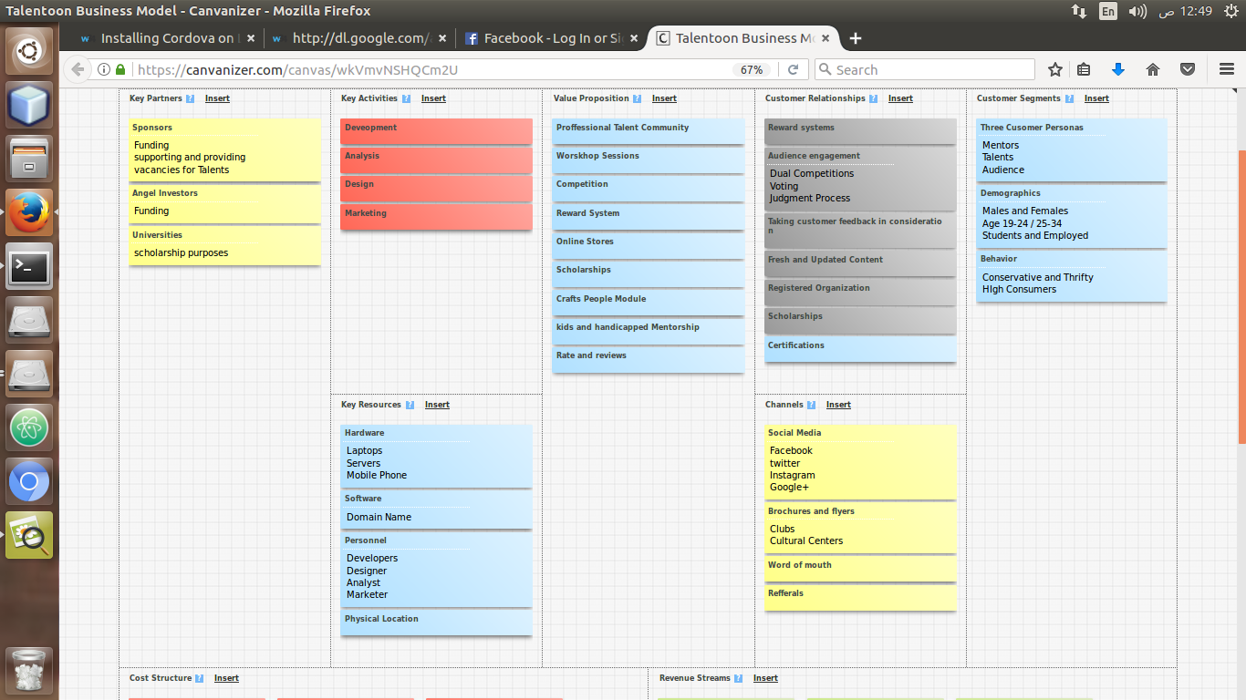

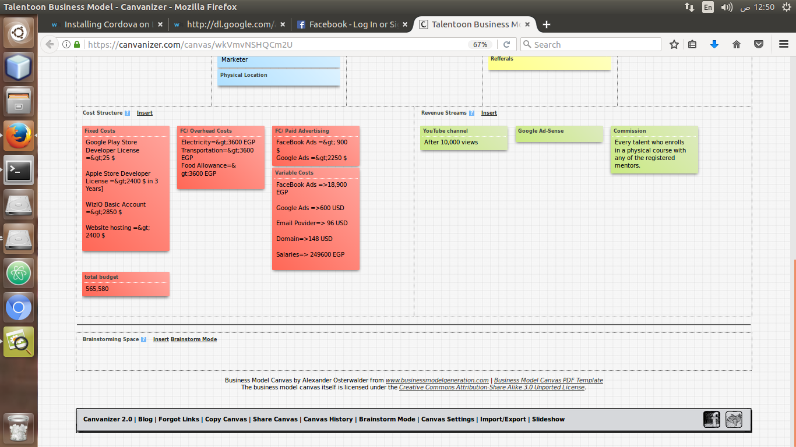

**Key Partners:**

* **Sponsors**
* Funding
* supporting and providing vacancies for Talents
* **Angel Investors**
  + Funding
* **Universities**
  + scholarship purposes

**Key Activities:**

* Development
* Analysis
* Design
* Marketing

**Value Proposition:**

* Professional Talent Community
* Workshop Sessions
* Competition
* Reward System
* Online Stores
* Certifications
* Scholarships
* Crafts People Module
* kids and handicapped Mentorship
* Rate and reviews

**Customer Relationships:**

* Reward systems
* Audience engagement
  + Dual Competitions
  + Voting
  + Judgment Process
* Taking customer feedback in consideration
* Fresh and Updated Content
* Registered Organization
* Scholarships
* Certifications

**Customer Segments:**

* Three Cusomer Personas
  + Mentors
  + Talents
  + Audience
* Demographics
  + Males and Females
  + Age 19-24 / 25-34
  + Students and Employed
* Behavior
  + Conservative and Thrifty
  + HIgh Consumers

**Key Resources:**

* Hardware
  + Laptops
  + Servers
  + Mobile Phone
* Software
  + Domain Name
* Personnel
  + Developers
  + Designer
  + Analyst
  + Marketer
* Physical Location

**Channels:**

* Social Media
  + Facebook
  + twitter
  + Instagram
  + Google+
* Brochures and flyers
  + Clubs
  + Cultural Centers
* Word of mouth
* Referrals

**Cost Structure:**

* Fixed Costs
* Google Play Store Developer License =&amp;gt;25 $
* Apple Store Developer License =&amp;gt;2400 $ in 3 Years]
* WizIQ Basic Account =&amp;gt;2850 $
* Website hosting =&amp;gt; 2400 $
* FC/ Overhead Costs
  + Electricity=&amp;gt;3600 EGP
  + Transportation=&amp;gt;3600 EGP
  + Food Allowance=&amp;gt;3600 EGP
* FC/ Paid Advertising
  + FaceBook Ads =&amp;gt; 900 $
  + Google Ads =&amp;gt;2250 $
* Variable Costs
  + FaceBook Ads =&gt;18,900 EGP
  + Google Ads =&gt;600 USD
  + Email Povider=&gt; 96 USD
  + Domain=&gt;148 USD
  + Salaries=&gt; 249600 EGP
* total budget
  + 565,580

**Revenue Streams:**

* YouTube channel
  + After 10,000 views
* Google Ad-Sense
* Commission
  + Every talent who enrolls in a physical course with any of the registered mentors.