

**Faculty of engineering - Shoubra**

**Benha University**

**Research Project**

in fulfillment of the requirements of

|  |  |
| --- | --- |
| **Department** | **Engineering Mathematics and Physics** |
| **Division** | **-----------** |
| **Academic Year** | **2019-2020 Preparatory** |
| **Course name** | **Computer** |
| **Course code** | **ECE001** |

**Title: -**

**Artificial Intelligence**

By:

|  |  |  |  |
| --- | --- | --- | --- |
|  | Name | Edu mail | B.N |
| 1 | اسراء محمد اسماعيل محمد | Esraa195184@feng.bu.edu.eg | 172 |

**Approved by:**

|  |  |
| --- | --- |
| **Examiners committee** | **Signature** |
| Dr.Ahmed Bayoumi |  |
| Dr.Shady Elmashad |  |
| Dr. Abdelhamid Attaby |  |

**Table of content**

|  |  |
| --- | --- |
| **Subject / section** | **Page** |
| **Application brief** | **3** |
| **Examples for artificial intelligence** | **4** |
| **Screenshots** | **4** |
| **Source code** | **7** |
| **References** | **9** |
|  |  |

**List of Figures (If any)**

|  |  |
| --- | --- |
| **Figure I.D** | **Page** |
| **Fig1** | **4** |
| **Fig2** | **5** |
| **Fig3** | **5** |
| **Fig4** | **6** |
| **Fig5** | **6** |
| **Fig6** | **7** |

**Name**: **اسراء محمد اسماعيل محمد**

**B.N: 172**

**Date: 27/5/2020**

**Topic:** artificial intelligence

**Github link:** <https://github.com/EsraaMohamed484/Html-Project>

**Github page:** <https://esraamohamed484.github.io/Html-Project/>

**Application brief :**

Artificial intelligence (AI)[1]:-

Artificial intelligence (AI) is defined as intelligence exhibited by an artificial entity. Such a system is generally assumed to be a computer.

Although AI has a strong science fiction connotation, it forms a vital branch of computer science, dealing with intelligent behaviour, learning and adaptation in machines. Research in AI is concerned with producing machines to automate tasks requiring intelligent behavior. Examples include control, planning and scheduling, the ability to answer diagnostic and consumer questions, handwriting, speech, and facial recognition. As such, it has become a scientific discipline, focused on providing solutions to real life problems. AI systems are now in routine use in economics, medicine, engineering and the military, as well as being built into many common home computer software applications, traditional strategy games like computer chess and other video games.

Some common examples[2] of machine learning which you might use every day on your Smartphone include:

* Siri, or voice recognition;
* Facial recognition;
* Music, TV, or film streaming services such as Netflix and Apple Music, which learn the user’s preferences and predict related content; and
* Social media feeds such as Instagram, where artificial intelligence algorithms are used to determine which content to show the user first. Other common applications of artificial intelligence include:
* Autonomous vehicles, such as self-driving cars;
* Healthcare apps
* Robotics
  + **Screenshots:**

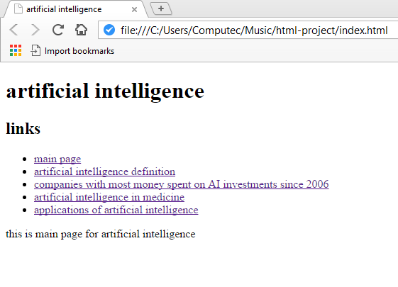

Fig1

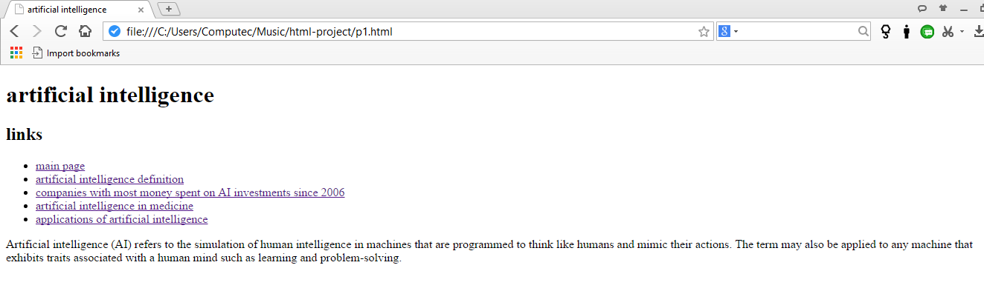

Fig2

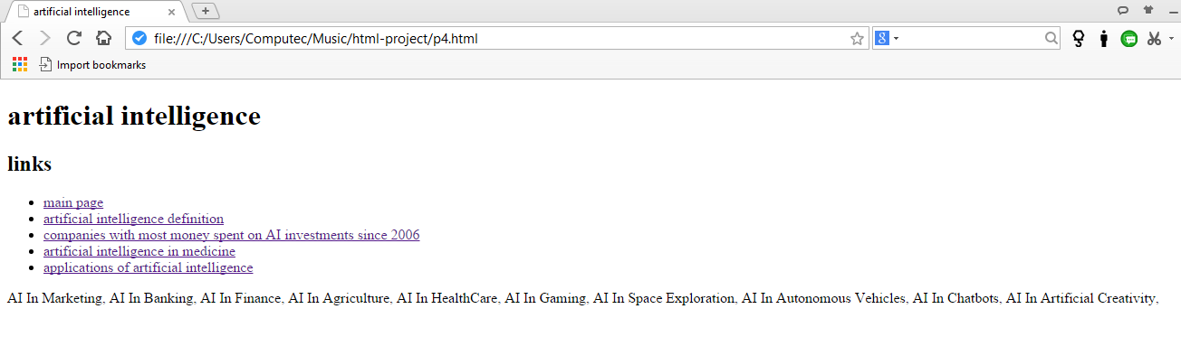

Fig3

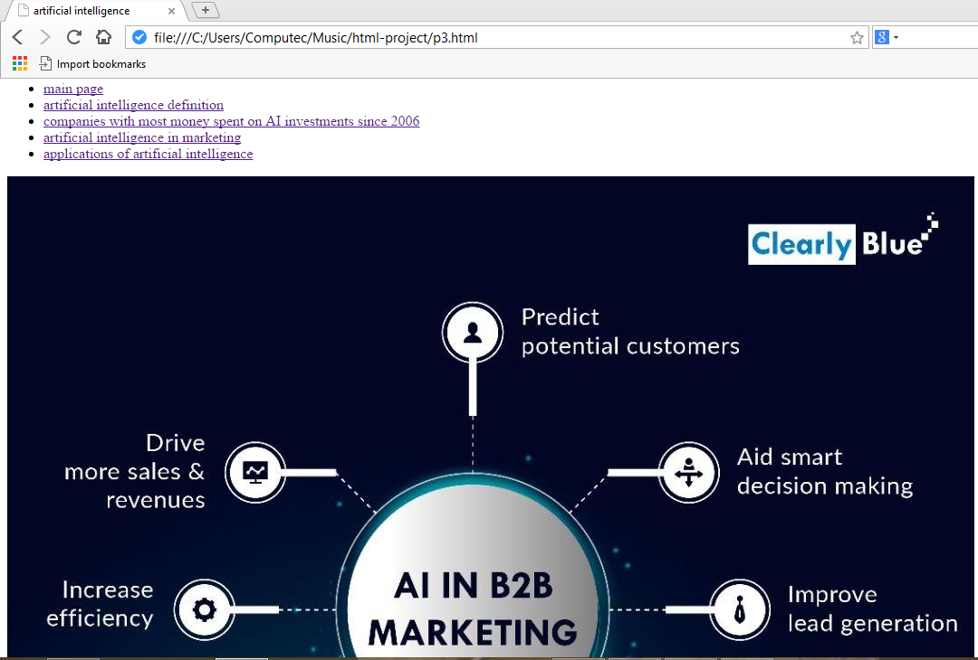

Fig4

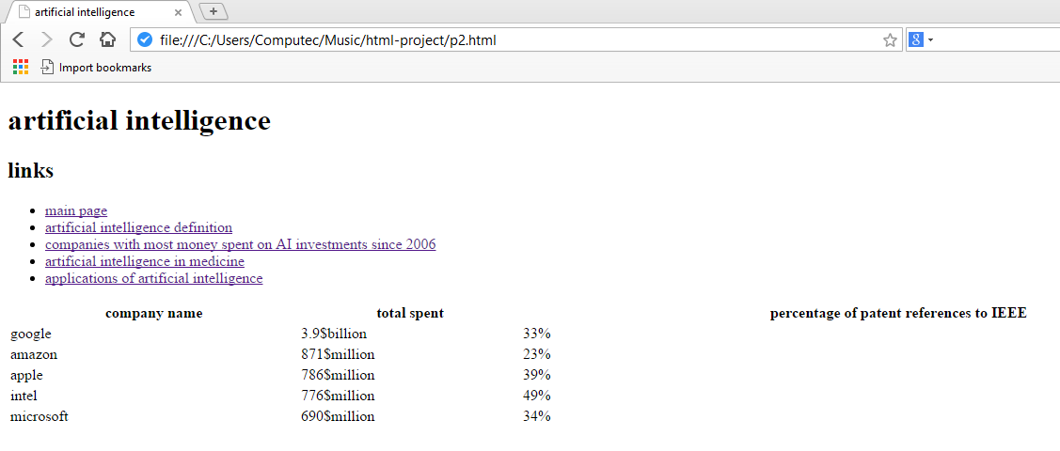

**Fig5**

* **Source code:**

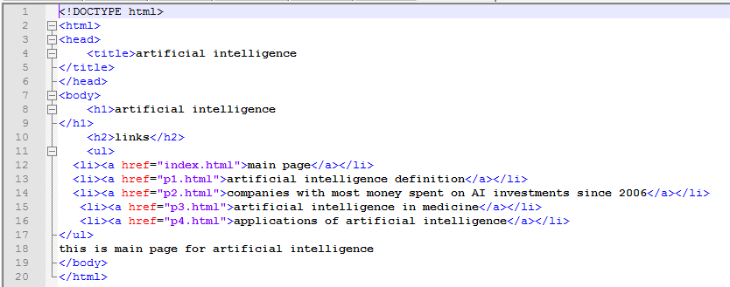

Fig6

**Layout and formatting**

**(Guide, don’t include this page in your research)**

Use this template

**Paper:** A4

**Margins:** 2.5 cm all from top and bottom

**1.**9 cm from left and right

**Line spacing:** 1.5

**Font:** Time New Roman

**Font size:** 14 (Except headings)

**No of pages:**Between 5 and 10 pages (Not including cover)

**References**

1. Charniak, E. (1985). *Introduction to artificial intelligence*. Pearson Education India.‏
2. <https://www.datamation.com/artificial-intelligence/examples-of-artificial-intelligence.html>