**Chapter 5: User Interfaces**

**5.1 Registration Page**

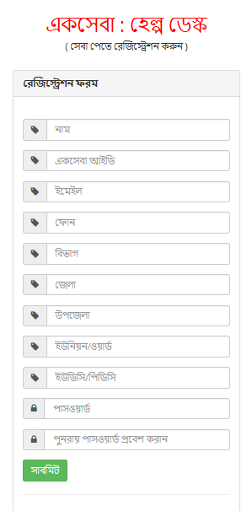

**5.2 Login Page**

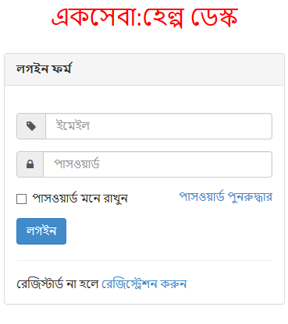

**5.3 Admin Dashboard**

