Prerequisites
- Internet Information Services
- ASP.net Support for Internet Information Services

Installation
- Extract zip file to a folder inside of C:\inetpub\wwwroot
- Right click my computer and click “manage”
- Under “Services and Applications” click “Internet Information Services” (roles for Windows Server)
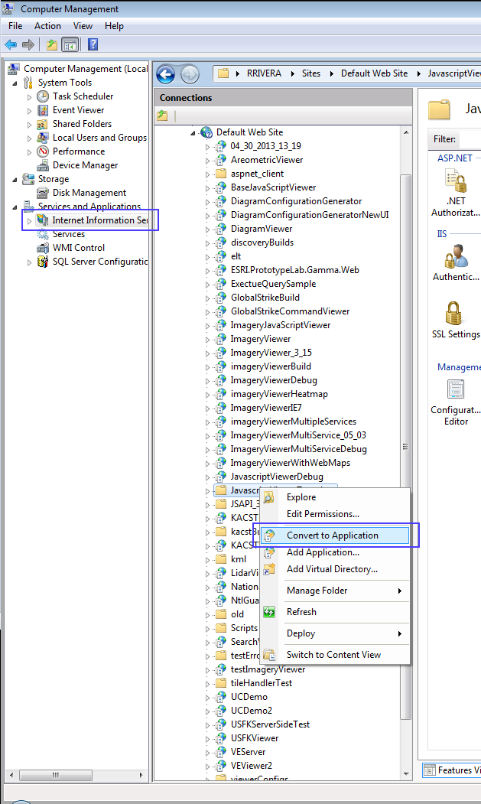
- Accept defaults and click “OK”
- With Template folder highlighted double click “MIME TYPES”
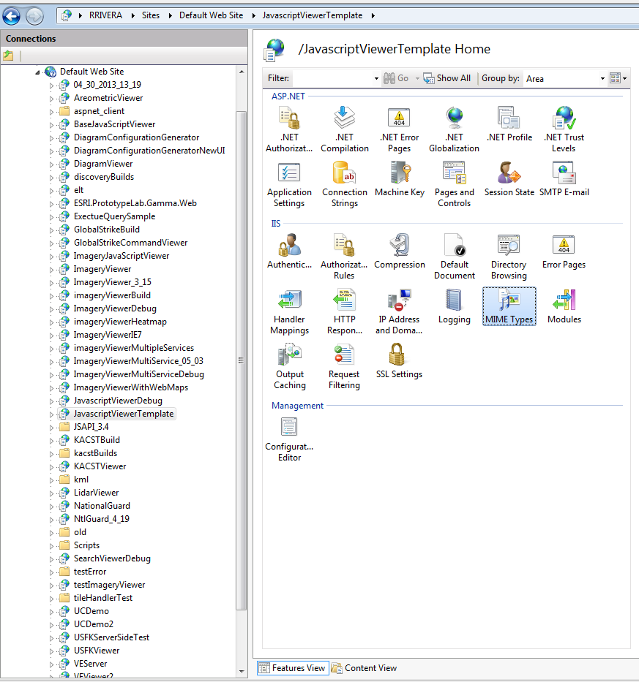

- Click “Add”
- Add extension “.json” MIME Type: “application/json”
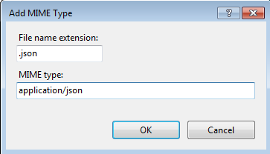

- Installation is complete

