# Installation

Extract provided zip file to C:\inetpub\wwwroot

Open IIS manager

Convert To Application

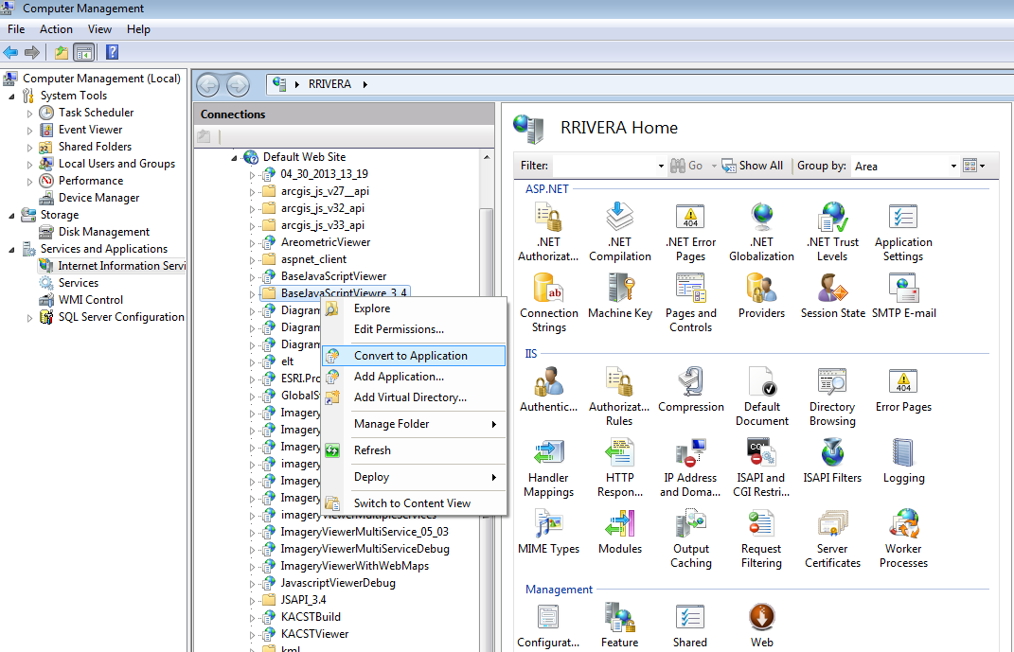

Add JSON MIME type

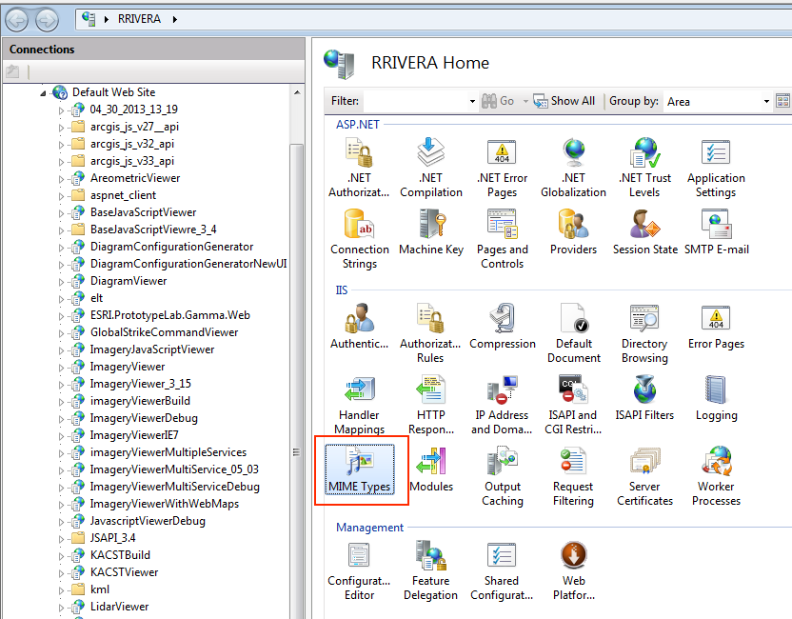

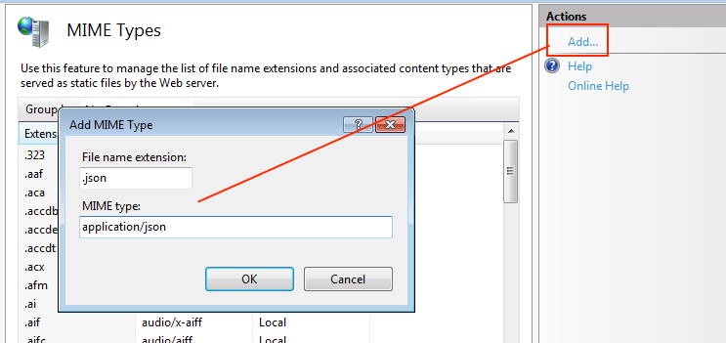

# Viewer Configuration

Discovery application configuration files are located in C:\inetpub\wwwroot\*EXTRACTED_DIRECTORY*\config\imagery

**imageryConfig.json – general setting for web application**

description of entries are located in: C:\inetpub\wwwroot\*EXTRACTED_DIRECTORY*\config\templates\viewerConfiguration.json

**imageQueryConfiguration.json – configuration related to imagery discovery**

description of entries are located in:

C:\inetpub\wwwroot\*EXTRACTED_DIRECTORY*\config\templates\imageQueryConfiguration.json