PART ONE-COVER SHEET

CP TITLE: Axis of Advance and Direction of Attack Redundancies
SSMC CP NUMBER:
ORIGINATOR’S INTERNAL TRACKING NUMBER: ESRI 111914-1

ORIGINATOR CONTACT INFORMATION: Andy Bouffard (Esri) (on behalf of DISA) – abouffard@esri.com

SSMC DECISION/RECOMMENDATION:
APPROVE AS WRITTEN (AAW)
APPROVE AS MODIFIED (AAM)
DISAPPROVED (DIS)
WITHDRAWN BY ORIGINATOR (WBO)
DEFERRED (DFR)

RECORD OF PROCESSING:
DATE:

ACTION:

COORDINATION WITH NATO JOINT SYMBOLOGY PANEL:
PASSED TO JSP FOR ACTION N/A

DATE:

ACTION:

PART TWO- DEFINITION

- STATEMENT OF THE PROBLEM: In tables H-X and H-XI, separate Axis of Advance and Direction of Attack arrow symbols have been designed, illustrated, and given unique SIDCs for planned/on-order vs. present/actual, and also identified as friend vs. enemy, when in fact this information is already captured through other parts of the SIDC (namely the first 10 digits of the SIDC).

This has the strong potential to cause redundancy, confusion, or worse, if the wrong Standard Identity and/or Status codes are assigned to a 20 digit SIDC for some of these symbols.

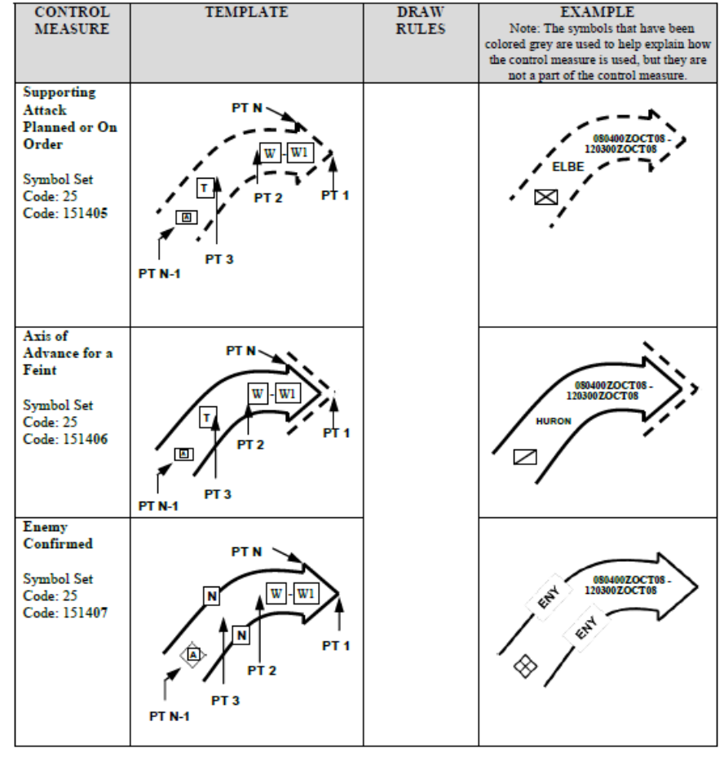

2. PROPOSED SOLUTION: Simplify this group of symbols to fewer arrow symbols, by removing the Enemy and Planned/On Order versions, and rely instead on the codes in the first 10 digits of SIDCs to provide the distinctions between individual symbol instances in terms of Standard Identity and Status.

Change Friendly Airborne/Aviation to Airborne/Aviation.
Remove the separate SIDC for Supporting Attack Planned or On Order.
Remove the separate SIDC for Enemy Confirmed.
Remove the separate SIDC for Enemy Templated or Suspected.
Change Friendly Aviation to Aviation.
Change Friendly Direction of Main Attack to Direction of Main Attack.
Change Friendly Direction of Supporting Attack to Direction of Supporting Attack.
Remove Friendly Ground Axis Planned or On Order with Effective Date and Time (if known).
Remove the separate SIDC for Enemy Confirmed.
Remove the separate SIDC for Enemy Templated or Suspected.

3. ALTERNATIVE SOLUTIONS:

The above redundant symbols could either be removed completely from the document, to avoid confusion, or kept in the document as additional examples of the use of these arrow symbols, but remove the extra SIDC EntitySubType codes.

4. SUBMITTED GRAPHICS FILES:

5. IMPACT ON INTEROPERABILITY:

6. IMPACT ON RELATED DOCUMENTS:

7. IMPLEMENTATION DATES:

8. OTHER CONSIDERATIONS:

9. REFERENCES:

PART THREE- APPLICABILITY

AFFECTED DOCUMENT(S): (check applicable documents)
MIL-STD-2525
APP-6
OTHER
List others here:

TYPE OF CHANGE PROPOSAL: (check all that apply)
Administrative change(s)
New appendix (ices)
New symbol(s)/icon(s)
Revision to existing symbol(s)/icon(s)

APPLICABLE TRACKS/APPENDICES: (check all that apply)
Space
Air
Land
Sea Surface
Subsurface
Activities
Control Measures
Meteorological
Oceanographic
Cyberspace
Signals Intelligence
2-D+
Base Document
SIDC Tables
All of the above

NEW SYMBOL/ICON CHARACTERISTICS: (check all that apply)
Full Frame
Full Octagon
Modifiers
Amplifiers

