PART ONE-COVER SHEET

CP TITLE: Remove Redundant Control Measures
SSMC CP NUMBER:
ORIGINATOR’S INTERNAL TRACKING NUMBER: 021115-1

ORIGINATOR CONTACT INFORMATION: Andy Bouffard, Esri Inc, via DISA

SSMC DECISION/RECOMMENDATION:
APPROVE AS WRITTEN (AAW)
APPROVE AS MODIFIED (AAM)
DISAPPROVED (DIS)
WITHDRAWN BY ORIGINATOR (WBO)
DEFERRED (DFR)

RECORD OF PROCESSING:
DATE:

ACTION:

COORDINATION WITH NATO JOINT SYMBOLOGY PANEL:
PASSED TO JSP FOR ACTION N/A

DATE:

ACTION:

PART TWO- DEFINITION

1. STATEMENT OF THE PROBLEM:

Before 2525D was completed extra or redundant control measures received their own unique SIDC entity type/subtype codes, lending to some confusion now. These symbols are redundant because the standard identity and status characteristics that distinguish them from each other are already handled through SIDC codes in the first ten digits of a full 20 digit SIDC. The standard doesn’t need a set of 10 unique second-set digits for each practical combination of standard identity and status.

For example, the Friendly Present Forward Line of Troops (25-140101), Friendly Planned or On Order Forward Line of Troops (25-140102), Enemy Known Forward Line of Troops (25-140103), and Enemy Suspected or Templated Forward Line of Troops (25-140104) can all be eliminated since Forward Line of Troops (25-140100) can represent them all, using the standard identity and status codes in the first ten digits of the SIDC. There is no need for five different control measures when one will suffice.

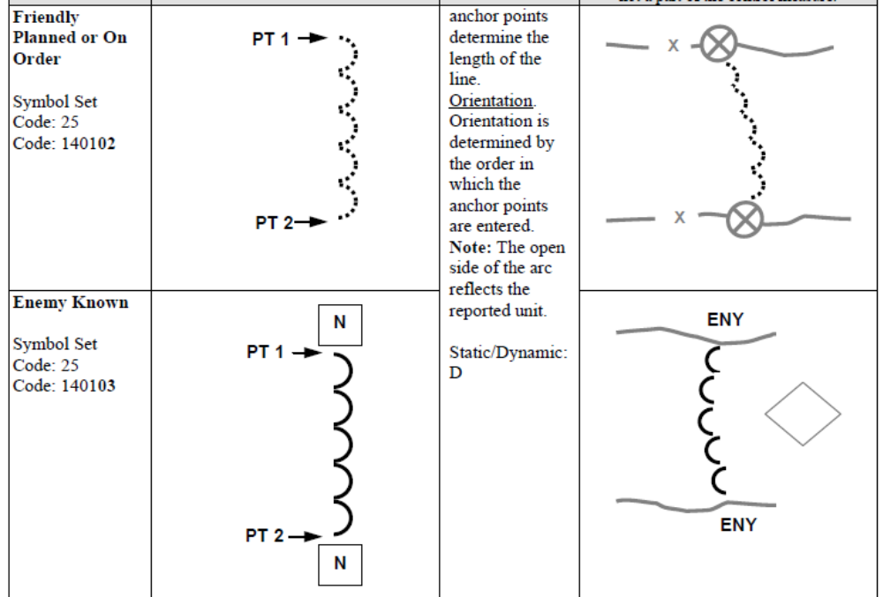

Operational complications will arise if these redundant control measures are allowed to remain in the standard. For example, a system will not know how to definitively interpret a control measure SIDC if that SIDC contains a Friendly Present coding in its first ten digits, but its second ten digits indicates Enemy/Hostile Suspected or Templated.

2. PROPOSED SOLUTION:
Remove the following control measures as they are all redundant (all of the following control measures duplicate information already captured in standard identity and/or status and can still be represented with the control measures that remain). The SIDCs shown in parentheses are the parent SIDCs that can still be used to represent the removed symbols.

25-140101 (25-140100)
25-140102
25-140103
25-140104

25-140401 (25-140400)

25-150101 (25-150100)
25-150102
25-150103
25-150104

25-150300 and its children can be removed, as 25-150200 suffices. The Note associated with these is describing doctrine, how to use symbols together, and not describing new symbols.

25-150400 (25-150300)

25-151201 (25-151200)

25-151405 (25-151404)
25-151407
25-151408

25-140604 (25-140603)
25-140606
25-140607

25-151801 (25-151800)
25-151802

25-240807 (25-240806)

25-270702 (25-270701)
25-270703
25-270704

In all of the above cases, the same information portrayed by each of these redundant control measures can already be captured with one of its parent control measures, and proper use of the SIDC’s standard identity and status coding positions.

Within the standard, the examples/templates should be edited to reflect these facts. Examples of the planned or on order and/or hostile version of these control measures may still be useful, but they should just remain as examples, not be assigned unique entity subtype IDs.

3. ALTERNATIVE SOLUTIONS:

4. SUBMITTED GRAPHICS FILES:

5. IMPACT ON INTEROPERABILITY:

6. IMPACT ON RELATED DOCUMENTS:

7. IMPLEMENTATION DATES:

8. OTHER CONSIDERATIONS:

9. REFERENCES:

PART THREE- APPLICABILITY

AFFECTED DOCUMENT(S): (check applicable documents)
MIL-STD-2525
APP-6
OTHER
List others here:

TYPE OF CHANGE PROPOSAL: (check all that apply)
Administrative change(s)
New appendix (ices)
New symbol(s)/icon(s)
Revision to existing symbol(s)/icon(s)

APPLICABLE TRACKS/APPENDICES: (check all that apply)
Space
Air
Land
Sea Surface
Subsurface
Activities
Control Measures
Meteorological
Oceanographic
Cyberspace
Signals Intelligence
2-D+
Base Document
SIDC Tables
All of the above

NEW SYMBOL/ICON CHARACTERISTICS: (check all that apply)
Full Frame
Full Octagon
Modifiers
Amplifiers

