PART ONE-COVER SHEET

CP TITLE: Allow Unspecified Entities
SSMC CP NUMBER:
ORIGINATOR’S INTERNAL TRACKING NUMBER: 031815-3

ORIGINATOR CONTACT INFORMATION: Andy Bouffard via DISA

SSMC DECISION/RECOMMENDATION:
APPROVE AS WRITTEN (AAW)
APPROVE AS MODIFIED (AAM)
DISAPPROVED (DIS)
WITHDRAWN BY ORIGINATOR (WBO)
DEFERRED (DFR)

RECORD OF PROCESSING:
DATE:

ACTION:

COORDINATION WITH NATO JOINT SYMBOLOGY PANEL:
PASSED TO JSP FOR ACTION N/A

DATE:

ACTION:

PART TWO- DEFINITION

- STATEMENT OF THE PROBLEM: Entity codes that are all zero (i.e., “1006150000, 0000000000”) are currently considered invalid symbols.

Entity Codes that have not been set, ex. have a value of "000000", should still be a valid symbol id that is exchanged and should still show a valid frame+symbol set (example illustrated below).

This is mainly an ease-of-use/usability issue. So if an operator is under duress and only has time to set the affiliation and symbol set that should be enough to exchange a valid symbol with another system.

An operator shouldn't necessarily need to select from a myriad of entity possibilities/codes just to get a basic symbol.

For this same reason, I also believe those comments on symbols that are marked as "This symbol shall not be displayed on a C2 system but may be displayed for training or hierarchical explanation purposes" should be removed.

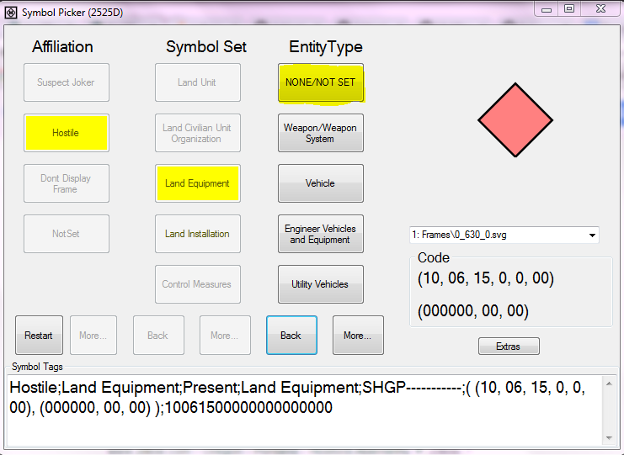

2. PROPOSED SOLUTION:

Add a new first row in each of TABLES A-VII, A-XIII, etc. (i.e., all the Appendix A entity/entity type/entity subtype icon-based tactical graphic tables), and make this new first row have its Entity as “Unspecified” and its Code is 000000. Do not add Unspecified to the control measures.

Add the following to the Appendix A guidance for entity/entity type/entity subtype,

“If an entity is Unspecified, then the remainder of the second set of ten digits shall be set to 0.”

For example:

Entity  (Digits 1and 2) | Entity Type  (Digits 3 and 4) | Entity Subtype  (Digits 5 and 6) | Code  Note: The actual code is shown in bold numbers. The remaining numbers are used to show placement within the six digits.
Unspecified [insert name of symbol set here] |  |  | 000000
Weapons/Weapons System |  |  | 110000
 | Rifle |  | 110100
 |  | Single Shot Rifle | 110101

Remove all occurrences of the string, “This symbol shall not be displayed on a C2 system but may be displayed for training or hierarchical explanation purposes.”

For those entities or entity types that are documented for hierarchical purposes only, we will remove the Type and Icon Type entries and change the “No icon associated” comment to “Reserved for hierarchical purposes”. These entries in the Appendix A tables should be greyed out to accentuate this decision.

3. ALTERNATIVE SOLUTIONS:

4. SUBMITTED GRAPHICS FILES:

5. IMPACT ON INTEROPERABILITY:

6. IMPACT ON RELATED DOCUMENTS:

7. IMPLEMENTATION DATES:

8. OTHER CONSIDERATIONS:

9. REFERENCES:

PART THREE- APPLICABILITY

AFFECTED DOCUMENT(S): (check applicable documents)
MIL-STD-2525
APP-6
OTHER
List others here:

TYPE OF CHANGE PROPOSAL: (check all that apply)
Administrative change(s)
New appendix (ices)
New symbol(s)/icon(s)
Revision to existing symbol(s)/icon(s)

APPLICABLE TRACKS/APPENDICES: (check all that apply)
Space
Air
Land
Sea Surface
Subsurface
Activities
Control Measures
Meteorological
Oceanographic
Cyberspace
Signals Intelligence
2-D+
Base Document
SIDC Tables
All of the above

NEW SYMBOL/ICON CHARACTERISTICS: (check all that apply)
Full Frame
Full Octagon
Modifiers
Amplifiers

