**PART ONE- DECISION COVER SHEET**

CP TITLE: Correction to Minimum Safe Distance (MSD) Control Measure Symbol

SSMC CP NUMBER: 15-029C01-AR

ORIGINATOR’S INTERNAL TRACKING NUMBER: USA PMMC009-15

ORIGINATOR CONTACT INFORMATION:

Carlos L. Soto (Carlos.l.soto3.civ.@mail.mil)

U.S. Army Symbologist

Phone: 910-684-2601

*On behalf of:*

Bill Otten

SETA Support to

US Army, PEO C3T, PM Mission Command, TMD

256-842-1948

William.r.otten.ctr@mail.mil

SSMC DECISION/RECOMMENDATION:

APPROVE AS WRITTEN (AAW)

APPROVE AS MODIFIED (AAM)

DISAPPROVED (DIS)

WITHDRAWN BY ORIGINATOR (WBO)

DEFERRED (DFR)

RECORD OF PROCESSING:

DATE:

VOTING RECORD:

|  |  |  |  |  |  |  |  |  |  |
| --- | --- | --- | --- | --- | --- | --- | --- | --- | --- |
| **Motion** | **Second** | **USA Vote** | **USAF Vote** | **USN Vote** | **USMC Vote** | **USCG Vote** | **NGA Vote** | **JS/J6 Vote** | **DISA Vote\*** |
|  |  |  |  |  |  |  |  |  |  |

COORDINATION WITH NATO JOINT SYMBOLOGY PANEL:

PASSED TO JSP FOR ACTION  N/A

DATE:

ACTION:

**PART TWO- DEFINITION**

1. STATEMENT OF THE PROBLEM: The Minimum Safe Distance (MSD) Control Measure Symbol is Doctrinally Incorrect.

2. PROPOSED SOLUTION:

a. Remove the third circle from this control measure. Update the draw rules to include removing the note. Proposed solution is located on page 6.

b. Correct the draw rules to comply with FM 3-11.3/MCRP 3-37.2A/NTTP 3-11.25/AFTTP(I) 3-2.56, C1 and ATP-45(D). As clearly depicted and stated in the references, the two circles are defined by a center point and two radii, not a center point and two additional points. Please see the last page of this change proposal for the change 1 proposed solution.

3. ALTERNATIVE SOLUTIONS: None.

4. SUBMITTED GRAPHICS FILES: None.

5. IMPACT ON INTEROPERABILITY: Interoperability will improve when the Minimum Safe Distance (MSD) control measure symbol is doctrinally correct.

6. IMPACT ON RELATED DOCUMENTS: None.

7. IMPLEMENTATION DATES: Include in MIL-STD-2525D Change 1 when published.

8. OTHER CONSIDERATIONS: None.

9. REFERENCES:

1. FM 3-11.3/MCRP 3-37.2A/NTTP 3-11.25/AFTTP(I) 3-2.56, C1 – page I-4
2. ATP-45(D) – page 8-7

**PART THREE- APPLICABILITY**

AFFECTED DOCUMENT(S): (check applicable documents)

MIL-STD-2525

APP-6

OTHER

List others here:

TYPE OF CHANGE PROPOSAL: (check all that apply)

Administrative change(s)

New appendix (ices)

New symbol(s)/icon(s)

Revision to existing symbol(s)/icon(s)

APPLICABLE TRACKS/APPENDICES: (check all that apply)

Space

Air

Land

Sea Surface

Subsurface

Activities

Control Measures

Meteorological

Oceanographic

Cyberspace

Signals Intelligence

2.5D Displays

Base Document

SIDC Tables

**All of the above**

NEW SYMBOL/ICON CHARACTERISTICS: (check all that apply)

Full Frame

Full Octagon

Modifiers

Amplifiers

**PART FOUR- SUPPORTING DOCUMENTATION**

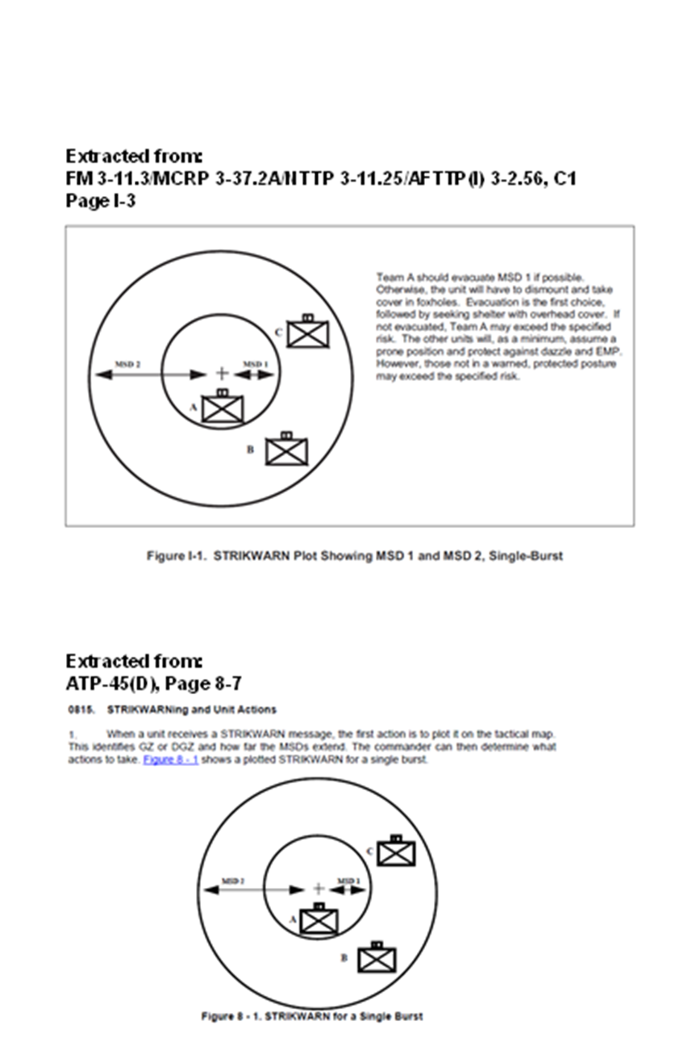





Change 1 proposed solution – delete existing control measure and replace it with the following.

|  |  |  |  |
| --- | --- | --- | --- |
| CONTROL MEASURE | **TEMPLATE** | **DRAW RULES** | **EXAMPLE**  Note: The symbols that have been colored grey are used to help explain how the control measure is used, but they are not a part of the control measure. |
| Minimum Safe Distance Zone  Symbol Set  Code: 25  Code: 27**21**00 | **1**  **2**  **Center Point**  **AM**  **AM1** | Anchor Points. This symbol requires one center point and two radii. The center point defines the center of the symbol. One radius defines the inner circle Minimum Safe Distance (MSD) 1 and one radius defines the outer circle MSD2.  Size/Shape. Static.  Orientation. The center point is typically centered over Ground Zero (GZ) or Designated Ground Zero (DGZ).  Static/ Dynamic: D | **1**  **2** |