**Solution Symbol Resource**

**Access Points**

**Symbol Name:**

**Symbol Picture:** C:\Data\Symbology\Utilities\Water\CCTVProcessor\web\Access-Points.png

**Symbol Source:**

**Symbol Date:** May 2015

**Created by:** Esri Solutions Team

**License:** None

**Acknowledgement:** None required

**Notes:** None

**Act of Nature**

**Symbol Name:** [Storm](https://thenounproject.com/search/?q=storm&i=24502)

**Symbol Picture:** C:\Users\heat5533\Documents\GitHub\solutions-symbology-data\symbology\web\png\Natural-Disaster-Incident.png

**Symbol Source:**  The Noun Project

**Symbol Date:** December 2015

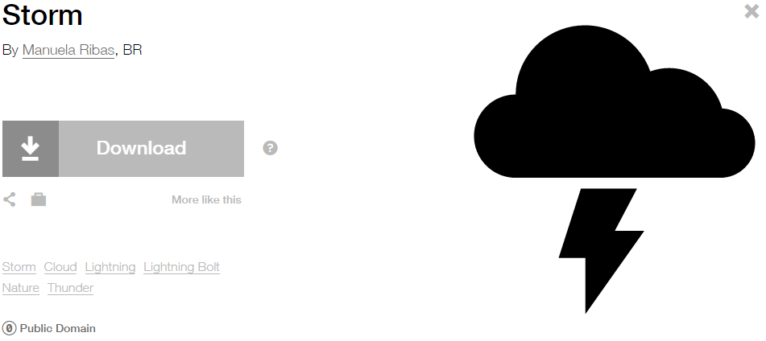

**Modified by:** Esri Solutions Team

**License:** Public Domain

**Acknowledgement:** None required

**Notes:** None

**Adult Care**

**Symbol Name:** L1 Adult Day Care

**Symbol Picture:** C:\Data\Symbology\StateGov\MyHealthServices\web\Adult-Care.png

**Symbol Source:** ERS Homeland Security style file

**Symbol Date:** March 2015

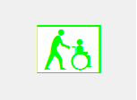

**Modified by:** Esri Solutions Team

**License:** None

**Acknowledgement:** None Required

**Notes:** None

**Agriculture Animal Health Incident**

**Symbol Name:** L1 Animal Feedlots

**Symbol Picture:** C:\Data\Symbology\Solutions\OpsIncident\web\Agriculture-Animal-Health.png

**Symbol Source:** ERS Homeland Security style file

**Symbol Date:** February 2015

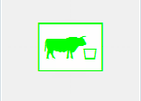

**Modified** **by:** Esri Solutions Team

**License:** None

**Acknowledgement:** None required

**Notes:** None

**Air Incident**

**Symbol Name:** Air Incident

**Symbol Picture:** C:\Data\Symbology\Solutions\OpsIncident\web\Air-Incident.png

**Symbol Source:** ERS Homeland Security style file

**Symbol Date:** February 2015



**Modified** **by:** Esri Solutions Team

**License:** None

**Acknowledgement:** None required

**Notes:** None

**Airports**

**Symbol Name:** Airport

**Symbol Picture:** C:\Users\heat5533\Documents\GitHub\solutions-symbology-data\symbology\web\png\Airports.png

**Symbol Source:** Forestry style file

**Symbol Date:** May 2014



**Modified by:** Esri Solutions Team

**License:** None

**Acknowledgement:** None required

**Notes:** None

**Amphibian**

**Symbol Name:** [Toad](https://thenounproject.com/term/toad/4708/)

**Symbol Picture:** C:\Data\Symbology\StateGov\CitizenScience\web\Amphibians.png

**Symbol Source:** The Noun Project

**Symbol Date:** March 2015

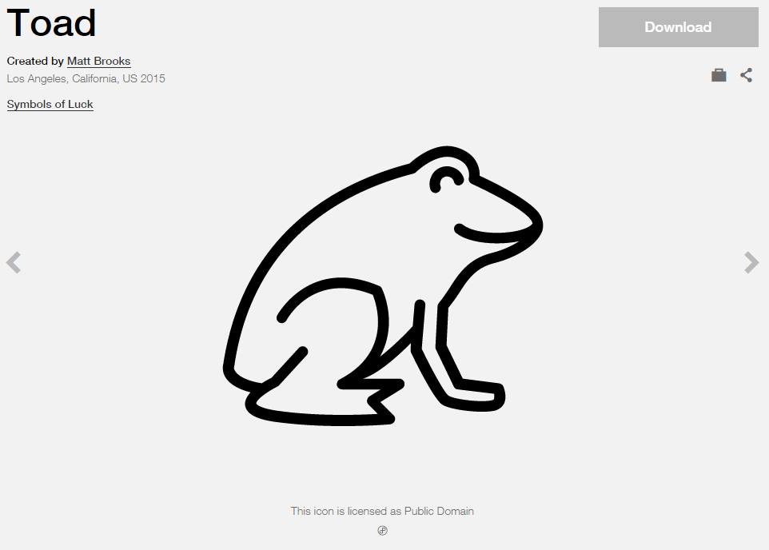

**Modified by:** Esri Solutions Team

**License:** Public Domain

**Acknowledgement:** None required

**Notes:** None

**Animal Feeding Operations Permit**

**Symbol Name:** Horse Area

**Symbol Picture:** **C:\Users\heat5533\Documents\GitHub\solutions-symbology-data\symbology\web\png\Animal-Feeding-Operation.png**

**Symbol Source:** Forestry style file

**Symbol Date:** August 2014

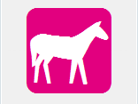

**Modified by:** Esri Solutions Team

**License:** None

**Acknowledgement:** None required

**Notes:** None

**Animal Health Emergency**

**Symbol Name:** Cross 2

**Symbol Picture:** C:\Data\UC\UC2015\SituationalAwareness\web\Animal-Health-Emergency.png

**Symbol Source:**  ESRI Default style file

**Symbol Date:** July 2015

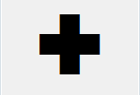

**Modified by:** Esri Solutions Team

**License:** None

**Acknowledgement:** None required

**Notes:** None

**Appliances**

**Symbol Name:**

**Symbol Picture:** C:\Data\Symbology\Solutions\Debris\web\Appliances.png

**Symbol Source:**

**Symbol Date:** March 2015

**Created** **by:** Esri Solutions Team

**License:** None

**Acknowledgement:** None required

**Notes:** None

**Aquatic Resource Alteration Permit**

**Symbol Name:** Water Recreation

**Symbol Picture:** C:\Users\heat5533\Documents\GitHub\solutions-symbology-data\symbology\web\png\Aquatic-Resource-Alteration.png

**Symbol Source:** Forestry style file

**Symbol Date:** August 2014



**Modified by:** Esri Solutions Team

**License:** None

**Acknowledgement:** None required

**Notes:** None

**Art Galleries**

**Symbol Name:**

**Symbol Picture:** C:\Users\heat5533\Documents\GitHub\solutions-symbology-data\symbology\web\png\Art-Galleries.png

**Symbol Source:**

**Symbol Date:** March 2015

**Created by:** Esri Solutions Team

**License:** None

**Acknowledgement:** None required

**Notes:** None

**Arts and Cultural Centers**

**Symbol Name:** [Arts-And-Culture](http://thenounproject.com/term/arts-and-culture/13644/)

**Symbol Picture:** C:\Users\heat5533\Documents\GitHub\solutions-symbology-data\symbology\web\png\Arts-and-Culture.png

**Symbol Source:** The Noun Project

**Symbol Date:** February 2015

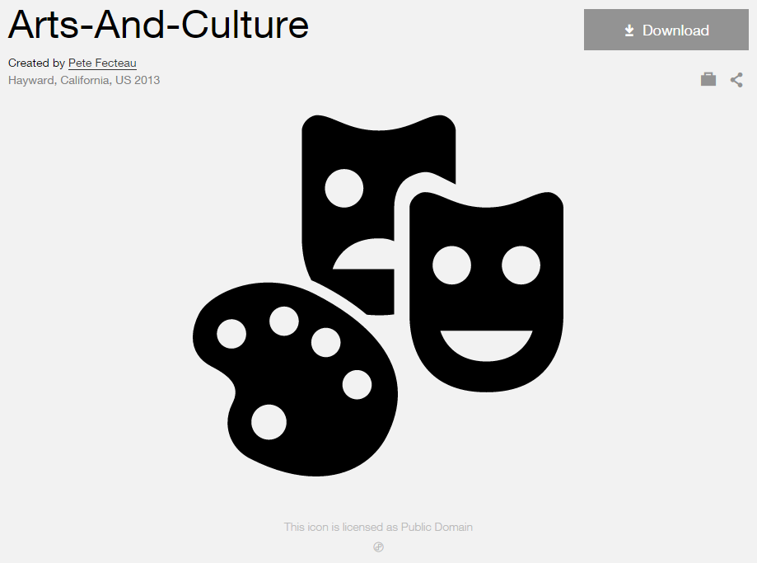

**Modified by:** Esri Solutions Team

**License:** Public Domain

**Acknowledgement:** None required

**Notes:** None

**Assessment Appeal Applicant**

**Symbol Name:** [Coordinated Assessment](https://thenounproject.com/search/?q=Appeal+Assessment&i=4190)

**Symbol Picture:** C:\Data\Symbology\LocalGov\AssessmentAppeals\web\AssessmentAppeals12.png

**Symbol Source:** The Noun Project

**Symbol Date:** October 2015

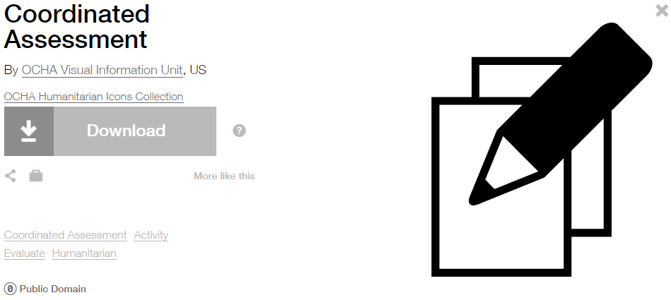

**Modified by:** Esri Solutions Team

**License:** Public Domain

**Acknowledgement:** None required

**Notes:** None

**Asset Misplaced**

**Symbol Name:** [Map](https://thenounproject.com/term/map/2312/)

**Symbol Picture:** C:\Users\heat5533\Documents\GitHub\solutions-symbology-data\symbology\mobile\png\Asset-Misplaced.pngC:\Users\heat5533\Documents\GitHub\solutions-symbology-data\symbology\web\png\Asset-Misplaced.png

**Symbol Source:** The Noun Project

**Symbol Date:** May 2015

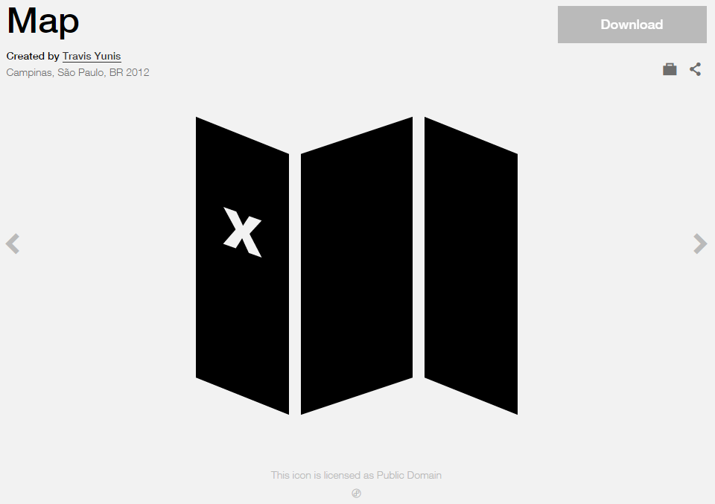

**Modified by:** Esri Solutions Team

**License:** Public Domain

**Acknowledgement:** None required

**Notes:** None

**Automated External Defibrillators**

**Symbol Name:** Bolt & [Heart](https://thenounproject.com/search/?q=heart&i=822)

**Symbol Picture:** C:\Data\Symbology\LocalGov\AEDInventory\mobile\AED.png

**Symbol Source:** Esri style file & The Noun Project

**Symbol Date:** July 2015

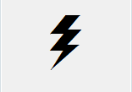 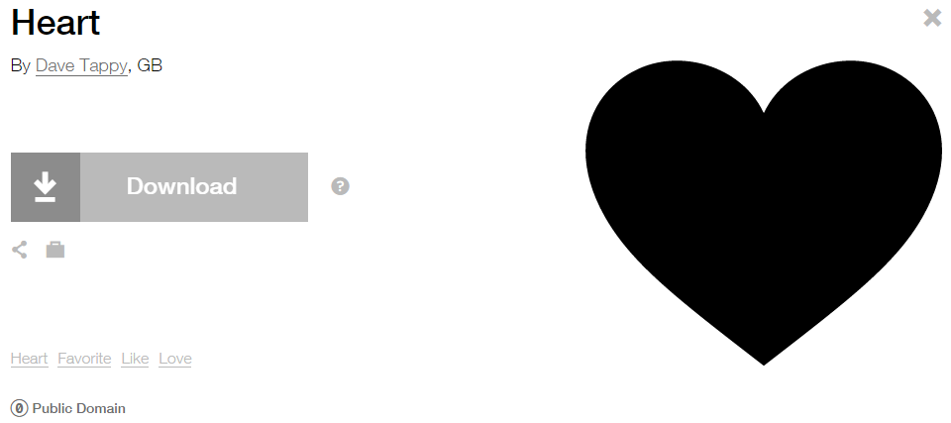

**Modified by:** Esri Solutions Team

**License:** Public Domain

**Acknowledgement:** None required

**Notes:** None

**Bioscience Employers**

**Symbol Name:**

**Symbol Picture:** C:\Users\heat5533\Documents\GitHub\solutions-symbology-data\symbology\web\png\Bioscience-Employers.png

**Symbol Source:**

**Symbol Date:** March 2015

**Created by:** Esri Solutions Team

**License:** None

**Acknowledgement:** None required

**Notes:** None

**Bioretention Basin**

**Symbol Name:** BB

**Symbol Picture:** C:\Data\Symbology\Utilities\Water\GreenInfrastructure\mobile\Bioretention-Basin.pngC:\Data\Symbology\Utilities\Water\GreenInfrastructure\web\Bioretention-Basin.png

**Symbol Source:** Arial Rounded MT Bold

**Symbol Date:** March 2015

**Modified** **by:** Esri Solutions Team

**License:** None

**Acknowledgement:** None required

**Notes:** None

**Biosolids Permit**

**Symbol Name:** Unicode 50

**Symbol Picture:** C:\Users\heat5533\Documents\GitHub\solutions-symbology-data\symbology\web\png\Biosolids.png

**Symbol Source:** ESRI Enviro Hazard Sites font

**Symbol Date:** September 2014

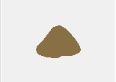

**Modified by:** Esri Solutions Team

**License:** None

**Acknowledgement:** None required

**Notes:** None

**Bioswale**

**Symbol Name:** B

**Symbol Picture:** C:\Data\Symbology\Utilities\Water\GreenInfrastructure\mobile\Bioswale.pngC:\Data\Symbology\Utilities\Water\GreenInfrastructure\web\Bioswale.png

**Symbol Source:** Arial Rounded MT Bold Font

**Symbol Date:** March 2015

**Modified** **by:** Esri Solutions Team

**License:** None

**Acknowledgement:** None required

**Notes:** None

**Bird**

**Symbol Name:** Bird Infestation

**Symbol Picture:** C:\Data\Symbology\StateGov\CitizenScience\web\Bird.png

**Symbol Source:** Esri ERS Homeland Security style file

**Symbol Date:** March 2015



**Modified by:** Esri Solutions Team

**License:** None

**Acknowledgement:** None required

**Notes:** None

**BMP Maintenance Violation**

**Symbol Name:** BMP

**Symbol Picture:** C:\Data\Symbology\Utilities\Water\ConstructionSiteViolations\mobile\BMP-Maintenance-Violation.png

**Symbol Source:** Arial Rounded MT Bold Font

**Symbol Date:** March 2015

**Modified** **by:** Esri Solutions Team

**License:** None

**Acknowledgement:** None required

**Notes:** None

**Birth Service**

**Symbol Name:** [Baby](http://thenounproject.com/term/baby/47/)

**Symbol Picture: C:\Data\Symbology\StateGov\MyHealthServices\web\Birth-Services.png**

**Symbol Source:** The Noun Project

**Symbol Date:** March 2015

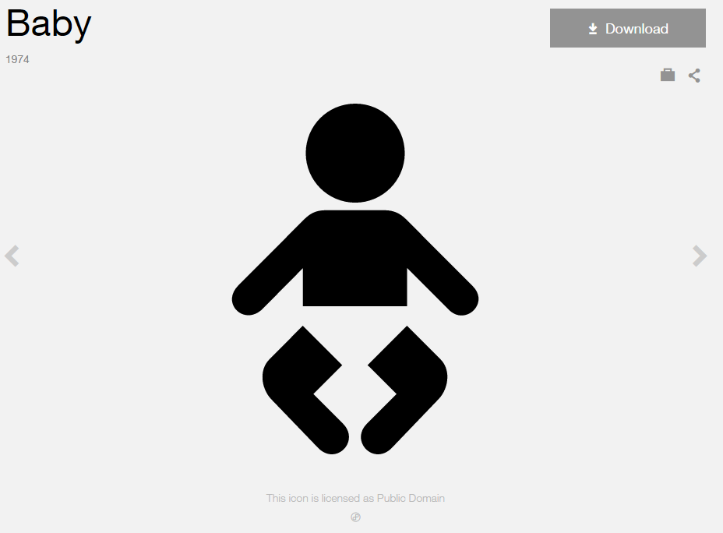

**Modified by:** Esri Solutions Team

**License:** Public Domain

**Acknowledgement:** None Required

**Notes:** None

**Boat Launch**

**Symbol Name:** Boat Launch

**Symbol Picture:** C:\Users\heat5533\Documents\GitHub\solutions-symbology-data\symbology\web\png\Boat-Launch.png

**Symbol Source:** Forestry style file

**Symbol Date:** May 2014



**Modified by:** Esri Solutions Team

**License:** None

**Acknowledgement:** None required

**Notes:** None

**Brickwork**

**Symbol Name:**

**Symbol Picture:** C:\Data\Symbology\Utilities\Water\CCTVProcessor\web\Brickwork.png

**Symbol Source:**

**Symbol Date:** May 2015

**Created by:** Esri Solutions Team

**License:** None

**Acknowledgement:** None required

**Notes:** None

**Bridges**

**Symbol Name:** [Highway](https://thenounproject.com/search/?q=freeway&i=13084)

**Symbol Picture:** C:\Data\UC\UC2015\SituationalAwareness\web\Bridges.pngC:\Users\heat5533\Documents\GitHub\solutions-symbology-data\symbology\mobile\png\Bridges.png

**Symbol Source:** The Noun Project

**Symbol Date:** July 2015

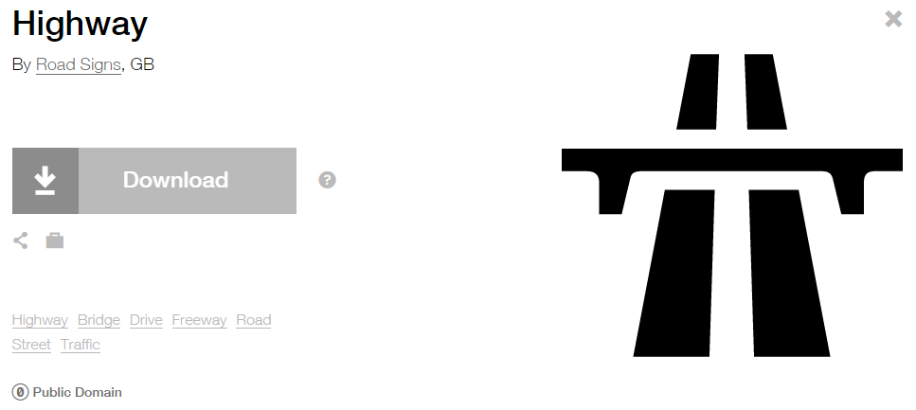

**Modified by:** Esri Solutions Team

**License:** Public Domain

**Acknowledgement:** None required

**Notes:** None

**Broken**

**Symbol Name:**

**Symbol Picture:** C:\Data\Symbology\Utilities\Water\CCTVProcessor\web\Broken.png

**Symbol Source:**

**Symbol Date:** May 2015

**Created by:** Esri Solutions Team

**License:** None

**Acknowledgement:** None required

**Notes:** None

**Business Location**

**Symbol Name:** Building 3

**Symbol Picture:** C:\Users\heat5533\Documents\GitHub\solutions-symbology-data\symbology\mobile\png\Business-Location.pngC:\Users\heat5533\Documents\GitHub\solutions-symbology-data\symbology\web\png\Business-Location.png

**Symbol Source:** Civic style file

**Symbol Date:** April 2015

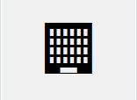

**Modified by:** Esri Solutions Team

**License:** None

**Acknowledgement:** None required

**Notes:** None

**Call Cancelled Incident**

**Symbol Name:** Phone 1

**Symbol Picture:** C:\Users\heat5533\Documents\GitHub\solutions-symbology-data\symbology\web\png\Call-Cancelled-Incident.png

**Symbol Source:**  Civic style file

**Symbol Date:** November 2015



**Modified by:** Esri Solutions Team

**License:** None

**Acknowledgement:** None required

**Notes:** None

**Children’s Activities**

**Symbol Name:** Slow Children at Play

**Symbol Picture:** C:\Users\heat5533\Documents\GitHub\solutions-symbology-data\symbology\web\png\Childrens-Activities.png

**Symbol Source:** Transportation style file

**Symbol Date:** February 2015

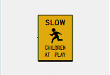

**Modified by:** Esri Solutions Team

**License:** None

**Acknowledgement:** None required

**Notes:** None

**Churches**

**Symbol Name:** Church

**Symbol Picture:** **C:\Users\heat5533\Documents\GitHub\solutions-symbology-data\symbology\web\png\Churches.png**

**Symbol Source**: Civic style file

**Symbol Date:** January 2015



**Modified** **by:** Esri Solutions Team

**License:** None

**Acknowledgement:** None required

**Notes:** None

**Civil Disturbance Incident**

**Symbol Name:** Civil Disturbance

**Symbol Picture:** C:\Data\Symbology\Solutions\OpsIncident\web\Civil-Disturbance.png

**Symbol Source:** ERS Homeland Security style file

**Symbol Date:** February 2015

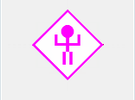

**Modified** **by:** Esri Solutions Team

**License:** None

**Acknowledgement:** None required

**Notes:** None

**Clinics**

**Symbol Name:** Cross 2

**Symbol Picture:** C:\Data\Symbology\StateGov\MyHealthServices\web\Hospital-and-Clinics.png

**Symbol Source:** ESRI style file

**Symbol Date:** May 2014



**Modified by:** Esri Solutions Team

**License:** None

**Acknowledgement:** None required

**Notes:** None

**Collapse**

**Symbol Name:**

**Symbol Picture:** C:\Data\Symbology\Utilities\Water\CCTVProcessor\web\Collapse.png

**Symbol Source:**

**Symbol Date:** May 2015

**Created by:** Esri Solutions Team

**License:** None

**Acknowledgement:** None required

**Notes:** None

**College/University**

**Symbol Name:** L1 College University

**Symbol Picture:** C:\Users\heat5533\Documents\GitHub\solutions-symbology-data\symbology\web\png\College-University.png

**Symbol Source:** ESRI ERS Homeland Security style file

**Symbol Date:** January 2015



**Modified** **by:** Esri Solutions Team

**License:** None

**Acknowledgement:** None required

**Notes:** None

**Community Center**

**Symbol Name:** [Leadership](https://thenounproject.com/term/leadership/4199/)

**Symbol Picture:** C:\Users\heat5533\Documents\GitHub\solutions-symbology-data\symbology\web\png\Community-Center.png

**Symbol Source:** The Noun Project

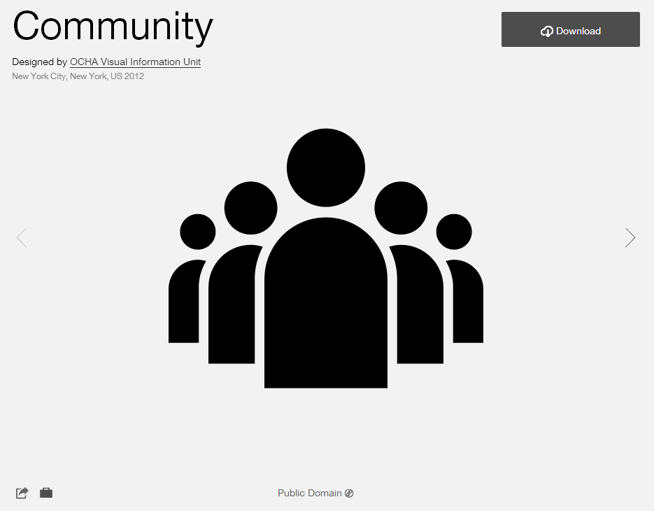

**Symbol Date:** February 2015

**Modified** **by:** Esri Solutions Team

**License:** Public Domain

**Acknowledgement:** None required

**Notes:** None

**Construction/Demolition**

**Symbol Name:** [Construction](http://thenounproject.com/term/construction/4275/)

**Symbol Picture:** C:\Data\Symbology\Solutions\Debris\web\Construction_Demolition.png

**Symbol Source:** The Noun Project

**Symbol Date:** March 2015

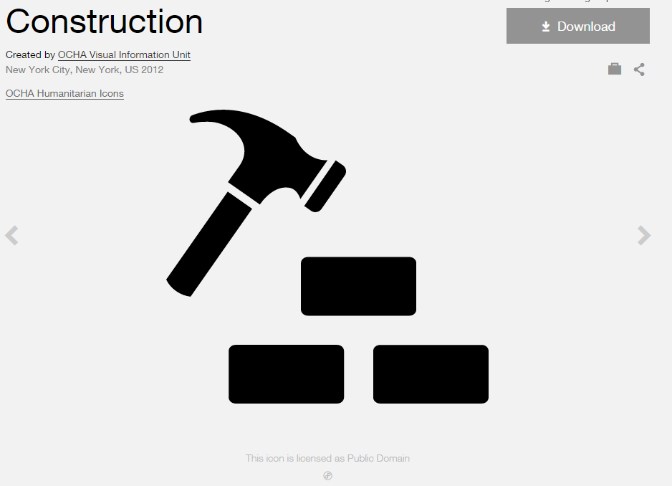

**Modified by:** Esri Solutions Team

**License:** Public Domain

**Acknowledgement:** None required

**Notes:** None

**Construction Permit**

**Symbol Name:** [Construction](http://thenounproject.com/term/construction/4275/)

**Symbol Picture:** C:\Users\heat5533\Documents\GitHub\solutions-symbology-data\symbology\web\png\Construction.png

**Symbol Source:** The Noun Project

**Symbol Date:** March 2015



**Modified by:** Esri Solutions Team

**License:** Public Domain

**Acknowledgement:** None required

**Notes:** None

**Cooling Center**

**Symbol Name:** Unicode 160

**Symbol Picture:** C:\Users\heat5533\Documents\GitHub\solutions-symbology-data\symbology\web\png\Cooling-Center.png

**Symbol Source**: ESRI US MUTCD 3 font

**Symbol Date:** February 2015

**Modified** **by:** Esri Solutions Team

**License:** None

**Acknowledgement:** None required

**Notes:** None

**Corporate Headquarters**

**Symbol Name:** Building 4

**Symbol Picture:** C:\Users\heat5533\Documents\GitHub\solutions-symbology-data\symbology\web\png\Corportate-Headquarters.png

**Symbol Source:** Civic style file

**Symbol Date:** January 2015

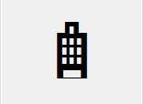

**Modified** **by:** Esri Solutions Team

**License:** None

**Acknowledgement:** None required

**Notes:** None

**Crack**

**Symbol Name:**

**Symbol Picture:** C:\Data\Symbology\Utilities\Water\CCTVProcessor\web\Crack.png

**Symbol Source:**

**Symbol Date:** May 2015

**Created by:** Esri Solutions Team

**License:** None

**Acknowledgement:** None required

**Notes:** None

**Criminal Activity Incident**

**Symbol Name:** Criminal Activity

**Symbol Picture:** C:\Data\Symbology\Solutions\OpsIncident\web\Criminal-Activity-Incident.png

**Symbol Source:** ERS Homeland Security style file

**Symbol Date:** February 2015



**Modified** **by:** Esri Solutions Team

**License:** None

**Acknowledgement:** None required

**Notes:** None

**Curb Ramps**

**Symbol Name:** Walk 1

**Symbol Picture:** C:\Data\Symbology\LocalGov\SidewalkInventory\mobile\Curb-Ramps.png

**Symbol Source:** Transportation style file

**Symbol Date:** July 2015

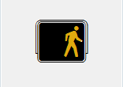

**Modified** **by:** Esri Solutions Team

**License:** None

**Acknowledgement:** None required

**Notes:** None

**Customer Contacted**

**Symbol Name:**

**Symbol Picture:** C:\Data\Symbology\Utilities\Gas\PotentialNewCustomers\web\Customer-Contacted.png

**Symbol Source:**

**Symbol Date:** May 2015

**Created by:** Esri Solutions Team

**License:** None

**Acknowledgement:** None required

**Notes:** None

**Customer Interested**

**Symbol Name:**

**Symbol Picture:** C:\Data\Symbology\Utilities\Gas\PotentialNewCustomers\web\Customer-Interested.png

**Symbol Source:**

**Symbol Date:** May 2015

**Created by:** Esri Solutions Team

**License:** None

**Acknowledgement:** None required

**Notes:** None

**Customer Not Contacted**

**Symbol Name:**

**Symbol Picture:** C:\Data\Symbology\Utilities\Gas\PotentialNewCustomers\web\Customer-Not-Contacted.png

**Symbol Source:**

**Symbol Date:** May 2015

**Created by:** Esri Solutions Team

**License:** None

**Acknowledgement:** None required

**Notes:** None

**Customer Not Interested**

**Symbol Name:**

**Symbol Picture:** C:\Data\Symbology\Utilities\Gas\PotentialNewCustomers\web\Customer-Not-Interested.png

**Symbol Source:**

**Symbol Date:** May 2015

**Created by:** Esri Solutions Team

**License:** None

**Acknowledgement:** None required

**Notes:** None

**Damage Assessment - Commercial Buildings – Affected**

**Symbol Name:** Building 3

**Symbol Picture:** C:\Data\Symbology\Solutions\DamageAssessment\mobile\CommericalBuilding-Affected.png

**Symbol Source:** Civic style file

**Symbol Date:** March 2015

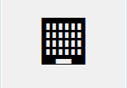

**Modified** **by:** Esri Solutions Team

**License:** None

**Acknowledgement:** None required

**Notes:** None

**Damage Assessment - Commercial Buildings – Destroyed**

**Symbol Name:** Building 3

**Symbol Picture:** C:\Data\Symbology\Solutions\DamageAssessment\mobile\Commerical-Buildings-Destroyed.png

**Symbol Source:** Civic style file

**Symbol Date:** March 2015



**Modified** **by:** Esri Solutions Team

**License:** None

**Acknowledgement:** None required

**Notes:** None

**Damage Assessment - Commercial Buildings – Inaccessible**

**Symbol Name:** Building 3

**Symbol Picture:** C:\Data\Symbology\Solutions\DamageAssessment\mobile\CommericalBuilding-Inaccessible.png

**Symbol Source:** Civic style file

**Symbol Date:** March 2015



**Modified** **by:** Esri Solutions Team

**License:** None

**Acknowledgement:** None required

**Notes:** None

**Damage Assessment - Commercial Buildings – Major**

**Symbol Name:** Building 3

**Symbol Picture:** C:\Data\Symbology\Solutions\DamageAssessment\mobile\Commerical-Buildings-Major.png

**Symbol Source:** Civic style file

**Symbol Date:** March 2015



**Modified** **by:** Esri Solutions Team

**License:** None

**Acknowledgement:** None required

**Notes:** None

**Damage Assessment - Commercial Buildings – Minor**

**Symbol Name:** Building 3

**Symbol Picture:** C:\Data\Symbology\Solutions\DamageAssessment\mobile\Commerical-Buildings-Minor.png

**Symbol Source:** Civic style file

**Symbol Date:** March 2015



**Modified** **by:** Esri Solutions Team

**License:** None

**Acknowledgement:** None required

**Notes:** None

**Damage Locations - High**

**Symbol Name:** [Light Bulb](https://thenounproject.com/search?q=light-bulb&i=8699)

**Symbol Picture:** C:\Data\Symbology\Utilities\Electric\DamageAssessment\mobile\Damage-Assessment-Electric-High-Damage.pngC:\Data\Symbology\Utilities\Electric\DamageAssessment\web\Damage-Assessment-Electric-High-Damage.png

**Symbol Source:** The Noun Project

**Symbol Date:** April 2015

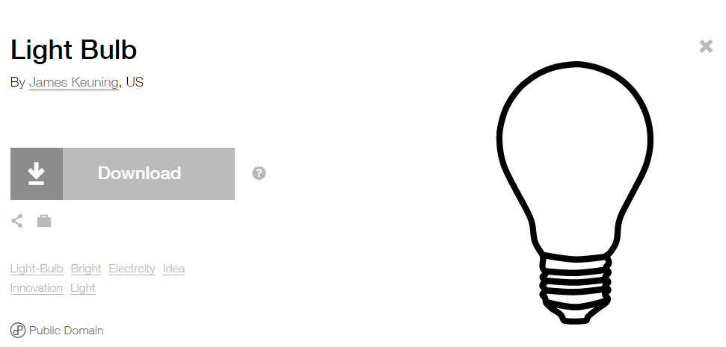

**Modified by:** Esri Solutions Team

**License:** Public Domain

**Acknowledgement:** None required

**Notes:** None

**Damage Locations - Low**

**Symbol Name:** [Light Bulb](https://thenounproject.com/search?q=light-bulb&i=8699)

**Symbol Picture:** C:\Data\Symbology\Utilities\Electric\DamageAssessment\mobile\Damage-Assessment-Electric-Low-Damage.pngC:\Data\Symbology\Utilities\Electric\DamageAssessment\web\Damage-Assessment-Electric-Low-Damage.png

**Symbol Source:** The Noun Project

**Symbol Date:** April 2015



**Modified by:** Esri Solutions Team

**License:** Public Domain

**Acknowledgement:** None required

**Notes:** None

**Damage Locations - Medium**

**Symbol Name:** [Light Bulb](https://thenounproject.com/search?q=light-bulb&i=8699)

**Symbol Picture:** C:\Data\Symbology\Utilities\Electric\DamageAssessment\mobile\Damage-Assessment-Electric-Medium-Damage.pngC:\Data\Symbology\Utilities\Electric\DamageAssessment\web\Damage-Assessment-Electric-Medium-Damage.png

**Symbol Source:** The Noun Project

**Symbol Date:** April 2015



**Modified by:** Esri Solutions Team

**License:** Public Domain

**Acknowledgement:** None required

**Notes:** None

**Damage Locations - No Damage**

**Symbol Name:** [Light Bulb](https://thenounproject.com/search?q=light-bulb&i=8699)

**Symbol Picture:** C:\Data\Symbology\Utilities\Electric\DamageAssessment\mobile\Damage-Assessment-Electric-No-Damage.pngC:\Data\Symbology\Utilities\Electric\DamageAssessment\web\Damage-Assessment-Electric-No-Damage.png

**Symbol Source:** The Noun Project

**Symbol Date:** April 2015



**Modified by:** Esri Solutions Team

**License:** Public Domain

**Acknowledgement:** None required

**Notes:** None

**Damage Locations – Other/Unknown**

**Symbol Name:** [Light Bulb](https://thenounproject.com/search?q=light-bulb&i=8699)

**Symbol Picture:** C:\Data\Symbology\Utilities\Electric\DamageAssessment\mobile\Damage-Assessment-Electric-Other-Unknown.pngC:\Data\Symbology\Utilities\Electric\DamageAssessment\web\Damage-Assessment-Electric-Other-Unknown.png

**Symbol Source:** The Noun Project

**Symbol Date:** April 2015



**Modified by:** Esri Solutions Team

**License:** Public Domain

**Acknowledgement:** None required

**Notes:** None

**Damage Locations - Urgent**

**Symbol Name:** [Light Bulb](https://thenounproject.com/search?q=light-bulb&i=8699)

**Symbol Picture:** C:\Data\Symbology\Utilities\Electric\DamageAssessment\mobile\Damage-Assessment-Electric-Urgent.pngC:\Data\Symbology\Utilities\Electric\DamageAssessment\web\Damage-Assessment-Electric-Urgent.png

**Symbol Source:** The Noun Project

**Symbol Date:** April 2015



**Modified by:** Esri Solutions Team

**License:** Public Domain

**Acknowledgement:** None required

**Notes:** None

**Damage Locations - High**

**Symbol Name:** [Gas](https://thenounproject.com/term/gas/37872/)

**Symbol Picture:** C:\Users\heat5533\Documents\GitHub\solutions-symbology-data\symbology\mobile\png\Damage-Assessment-Gas-High-Damage.png

**Symbol Source:** The Noun Project

**Symbol Date:** April 2015

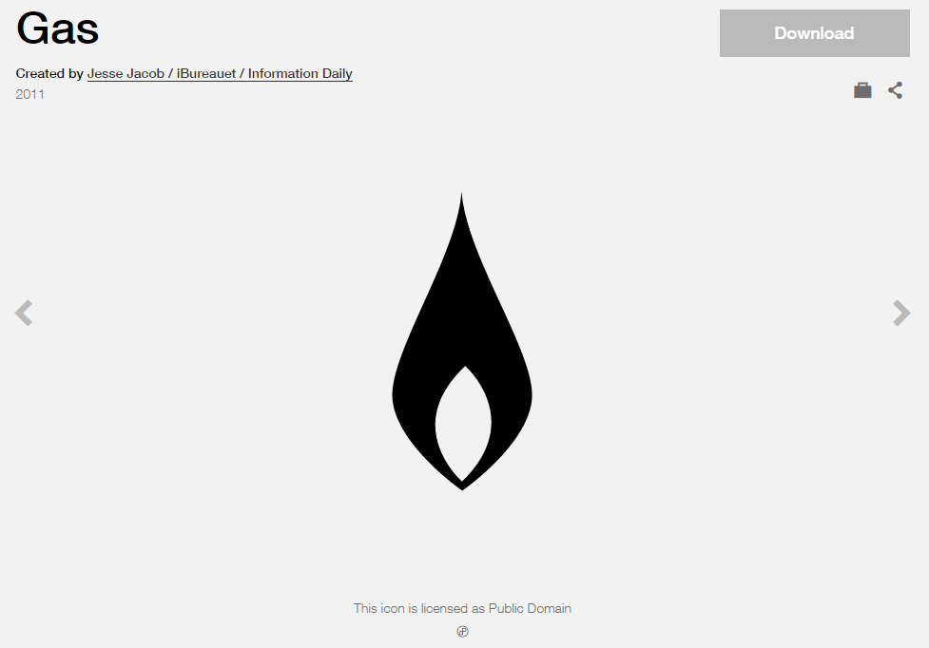

**Modified by:** Esri Solutions Team

**License:** Public Domain

**Acknowledgement:** None required

**Notes:** None

**Damage Locations - Low**

**Symbol Name:** [Gas](https://thenounproject.com/term/gas/37872/)

**Symbol Picture:** C:\Users\heat5533\Documents\GitHub\solutions-symbology-data\symbology\mobile\png\Damage-Assessment-Gas-Low-Damage.png

**Symbol Source:** The Noun Project

**Symbol Date:** April 2015



**Modified by:** Esri Solutions Team

**License:** Public Domain

**Acknowledgement:** None required

**Notes:** None

**Damage Locations - Medium**

**Symbol Name:** [Gas](https://thenounproject.com/term/gas/37872/)

**Symbol Picture:** C:\Users\heat5533\Documents\GitHub\solutions-symbology-data\symbology\mobile\png\Damage-Assessment-Gas-Medium-Damage.png

**Symbol Source:** The Noun Project

**Symbol Date:** April 2015



**Modified by:** Esri Solutions Team

**License:** Public Domain

**Acknowledgement:** None required

**Notes:** None

**Damage Locations – No Damage**

**Symbol Name:** [Gas](https://thenounproject.com/term/gas/37872/)

**Symbol Picture:** C:\Users\heat5533\Documents\GitHub\solutions-symbology-data\symbology\mobile\png\Damage-Assessment-Gas-No-Damage.png

**Symbol Source:** The Noun Project

**Symbol Date:** April 2015



**Modified by:** Esri Solutions Team

**License:** Public Domain

**Acknowledgement:** None required

**Notes:** None

**Damage Locations - No Damage**

**Symbol Name:** [Gas](https://thenounproject.com/term/gas/37872/)

**Symbol Picture:**

**Symbol Source:** The Noun Project

**Symbol Date:** April 2015



**Modified by:** Esri Solutions Team

**License:** Public Domain

**Acknowledgement:** None required

**Notes:** None

**Damage Locations - Other/Unknown**

**Symbol Name:** [Gas](https://thenounproject.com/term/gas/37872/)

**Symbol Picture:** C:\Users\heat5533\Documents\GitHub\solutions-symbology-data\symbology\mobile\png\Damage-Assessment-Gas-Other-Unknown.png

**Symbol Source:** The Noun Project

**Symbol Date:** April 2015



**Modified by:** Esri Solutions Team

**License:** Public Domain

**Acknowledgement:** None required

**Notes:** None

**Damage Locations - Urgent**

**Symbol Name:** [Gas](https://thenounproject.com/term/gas/37872/)

**Symbol Picture:** C:\Users\heat5533\Documents\GitHub\solutions-symbology-data\symbology\mobile\png\Damage-Assessment-Gas-Urgent.png

**Symbol Source:** The Noun Project

**Symbol Date:** April 2015



**Modified by:** Esri Solutions Team

**License:** Public Domain

**Acknowledgement:** None required

**Notes:** None

**Damage Assessment - Residential Buildings – Affected**

**Symbol Name:** House 2

**Symbol Picture:** C:\Data\Symbology\Solutions\DamageAssessment\mobile\Residential-Buildings-Affected.png

**Symbol Source:** Business style file

**Symbol Date:** March 2015

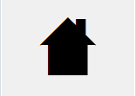

**Modified** **by:** Esri Solutions Team

**License:** None

**Acknowledgement:** None required

**Notes:** None

**Damage Assessment - Residential Buildings – Destroyed**

**Symbol Name:** House 2

**Symbol Picture:** C:\Data\Symbology\Solutions\DamageAssessment\mobile\Residential-Buildings-Destroyed.png

**Symbol Source:** Business style file

**Symbol Date:** March 2015



**Modified** **by:** Esri Solutions Team

**License:** None

**Acknowledgement:** None required

**Notes:** None

**Damage Assessment - Residential Buildings – Inaccessible**

**Symbol Name:** House 2

**Symbol Picture:** C:\Data\Symbology\Solutions\DamageAssessment\mobile\Residential-Buildings-Inaccessible.png

**Symbol Source:** Business style file

**Symbol Date:** March 2015



**Modified** **by:** Esri Solutions Team

**License:** None

**Acknowledgement:** None required

**Notes:** None

**Damage Assessment - Residential Buildings – Major**

**Symbol Name:** House 2

**Symbol Picture:** C:\Data\Symbology\Solutions\DamageAssessment\mobile\Residential-Buildings-Major.png

**Symbol Source:** Business style file

**Symbol Date:** March 2015



**Modified** **by:** Esri Solutions Team

**License:** None

**Acknowledgement:** None required

**Notes:** None

**Damage Assessment - Residential Buildings – Minor**

**Symbol Name:** House 2

**Symbol Picture:** C:\Data\Symbology\Solutions\DamageAssessment\mobile\Residential-Buildings-Minor.png

**Symbol Source:** Business style file

**Symbol Date:** March 2015



**Modified** **by:** Esri Solutions Team

**License:** None

**Acknowledgement:** None required

**Notes:** None

**Damage Assessment - Public Facilities - CAT-A-Debris-Removal**

**Symbol Name:** A

**Symbol Picture:** C:\Data\Symbology\Solutions\DamageAssessment\mobile\Public-Facilities-CAT-A-Debris-Removal.png

**Symbol Source:** Arial Rounded MT Bold Font

**Symbol Date:** March 2015

**Modified** **by:** Esri Solutions Team

**License:** None

**Acknowledgement:** None required

**Notes:** None

**Damage Assessment - Public Facilities - CAT-B-Protective-Measures**

**Symbol Name:** B

**Symbol Picture:** C:\Data\Symbology\Solutions\DamageAssessment\mobile\Public-Facilities-CAT-B-Protective-Measures.png

**Symbol Source:** Arial Rounded MT Bold

**Symbol Date:** March 2015

**Modified** **by:** Esri Solutions Team

**License:** None

**Acknowledgement:** None required

**Notes:** None

**Damage Assessment - Public Facilities - CAT-C-Roads-and-Bridges**

**Symbol Name:** C

**Symbol Picture:** C:\Data\Symbology\Solutions\DamageAssessment\mobile\Public-Facilities-CAT-C-Roads-and-Bridges.png

**Symbol Source:** Arial Rounded MT Bold

**Symbol Date:** March 2015

**Modified** **by:** Esri Solutions Team

**License:** None

**Acknowledgement:** None required

**Notes:** None

**Damage Assessment - Public Facilities - CAT-D-Water-Control-Facilities**

**Symbol Name:** D

**Symbol Picture:** C:\Data\Symbology\Solutions\DamageAssessment\mobile\Public-Facilities-CAT-D-Water-Control-Facilities.png

**Symbol Source:** Arial Rounded MT Bold

**Symbol Date:** March 2015

**Modified** **by:** Esri Solutions Team

**License:** None

**Acknowledgement:** None required

**Notes:** None

**Damage Assessment - Public Facilities - CAT-E-Public-Buildings**

**Symbol Name:** E

**Symbol Picture:** C:\Data\Symbology\Solutions\DamageAssessment\mobile\Public-Facilities-CAT-E-Public-Buildings.png

**Symbol Source:** Arial Rounded MT Bold

**Symbol Date:** March 2015

**Modified** **by:** Esri Solutions Team

**License:** None

**Acknowledgement:** None required

**Notes:** None

**Damage Assessment - Public Facilities - CAT-F-Public-Utilities**

**Symbol Name:** F

**Symbol Picture:** C:\Data\Symbology\Solutions\DamageAssessment\mobile\Public-Facilities-CAT-F-Public-Utilities.png

**Symbol Source:** Arial Rounded MT Bold

**Symbol Date:** March 2015

**Modified** **by:** Esri Solutions Team

**License:** None

**Acknowledgement:** None required

**Notes:** None

**Damage Assessment - Public Facilities - CAT-G-Parks-Other**

**Symbol Name:** G

**Symbol Picture:** C:\Data\Symbology\Solutions\DamageAssessment\mobile\Public-Facilities-CAT-G-Parks-Other.png

**Symbol Source:** Arial Rounded MT Bold

**Symbol Date:** March 2015

**Modified** **by:** Esri Solutions Team

**License:** None

**Acknowledgement:** None required

**Notes:** None

**Debris Mixed**

**Symbol Name:**

**Symbol Picture:** C:\Data\Symbology\Solutions\Debris\web\Debris-Mixed.png

**Symbol Source:** ESRI Enviro Hazard Sites Unicode 50

**Symbol Date:** March 2015

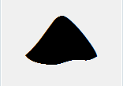

**Modified** **by:** Esri Solutions Team

**License:** None

**Acknowledgement:** None required

**Notes:** None

**Debris Other**

**Symbol Name:**

**Symbol Picture:** C:\Data\Symbology\Solutions\Debris\web\Debris-Other.png

**Symbol Source:** ESRI Enviro Hazard Sites Unicode 50

**Symbol Date:** May 2014



**Modified** **by:** Esri Solutions Team

**License:** None

**Acknowledgement:** None required

**Notes:** None

**Dangerous Animal**

**Symbol Name:**

**Symbol Picture:** C:\Data\Symbology\Utilities\Electric\HazardReportingCollector\mobile\Dangerous-Animal.pngC:\Data\Symbology\Utilities\Electric\HazardReportingCollector\web\Dangerous-Animal.png

**Symbol Source:**

**Symbol Date:** June 2015

**Created by:** Esri Solutions Team

**License:** None

**Acknowledgement:** None required

**Notes:** None

**Deformed**

**Symbol Name:**

**Symbol Picture:** C:\Data\Symbology\Utilities\Water\CCTVProcessor\web\Deformed.png

**Symbol Source:**

**Symbol Date:** May 2015

**Created by:** Esri Solutions Team

**License:** None

**Acknowledgement:** None required

**Notes:** None

**Department of Public Works**

**Symbol Name:** L3 Traffic Control Point

**Symbol Picture:** C:\Users\heat5533\Documents\GitHub\solutions-symbology-data\symbology\web\png\Department-Public-Works.png

**Symbol Source:** ERS Traffic Control Point

**Symbol Date:** March 2015

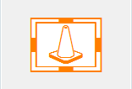

**Modified** **by:** Esri Solutions Team

**License:** None

**Acknowledgement:** None required

**Notes:** None

**Deposits**

**Symbol Name:**

**Symbol Picture:** C:\Data\Symbology\Utilities\Water\CCTVProcessor\web\Deposits.png

**Symbol Source:**

**Symbol Date:** May 2015

**Created by:** Esri Solutions Team

**License:** None

**Acknowledgement:** None required

**Notes:** None

**Dialysis**

**Symbol Name:** [Kidney](http://thenounproject.com/term/kidney/600/)

**Symbol Picture: C:\Data\Symbology\StateGov\MyHealthServices\web\Dialysis.png**

**Symbol Source:** The Noun Project

**Symbol Date:** March 2015

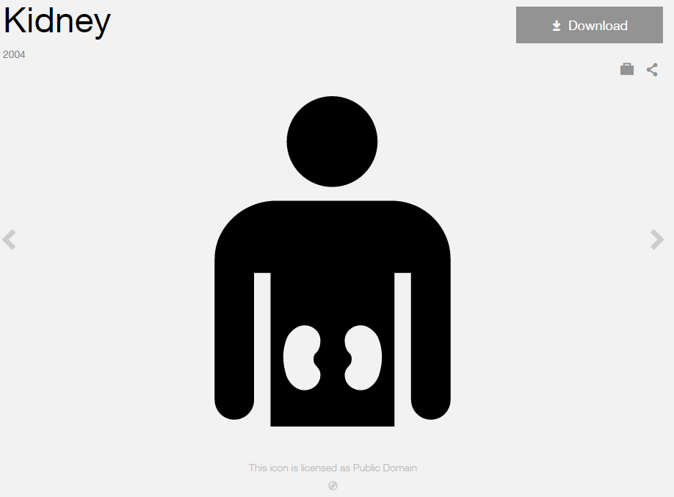

**Modified by:** Esri Solutions Team

**License:** Public Domain

**Acknowledgement:** None Required

**Notes:** None

**Disaster Recovery Center**

**Symbol Name:** [Community](http://thenounproject.com/term/community/288/)

**Symbol Picture:** C:\Data\UC\UC2015\SituationalAwareness\web\Disaster-Recovery-Center.png

**Symbol Source:** The Noun Project



**Symbol Date:** February 2015

**Modified** **by:** Esri Solutions Team

**License:** Public Domain

**Acknowledgement:** None required

**Notes:** None

**Discharge Point**

**Symbol Name:** Discharge Point

**Symbol Picture:** C:\Users\heat5533\Documents\GitHub\solutions-symbology-data\symbology\mobile\png\Discharge-Points.pngC:\Users\heat5533\Documents\GitHub\solutions-symbology-data\symbology\web\png\Discharge-Point.png

**Symbol Source:** Water Wastewater style file

**Symbol Date:** April 2015



**Modified by:** Esri Solutions Team

**License:** None

**Acknowledgement:** None required

**Notes:** None

**Dissatisfied Customer**

**Symbol Name:**

**Symbol Picture:** C:\Data\Symbology\Utilities\Electric\HazardReportingCollector\mobile\Dissatisfied-Customer.pngC:\Data\Symbology\Utilities\Electric\HazardReportingCollector\web\Dissatisfied-Customer.png

**Symbol Source:**

**Symbol Date:** June 2015

**Created by:** Esri Solutions Team

**License:** None

**Acknowledgement:** None required

**Notes:** None

**Ditch and Channel Stabilization Violation**

**Symbol Name:** DCS

**Symbol Picture:** C:\Data\Symbology\Utilities\Water\ConstructionSiteViolations\mobile\Ditch-and-Channel-Stabilization-Violation.png

**Symbol Source:** Arial Rounded MT Bold Font

**Symbol Date:** March 2015

**Modified** **by:** Esri Solutions Team

**License:** None

**Acknowledgement:** None required

**Notes:** None

**Drainage Management Violation**

**Symbol Name:** DM

**Symbol Picture:** C:\Data\Symbology\Utilities\Water\ConstructionSiteViolations\mobile\Drainage-Management-Violation.png

**Symbol Source:** Arial Rounded MT Bold Font

**Symbol Date:** March 2015

**Modified** **by:** Esri Solutions Team

**License:** None

**Acknowledgement:** None required

**Notes:** None

**Electronic**

**Symbol Name:**

**Symbol Picture:** C:\Data\Symbology\Solutions\Debris\web\Electronics.png

**Symbol Source:**

**Symbol Date:** May 2014

**Created** **by:** Esri Solutions Team

**License:** None

**Acknowledgement:** None required

**Notes:** None

**Emergency Assistance**

**Symbol Name:** [Protection](https://thenounproject.com/search/?q=protection&i=4218)

**Symbol Picture:** **C:\Users\heat5533\Documents\GitHub\solutions-symbology-data\symbology\web\png\Emergency-Assistance.png**

**Symbol Source:** The Noun Project

**Symbol Date:** July 2015



**Modified** **by:** Esri Solutions Team

**License:** Public Domain

**Acknowledgement:** None required

**Notes:** None

**Emergency Clothing Distribution Center**

**Symbol Name:** [Clothes](https://thenounproject.com/term/clothes/4309/)

**Symbol Picture:** C:\Data\UC\UC2015\SituationalAwareness\web\Emergency-Clothing-Distribution-Center.png

**Symbol Source:** The Noun Project

**Symbol Date:** July 2015

**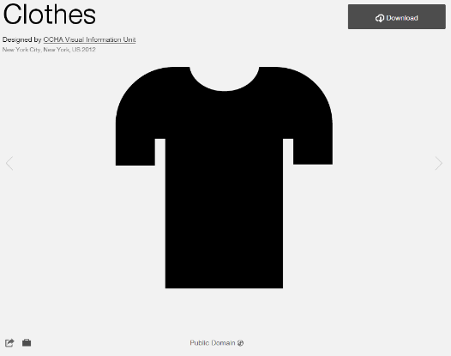**

**Modified by:** Esri Solutions Team

**License:** Public Domain

**Acknowledgement:** None required

**Notes:** None

**Erosion Protection Violation**

**Symbol Name:** EP

**Symbol Picture:** C:\Data\Symbology\Utilities\Water\ConstructionSiteViolations\mobile\Erosion-Protection-Violation.png

**Symbol Source:** Arial Rounded MT Bold Font

**Symbol Date:** March 2015

**Modified** **by:** Esri Solutions Team

**License:** None

**Acknowledgement:** None required

**Notes:** None

**Emergency Medical Services**

**Symbol Name:** Emergency Medical Services

**Symbol Picture:** C:\Data\UC\UC2015\SituationalAwareness\web\Emergency-Medical-Services.png

**Symbol Source:**  Transportation style file

**Symbol Date:** July 2015

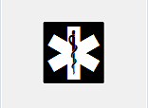

**Modified by:** Esri Solutions Team

**License:** None

**Acknowledgement:** None required

**Notes:** None

**Event Calendar**

**Symbol Name:** 1

**Symbol Picture:** C:\Data\Symbology\Solutions\EventCalendar\web\Event-Calendar.png

**Symbol Source:** Arial Rounded MT Bold

**Symbol Date:** June 2015

**Modified by:** Esri Solutions Team

**License:** None

**Acknowledgement:** None required

**Notes:** None

**Failure of equipment or heat source**

**Symbol Name:** [Cog](https://thenounproject.com/search/?q=cog&i=222491)

**Symbol Picture:** C:\Users\heat5533\Documents\GitHub\solutions-symbology-data\symbology\web\png\Failure-of-equipment-or-heat-source.png

**Symbol Source:**  The Noun Project

**Symbol Date:** December 2015

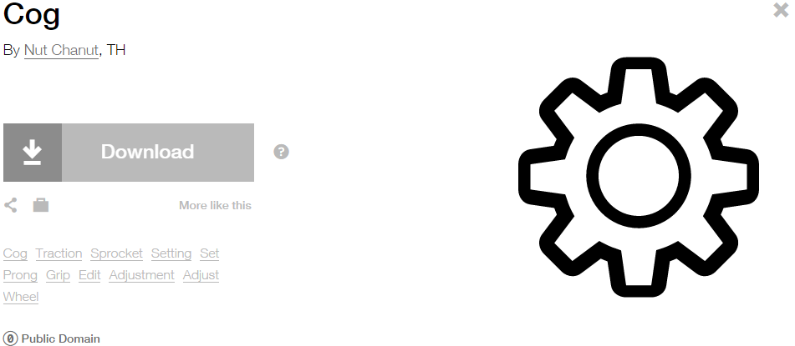

**Modified by:** Esri Solutions Team

**License:** Public Domain

**Acknowledgement:** None required

**Notes:** None

**False Alarm Incident**

**Symbol Name:** Phone 1

**Symbol Picture:** C:\Users\heat5533\Documents\GitHub\solutions-symbology-data\symbology\web\png\False-Alarm-Incident.png

**Symbol Source:**  Civic style file

**Symbol Date:** November 2015



**Modified by:** Esri Solutions Team

**License:** None

**Acknowledgement:** None required

**Notes:** None

**Field Interviews**

**Symbol Name:**

**Symbol Picture:** C:\Data\Symbology\LocalGov\FieldInterview\mobile\Field-Interviews.png

**Symbol Source:**

**Symbol Date:** July 2015

**Created by:** The Solutions Team

**License:** None

**Acknowledgement:** None required

**Notes:** None

**Fire and Hazardous Materials**

**Symbol Name:** Fire Incident

**Symbol Picture:** C:\Data\UC\UC2015\SituationalAwareness\web\Fire-and-Hazardous-Material.pngC:\Users\heat5533\Documents\GitHub\solutions-symbology-data\symbology\web\png\Fire-Incident-Circle.png

**Symbol Source:** ERS Homeland Security style file

**Symbol Date:** July 2015



**Modified** **by:** Esri Solutions Team

**License:** None

**Acknowledgement:** None required

**Notes:** None

**Fire Incident**

**Symbol Name:** Fire Incident

**Symbol Picture:** C:\Data\Symbology\Solutions\OpsIncident\web\Fire-Incident.png

**Symbol Source:** ERS Homeland Security style file

**Symbol Date:** February 2015



**Modified** **by:** Esri Solutions Team

**License:** None

**Acknowledgement:** None required

**Notes:** None

**Fire Safety Survey - Inspected**

**Symbol Name:**

**Symbol Picture:** C:\Users\heat5533\Documents\GitHub\solutions-symbology-data\symbology\mobile\png\Fire-Safety-Survey-Yes.png

**Symbol Source:**

**Symbol Date:** April 2014

**Created by:** Esri Solutions Team

**License:** None

**Acknowledgement:** None required

**Notes:** None

**Fire Safety Survey – Not Inspected**

**Symbol Name:**

**Symbol Picture:** C:\Users\heat5533\Documents\GitHub\solutions-symbology-data\symbology\mobile\png\Fire-Safety-Survey-No.png

**Symbol Source:**

**Symbol Date:** April 2014

**Created by:** Esri Solutions Team

**License:** None

**Acknowledgement:** None required

**Notes:** None

**Fire Stations**

**Symbol Name:** Fire Rescue 2

**Symbol Picture:** C:\Users\heat5533\Documents\GitHub\solutions-symbology-data\symbology\web\png\Fire-Station.png

**Symbol Source:** Hazmat style file

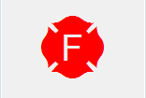

**Symbol Date:** February 2015

**Modified** **by:** Esri Solutions Team

**License:** None

**Acknowledgement:** None required

**Notes:** None

**First Aid Station**

**Symbol Name:**

**Symbol Picture:** C:\Data\UC\UC2015\SituationalAwareness\web\First-Aid-Station.png

**Symbol Source:**

**Symbol Date:** July 2015

**Created by:** Esri Solutions Team

**License:** None

**Acknowledgement:** None required

**Notes:** None

**Fishing Site**

**Symbol Name:** Fishing Area

**Symbol Picture: C:\Users\heat5533\Documents\GitHub\solutions-symbology-data\symbology\web\png\Fishing-Site.png**

**Symbol Source:** Forestry style file

**Symbol Date:** May 2014



**Modified by:** Esri Solutions Team

**License:** None

**Acknowledgement:** None Required

**Notes:** None

**Flooding**

**Symbol Name:** House 2 and Water Recreation

**Symbol Picture:** C:\Data\Symbology\Utilities\Electric\HazardReportingCollector\mobile\Flooding.pngC:\Data\Symbology\Utilities\Electric\HazardReportingCollector\web\Flooding.png

**Symbol Source:** Business style file and Forestry style file

**Symbol Date:** June 2015

 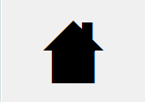

**Modified by:** Esri Solutions Team

**License:** None

**Acknowledgement:** None required

**Notes:** None

**Food Distribution Center**

**Symbol Name:** [Food Warehouse](https://thenounproject.com/search/?q=food-warehouse&i=5858)

**Symbol Picture:** C:\Data\UC\UC2015\SituationalAwareness\web\Food-Distribution-Center.png

**Symbol Source:** The Noun Project

**Symbol Date:** July 2015

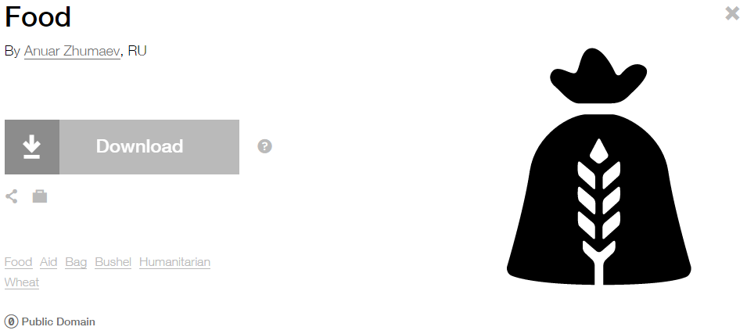

**Modified by:** Esri Solutions Team

**License:** Public Domain

**Acknowledgement:** None required

**Notes:** None

**Form Completed and Attached**

**Symbol Name:** [Paper-Clip](https://thenounproject.com/term/paper-clip/45494/)

**Symbol Picture:** C:\Users\heat5533\Documents\GitHub\solutions-symbology-data\symbology\mobile\png\Form-Completed-and-Attached.png

**Symbol Source:** The Noun Project

**Symbol Date:** May 2015

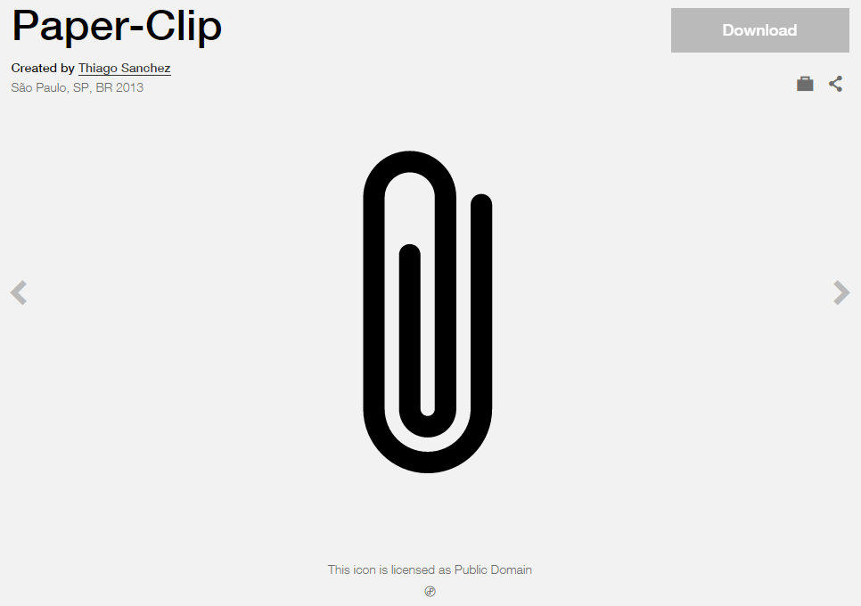

**Modified by:** Esri Solutions Team

**License:** Public Domain

**Acknowledgement:** None required

**Notes:** None

**Form Received by Office**

**Symbol Name:** [Mail](https://thenounproject.com/term/mail/31283/)

**Symbol Picture:** C:\Users\heat5533\Documents\GitHub\solutions-symbology-data\symbology\mobile\png\Form-Recieved-by-Office.png

**Symbol Source:** The Noun Project

**Symbol Date:** May 2015

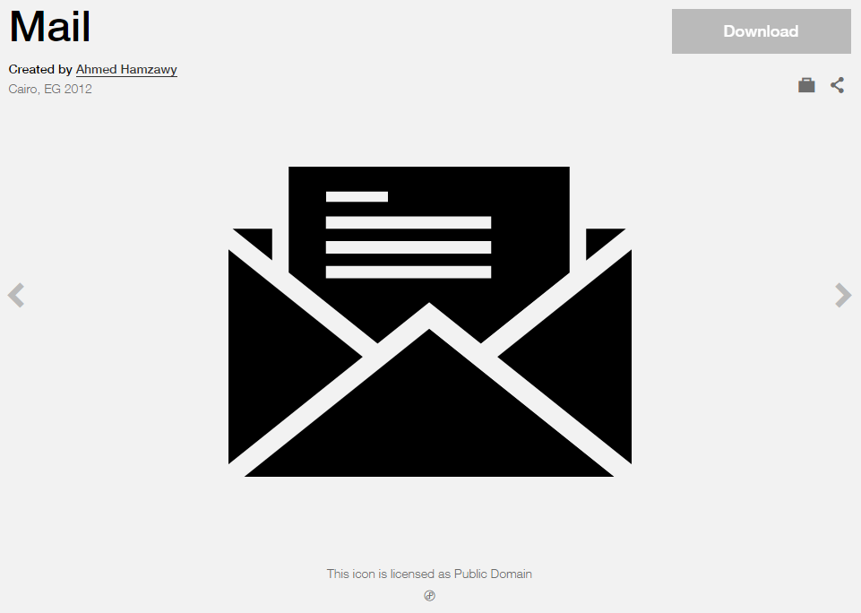

**Modified by:** Esri Solutions Team

**License:** Public Domain

**Acknowledgement:** None required

**Notes:** None

**Form Recorded by Office**

**Symbol Name:** [Write](https://thenounproject.com/term/write/43189/)

**Symbol Picture:** C:\Users\heat5533\Documents\GitHub\solutions-symbology-data\symbology\mobile\png\Form-Recorded-by-Office.png

**Symbol Source:** The Noun Project

**Symbol Date:** May 2015

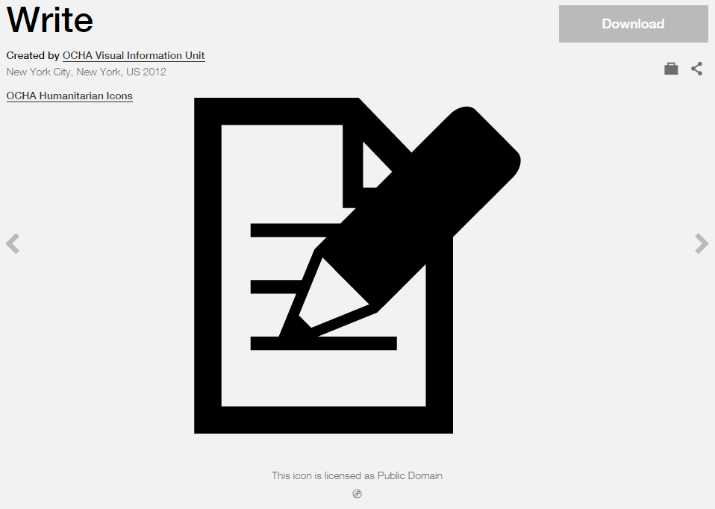

**Modified by:** Esri Solutions Team

**License:** Public Domain

**Acknowledgement:** None required

**Notes:** None

**Fracture**

**Symbol Name:**

**Symbol Picture:** C:\Data\Symbology\Utilities\Water\CCTVProcessor\web\Fracture.png

**Symbol Source:**

**Symbol Date:** May 2015

**Created by:** Esri Solutions Team

**License:** None

**Acknowledgement:** None required

**Notes:** None

**Geologic Incident**

**Symbol Name:** Rock Collecting

**Symbol Picture:** C:\Data\Symbology\Solutions\OpsIncident\web\Geological-Incident.png

**Symbol Source:** Forestry style file

**Symbol Date:** February 2015



**Modified** **by:** Esri Solutions Team

**License:** None

**Acknowledgement:** None required

**Notes:** None

**Green Landscaping**

**Symbol Name:** GL

**Symbol Picture:** C:\Data\Symbology\Utilities\Water\GreenInfrastructure\mobile\Green-Landscaping.pngC:\Data\Symbology\Utilities\Water\GreenInfrastructure\web\Green-Landscaping.png

**Symbol Source:** Arial Rounded MT Bold Font

**Symbol Date:** March 2015

**Modified** **by:** Esri Solutions Team

**License:** None

**Acknowledgement:** None required

**Notes:** None

**Green Roof**

**Symbol Name:** GR

**Symbol Picture:** C:\Data\Symbology\Utilities\Water\GreenInfrastructure\mobile\Green-Roof.pngC:\Data\Symbology\Utilities\Water\GreenInfrastructure\web\Green-Roof.png

**Symbol Source:** Arial Rounded MT Bold Font

**Symbol Date:** March 2015

**Modified** **by:** Esri Solutions Team

**License:** None

**Acknowledgement:** None required

**Notes:** None

**Grout Test and Seal**

**Symbol Name:**

**Symbol Picture:** C:\Data\Symbology\Utilities\Water\CCTVProcessor\web\Grout-Test-and-Seal.png

**Symbol Source:**

**Symbol Date:** May 2015

**Created by:** Esri Solutions Team

**License:** None

**Acknowledgement:** None required

**Notes:** None

**Habilitation Facility**

**Symbol Name:** [Hands](https://thenounproject.com/term/hands/23909/)

**Symbol Picture: C:\Data\Symbology\StateGov\MyHealthServices\web\Habilitation-Facility.png**

**Symbol Source:** The Noun Project

**Symbol Date:** March 2015

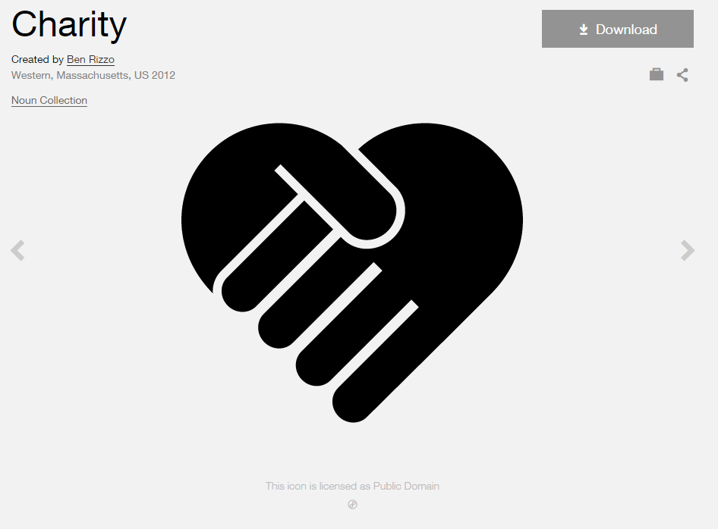

**Modified by:** Esri Solutions Team

**License:** Public Domain

**Acknowledgement:** None Required

**Notes:** None

**Hazardous Condition Incident**

**Symbol Name:** !

**Symbol Picture:** C:\Users\heat5533\Documents\GitHub\solutions-symbology-data\symbology\web\png\Hazardous-Condition-Incident.png

**Symbol Source:**  Arial Rounded MT Bold

**Symbol Date:** July 2015

**Created by:** Esri Solutions Team

**License:** None

**Acknowledgement:** None required

**Notes:** None

**Golf Courses**

**Symbol Name:** Golf Course 1

**Symbol Picture:** C:\Users\heat5533\Documents\GitHub\solutions-symbology-data\symbology\web\png\Golf-Courses.png

**Symbol Source:** Civic style file

**Symbol Date:** January 2015



**Modified** **by:** Esri Solutions Team

**License:** None

**Acknowledgement:** None required

**Notes:** None

**Hazardous Facilities**

**Symbol Name:** Hazardous Material Incident

**Symbol Picture:** C:\Users\heat5533\Documents\GitHub\solutions-symbology-data\symbology\web\png\Hazardous-Facilities.png

**Symbol Source:** ERS Homeland Security style file

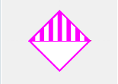

**Symbol Date:** February 2015

**Modified** **by:** Esri Solutions Team

**License:** None

**Acknowledgement:** None required

**Notes:** None

**Hazardous Material Incident**

**Symbol Name:** Hazardous Material Incident

**Symbol Picture:** C:\Data\Symbology\Solutions\OpsIncident\web\Hazardous-Material-Incident.png

**Symbol Source:** ERS Homeland Security style file

**Symbol Date:** February 2015



**Modified** **by:** Esri Solutions Team

**License:** None

**Acknowledgement:** None required

**Notes:** None

**Hazardous Waste**

**Symbol Name:** Hazardous Material

**Symbol Picture:** C:\Data\Symbology\Solutions\Debris\web\Hazardous-Waste.png

**Symbol Source:** ERS Homeland Security style file

**Symbol Date:** February 2015

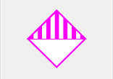

**Modified** **by:** Esri Solutions Team

**License:** None

**Acknowledgement:** None required

**Notes:** None

**Hazards - Other**

**Symbol Name:** Hazardous

**Symbol Picture:** C:\Data\Symbology\Utilities\Electric\HazardReportingCollector\mobile\Hazards-Other.pngC:\Data\Symbology\Utilities\Electric\HazardReportingCollector\web\Hazards-Other.png

**Symbol Source:** Environmental style file

**Symbol Date:** June 2015

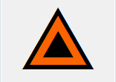

**Modified** **by:** Esri Solutions Team

**License:** None

**Acknowledgement:** None required

**Notes:** None

**Healthcare Facilities**

**Symbol Name:** Cross 2

**Symbol Picture:** C:\Users\heat5533\Documents\GitHub\solutions-symbology-data\symbology\web\png\Healthcare-Facilities.png

**Symbol Source:** ESRI style file

**Symbol Date:** May 2014



**Modified by:** Esri Solutions Team

**License:** None

**Acknowledgement:** None required

**Notes:** None

**Hearing**

**Symbol Name:** [Hear](http://thenounproject.com/term/hear/1583/)

**Symbol Picture: C:\Data\Symbology\StateGov\MyHealthServices\web\Hearing.png**

**Symbol Source:** The Noun Project

**Symbol Date:** March 2015

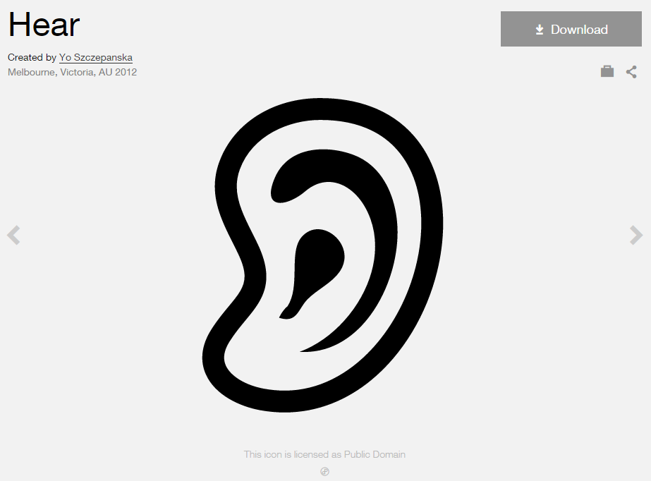

**Modified by:** Esri Solutions Team

**License:** Public Domain

**Acknowledgement:** None Required

**Notes:** None

**Hole**

**Symbol Name:**

**Symbol Picture:** C:\Data\Symbology\Utilities\Water\CCTVProcessor\web\Hole.png

**Symbol Source:**

**Symbol Date:** May 2015

**Created by:** Esri Solutions Team

**License:** None

**Acknowledgement:** None required

**Notes:** None

**Home Health, Residential Care**

**Symbol Name:** House 2

**Symbol Picture: C:\Data\Symbology\StateGov\MyHealthServices\web\Home-Health.png**

**Symbol Source:** Business style file

**Symbol Date:** March 2015



**Modified by:** Esri Solutions Team

**License:** None

**Acknowledgement:** None Required

**Notes:** None

**Hospice**

**Symbol Name:** [Bunk-Bed](https://thenounproject.com/term/bunk-bed/3365/)

**Symbol Picture: C:\Data\Symbology\StateGov\MyHealthServices\web\Hospice.png**

**Symbol Source:** The Noun Project

**Symbol Date:** March 2015

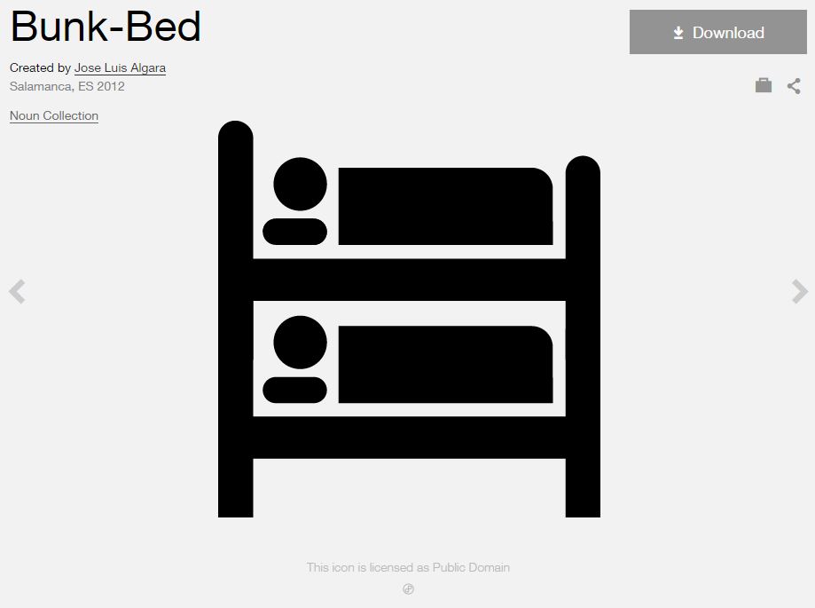

**Modified by:** Esri Solutions Team

**License:** Public Domain

**Acknowledgement:** None Required

**Notes:** None

**Hospital**

**Symbol Name:** Hospital

**Symbol Picture:** C:\Data\Symbology\Solutions\Live-Work-Locate\web\Hospital.png

**Symbol Source:** Business style file

**Symbol Date:** January 2015

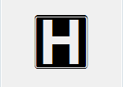

**Modified** **by:** Esri Solutions Team

**License:** None

**Acknowledgement:** None required

**Notes:** None

**Hydrant - Inoperable**

**Symbol Name:** FireHydrant 1

**Symbol Picture:** C:\Data\Symbology\LocalGov\Hydrant\Hydrant-Inoperable.png

**Symbol Source:** Hazmat style file

**Symbol Date:** March 2015

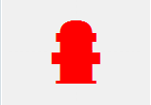

**Modified by:** Esri Solutions Team

**License:** None

**Acknowledgement:** None required

**Notes:** None

**Hydrant - Operable**

**Symbol Name:** FireHydrant 1

**Symbol Picture:** C:\Data\Symbology\LocalGov\Hydrant\Hydrant.png

**Symbol Source:** Hazmat style file

**Symbol Date:** March 2015



**Modified by:** Esri Solutions Team

**License:** None

**Acknowledgement:** None required

**Notes:** None

**Hydrant – Out of Order**

**Symbol Name:** FireHydrant 1

**Symbol Picture:** C:\Data\Symbology\LocalGov\Hydrant\mobile\Hydrant-Out-of-Order.png

**Symbol Source:** Hazmat style file

**Symbol Date:** March 2015



**Modified by:** Esri Solutions Team

**License:** None

**Acknowledgement:** None required

**Notes:** None

**Hydro-Meteorological Incident**

**Symbol Name:**

**Symbol Picture:** C:\Data\Symbology\Solutions\OpsIncident\web\Hydro-Meteorological-Incident.png

**Symbol Source:**

**Symbol Date:** February 2015

**Created** **by:** Esri Solutions Team

**License:** None

**Acknowledgement:** None required

**Notes:** None

**Hydrostatic Permit**

**Symbol Name:** Droplet, Water

**Symbol Picture:** C:\Users\heat5533\Documents\GitHub\solutions-symbology-data\symbology\web\png\Hydrostatic.png

**Symbol Source:** Environmental style file

**Symbol Date:** September 2014

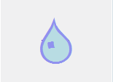

**Modified by:** Esri Solutions Team

**License:** None

**Acknowledgement:** None required

**Notes:** None

**Incident Command Post**

**Symbol Name:** Incident Command Post

**Symbol Picture:** C:\Data\UC\UC2015\SituationalAwareness\web\Incident-Command-Post.png

**Symbol Source:** Forestry style file

**Symbol Date:** July 2015



**Modified by:** Esri Solutions Team

**License:** None

**Acknowledgement:** None required

**Notes:** None

**Incident Management**

**Symbol Name:** !

**Symbol Picture:** C:\Data\UC\UC2015\SituationalAwareness\web\Incident-Management.png

**Symbol Source:**  Arial Rounded MT Bold

**Symbol Date:** July 2015

**Created by:** Esri Solutions Team

**License:** None

**Acknowledgement:** None required

**Notes:** None

**Incorrect Attribute**

**Symbol Name:** [Map](https://thenounproject.com/term/map/2312/)

**Symbol Picture:** C:\Users\heat5533\Documents\GitHub\solutions-symbology-data\symbology\mobile\png\Incorrect-Attribute.pngC:\Users\heat5533\Documents\GitHub\solutions-symbology-data\symbology\web\png\Incorrect-Attribute.png

**Symbol Source:** The Noun Project

**Symbol Date:** May 2015



**Modified by:** Esri Solutions Team

**License:** Public Domain

**Acknowledgement:** None required

**Notes:** None

**Incubators**

**Symbol Name:** [Business-Incubator](http://thenounproject.com/term/business-incubator/21040/)

**Symbol Picture:** C:\Data\Symbology\Solutions\Live-Work-Locate\web\Incubator.png

**Symbol Source:** The Noun Project

**Symbol Date:** March 2015

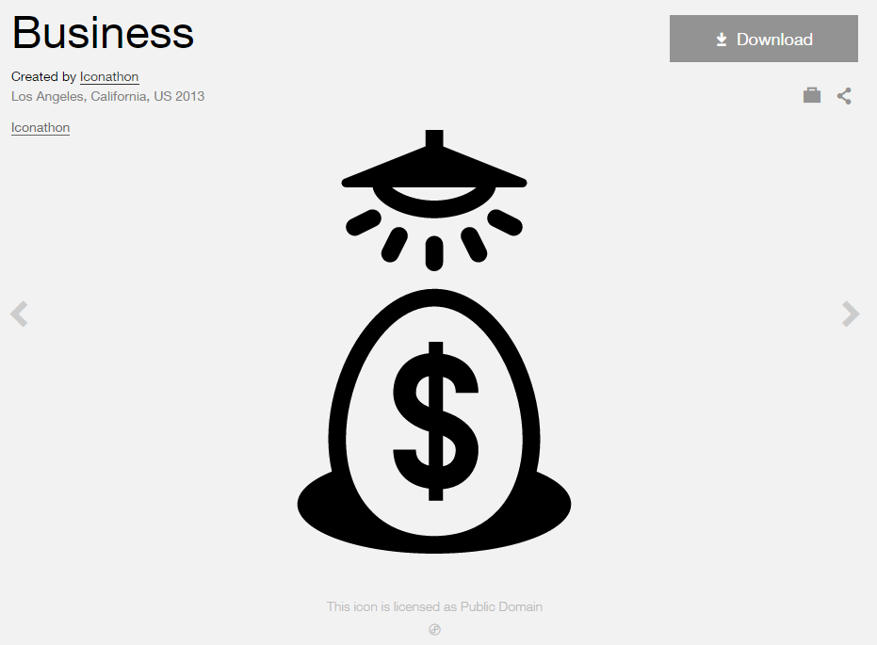

**Modified by:** Esri Solutions Team

**License:** Public Domain

**Acknowledgement:** None required

**Notes:** None

**Individual Permit**

**Symbol Name:**

**Symbol Picture:** C:\Users\heat5533\Documents\GitHub\solutions-symbology-data\symbology\web\png\Individual.png

**Symbol Source:**

**Symbol Date:** September 2014

**Created by:** Esri Solutions Team

**License:** None

**Acknowledgement:** None required

**Notes:** None

**Infestation Incident**

**Symbol Name:** [Ant](https://thenounproject.com/term/ant/4002/)

**Symbol Picture:** C:\Data\Symbology\Solutions\OpsIncident\web\Infestation-Incident.png

**Symbol Source:** The Noun Project

**Symbol Date:** March 2015

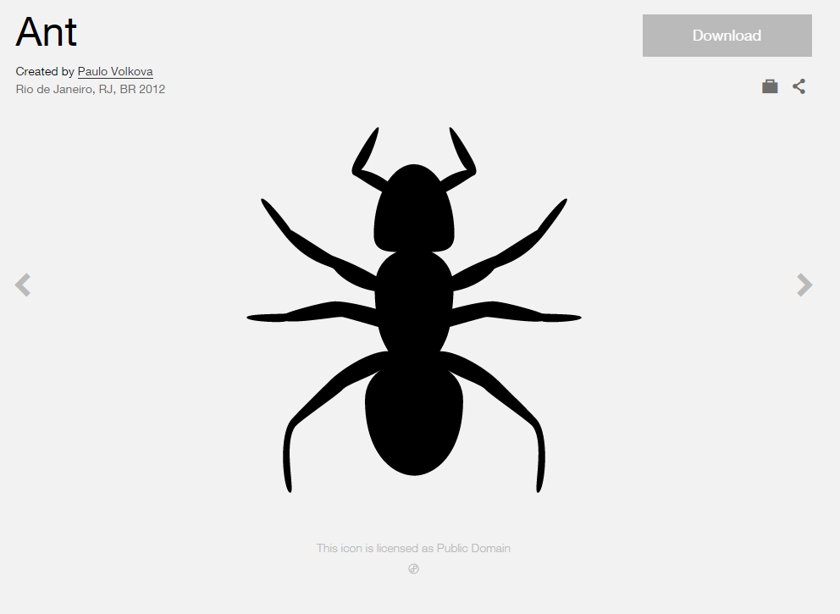

**Modified** **by:** Esri Solutions Team

**License:** Public Domain

**Acknowledgement:** None required

**Notes:** None

**Infiltration**

**Symbol Name:**

**Symbol Picture:** C:\Data\Symbology\Utilities\Water\CCTVProcessor\web\Infiltration.png

**Symbol Source:**

**Symbol Date:** May 2015

**Created by:** Esri Solutions Team

**License:** None

**Acknowledgement:** None required

**Notes:** None

**Inlet Protection Violation**

**Symbol Name:** IP

**Symbol Picture:** C:\Data\Symbology\Utilities\Water\ConstructionSiteViolations\mobile\Inlet-Protection-Violation.png

**Symbol Source:** Arial Rounded MT Bold Font

**Symbol Date:** March 2015

**Modified** **by:** Esri Solutions Team

**License:** None

**Acknowledgement:** None required

**Notes:** None

**Inlets**

**Symbol Name:**

**Symbol Picture:** C:\Data\Symbology\Utilities\Water\IllicitDischarge\mobile\Inlets.pngC:\Data\Symbology\Utilities\Water\IllicitDischarge\web\Inlets.png

**Symbol Source:**

**Symbol Date:** April 2015

**Created by:** Esri Solutions Team

**License:** None

**Acknowledgement:** None required

**Notes:** None

**Intentional**

**Symbol Name:** [Match](https://thenounproject.com/search/?q=cog&i=1120)

**Symbol Picture:** C:\Users\heat5533\Documents\GitHub\solutions-symbology-data\symbology\web\png\Intentional.png

**Symbol Source:**  The Noun Project

**Symbol Date:** December 2015

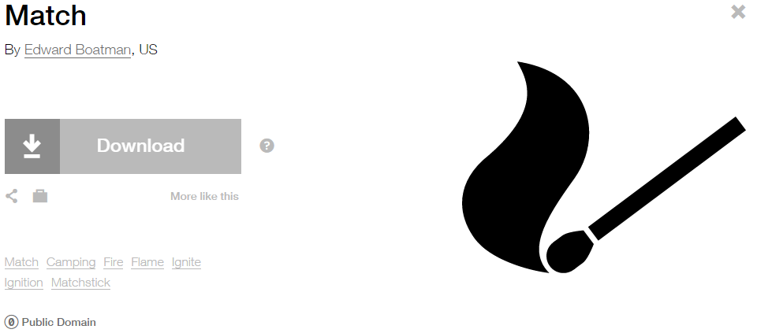

**Modified by:** Esri Solutions Team

**License:** Public Domain

**Acknowledgement:** None required

**Notes:** None

**Interbasin Water Transfer**

**Symbol Name:** Water Recreation

**Symbol Picture:** C:\Users\heat5533\Documents\GitHub\solutions-symbology-data\symbology\web\png\Interbasin-Water-Transfer.png

**Symbol Source:** Forestry style file

**Symbol Date:** September 2014



**Modified by:** Esri Solutions Team

**License:** None

**Acknowledgement:** None required

**Notes:** None

**Intruding Sealing Material**

**Symbol Name:**

**Symbol Picture:** C:\Data\Symbology\Utilities\Water\CCTVProcessor\web\Intruding-Sealing-Material.png

**Symbol Source:**

**Symbol Date:** May 2015

**Created by:** Esri Solutions Team

**License:** None

**Acknowledgement:** None required

**Notes:** None

**Joint**

**Symbol Name:**

**Symbol Picture:** C:\Data\Symbology\Utilities\Water\CCTVProcessor\web\Joint.png

**Symbol Source:**

**Symbol Date:** May 2015

**Created by:** Esri Solutions Team

**License:** None

**Acknowledgement:** None required

**Notes:** None

**Joint Use Survey - Assigned**

**Symbol Name:**

**Symbol Picture:** C:\Data\Symbology\Utilities\Electric\JointUseSurvey\web\Joint-Use-Survey-Assigned.png

**Symbol Source:**

**Symbol Date:** April 2015

**Created** **by:** Esri Solutions Team

**License:** None

**Acknowledgement:** None required

**Notes:** None

**Joint Use Survey - Completed**

**Symbol Name:**

**Symbol Picture:** C:\Data\Symbology\Utilities\Electric\JointUseSurvey\web\Joint-Use-Survey-Completed.png

**Symbol Source:**

**Symbol Date:** April 2015

**Created** **by:** Esri Solutions Team

**License:** None

**Acknowledgement:** None required

**Notes:** None

**Joint Use Survey – Not On Map**

**Symbol Name:**

**Symbol Picture:** C:\Data\Symbology\Utilities\Electric\JointUseSurvey\web\Joint-Use-Survey-Not-On-Map.png

**Symbol Source:**

**Symbol Date:** April 2015

**Created** **by:** Esri Solutions Team

**License:** None

**Acknowledgement:** None required

**Notes:** None

**Joint Use Survey – Pole Not Found**

**Symbol Name:**

**Symbol Picture:** C:\Data\Symbology\Utilities\Electric\JointUseSurvey\web\Joint-Use-Survey-Pole-Not-Found.png

**Symbol Source:**

**Symbol Date:** April 2015

**Created** **by:** Esri Solutions Team

**License:** None

**Acknowledgement:** None required

**Notes:** None

**Joint Use Survey – Unassigned**

**Symbol Name:** ?

**Symbol Picture:** C:\Data\Symbology\Utilities\Electric\JointUseSurvey\web\Joint-Use-Survey-Unassigned.png

**Symbol Source:** Arial Rounded MT Bold

**Symbol Date:** April 2015

**Modifed by:** Esri Solutions Team

**License:** None

**Acknowledgement:** None required

**Notes:** None

**Land Use Code Violation Closed**

**Symbol Name:** X

**Symbol Picture:** **C:\Data\Symbology\LocalGov\CodeViolation\mobile\Code-Violation-Open.png**

**Symbol Source:** Myriad Pro – Semi bold font

**Symbol Date:** March 2015

**Modified** **by:** Esri Solutions Team

**License:** None

**Acknowledgement:** None required

**Notes:** None

**Land Use Code Violation Open**

**Symbol Name:** Check 1

**Symbol Picture:** C:\Data\Symbology\LocalGov\CodeViolation\mobile\Code-Violation-Closed.png

**Symbol Source:** ESRI style file

**Symbol Date:** March 2015



**Modified** **by:** Esri Solutions Team

**License:** None

**Acknowledgement:** None required

**Notes:** None

**Large mammal**

**Symbol Name:** [Bear](https://thenounproject.com/term/bear/653/)

**Symbol Picture:** C:\Data\Symbology\StateGov\CitizenScience\web\Large-Mammal.png

**Symbol Source:** The Noun Project

**Symbol Date:** March 2015

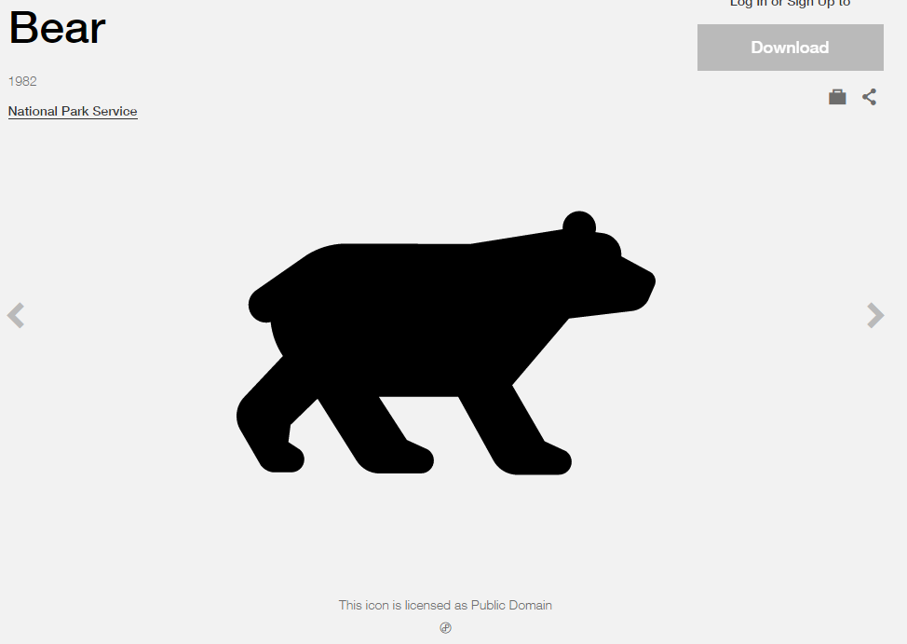

**Modified by:** Esri Solutions Team

**License:** Public Domain

**Acknowledgement:** None required

**Notes:** None

**Law Enforcement and Security**

**Symbol Name:** Police Badge & L1 Law Enforcement Operations

**Symbol Picture:** C:\Data\UC\UC2015\SituationalAwareness\web\Law-Enforcement-and-Security.png

**Symbol Source:** ESRI Crime Analysis & ERS Homeland Security style file

**Symbol Date:** July 2015

 

**Modified** **by:** Esri Solutions Team

**License:** None

**Acknowledgement:** None required

**Notes:** None

**Leak Severity - Cosmetic**

**Symbol Name:** Oil Droplet

**Symbol Picture:** C:\Users\heat5533\Documents\GitHub\solutions-symbology-data\symbology\mobile\png\Leak-Severity-Cosmetic.pngC:\Users\heat5533\Documents\GitHub\solutions-symbology-data\symbology\web\png\Leak-Severity-Cosmetic.png

**Symbol Source:** Petroleum style files

**Symbol Date:** May 2015

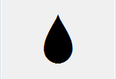

**Modified by:** Esri Solutions Team

**License:** None

**Acknowledgement:** None required

**Notes:** None

**Leak Severity - Critical**

**Symbol Name:** Oil Droplet

**Symbol Picture:** C:\Users\heat5533\Documents\GitHub\solutions-symbology-data\symbology\mobile\png\Leak-Severity-Critical.pngC:\Users\heat5533\Documents\GitHub\solutions-symbology-data\symbology\web\png\Leak-Severity-Critical.png

**Symbol Source:** Petroleum style files

**Symbol Date:** May 2015



**Modified by:** Esri Solutions Team

**License:** None

**Acknowledgement:** None required

**Notes:** None

**Leak Severity - Major**

**Symbol Name:** Oil Droplet

**Symbol Picture:** C:\Users\heat5533\Documents\GitHub\solutions-symbology-data\symbology\mobile\png\Leak-Severity-Major.pngC:\Users\heat5533\Documents\GitHub\solutions-symbology-data\symbology\web\png\Leak-Severity-Major.png

**Symbol Source:** Petroleum style files

**Symbol Date:** May 2015



**Modified by:** Esri Solutions Team

**License:** None

**Acknowledgement:** None required

**Notes:** None

**Leak Severity - Minor**

**Symbol Name:** Oil Droplet

**Symbol Picture:** C:\Users\heat5533\Documents\GitHub\solutions-symbology-data\symbology\mobile\png\Leak-Severity-Minor.pngC:\Users\heat5533\Documents\GitHub\solutions-symbology-data\symbology\web\png\Leak-Severity-Minor.png

**Symbol Source:** Petroleum style files

**Symbol Date:** May 2015



**Modified by:** Esri Solutions Team

**License:** None

**Acknowledgement:** None required

**Notes:** None

**Leak Severity - Moderate**

**Symbol Name:** Oil Droplet

**Symbol Picture:** C:\Users\heat5533\Documents\GitHub\solutions-symbology-data\symbology\mobile\png\Leak-Severity-Moderate.pngC:\Users\heat5533\Documents\GitHub\solutions-symbology-data\symbology\web\png\Leak-Severity-Moderate.png

**Symbol Source:** Petroleum style files

**Symbol Date:** May 2015



**Modified by:** Esri Solutions Team

**License:** None

**Acknowledgement:** None required

**Notes:** None

**Libraries**

**Symbol Name:** Library

**Symbol Picture:** C:\Users\heat5533\Documents\GitHub\solutions-symbology-data\symbology\web\png\Library.png

**Symbol Source:** Civic style file

**Symbol Date:** January 2015



**Modified** **by:** Esri Solutions Team

**License:** None

**Acknowledgement:** None required

**Notes:** None

**Line**

**Symbol Name:**

**Symbol Picture:** C:\Data\Symbology\Utilities\Water\CCTVProcessor\web\Line.png

**Symbol Source:**

**Symbol Date:** May 2015

**Created by:** Esri Solutions Team

**License:** None

**Acknowledgement:** None required

**Notes:** None

**Lining**

**Symbol Name:**

**Symbol Picture:** C:\Data\Symbology\Utilities\Water\CCTVProcessor\web\Lining.png

**Symbol Source:**

**Symbol Date:** May 2015

**Created by:** Esri Solutions Team

**License:** None

**Acknowledgement:** None required

**Notes:** None

**Manhole**

**Symbol Name:** Manhole

**Symbol Picture:** C:\Users\heat5533\Documents\GitHub\solutions-symbology-data\symbology\mobile\png\Manholes.pngC:\Users\heat5533\Documents\GitHub\solutions-symbology-data\symbology\web\png\Manhole.png

**Symbol Source:** Water Wastewater style file

**Symbol Date:** April 2015



**Modified by:** Esri Solutions Team

**License:** None

**Acknowledgement:** None required

**Notes:** None

**Marina**

**Symbol Name:** [Ship](https://thenounproject.com/term/ship/4409/)

**Symbol Picture:** C:\Users\heat5533\Documents\GitHub\solutions-symbology-data\symbology\web\png\Marina.png

**Symbol Source:** The Noun Project

**Symbol Date:** March 2015

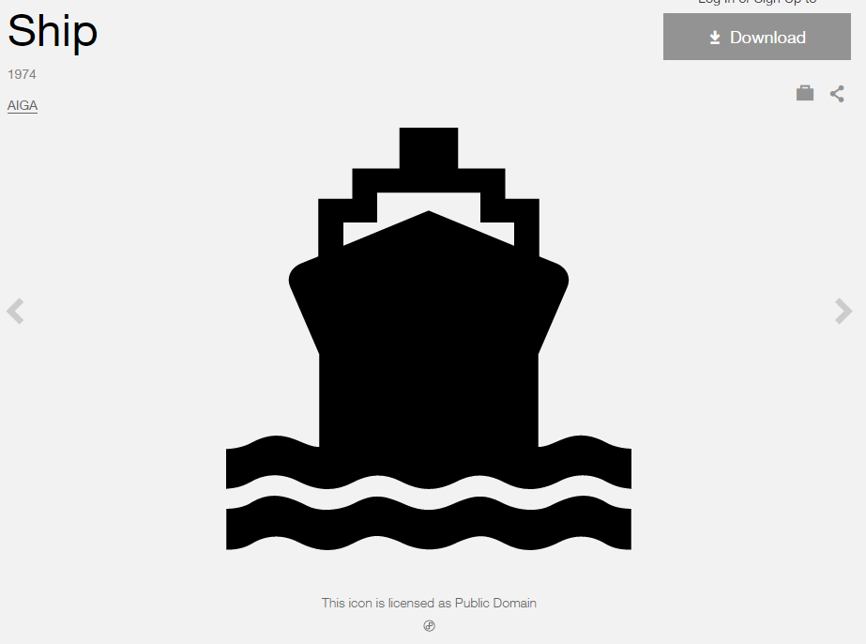

**Modified by:** Esri Solutions Team

**License:** Public Domain

**Acknowledgement:** None required

**Notes:** None

**Marine Incident**

**Symbol Name:** [Ship](http://thenounproject.com/term/ship/4409/)

**Symbol Picture: C:\Data\Symbology\Solutions\OpsIncident\web\Marine-Incident.png**

**Symbol Source:** The Noun Project

**Symbol Date:** March 2015



**Modified by:** Esri Solutions Team

**License:** Public Domain

**Acknowledgement:** None required

**Notes:** None

**Market**

**Symbol Name:** [Store](https://thenounproject.com/term/store/5284/)

**Symbol Picture:** C:\Users\heat5533\Documents\GitHub\solutions-symbology-data\symbology\web\png\Market.png

**Symbol Source:** The Noun Project

**Symbol Date:** February 2015

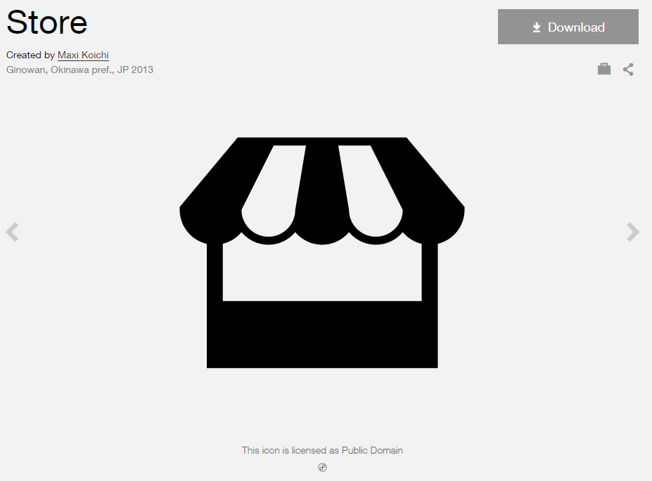

**Modified by:** Esri Solutions Team

**License:** Public Domain

**Acknowledgement:** None required

**Notes:** None

**Mass Transit Stations**

**Symbol Name:** Bus 2

**Symbol Picture:** C:\Users\heat5533\Documents\GitHub\solutions-symbology-data\symbology\web\png\Mass-Transit-Stations.png

**Symbol Source:** Business style file

**Symbol Date:** March 2015

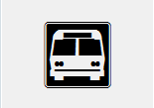

**Modified by:** Esri Solutions Team

**License:** None

**Acknowledgement:** None required

**Notes:** None

**Medical and Public Health**

**Symbol Name:** Men

**Symbol Picture:** C:\Data\UC\UC2015\SituationalAwareness\web\Medical-and-Public-Health.png

**Symbol Source:** Public Signs style file

**Symbol Date:** February 2015



**Modified** **by:** Esri Solutions Team

**License:** None

**Acknowledgement:** None required

**Notes:** None

**Medical Incident**

**Symbol Name:** Emergency Medical Services

**Symbol Picture:** C:\Users\heat5533\Documents\GitHub\solutions-symbology-data\symbology\web\png\Medical-Incident.png

**Symbol Source:**  Transportation style file

**Symbol Date:** July 2015



**Modified by:** Esri Solutions Team

**License:** None

**Acknowledgement:** None required

**Notes:** None

**Medivac Site**

**Symbol Name:** MediVac Site

**Symbol Picture:** C:\Data\UC\UC2015\SituationalAwareness\web\Medivac-Sites.png

**Symbol Source:** GSTOP\_2014 style file ([Symbol Style set for ArcGIS](http://gis.nwcg.gov/gstop_symbol.html))

**Symbol Date:** July 2015



**Modified by:** Esri Solutions Team

**License:** None

**Acknowledgement:** National Wildfire Coordinating Group (NWCG)

**Notes:** None

**Meter Setting**

**Symbol Name:**

**Symbol Picture:** C:\Data\Symbology\Utilities\Gas\PotentialNewCustomers\web\Meter-Setting.png

**Symbol Source:**

**Symbol Date:** May 2015

**Created by:** Esri Solutions Team

**License:** None

**Acknowledgement:** None required

**Notes:** None

**Materials, Storage, Cleanup Violation**

**Symbol Name:** MST

**Symbol Picture:** C:\Data\Symbology\Utilities\Water\ConstructionSiteViolations\mobile\Materials-Storage-Cleanup-Violation.png

**Symbol Source:** Arial Rounded MT Bold Font

**Symbol Date:** March 2015

**Modified** **by:** Esri Solutions Team

**License:** None

**Acknowledgement:** None required

**Notes:** None

**Mining Permit**

**Symbol Name:** Mining/Process

**Symbol Picture:** C:\Users\heat5533\Documents\GitHub\solutions-symbology-data\symbology\web\png\Mining.png

**Symbol Source:** Environmental style file

**Symbol Date:** September 2014

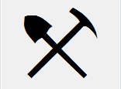

**Modified by:** Esri Solutions Team

**License:** None

**Acknowledgement:** None required

**Notes:** None

**Miscellaneous**

**Symbol Name:**

**Symbol Picture:** C:\Data\Symbology\Utilities\Water\CCTVProcessor\web\Miscellaneous.png

**Symbol Source:**

**Symbol Date:** May 2015

**Created by:** Esri Solutions Team

**License:** None

**Acknowledgement:** None required

**Notes:** None

**Missing Asset**

**Symbol Name:** [Map](https://thenounproject.com/term/map/2312/)

**Symbol Picture:** C:\Users\heat5533\Documents\GitHub\solutions-symbology-data\symbology\mobile\png\Missing-Asset.pngC:\Users\heat5533\Documents\GitHub\solutions-symbology-data\symbology\web\png\Missing-Asset.png

**Symbol Source:** The Noun Project

**Symbol Date:** May 2015



**Modified by:** Esri Solutions Team

**License:** Public Domain

**Acknowledgement:** None required

**Notes:** None

**Municipal Stormwater Discharge Permit**

**Symbol Name:** Overboard Discharge (right)

**Symbol Picture:** C:\Users\heat5533\Documents\GitHub\solutions-symbology-data\symbology\web\png\Municipal-Stormwater-Discharge.png

**Symbol Source:** Environmental style file

**Symbol Date:** September 2014

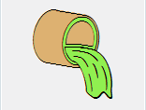

**Modified by:** Esri Solutions Team

**License:** None

**Acknowledgement:** None required

**Notes:** None

**Museums**

**Symbol Name:** Bank 1

**Symbol Picture:** C:\Users\heat5533\Documents\GitHub\solutions-symbology-data\symbology\web\png\Museum.png

**Symbol Source:** Business style file

**Symbol Date:** January 2015



**Modified** **by:** Esri Solutions Team

**License:** None

**Acknowledgement:** None required

**Notes:** None

**Music Venues**

**Symbol Name:** [Music](http://thenounproject.com/term/music/928/)

**Symbol Picture:** C:\Users\heat5533\Documents\GitHub\solutions-symbology-data\symbology\web\png\Music-Venue.png

**Symbol Source:** The Noun Project

**Symbol Date:** February 2015

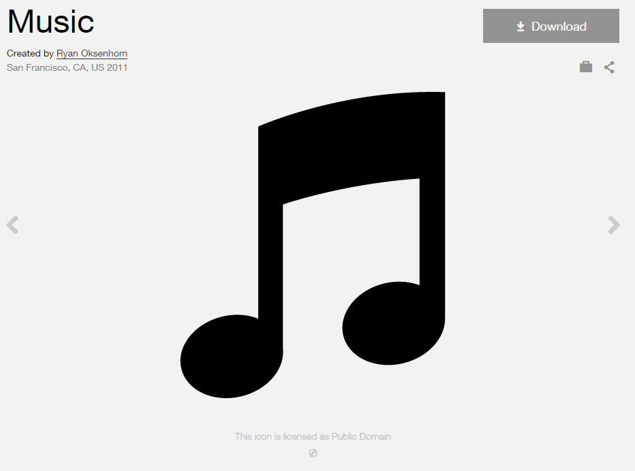

**Created by:** Esri Solutions Team

**License:** Public Domain

**Acknowledgement:** None required

**Notes:** None

**Natural Disaster Incident**

**Symbol Name:** [Storm](https://thenounproject.com/search/?q=storm&i=24502)

**Symbol Picture:** C:\Users\heat5533\Documents\GitHub\solutions-symbology-data\symbology\web\png\Natural-Disaster-Incident.png

**Symbol Source:**  The Noun Project

**Symbol Date:** December 2015



**Modified by:** Esri Solutions Team

**License:** Public Domain

**Acknowledgement:** None required

**Notes:** None

**Obstacle**

**Symbol Name:**

**Symbol Picture:** C:\Data\Symbology\Utilities\Water\CCTVProcessor\web\Obstacle.png

**Symbol Source:**

**Symbol Date:** May 2015

**Created by:** Esri Solutions Team

**License:** None

**Acknowledgement:** None required

**Notes:** None

**On Street Parking**

**Symbol Name:**

**Symbol Picture:** C:\Data\Symbology\LocalGov\PublicParking\web\On-Street-Parking.png

**Symbol Source:**

**Symbol Date:** July 2015

**Created by:** Esri Solutions Team

**License:** None

**Acknowledgement:** None required

**Notes:** None

**Other**

**Symbol Name:**

**Symbol Picture:** C:\Data\Symbology\Utilities\Water\CCTVProcessor\web\Other.png

**Symbol Source:**

**Symbol Date:** May 2015

**Created by:** Esri Solutions Team

**License:** None

**Acknowledgement:** None required

**Notes:** None

**Outage - Planned**

**Symbol Name:** [Light Bulb](https://thenounproject.com/search?q=light-bulb&i=8699)

**Symbol Picture:** C:\Data\Symbology\Utilities\Electric\DamageAssessment\web\Damage-Assessment-Electric-High-Damage.png

**Symbol Source:** The Noun Project

**Symbol Date:** April 2015



**Modified by:** Esri Solutions Team

**License:** Public Domain

**Acknowledgement:** None required

**Notes:** None

**Outage - Unplanned**

**Symbol Name:** [Light Bulb](https://thenounproject.com/search?q=light-bulb&i=8699)

**Symbol Picture:** C:\Data\Symbology\Utilities\Electric\PublicOutageMap\web\Planned-Outage.png

**Symbol Source:** The Noun Project

**Symbol Date:** April 2015



**Modified by:** Esri Solutions Team

**License:** Public Domain

**Acknowledgement:** None required

**Notes:** None

**Outlet Protection Violation**

**Symbol Name:** OP

**Symbol Picture:** C:\Data\Symbology\Utilities\Water\ConstructionSiteViolations\mobile\Outlet-Protection-Violation.png

**Symbol Source:** Arial Rounded MT Bold Font

**Symbol Date:** March 2015

**Modified** **by:** Esri Solutions Team

**License:** None

**Acknowledgement:** None required

**Notes:** None

**Outpatient**

**Symbol Name:** [Outpatient](http://thenounproject.com/term/outpatient/576/)

**Symbol Picture: C:\Data\Symbology\StateGov\MyHealthServices\web\Outpatient-Surgery.png**

**Symbol Source:** The Noun Project

**Symbol Date:** March 2015

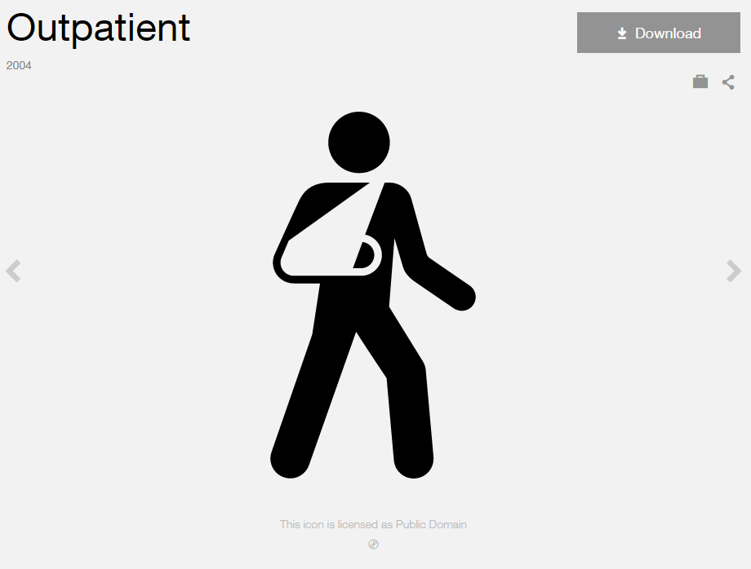

**Modified by:** Esri Solutions Team

**License:** Public Domain

**Acknowledgement:** None Required

**Notes:** None

**Park**

**Symbol Name:** National Park

**Symbol Picture:** C:\Users\heat5533\Documents\GitHub\solutions-symbology-data\symbology\web\png\Parks.png

**Symbol Source:** Environmental style file

**Symbol Date:** January 2015

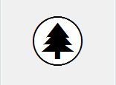

**Modified** **by:** Esri Solutions Team

**License:** None

**Acknowledgement:** None required

**Notes:** None

**Park Mowing Program – In Progress**

**Symbol Name:** National Park

**Symbol Picture:** C:\Data\Symbology\LocalGov\ParkMowing\Mobile\Inprogress.png

**Symbol Source:** Environmental style file

**Symbol Date:** May 2014



**Modified** **by:** Esri Solutions Team

**License:** None

**Acknowledgement:** None required

**Notes:** None

**Park Mowing Program – Inspected**

**Symbol Name:** National Park

**Symbol Picture:** C:\Data\Symbology\LocalGov\ParkMowing\Mobile\Inspected.png

**Symbol Source:** Environmental style file

**Symbol Date:** May 2014



**Modified** **by:** Esri Solutions Team

**License:** None

**Acknowledgement:** None required

**Notes:** None

**Park Mowing Program – Not Inspected**

**Symbol Name:** National Park

**Symbol Picture:** C:\Users\heat5533\Documents\GitHub\solutions-symbology-data\symbology\mobile\png\Park-Mowing-Program-Not-Inspected.png

**Symbol Source:** Environmental style file

**Symbol Date:** May 2014



**Modified** **by:** Esri Solutions Team

**License:** None

**Acknowledgement:** None required

**Notes:** None

**Parking**

**Symbol Name:** P

**Symbol Picture:** C:\Data\Symbology\LocalGov\PublicParking\web\Parking.png

**Symbol Source:** Arial Rounded MT Bold

**Symbol Date:** July 2015

**Modified by:** Esri Solutions Team

**License:** None

**Acknowledgement:** None required

**Notes:** None

**Pavement Marking - Blue**

**Symbol Name:**

**Symbol Picture:** C:\Users\heat5533\Documents\GitHub\solutions-symbology-data\symbology\web\png\Pavement-Marking-Blue.png

**Symbol Source:**

**Symbol Date:** September 2014

**Created by:** Esri Solutions Team

**License:** None

**Acknowledgement:** None required

**Notes:** None

**Pavement Marking - Green**

**Symbol Name:**

**Symbol Picture:** C:\Users\heat5533\Documents\GitHub\solutions-symbology-data\symbology\web\png\Pavement-Marking-Green.png

**Symbol Source:**

**Symbol Date:** September 2014

**Created by:** Esri Solutions Team

**License:** None

**Acknowledgement:** None required

**Notes:** None

**Pavement Marking - Other**

**Symbol Name:**

**Symbol Picture:** C:\Users\heat5533\Documents\GitHub\solutions-symbology-data\symbology\web\png\Pavement-Marking-Other.png

**Symbol Source:**

**Symbol Date:** September 2014

**Created by:** Esri Solutions Team

**License:** None

**Acknowledgement:** None required

**Notes:** None

**Pavement Marking - Red**

**Symbol Name:**

**Symbol Picture:** C:\Users\heat5533\Documents\GitHub\solutions-symbology-data\symbology\web\png\Pavement-Marking-Red.png

**Symbol Source:**

**Symbol Date:** September 2014

**Created by:** Esri Solutions Team

**License:** None

**Acknowledgement:** None required

**Notes:** None

**Pavement Marking - White**

**Symbol Name:**

**Symbol Picture:** C:\Users\heat5533\Documents\GitHub\solutions-symbology-data\symbology\web\png\Pavement-Marking-White.png

**Symbol Source:**

**Symbol Date:** September 2014

**Created by:** Esri Solutions Team

**License:** None

**Acknowledgement:** None required

**Notes:** None

**Pavement Marking - Yellow**

**Symbol Name:**

**Symbol Picture:** C:\Users\heat5533\Documents\GitHub\solutions-symbology-data\symbology\web\png\Pavement-Marking-Yellow.png

**Symbol Source:**

**Symbol Date:** September 2014

**Created by:** Esri Solutions Team

**License:** None

**Acknowledgement:** None required

**Notes:** None

**Pay Stations**

**Symbol Name:** [Parking Meter](https://thenounproject.com/search/?q=parking%20pay%20stations&i=755) & P

**Symbol Picture:** C:\Data\Symbology\LocalGov\PublicParking\web\Pay-Stations.png

**Symbol Source:** The Noun Project & Arial Rounded MT Bold

**Symbol Date:** July 2015

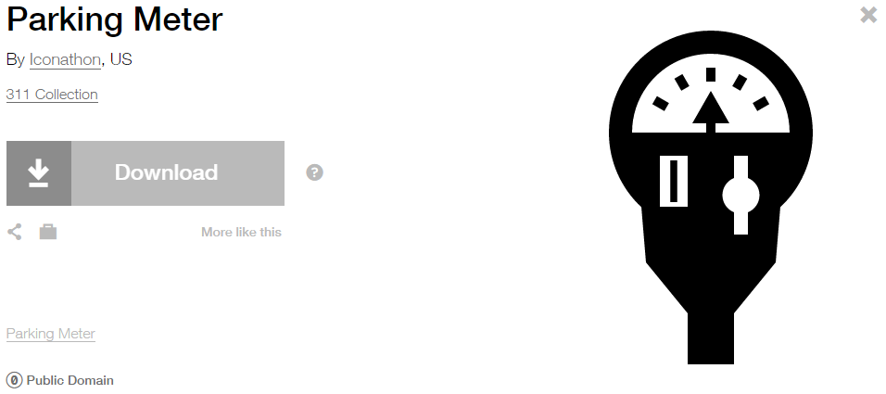

**Modified by:** Esri Solutions Team

**License:** Public Domain

**Acknowledgement:** None required

**Notes:** None

**Personal Property**

**Symbol Name:** [Community](http://thenounproject.com/term/community/288/)

**Symbol Picture:** C:\Data\Symbology\Solutions\Debris\web\Personal-Property.png

**Symbol Source:** The Noun Project



**Symbol Date:** February 2015

**Modified** **by:** Esri Solutions Team

**License:** Public Domain

**Acknowledgement:** None required

**Notes:** None

**Pesticide Discharge Permit**

**Symbol Name:** Water Recreation

**Symbol Picture:** C:\Users\heat5533\Documents\GitHub\solutions-symbology-data\symbology\web\png\Pesticides-Discharge.png

**Symbol Source:** Forestry style file

**Symbol Date:** September 2014



**Modified by:** Esri Solutions Team

**License:** None

**Acknowledgement:** None required

**Notes:** None

**Pet Collection Area**

**Symbol Name:** Unicode 117

**Symbol Picture:** C:\Data\UC\UC2015\SituationalAwareness\web\Pet-Collection.png

**Symbol Source:** ESRI Public 1 font

**Symbol Date:** July 2015



**Modified by:** Esri Solutions Team

**License:** None

**Acknowledgement:** None required

**Notes:** None

**Planning Limits Permit**

**Symbol Name:** City

**Symbol Picture:** C:\Users\heat5533\Documents\GitHub\solutions-symbology-data\symbology\web\png\Planning-Limits.png

**Symbol Source:** Business style file

**Symbol Date:** September 2014

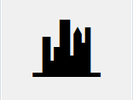

**Modified by:** Esri Solutions Team

**License:** None

**Acknowledgement:** None required

**Notes:** None

**Point Repair**

**Symbol Name:**

**Symbol Picture:** C:\Data\Symbology\Utilities\Water\CCTVProcessor\web\Point-Repair.png

**Symbol Source:**

**Symbol Date:** May 2015

**Created by:** Esri Solutions Team

**License:** None

**Acknowledgement:** None required

**Notes:** None

**Pole**

**Symbol Name:** P

**Symbol Picture:** C:\Data\Symbology\LocalGov\SignInventory\mobile\Poles.png

**Symbol Source:** Arial Rounded MT Bold

**Symbol Date:** July 2015

**Created by:** Esri Solutions Team

**License:** None

**Acknowledgement:** None required

**Notes:** None

**Police Stations**

**Symbol Name:** Police Badge

**Symbol Picture:** C:\Users\heat5533\Documents\GitHub\solutions-symbology-data\symbology\web\png\Police-Stations.png

**Symbol Source:** Crime Analysis style file

**Symbol Date:** February 2015



**Modified** **by:** Esri Solutions Team

**License:** None

**Acknowledgement:** None required

**Notes:** None

**Polling Places**

**Symbol Name:** [Polling-Place](http://thenounproject.com/term/polling-place/14292/) & Check 1

**Symbol Picture:** C:\Users\heat5533\Documents\GitHub\solutions-symbology-data\symbology\web\png\Polling-Place.png

**Symbol Source:** The Noun Project & ESRI style file

**Symbol Date:** March 2015

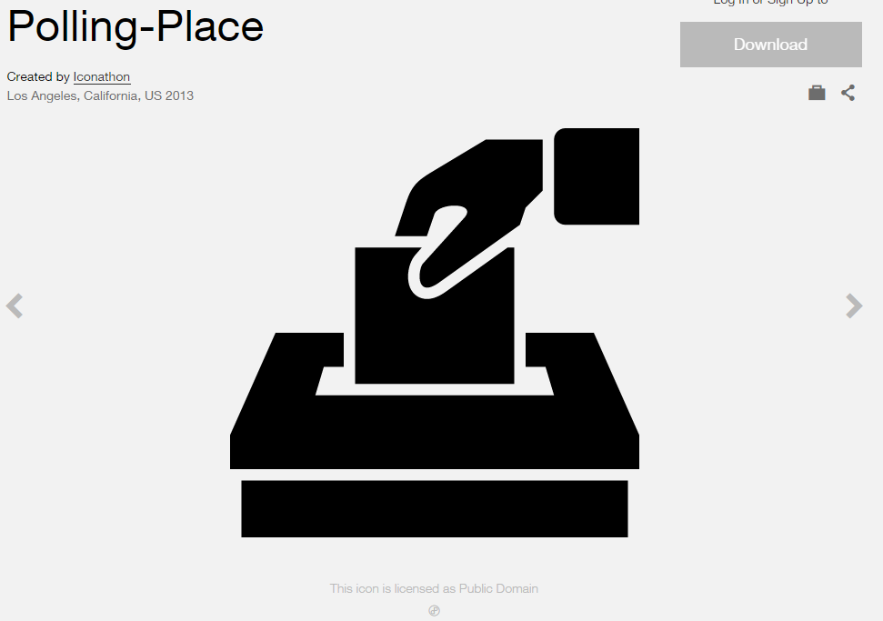 

**Modified by:** Esri Solutions Team

**License:** Public Domain

**Acknowledgement:** None required

**Notes:** None

**Porous Pavement**

**Symbol Name:** PP

**Symbol Picture:** C:\Data\Symbology\Utilities\Water\GreenInfrastructure\mobile\Porous-Pavement.pngC:\Data\Symbology\Utilities\Water\GreenInfrastructure\web\Porous-Pavement.png

**Symbol Source:** Arial Rounded MT Bold Font

**Symbol Date:** March 2015

**Modified** **by:** Esri Solutions Team

**License:** None

**Acknowledgement:** None required

**Notes:** None

**Post Offices**

**Symbol Name:** Post Office

**Symbol Picture:** C:\Users\heat5533\Documents\GitHub\solutions-symbology-data\symbology\web\png\Post-Office.png

**Symbol Source:** Forestry style file

**Symbol Date:** January 2015



**Modified** **by:** Esri Solutions Team

**License:** None

**Acknowledgement:** None required

**Notes:** None

**Potential Customer**

**Symbol Name:**

**Symbol Picture:** C:\Data\Symbology\Utilities\Gas\PotentialNewCustomers\web\Potential-Customers.png

**Symbol Source:**

**Symbol Date:** May 2015

**Created by:** Esri Solutions Team

**License:** None

**Acknowledgement:** None required

**Notes:** None

**Pressure Reducing Valve**

**Symbol Name:** PRV

**Symbol Picture:** C:\Data\Symbology\Utilities\Water\GreenInfrastructure\mobile\Pressure-Reducing-Valve.pngC:\Data\Symbology\Utilities\Water\GreenInfrastructure\web\Pressure-Reducing-Valve.png

**Symbol Source:** Arial Rounded MT Bold Font

**Symbol Date:** March 2015

**Modified** **by:** Esri Solutions Team

**License:** None

**Acknowledgement:** None required

**Notes:** None

**Project Operations Violation**

**Symbol Name:** PO

**Symbol Picture:** C:\Data\Symbology\Utilities\Water\ConstructionSiteViolations\mobile\Project-Operations-Violation.png

**Symbol Source:** Arial Rounded MT Bold Font

**Symbol Date:** March 2015

**Modified** **by:** Esri Solutions Team

**License:** None

**Acknowledgement:** None required

**Notes:** None

**Public Health Incident**

**Symbol Name:** Men

**Symbol Picture:** C:\Data\Symbology\Solutions\OpsIncident\web\Public-Health-Incident.png

**Symbol Source:** Public Signs style file

**Symbol Date:** February 2015



**Modified** **by:**

**License:** None

**Acknowledgement:** None required

**Notes:**

**Rail Incident**

**Symbol Name:** Rail Transportation

**Symbol Picture:** C:\Data\Symbology\Solutions\OpsIncident\web\Rail-Incident.png

**Symbol Source:** Public Signs style file

**Symbol Date:** February 2015

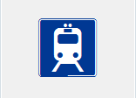

**Modified** **by:** Esri Solutions Team

**License:** None

**Acknowledgement:** None required

**Notes:** None

**Railroad Crossing**

**Symbol Name:** Railroad Crossing 2

**Symbol Picture:** **C:\Users\heat5533\Documents\GitHub\solutions-symbology-data\symbology\mobile\png\Railroad-Crossing.png**

**Symbol Source:** Transportation style file

**Symbol Date:** July 2015



**Modified by:** Esri Solutions Team

**License:** None

**Acknowledgement:** None required

**Notes:** None

**Railroad Stations**

**Symbol Name:** Rail Transportation

**Symbol Picture:** C:\Users\heat5533\Documents\GitHub\solutions-symbology-data\symbology\web\png\Railroad-Station.png

**Symbol Source:** ESRI Public Signs style file

**Symbol Date:** January 2015

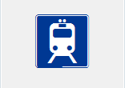

**Modified** **by:** Esri Solutions Team

**License:** None

**Acknowledgement:** None required

**Notes:** None

**Rain Barrel**

**Symbol Name:** RB

**Symbol Picture:** C:\Data\Symbology\Utilities\Water\GreenInfrastructure\mobile\Rain-Barrel.pngC:\Data\Symbology\Utilities\Water\GreenInfrastructure\web\Rain-Barrel.png

**Symbol Source:** Arial Rounded MT Bold Font

**Symbol Date:** March 2015

**Modified** **by:** Esri Solutions Team

**License:** None

**Acknowledgement:** None required

**Notes:** None

**Rain Water Catchment**

**Symbol Name:** RWC

**Symbol Picture:** C:\Data\Symbology\Utilities\Water\GreenInfrastructure\mobile\Rain-Water-Catchment.pngC:\Data\Symbology\Utilities\Water\GreenInfrastructure\web\Rain-Water-Catchment.png

**Symbol Source:** Arial Rounded MT Bold Font

**Symbol Date:** March 2015

**Modified** **by:** Esri Solutions Team

**License:** None

**Acknowledgement:** None required

**Notes:** None

**Ready Mix Concrete Facilities Permit**

**Symbol Name:**

**Symbol Picture:** C:\Users\heat5533\Documents\GitHub\solutions-symbology-data\symbology\web\png\Ready-Mix-Concrete-Facilities.png

**Symbol Source:**

**Symbol Date:** October 2014

**Created by:** Esri Solutions Team

**License:** None

**Acknowledgement:** None required

**Notes:** None

**Recycling Facility**

**Symbol Name:** Unicode 93

**Symbol Picture:** C:\Users\heat5533\Documents\GitHub\solutions-symbology-data\symbology\web\png\Recycling-Facility.png

**Symbol Source:** ESRI ArcPad font

**Symbol Date:** February 2015



**Modified** **by:** Esri Solutions Team

**License:** None

**Acknowledgement:** None required

**Notes:** None

**Reptiles**

**Symbol Name:** [Turtle](https://thenounproject.com/term/turtle/78103/)

**Symbol Picture:** C:\Data\Symbology\StateGov\CitizenScience\web\Reptiles.png

**Symbol Source:** The Noun Project

**Symbol Date:** March 2015

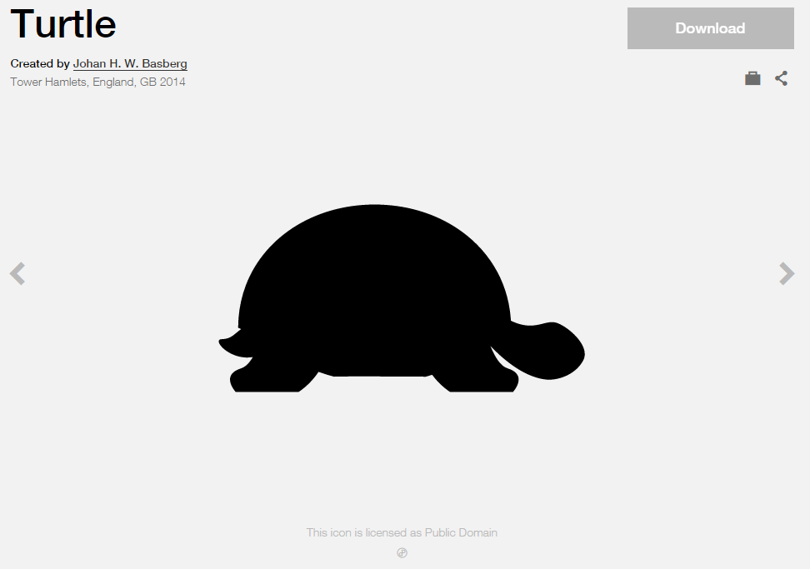

**Modified by:** Esri Solutions Team

**License:** Public Domain

**Acknowledgement:** None required

**Notes:** None

**Research Parks**

**Symbol Name:** [Microscope](http://thenounproject.com/term/microscope/648/)

**Symbol Picture:** C:\Users\heat5533\Documents\GitHub\solutions-symbology-data\symbology\web\png\Research-Parks.png

**Symbol Source:** The Noun Project

**Symbol Date:** March 2015

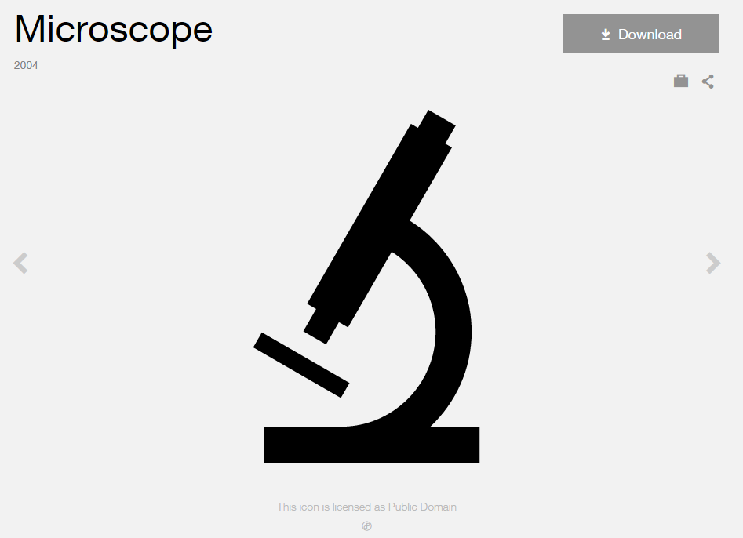

**Modified by:** Esri Solutions Team

**License:** Public Domain

**Acknowledgement:** None required

**Notes:** None

**Responding Company - Command**

**Symbol Name:**

**Symbol Picture:** C:\Users\heat5533\Documents\GitHub\solutions-symbology-data\symbology\web\png\Responding-Company-Command.png

**Symbol Source:**

**Symbol Date:** December 2015

**Created by:** Esri Solutions Team

**License:** None

**Acknowledgement:** None required

**Notes:** None

**Responding Company - Engine**

**Symbol Name:**

**Symbol Picture:** C:\Users\heat5533\Documents\GitHub\solutions-symbology-data\symbology\web\png\Responding-Company-Engine.png

**Symbol Source:**

**Symbol Date:** December 2015

**Created by:** Esri Solutions Team

**License:** None

**Acknowledgement:** None required

**Notes:** None

**Responding Company - Medical**

**Symbol Name:**

**Symbol Picture:** C:\Users\heat5533\Documents\GitHub\solutions-symbology-data\symbology\web\png\Responding-Company-Medical.png

**Symbol Source:**

**Symbol Date:** December 2015

**Created by:** Esri Solutions Team

**License:** None

**Acknowledgement:** None required

**Notes:** None

**Responding Company - Squad**

**Symbol Name:**

**Symbol Picture:** C:\Users\heat5533\Documents\GitHub\solutions-symbology-data\symbology\web\png\Responding-Company-Engine.png

**Symbol Source:**

**Symbol Date:** December 2015

**Created by:** Esri Solutions Team

**License:** None

**Acknowledgement:** None required

**Notes:** None

**Responding Company - Truck**

**Symbol Name:**

**Symbol Picture:** C:\Users\heat5533\Documents\GitHub\solutions-symbology-data\symbology\web\png\Responding-Company-Engine.png

**Symbol Source:**

**Symbol Date:** December 2015

**Created by:** Esri Solutions Team

**License:** None

**Acknowledgement:** None required

**Notes:** None

**Responding Company - Utility**

**Symbol Name:**

**Symbol Picture:** C:\Users\heat5533\Documents\GitHub\solutions-symbology-data\symbology\web\png\Responding-Company-Utility.png

**Symbol Source:**

**Symbol Date:** December 2015

**Created by:** Esri Solutions Team

**License:** None

**Acknowledgement:** None required

**Notes:** None

**Retail Centers**

**Symbol Name:** Vagrancy, Shopping Cart

**Symbol Picture:** C:\Data\Symbology\Solutions\Live-Work-Locate\web\Shopping-Retail.png

**Symbol Source:** Crime Analysis style file

**Symbol Date:** January 2015



**Modified** **by:** Esri Solutions Team

**License:** None

**Acknowledgement:** None required

**Notes:** None

**Road Blocks**

**Symbol Name:**

**Symbol Picture:** C:\Data\UC\UC2015\SituationalAwareness\web\Road-Blocks.png

**Symbol Source:**

**Symbol Date:** July 2015

**Created by:** Esri Solutions Team

**License:** None

**Acknowledgement:** None required

**Notes:** None

**Road Not Passable**

**Symbol Name:**

**Symbol Picture:C:\Data\Symbology\Utilities\Electric\HazardReportingCollector\mobile\Road-Not-Passable.pngC:\Data\Symbology\Utilities\Electric\HazardReportingCollector\web\Road-Not-Passable.png**

**Symbol Source:**

**Symbol Date:** June 2015

**Created by:** Esri Solutions Team

**License:** None

**Acknowledgement:** None required

**Notes:** None

**Roots**

**Symbol Name:**

**Symbol Picture:** C:\Data\Symbology\Utilities\Water\CCTVProcessor\web\Roots.png

**Symbol Source:**

**Symbol Date:** May 2015

**Created by:** Esri Solutions Team

**License:** None

**Acknowledgement:** None required

**Notes:** None

**Schools**

**Symbol Name:** School 1

**Symbol Picture:** C:\Users\heat5533\Documents\GitHub\solutions-symbology-data\symbology\web\png\School.png

**Symbol Source:** Civic style file

**Symbol Date:** January 2015

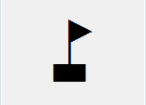

**Modified** **by:** Esri Solutions Team

**License:** None

**Acknowledgement:** None required

**Notes:** None

**Sea Ports**

**Symbol Name:** Marina

**Symbol Picture: C:\Users\heat5533\Documents\GitHub\solutions-symbology-data\symbology\web\png\Sea-Port.png**

**Symbol Source:** Forestry style file

**Symbol Date:** March 2015



**Modified by:** Esri Solutions Team

**License:** None

**Acknowledgement:** None Required

**Notes:** None

**Search and Rescue**

**Symbol Name:** Walk 1

**Symbol Picture:** C:\Data\UC\UC2015\SituationalAwareness\web\Search-and-Rescue.png

**Symbol Source:** Transportation style file

**Symbol Date:** July 2015



**Modified** **by:** Esri Solutions Team

**License:** None

**Acknowledgement:** None required

**Notes:** None

**Sediment**

**Symbol Name:**

**Symbol Picture:** C:\Data\Symbology\Solutions\Debris\web\Sediment.png

**Symbol Source:** ESRI Enviro Hazard Sites Unicode 50

**Symbol Date:** September 2014



**Modified by:** Esri Solutions Team

**License:** None

**Acknowledgement:** None required

**Notes:** None

**Sediment Barriers Violation**

**Symbol Name:** SB

**Symbol Picture:** C:\Data\Symbology\Utilities\Water\ConstructionSiteViolations\mobile\Sediment-Barriers-Violation.png

**Symbol Source:** Arial Rounded MT Bold Font

**Symbol Date:** March 2015

**Modified** **by:** Esri Solutions Team

**License:** None

**Acknowledgement:** None required

**Notes:** None

**Sediment Traps and Basins Violation**

**Symbol Name:** STB

**Symbol Picture:** C:\Data\Symbology\Utilities\Water\ConstructionSiteViolations\mobile\Sediment-Traps-and-Basins-Violation.png

**Symbol Source:** Arial Rounded MT Bold Font

**Symbol Date:** March 2015

**Modified** **by:** Esri Solutions Team

**License:** None

**Acknowledgement:** None required

**Notes:** None

**Service Call Incident**

**Symbol Name:** Phone 1

**Symbol Picture:** C:\Users\heat5533\Documents\GitHub\solutions-symbology-data\symbology\web\png\Service-Call-Incident.png

**Symbol Source:**  Civic style file

**Symbol Date:** November 2015



**Modified by:** Esri Solutions Team

**License:** None

**Acknowledgement:** None required

**Notes:** None

**Service Request**

**Symbol Name:** [Tools](https://thenounproject.com/term/tools/28771/)

**Symbol Picture:** C:\Users\heat5533\Documents\GitHub\solutions-symbology-data\symbology\web\png\Service-Request.png

**Symbol Source:** The Noun Project

**Symbol Date:** May 2015

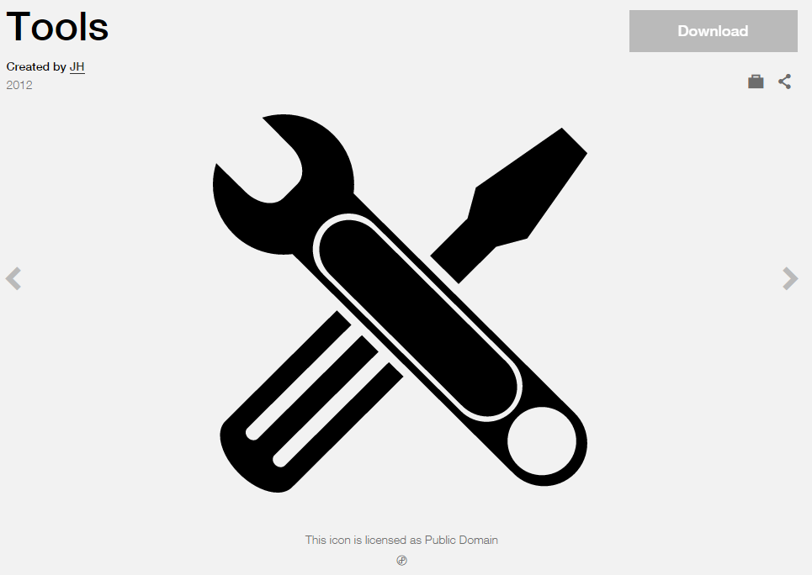

**Modified by:** Esri Solutions Team

**License:** Public Domain

**Acknowledgement:** None required

**Notes:** None

**Sewer Map Change Request**

**Symbol Name:** [Map](https://thenounproject.com/term/map/2312/)

**Symbol Picture:** C:\Users\heat5533\Documents\GitHub\solutions-symbology-data\symbology\mobile\png\Asset-Misplaced.pngC:\Users\heat5533\Documents\GitHub\solutions-symbology-data\symbology\web\png\Asset-Misplaced.png

**Symbol Source:** The Noun Project

**Symbol Date:** May 2015



**Modified by:** Esri Solutions Team

**License:** Public Domain

**Acknowledgement:** None required

**Notes:** None

**Sewer Map Change Request Critical**

**Symbol Name:** S

**Symbol Picture:** C:\Users\heat5533\Documents\GitHub\solutions-symbology-data\symbology\mobile\png\Sewer-Map-Change-Request-Critical.pngC:\Users\heat5533\Documents\GitHub\solutions-symbology-data\symbology\web\png\Sewer-Map-Change-Request-Critical.png

**Symbol Source:** Arial Rounded MT Bold Font

**Symbol Date:** March 2015

**Modified** **by:** Esri Solutions Team

**License:** None

**Acknowledgement:** None required

**Notes:** None

**Sewer Map Change Request Not Critical**

**Symbol Name:** S

**Symbol Picture:** C:\Users\heat5533\Documents\GitHub\solutions-symbology-data\symbology\mobile\png\Sewer-Map-Change-Request-Not-Critical.pngC:\Users\heat5533\Documents\GitHub\solutions-symbology-data\symbology\web\png\Sewer-Map-Change-Request-Not-Critical.png

**Symbol Source:** Arial Rounded MT Bold Font

**Symbol Date:** March 2015

**Modified** **by:** Esri Solutions Team

**License:** None

**Acknowledgement:** None required

**Notes:** None

**Shelter - Alert**

**Symbol Name:** Sleeping Shelter

**Symbol Picture:** C:\Data\Symbology\Solutions\ShelterLocator\Shelter-Alert.png

**Symbol Source:** Forestry style file

**Symbol Date:** December 2015



**Created by:** Esri Solutions Team

**License:** None

**Acknowledgement:** None required

**Notes:** None

**Shelter - Closed**

**Symbol Name:** Sleeping Shelter

**Symbol Picture:** C:\Data\Symbology\Solutions\ShelterLocator\Shelter-Closed.png

**Symbol Source:** Forestry style file

**Symbol Date:** December 2015



**Created by:** Esri Solutions Team

**License:** None

**Acknowledgement:** None required

**Notes:** None

**Shelter - Open**

**Symbol Name:** Sleeping Shelter

**Symbol Picture:** C:\Data\Symbology\Solutions\ShelterLocator\Shelter-Open.pngC:\Data\Symbology\Solutions\ShelterLocator\Shelter-Open(2).pngw

**Symbol Source:** Forestry style file

**Symbol Date:** December 2015



**Created by:** Esri Solutions Team

**License:** None

**Acknowledgement:** None required

**Notes:** None

**Shelter - Standby**

**Symbol Name:** Sleeping Shelter

**Symbol Picture:** C:\Data\Symbology\Solutions\ShelterLocator\Shelter-Standby.png

**Symbol Source:** Forestry style file

**Symbol Date:** December 2015



**Created by:** Esri Solutions Team

**License:** None

**Acknowledgement:** None required

**Notes:** None

**Shelter - Unknown**

**Symbol Name:** Sleeping Shelter

**Symbol Picture:** C:\Data\Symbology\Solutions\ShelterLocator\Shelter-Unknown.png

**Symbol Source:** Forestry style file

**Symbol Date:** December 2015



**Created by:** Esri Solutions Team

**License:** None

**Acknowledgement:** None required

**Notes:** None

**Signal**

**Symbol Name:**

**Symbol Picture:** C:\Users\heat5533\Documents\GitHub\solutions-symbology-data\symbology\mobile\png\Signal.png

**Symbol Source:** None

**Symbol Date:** July 2015

**Created by:** Esri Solutions Team

**License:** None

**Acknowledgement:** None required

**Notes:** None

**Signal Cabinet**

**Symbol Name:**

**Symbol Picture:** **C:\Users\heat5533\Documents\GitHub\solutions-symbology-data\symbology\mobile\png\Signal-Cabinet.png**

**Symbol Source:**

**Symbol Date:** July 2015

**Created by:** Esri Solutions Team

**License:** None

**Acknowledgement:** None required

**Notes:** None

**Slope Protection Violation**

**Symbol Name:** SP

**Symbol Picture:** C:\Data\Symbology\Utilities\Water\ConstructionSiteViolations\mobile\Slope-Protection-Violation.png

**Symbol Source:** Arial Rounded MT Bold Font

**Symbol Date:** March 2015

**Modified** **by:** Esri Solutions Team

**License:** None

**Acknowledgement:** None required

**Notes:** None

**Special Incident**

**Symbol Name:** !

**Symbol Picture:** C:\Users\heat5533\Documents\GitHub\solutions-symbology-data\symbology\web\png\Special-Incident.png

**Symbol Source:**

**Symbol Date:** December 2015

**Modified by:** Esri Solutions Team

**License:** None

**Acknowledgement:** None required

**Notes:** None

**Staging Area**

**Symbol Name:** S

**Symbol Picture:** C:\Data\UC\UC2015\SituationalAwareness\web\Staging-Area.png

**Symbol Source:** Arial font

**Symbol Date:** July 2015

**Modified by:** Esri Solutions Team

**License:** None

**Acknowledgement:** None required

**Notes:** None

**State Operating Permit**

**Symbol Name:**

**Symbol Picture:** C:\Users\heat5533\Documents\GitHub\solutions-symbology-data\symbology\web\png\State-Operating-Permit.png

**Symbol Source:**

**Symbol Date:** October 2014

**Modified by:** Esri Solutions Team

**License:** None

**Acknowledgement:** None required

**Notes:** None

**Stormwater Map Change Request**

**Symbol Name:** [Map](https://thenounproject.com/term/map/2312/)

**Symbol Picture:** C:\Users\heat5533\Documents\GitHub\solutions-symbology-data\symbology\mobile\png\Stormwater-Map-Change-Request.pngC:\Users\heat5533\Documents\GitHub\solutions-symbology-data\symbology\web\png\Stormwater-Map-Change-Request.png

**Symbol Source:** The Noun Project

**Symbol Date:** May 2015



**Modified by:** Esri Solutions Team

**License:** Public Domain

**Acknowledgement:** None required

**Notes:** None

**Stormwater Map Change Request Critical**

**Symbol Name:** SW

**Symbol Picture:** C:\Users\heat5533\Documents\GitHub\solutions-symbology-data\symbology\mobile\png\Stormwater-Map-Change-Request-Critical.pngC:\Users\heat5533\Documents\GitHub\solutions-symbology-data\symbology\web\png\Stormwater-Map-Change-Request-Critical.png

**Symbol Source:** Arial Rounded MT Bold Font

**Symbol Date:** March 2015

**Modified** **by:** Esri Solutions Team

**License:** None

**Acknowledgement:** None required

**Notes:** None

**Stormwater Map Change Request Not Critical**

**Symbol Name:** SW

**Symbol Picture:** C:\Users\heat5533\Documents\GitHub\solutions-symbology-data\symbology\mobile\png\Stormwater-Map-Change-Request-Not-Critical.pngC:\Users\heat5533\Documents\GitHub\solutions-symbology-data\symbology\web\png\Stormwater-Map-Change-Request-Not-Critical.png

**Symbol Source:** Arial Rounded MT Bold Font

**Symbol Date:** March 2015

**Modified** **by:** Esri Solutions Team

**License:** None

**Acknowledgement:** None required

**Notes:** None

**Stormwater Multisector Permit**

**Symbol Name:** Overboard Discharge (right)

**Symbol Picture:** C:\Users\heat5533\Documents\GitHub\solutions-symbology-data\symbology\web\png\Stormwater-Multisector-Permit.png

**Symbol Source:** Environmental style file

**Symbol Date:** September 2014



**Modified by:** Esri Solutions Team

**License:** None

**Acknowledgement:** None required

**Notes:** None

**Street Furniture**

**Symbol Name:** [Park](https://thenounproject.com/search/?q=park&i=12246)

**Symbol Picture:** C:\Data\Symbology\LocalGov\StreetFurnitureInventory\mobile\Street-Furniture.png

**Symbol Source:** The Noun Project

**Symbol Date:** June 2015

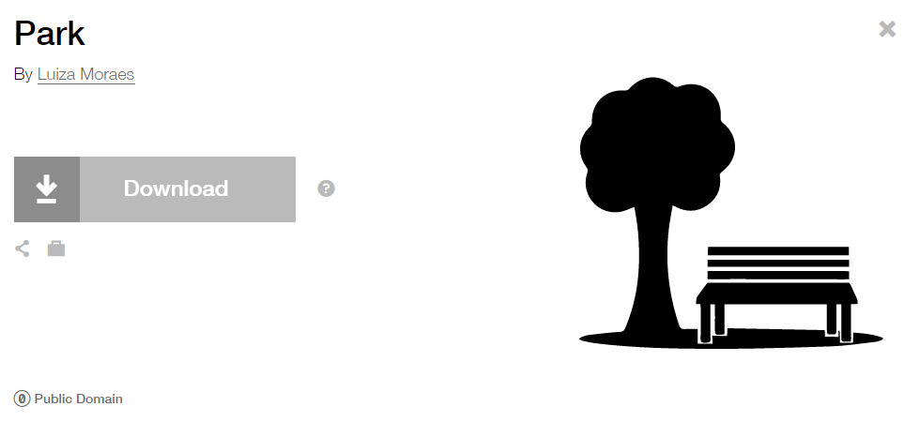

**Modified by:** Esri Solutions Team

**License:** None

**Acknowledgement:** None required

**Notes:** None

**Streetlight**

**Symbol Name:** [Light Bulb](https://thenounproject.com/search?q=light-bulb&i=8699)

**Symbol Picture:** C:\Data\Symbology\Utilities\Electric\DamageAssessment\mobile\Damage-Assessment-Electric-High-Damage.png

**Symbol Source:** The Noun Project

**Symbol Date:** April 2015



**Modified by:** Esri Solutions Team

**License:** Public Domain

**Acknowledgement:** None required

**Notes:** None

**Street Sign**

**Symbol Name:**

**Symbol Picture:** C:\Data\Symbology\LocalGov\SignInventory\mobile\Street-Sign.png

**Symbol Source:** None

**Symbol Date:** July 2015

**Created by:** Esri Solutions Team

**License:** None

**Acknowledgement:** None required

**Notes:** None

**Surface**

**Symbol Name:**

**Symbol Picture:** C:\Data\Symbology\Utilities\Water\CCTVProcessor\web\Surface.png

**Symbol Source:**

**Symbol Date:** May 2015

**Created by:** Esri Solutions Team

**License:** None

**Acknowledgement:** None required

**Notes:** None

**Substance Abuse**

**Symbol Name:** [Substance-Abuse-Service](http://thenounproject.com/term/substance-abuse-service/41339/)

**Symbol Picture: C:\Data\Symbology\StateGov\MyHealthServices\web\Sustance-Abuse.png**

**Symbol Source:** The Noun Project

**Symbol Date:** March 2015

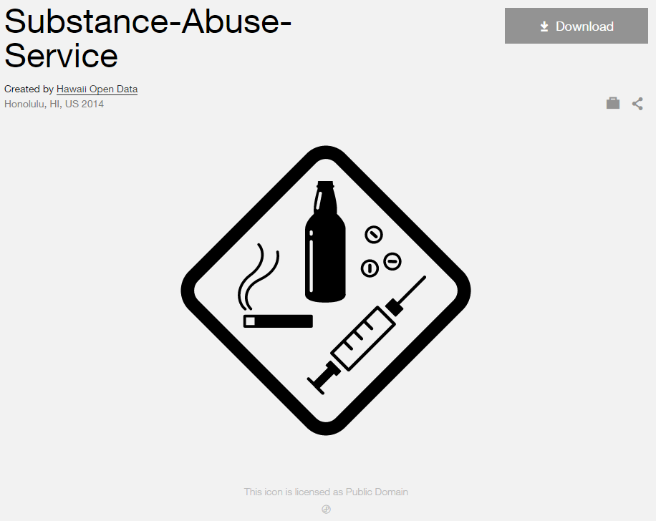

**Modified by:** Esri Solutions Team

**License:** Public Domain

**Acknowledgement:** None Required

**Notes:** None

**Tap**

**Symbol Name:**

**Symbol Picture:** C:\Data\Symbology\Utilities\Water\CCTVProcessor\web\Tap.png

**Symbol Source:**

**Symbol Date:** May 2015

**Created by:** Esri Solutions Team

**License:** None

**Acknowledgement:** None required

**Notes:** None

**Trees**

**Symbol Name:** Tree, Deciduous, Top

**Symbol Picture:** **C:\Data\Symbology\LocalGov\StreetTreeInventory\mobile\Street-Trees.png**

**Symbol Source:** Environmental style file

**Symbol Date:** July 2015



**Modified** **by:** EsriSolutions Team

**License:** None

**Acknowledgement:** None required

**Notes:** None

**Unauthorized Attachment - Cable**

**Symbol Name:** C

**Symbol Picture:** C:\Data\Symbology\Utilities\Electric\JointUseSurvey\web\Unauthorized-Attachment-Cable.png

**Symbol Source:** Arial Rounded MT Bold

**Symbol Date:** April 2015

**Created by:** Esri Solutions Team

**License:** None

**Acknowledgement:** None required

**Notes:** None

**Unauthorized Attachment - Fiber**

**Symbol Name:** Fb

**Symbol Picture:** C:\Data\Symbology\Utilities\Electric\JointUseSurvey\web\Unauthorized-Attachment-Fiber.png

**Symbol Source:** Arial Rounded MT Bold

**Symbol Date:** April 2015

**Created by:** Esri Solutions Team

**License:** None

**Acknowledgement:** None required

**Notes:** None

**Unauthorized Attachment - Fire**

**Symbol Name:** Fr

**Symbol Picture:** C:\Data\Symbology\Utilities\Electric\JointUseSurvey\web\Unauthorized-Attachment-Fire.png

**Symbol Source:** Arial Rounded MT Bold

**Symbol Date:** April 2015

**Created by:** Esri Solutions Team

**License:** None

**Acknowledgement:** None required

**Notes:** None

**Unauthorized Attachment - Other**

**Symbol Name:** O

**Symbol Picture:** C:\Data\Symbology\Utilities\Electric\JointUseSurvey\web\Unauthorized-Attachment-Other.png

**Symbol Source:** Arial Rounded MT Bold

**Symbol Date:** April 2015

**Created by:** Esri Solutions Team

**License:** None

**Acknowledgement:** None required

**Notes:** None

**Unauthorized Attachment - Sign**

**Symbol Name:** S

**Symbol Picture:** C:\Data\Symbology\Utilities\Electric\JointUseSurvey\web\Unauthorized-Attachment-Sign.png

**Symbol Source:** Arial Rounded MT Bold

**Symbol Date:** April 2015

**Created by:** Esri Solutions Team

**License:** None

**Acknowledgement:** None required

**Notes:** None

**Unauthorized Attachment - Telecommunications**

**Symbol Name:** T

**Symbol Picture:** C:\Data\Symbology\Utilities\Electric\JointUseSurvey\web\Unauthorized-Attachment-Telecommunication.png

**Symbol Source:** Arial Rounded MT Bold

**Symbol Date:** April 2015

**Created by:** Esri Solutions Team

**License:** None

**Acknowledgement:** None required

**Notes:** None

**Underground Storage Tank Permit**

**Symbol Name:** Underground Storage Tank

**Symbol Picture:** C:\Users\heat5533\Documents\GitHub\solutions-symbology-data\symbology\web\png\Underground-Storage-Tank.png

**Symbol Source:** Environmental style file

**Symbol Date:** September 2014

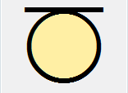

**Modified by:** Esri Solutions Team

**License:** None

**Acknowledgement:** None required

**Notes:** None

**Under Investigation**

**Symbol Name:** [Magnifying Glass](https://thenounproject.com/search/?q=cog&i=907)

**Symbol Picture:** C:\Users\heat5533\Documents\GitHub\solutions-symbology-data\symbology\web\png\Under-Investigation.png

**Symbol Source:**  The Noun Project

**Symbol Date:** December 2015

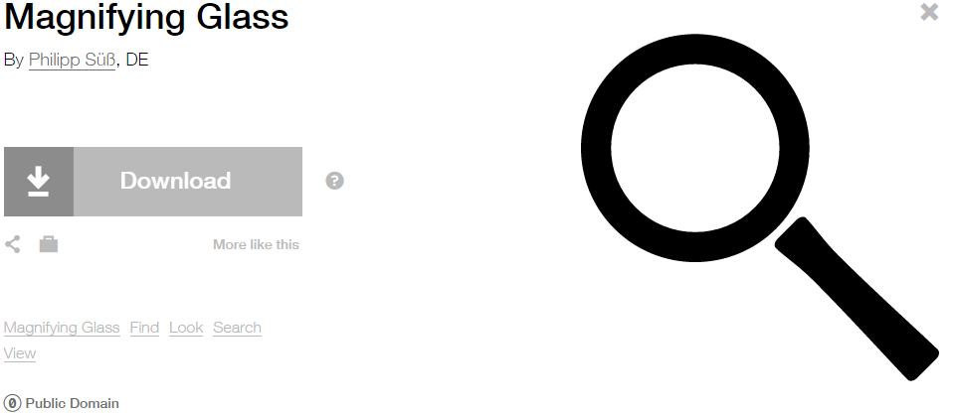

**Modified by:** Esri Solutions Team

**License:** Public Domain

**Acknowledgement:** None required

**Notes:** None

**Undetermined after Investigation**

**Symbol Name:** ?

**Symbol Picture:** C:\Users\heat5533\Documents\GitHub\solutions-symbology-data\symbology\web\png\Undetermined-after-Investigation.png

**Symbol Source:**  Arial Rounded MT Bold

**Symbol Date:** December 2015

**Modified by:** Esri Solutions Team

**License:** None

**Acknowledgement:** None required

**Notes:** None

**Unintentional**

**Symbol Name:** Fire Incident

**Symbol Picture:** C:\Users\heat5533\Documents\GitHub\solutions-symbology-data\symbology\web\png\Unintentional.png

**Symbol Source:** ERS Homeland Security style file

**Symbol Date:** July 2015



**Modified** **by:** Esri Solutions Team

**License:** None

**Acknowledgement:** None required

**Notes:** None

**Vegetation**

**Symbol Name:** [Leaf](https://thenounproject.com/term/leaf/5077/)

**Symbol Picture:** C:\Data\Symbology\Utilities\Electric\HazardReportingCollector\mobile\Vegetation.pngC:\Data\Symbology\Utilities\Electric\HazardReportingCollector\web\Vegetation.png

**Symbol Source:** The Noun Project

**Symbol Date:** March 2015

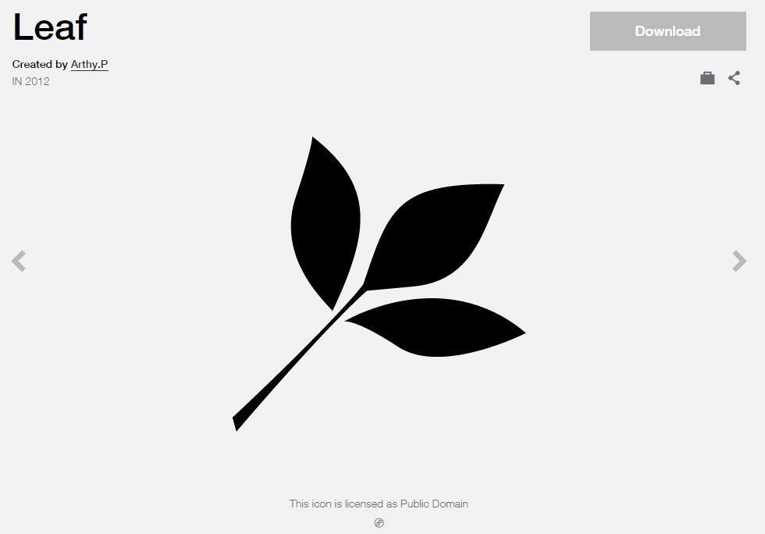

**Modified** **by:** Esri Solutions Team

**License:** Public Domain

**Acknowledgement:** None required

**Notes:** None

**Vehicle Incident**

**Symbol Name:** [Car](https://thenounproject.com/term/car/72/)

**Symbol Picture:** C:\Data\Symbology\Solutions\OpsIncident\web\Vehicle-Incident.png

**Symbol Source:** The Noun Project

**Symbol Date:** March 2015

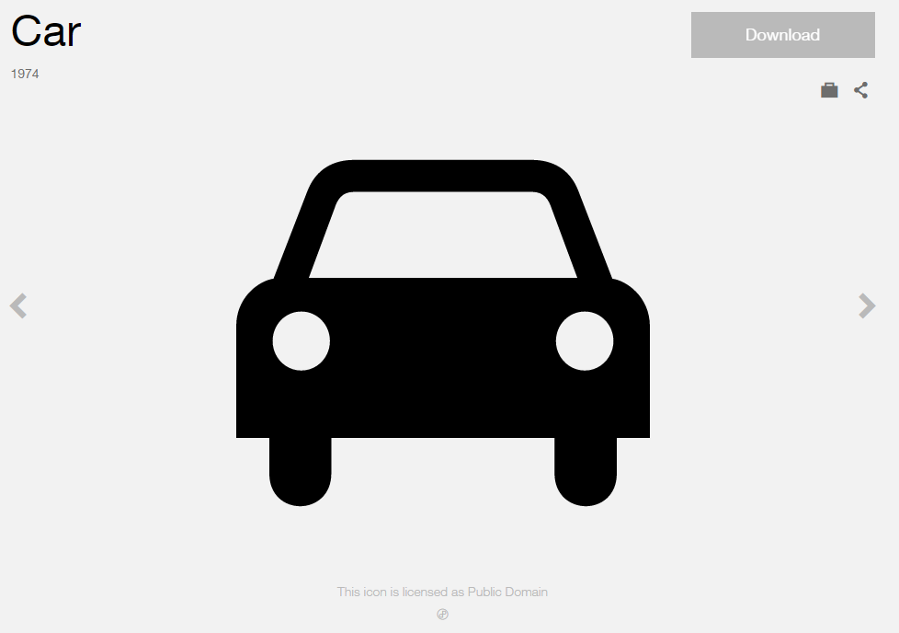

**Modified** **by:** Esri Solutions Team

**License:** Public Domain

**Acknowledgement:** None required

**Notes:** None

**Vermin**

**Symbol Name:**

**Symbol Picture:** C:\Data\Symbology\Utilities\Water\CCTVProcessor\web\Vermin.png

**Symbol Source:**

**Symbol Date:** May 2015

**Created by:** Esri Solutions Team

**License:** None

**Acknowledgement:** None required

**Notes:** None

**Vehicles and Vessels**

**Symbol Name:** [Ship](http://thenounproject.com/term/ship/4409/)

**Symbol Picture: C:\Data\Symbology\Solutions\OpsIncident\web\Marine-Incident.png**

**Symbol Source:** The Noun Project

**Symbol Date:** March 2015



**Modified by:** Esri Solutions Team

**License:** Public Domain

**Acknowledgement:** None Required

**Notes:** None

**Violations - Severe**

**Symbol Name:** !

**Symbol Picture:** C:\Data\Symbology\Utilities\Electric\JointUseSurvey\mobile\Violation-Severe.pngC:\Data\Symbology\Utilities\Electric\JointUseSurvey\web\Violation-High.png

**Symbol Source:** Arial Rounded MT Bold

**Symbol Date:** April 2015

**Created by:** Esri Solutions Team

**License:** None

**Acknowledgement:** None required

**Notes:** None

**Violations - Medium**

**Symbol Name:** !

**Symbol Picture:** C:\Data\Symbology\Utilities\Electric\JointUseSurvey\mobile\Violation-Medium.pngC:\Data\Symbology\Utilities\Electric\JointUseSurvey\web\Violation-Medium.png

**Symbol Source:** Arial Rounded MT Bold

**Symbol Date:** April 2015

**Created by:** Esri Solutions Team

**License:** None

**Acknowledgement:** None required

**Notes:** None

**Violations - Low**

**Symbol Name:** !

**Symbol Picture:** C:\Data\Symbology\Utilities\Electric\JointUseSurvey\mobile\Violation-Low.pngC:\Data\Symbology\Utilities\Electric\JointUseSurvey\web\Violation-Low.png

**Symbol Source:** Arial Rounded MT Bold

**Symbol Date:** April 2015

**Created by:** Esri Solutions Team

**License:** None

**Acknowledgement:** None required

**Notes:** None

**Violent Person**

**Symbol Name:** Assault, Solid Fist

**Symbol Picture:** C:\Data\Symbology\Utilities\Electric\HazardReportingCollector\mobile\Violent-Person.pngC:\Data\Symbology\Utilities\Electric\HazardReportingCollector\web\Violent-Person.png

**Symbol Source:** Crime Analysis style file

**Symbol Date:** June 2015



**Modified** **by:** Esri Solutions Team

**License:** None

**Acknowledgement:** None required

**Notes:** None

**Warming Center**

**Symbol Name:** Unicode 113

**Symbol Picture:** C:\Users\heat5533\Documents\GitHub\solutions-symbology-data\symbology\web\png\Warming-Center.png

**Symbol Source:** ESRI Enviro Hazard Analysis

**Symbol Date:** February 2015



**Modified** **by:** Esri Solutions Team

**License:** None

**Acknowledgement:** None required

**Notes:** None

**Water Distribution Center**

**Symbol Name:** Faucet

**Symbol Picture:** C:\Data\UC\UC2015\SituationalAwareness\web\Water-Distribution-Center.png

**Symbol Source:**  Civic style file

**Symbol Date:** July 2015

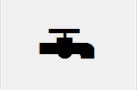

**Modified by:** Esri Solutions Team

**License:** None

**Acknowledgement:** None required

**Notes:** None

**Waste Disposal Violation**

**Symbol Name:** WD

**Symbol Picture:** C:\Data\Symbology\Utilities\Water\ConstructionSiteViolations\mobile\Waste-Disposal-Violation.png

**Symbol Source:** Arial Rounded MT Bold Font

**Symbol Date:** March 2015

**Modified** **by:** Esri Solutions Team

**License:** None

**Acknowledgement:** None required

**Notes:** None

**Water Map Change Request**

**Symbol Name:** [Map](https://thenounproject.com/term/map/2312/)

**Symbol Picture:** C:\Users\heat5533\Documents\GitHub\solutions-symbology-data\symbology\mobile\png\Water-Map-Change-Request.pngC:\Users\heat5533\Documents\GitHub\solutions-symbology-data\symbology\web\png\Water-Map-Change-Request.png

**Symbol Source:** The Noun Project

**Symbol Date:** May 2015



**Modified by:** Esri Solutions Team

**License:** Public Domain

**Acknowledgement:** None required

**Notes:** None

**Water Map Change Request Critical**

**Symbol Name:** W

**Symbol Picture:** C:\Users\heat5533\Documents\GitHub\solutions-symbology-data\symbology\mobile\png\Water-Map-Change-Request-Critical.pngC:\Users\heat5533\Documents\GitHub\solutions-symbology-data\symbology\web\png\Water-Map-Change-Request-Critical.png

**Symbol Source:** Arial Rounded MT Bold Font

**Symbol Date:** March 2015

**Modified** **by:** Esri Solutions Team

**License:** None

**Acknowledgement:** None required

**Notes:** None

**Water Map Change Request Not Critical**

**Symbol Name:** W

**Symbol Picture:** C:\Users\heat5533\Documents\GitHub\solutions-symbology-data\symbology\mobile\png\Water-Map-Change-Request-Not-Critical.pngC:\Users\heat5533\Documents\GitHub\solutions-symbology-data\symbology\web\png\Water-Map-Change-Request-Not-Critical.png

**Symbol Source:** Arial Rounded MT Bold Font

**Symbol Date:** March 2015

**Modified** **by:** Esri Solutions Team

**License:** None

**Acknowledgement:** None required

**Notes:** None

**Water Quality Advisory - No**

**Symbol Name:** Water Recreation & Droplet, Water

**Symbol Picture:** C:\Users\heat5533\Documents\GitHub\solutions-symbology-data\symbology\web\png\Water-Quality-Advisory-No.png

**Symbol Source:** Forestry & Environmental style file

**Symbol Date:** December 2015

 

**Modified by:** Esri Solutions Team

**License:** None

**Acknowledgement:** None required

**Notes:** None

**Water Quality – Not Applicable**

**Symbol Name:** Water Recreation & Droplet, Water

**Symbol Picture:** C:\Users\heat5533\Documents\GitHub\solutions-symbology-data\symbology\web\png\Water-Quality-Advisory-Not-Applicable.png

**Symbol Source:** Forestry & Environmental style file

**Symbol Date:** December 2015

 

**Modified by:** Esri Solutions Team

**License:** None

**Acknowledgement:** None required

**Notes:** None

**Water Quality - Yes**

**Symbol Name:** Water Recreation & Droplet, Water

**Symbol Picture:** C:\Users\heat5533\Documents\GitHub\solutions-symbology-data\symbology\web\png\Water-Quality-Advisory-Yes.png

**Symbol Source:** Forestry & Environmental style file

**Symbol Date:** December 2015

 

**Modified by:** Esri Solutions Team

**License:** None

**Acknowledgement:** None required

**Notes:** None

**Water Treatment Plant Permit**

**Symbol Name:** Tank Farm

**Symbol Picture:** C:\Users\heat5533\Documents\GitHub\solutions-symbology-data\symbology\web\png\Water-Treatment-Plant.png

**Symbol Source:** Environmental style file

**Symbol Date:** September 2014

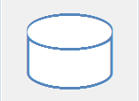

**Modified by:** Esri Solutions Team

**License:** None

**Acknowledgement:** None required

**Notes:** None

**Watering Violations - Commercial**

**Symbol Name:** !

**Symbol Picture:C:\Users\heat5533\Documents\GitHub\solutions-symbology-data\symbology\mobile\png\Watering-Violations-Commerial.png**

**Symbol Source:** Arial Rounded MT Bold

**Symbol Date:** May 2015

**Modified by:** Esri Solutions Team

**License:** None

**Acknowledgement:** None required

**Notes:** None

**Watering Violations - Industrial**

**Symbol Name:** !

**Symbol Picture:** C:\Users\heat5533\Documents\GitHub\solutions-symbology-data\symbology\mobile\png\Watering-Violations-Industrial.png

**Symbol Source:** Arial Rounded MT Bold

**Symbol Date:** May 2015

**Modified by:** Esri Solutions Team

**License:** None

**Acknowledgement:** None required

**Notes:** None

**Watering Violations - Parks**

**Symbol Name:** !

**Symbol Picture:** C:\Users\heat5533\Documents\GitHub\solutions-symbology-data\symbology\mobile\png\Watering-Violations-Parks.png

**Symbol Source:** Arial Rounded MT Bold

**Symbol Date:** May 2015

**Modified by:** Esri Solutions Team

**License:** None

**Acknowledgement:** None required

**Notes:** None

**Watering Violations - Residential**

**Symbol Name:** !

**Symbol Picture:** C:\Users\heat5533\Documents\GitHub\solutions-symbology-data\symbology\mobile\png\Watering-Violations-Residential.png

**Symbol Source:** Arial Rounded MT Bold

**Symbol Date:** May 2015

**Modified by:** Esri Solutions Team

**License:** None

**Acknowledgement:** None required

**Notes:** None

**Weeds**

**Symbol Name:** [Dandelion](https://thenounproject.com/term/dandelion/20016/)

**Symbol Picture:** C:\Data\Symbology\StateGov\CitizenScience\web\Weeds.png

**Symbol Source:** The Noun Project

**Symbol Date:** March 2015

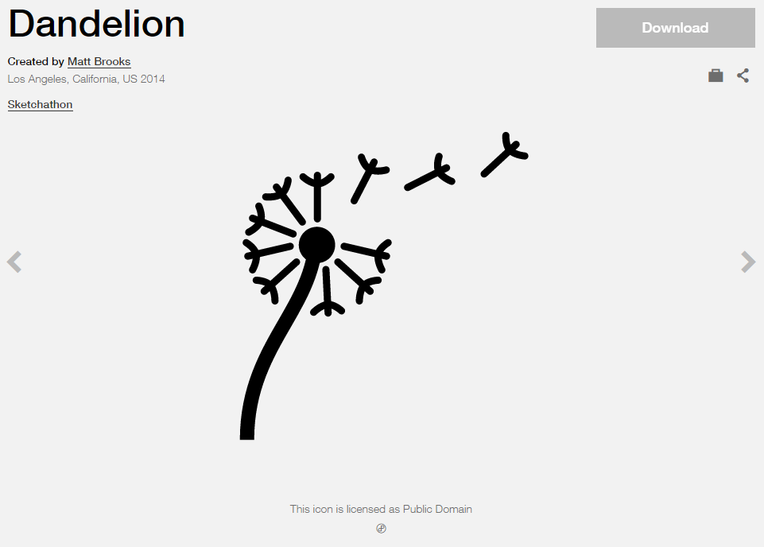

**Modified by:** Esri Solutions Team

**License:** Public Domain

**Acknowledgement:** None required

**Notes:** None

**Weld**

**Symbol Name:**

**Symbol Picture:** C:\Data\Symbology\Utilities\Water\CCTVProcessor\web\Weld.png

**Symbol Source:**

**Symbol Date:** May 2015

**Created by:** Esri Solutions Team

**License:** None

**Acknowledgement:** None required

**Notes:** None

**Wildlife Management Locations**

**Symbol Name:** Wildlife 2

**Symbol Picture:** C:\Users\heat5533\Documents\GitHub\solutions-symbology-data\symbology\web\png\Wildlife-Management-Areas.png

**Symbol Source:** Conservation style file

**Symbol Date:** May 2014



**Modified by:** Esri Solutions Team

**License:** None

**Acknowledgement:** None required

**Notes:** None

**Wineries**

**Symbol Name:**

**Symbol Picture:** C:\Users\heat5533\Documents\GitHub\solutions-symbology-data\symbology\web\png\Wineries.png

**Symbol Source:**

**Symbol Date:** March 2015

**Created by:** Esri Solutions Team

**License:** None

**Acknowledgement:** None required

**Notes:** None

**Wire Down**

**Symbol Name:** [Power Lines](https://thenounproject.com/search/?q=power&i=4928)

**Symbol Picture:** C:\Data\Symbology\Utilities\Electric\HazardReportingCollector\mobile\Wire-Down.pngC:\Data\Symbology\Utilities\Electric\HazardReportingCollector\web\Wire-Down.png

**Symbol Source:** The Noun Project

**Symbol Date:** June 2015

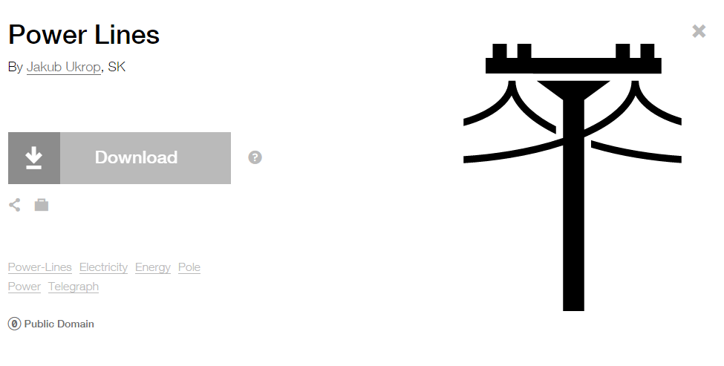

**Modified by:** Esri Solutions Team

**License:** Public Domain

**Acknowledgement:** None required

**Notes:** None