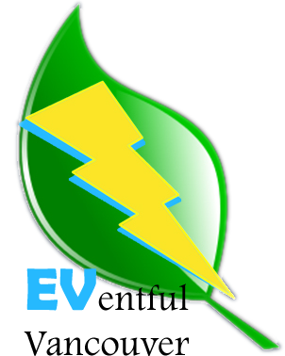

**What is EVentful Vancouver?** An App designed to mobilize the City of Vancouver to a greener future by empowering existing electric vehicle (EV) users and promoting the growth of the community through increased access and ease of use.

**Why?** Climate change is upon us and technological development has gotten us into it, now let it help get us back out! We needed to stop burning fossil fuels, yesterday, but no one is willing to lower their standard of living to do it. Luckily driving personal vehicles is a huge part of what we as first world consumers can change!

The future is already here, electric vehicles are zipping about on the roads next to you whether you’ve noticed or not! Almost every major car company now has an electric vehicle or hybrid style model out in a competitive production line. Now why are you still paying for and burning fossil fuel you might ask yourself? Unfortunately the answer is simple; it’s still easier and cheaper than electric.

That’s where our App comes in; with an ever increasing ratio of electric vehicles on the roads, community sourced charging stations are the way of the future to build capacity and optimize use of electric vehicles. The idea is simple, with more electric vehicles on the roads there will be an equal number more home chargers. With our App users can locate, share, edit and even add places of interest nearby chargers to make others experience simpler, cheaper and greener. As more capacity is created for electric vehicle use its positive feedback will incentivize more drivers to switch to electric in a self-sustaining cycle.

Make the change, be a part of the solution, invest in your and your children’s future, the community is growing and we’d love you to be involved!