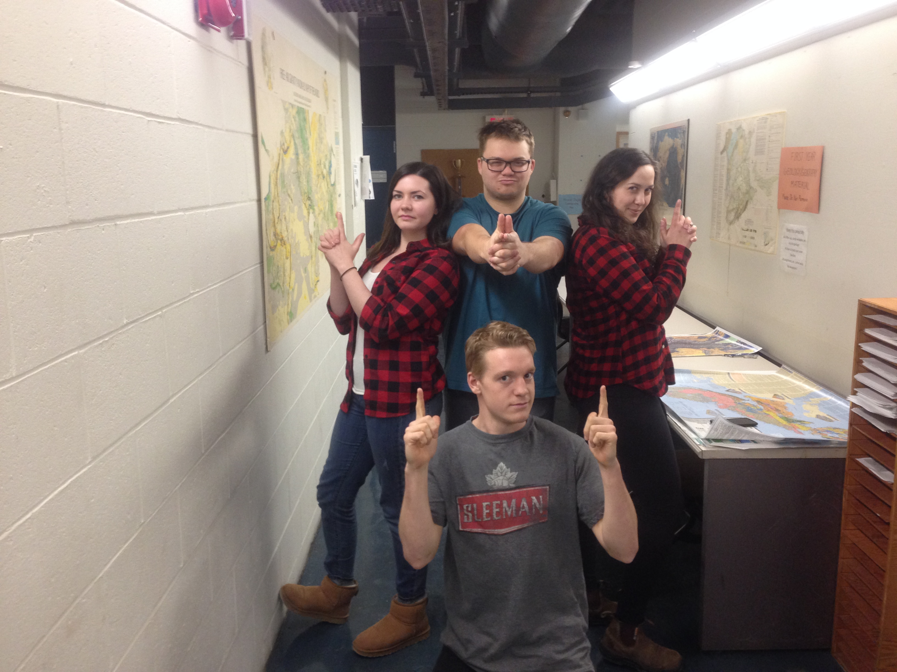

Biography

Team Name: Charlie’s Angels

From left to right:

Meagan Cooper

Meagan is a fourth year Earth Science student at Dalhousie and hopes to continue her academic career at Dal Med next fall. Her hobbies include pina coladas and getting caught in the rain. Her favourite part of the app challenge has been getting to know her teammates, with nobody being the clear favourite yet. Meagan hates walking on the beach, but loves the sand between her toes, resulting in a quite frustrating search for adequate sand within her hometown. She also a severe allergy to the computer screen and keyboard. Favourite movie is Charlie’s Angels.

Sarah McLeod

Sarah is a fourth year earth science student at Dalhousie University who has a strong interest in GIS. Along with her earth science degree Sarah has perused a certification in GIS. In the process of completing this certification Sarah has participated in a number of esri-based courses including an advanced research project. Sarah is looking forward to getting to know her team members and working with them to learn about the app making process. Her life goal is to be the next Vanna White through her keen interests in spelling, sparkly dresses, and Pat Sajak. Her favourite movie is Charlie’s Angels.

Tyson Shushkewich (in the back)

As a fourth year student, Tyson is in his last year at Dalhousie. Tyson hails from the lonely prairie grassland province of Alberta but wanted to see seagulls, so he enrolled at Dalhousie University. Completing a project for his last required course for the GIS certificate, Tyson is excited to apply his trade to the ESRI App Challenge. His hobbies include baseball, sleeping, learning, listening, and long periods of self reflection whilst hurling stones at nearby lakes. Tyson’s lifetime career goal is to be the next David Attenborough. His favourite movie is Charlie’s Angels.

Kevin Duffin (front)

Kevin hails from Ottawa, Ontario. Intrigued by the coast, Kevin enrolled at Dalhousie University and has not looked back over the past four years. He is set to graduate this upcoming fall after completing some pesky field school courses that have evaded him over the past few summers. Kevin has had a severe love for GIS and has enjoyed working on the App Challenge with his fellow teammates. Kevin enjoys long walks on the beaches, listening to conch shells, and listening to Mariah Carey Christmas Albums (ask him and he will sing a few bars). His favourite movie was Wild Hogs, but it is now Charlie’s Angels.