Team Name: **GIS**oar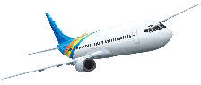

# Carleton University

# Team Picture;

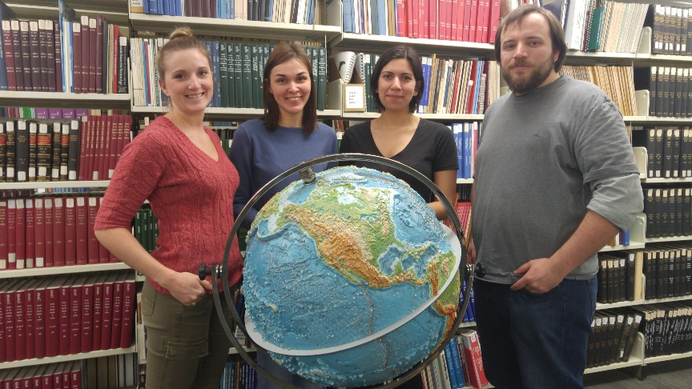

# Biography;

Rafael Seyler

Rafael is finishing his third year at Carleton University in the Geomatics program. His knowledge and experience is diverse, with having achieved a diploma from Algonquin College in GIS and a degree from Ottawa University in Medieval History and Religious Studies. He is passionate about understanding the patterns and relationships of our current world and hopes to pursue a career where he can develop strong skills and knowledge in areas of GIS and python code.

Yulia Antropova

Yulia previously obtained a degree in Russia of Information Technologies in Business. She wanted to connect her knowledge in IT with her interests in the environment and geography, and has thus found a home at Carleton University in the Geomatics program. She is now completing her fourth and final year, hoping to pursue these combined fields in a setting where she can expand her knowledge and practices to help make advancements in GIS.

Jessica Smith

Jessica is in her third year at Carleton University majoring in Geography with a double minor in Geomatics and French. Her studies have routed her to have a strong passion for GIS where she thrives to find a balance between Human Geography and Geomatics. In the future, she would like to expand her knowledge and skills in Python and other languages to further improve her skillset and to gain a deeper understanding of GIS.

Danielle Derrick

Danielle is currently a fourth year undergraduate student studying in Biology with a strong focus on GIS. She is extending her knowledge and experience into Master’s research studying Humpback Whales in Alaska, focusing on their conservation and foraging ecology. Ultimately, Danielle is hoping to combine her passion for understanding how ecosystems function and her interests in GIS into a career focusing on conservation and public outreach.