**Mission Statement**

We want to promote cycling as a mode of transportation to new, preciously unvisited locations by enabling cyclists to find bicycle parking before they arrive at their destination.

**Statement of the characteristics of the app**

Have you ever cycled to a new location, and then proceeded to spend almost as much time as your commute trying to find a place to lock up your bicycle? Us too!   
In order to get around this frustration, we have often found ourselves in situations where we opt to drive with a motor vehicle, a less sustainable form of transportation, rather than risk being unable to lock up our bicycles.

Our app will allow you to type in the address or click on the location you are planning to go to, and the closest bike rack will pop up within a buffer zone that is set by the user (ex: 100m, 200m etc.) so you know where to lock up your bike and how far it is away from your final destination. Thus making commuting via bicycle to a new location a lot easier.

**Model description**

Our app uses a tool that we built using ArcMap’s model builder. The model begins by buffering the input destination based on the input maximum travel distance. The input location and maximum travel distance are both parameters in the model and are modifiable by the user. The model then uses a clip to select all the features that fall within the buffer. The features to be clipped are the points in the bike rack shape file representing the x, y locations of the bike racks in Toronto. The output is the result of the clip and contains the bike racks that fall within one travel distance radius of the input location.

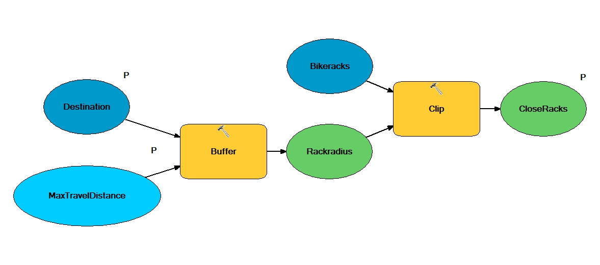

**Video demonstrate use of your app**

See good_enough.webM Video File

**Data Source**

The shapefile* containing the bike rack locations of Toronto was retrieved from the city of Toronto’s open data catalogue:

http://www1.toronto.ca/wps/portal/contentonly?vgnextoid=d46e94ec9fbf3310VgnVCM1000003dd60f89RCRD&vgnextchannel=1a66e03bb8d1e310VgnVCM10000071d60f89RCRD

*Spatial reference system: WGS 1984 MTM 3 Degree Zone 10N

Last update in 2011

**Link to App:** http://dalspatial.maps.arcgis.com/apps/webappviewer/index.html?id=a9298cdd87fb40c1ad3784161538df53