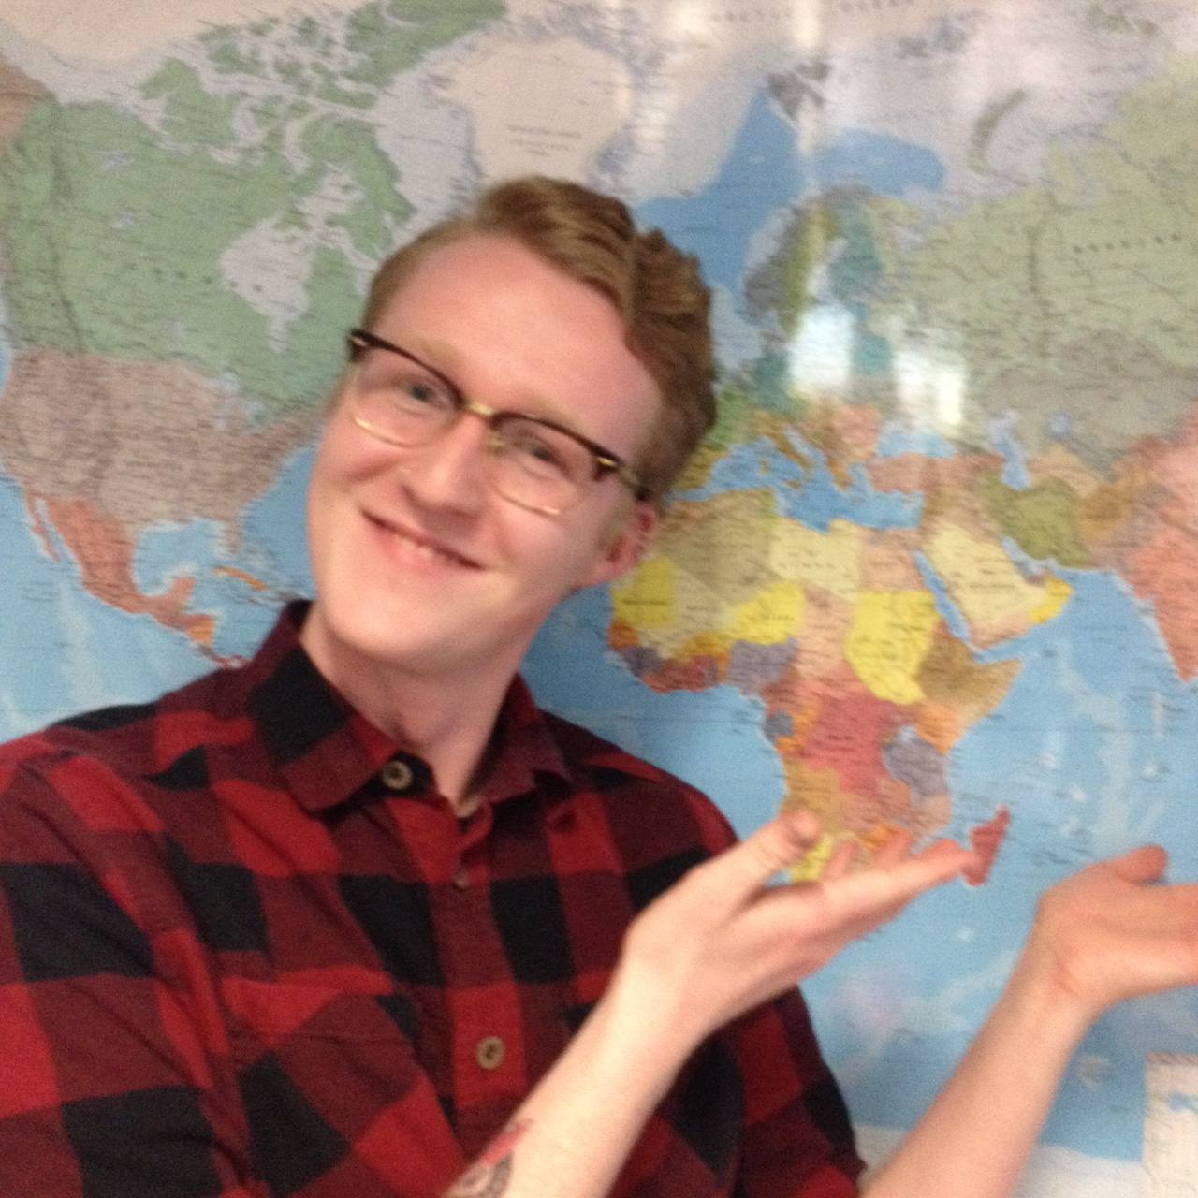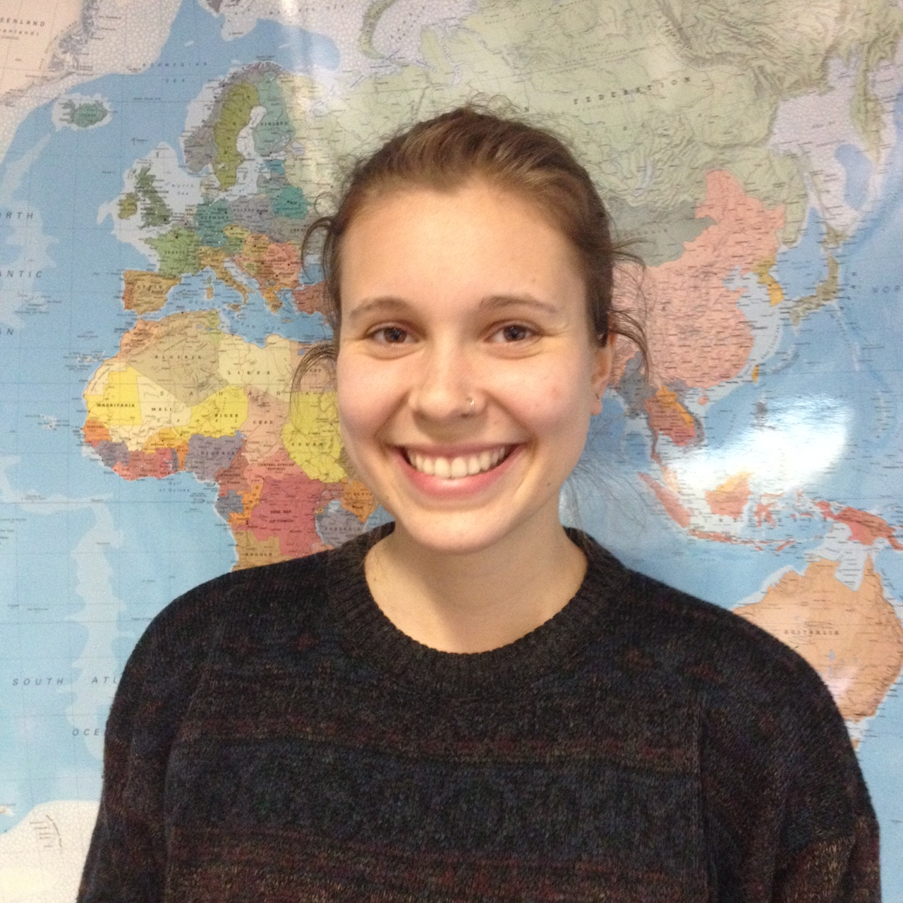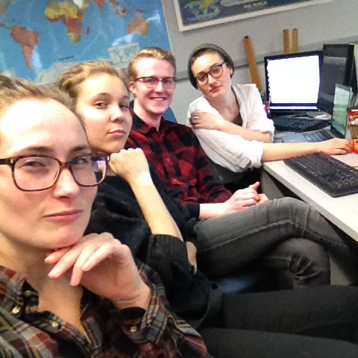

**Our Team: Just Trying to Graduate**

**School: Dalhousie University**

**Class: ENVS 4850**

Alistair Ozon is a dedicated undergraduate student perusing a degree in

BSc Environmental Science and a minor in Earth Sciences. He appreciates a good laugh and even better beer.

Krista Jager is from London Ontario and is an avid cyclist. She is perusing a Bachelor of Science with a double major in Environment Sustainability and Society and Biology, and a minor in German.

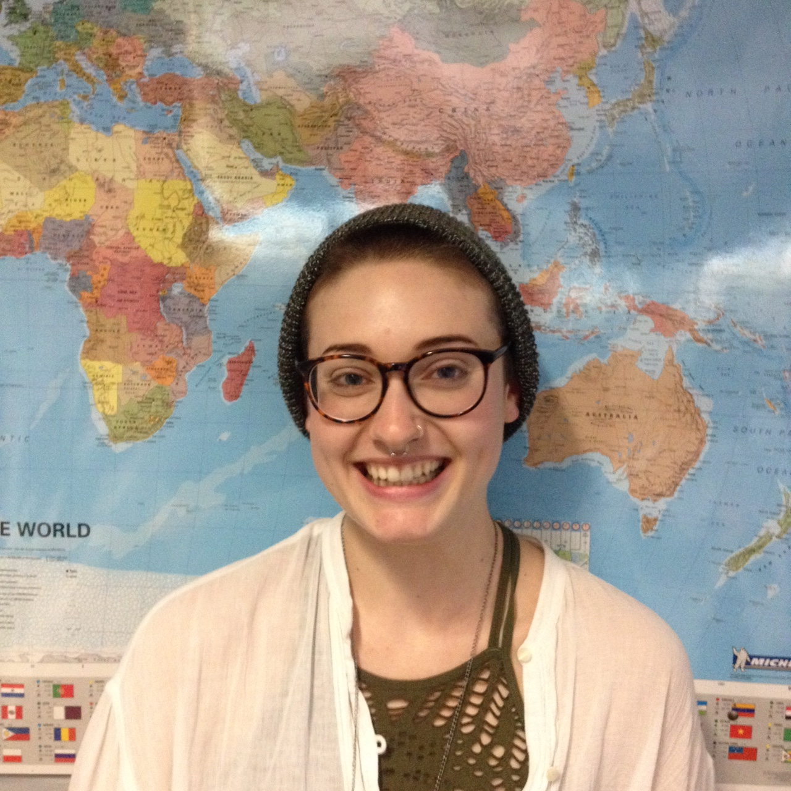Emily Bibeau loves to scuba dive, most recently she explored the Halifax harbour. She is perusing a Bachelor of Science with a double major in Environment Sustainability and Society and Environmental Science.

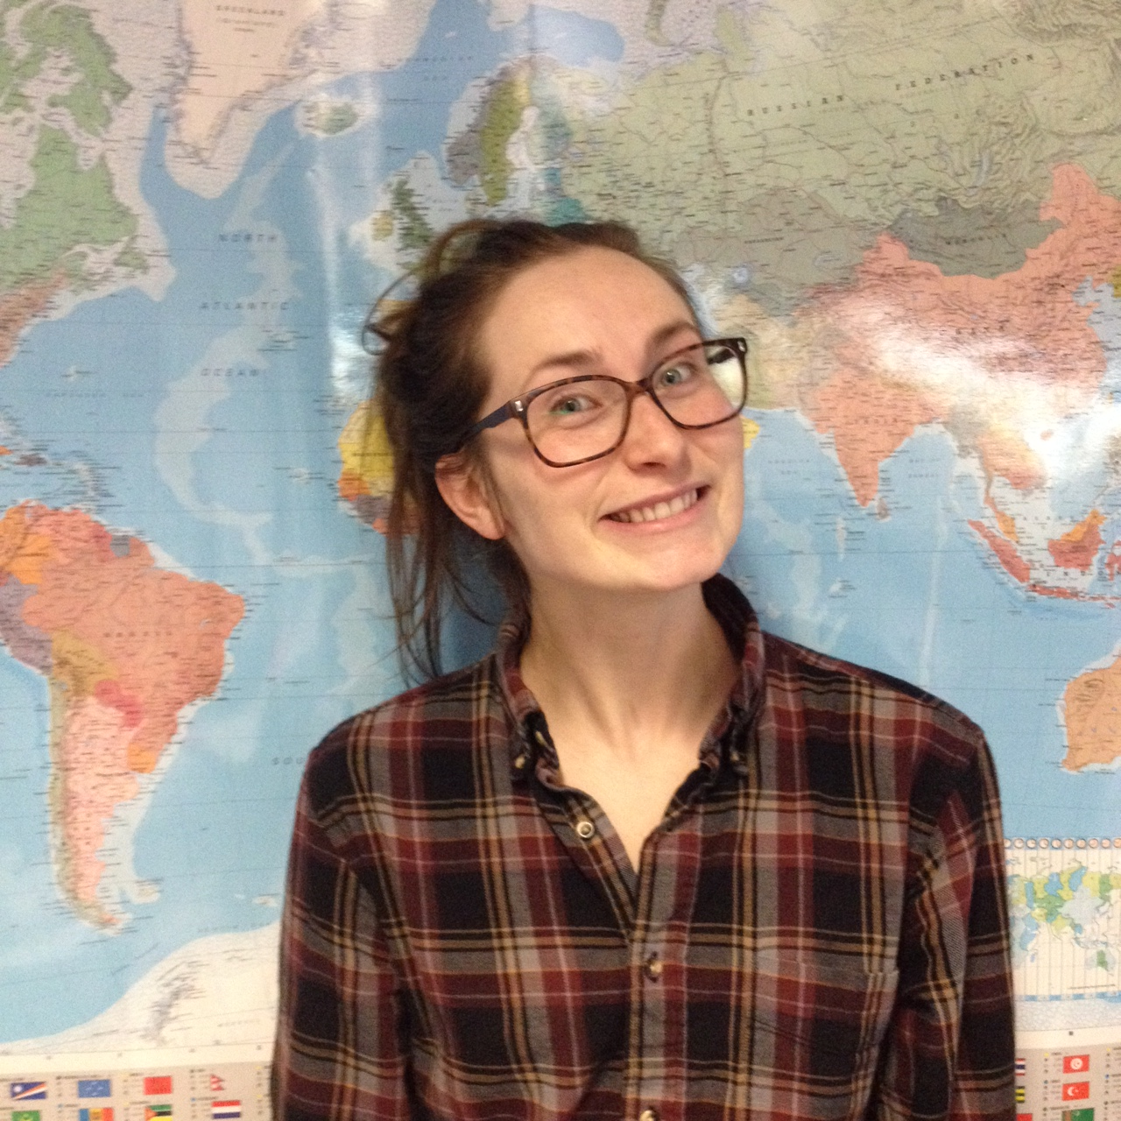

Alice Main, from southern Alberta, loves to hike in the mountains. She is perusing a Bachelor of Science with a double major in Environment Sustainability and Society and Environmental Science.