# Products installation and environment set-up Guide

## System prerequisites:

* Windows systems or have Parallels on Mac
* 64-bit system

## Installation steps:

### Install/Update to ArcGIS Pro 3.1

ArcGIS Pro Licensing steps (single use): https://pro.arcgis.com/en/pro-app/latest/get-started/authorize-and-start-arcgis-pro-with-a-single-use-license.htm

### Install/Update to R 4.2.2

https://cran.r-project.org/bin/windows/base/

### Install/Update to RStudio 2022.12.0+353 (Optional)

https://posit.co/download/rstudio-desktop/

### Install arcgisbinding

1. Open ArcGIS Pro, if necessary
2. After opening the Pro 3.1 backstage, go to the ‘Settings’ tab on the left-hand side.

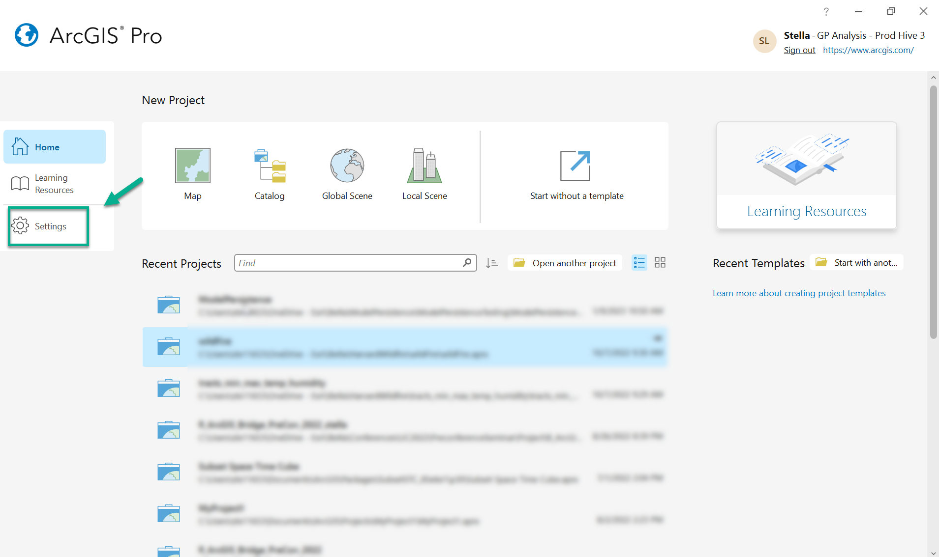

1. Then choose Options > Geoprocessing. Under the R-ArcGIS Support section, specify the **R** **4.2.2** that you just installed on your machine. 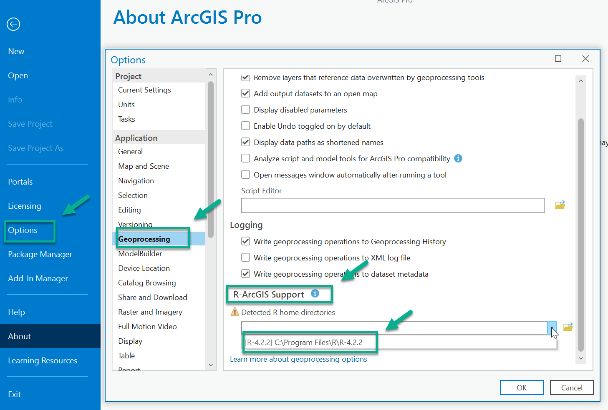
2. Click on the icon below and select ‘Install package from the Internet’. The arcgisbinding package should be **1.0.1.300**.

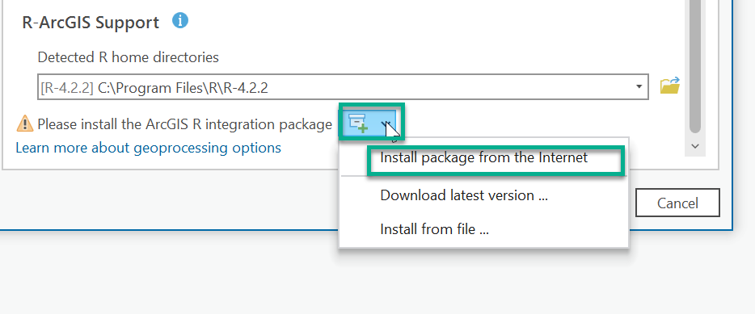

1. Click ‘Yes’ on the pop-up window. And Click ‘OK’ to close the Options window.

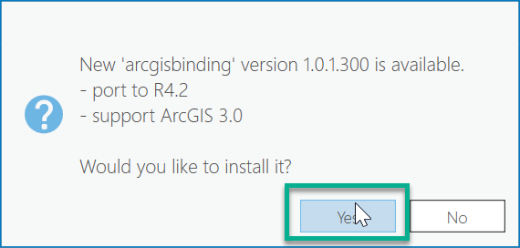

## Environment set-up:

### Clone a conda environment in Pro

1. Go to Settings > Package Manager > The gear icon next to the ‘Active Environment’

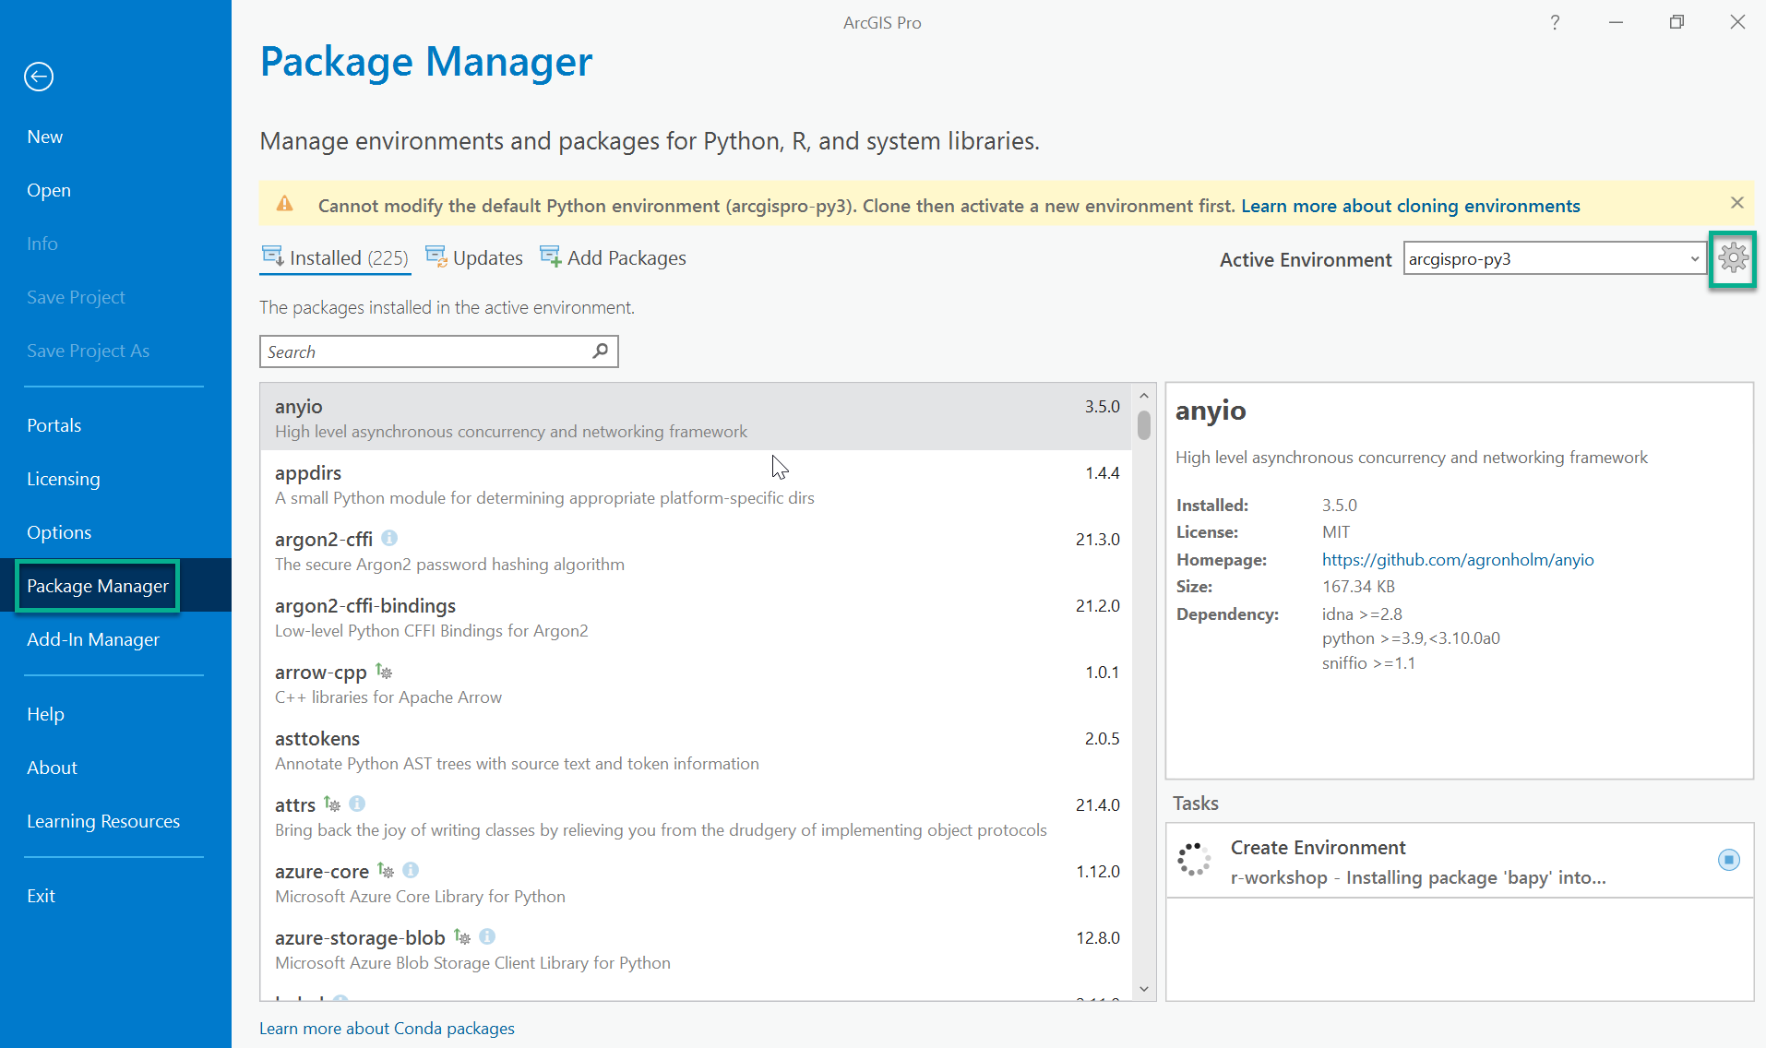

1. Click on the Clone new environment button on the upper right corner. A ‘Clone Environment’ window will pop up with a default destination and default cloned environment name. Feel free to edit the new environment name to make it more meaningful to you. Click the ‘OK’ button after you finish editing. It will take a few minutes to clone the environment.

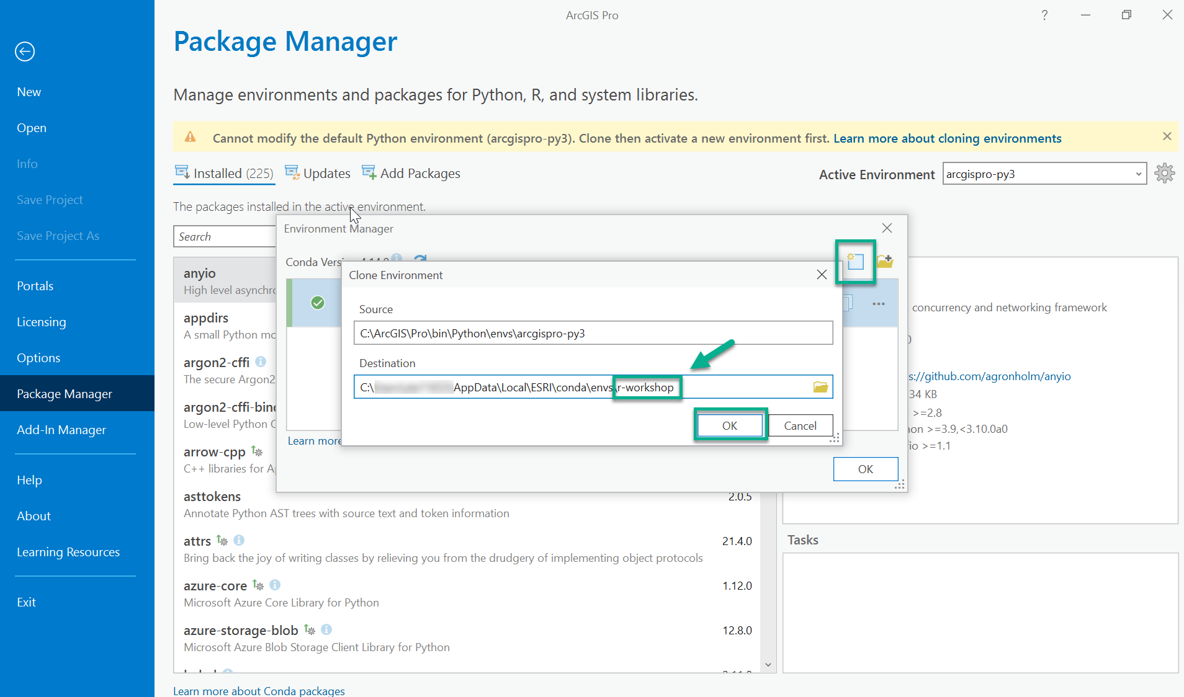

1. Switch to the cloned new environment through the ‘Active Environment’ drop down list. You will need to restart Pro to activate the new environment. Click the Gear button and refresh the cloned environment.

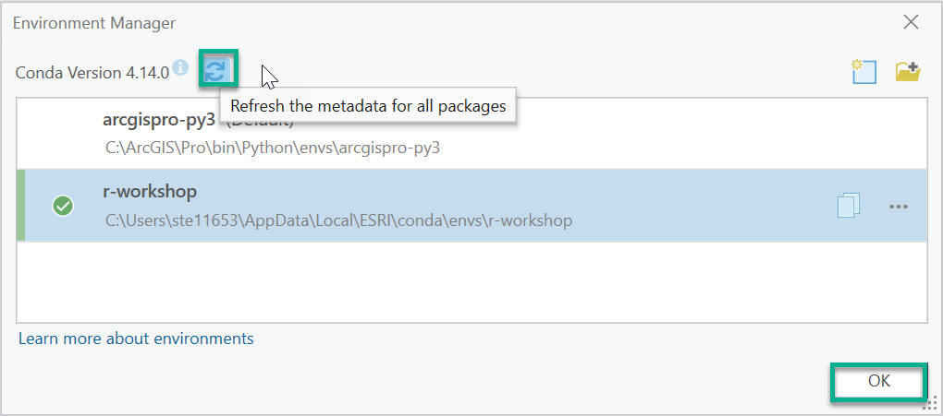

1. Go to ‘Add Packages’ tab and type ‘r-arcgis-essentials’ in the search box. You will see the package metadata to the right. Click the ‘Install’ icon to install the package. Check the agreement box to start the installation.

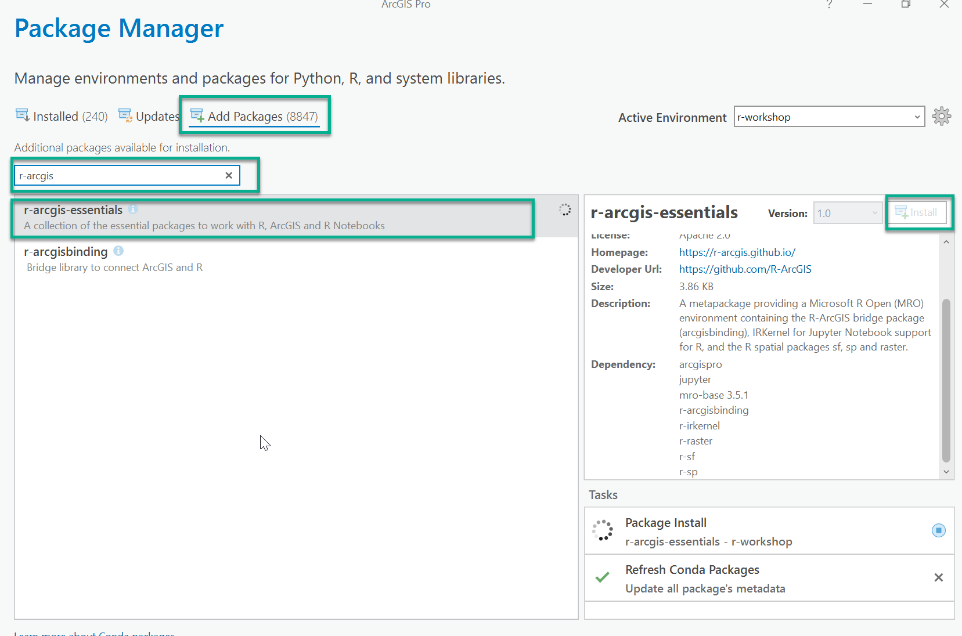

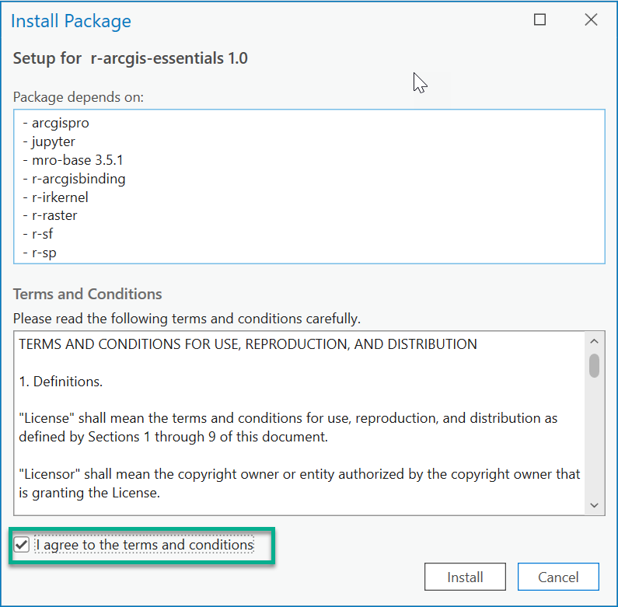

1. After the package is installed. You are all set! Look forward to seeing you in the DevSummit pre-con workshop!