**تطبيق اخبار**

Abstract:

A dedicated news application that allows you to discover breaking news, trending topics, and see all the news that is happening around you. It also cares about local and foreign economic affairs.

**Table of Contents:**

1. **Chapter One Introduction:**
2. Introduction to the system
3. Problem Statement
4. Objectives
5. Methodology
6. Scope
7. Related works.
8. **Chapter Two: Analysis**
9. **Chapter Three: Design and Implementation**
   1. Design And Codes.
10. **References**

**Introduction:**

**Introduction to the system:**

The system is an application to display the latest local, international and urgent news. The system is also accused of displaying economic indicators and the visual market as well as the latest sports news.

**Problem Statement:**

The expansion of global events and the lack of an application that takes all sources and works to detect fake and false news.

**Objectives:**

An application that takes all the news sources and works on transmitting the news as quickly as possible.

**Methodology:**

In building the project, the Cycle Life development System SDLC methodology will be used, which facilitates early prediction of errors and allows developers to focus on the quality of the application and the time specified for the implementation of the program and also put the required cost into account. This methodology is characterized by facilitating the future development process of the system.

**Scope:**

1. Ability to publish posts.
2. The ability to upload photos.
3. Ability to edit posts.
4. Ability to delete posts.

**Related works:**

Similar workers have been viewed and discussed, namely:

BBC News App – Euronews App-New York Post App

**Analysis**

We searched for an idea that targets a large segment of users, and we found that news applications are one of the best methods used

We searched for several applications used locally and internationally, and the idea of the applications did not exceed the main functions, which are:

Add - Delete Edit

As for what the application offers, it is to display the title of the news and pictures of the news, in addition to the details of the news

As for the remaining extensions from displaying videos in the application, as well as the rest of the files, these features will be added in the future in later versions of the application

**Design and Implementation:**

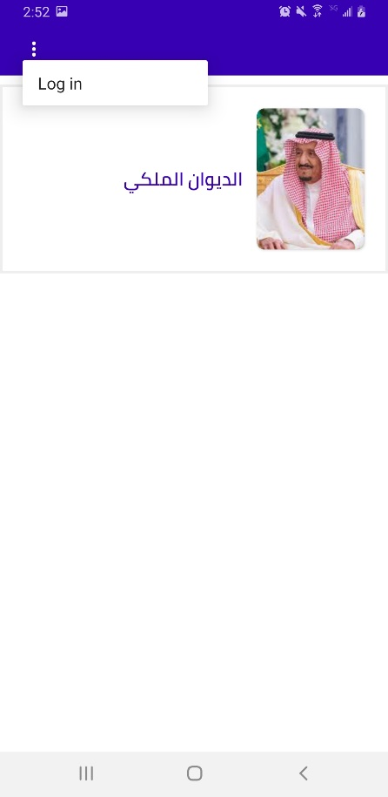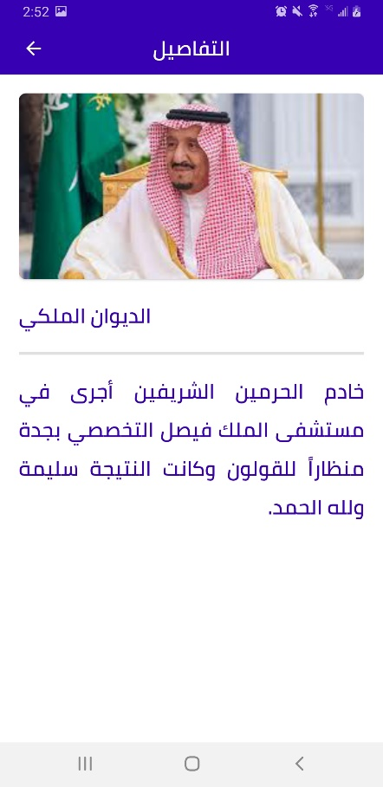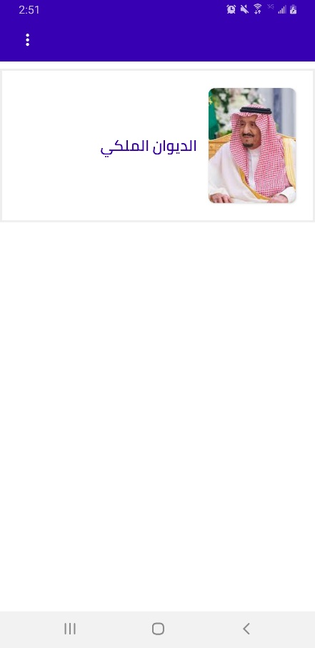

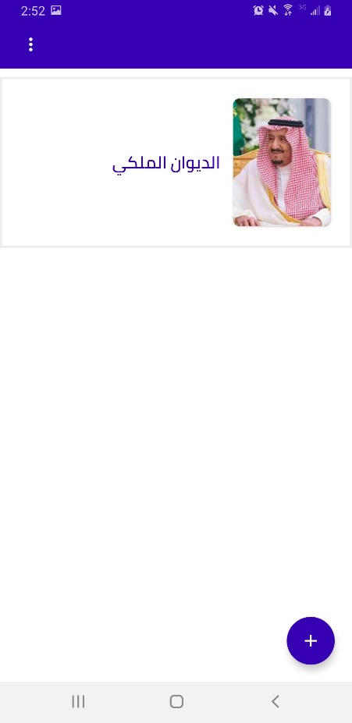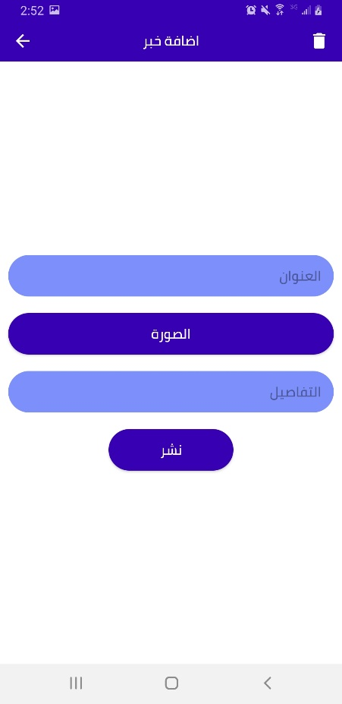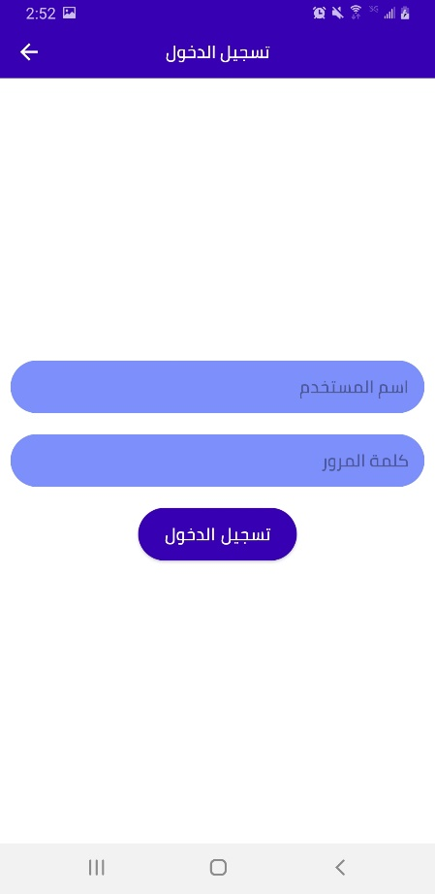

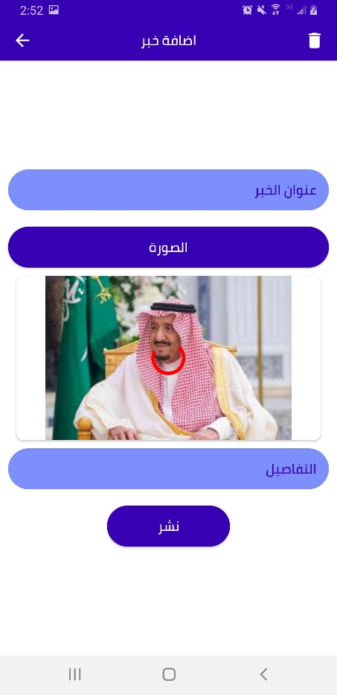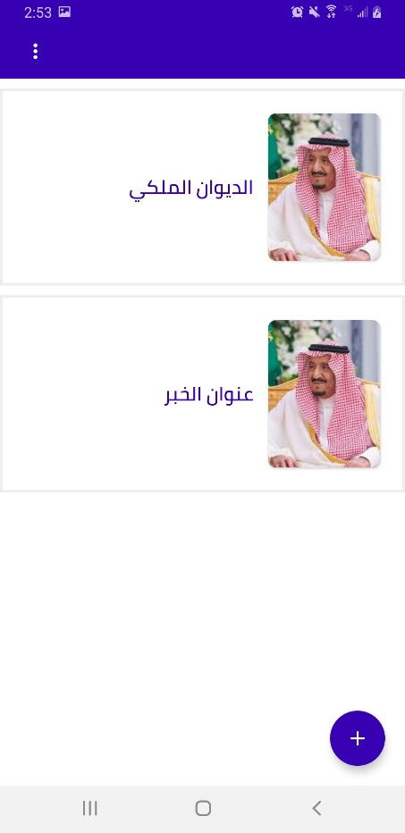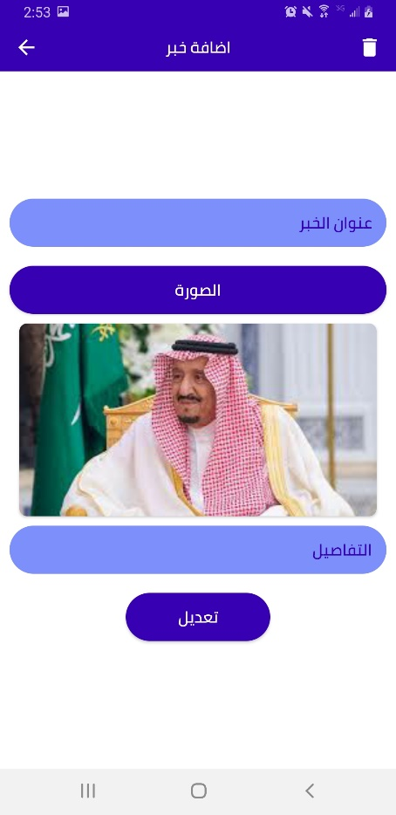

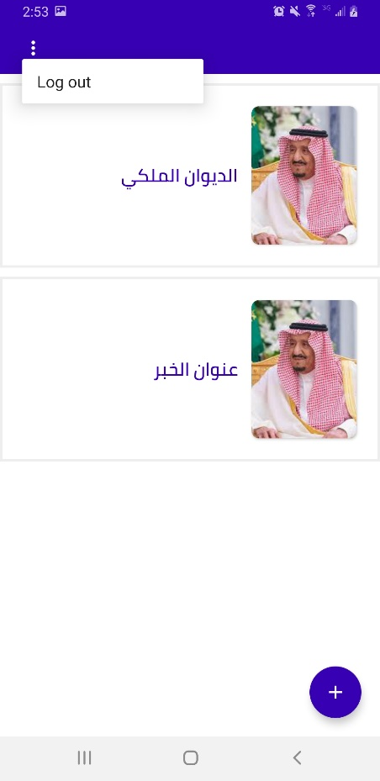

**References:**

<https://stackoverflow.com/>

<https://developer.android.com/>

<https://www.codegrepper.com/>